**Uncommon Solutions**

**Group 3**

**System Specification**

**UNCOMMON SOLUTIONS SYSTEM SPECIFICATION**

**Prepared By**

|  |  |
| --- | --- |
| Document Owner(s) | Project Role |
| Michael Kiefer | Project Manager |

**Requirements Version Control**

|  |  |  |  |
| --- | --- | --- | --- |
| Version | Date | Author | Change Description |
| 1.0 | 12/13/2019 | Michael Kiefer | Document creation |

**Summary Details**

|  |  |
| --- | --- |
| Participants | Name(s) |
| Project Manager: | Michael Kiefer |
| Project Team: | Hither Guzha – Technical Writer  Andrew Benson - Software Engineer  Donn Eddy - UX/HCI  Sean Mooneyham - Integration Engineer  Chase Thorpe - Test Engineer |
| End Users: | HR Departments |
| Description w/ Goal: | The purpose of this project is the implementation of an HR database and front end for personnel tracking. This document outlines the system requirements specified for the completion of the project as planned |

INTRODUCTION 4

1.1 Purpose 4

1.2 Background 4

1.3 Scope 4

1.4 Assumptions 4

1.5 Constraints 4

2 System Requirements 5

2.1 Operating Environment 5

2.2 Design and Implementation Constraints 5

2.3 Assumptions and Dependencies 5

2.4 Hardware Interfaces 5

2.5 Software Interfaces 5

2.6 Communication Interfaces 6

2.7 Software Quality Attributes 6

2.8 Performance Requirements 6

2.9 Security Requirements 6

3 APPROVALS 7

# 

# INTRODUCTION

## Purpose

The purpose of this document is to detail the system specification requirements of the Uncommon Solutions HR Management System. The Uncommon Solutions HR Management System is being developed using an Agile SDLC framework. Any deviations from the planned Uncommon Solutions HR Management System will be reflected by updated changes to the associated design and system management documents. This document contains the necessary details to implement the system level requirements for the planned development process.

## Background

The Uncommon Solutions HR Management System will be designed in a way that makes it easy to support multiple platforms such as Windows, macOS, iOS and Android. This web-based tool provides a direct method for storing and providing access to individual personnel records, and for all processes required for HR tracking and data aggregation requirements. The HR system will be implemented using AWS Elastic Compute Cloud (EC2) and Amazon’s Relational Database Service (RDS) in order to allow for universal deployability and access.

## Scope

This document provides a clear overview of the designed system requirements for the completion of the Uncommon Solutions HR Management System. Specific software requirements for development and deployment are covered within the Requirements Specification accompanying this document.

## Assumptions

The following assumptions are relevant to the design of the proposed system:

* The proposed new system will leverage the Uncommon Solutions HR architecture.
* The existing architecture and system design will be used including all existing components and sub-systems.
* It is assumed that additional functionality will be added to the proposed solution as required during development and testing.

## Constraints

* There are no hardware or software technical constraints identified with this project.
* System interoperability may be a constraint since the design will leverage free tier AWS EC2 instance and RDS with the potential to expand to paid utilization at a larger-scale fielding.

# System Requirements

## Operating Environment

The product system design utilizes two different AWS services, Elastic Compute Cloud (EC2) and Amazon’s Relational Database Service (RDS). Using AWS as a platform for fielding the application is the most cost-effective way to host the application while also providing access to the application for all project team members and product owners. AWS is an excellent platform for quickly spinning up application prototypes and rapidly deploying solutions to multiple customers.

The application uses Apache version 2.4.29 as a web server and is installed on the EC2 T2 instance and uses Ubuntu 18.04 as an operating system. All source code including the user interface and API will be on the apache server. The application uses a MySQL database installed on an RDS instance to house all the application data.

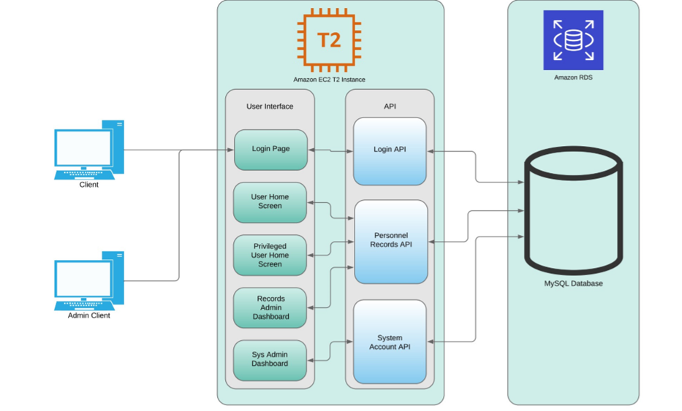

Figure 1: System Design Diagram

## Design and Implementation Constraints

As this is a proof of concept demonstration and not a final fielding, the implementation will be restricted to the storage and processing capabilities provided within the free tier of AWS processing. A fielding for customer utilization would require instances generated on that customer’s AWS hosting services account and could be scaled to the level of storage and processing required for the size of their organization. The implementation plan must be something that can be completed by a small and relatively inexperienced team within the implementation timeline of three weeks with a fourth week available as project flex if required.

## Assumptions and Dependencies

The system is being developed based on the assumption of existing cloud services being present and available for development and implementation. Final functionality is dependent on the availability of hosting services for the database and front-end hosting and functionality. The underlying hosting services for both are expected to remain functional on the hosting server. While the designed implementation makes use of AWS hosting services, any client with an independent web hosting and database hosting capability will be able to internally execute the client with minor configuration changes.

## Hardware Interfaces

As the hardware is controlled by a third-party entity (AWS) there are no hardware interfaces for our system. The Uncommon Solutions HR Management System is platform agnostic so long as configuration files are set to represent the hardware hosting the system.

## Software Interfaces

As the hardware is controlled by a third-party entity (AWS) there are no software interfaces for our system. The Uncommon Solutions HR Management System is platform agnostic so long as configuration files are set to represent the software hosting the system. The current implementation utilizes MySQL and PHP interfaces, so long as the hosting system is executing these system level services there are no additional interface requirements.

## Communication Interfaces

In order to correctly function, the Uncommon Solutions HR Management System must be hosted on an environment with network access for all client systems. The initial build implementation makes use of AWS hosting, allowing for access from any client systems with internet access. Should a client wish to implement on a closed network system, the only requirement is that all intended clients be able to have network access to the hosting site.

## Software Quality Attributes

All software design will adhere to industry standards for modularity, programming structure, algorithm efficiency, object-oriented design and clear and understandable in-source documentation (commenting). Known security vulnerabilities will be protected against and the software will be built in such a way as to ensure that future optimizations, security fixes, and expansions will be able to be implemented without additional effort to understand existing source code.

## Performance Requirements

The program will execute making efficient use of processing resources. Page loads should never exceed 5 seconds on a client system considered to be of current (within 5 years) processing capabilities. System load generated should not exceed that required to execute required processing and the use of efficient algorithms should be maximized to keep per-user load and storage costs to a minimum.

## Security Requirements

Access controls must be in place and function to ensure that only authorized users have access to the system. Privilege escalation protection will be in place to ensure that only user accounts with the appropriate privilege level have access to administrative functions and larger data level access. This will be managed through internal security controls of the software to validate session management and user access level within every program module, preventing any known-source attacks.

# APPROVALS

I have read the above Software Development progress report and agree that it is an accurate summary of software development efforts to date. I will continue to execute my proscribed tasks for each phase of development and pledge my full commitment and support for the Development Effort.

Sign-off Sheet

**Prepared by** ___Michael Kiefer_________________________

Project Manager– Michael Kiefer

**Approved by**___Hither Guzha________________________

Technical Writer– Hither Guzha

**Approved by**___Andrew Benson_______________________

Project Team Member– Andrew Benson

**Approved by**___Donn Eddy___________________________

Project Team Member– Donn Eddy

**Approved by**___Sean Mooneyham_____________________

Project Team Member– Sean Mooneyham

**Approved by**___Chase Thorpe_________________________

Project Team Member– Chase Thorpe