**Uncommon Solutions**

**Group 3**

**User Guide**

**UNCOMMON SOLUTIONS USER GUIDE**

**Prepared By**

|  |  |
| --- | --- |
| Document Owner(s) | Project Role |
| Michael Kiefer | Project Manager |

**Requirements Version Control**

|  |  |  |  |
| --- | --- | --- | --- |
| Version | Date | Author | Change Description |
| 1.0 | 12/12/2019 | Hither Guzha | Document creation |

**Summary Details**

|  |  |
| --- | --- |
| Participants | Name(s) |
| Project Manager: | Michael Kiefer |
| Project Team: | Hither Guzha – Technical Writer  Andrew Benson - Software Engineer  Donn Eddy - UX/HCI  Sean Mooneyham - Integration Engineer  Chase Thorpe - Test Engineer |
| End Users: | HR Departments |
| Description w/ Goal: | The purpose of this project is the implementation of an HR database and front end for personnel tracking. The purpose of this document is to provide general information about the Uncommon Solutions HR Management System to all users. |

INTRODUCTION 4

1.1 Purpose 4

1.2 Scope 4

1.1 Assumptions 4

1.2 Cautions & Warnings 4

2 Getting Started 4

2.1 Set-Up Considerations 4

2.2 User Access Considerations 4

2.3 Accessing the System 4

2.4 The Uncommon Solutions HR Management System Access Page 4

2.5 Overview of the Management Console 5

2.6 Editing User’s Information 5

2.7 Adding A Completed Training 6

2.8 Adding A New File and Resume 7

2.9 Logout to the System 8

2.10 User Assistance 8

3 APPROVALS 9

# 

# INTRODUCTION

## Purpose

The purpose of this document is to provide user guides for the Uncommon Solutions HR Management System to all users. The Uncommon Solutions HR Management System is a HR database and front end for personnel tracking to be used by several HR departments This document contains the necessary information required to effectively access the HR Management System.

## Scope

This document describes best practice and technical user activities for all users. This is a living document and will be updated as changes are made to the HR Management System.

## Assumptions

The following assumptions are relevant to the user guide of the proposed system:

* The User has a basic understanding of using the system.
* The User has appropriate privileges to access the system.

## Cautions & Warnings

Users of The Uncommon Solutions HR Management System must be aware of warnings regarding unauthorized access to the system. There will be logs to track user’s activities on the system. The user must read and agree to the Terms and Conditions including the Privacy Act statement and the Rules of Behavior before accessing the online application.

# Getting Started

## Set-Up Considerations

The user should get correct access from the administrators to access the system. User can access the system from any browser.

## User Access Considerations

The Uncommon Solutions HR Management System consists of the following types of system users:

* Application Users.
* Privileged Users.
* Administrators.

## Accessing the System

The Uncommon Solutions HR Management System can be accessed through any web browser. Users may access the system by using the following link

<http://3.81.54.213/Project/source/login.php>

## The Uncommon Solutions HR Management System Access Page

The Uncommon Solutions HR Management System Access Page is the main page for accessing the system’s application and self-service features.

To access the system, login with your credentials on this page.

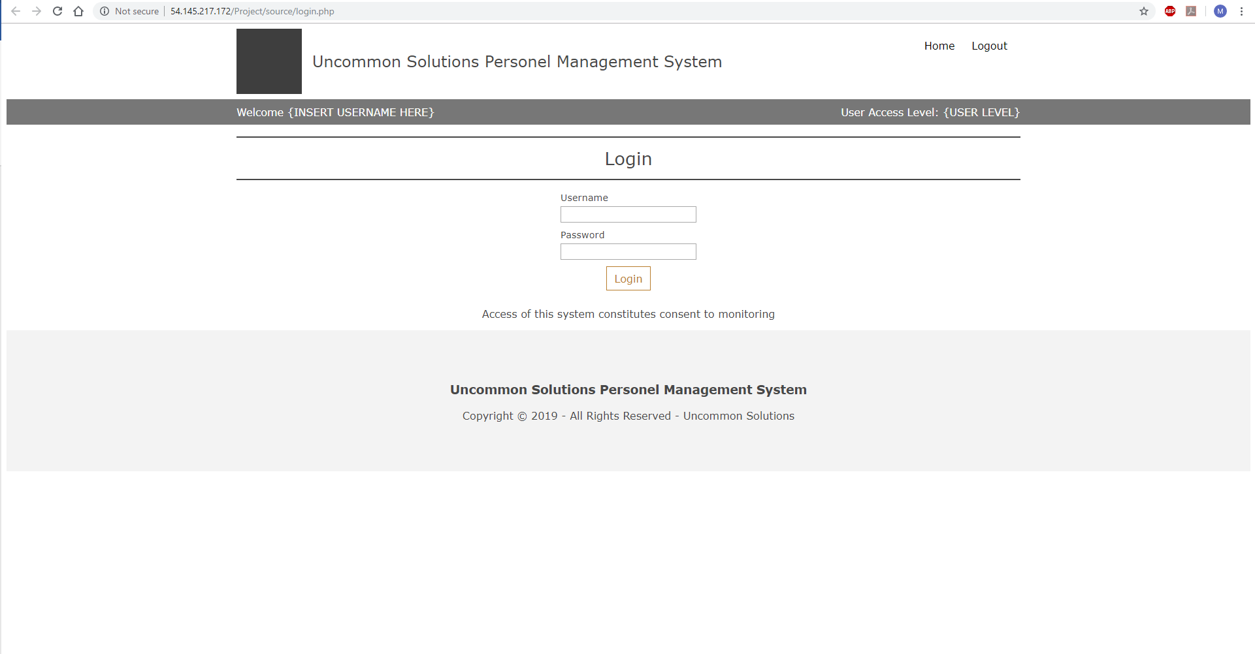

## Overview of the Management Console

Personnel information of every user is displayed on the Management Console after successfully login.

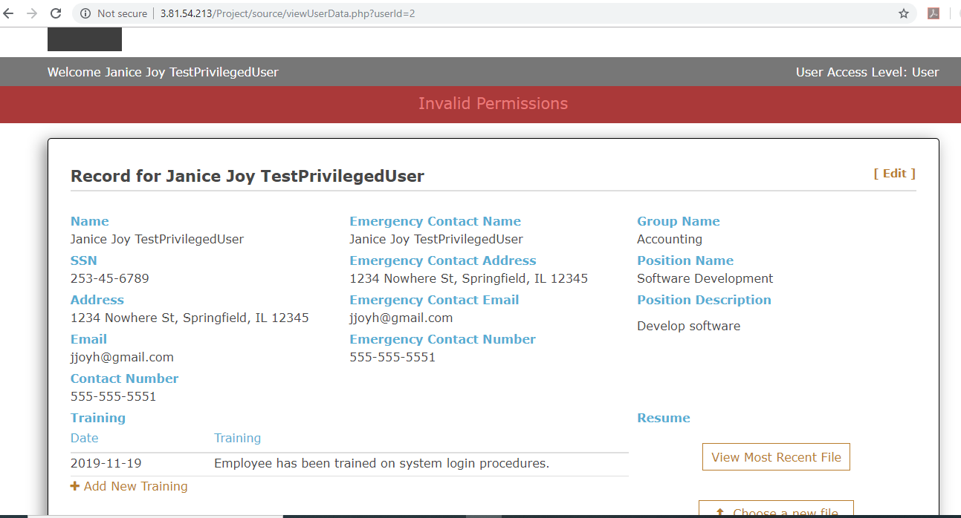

## Editing User’s Information

To edit any information, click on the **Edit** button

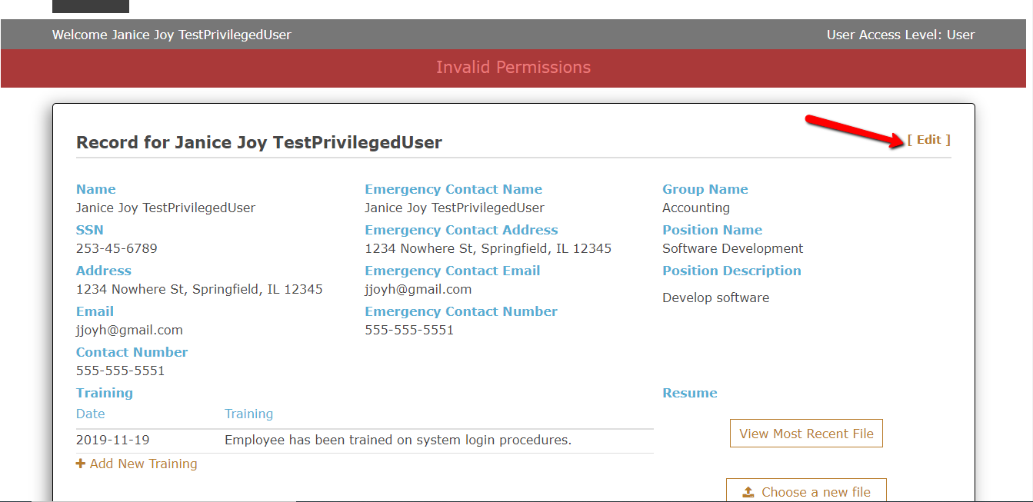

Select the section in which you need to edit. After edits, click the **Save** button to save all changes made.

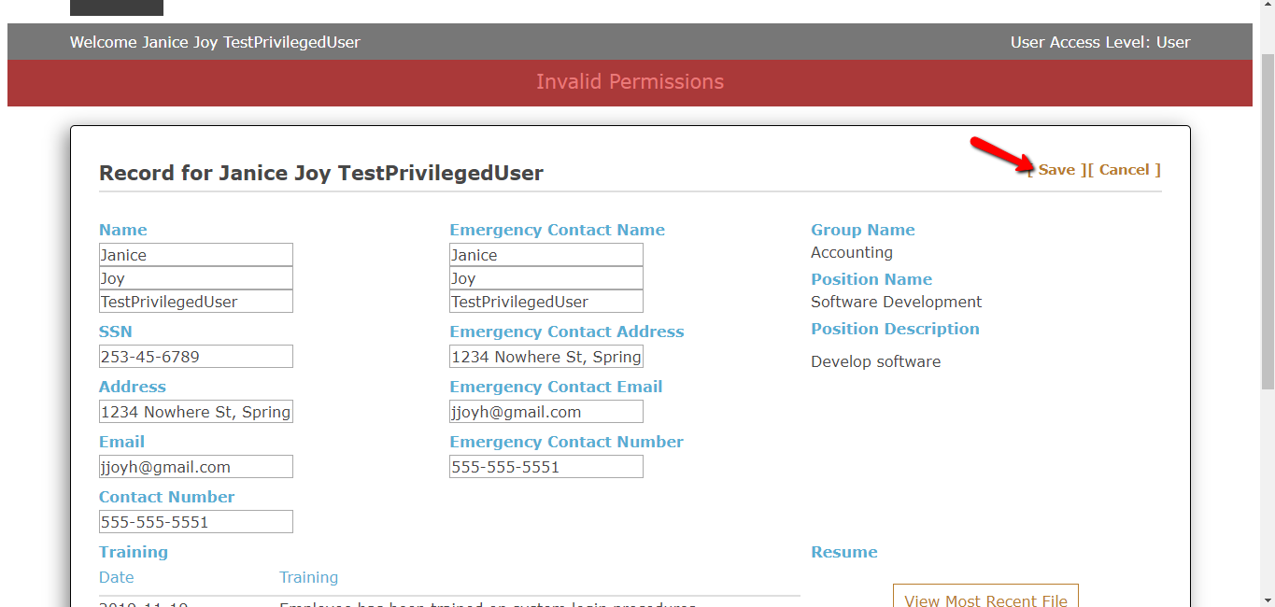

## Adding A Completed Training

To add a completed training, click on the **Add New Training** button.

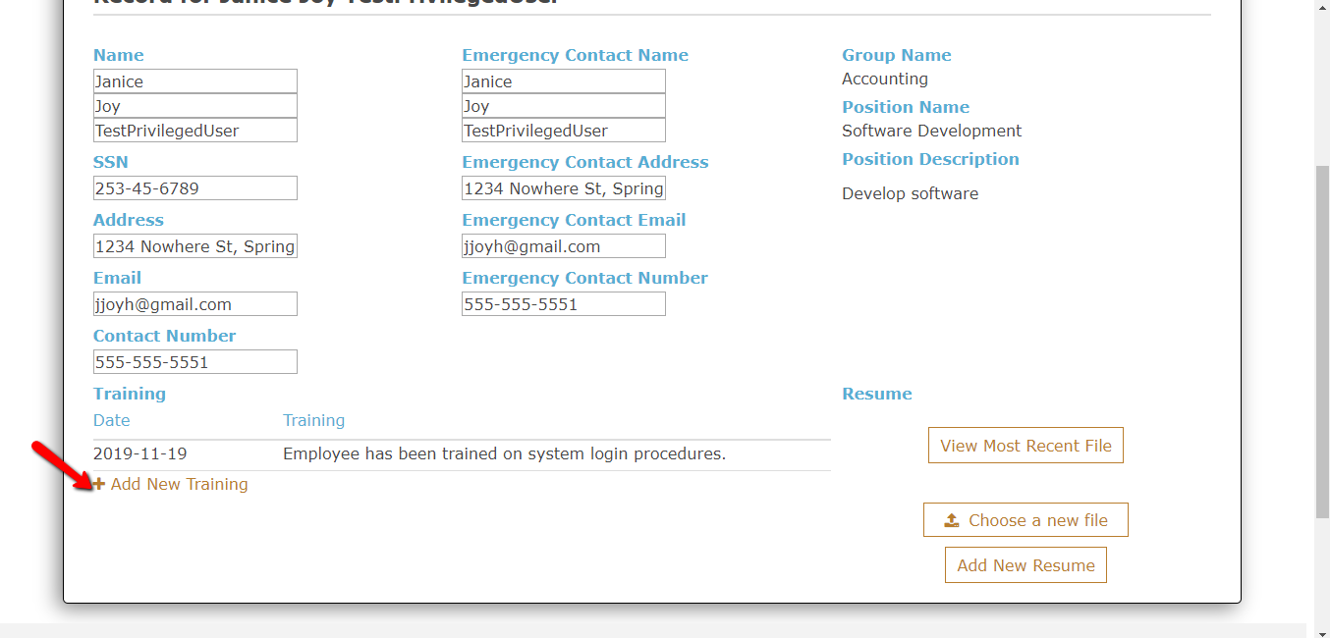

Enter the date the training was completed and the training details, click **Save** to save new details.

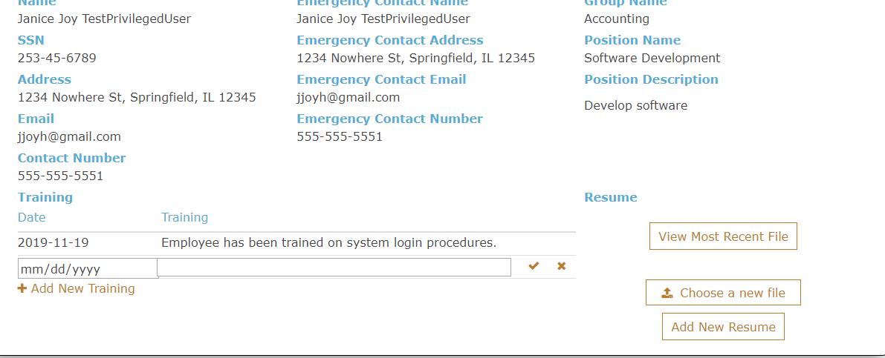

## Adding A New File and Resume

To add new resume or file click on the **Choose a New File** and select the desired file, upload the file and click save.

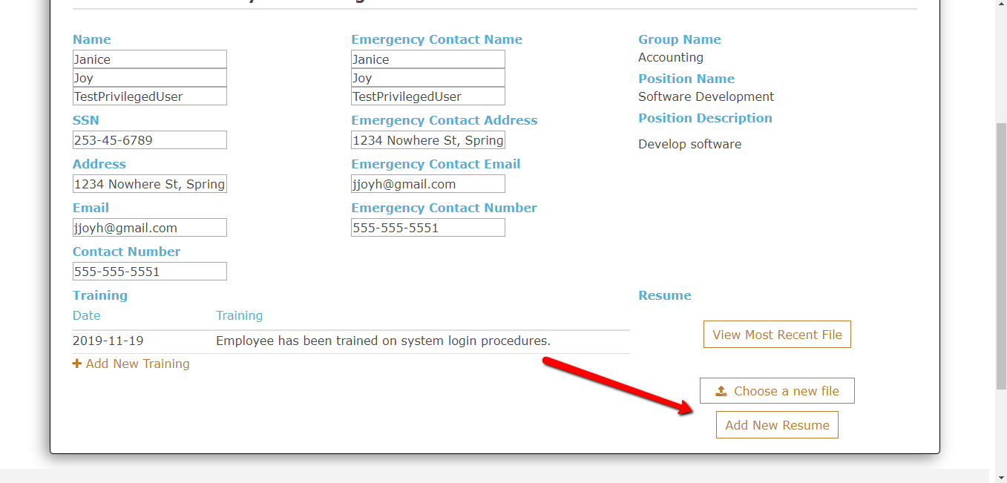

## Logout to the System

When you have completed all necessary modification, you can logout to the system by clicking **Logout**.

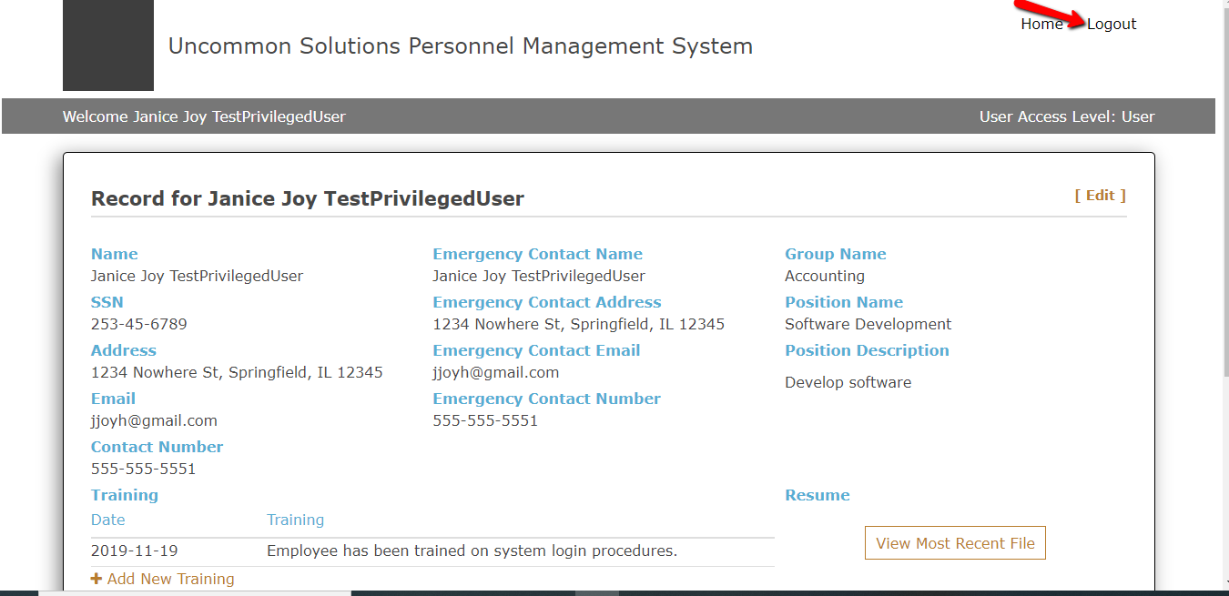

## User Assistance

You can contact the Administrators for any assistance.

# APPROVALS

I have read the above Software Development progress report and agree that it is an accurate summary of software development efforts to date. I will continue to execute my proscribed tasks for each phase of development and pledge my full commitment and support for the Development Effort.

Sign-off Sheet

**Prepared by** ___Michael Kiefer_________________________

Project Manager– Michael Kiefer

**Approved by**___Hither Guzha________________________

Technical Writer– Hither Guzha

**Approved by**___Andrew Benson_______________________

Project Team Member– Andrew Benson

**Approved by**___Donn Eddy___________________________

Project Team Member– Donn Eddy

**Approved by**___Sean Mooneyham_____________________

Project Team Member– Sean Mooneyham

**Approved by**___Chase Thorpe_________________________

Project Team Member– Chase Thorpe