|  |  |
| --- | --- |
| Use Case Name | Start Game |
| Use Case Description | Starts a blackjack game |
| Primary Actor | Player |
| Precondition | N/A |
| Main Incident Flow | 1. The use case starts when player indicates the wish to start game. 2. System verifies the player’s status 3. Player receives cards 4. System indicates player and dealer’s shown card 5. System calculates the card value   Repeats step 3-5 until player doesn’t want new card.   1. System indicates the round result. 2. Use case ends in success. |
| Exception Flow | 2.A Player doesn’t have enough chip balance  2.A.1 System informs player to purchase chip  2.A.2 Use case ends in failure  5.A Player or dealer’s card value is greater than 21  5.A.1 Use case continues to step 7 |
| Postcondition | N/A |

|  |  |
| --- | --- |
| Use Case Name | Purchase Chip |
| Use Case Description | Add chips to player |
| Primary Actor | Player |
| Precondition | N/A |
| Main Incident Flow | 1. Use case starts when player indicates the wish to purchase chip 2. System asks the player the amount of chip 3. Player inputs the system the amount of chip 4. System informs the player the result of purchase 5. Use case ends in success |
| Exception Flow | 3.A Illegal input  3.A.1 System informs the input error  3.A.2 Use case ends in failure |
| Postcondition | Player’s chip balance increases |

|  |  |
| --- | --- |
| Use Case Name | Leave Game |
| Use Case Description | Leaves and terminates the game |
| Primary Actor | Player |
| Precondition | N/A |
| Main Incident Flow | 1. Player indicates the wish to leave. 2. System terminates. |
| Postcondition | N/A |

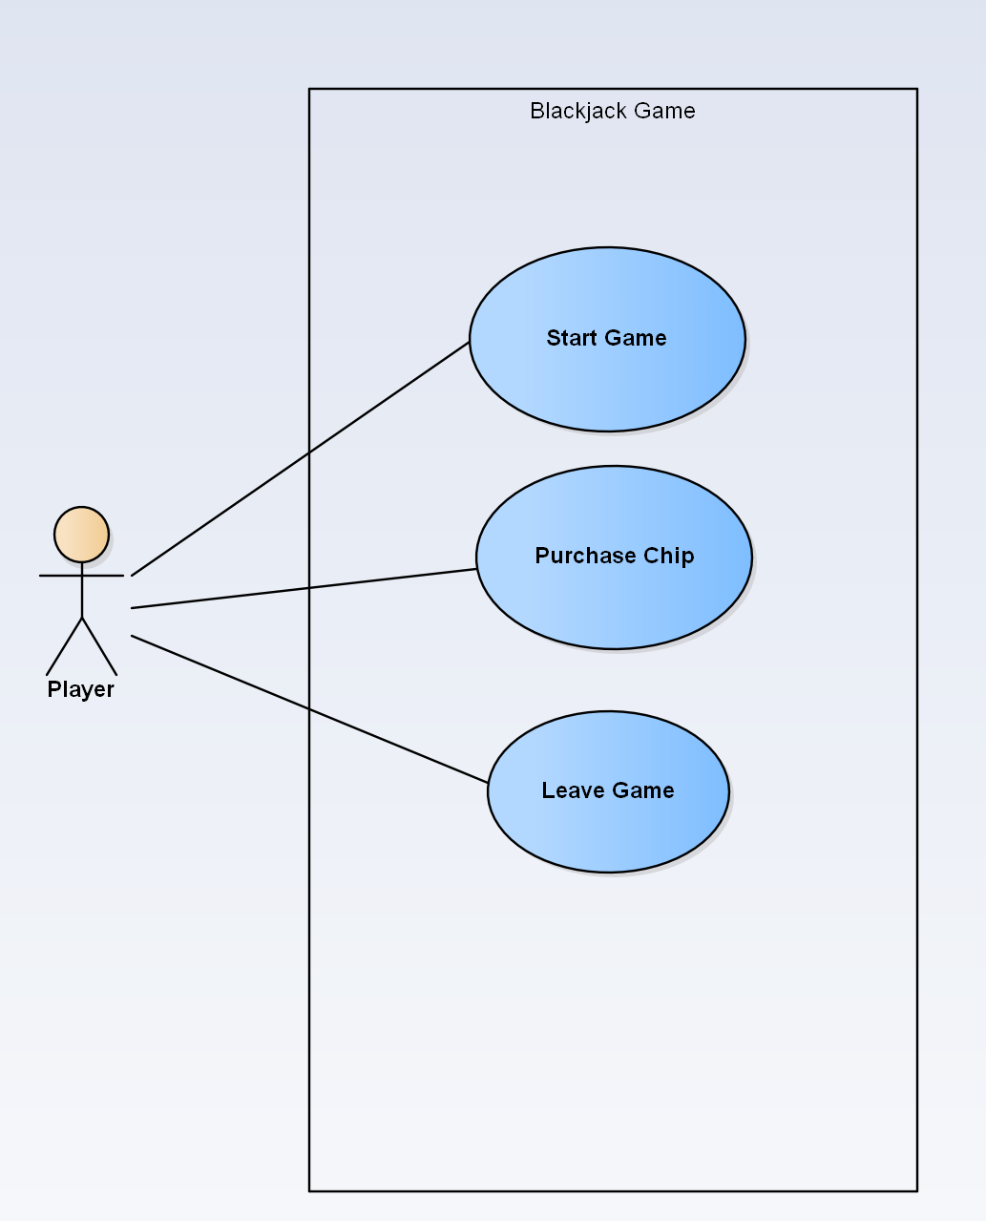

Domain Model

Class Diagram