

НАЦІОНАЛЬНИЙ ТЕХНІЧНИЙ УНІВЕРСИТЕТ УКРАЇНИ
«КИЇВСЬКИЙ ПОЛІТЕХНІЧНИЙ ІНСТИТУТ імені Ігоря Сікорського»
ФАКУЛЬТЕТ ПРИКЛАДНОЇ МАТЕМАТИКИ
Кафедра системного програмування та спеціалізованих комп’ютерних систем

Лабораторна робота №3
з дисципліни
«Бази даних і засоби управління»

Виконав студент ІII курсу
ФПМ групи КВ-71
Колпаков П.С.
Перевірив: Павловський В.І.

Київ – 2019
Ознайомлення з базовими операціями СУБД PostgreSQL
Завдання роботи полягає у наступному:
- Перетворити модуль “Модель” з шаблону MVC лабораторної роботи №2 у вигляд об’єктно-реляційної проекції (ORM).
- Створити та проаналізувати різні типи індексів у PostgreSQL.
- Розробити тригер бази даних PostgreSQL.
- Навести приклади та проаналізувати рівні ізоляції транзакцій уPostgreSQL.

В ході роботи розроблено:
- Логічну модель БД та Діаграму класів;
- Функціонал програмного додатку;
- Об'єктно-орієнтований програмний додаток роботи з БД "Рекламна База". Для взаємодії з БД використано ORM модуль SQLAlchemy.
Варіант 11
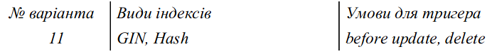
Логічна модель бази даних
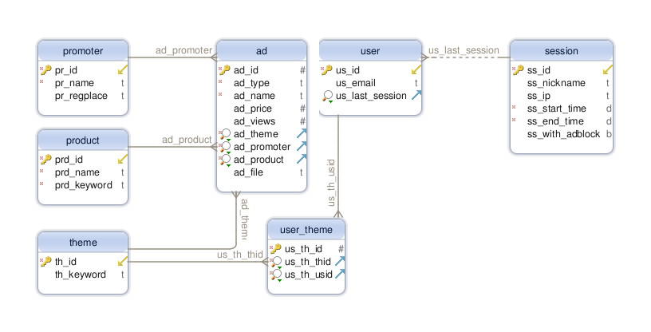
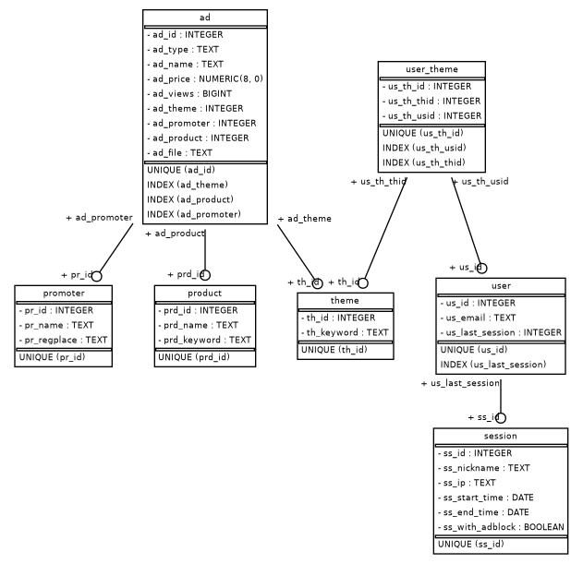
Зв’язки між сутнісними класами, сгенеровані за допомогою SqlAlchemy

Опис меню програми
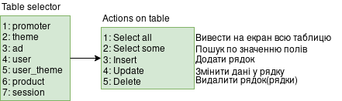
Посилання на основні класи та методи програми
- Main
- Utils
- Model
  - Завдання 1
    - Метод, який дістає інформацію з таблиці
    - Метод, який додає інформацію до БД
    - Метод, який видаляє інформацію з БД
    - Метод, який оновлює інформацію в БД
  - Завдання 2
    - Метод, який створює випадкову інформацію і додає її до таблиці
  - Завдання 3
    - Метод, який реалізує вибір інформації за логічним значенням у двох таблицях одночасно
    - Метод, який реалізує вибір інформації за наявності слова у трьох таблицях одночасно
    - Метод, який реалізує вибір інформації за діапазоном дат у двох таблицях одночасно
    - Метод, який реалізує вибір інформації за відсутності слова у двох таблицях одночасно
  - Завдання 4
    - Метод, який запускає пошук по фразі у БД
- View
  - Метод, який виводить на екран таблицю
- Controller

Лістинг програми
main.py
from controller import Controller
import utils
from model import Model
from view import View
def main():
controller = Controller(Model("127.0.0.1", "1"), View())
controller.start()
if __name__ == '__main__':
main()
utils.py
import psycopg2
import random
from psycopg2 import sql
# Connect to psql database
def open_connection(phost, pport, pdatabase, puser, ppassword):
try:
return psycopg2.connect(host=phost, port=pport, database=pdatabase, user=puser, password=ppassword)
except (Exception, psycopg2.Error) as error:
print("Error: connection with PostgreSQL\n\t", error)
# Execute query and get result. If error - print exception
def query(cursor, q, query_params):
try:
cursor.execute(q, query_params)
retval = cursor.fetchall()
if retval:
return retval
except BaseException as e:
print("ERROR: ", str(e))
# Get list of tables in database
def list_tables(cursor):
data = query(cursor, """
SELECT table_name FROM information_schema.tables
WHERE table_schema = 'public';
""", ())
if data:
return [x[0] for x in data]
# Get list of columns for some table in database
def list_table_columns(cursor, table):
data = query(cursor, """
SELECT column_name
FROM information_schema.columns
WHERE table_schema = 'public'
AND table_name = %s;
""", (table,))
if data:
return [x[0] for x in data]
# Get type of column(integer, text, etc.)
def get_column_type(cursor, table, column):
data = query(cursor, """
SELECT data_type
FROM information_schema.columns
WHERE table_schema = 'public'
AND table_name = %s
AND column_name = %s;
""", (table, column))
if data:
return data[0][0]
# Just random string with random length
def random_string():
random_str = ""
for i in range(0, random.randint(5, 10)):
random_str += str(random.choice("0123456789abcdefghijklmnopqrstuvwxyz"))
return random_str
# Get random value for some SQL type.
# Unknown type => None
def gen_random(type_v):
switcher = {
'integer':
lambda: random.randint(0, 16387),
'text':
lambda: random_string(),
'bigint':
lambda: random.randint(0, 16387),
'boolean':
lambda: random.choice(['true', 'false']),
'timestamp with time zone':
# 2019-08-21 08:30:00+03:00
lambda: "%04d-%02d-%02d %02d:%02d:%02d+%02d:00" %
(random.randint(1970, 2037), # year
random.randint(1, 12), # month
random.randint(1, 28), # day
random.randint(0, 23), # hour
random.randint(0, 59), # minute
random.randint(0, 59), # second
random.randint(0, 11), # timezone
),
}
return (switcher.get(type_v, lambda: None))()
# Do nothing
def do_nothing():
return None # do nothing
view.py
from prettytable import PrettyTable
import getch
import sys
class View(object):
# This message is displayed on program start
def print_hello_message(self):
print("Hello. You can always type 'back' and 'exit', even if i don't say that. Enjoy.")
# Print start menu entries
def print_start_menu(self):
print("\n::::::::::::::::::::::::::::::::::::::::")
print("\t1: View Tables")
print("\t2: SQL Query")
print("\t3: Find some")
print("\t4: Find in all tables by phraze")
print("\t5: Exit")
# Print some data. Data - list of tuples(table). No columns names specified.
def print_data(self, table_data, on_none_message=None):
if table_data:
x = PrettyTable()
for row in table_data:
x.add_row(row)
print(x)
elif on_none_message:
print(on_none_message)
# Print menu entries for selection of some column from column list
def select_column_menu(self, table_name, columns):
print("Select some field of table '", table_name, "':", sep="")
counter = 1
for column in columns:
print("\t%d: %s" % (counter, column))
counter += 1
# Like print data, but with printing column names. There are in first element of 'table_data'
def print_table(self, table_data, on_none_message=None):
if table_data:
x = PrettyTable()
x.field_names = table_data[0]
for row in table_data[1]:
x.add_row(row)
print(x)
elif on_none_message:
print(on_none_message)
# Request some input from user. Validation can be done with list of valid cases or with lambda.
# 'back' and 'exit' are allways valid.
# 'exit' means exit from program
# Very nice looking code
def request_input(self,
message,
valid_cases=[],
validator=None,
message_on_wrong="Wrong input, try again(or enter 'back'):"):
if validator is None:
validator = (lambda x: (any(x is s for s in valid_cases))) if valid_cases else (lambda _: True)
print(message, end=" ")
while True:
try:
retval = input()
if retval == 'back' or validator(retval):
return retval
else:
if retval == 'exit':
print("Bye")
sys.exit(0)
else:
print(message_on_wrong, end=" ")
except KeyboardInterrupt:
print("\nInterrupted by user")
sys.exit()
except Exception as e:
print("Error on input:", e)
# Print tables list (menu entries)
def print_tables(self, tables_list):
counter = 1
for table in tables_list:
print("\t", counter, ": ", table, sep="")
counter += 1
# Print some message and call 'getch'.
# User may have some time to rest before menu loop will continue.
def print_and_getch(self, message):
print(message)
return getch.getch()
# Print Ok if 'is_all_ok', else print 'FAIL'
# Then call 'getch'
def after_action_message(self, is_all_ok):
return self.print_and_getch("Ok" if is_all_ok else "FAIL")
# Print table actions menu entries
def print_table_menu(self, table_name):
print("TABLE:", table_name)
print("\t1: Select all")
print("\t2: Delete")
print("\t3: Insert")
print("\t4: Update")
print("\t5: Select where")
print("\t6: Insert random data")
print("\t7: Find")
# Print find menu entries
def find_menu(self):
print("FIND MENU")
print("\t1: Users, who used/not-used adblock at last session")
print("\t2: Themes, that are connected with product, that contains word in name")
print("\t3: Users, who have last session in time period")
print("\t4: Ads, whose promotes don't have word in registration place")
model.py
import utils as utils
import psycopg2
from psycopg2 import sql
from utils import list_table_columns
class Model(object):
def __init__(self, host, password):
self.open_connection = lambda: utils.open_connection(host, 5432, "postgres", "postgres", password)
# Select some from some table
def select_some(self, table_name, column, value):
with self.open_connection() as conn:
with conn.cursor() as cursor:
data = utils.query(cursor, sql.SQL("""
SELECT * FROM {} WHERE {}=%s;
""").format(sql.Identifier(table_name), sql.Identifier(column)), (value,))
if data:
return [utils.list_table_columns(cursor, table_name), data]
# Update item in table. Selection of item is done with selection of some value in some field.
# New data passed through list with strings. If string is empty - don't update that field.
def update(self, table_name, column_to_check, exp_value, new_data):
with self.open_connection() as conn:
with conn.cursor() as cursor:
columns = list_table_columns(cursor, table_name)
insert_str = ""
for i in range(0, len(columns)):
# '' means default value
if new_data[i] != '':
if insert_str != "":
insert_str += ', '
insert_str += "%s='%s'" % (columns[i], new_data[i])
q = sql.SQL("""
UPDATE {} SET """ + insert_str + """ WHERE {}=%s;
""").format(sql.Identifier(table_name), sql.Identifier(column_to_check))
try:
cursor.execute(q, (exp_value,))
conn.commit()
except BaseException as e:
print("ERROR: ", str(e))
result = False
result = True
return result
# Search phraze in all text columns of table
def find_by_phraze(self, table_name, phraze):
with self.open_connection() as conn:
with conn.cursor() as cursor:
def find_by_phraze(column):
return val
columns = utils.list_table_columns(cursor, table_name)
columns = list(filter((lambda x: utils.get_column_type(cursor, table_name, x) == 'text'), columns))
data = []
for column in columns:
val = utils.query(cursor, sql.SQL("""
SELECT * FROM {} WHERE {} LIKE %s;
""").format(sql.Identifier(table_name), sql.Identifier(column)),
("%{}%".format(phraze),))
if val:
data.extend(val)
if data:
return [utils.list_table_columns(cursor, table_name), list(dict.fromkeys(data))]
# Look in 'utils'
def list_tables(self):
with self.open_connection() as conn:
with conn.cursor() as cursor:
return utils.list_tables(cursor)
# Look in 'utils'
def list_columns(self, table_name):
with self.open_connection() as conn:
with conn.cursor() as cursor:
return utils.list_table_columns(cursor, table_name)
# Get full table from database.
def get_full_table(self, table_name):
with self.open_connection() as conn:
with conn.cursor() as cursor:
columns = utils.list_table_columns(cursor, table_name)
data = utils.query(cursor, sql.SQL("""
SELECT * FROM {};
""").format(sql.Identifier(table_name)), ())
if columns and data:
return [columns, data]
# Insert some random value to some table.
def insert_random(self, table_name):
with self.open_connection() as connection:
with connection.cursor() as cursor:
def gen_rand_data(x):
return utils.gen_random(utils.get_column_type(cursor, table_name, x))
random_data = tuple(gen_rand_data(x) for x in (utils.list_table_columns(cursor, table_name)))
q = sql.SQL("""
INSERT INTO {} VALUES %s;
""").format(sql.Identifier(table_name))
try:
cursor.execute(q, (random_data,))
connection.commit()
except BaseException as e:
print("ERROR: ", str(e))
result = False
result = True
return result
# Get column data from table.
# Returns list of tuples, where first element is column name and second - type of column
def get_table_columns_data(self, table_name):
with self.open_connection() as connection:
with connection.cursor() as cursor:
columns = utils.list_table_columns(cursor, table_name)
return list(zip(columns, map((lambda x: utils.get_column_type(cursor, table_name, x)), columns)))
# Insert some data to table. NO TYPE CHECKS!!!
def insert_data(self, table_name, data):
with self.open_connection() as connection:
with connection.cursor() as cursor:
q = sql.SQL("""
INSERT INTO {} VALUES %s;
""").format(sql.Identifier(table_name))
try:
cursor.execute(q, (data,))
connection.commit()
except BaseException as e:
print("ERROR: ", str(e))
result = False
result = True
return result
# Delete some data in database.
# NO CHECKS!!!
def delete_data(self, table_name, column_name, expected_value):
with self.open_connection() as connection:
with connection.cursor() as cursor:
q = sql.SQL("""
DELETE FROM {} WHERE {}=%s;
""").format(sql.Identifier(table_name), sql.Identifier(column_name))
try:
cursor.execute(q, (expected_value,))
connection.commit()
except BaseException as e:
print("ERROR: ", str(e))
result = False
result = True
return result
# Details in 'utils'
def query(self, q):
with self.open_connection() as connection:
with connection.cursor() as cursor:
return utils.query(cursor, q, ())
# TABLE DEPENDENCY ZONE
# Find all users by using/not-using adblock in last session
def find_1(self, adblock_using):
with self.open_connection() as connection:
with connection.cursor() as cursor:
data = utils.query(cursor, """
SELECT "user".* FROM "user"
JOIN "session" ON us_last_session=ss_id
WHERE ss_with_adblock IS %s;
""", (adblock_using,))
if data:
return [utils.list_table_columns(cursor, 'user'), data]
# Find themes, where connected product contains in name some word.
def find_2(self, prd_name_contains):
with self.open_connection() as connection:
with connection.cursor() as cursor:
data = utils.query(cursor, """
SELECT theme.* FROM theme
JOIN ad ON ad_theme=th_id
JOIN product ON ad_product=prd_id
WHERE to_tsvector(prd_name) @@ to_tsquery(%s)
GROUP BY th_id;
""", (prd_name_contains,))
if data:
return [utils.list_table_columns(cursor, 'theme'), data]
# Find users with last session in time between two timestamps
def find_3(self, start_time, end_time):
with self.open_connection() as connection:
with connection.cursor() as cursor:
data = utils.query(cursor, """
SELECT "user".* FROM "user"
JOIN "session" ON us_last_session=ss_id
WHERE
ss_start_time > %s AND
ss_end_time < %s;
""", (start_time, end_time))
if data:
return [utils.list_table_columns(cursor, 'user'), data]
# Find all ads, promoter of that does not contains some word in registration place(country, for example)
def find_4(self, not_contains_word):
with self.open_connection() as connection:
with connection.cursor() as cursor:
data = utils.query(cursor, """
SELECT ad.* FROM ad
JOIN promoter ON ad_promoter=pr_id
WHERE NOT (to_tsvector(pr_regplace) @@ to_tsquery(%s));
""", (not_contains_word, ))
if data:
return [utils.list_table_columns(cursor, 'ad'), data]
controller.py
import utils as utils
class Controller(object):
# Very strange and not typical code
def __init__(self, model, view):
self.model = model
self.view = view
def start(self):
self.view.print_hello_message()
self.show_main_menu()
# Main menu handler
def show_main_menu(self):
self.view.print_start_menu()
input_v = self.view.request_input("Enter number (from 1 to 5):",
valid_cases=['1', '2', '3', '4', '5'])
if input_v == "1":
self.print_tables()
self.show_main_menu()
if input_v == "2":
sql_query = self.view.request_input("Enter query:")
self.view.print_data(self.model.query(sql_query), on_none_message="NOTHING")
self.show_main_menu()
if input_v == "3":
self.find_menu()
if input_v == "4":
tables = self.model.list_tables()
phraze = self.view.request_input("Enter phraze:")
for table in tables:
print("On table %s:" % (table,))
self.view.print_table(self.model.find_by_phraze(table, phraze), "NOTHING")
self.show_main_menu()
# Ask user to enter fields values of some object. Return None if problems
def request_input_object(self, table_name, message="You can enter nothing for random value.", random_on_none=True):
data_list = []
print(message)
for column_data in self.model.get_table_columns_data(table_name):
data = self.view.request_input("\tField '" + column_data[0] + "'(" + column_data[1] + "):")
if data == 'back':
return
elif random_on_none and data == '':
data_list.append(utils.gen_random(column_data[1]))
else:
data_list.append(data)
return data_list
# Select table menu
def print_tables(self):
tables = self.model.list_tables()
self.view.print_tables(tables)
input_v = self.view.request_input("Enter number (from 1 to " + str(len(tables)) + "):",
validator=lambda x: x.isdigit() and 0 < int(x) <= len(tables))
if input_v == "back":
return None
self.table_menu(tables[int(input_v) - 1])
# Ask user to select some field of table and expected value on this field(for SELECT's)
def select_obj_menu(self, table_name):
columns = self.model.list_columns(table_name)
self.view.select_column_menu(table_name, columns)
input_v = self.view.request_input("Enter number (from 1 to " + str(len(columns)) + "):",
validator=lambda x: x.isdigit() and 0 < int(x) <= len(columns))
if input_v != "back":
column = columns[int(input_v) - 1]
expected_value = self.view.request_input("\tEnter expected value on field %s:" % (column,))
if expected_value != "back":
return column, expected_value
return None, None
# What can you do with table?
def table_menu(self, table_name):
self.view.print_table_menu(table_name)
input_v = self.view.request_input("Enter number (from 1 to 6):",
valid_cases=["1", "2", "3", "4", "5", "6"])
if input_v != "back":
# SELECT ALL
if input_v == "1":
data = self.model.get_full_table(table_name)
self.view.print_table(data)
self.view.after_action_message(data)
self.table_menu(table_name)
# DELETE
if input_v == "2":
column, value = self.select_obj_menu(table_name)
if column and value:
self.view.after_action_message(self.model.delete_data(table_name, column, value))
self.table_menu(table_name)
# INSERT
if input_v == "3":
def insert():
self.view.after_action_message(self.model.insert_data(table_name,
tuple(self.request_input_object(table_name))))
insert()
self.table_menu(table_name)
# UPDATE
if input_v == "4":
self.update_menu(table_name)
self.table_menu(table_name)
# SELECT
if input_v == "5":
column, value = self.select_obj_menu(table_name)
if column and value:
data = self.model.select_some(table_name, column, value)
self.view.print_table(data, on_none_message="NOTHING FOUND")
self.view.after_action_message(data)
self.table_menu(table_name)
# INSERT RANDOM
if input_v == "6":
self.view.after_action_message(self.model.insert_random(table_name))
self.table_menu(table_name)
# Update menu
def update_menu(self, table_name):
print("SELECT OBJECT TO UPDATE:")
c, v = self.select_obj_menu(table_name)
if c and v:
obj = self.request_input_object(table_name, "Enter nothing for not touching field", False)
if obj:
self.view.after_action_message(self.model.update(table_name, c, v, obj))
# TABLE DEPENDENCY ZONE
# Just find menu
def find_menu(self):
self.view.find_menu()
input_v = self.view.request_input("Enter number (from 1 to 4):",
valid_cases=["1", "2", "3", "4"])
if input_v != 'back':
if input_v == '1':
data = self.view.request_input("Enter 'adblock_using' param(boolean):")
if data != 'back' and data:
data = data.lower()
if data != 'true' and data != 'false' and data != 'none' and data != 'null':
print(data, "isn't bool")
else:
val = self.model.find_1((data == 'true') if data == 'true' or data == 'false' else None)
self.view.print_table(val, on_none_message="NOTHING FOUND")
self.view.after_action_message(val)
if input_v == '2':
data = self.view.request_input("Enter word(text):")
if data != 'back' and data:
val = self.model.find_2(data)
self.view.print_table(val, on_none_message="NOTHING FOUND")
self.view.after_action_message(val)
if input_v == '3':
data_s = self.view.request_input("Enter start_time param(timestamp with time zone):")
if data_s != 'back' and data_s:
data_e = self.view.request_input("Enter start_time param(timestamp with time zone):")
if data_e != 'back' and data_e:
val = self.model.find_3(data_s, data_e)
self.view.print_table(val, on_none_message="NOTHING FOUND")
self.view.after_action_message(val)
if input_v == '4':
data = self.view.request_input("Enter word param(text):")
if data != 'back' and data:
val = self.model.find_4(data)
self.view.print_table(val, on_none_message="NOTHING FOUND")
self.view.after_action_message(val)
self.find_menu()
Приклад роботи програми
Hello. You can always type 'back' and 'exit', even if i don't say that. Enjoy.

::::::::::::::::::::::::::::::::::::::::
1: View Tables
2: SQL Query
3: Find some
4: Find in all tables by phraze
5: Exit
Enter number (from 1 to 5): 4
Enter phraze: BMW
On table promoter:
NOTHING
On table theme:
NOTHING
On table ad:
+-------+---------+-------------------+----------+----------+----------+-------------+------------+-------------------------------+
| ad_id | ad_type | ad_name | ad_price | ad_views | ad_theme | ad_promoter | ad_product | ad_file |
+-------+---------+-------------------+----------+----------+----------+-------------+------------+-------------------------------+
| 0 | Video | BMW X739 MEGATEST | 20.00 ₴ | 32 | 0 | 1 | 0 | /home/vanya/reklama/video.mp4 |
+-------+---------+-------------------+----------+----------+----------+-------------+------------+-------------------------------+
On table user:
NOTHING
On table user_theme:
NOTHING
On table product:
+--------+----------+-------------+
| prd_id | prd_name | prd_keyword |
+--------+----------+-------------+
| 0 | BMW X739 | bmw |
+--------+----------+-------------+
On table session:
NOTHING

::::::::::::::::::::::::::::::::::::::::
1: View Tables
2: SQL Query
3: Find some
4: Find in all tables by phraze
5: Exit
Enter number (from 1 to 5): 1
1: promoter
2: theme
3: ad
4: user
5: user_theme
6: product
7: session
Enter number (from 1 to 7): 3
TABLE: ad
1: Select all
2: Delete
3: Insert
4: Update
5: Select where
6: Insert random data
7: Find
Enter number (from 1 to 6): 1
+-------+-----------+------------------------+----------+----------+----------+-------------+------------+-------------------------------+
| ad_id | ad_type | ad_name | ad_price | ad_views | ad_theme | ad_promoter | ad_product | ad_file |
+-------+-----------+------------------------+----------+----------+----------+-------------+------------+-------------------------------+
| 1 | Animation | INDUCTION FURNACE 2030 | 10.00 ₴ | 947 | 1 | 2 | 1 | /home/andy51984/data/a.gif |
| 2 | Image | INDUCTION FURNACE 2030 | 2.00 ₴ | 94317 | 1 | 2 | 1 | /home/andy51984/data/b.png |
| 0 | Video | BMW X739 MEGATEST | 20.00 ₴ | 32 | 0 | 1 | 0 | /home/vanya/reklama/video.mp4 |
+-------+-----------+------------------------+----------+----------+----------+-------------+------------+-------------------------------+
Ok
TABLE: ad
1: Select all
2: Delete
3: Insert
4: Update
5: Select where
6: Insert random data
7: Find
Enter number (from 1 to 6): 2
Select some field of table 'ad':
1: ad_id
2: ad_type
3: ad_name
4: ad_price
5: ad_views
6: ad_theme
7: ad_promoter
8: ad_product
9: ad_file
Enter number (from 1 to 9): 1
Enter expected value on field ad_id: 0
Ok
TABLE: ad
1: Select all
2: Delete
3: Insert
4: Update
5: Select where
6: Insert random data
7: Find
Enter number (from 1 to 6): 1
+-------+-----------+------------------------+----------+----------+----------+-------------+------------+----------------------------+
| ad_id | ad_type | ad_name | ad_price | ad_views | ad_theme | ad_promoter | ad_product | ad_file |
+-------+-----------+------------------------+----------+----------+----------+-------------+------------+----------------------------+
| 1 | Animation | INDUCTION FURNACE 2030 | 10.00 ₴ | 947 | 1 | 2 | 1 | /home/andy51984/data/a.gif |
| 2 | Image | INDUCTION FURNACE 2030 | 2.00 ₴ | 94317 | 1 | 2 | 1 | /home/andy51984/data/b.png |
+-------+-----------+------------------------+----------+----------+----------+-------------+------------+----------------------------+
Ok
TABLE: ad
1: Select all
2: Delete
3: Insert
4: Update
5: Select where
6: Insert random data
7: Find
Enter number (from 1 to 6): exit
Bye

