IRSTI 61.01.93

**OVERVIEW OF MECHANISMS FOR ENSURING SAFE WORK IN CHEMICAL PRODUCTION**

**1,2M.A. Yelubay** [](https://orcid.org/0000-0002-6209-5215)**, 1A.B. Bekmagambetov**[](https://orcid.org/0000-0002-2033-3625)**, 1E.A.Kulmagambetova**[](https://orcid.org/0000-0002-7799-3974)**, 1A.M. Rakhmetova**[](https://orcid.org/0000-0002-0008-4887)**,**

**2D.T. Tolegenov**[](https://orcid.org/0000-0002-0008-4887)

*1Republican Research Institute for Occupational Safety and Health of the Ministry of Labor and Social*

*Protection of the Population of the Republic of Kazakhstan, Astana,Kazakhstan,*

*2 Toraighyrov University, Republic of Kazakhstan, Pavlodar, Kazakhstan*

Corresponding author: www.dika-92@mail.ru

This article presents the results of the review of scientific and technical information on the use of a risk-based approach (RBA) in providing personal protective equipment (PPE) at an enterprise. Regulatory documents, scientific works and developments of domestic and foreign scientists on the use of PPE against industrial health and safety hazards and their selection based on RBA were used as the theoretical and methodological basis for the study.

Scientific works are considered in the Science Direct, Dergi Park, Web of Science (Publon), Elsiever, Google Scholar databases, on professional industry platforms on labor protection ILO, EU-OSHA, NEBOSH, IOSH.

The study contains information retrieval, descriptive, experimental and effective research stages. The information retrieval stage includes the study of scientific and methodological literature, national and interstate standards. This article covers the entire range of theoretical and methodological substantiation of the use of PPE in the provision of RBA, including regulatory standards for the use of PPE, in force in the Republic of Kazakhstan in comparison with international practice

**Keywords:** personal protective equipment (PPE), labor protection, Labor Code, collective agreement, industrial safety, harmful production factors, professional risks, regulatory and technical framework.

**ХИМИЯЛЫҚ ӨНДІРІСТЕГІ ҚАУІПСІЗ ЖҰМЫСТЫ ҚАМТАМАСЫЗ ЕТУ МЕХАНИЗМДЕРІНЕ ШОЛУ**

**1,2M.A.Елубай, 1A.Б. Бекмағамбетов, 1E.A. Құлмағамбетов, 1A.M. Рахметова**

**2Д.T. Төлегенов**

*1Қазақстан Республикасы Еңбек және халықты әлеуметтік қорғау министрлігінің еңбек қауіпсіздігі*

*және еңбекті қорғау жөніндегі республикалық ғылыми-зерттеу институты, Астана қ., Қазақстан,*

*2Торайғыров университеті, Қазақстан республикасы, Павлодар қ., Қазақстан,*

*e-mail: www.dika-92@mail.ru*

Бұл мақалада кәсіпорында жеке қорғаныс құралдары (ЖҚҚ) қамтамасыз етуде тәуекелге бағытталған тәсілді (ТБТ) қолдану туралы ғылыми-техникалық ақпаратты қарау нәтижелері келтірілген. Зерттеудің теориялық және әдістемелік негізі ретінде нормативтік құжаттар, ғылыми еңбектер мен отандық және шетелдік ғалымдардың ЖҚҚ-ны өнеркәсіптік денсаулық пен қауіпсіздік қатерлеріне қарсы қолдану және оларды ТБТ негізінде таңдау бойынша әзірлемелері пайдаланылды.

Ғылыми жұмыстар Science Direct, Dergi Park, Web Of Science (Publon), Elsiever, Google Scholar дерекқорларында, ХЕҰ, ЕО-OSHA, NEBOSH, IOSH еңбекті қорғау бойынша кәсіби салалық платформаларда қарастырылады.

Зерттеу ақпаратты іздеу, сипаттамалық, эксперименттік және тиімді зерттеу кезеңдерін қамтиды. Ақпаратты іздеу кезеңі ғылыми-әдістемелік әдебиеттерді, ұлттық және мемлекетаралық стандарттарды зерттеуді қамтиды. Бұл мақала Қазақстан Республикасында халықаралық практикамен салыстырғанда қолданыстағы ЖҚҚ пайдалану жөніндегі нормативтік стандарттарды қоса алғанда, ЖҚҚ көрсету кезінде ЖҚҚ пайдаланудың теориялық және әдіснамалық негіздемелерінің барлық спектрін қамтиды.

**Түйін сөздер:** жеке қорғаныс құралдары (ЖҚҚ), еңбекті қорғау, Еңбек Кодексі, ұжымдық шарт, өнеркәсіптік қауіпсіздік, зиянды өндірістік факторлар, кәсіби тәуекелдер, нормативтік-техникалық база.

**ОБЗОР МЕХАНИЗМОВ ОБЕСПЕЧЕНИЯ БЕЗОПАСНОГО ТРУДА НА ХИМИЧЕСКОМ ПРОИЗВОДСТВЕ**

**1,2M.A.Елубай, 1A.Б.Бекмагамбетов, 1E.A.Кульмагамбетова, A.M. Рахметова, 1Д.T.Толегенов**

*1Республиканский научно-исследовательский институт охраны труда Министерства труда и социальной защиты населения Республики Казахстан, Астана, Казахстан,*

*2Торайгыров университет, Республика Казахстан, 1Павлодар, Казахстан,*

*e-mail: www.dika-92@mail.ru*

В данной статье представлены результаты обзора научно-технической информации об использовании риск-ориентированного подхода (РОП) при обеспечении средствами индивидуальной защиты (СИЗ) на предприятии. В качестве теоретико-методологической основы исследования были использованы нормативные документы, научные труды и разработки отечественных и зарубежных ученых по применению средств индивидуальной защиты от производственных рисков для здоровья и техники безопасности и их подбору на основе РОП.

Научные работы рассматриваются в базах данных Science Direct, Dergi Park, Web of Science (Publon), Elsiever, Google Scholar, на профессиональных отраслевых платформах по охране труда ILO, EU-OSHA, NEBOSH, IOSH.

Исследование содержит информационно-поисковый, описательный, экспериментальный и результативный этапы исследования. Информационно-поисковый этап включает в себя изучение научно-методической литературы, национальных и межгосударственных стандартов. Данная статья охватывает весь спектр теоретических и методологических обоснований использования СИЗ при оказании РСА, включая нормативные стандарты по использованию СИЗ, действующие в Республике Казахстан в сравнении с международной практикой.

**Ключевые слова:** средства индивидуальной защиты (СИЗ), охрана труда, Трудовой кодекс, коллективный договор, промышленная безопасность, вредные производственные факторы, профессиональные риски, нормативно-техническая база.

**Introduction.** As is known, occupational safety and health requirements are established by regulatory legal acts of the Republic of Kazakhstan and must contain rules, procedures and standards aimed at preserving the life and health of workers in the course of their work.

Occupational safety and health requirements are mandatory for employers and employees when they carry out their activities in the territory of the Republic of Kazakhstan [1].

In the system of measures aimed at ensuring safe working conditions, PPE of workers plays an important role. Ensuring safe working conditions is one of the main tasks of the International Labour Organization (ILO). According to Article 16 of the ILO Occupational Safety and Health Convention, 1981 (No. 155), employers are obliged to ensure the safety of workplaces, machinery, equipment and processes under their control, as well as the use of PPE to prevent accidents or harmful effects on the health of their workers. In all the sources studied, four distinctive approaches to the selection of PPE were found:

- approaches related to the provision of PPE and their proper use (information, training in the correct use of PPE);

- collective, personal disciplinary responsibility for failure to use PPE;

- unification and modernization of protective equipment;

- factor approach [2].

New threats are emerging, principles and approaches to providing PPE during a pandemic are changing, including poorly studied biological threats [3-7].

However, at present there are no works that would cover the entire broad range of theoretical and methodological justification for the use of PPE in the provision of RBA with an analysis of regulatory standards for the use of PPE in force in the Republic of Kazakhstan in accordance with international practice.

**Materials and methods.** The theoretical and methodological basis of the study was based on regulatory documents, scientific works and developments of domestic and foreign scientists on the use of PPE against the impact of harmful and hazardous production factors and their selection based on RBA [8].

The results of the review revealed that in the post-Soviet countries (RF, RB, RK) PPE and its components must comply with the requirements of the Technical Regulations of the Customs Union "On the safety of personal protective equipment" (hereinafter - TR CU019/2011) [9].

In the Russian Federation, there are currently standard standards for the issuance of PPE for 195 professions in accordance with the Order of the Ministry of Labor of Russia dated December 9, 2014 "On approval of standard standards for the free issuance of special clothing, special footwear and other personal protective equipment to workers of cross-cutting professions and positions of all types of economic activity engaged in work with harmful and (or) hazardous working conditions, as well as in work performed in special temperature conditions or associated with pollution" [10], which specifies the standards, rules for the issuance, storage and use of PPE. In the Republic of Belarus, the procedure for providing workers with PPE is regulated by the Instructions for Providing Workers with PPE. Figures 1 and 2 show the mechanisms for providing and issuing PPE in Russia and the Republic of Belarus, respectively.

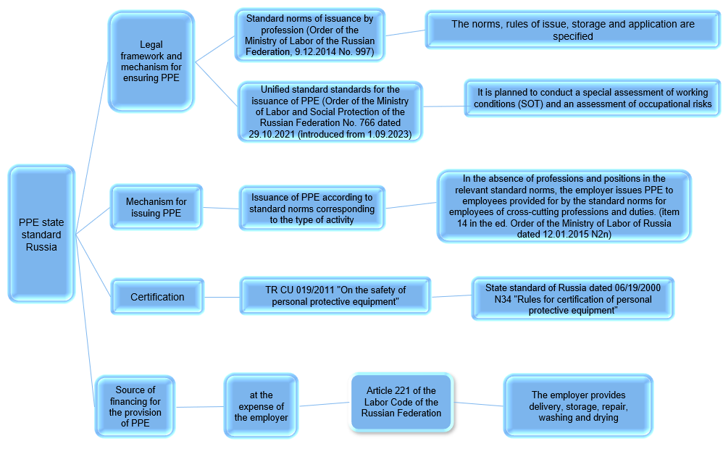

**Fig. 1- Mechanism for Providing and Issuing PPE in Russia**

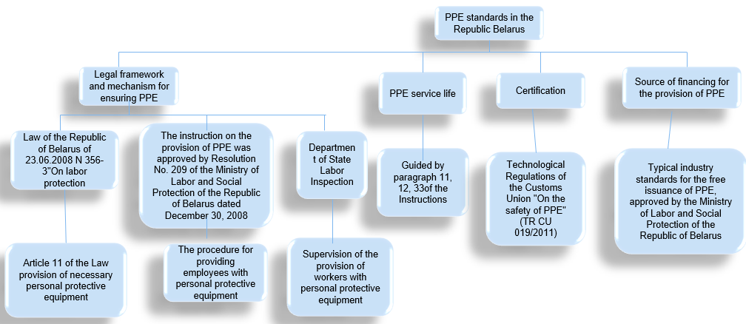

**Fig. 2 - Mechanism for Providing and Issuing PPE in the Republic of Belarus**

Based on the results of the review of best practices in PPE provision mechanisms using the example of Canada, the USA, Great Britain, Poland, and Japan [11-17], two countries from the North American continent were identified as leaders.

The priority in ensuring occupational safety in Canada is the organization of preventive measures, i.e., the reduction and elimination of hazards. PPE is designed to protect against safety and/or health threats. For example, helmets, safety glasses, and safety boots are designed to prevent or reduce the severity of injury in case of emergency (Figure 3).

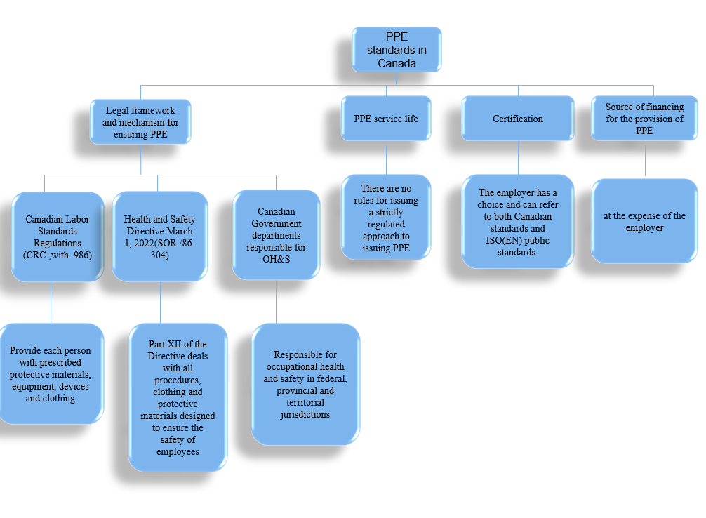

**Fig. 3- Mechanism for providing and issuing PPE in Canada**

The type and nature of hazards in the workplace in the USA are the main indicators of the correct choice of PPE purchased at the employer's expense [12]. At the same time, employees are given instructions on the risks that can be avoided or limited by using PPE, the reasons for using PPE, how to use it safely and effectively, and the actions to maintain it in good condition, such as cleaning, replacing, storing (Figure 4).

In the UK, eliminating the hazard is the most effective way to manage risks. According to the PPE provision policy (Figure 5), after conducting a risk assessment using various control levels, the employer is obliged to provide PPE to its employees at its own expense [13].

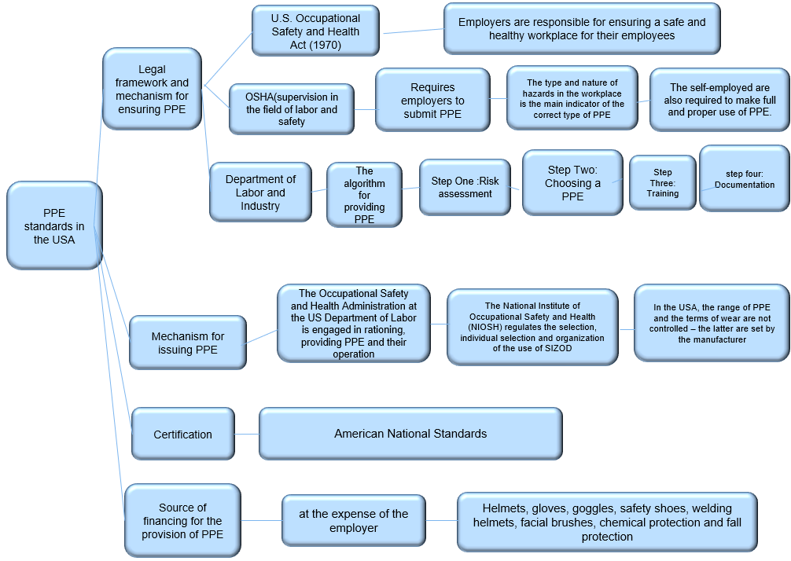

**Fig. 4 - PPE provision and issue mechanism in the USA**



**Fig. 5 - PPE provision and issue mechanism in the UK**

In the EU countries, the conformity assessment processes for personal protective equipment are carried out only in accordance with the EU Regulation 2016/425. Thus, in Poland they must also comply with the requirements specified in the Act dated August 30, 2002 "On the Conformity Assessment System" [14]. In Japan, the regulations on the provision of PPE are based on risk assessment (Figure 6). According to the requirements of the Occupational Safety and Health Act, Japanese employers are required to independently develop accident prevention programs at work and determine what protective equipment they will use to prevent accidents [16].

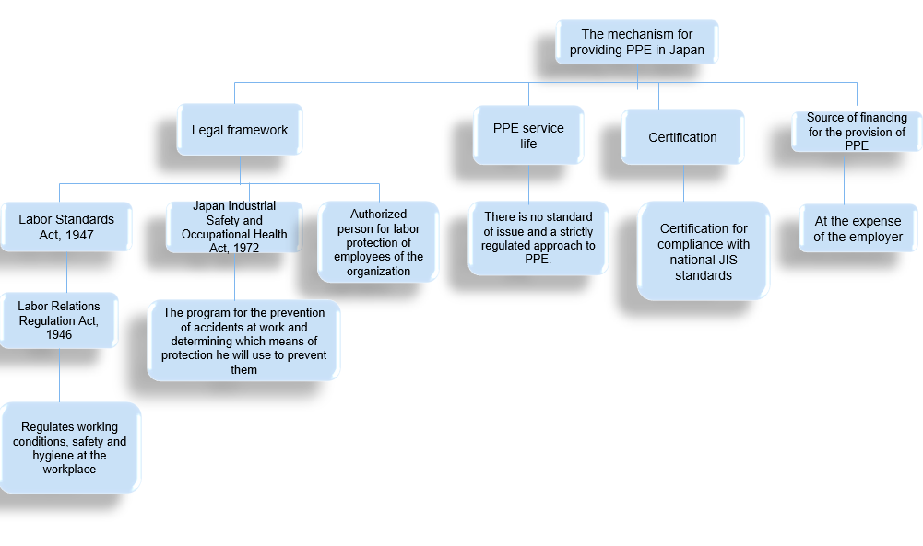

**Fig. 6 - Mechanism for providing and issuing PPE in Japan**

Mixed/hybrid approach – is currently typical for providing PPE in Poland (Figure 7) and Russia. In Poland [14], according to the Labor Code, the employer determines the types of personal protective equipment, as well as work clothes and footwear, the use of which is required in certain positions. At the same time, this is done on the basis of the Resolution of the Minister of Labor and Social Policy of September 26, 1997 "On General Rules for Occupational Health and Safety", which contains detailed rules for the use of PPE, including a list of risks that require personal protective equipment (“Types of work requiring the use of personal protective equipment with an indication and decoding of the types of personal protective equipment”). At the same time, the period of wear and operation is determined based on the manufacturer's requirements provided in the documentation for the PPE. Accordingly, the regulatory framework for the list of risks imposes on the employer an obligation to assess the professional risk of each employee, which is provided for by the Labor Code.

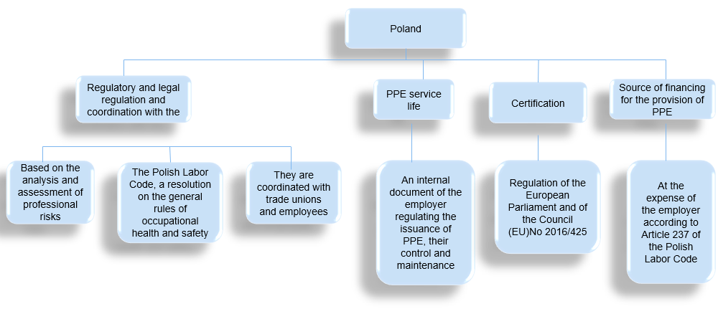

**Fig. 7 - Mechanism for providing and issuing PPE in Poland**

Thus, the employer of any enterprise must develop and approve by a local act the standards for the free issuance of PPE to employees, based on the Unified Standard Standards, taking into account the results of the special assessment of working conditions, the results of the assessment of professional risks, the opinion of the representative body of employees. These standards can be developed by the enterprise itself, as well as by involving third-party organizations or specialists [14].

Based on the results of the analysis, the mechanisms and features of the legal regulation of the provision of PPE were grouped as follows:

The list approach, which is based on strict regulatory consolidation of the list of professions and types of work, for which PPE is provided, sets and wearing periods are regulated, in some cases, provision in excess of standards is prohibited. Regulation is carried out on an industry basis, equalizing the working conditions of employees without taking into account the actual state and measures taken by the employer to improve working conditions (change in technology, technical re-equipment, use of collective protective equipment, exclusion of employee employment directly in the zone of exposure to harmful factors, etc.). Approval of standards by an act of the employer is formal in nature, the assessment of the provision of PPE consists in comparing it with uniform/industry standards. This approach is observed in post-Soviet countries such as Russia, Belarus, Kazakhstan.

Risk-oriented approach, which is based on mandatory assessment of the professional risk of a specific employee. The provision of PPE is not standardized at the legislative level, but the employer's responsibilities to ensure the protection of employees are legislatively established. However, there are certain PPE that are presented in the standards for specific works (helmet and high-visibility vest for loading and unloading works without the obligation to provide special clothing against contamination, etc.) [18-21]. The standards for issuing and the terms of wearing/operation of PPE are tied to the information contained in the technical documentation for a specific product. The role of employee representatives in this aspect is very important, since the formation of the PPE register by the employer is carried out with their participation/agreement, often with the agreement of the employee himself. This approach is used in Canada, the USA, Great Britain, and Japan.

A mixed/hybrid approach, which is currently typical for providing PPE in Poland and Russia. In Poland, according to the Labor Code, the employer determines the types of personal protective equipment, as well as work clothes and footwear, the use of which is required in certain positions. At the same time, this is done on the basis of the Resolution of the Minister of Labor and Social Policy of September 26, 1997 "On General Rules for Occupational Health and Safety" [15], which contains detailed rules for the use of PPE, including a list of risks that require personal protective equipment (“Types of work requiring the use of personal protective equipment with an indication and decoding of the types of personal protective equipment”). At the same time, the period of wear and operation is determined based on the manufacturer's requirements, given in the documentation for the PPE. Accordingly, the regulatory framework for the list of risks imposes on the employer an obligation to assess the professional risk of each employee, which is provided for by the Labor Code.

Russia is in a transitional stage from the list approach and the hybrid approach used alongside it, characterized by legislative regulation of the procedure for providing PPE (Rules, Standard Standards) without taking into account the industry focus. The key reform provides for the transition from Standard Industry Standards for the Issuance of PPE (more than 60 documents) in favor of Uniform Standard Standards acceptable for all industries and sectors of the economy, which indicate the names of professions, names and types of PPE, their quantities per year. Risk-focused approach consists in introducing standards for the issuance of PPE depending on the hazards that pose a threat to the life and health of workers. A separate appendix provides the names of hazards identified based on the results of the assessment of professional risks, PPE that must be issued with a possible design, additional elements and quantity per year. The approved standards serve as the basis for local regulations at enterprises.

**Results and discussion.** At the same time, the employer's obligation to use certified PPE remains a single regulated requirement for all approaches. There is a significant regulatory and technical framework, standards, bodies for confirming product compliance with safety and quality requirements, and state control is carried out.

The study found that to ensure occupational safety, it is necessary to identify hazards, subsequently assess the risk of their impact, and provide protective equipment taking into account the risk. The basis for identifying hazards is the classification of hazardous and harmful production factors. It is necessary to highlight those features that will allow the best identification of hazardous and harmful production factors, assess the risks of their impact on the worker's body, develop protective measures and implement them in practice, thereby preventing injuries and diseases associated with the employee's work and the employer's production activities. Based on the classification, it is possible to fully and reliably identify hazards in the workplace [21-24].

In this regard, in the course of scientific work, a classifier of risks associated with the impact of production factors on the worker's body was developed (Table 1-2) [25,26].

**Table 1 – Classifier of harmful and hazardous production factors**

|  |  |  |  |
| --- | --- | --- | --- |
| **No.** | **Factor code** | **Name of risks associated with factors of the production environment** | **Need to provide PPE (+/-)** |
|  | **1** | **Impact of industrial factors of mechanical nature** |  |
|  | **1.1** | **Fall in the work area** |  |
|  | 1.1.1 | Fall from a height or to a depth | + |
|  | 1.1.2 | Fall when slipping on slippery surfaces | + |
|  | 1.1.3 | Fall, collapse, avalanche of objects (solid, liquid or gaseous objects) | + |
|  | 1.1.4 | Fall, destruction of buildings, structures and their elements | + |
|  | **1.2** | **Road accident** |  |
|  | 1.2.1 | Vehicle collision | + |
|  | 1.2.2 | Transport accidents | - |
|  | **1.3** | **Impact of production equipment** |  |
|  | 1.3.1 | Moving and rotating parts of equipment, mechanisms, machines, tools (impacts, grips, crushing) | + |
|  | 1.3.2 | Stationary cutting parts of production equipment, mechanisms, machines, tools (cuts, scratches) | + |
|  | 1.3.3 | Impact of high surface temperatures of equipment, mechanisms, machines, tools, liquids, gases, vapors | + |
|  | 1.3.4 | Impact of low surface temperatures of equipment, mechanisms, machines, tools | + |
|  | **2** | **Impact of production factors of a physical nature** |  |
|  | **2.1** | **Impact of electric current** |  |
|  | 2.1.1 | Electric shock from equipment, mechanisms, machines, tools | + |
|  | 2.1.2 | Impact of an electric arc | + |
|  | **2.2** | **Risk of fire or explosion** |  |
|  | 2.2.1 | Ignition of flammable substances | + |
|  | 2.2.2 | Static electricity | + |
|  | 2.2.3 | Exposure to smoke, steam, harmful gases and dust | + |
|  | 2.2.4 | Working with pressure vessels | + |
|  | **2.3** | ***Climate/microclimate*** |  |
|  | 2.3.1 | Increased air temperature in open areas | + |
|  | 2.3.2 | Decreased air temperature in open areas | + |
|  | 2.3.3 | Increased air velocity in open areas | + |
|  | 2.3.4 | Increased air humidity in open areas | + |
|  | 2.3.4 | Increased air temperature indoors | + |
|  | 2.3.4 | Decreased air temperature indoors | + |
|  | 2.3.4 | Increased air velocity indoors | + |
|  | 2.3.4 | Increased air humidity indoors | + |
|  | 2.3.4 | Increased thermal radiation | + |
|  | 2.3.4 | Increased atmospheric pressure | - |
|  | **2.4** | ***Ionizing radiation*** |  |
|  | 2.4.1 | Alpha radiation | ***+*** |
|  | 2.4.2 | Beta radiation | ***+*** |
|  | 2.4.3 | Gamma radiation (expository) | ***+*** |
|  | 2.4.4 | X-ray radiation | ***+*** |
|  | 2.4.5 | Electrically charged air particles - aeroions | ***+*** |

The proposed classifier consists of 6 main groups, 19 names, and 55 subgroups of production factors, and its application is substantiated using examples.

**Table 2 - Classifier of harmful and hazardous production factors**

|  |  |  |  |
| --- | --- | --- | --- |
| **No.** | **Factor code** | **Name of risks associated with factors of the production environment** | **Need to provide PPE (+/-)** |
|  | **2.5** | ***Non-ionizing radiation*** |  |
|  | 2.5.1 | Electrostatic field | + |
|  | 2.5.2 | Permanent magnetic field (including hypogeomagnetic) | + |
|  | 2.5.3 | Industrial frequency electric and magnetic fields | + |
|  | 2.5.4 | Broadband electromagnetic fields generated by personal computers | - |
|  | 2.5.5 | Infrared radiation | **+** |
|  | 2.5.6 | Ultraviolet radiation | + |
|  | 2.5.7 | Laser radiation | + |
|  | **2.6** | ***Vibroacoustic factors*** |  |
|  | 2.6.1 | Continuous noise | + |
|  | 2.6.2 | Pulsed noise | + |
|  | 2.6.3 | General vibration | + |
|  | 2.6.4 | Local vibration | + |
|  | 2.6.5 | Infrasound | + |
|  | 2.6.6 | Ultrasound | + |
|  | **2.7** | ***Light environment*** |  |
|  | 2.7.1 | Insufficient illumination of the work area | + |
|  | 2.7.2 | Increased illumination of the work area (brightness of light, direct and reflected, increased pulsation of the light flux) | + |
|  | **2.8** | ***Aerosol composition of air*** |  |
|  | 2.8.1 | Highly and moderately fibrogenic aerosols | + |
|  | 2.8.2 | Low-fibrogenic aerosols | + |
|  | **3** | **Impact of industrial factors of chemical nature** |  |
|  | 3.1 | ***Chemical substances contained in the air of the working area (aerosols, vapors, gases, fumes)*** |  |
|  | 3.1.1 | Acute toxicity substances | **+** |
|  | 3.1.2 | Irritant substances | **+** |
|  | 3.1.3 | Carcinogenic substances | **+** |
|  | 3.1.4 | Allergenic substances | **+** |
|  | 3.1.5 | Substances hazardous to reproductive health | **+** |
|  | 3.1.6 | Substances prohibited for inhalation and skin contact (antitumor drugs, estrogen hormones, narcotic analgesics) | **+** |
|  | 3.1.7 | Solutions of acids, alkalis, etc., solid and bulk substances that affect the skin and mucous membranes | **+** |
|  | **4** | **Impact of production factors of biological nature** |  |
|  | 4.1 | Microorganisms-producers, preparations containing living cells and spores of microorganisms | + |
|  | 4.2 | Pathogenic microorganisms and viruses (causative agents of especially dangerous and other infectious diseases) | + |
|  | 4.3 | Getting of poisons, waste products and plants themselves, insects, arachnids, animals on the skin and inside the body | + |
|  | **5** | **Impact of production factors of psychophysiological nature** |  |
|  | 5.1 | Difficulty of labor | - |
|  | 5.2 | Intensity of labor | - |
|  | **6** | **Exposure to general industrial contaminants** |  |
|  | 6.1 | Water (including contaminated) and solutions of non-toxic substances (dyes, adhesives, oily and other substances) and labor products | + |
|  | 6.2 | Non-toxic dust (fine chips, small fragments, coarse dust) | + |

The classifier contains the following main names of risks associated with the impact of factors of the production environment and the work process on the worker's body:

- impact of production factors of a mechanical nature (fall in the work area, road traffic accident, impact of production equipment);

- impact of production factors of a physical nature (electric current, threat of fire or explosion, climate/microclimate, ionizing radiation, non-ionizing radiation, vibroacoustic factors, light environment, aerosol composition of air);

- impact of production factors of a chemical nature (chemical substances contained in the air of the working area (aerosols, vapors, gases, fumes);

- impact of production factors of a biological nature (microorganisms - producers, pathogenic microorganisms and viruses, waste products of plants, insects, arachnids, animals);

- impact of production factors of a psychophysiological nature (severity of work, labor intensity);

- impact of general industrial pollutants (water and solutions of non-toxic substances, non-toxic dust)

**Conclusions.** Analysis of the current mechanisms for providing PPE in the Republic of Kazakhstan has established that regulation is determined by 22 industries and 3,544 professions based on approved standards for issuing special clothing and other personal protective equipment to employees of organizations of various types of economic activity.

Compliance with the established standards in practice puts the employer in a strict framework, on the one hand, with the need to purchase PPE that is inadequate for working conditions, on the other hand, with the impossibility of increasing/decreasing the wearing period and quantity, changing the completeness, etc. The domestic mechanism for providing PPE is characterized by a “list” approach and strict regulation of the types of PPE depending on the profession or position of the employee, which in some cases leads to the creation of barriers in ensuring safe work at enterprises. At the same time, the experience of developed countries shows the effectiveness of using RBA in providing PPE.

Thus, developed foreign countries use models for providing PPE based on an assessment of professional risks, analyzing specific hazards and providing relevant means of protection against them. The introduction of risk assessment into the labor legislation of the Republic of Kazakhstan and the existing regulatory mechanism for the provision of PPE, which does not take into account the specifics of the labor process and the presence/absence of harmful production factors and professional risks, requires revision. It is assumed that based on the results of the assessment of professional risks, as well as taking into account the physical, chemical, biological factors of the production environment and factors of the labor process, employers should be able to independently develop and approve standards for providing PPE to employees of the enterprise [2].

In this regard, it is necessary to improve the current regulatory mechanism for providing special clothing, footwear and other PPE with increased flexibility in determining the contingent of employees, choosing protective equipment, assigning additional sets, replacement and complex PPE, service life.

Thus, the employer of any enterprise must develop and approve by a local act the standards for the free issuance of PPE to employees, based on the unified standard guidelines, taking into account the results of the special assessment of working conditions, the results of the assessment of professional risks, the opinion of the representative body of employees. These standards can be developed by the enterprise itself, or by involving third-party organizations or specialists.

Considering that the range of modern PPE fully covers protection against all possible factors of the production environment and professional risks, a methodology for providing PPE based on RBA will be developed and implemented, as well as a nomenclature of PPE corresponding to the degree and type of exposure to harmful and (or) hazardous production factors [2].

Also, based on the results of the study, a classifier of risks associated with the impact of production factors on the worker's body, as well as a classifier of harmful and hazardous production factors were developed.

***Financing:*** *This research has been/was/is funded by the Science Committee of the Ministry of Education and Science of the Republic of Kazakhstan (Grant No. BR22182667 “Working Conditions and Occupational Risks: Classification, Categories, and Grouping Criteria in the Transition to the "Green Economy").*

**References**

1. Labor Code of the Republic of Kazakhstan. Code of the Republic of Kazakhstan dated November 23, 2015 No. 414-V ZRK. <https://adilet.zan.kz/rus/docs/K1500000414>.Data obrashhenija: 13.10.2024. [in Russian].

2. Risk-orientirovannyj podhod k obespecheniju sredstvami individual'noj zashhity na predprijatii // Kollektiv avtorov pod redakciej Abikenovoj Sh.K. Nauchno-informacionnoe izdanie. ISBN 978-601-08-2792-9. – Nur-Sultan: RGP na PHV “RNIIOT MTSZN RK”, 2022. -220 s.[in Kazakh].

3. Personal Protective Equipment and the Role of a Trained Observer, NETEC [URL: <http://file.lacounty.gov/SDSInter/dhs/1068461_SlideDeck5-PPEandInfectionControlPrinciples.pdf>]. Data obrashhenija:13.10.2024.

4. Foster, J., Hodder, S.G., Goodwin, J., Havenith, G. (2020). Occupational heat stress and practical cooling solutions for healthcare and industry workers during the COVID-19 pandemic// Ann Work Expo Health.- 2022.-Vol.64(9).- P. 915-922. DOI 10.1093/annweh/wxaa082

5. Zakon Respubliki Kazahstan “O biologicheskoj bezopasnosti Respubliki Kazahstan” Postanovlenie Pravitel'stva Respubliki Kazahstan ot 21 maja 2022 goda № 122-VII ZRK https://adilet.zan.kz/rus/docs/Z2200000122. [in Russian]. (Data obrashhenija: 28.04.2022).

6. Ortega, R., Gonzalez, M., Nozari, A., & Canelli, R. (2020). Personal Protective Equipment and Covid-19//The New England journal of medicine.-2020.- Vol. 382(26).- e105.

DOI 10.1056/NEJMvcm2014809

7. Pritchard, A. (2020). Personal protective equipment//Australian journal of general practice/-2020. DOI 10.31128/AJGP-COVID-07

8. Tehnicheskie reglamenty Tamozhennogo sojuza. O bezopasnosti sredstv individual'noj zashhity (TR TS 019/2011) / Prinjat resheniem Komissii Tamozhennogo sojuza ot 9 dekabrja 2011 g. № 878. https://adilet.zan.kz/rus/docs/H11T0000878. [in Russian]. Data obrashhenija: 30.10.2024.

9.Prikaz Ministerstva truda i social'noj zashhity Rossijskoj Federacii ot 9 dekabrja 2014 g. «Ob utverzhdenii tipovyh norm besplatnoj vydachi special'noj odezhdy, special'noj obuvi i drugih sredstv individual'noj zashhity rabotnikam skvoznyh professij i dolzhnostej vseh vidov jekonomicheskoj dejatel'nosti, zanjatym na rabotah s vrednymi i (ili) opasnymi uslovijami truda, a takzhe na rabotah, vypolnjaemyh v osobyh temperaturnyh uslovijah ili svjazannyh s zagrjazneniem» https://normativ.kontur.ru/document?moduleId=1&documentId=247205. [in Russian]. Data obrashhenija: 30.10.2024.

10. Prikaz Ministerstva truda i social'noj zashhity Rossijskoj Federacii ot 16.11.2020 № 782n. "Ob utverzhdenii Pravil po ohrane truda pri vypolnenii rabot na vysote" https://normativ.kontur.ru/document?moduleId=1&documentId=379253&ysclid=l9u855zqyi192989478. [in Russian]. Data obrashhenija:30.10.2024.

11. Technical Report TR-0200 (4230-46)-3. Aerospace Corporation, Los Angeles, California, USA. The Infrastructure Health and Safety Association (IHSA) <https://www.ihsa.ca/topics_hazards/ppe.aspx>. Date of access: 30.10.2024.

12. Occupational Safety and Health Administration: Employer Payment for Personal Protective Equipment; Final Rule. <https://www.osha.gov/laws-regs/federalregister/2007-11-15-0>. Date of access: 02.12.2024.

13. Rules for using PPE in the UK. UK Statutory Instruments, 2022 No. 8: The Personal Protective Equipment at Work (Amendment) Regulations 2022. https://www.hse.gov.uk/ppe/ppe-regulations-2022.htm#:~:text=Under%20PPER%202022%2C%20the%20types,on%20the%20use%20of%20PPE. Date of access:11.01.2025.

14. Law of August 30, 2002 on the conformity assessment system. [Electronic resource]. https://isap.sejm.gov.pl/isap.nsf/DocDetails.xsp?id=WDU20021661360. Date of access: 11.01.2025.

15. Decree of the Minister of Labor and Social Policy Poland Republic of September 26, 1997. On general rules of labor protection and safety at work. https://www.global-regulation.com/translation/poland/2986216/regulation-of-the-minister-of-labour-and-social-policy-of-26-september-1997-on-general-provisions-of-occupational-safety-and-health.html Date of access: 30.10.2024.

16. Japan International Cooperation Agency. JICA standard safety specification (JSSS).https://www.jica.go.jp/Resource/english/our_work/types_of_assistance/c8h0vm00008zx0m8-att/jsss_01.pdf. Date of access: 08.01.2025

17. Vukicevic, A.M., Djapan, M., Isailovic, V., Milasinovic, D., Savkovic, M., Milosevic, P. (2022). Generic compliance of industrial PPE by using deep learning techniques// Safety Sci.- 2020.-Vol.148(5):105646. DOI 10.1016/j.ssci.2021.105646

18. Balamurugan, B., Grant, R., Gaurav N. PPE Compliance Detection using Artificial Intelligence in Learning Factories //Procedia Manufacturing.-2020.- Vol.45.- P.277-282. DOI 10.1016/j.promfg.2020.04.017

19. Kursunoglu, N., Onder, S., Onder, M. (2022). The Evaluation of Personal Protective Equipment Usage Habit of Mining Employees Using Structural Equation Modeling//Safety and Health at Work.-2022.-Vol.13(2).- P. 180-186. DOI 10.1016/j.shaw.2022.03.004

20. Jack C.P.Cheng, Peter Kok-YiuWong, Han Luo et al. Vision-based monitoring of site safety compliance based on worker re-identification and personal protective equipment classification//Automation in Construction.-2022.-Vol.139. DOI 10.1016/j.autcon.2022.104312

21. Sholpan Abikenova, Gulnara Issamadiyeva, Elmira Kulmagambetova, Gulzhan Daumova, Nazgul Abdrakhmanova. Assessing Occupational Risk: A Classification of Harmful Factors in the Production Environment and Labor Process // International Journal of Safety and Security Engineering. -2023ю Vol. 13(5).- P.871-881 DOI10.18280/ijsse.130511  
22. GOST 12.0.003-2015 “Systema standartov po ohrane truda. Opasnye I vrednye proizvodstvennye factory. Klassifikacya" GOST RK <https://online.zakon.kz/Document/?doc_id=34182412> [in Russian]. Data obrashhenija: 11.01.2025)

23. Opasnye i vrednye proizvodstvennye faktory. [Jelektronnyj resurs]. <https://nalog-nalog.ru/ohrana_truda/opasnye_i_vrednye_proizvodstvennye_faktory_perechen>]. [in Russian]. Data obrashhenija: 15.10.2024

24. Metodicheskie rekomendacii: Gigienicheskie kriterii ocenki i klassifikacija uslovij truda po pokazateljam vrednosti i opasnosti faktorov proizvodstvennoj sredy, tjazhesti i intensivnosti trudovogo processa. Utverzhdeno prikazom Predsedatelja Komiteta sanitarno-jepidemiologicheskogo nadzora Ministerstva zdravoohranenija Respubliki Kazahstan ot 31 dekabrja 2020 goda № 24. https://online.zakon.kz/Document/?doc_id=35193093]. [in Russian]. Data obrashhenija: 15.10.2024.

25. A.S. № 28600 ot 06.09.2022 g. Nomenklatura sredstv individual'noj zashhity v zavisimosti ot vrednyh proizvodstvennyh faktorov i stepeni ih vozdejstvija / Zajavitel': Respublikanskij nauchno-issledovatel'skij institut ohrany truda Ministerstva truda i social'noj zashhity naselenija Respubliki Kazahstan, Astana, 2022 g.

26.Abikenova Sh., Issmadiyeva G., Kulmagambetova E., Daumova G. Assessing Occupational Risk: A Classification of Harmful Factors in the Production Environment and Labor Process// International Journal of Safety and Security Engineering.- 2023.-Vol/13(5).-P.871-881

DOI. 10.18280/ijsse.130511

***Information about the author***

Bekmagambetov A.- higher law degree, candidate of legal sciences, Associate Professor, REM with RSE Republican Research Institute for Labor Protection of the Ministry of Labor and Social Protection of Population of the Republic of Kazakhstan, Astana,Kazakhstan,e-mail: Adilet1979@mail.ru;

Kulmagambetova E. - candidate of chemical science, Leading Researcher of the Department of Monitoring and Occupational Health, REM with RSE Republican Research Institute for Labor Protection of the Ministry of Labor and Social Protection of Population of the Republic of Kazakhstan, Astana, 010000, Republic of Kazakhstan,e-mail: elya_[kulmagambet@.mail.ru](mailto:kulmagambet@.mail.ruedu.kz);

Madeniyet Y. - Candidate of Chemical Science, Dean of the Faculty of Natural Sciences, Professor «Toraighyrov University» NCJSC, Pavlodar, Kazakhstan, e-mail: [yelubay.m@tou.edu.kz](mailto:yelubay.m@tou.edu.kz);

Rakhmetova A. - candidate of medical science, Associate Professor Head of the Department of Monitoring and Occupational Health, REM with RSE Republican Research Institute for Labor Protection of the Ministry of Labor and Social Protection of Population of the Republic of Kazakhstan, Astana, Kazakhstan, e-mail:elya_[ra_anar@.mail.ru](mailto:ra_anar@.mail.ru);

TolegenovD.- Researcher at the Department of Chemistry and Chemical Technologies «Toraighyrov University»

NCJSC, Faculty of Natural Sciences, Pavlodar, Kazakhstan, e-mail: [www.dika-92@mail.ru](http://www.dika-92@mail.ru)

***Сведения об авторах***

Бекмагамбетов А.- кандидат юридических наук, ассоцированный профессор, Республиканский научно-исследовательский институт по охране труда Министерства труда и социальной защиты населения Республики Казахстан и. о. генерального директора, e-mail: Adilet1979@mail.ru;

Кульмагамбетова Э.- кандидат химических наук, Республиканский научно-исследовательский институт по охране труда Министерства труда и социальной защиты населения Республики Казахстан, dедущий научный сотрудник отдела биомониторинга и гигиены труда, e-mail: elya_[kulmagambet@.mail.ru](mailto:kulmagambet@.mail.ruedu.kz);

Мадениет Е. - кандидат химических наук, профессор декан факультета естественных наук, НАО «Торайгыров Университет»,Павлодар, Казахстан, e-mail: [yelubay.m@tou.edu.kz](mailto:yelubay.m@tou.edu.kz);

Рахметова A. - кандидат медицинских наук, доцент, Республиканский научно-исследовательский институт по охране труда Министерства труда и социальной защиты населения Республики Казахстан», руководитель отдела биомониторинга и гигиены труда, Астана, Казахстан, e-mail: elya_[ra_anar@.mail.ru](mailto:ra_anar@.mail.ru);

Төлегенов Д. **-** научный сотрудник кафедры «Химия и химические технологии», НАО «Торайгыров университет», факультет естественных наук, Павлодар, Казахстан, e-mail: [www.dika-92@mail.ru](http://www.dika-92@mail.ru)

IRSTI 47.09.48

**IMPORTANCE OF MXENE NANOCOMPOSITES IN THE DETECTION**

**OF HEAVY METALS**

**D.B. Konarbay****, Y. Bakytkarim**[](https://orcid.org/0000-0002-8253-1133)**, Zh.S. Mukataeva**[](https://orcid.org/0000-0002-1584-5810)**, N.A. Shadin**[](https://orcid.org/0000-0001-7713-1795)**,**

**D.A. Karazhanova** [Picture background](https://orcid.org/0000-0001-9801-0562)**, Zh.R. Kozhagulova**[Picture background](https://orcid.org/0000-0003-0638-8141)

*1Abai Kazakh National Pedagogical University», Almaty city, Kazakhstan*

Corresponding-author:[*konarbay98@bk.ru*](mailto:konarbay98@bk.ru)*,* [*Rysgul_01_88@mail.ru*](mailto:Rysgul_01_88@mail.ru)

One of the strongest and most common chemical pollution is its environmental pollution with heavy metals. Heavy metals are actively involved in biological processes, which are part of many enzymes. The toxicity of heavy metal ions causes a number of harm to environmental components and human health. That is why the detection of heavy metals is so important. The creation of a reliable and effective system for detecting heavy metals is crucial. And traditional detection methods are often not enough to meet the current needs. Therefore, the use of electrochemical sensors in the detection of heavy metals is currently taking an important place. Electrochemical sensors have become a promising area of research due to their unique capabilities. Improving the detection efficiency of electrochemical sensors is the main area of research. The leading strategy for significantly improving detection performance involves adding nanomaterials to electrochemical sensors. This review compares MXene nanocompasites with the achievements of nanomaterials in the field of electrochemical sensors in recent years. This makes it possible to obtain new ideas for the manufacture of electrochemical sensors with high sensitivity and low detection threshold. We believe that knowing and combining the benefits of different nanomaterials to produce innovative electrode modification materials can eliminate the risk of heavy metal ions in many food, environmental and other industries.

**Keywords:** heavy metals, electrochemical sensors, nanomaterials, modification, MXene nanocomposites.

**АУЫР МЕТАЛДАРДЫ АНЫҚТАУДА MXENE НАНОКОМПОЗИТТЕРДІҢ МАҢЫЗЫ**

**Д.Б. Қонарбай ,** **Ы. Бақыткәрім**, **Ж.С.Мұқатаева,** **Н.А. Шадин,**

**Д.А. Каражанова, Ж.Р. Кожагулова**

*1Абай атындағы Қазақ ұлттық педагогикалық университеті», Алматы, Қазақстан,*

e-mail:[*konarbay98@bk.ru*](mailto:konarbay98@bk.ru)*,* [*Rysgul_01_88@mail.ru*](mailto:Rysgul_01_88@mail.ru)

Ең күшті және ең көп таралған химиялық ластанудың бірі - ол қоршаған ортаның ауыр металдармен ластануы. Ауыр металдар көптеген ферменттердің құрамына кіретін биологиялық процестерге белсенді қатысады. Ауыр металл иондарының уыттылығы қоршаған орта компоненттеріне және адам денсаулығына бірқатар зиянын келтіреді. Сондықтан да ауыр металдарды анықтау өте маңызды болып табылады. Ауыр металдарды анықтау үшін сенімді және тиімді жүйені құру қажет. Ал дәстүрлі анықтау әдістері көбінесе қазіргі қажеттіліктерді қанағаттандыру үшін жеткіліксіз. Сондықтанда қазіргі кезде ауыр металдарды анықтауда электрохимиялық сенсорларды қолдану маңызды орын алып отыр. Электрохимиялық сенсорлар өзінің ерекше мүмкіндіктерінің арқасында зерттеудің перспективалық бағытына айналды. Электрохимиялық сенсорларды анықтау тиімділігін арттыру зерттеудің негізгі бағыты болып табылады. Анықтау өнімділігін айтарлықтай жақсартудың жетекші стратегиясы наноматериалдарды электрохимиялық сенсорларға қосуды қамтиды. Бұл шолу MXene нанокомпазиттерін соңғы жылдардағы электрохимиялық сенсорлар саласындағы наноматериалдардың жетістіктерін салыстырады. Бұл жоғары сезімталдығы бар және анықтау шегі төмен электрохимиялық сенсорларды дайындау үшін жаңа идеялар алуға мүмкіндік береді. Электродтарды модификациялау үшін инновациялық материалдар алу үшін әртүрлі наноматериалдардың артықшылықтарын білу және біріктіру көптеген азық-түлік, экологиялық және де басқа салалардағы ауыр металл иондарының қаупін жоя алады деген ойдамыз.

**Түйін сөздер:** Ауы****р металдар, электрохимиялық сенсорлар, наноматериалдар, модификация, MXene нанокомпозиттері.

**ВАЖНОСТЬ НАНОКОМПОЗИТОВ MXENE ДЛЯ ОПРЕДЕЛЕНИЯ ТЯЖЕЛЫХ МЕТАЛЛОВ**

**Д.Б.** **Кон****арбай, Ы. Бакыткарим,** **Ж.С. Мукатаева, Н.А.Шадин,**

**Д.А. Каражанова, Ж.Р. Кожагулова**

*Казахский национальный педагогический университет имени Абая», г. Алматы, Казахстан,*

*e-mail:* [*konarbay98@bk.ru*](mailto:konarbay98@bk.ru)*,* [*Rysgul_01_88@mail.ru*](mailto:Rysgul_01_88@mail.ru)

Одним из самых сильных и распространенных химических загрязнений является загрязнение окружающей среды тяжелыми металлами. Тяжелые металлы активно участвуют в биологических процессах, входя в состав многих ферментов. Токсичность ионов тяжелых металлов наносит ряд повреждений компонентам окружающей среды и здоровью человека. Именно поэтому обнаружение тяжелых металлов так важно. Необходимо создать надежную и эффективную систему для обнаружения тяжелых металлов. А традиционных методов обнаружения зачастую недостаточно для удовлетворения современных потребностей. Поэтому использование электрохимических сенсоров для обнаружения тяжелых металлов в настоящее время занимает важное место. Электрохимические сенсоры стали перспективным направлением исследований благодаря своим уникальным возможностям. Повышение эффективности обнаружения электрохимических сенсоров является основным направлением исследований. Ведущей стратегией для значительного повышения эффективности обнаружения является добавление наноматериалов в электрохимические сенсоры. В данном обзоре сравниваются нанокомпозиты MXene с достижениями наноматериалв в области электрохимических сенсоров за последние годы. Это позволяет получить новые идеи для изготовления электрохимических сенсоров с выской чувствительностью и низким порогом обнаружения. Мы считаем, что знание и комбинирование преимуществ различных наноматериалов для создания инновационных материалов для модификации электродов может устранить опасность ионов тяжелых металлов во многих пищевых, экологических и других отраслях промышленности.

**Ключевые слова:** тяжелые металлы, электрохимические сенсоры, наноматериалы, модификация, нанокомпозиты MXene.

**Introduction.** Heavy metals are particularly biodegradable pollutants. They enter aquatic ecosystems, enter water and sediment phases, accumulate in organisms, and even at low levels cause a number of serious diseases and disorders [1-4]. For example, neurological, cardiovascular, respiratory and reproductive diseases [5]. Heavy metals in the environment pose a serious threat to wildlife and human health because they are bioavailable and can be absorbed and enriched in food [6]. Toxic metals are largely distributed into the environment. The distribution of heavy metals by wind in the form of particles or vapor depends on their physical state. The meta-components move from the atmosphere to the soil or water surface, resulting in environmental pollution. Industrial wastewater is a major source of metal pollution in the hydrosphere. Wastewater containing toxic heavy metals like nickel, lead, copper, chromium, cadmium, and arsenic poses environmental and health hazards [7]. Heavy metals affecting human health include elements such as mercury, nickel, lead, chromium, cadmium, aluminum and copper [8]. Heavy metals in water, air and soil can be transferred to plants, aquatic organisms and organisms and then enter the food chain and pose a threat to human health [9].

Year after year, the population around the world is growing. As the world's population grows, the demand for food, drinking water and many other industries increases. Due to the increased demand, the quality requirements for food and drinking water are increasing. To ensure consumer safety, we must detect harmful substances present in very low concentrations. One of the most commonly used methods today is the use of electrochemical sensors.

Electrochemical sensors are tools for detecting and counting heavy metals because they tend to be highly specific, sensitive, inexpensive and portable. This makes them valuable for small and mobile remote applications. Since complete elimination of food and drinking water contamination may not seem possible in the near future, assessment of legal limits should always be considered in the context of general nutrition, especially in the case of children. Ongoing research continues to improve sensor performance, enhance detection capabilities, and address calibration, interference, and sample preparation issues, further advancing the development of electrochemical sensors in food safety applications [10].

The world of sensors is diverse and due to this, it is developing at a rapid pace. Due to continuous technological improvement it is becoming more and more in demand. Electrochemical sensors are a convenient solution for variable analyzer detection due to their low cost and availability and are widely used in agriculture, food and oil industry as well as in environmental and biomedical fields. Electrochemical sensors have long been required for the study of biological substances. The sensors are characterized not only by their durability, high sensitivity and accuracy, but also by their low cost, speed and simplicity. Many nanomaterials have been obtained in more than two decades. Specific metals, conducting polymers, metal oxides and organometallic and carbon-based nanomaterial structures. Nanomaterials contribute to the analytical performance included in electrochemical analysis. This modification increases the payload capacity by utilizing recognition molecules such as enzymes, antibodies and aptamers as well as bioinspired receptors that can accurately and efficiently capture the target, thereby increasing the specificity of electrochemical sensors [11].

Electrochemistry-an important quantitative analysis strategy for testing various biochemical entities such as proteins, metabolites, neurotransmitters, electrolytes, heavy metals, etc. Further, demonstrating wide applications in the fields of private health care, public health, clinical diagnostics, food safety and environmental analysis [12-14]. Generally, a complete electrochemical conversion system usually consists of two parts: sensing electrodes and electrochemically sensitive circuits. The former is used to convert biochemical signals into electrical signals. The latter uses various electrochemical test methods to excite the electrodes with voltage, collect, process, analyze the data and transmit them as electrical signals [15,16].

MXenes' electrical conductivity, rich surface chemistry and high aspect ratio are attractive characteristics for sensor processing . The ideal sensor has high performance, low detection , low production cost, low hysteresis, fast and efficient processing reaction, as well as fast recovery properties during reuse . Pressure and deformation sensors are production responsible in a wide pressure range and require high performance in thousands of deformation cycles. The cycles require high resistance in thousands of deformation cycles. The sensors demonstrated this product when made from MXenes, mxen/polymer nanocomposites, and mixed two-dimensional (2D) mxen-based heterostructures. Examples: silver nanoparticles, carbon nanotubes, and graphene oxide nanoparticles are 0D, 1D, and 2D nanoparticles that were combined with MXene and used to create Mxene-based 2D heterostructures [17].The latter includes mxen and heterostructure of 0D, 1D or 2D nanomaterials. These are heterostructures, as well as the detection of pure MXene and MXene /polymer nanocomposites and toxic compounds in food, monitoring of human movements and health status, gas and condition measurement, voice recognition and other input in sensory systems. appropriateness, voice recognition and other aspects [18].

**Table 1- Lists many MXene-based sensors and their corresponding applications [19]**

|  |  |
| --- | --- |
| **Nanocomposite components** | **Application** |
| **Ti3C2 / reduced graphene oxide** | Pressure sensor |
| **Ti3C2/ Ag nanowire** | Strain sensor |
| **Ti3C2 / chitosan** | Biosensor for detecting pesticides |
| **Ti3C2 / Nafion** | Detecting nitrile ions |
| **Ti3C2 / PANI** | Ethanol, methanol, ammonia, and acetone detection |
| **Ti3C2 / polyurethane** | Stretchable strain sensing fabric |
| **Ti3C2/ poly(vinylidene fluoride-trifluoroethylene)** | Capacitive pressure sensor |
| **Ti3C2 / natural microcapsules** | Epidermal flexible pressure sensors |
| **Ti3C2 / poly(dimethylsiloxane)** | Skin conformal sensors for health monitoring |
| **Ti3C2 / gold nanoparticles** | Glucose detection biosensor |
| **Ti3C2 and TiO2** | H2O2 detection |
| **hollow MXene spheres/ reduced graphene** | Piezoresistive pressure sensor |
| **Ti3C2 / ink** | Strain sensor for health monitoring |

MXene performance in sensor systems depends on the type and concentration of surface functional groups (hydroxyl, oxygen, fluorine, chlorine). For example, the simulation results showed that oxygen-ending MXene has excellent performance for ammonia detection, while hydroxyl-ending MXene has better performance for ethanol detection.To further improve the electrochemical performance of electrochemical sensors, sensitive Nanomaterials and 2D materials have been introduced due to high electrocatalytic effect and high electrical conductivity [20].

Mxene is a novel 2D material with a rare combination of properties such as electrical and metallic conductivity, hydrophilicity, biocompatibility and large surface area , convenient size customization, rich surface chemistry, flexibility, and layered structure. Due to its versatile properties, MXene is considered as a building material for future materials and devices [21].

As an electrode material, MXene is a potential candidate for synthesis for various energy storage devices such as supercapacitors and batteries. Composites based on metal oxides and metal sulfides are the most effective electrode materials for supercapacitor electrodes. Research was carried out to improve the properties of MXene-based composites [22 ].

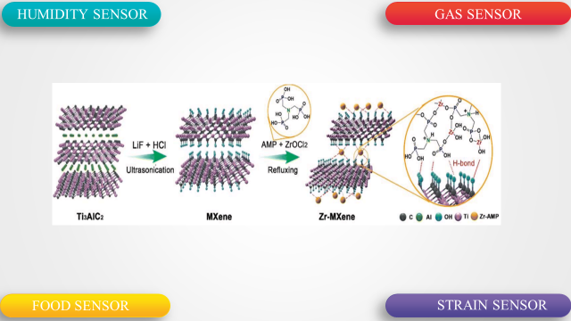

**Figure 1 - Types of Mxene-based sensors [19]**

**Table 2 - Advantages and disadvantages of MXepe materials**

|  |  |  |
| --- | --- | --- |
|  | **Advantages** | **Disadvantages** |
| **MXene** | -Stability  - Optical properties  - Good hydrophilicity  - Conductivity  -Outstanding mechanical properties  - Thermal effect  - Excellent biocompatibility  - High electrical conductivity | -The preparation process of MXene sensitive materials must be further developed  - The abundant functional groups on the surface of MXene materials endow them with customizable optical and electrical properties, but also bring new challenge |

**Materials and methods.** *Nanocomposite WO3/Mxene*

Al-Zoha Wapsi and others [23] used a hydrothermal method for the synthesis of tungsten oxide nanorods. The synthesis of WO3/MXene by a simple ultrasound method was carried out. The samples obtained were characterized by structural, spectral, morphological and elemental analysis. The photocatalytic and antibacterial activity of synthesized samples, these aspects are discussed in detail. Max (Ti3AlC2) powder was used in a 50 ml Teflon container to synthesize MXene with the formula Ti3C2Tx used. To synthesize MXene with the formula Ti3C2Tx in a 50 ml Teflon container. For MXene synthesis, 10 ml of HF is poured into a Teflon container and then released into a suction cup . Then, instead of low HF, MAX 0.5 g powder and a pinch were added. The mixture was equipped with magnetic instruments for an hour at room temperature.

The combustion optimization of the mixture was carried out at the installation temperature for 24 hours with magnetic power. Deionized (DI) water was added to dilute the product, and MXene was obtained by centrifugation at more than 5000 rpm. The washing of these deposits was performed until the PH reached 6. The Aqueous Dispersion was carried out using a PTFE membrane by vaum filtration. Filtrate is here.

For FESEM analysis, samples were sprayed with gold for 120 seconds at a current of 15 ma. Figure-2 A, B WO3 and WO3/MXene nanocomposite morphology control. Figure-2 - (a) illustrates the block/stick pattern morphology of WO3. Figure-2 (b) MXene WO3 is defined as impregnated with nano wires. MXene Nano sample structure formation in Figure 2 - (c). The size of the WO3 was about 13 nm, after the reduction of FESEM. The MXene layer was estimated at ~175 nm on an additional micro-image. For FESEM analysis, the samples were subjected to gold spraying for 120 seconds at a current of 15 ma. Figure-2 A,B WO3 and WO3/MXene nanocomposite morphology control. Figure 1 shows the morphology of WO3 with a block or stick inscription. Figure - 2 (b) MXene WO3 is detected in an impregnated manner with nano wires. Figure 2 (c) shows the MXene formation of the nanoscale structure. The size of the WO3 volume was about 13 nm, which is after the reduction of FESEM. In the micrograph, the size of the mxen layer was 175 nm.

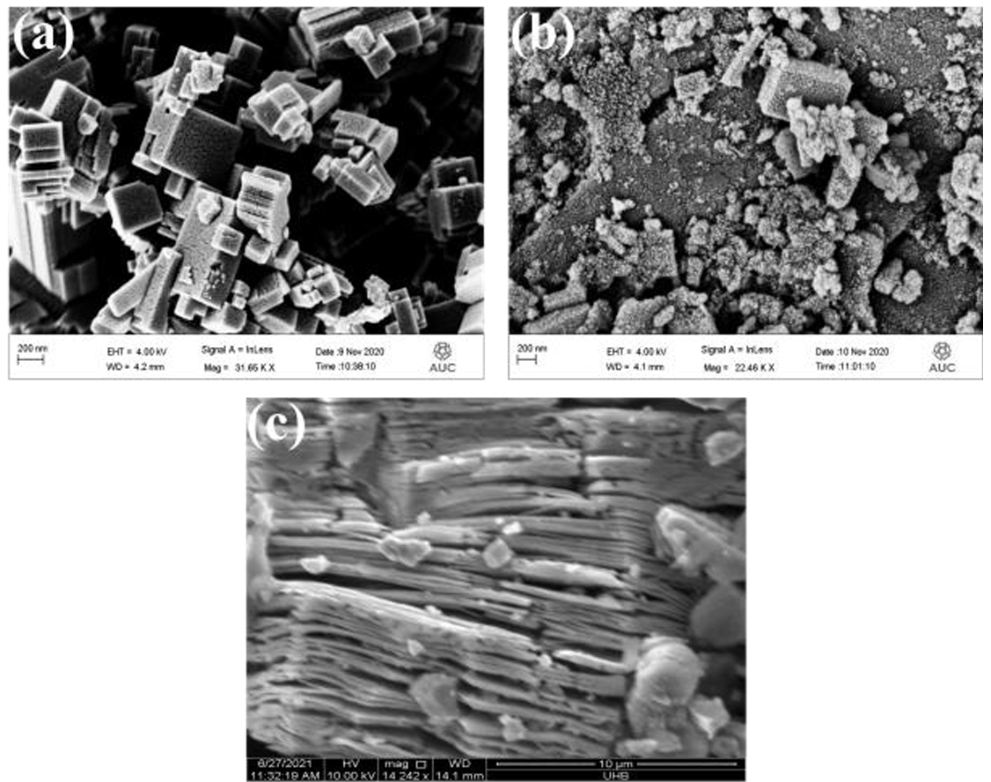

**Figure 2 - FESEM images (A) WO3, (b) WO3/MXene nanocomposite and (c) MXene [23]**

In this paper, A.Z. Warsi, Aziz, F. Zulfiqar et al. prepared WO3, MXene and WO3/MXene nanocomposite which showed potential applications in biological and environmental remediation. WO3, MXene and WO/Mxene nanocomposite were synthesized by hydrothermal method, wet chemical etching and sonication, respectively. XRD, XRD, FTIR, EDX and FESEM were used to determine the structural, spectral, elemental and morphological characteristics of the synthesized samples, respectively. BET analysis was performed to determine the surface area. The photocatalytic degradation of methylene blue using WO3, MXene and WO3/MXene nanocomposites was 99%, 54% and 89%, respectively. The photocatalytic activity of WO3 was significant. MXene is a two-dimensional material with very low photocatalytic activity, which acts only as an auxiliary material to enhance the photocatalytic ability of the composite with WO3.

The prepared samples also showed good antibacterial activity against bacteria of positive strain; in case of negative strains, WO3, MXene and WO3/MXene nanocomposite showed antibacterial activity at high concentrations [23].

*Bi2S3/MXene nanocomposite*

In a study [24] by S. Sinha, A. Raucci et al. developed a novel electrochemical sensing platform using Bi2S3/MXene nanocomposite. The modified shape, composition and electrical characteristics of the prepared composites and their electrodes were studied by various electrochemical methods SEM, XRD, XPS and others. A 1 mg/ml solution of Bi2S3/Mxene nanocomposite was prepared by dispersing DI (deionized) in water. This standard solution was the base of the electrode modification process. This initial solution base served as the electrode modification process. An 8 μL dispersion of Bi2S3/Mxene nanocomposites was carefully placed on the surface of SPE to modify the electrode. Bi2S3/Mxene nanocomposites were synthesized directly by microwave-assisted hydrothermal method. The figure below shows the accumulation of 3 - (A) [24] Bi2S3 nanoparticles. These are granular nanoparticles with diameters ranging from 70 to 100 nm. And figure 3 - (B) shows the MXene SPE image. This figure shows the complex layered lamellar structure of MXene after removing the Al layers from the MAX phase. SEM image of Bi2S3-MXene nanocomposites are shown in Fig.3C and 3D (small and large scale).

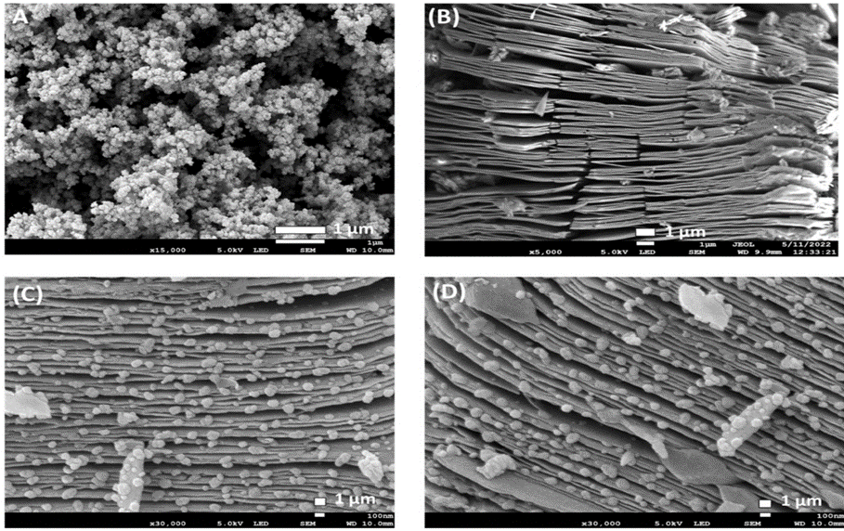

**Figure 3 - Structural characteristics of (A) Bi2S3; (B) MXene; (C) Bi2S3-MXene nanocomposite at low magnification; (D) Bi2S3-MXene nanocomposite at high magnification [24]**

The uniform growth of Bi2S3 nanoparticles in MXene layers growth of Bi2S3 nanoparticles (F and OH) was due to the presence of electronegative functional groups. The synergistic effect of Bi2S3 nanoparticles and MXene can improve the electrochemical performance. First, MXene provides a highly conductive platform for the uniform growth of Bi2S3 nanoparticles. This leads to reduced agglomeration of Bi2S3 nanoparticles and increased number of detection sites for the target analyte [25]. Secondly, MXene is highly conductive, which leads to an increase in charge between Bi2S3 nanoparticles and the electrolyte [26]. In addition, the oxidation resistance property demonstrated by MXene plays an important role in protecting Bi2S3 nanoparticles from corrosion [27]. The binding of MXene and Bi2S3 nanoparticles can lead to improved performance in Zn(II) detection.

*The study focuses on the synthesis of a composite made of MoO2@Mo2C-MXene.*

This article discusses the new CdS/MoO2 photocatalyst @Mo2C-MXene developed by You Jin, Huizhuan Jing, Libo Wang, Qianku Hu and Aigo Zhou. 0.2 g of NaBF4 (99.9%, McLean, China) was used as a guiding reagent, dissolved in 15 ml of 1.0 m HCl solution (36-38% C/a , Yantai Shuangshuang Chemical, China) and stirred for 30 minutes. The temperature of the hydraulic system is maintained at 180 ℃ for 24 hours every day. The temperature of the hydraulic system is kept at 180 ℃ for 24 hours every day. Subsequently, MoO2@Mo2C-MXene Composite powders were collected, subjected to washing with deionized water and ethanol to achieve a neutral reaction, and then dried for 12 hours at 60 ℃ for 12 hours under vacuum conditions.

CdS / MoO2@ Mo2C photocatalysts were effectively synthesized by a two-stage hydrothermal method . In this system, a sediment formed on the surface of the CdS MoO2@Mo2C-MXene Composite, forming an acanthospheric structure. CdS / MoO2@Mo2C(CMM5) showed an exceptional H2 generation rate of 22,672 µmol/(g-h) in visible light under optimal conditions, which is 11.8 times higher than CdS. full row, Moo2@Mo2C-MXene binary co-catalyst using CdS using high photocatalytic activity of productive H2 generation with Mo2C MXene as the only co-catalyst. Experimental effects the CdS/Mo2C system effects work with CdS /Mo2C with high photophysical and photoelectrochemical properties to serve as an electronic bridge between CdS and Mo2C MXene with improved electrical conductivity . "no," he said. In addition to the CdS/Mo2C script, the CdS conduction band (CB) is a place to charge when MoO2@Mo2C is MXene bound. This effectively limits the re - diffusion of Altered electrons into CdS , thus facilitating the operation of recombination. The band forbidden to control over CdS/MoO2@ Mo2C makes it easy to absorb visible light. This CdS/Mo2C [28] element restored a new photocatalytic system with the formation of a binary H2 co-catalyst.

The process of preparing Ti3C2 involves the use of various chemical and physical methods to create a highly durable and efficient material: The crude powder (50 g) was weighed in the following ratio TiC:Ti:Al = 3.6:1.4:1 and then placed in a Teflon ball mill. Anhydrous ethanol was then added to the ball mill tank as a ball grinding aid and zirconium dioxide (5 nm diameter) as a grinding medium. The mass ratio of raw material powder, anhydrous ethanol and pellets should be 1:1:3. The ball was placed in a grinding vessel and the powder mixture was pulverized at 300 rpm for 4 hours. Next, a ball mill was used to obtain a homogeneous mixture and then it was transferred into a petri dish. The mixture was dried in an oven at 40°C for 24 hours, then sintered in a corundum crucible without pressure.

After the reaction was completely completed, the sintering furnace was allowed to cool down naturally to room temperature and a Ti3AlC2 ceramic block was obtained by pressureless sintering. A high-energy ball mill was used to completely pulverize the Ti3AlC2 ceramic block obtained by pressureless sintering i+n the previous step; finally, the desired Ti3AlC2 powder was successfully obtained. At room temperature, 5 g of Ti3AlC2 powder was slowly added to 80 mL of 40 wt% HF and left to react for 24 h under magnetic stirring at 1200 rpm. The above corrosion products were purified with deionized water until the pH of the supernatant became > 6 after centrifugation. The substrate was lyophilized to obtain Ti3C2 powder.

Preparation of the PANI-Ti3C2 composite: first, 0.2 g of Ti3C2 powder was dispersed in 30 mL of 1M hydrochloric acid solution, then ultrasonic dispersion was carried out for 1 h until a homogeneous suspension was obtained. Second, 100 μL of pure aniline (ANI) obtained by distillation was added to the suspension and dispersed by ultrasonic dispersion for 1h. Then, 0.335 g of ammonium persulfate (APS) was dissolved in 30 mL of 1 M hydrochloric acid solution and added dropwise to the above solution. Finally, the solution was placed in an ice bath and stirred at 0°C for 6 hours. After reaction, the reaction product was washed with ultrapure water 5 times. After purification, the reaction product was lyophilized to obtain PANI-Ti3C2 nanocomposite [29].

Figure 1A shows the X-ray diffraction patterns of the obtained PANI, Ti3C2 and PANI-Ti3C2. The figure shows that the X-ray diffraction peak of PANI at 2 theta=20.5° corresponds to the surface (020) of the PANI crystal. The diffraction peak of Ti3C2 on the crystal plane (002) is shifted to the left along the x-axis from that of the original phase Ti3AlC2, which makes the characteristic peak of Ti3C2 weaker and wider.

This X-ray diffraction pattern can show that the degree of crystallinity and the degree of structural order of Ti3C2 are greatly reduced. In the X-ray radiograph of Ti3C2, the diffraction peaks at 2 theta =7.1°, 17°, 28°, 35°, 41° and 61° correspond to the crystal planes (002), (006), (008), ( 0010), (0012) and (110), respectively. Compared with the Ti3C2 XRD, the PANI-Ti3C2 XRD shows a new diffraction peak at 2 theta =20.7° corresponding to (020) crystal surface of PANI. The XRD peak of PANI-Ti3C2 at 2 theta =26° corresponds to TiO2. This value is due to the fact that a small amount of Ti3C2 is oxidized by the addition of ammonium persulfate, an oxidizing agent, during the preparation of the PANI-Ti3C2 composite material. Thus, the phase analysis shows the successful preparation of PANI-Ti3C2 nanocomposite. Ti3C2 can easily immobilize enzymes/proteins on its surface, thus acting as a promising support to achieve DET with accelerated electrode kinetics, low detection limits, and high sensitivity and selectivity [30].

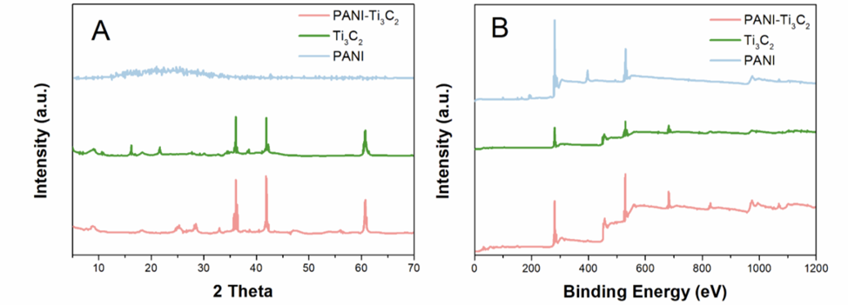

**Figure 4 - (A) XRD patterns of PANI, Ti3C2 and PANI-Ti3C2. (B) XPS spectras of PANI, Ti3C2 and PANI-Ti3C2 [30]**

Figure 1B shows the XRD spectra of the obtained PANI, Ti3C2 and PANI-Ti3C2. As can be seen from the figure, characteristic peaks C1s, O1s, F1s and Ti2p appear, proving the existence of Ti3C2. At the same time, the appearance of characteristic peaks O1s and F1s proves the existence of functional groups -O, -OH and -F on the laminates of Ti3C2. The appearance of C1s and N1s peaks indicates the successful obtaining of PANI. Compared with Ti3C2 , the broad XPS spectrum of PANI-Ti3C2 shows N1s peak, which further proves the successful preparation of PANI-Ti3C2 nanocomposites under low temperature stirring conditions. The above results are in agreement with the results of X-ray diffraction analysis. By the integral approximation method, N1s -analysis of the RFES spectra of the PANI-Ti3C2 nanocomposite showed four characteristic peaks at 397.1 eV, 398.2 eV, 400.1 eV and 400.5 eV corresponding to the imine structure (=NH-), amino group (-NH-). -), N atom (N-+) with positron and protonated amino group, respectively. The results show that the PANI-Ti3C2 nanocomposite was successfully obtained by low-temperature oxidation reaction between Ti3C2 and aniline.

*Ti3C2/TiO2/CuO nanocomposites*

In experiments, researchers Li, Wang, and Sun dissolved copper nitrate in deionized water and added Ti3C2 powder. The mixture was incubated for 24 hours, dried, and then synthesized into Ti3C2/TiO2/CuO nanocomposites by annealing in an argon atmosphere at 500C for 30 minutes at a heating rate of 100C/min [31].

The fabrication of Ti3C2/TiO2/CuO ternary nanocomposites, consisting of Ti3C2 nanosheets, TiO2, and CuO nanoparticles, was enhanced by higher electron and hole separation efficiency compared to TiO2, thereby improving their photocatalytic activity [32].

**Discussion and results.** In this research, a series of MXene-based nanocomposites including WO3/MXene, Bi2S3/MXene, and Ti3C2/TiO2/CuO were synthesized and characterized. The obtained materials showed high efficiency in various applications including photocatalytic decomposition of organic pollutants and electrochemical detection of heavy metals.

WO3/MXene:

* The morphology of the nanocomposite determined by FESEM revealed the presence of nanowires and layered structure.
* The photocatalytic activity for methylene blue degradation reach-ed 89%, which is higher than that of pure WO3 (99%) and significantly superior to that of MXene (54%).
* The nanocomposite demonstrated antibacterial activity against both positive and negative bacterial strains at high concentrations.

Bi2S3/MXene:

* The synergistic effect of Bi2S3 and MXene was found to improve electrochemical performance, increase the number of active sites for analytical detection, and improve corrosion resistance.
* The nanocomposite was successfully used for Zn(II) detection with high sensitivity.

Ti3C2/TiO2/CuO:

* The ternary nanocomposite showed enhanced photocatalytic activity due to the improved electron-hole separation ability.
* The enhanced photocatalytic efficiency was attributed to the presence of TiO2 and CuO, which enhanced the interaction with Ti3C2.

These results confirm the potential of MXene-based nanomaterials in applications related to ecological remediation, biosensing and environmental monitoring.

The results confirm the significant contribution of MXene-based nanocomposites in improving the properties of sensors and catalysts.

*Photocatalytic activity:*

The high efficiency of WO3/MXene in the photocatalytic decomposition of methylene blue can be explained by the combination of MXene (high conductivity) and WO3 (active catalytic ability) properties. This supports the hypothesis of a synergistic effect in the creation of hybrid nanomaterials. Similarly, Ti3C2/TiO2/CuO nanocomposite demonstrates that the addition of CuO enhances the charge separation ability, which is critical for photocatalysis.

*Electrochemical detection:*

Bi2S3/MXene showed high sensitivity to Zn(II), which is attributed to the increase of active centers on the surface of MXene and its interaction with Bi2S3. This result is in line with current research in electrochemistry, where MXene is used as a basic structure to improve the sensor response.

*Lim**itations and prospects:*

Despite significant advances, difficulties in scaling up the production of MXene nanocomposites should be considered. Additional research is required to optimize synthesis methods and material stability. Prospects for the use of these materials include expanding their applications in environmental monitoring, biomedicine, and water quality control.

Thus, the results of this study confirm the relevance and promise of MXene-based nanocomposites for the development of high-performance sensors and catalysts. Future research should focus on improving the stability and fabrication processes of these materials.

**Conclusion.** This literature review is devoted to the detection of heavy metals. Heavy metals are found in many substances. There are many methods for detecting heavy metals. Despite the large number of methods, we must use the most effective of them. The article is written about the detection of heavy metals using a sensor. In order to improve the sensor, various nanomaterials are used. As a material, Mxene-based nanocompasites were considered. Focused on MXene-based nanocomposites and sensor research methods developed on their basis. MXene materials are a stable single-phase structure consisting of five or more atoms, and its elemental ratio can be adjusted. MXene contains more transition metals, which greatly optimizes material properties such as conductivity, hardness, chemical stability, and bulk capacity.

**References**

1. Singovszka E., Balintova M., Junakova N. The Impact of Heavy Metals in Water from Abandoned Mine on Human Health//SN Applied Sciences.-2020.-Vol.2:934

 DOI 10.1007/s42452-020-2731-2

2. Munir N., Jahangeer M., Bouyahya A., El Omari N., Ghchime R., Balahbib A., Aboulaghras S., Mahmood Z., Akram M., Ali Shah S.M. Heavy Metal Contamination of Natural Foods Is a Serious Health Issue: A Review//Sustainability.-2022.-Vol.14(1),161. [DOI 10.3390/su14010161](https://doi.org/10.3390/su14010161)

3. Ali H., Khan E. Trophic Transfer, Bioaccumulation, and Biomagnification of Non-Essential Hazardous Heavy Metals and Metalloids in Food Chains/Webs-Concepts and Implications for Wildlife and Human Health//Human and Ecological Risk Assessment.-2018.-Vol. 25(6).-P.1353-1376 [DOI 10.1080/10807039.2018.1469398](https://doi.org/10.1080/10807039.2018.1469398)

4. Kumari P., Chowdhury A., Maiti S.K. Assessment of Heavy Metal in the Water, Sediment, and Two Edible Fish Species of Jamshedpur Urban Agglomeration, India with Special Emphasis on Human Health//Human and Ecological Risk Assessment.-2018.-Vol.24(7).-P.1-24

[DOI 10.1080/10807039.2017.1415131](https://doi.org/10.1080/10807039.2017.1415131)

5. Sharma S., Nagpal A.K., Kaur I. Appraisal of Heavy Metal Contents in Groundwater and Associated Health Hazards Posed to Human Population of Ropar Wetland, Punjab, India and its Environs//Chemosphere.-2019.-Vol. 227.- P.179 - 190. [DOI 10.1016/j.chemosphere.2019.04.009](https://doi.org/10.1016/j.chemosphere.2019.04.009)

6. Cheng S. Heavy metal pollution in China: Origin, pattern and control// Enviro nmental Science

and Pollution Research.-2003.-Vol.10.-P.192-198. [DOI 10.1065/espr2002.11.141.1](https://doi.org/10.1065/espr2002.11.141.1)

7. Zykova I., Maksimuk N., Rebezov M., Kuznetsova E., Derkho M., Sereda T., Kazhibayeva G., Somova Y., Zaitseva T. Interaction between Heavy Metals and Microorganisms during Wastewater Treatment by Activated Sludge//ARPN Journal of Engineering and Applied Sciences.-2020.-Vol.14(11).- P.2139–2145(2019).

8. Maria J.da Silva M, Paim A.P., I., Pimentel M.F., Cervera M.L., de la Guardia M. Determination of TOtal Mercury in Spanish Samples of Baby Food, Fast Food, and Daily Meal//Journal of the Brazilian Chemical Society.-2023.-Vol.34(4).-P.517-526. [DOI 10.21577/0103-5053.20220125](http://dx.doi.org/10.21577/0103-5053.20220125)

9. Qin G., Niu Z., Yu J., Li Z., Ma J., Xiang P. Soil heavy metal pollution and food safety in China: Effects, sources and removing technology//Chemosphere.-2021.-Vol.267:129205

[DOI 10.1016/j.chemosphere.2020.129205](https://doi.org/10.1016/j.chemosphere.2020.129205)

10. Liliana A.N., Gheorghe G., Elena T., Sonia A. Electrochemical sensors and biosensors: effective tools for detecting heavy metals in water and food with possible implications for children’s health//International Journal of Electrochemical Science, 19(2024). [DOI 10.1016/j.ijoes.2024.100643](https://doi.org/10.1016/j.ijoes.2024.100643)

11. Baranwal J., Barse B., Gatto G., Broncova G., Kumar A. Electrochemical Sensors and Their Applications: A Review//Chemosensors.-2022.-Vol.10(9):363.

[DOI 10.3390/chemosensors10090363](https://doi.org/10.3390/chemosensors10090363)

12. Sammer-ul H., Zhang X. Microfluidics as an emerging platform for tackling antimicrobial resistance (AMR): a review// Current Analytical Chemistry.-2020.-Vol.16 (1).-P. 41-51

DOI 10.2174/1573411015666181224145845

13. Pohanka M. Screen printed electrodes in biosensors and bioassays. A review// International Journal of Electrochemical Science.-2020.-Vol.15 (11).-P.11024-11035.

DOI 10.20964/2020.11.19

14. Ozcelikay G., Karadurmus L., Kaya S.I., Bakirhan N.K., Ozkan S.A. A review: new trends in electrode systems for sensitive drug and biomolecule analysis// Critical Reviews in Analytical Chemistry.-2020.-Vol.50(3).-P. 212-225(2020). DOI 10.1080/10408347.2019.1615406

15. Wang X., Kong L., Zhou S., Ma C., Lin W., Sun X., Kirsanov D., Legin A.,. Wan H, Wang P. Development of QDs-based nanosensors for heavy metal detection: a review on transducer principles and in-situ detection// Talanta.- 2022.-Vol.239. DOI [10.1016/j.talanta.2021.122903](https://doi.org/10.1016/j.talanta.2021.122903)

16. Shenashen M.A., Emran M.Y., El Sabagh A., Selim M.M., Elmarakbi A.,. El- Safty S.A. Progress in sensory devices of pesticides, pathogens, coronavirus, and chemical additives and hazards in food assessment: food safety concerns//Progress in Materials Science.-2020.-Vol. 124 DOI [10.1016/j.pmatsci.2021.100866](http://dx.doi.org/10.1016/j.pmatsci.2021.100866)

17. Huang W., Hu L., Tang Y., Xie Z., Zhang H. Recent Advances in Functional 2D MXene-Based Nanostructures for Next Generation Devices// Adv. Funct. Mater.- 2020.- Vol.30 (49).

DOI 10.1002/adfm.202005223

18. Zhou L., Zhang X., Ma L., Gao J., Jiang Y. Acetylcholinester ase/chitosan-transition metal carbides nanocomposites-based bio sensor for the organophosphate pesticides detection// Biochem. Eng. J.-2017.-Vol.128. P.243-249. [DOI 10.1016/j.bej.2017.10.008](https://doi.org/10.1016/j.bej.2017.10.008)

19. Hossein R., Golnoush T., Masoud S. MXene-Based Nanocomposite Sensors// ACS Omega.-2021.-Vol. Vol.6(17).- P.11103-11793[. DOI /10.1021/acsomega.0c05828](https://pubs.acs.org/doi/10.1021/acsomega.0c05828)

20. Garcia-Miranda Ferrari A., Carrington P., Rowley-Neale S.J., Banks C.E. Recent advances in portable heavy metal electrochemical sensing platforms, Envi- ron// Environmental Science: Water Research & Technology.-2020.-Vol. 6 (10).- P.2676-2690.DOI 10.1039/D0EW00407C

21. Amtul N., Kulamani P. A Glimpse on the plethora of applications of prodigious material MXene//Sustainable Materials and Technologies.-2022.-Vol.32: e00439

[DOI 10.1016/j.susmat.2022.e00439](https://doi.org/10.1016/j.susmat.2022.e00439)

22. Aadil M., Zulfiqar S., Shahid M., Haider S., Shakir I., Warsi M.F. Binder free mesoporous Ag-doped Co3O4 nanosheets with outstanding cyclic stability and rate capability for advanced supercapacitor applications//Journal of Alloys and Compounds.-2020.-Vol.844:156062

[DOI 10.1016/j.jallcom.2020.156062](https://doi.org/10.1016/j.jallcom.2020.156062)

23. Warsi A.-Z., Aziz F., Zulfiqar S., Haider S., Shakir I., Agboola P.O. Synthesis, Characterization, Photocatalysis, and Antibacterial Study of WO3, MXene and WO3/MXene Nanocomposite// Nanomaterials.-2022.-Vol.12(4): 713 DOI [10.3390/nano12040713](http://dx.doi.org/10.3390/nano12040713)

24.Sima S., Ada R., Wanda C., Arshid N., Mohammad K., Stefano C. Bismuth-MXene nanocomposite: A low-cost portable solution for zinc (II) detection in water for safer environmental monitoring//Sensors and Actuators B: Chemical.-2024. Vol 418:136219.

[DOI 10.1016/j.snb.2024.136219](https://doi.org/10.1016/j.snb.2024.136219)

25. Iqbal M.A., Tariq A., Zaheer A., Gul S., Ali S.I., Iqbal M.Z., Akinwande D., Rizwan S. Ti3C2-MXene/bismuth ferrite nanohybrids for efficient degradation of organic dyes and colorless pollutants//ACS Omega.-2019.-Vol. 4(24)-P.20530-20539. [DOI 10.1021/acsomega.9b02359](https://doi.org/10.1021/acsomega.9b02359)

26. Palei S., Murali G., Kim C.H., In I., Lee S.Y., Park S.J. A review on interface engineering of MXenes for perovskite solar cells//Nano-Micro Lett.-2023.-Vol.15(1):123

[DOI 10.1007/s40820-023-01083-9](https://doi.org/10.1007/s40820-023-01083-9).

27. Gogotsi Y., Anasori B. The Rise of MXenes//ACS Nano.-2019.-Vol.13(8).-P. 8491-8494.

[DOI 10.1021/acsnano.9b06394](https://doi.org/10.1021/acsnano.9b06394).

28. Sen J., Huijuan J., Libo W., Qianku H., Aiguo Z. Construction and performance of CdS/MoO2@Mo2C-MXene photocatalyst for H2 production// Journal of Advanced Ceramics.-2022.- Vol.11. -P.1431- 1444. [DOI 10.1007/s40145-022-0621-3](https://doi.org/10.1007/s40145-022-0621-3).

29. Haoliang C., Jurui Y. Preparation of Ti3C2-PANI Composite as Sensor for Electrochemical Determination of Mercury Ions in Water//International Journal of Electrochemical Science.-2020.- Vol.15(3).-P. 2295 – 2306. DOI 10.20964/2020.03.24

30. Sinha A., Dhanjai, Zhao H., Huang Y., Lu X., Chen J., Jain R. MXene: An emerging material for sensing and biosensing//TrAC Trends in Analytical Chemistry.-2018.-Vol.105.-P. 424-435 DOI [10.1016/j.trac.2018.05.021](http://dx.doi.org/10.1016/j.trac.2018.05.021)

31. Li Z.Y., Wang L.B., Sun D.D. Synthesis and thermalstability of two-dimensional carbide MXene Ti3C2//[Materials Science and Engineering](https://www.researchgate.net/journal/Materials-Science-and-Engineering-B-0921-5107?_tp=eyJjb250ZXh0Ijp7ImZpcnN0UGFnZSI6InB1YmxpY2F0aW9uIiwicGFnZSI6InB1YmxpY2F0aW9uIn19) B- 2015.-Vol.191.- P.33-40.

DOI [10.1016/j.mseb.2014.10.009](http://dx.doi.org/10.1016/j.mseb.2014.10.009)

32. Yang L., Meihuan Y., Aiguo Z., Qianku H., Libo W. Preparation and Photocatalytic Performance of Ti3C2/TiO2/CuO Ternary Nanocomposites// Journal of Nanomaterials.-2017.-Vol.2017. P.1-5 DOI 10.1155/2017/1978764

***Information about the authors***

Konarbay D.B. **-** Doctoral student at the Kazakh National Pedagogical University named after Abay, Almaty, Kazakhstan,e-mail: [konarbay98@bk.ru](mailto:konarbay98@bk.ru);

Bakytkarim Y. **-** Doctor Ph.D, Abai Kazakh National Pedagogical University, Almaty, Kazakhstan, e-mail: [Rysgul_01_88@mail.ru](mailto:Rysgul_01_88@mail.ru);

Mukatayeva Zh.-Can****didate of Chemical Sciences, Associate Professor, Abai Kazakh National Pedagogical University, Almaty, Kazakhstan, e-mail: [zh.mukatayeva@abaiuniversity.edu.kz](mailto:zh.mukatayeva@abaiuniversity.edu.kz);

Shadin N.A **-** Doc****tor Ph.D, Senior Lecturer of the Department of Chemistry, Abai Kazakh National Pedagogical University, Almaty, Kazakhstan, e-mail: nugen_87@mail.ru;

Kozhagulova Zh.R. **-** Senior Lecturer of the Department of Chemistry, Abai Kazakh National Pedagogical University, Almaty, Kazakhstan, e-mail: [karazhanova71@mail.ru](mailto:karazhanova71@mail.ru);

Karazhanova D.A. **-** Senior Lecturer of the Department of Chemistry, Abai Kazakh National Pedagogical University, Almaty, Kazakhstan, e-mail: [Kozhagulova.zh@gmail.com](mailto:Kozhagulova.zh@gmail.com)

***Сведения об авторах***

Конарбай Д.Б.– докторант Казахский Национальный Педагогического им. Абая, Алматы, Казахстан, e-mail: [konarbay98@bk.ru](mailto:konarbay98@bk.ru);

Бакыткарим Ы**.** – доктор PhD, старший преподаватель кафедры химии Казахского национального педагогического университета им. Абая, Алматы, Казахстан. e-mail: [Rysgul_01_88@mail.ru](mailto:Rysgul_01_88@mail.ru);

Мукатаева Ж.С.– кандидат химических наук, ассоциированный профессор, заведующий кафедрой химии Казахского национального педагогического университета им. Абая, Алматы, Казахстан. e-mail: [zh.mukatayeva@abaiuniversity.edu.kz](mailto:zh.mukatayeva@abaiuniversity.edu.kz);

Шадин Н.А.– доктор PhD, старший преподаватель кафедры химии Казахского национального педагогического университета им. Абая, Алматы, Казахстан. e-mail: nugen_87@mail.ru;

Кожагулова Ж.Р. - старший преподаватель кафедры химии Казахского национального педагогического университета им. Абая, Алматы, Казахстан. e-mail: [karazhanova71@mail.ru](mailto:karazhanova71@mail.ru);

Каражанова Д.А. старший преподаватель кафедры химии Казахского национального педагогического университета им. Абая, Алматы, Казахстан. e-mail: [Kozhagulova.zh@gmail.com](mailto:Kozhagulova.zh@gmail.com)

IRSTI 61.01.91

**TESTING A NEW TECHNOLOGY OF PROCESSING COPPER ELECTROLYTE**

**TO OBTAIN NICKEL SULFATE**

**1Kh.B. Omarov**[ircid icon](https://orcid.org/0000-0003-2931-652X)**, 1N.U. Nurgaliyev**[ircid icon](https://orcid.org/0000-0001-9171-2238)**, 4A.S. Mostovoy**[ircid icon](https://orcid.org/0000-0003-2828-9988)**, 2Z.B. Absat**[ircid icon](https://orcid.org/0000-0001-5980-911X)**,   
2S.K. Aldabergenova**[ircid icon](https://orcid.org/0000-0002-4262-911X)**, 1Zh.T. Nurtai**[ircid icon](https://orcid.org/0000-0002-0744-0389)**, 1E.B. Zhunussova**[ircid icon](https://orcid.org/0000-0002-9844-6291)**, 1A.K. Zhumabekova**[ircid icon](http://orcid.org/0000-0001-6743-8953)**,  
3М.А. Issabayeva**[ircid icon](https://orcid.org/0000-0002-8119-3865)

*1Kazakh University of Technology and Business named after K. Kulazhanov, Astana, Kazakhstan,*

*2Karaganda State University named after E.A. Buketov, Karaganda, Kazakhstan,*

*3Toraighyrov university, Pavlodar, Kazakhstan,*

*4Saratov State Technical University named after Y.Gagarin, Saratov, Russia*

Corresponding author’s: [homarov1963@mail.ru](mailto:homarov1963@mail.ru); [nurgaliev_nao@mail.ru](mailto:nurgaliev_nao@mail.ru)

Complex processing of electrolyte is one of the priority tasks of copper producers. In this work, in order to obtain high-quality copper products and nickel sulfate, the following methods were used: neutralization, demineralization, extraction of impurities (As, Sb, Bi) with pseudo-brookite, additional oxidation of iron to trivalent, neutralization of the solution with nickel carbonate with the release of insoluble compounds of copper, iron and zinc and crystallization of nickel sulfate. The advantage of using basic copper sulfate as a neutralizing agent is the prevention of contamination of the electrolyte with foreign components, as well as its high chemical activity. The quantities required of basic copper sulfate for the implementation of the technology are formed at subsequent stages of processing. High-quality copper sulfate is obtained. Basic copper sulfate is also a raw material for obtaining copper oxide. The removal of such impurities as arsenic, antimony and bismuth is carried out using pseudo-brookite as their extractant. To prevent the ingress of divalent iron into the products, it was oxidized to trivalent by introducing calculated amounts of hydrogen peroxide. The working solution was purified from iron, zinc and residual copper by introducing phosphoric acid and nickel carbonate. Nickel sulfate was isolated from the solution by crystallization, its average yield was 71.6%. Identification of intermediate and target products was carried out by IR spectroscopy and laser atomic emission spectroscopy. The test results showed the efficiency of this method of processing copper electrolyte, aimed at expanding the range of products based on copper and nickel.

**Keywords:** copper electrolyte, pseudobrookite, nickel sulfate, deep decontamination, copper sulfate, neutralization, crystallization

**НИКЕЛЬ СУЛЬФАТЫН АЛУ ҮШІН МЫС ЭЛЕКТРОЛИТІН ҚАЙТА ӨҢДЕУДІҢ ЖАҢА ТЕХНОЛОГИЯСЫН СЫНАУ**

**1Х.Б. Омаров, 1Н.У. Нургалиев, 4А.С. Мостовой, 2З.Б. Абсат, 2С.К. Алдабергенова,   
1Ж.Т. Нұртай, 1Э.Б. Жунусова, 1А.К. Жумабекова, 3М.А. Исабаева**

*1Қ.Құлажанов атындағы технология және бизнес университеті, Астана, Қазақстан,*

*2Е.А. Бөкетов атындағы Қарағанды университеті ұлттық, Қарағанды, Қазақстан,*

*3Торайғыров университеті, Павлодар, Қазақстан,*

*4Ю.А. Гагарин атындағы Саратов мемлекеттік техникалық университеті, Саратов, Ресей,*

*e-mail:* [*homarov1963@mail.ru*](mailto:homarov1963@mail.ru)*;* [*nurgaliev_nao@mail.ru*](mailto:nurgaliev_nao@mail.ru)

Электролитті кешенді өңдеу мыс өндірушілердің басым міндеттерінің бірі болып табылады. Бұл жұмыста жоғары сапалы мыс өнімдері мен никель сульфатын алу үшін келесі әдістер қолданылды: бейтараптандыру, мыссыздандыру, қоспаларды (As, Sb, Bi) псевдобрукитпен экстракциялау, темірді үш валентті темірге дейін тотықтыру, темір, мырыш және мысты ерімейтін қосылыстар түрінде шығару үшін ерітіндіні никель карбонатымен бейтараптандыру және никель сульфатын кристалдандыру. Бейтараптандырушы реагент ретінде негізгі мыс сульфатын пайдаланудың артықшылығы электролиттің бөгде компоненттермен ластануын болдырмау, сонымен қатар оның жоғары химиялық белсенділігі болып табылады. Технологияны жүзеге асыруға оның қажетті мөлшерлері өңдеудің келесі кезеңдерінде қалыптасады. Жоғары сапалы мыс купоросын өндіруді қамтамасыз етеді. Негізгі мыс сульфаты да мыс оксидін алу үшін шикізат болып табылады. Мышьяк, сурьма және висмут сияқты қоспаларды жою үшін экстрагент ретінде псевдобрукитт қолданылды. Екі валентті темірдің өнімдерге енуіне жол бермеу үшін оны сутегі асқын тотығының есептік мөлшерін енгізу арқылы үш валентті темірге дейін тотықтырдық. Жұмыс ерітіндісін темірден, мырыштан және мыс қалдықтарынан тазартуға фосфор қышқылы мен никель карбонатын енгізу арқылы қол жеткізілді. Никель сульфаты ерітіндіден кристалдану арқылы бөлініп алынды, оның орташа шығымы 71,6% құрады. Аралық және мақсатты өнімдерді анықтау ИҚ-спектроскопия және лазерлік атомдық эмиссиялық спектроскопия көмегімен жүзеге асырылды. Сынақ нәтижелері мыс пен никель негізіндегі өнімдердің ассортиментін кеңейтуге бағытталған мыс электролитін өңдеудің бұл әдісінің тиімділігін көрсетті.

**Түйін сөздер:** мыс электролиті, псевдобрукит, никель сульфаты, мыс электролитін терең мыссыздандыру, мыс купоросы, бейтараптау, кристаллдау.

**ИСПЫТАНИЕ НОВОЙ ТЕХНОЛОГИИ ПЕРЕРАБОТКИ МЕДНОГО ЭЛЕКТРОЛИТА ДЛЯ ПОЛУЧЕНИЯ СУЛЬФАТА НИКЕЛЯ**

**1Х.Б. Омаров, 1Н.У. Нургалиев, 4А.С. Мостовой, 2З.Б. Абсат, 2С.К. Алдабергенова,   
1Ж.Т. Нұртай, 1Э.Б. Жунусова, 1А.К. Жумабекова, 3М.А. Исабаева**

*1Казахский университет технологии и бизнеса им. К.Кулажанова, Астана, Казахстан,*

*2Карагандинский государственный университет им. Е.А. Букетова, Караганда, Казахстан,*

*3Торайгыров университет, Павлодар, Казахстан,*

*4Саратовский государственный технический университет имени Ю.А. Гагарина, Саратов, Россия,*

*e-mail: homarov1963@mail.ru;* [*nurgaliev_nao@mail.ru*](mailto:nurgaliev_nao@mail.ru)

Комплексная переработка электролита одна из приоритетных задач производителей меди. В данной работе с целью получения качественной медной продукции и сульфата никеля использованы метод нейтрализации, обезмеживание, экстракция примесей (As, Sb, Bi) псевдобрукитом, доокисление железа до трехвалентного, нейтрализация раствора карбонатом никеля с выделением нерастворимых соединений меди, железа и цинка и кристаллизации сульфата никеля. Преимуществом использования основного сульфата меди в качестве нейтрализующего реагента является недопущение загрязнения электролита посторонними компонентами, а также его высокая химическая активность. Необходимые его количества для реализации технологии образуются на последующих стадиях переработки. Обеспечивается получение качественного медного купороса. Основной сульфат меди является также сырьем для получения оксида меди. Вывод таких примесей, как мышьяк, сурьма и висмут осуществлен применением псевдобрукита в качестве их экстрагента. Для предупреждения попадания двухвалентного железа в продукты, его окисляли до трехвалентного введением расчетных количеств пероксида водорода. Очистка рабочего раствора от железа, цинка и остаточного содержания меди достигалась введением фосфорной кислоты и карбоната никеля. Сульфат никеля выделен из раствора методом кристаллизации, его средний выход составил 71,6%. Идентификация промежуточных и целевого продуктов проведена методами ИК-спектроскопии и лазерной атомно-эмиссионной спектроскопии. Результаты испытаний показали эффективность данного способа переработки медного электролита, направленной на расширение ассортимента продукции на основе меди и никеля.

**Ключевые слова:** медный электролит, псевдобрукит, сульфат никеля, глубокое обезмеживание, медный купорос, нейтрализация, кристаллизация

**Introduction.** Processed technological solutions of electrolytic refining of copper contain significant amounts of copper and nickel sulfates, sulfuric acid, arsenic and other components of copper electrolyte. To avoid the concentration of impurities in the electrolyte, part of the working solution is removed from the process for processing. The process of processing copper electrolyte is aimed at creating conditions for the selective release of harmful and undesirable impurities and ensuring the effective separation of valuable components for their further use in the technological cycle of copper production and obtaining marketable products. Analysis of existing developments [1-11] indicates a number of significant shortcomings in the known technological developments for the removal of arsenic from copper electrolyte and further processing of the solution, such as contamination of the electrolyte with foreign components, loss of copper in the form of copper-arsenate cakes, etc., due to which some of the proposed technologies have not been implemented.

To eliminate copper losses and obtain nickel sulfate, we have developed a new method for processing copper electrolyte [12]. The electrolyte processing process consists of four main stages, followed by vacuum filtration and crystallization of the final product:

- neutralization and deep de-copperization of copper electrolyte;

- extraction of arsenic, antimony and bismuth into the solid phase with pseudobrookite;

- additional oxidation of ferrous iron to ferric;

- deep neutralization of the working solution of carbon nickel with the release of insoluble compounds, iron and zinc, and crystallization of nickel sulfate.

According to the technological scheme, the process of processing copper electrolyte with obtaining nickel sulfate as a target product consists of four main stages:

This stage is carried out under the conditions accurately determined by the authors [12, 13]. The copper electrolyte is preliminarily diluted with water by two times. The latter neutralization is carried out by introducing a copper (II) oxide weighed portion in a molar ratio of CuO : Cu = 3:1 with constant stirring for four hours at a temperature of 980С. The basic copper sulphate formed after separation is used to neutralize the electrolyte following portions. This operation is carried out at a temperature of 850С with constant stirring for 15 minutes until the pH 1.3-1.5 reached. The basic copper sulfate is taken in a molar ratio to sulfuric acid of 2:1. Electrolyte samples are taken throughout the experiment and the solution pH is determined until the required value is reached.

The resulting copper-nickel mother liquors are re-diluted with water 2 times and subjected to deep de-curing with copper (II) oxide (CuO:Cu = 3:1) at 980С for four hours with constant stirring.

2. The arsenic, antimony and bismuth extraction into the solid phase with the help of pseudobrukite is carried out in accordance with the method developed by us earlier [14].

The process is carried out in a thermostated cell at a temperature of 600С with a given sulfuric acid concentration at constant stirring for one hour. A pseudobrukite weighed portion is taken equal to the ratio of the precipitant to arsenic 1:1 and served in two portions (the precipitant (DRP) dosage ratio is equal to 2). The hot solutions are then filtered out. The precipitate is separated from the resulting solution.

3. Additional oxidation of ferrous iron to ferric iron is carried out according to the conditions strictly specified by the authors [15]: a 50% solution of hydrogen peroxide is used as an oxidizing reagent, which is introduced into solutions at a temperature of 550С, the oxidation process takes 1 hour with constant stirring. The amount of hydrogen peroxide required to oxidize all Fe2+ ions to Fe3+ is calculated from the reaction equation:

H2O2 + Fe2++ H2→ Fe3+ + 2H2O (1)

4. Deep neutralization of the working solution with nickel carbonate with the release of insoluble compounds of copper, iron and zinc, and crystallization of nickel sulfate.

Before deep neutralization of the electrolyte with nickel carbonate, it is necessary to transfer iron, zinc and the residual content of copper in solutions into a solid phase.

For this purpose, an 87% solution of orthophosphoric acid in a predetermined amount is injectedinto the working solutions. Orthophosphoric acid in a stoichiometric ratio is injected to bind impurities into sparingly soluble phosphates according to the reaction equation:

3Me2+ + 3NiCO3+ 2H3PO4 → Me3 (PO4)2↓ + 3Ni2+ + 3CO2↑+ 3H2O (2)

whereas – Me2+- ions Cu2+and Zn2+.

With the participation of the Fe3+ ion, the reaction proceeds according to the following equation:

2Fe3+ + 3NiCO3+ 2H3PO4 → 2FePO4↓ + 3Ni2+ + 3CO2↑+ 3H2O (3)

Then the solutions are heated to 850С with stirring. Water is added in an amount calculated from the reaction equation and heated further to 900С. A nickel carbonate predetermined amount is added to the heated solutions in portions.

The solutions are constantly stirred and maintained at a temperature of 900С for one and a half hours. When adding each portion, it is necessary to take a sample and measure the solutions pH. Measurements of pH are carried out until the value of 5.5-5.9 is set. With each pH measurement, the samples are cooled to a temperature of 23-250C. Then the solutions are maintained at a temperature of 900С. The authors of [15] found required conditions under which precipitates of iron, copper and zinc insoluble salts are formed, namely pH = 5.5-5.9.

At the process end, the solutions are subjected to vacuum filtration in a hot state. Unreacted nickel carbonate as well as copper, iron and zinc salts insoluble precipitates remain on the filter. The solutions pH is brought to values of ≈ 1.99-2.02 with the help of adding the calculated amounts of concentrated sulfuric acid. The authors of [15] established that this pH limit is the conditions under which the nickel sulfate crystallization occurs. Further, the investigated solutions are cooled to a temperature of 20-230С and left to stay aside for the nickel sulfate crystallization.

The purpose of this work is to test a new technology of processing of copper electrolyte with the removal of copper in the form of products assalts and hydroxides in large-scale laboratory conditions, and obtain a new product - nickel sulfate in accordance with the technological scheme developed by us (Figure 1).

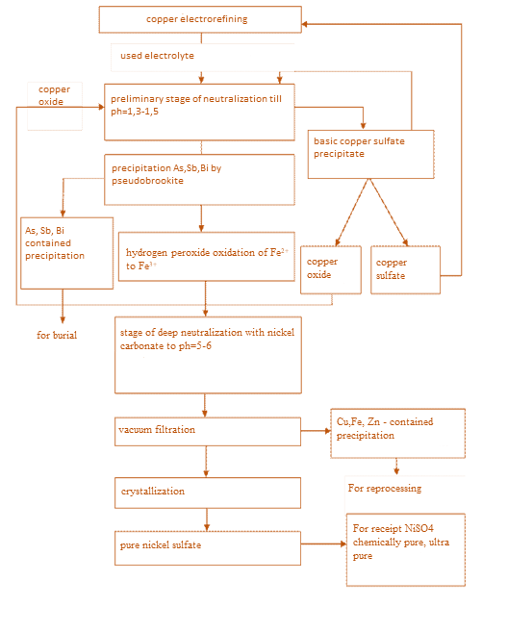

**Fig. 1 -Technological scheme of the integrated processing of copper electrolyte to obtain nickel sulfate**

**Materials and methods.**The object of large-scale laboratory tests is the technological copper-containing sulfuric solution of the corporation "KAZAKHMYS SMELTING" (Republic of Kazakhstan, city of Balkhash). The quantitative content of the main components of the process solution (Cu, Ni, H2SO4, As, Sb, Bi, Fe, Zn) was determined on a SPEKS SSP-705-4 scanning spectrophotometer, as well as on a laser atomic emission spectrometer SPEKS LAES MATRIX CONTINUUM (Closed Joint Stock «Company Spectroscopic Systems» Russian Federation, 2016) , the results of which are presented in Table 1.

Large-scale laboratory tests were carried out with a volume of the working solution equal to 500 ml.

**Table 1 - Electrolytecomposition**

|  |  |  |  |  |  |  |  |  |
| --- | --- | --- | --- | --- | --- | --- | --- | --- |
| Component | Cu | Ni | H2SO4 | As | Sb | Bi | Fe | Zn |
| g/l | 51.20 | 16.98 | 95.88 | 14.04 | 8.63 | 5.78 | 9.42 | 9.17 |

**Results and discussion.** Based on known methods for processing copper electrolyte [12,14], 500 ml of water was added to a copper electrolyte with a volume of 500 ml, and treated with 96 g of copper (II) oxide in a molar ratio CuO:Cu = 3:1. The reaction mass was heated in a thermostated cell to 980С with constant stirring for four hours. The solution volume was decreased by 2 times at the end of the neutralizing process. The solution was filtered in a hot state, resulting in a precipitate of basic dark green copper sulfate weighing 406.59 g on the filter. Further, basic copper sulfate obtained in an amount of 348.3 g was used for subsequent neutralization of copper electrolyte with a volume of 500 ml for each experiment.

The neutralization of free sulfuric acid was carried out for 15 min in a thermostated cell at a temperature of 850С. The solution pH was monitored during the experiment until its values reached 1.31. Hot solutions were subjected to vacuum filtration, and then cooled to a temperature of 200С. Copper sulfate weighing ≈ 43.8 g was obtained in each experiment. The solutions were analyzed for the residual content of sulfuric acid, copper, nickel, and arsenic. The average values of the investigation results are shown in Table 2.

**Table 2 - Results of the copper electrolyte neutralization process**

**(Cu3(OH)4SO4:H2SO4) = 2:1; t = 850С; τ = 15 min)**

|  |  |  |  |  |  |
| --- | --- | --- | --- | --- | --- |
| рН of working solution | | H2SO4(g/l) | Cu(g/l) | Ni(g/l) | As(g/l) |
| Before experiment | After experiment |
| 0.08 | 1.31 | 2.79 | 31.0 | 16.70 | 14.03 |

The obtained copper-nickel mother liquors were re-diluted with water 2 times and subjected to de-curing with copper (II) oxide. Width of the confidence interval according to the Cochran criterion for copper content = 0.18 = 2.

The resulting basic copper sulfate weighing 24.99 g was used to neutralize the next portion of the electrolyte. The main copper sulfate is also a raw material for the production of copper oxide, copper sulfate. The resulting solutions, after neutralization and de-curing of the electrolyte, were analyzed for the residual content of sulfuric acid, copper, nickel, and arsenic. The average values of the analysis results are shown in Table 3.

**Table 3 -** **Copper electrolyte dressing from copper results   
(CuO:Cu= 3:1; t = 980С; τ = 4 hour)**

|  |  |  |  |  |  |  |  |
| --- | --- | --- | --- | --- | --- | --- | --- |
| рН of working solution | | H2SO4(g/l) | Cu(g/l) | | | Ni(g/l) | As(g/l) |
| Before experiment | After experiment | Before experiment | | After  experiment |
| 1.31 | 2.37 | 0.21 | 31.0 | 0.79 | | 16.5 | 14.01 |

Copper-bearing sediments were identified by IR spectroscopic analysis (Figure 2). According to reference data [15], intense absorption bands at 1106-1366 cm-1 and 451-621 cm-1 are related to the sulfate ion. Also, a band in the region of 3140 - 3433 cm-1 is characteristic of stretching vibrations of OH-groups, and absorption bands at 1340-1627 cm-1 associated with the presence of water molecules in a highly hydrated sediment. Based on the data of the IR spectra of the precipitate and the results of photometric analysis for copper, it was established that the resulting precipitate is the main copper sulfate Cu3(OH)4SO4.

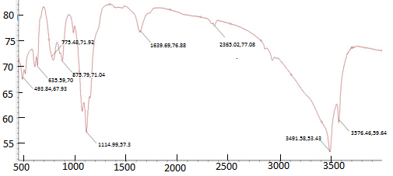

**Fig. 2 - IR spectrogram of a copper-bearing precipitate**

Additionally, the analysis for the content of impurities in the resulting sediment was carried out on a laser atomic emission spectrometer SPEX LAES MATRIX CONTINUUM (Figure 3). As can be seen from the spectrogram, intense green peaks are observed, which correspond to copper ions. The presence of such impurities as iron, zinc, arsenic, antimony, bismuth in the composition of the precipitate is not observed on the spectrogram. Thus, the resulting basic copper sulfate does not contain foreign impurities of other metals and is a chemically pure compound.

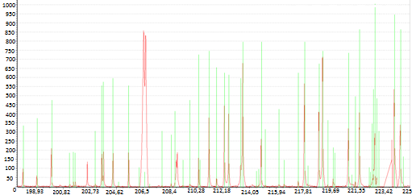

**Fig. 3 ‒ Laser spectrogram of copper-bearing sediment**

The deposition of arsenic, antimony and bismuth with pseudobrookite was carried out in a thermostated cell at a temperature of 600С, with a given concentration of sulfuric acid with constant stirring for one hour. We used the resulting solutions with a volume of 182 ml each. A weighed portion of pseudobrookite was taken equal to the ratio of the precipitant to arsenic 1:1 in the amount of 14.01 g and fed in two portions (DRP= 2). Then the solution was filtered while hot, the resulting filtrates with a volume of 165 ml were analyzed for the residual arsenic content, antimony and bismuth in them. The results of analyzes for the residual content of antimony, bismuth arsenic, shown in Table 4, showed that their content in solutions is reduced to trace amounts, i.e., the resulting solutions are almost completely purified from them.

For the oxidation of Fe2+ ions to Fe3+, 3.1 ml of hydrogen peroxide was introduced into solutions with a volume of 158 ml of each experiment. Then the solutions were stirred for one hour in a thermostated cell at a temperature of 50-550С. At the end of the experiments, the solutions were cooled and analyzes were carried out for the total iron content and for Fe3+, the results of all analyzes of the experiments were averaged (g/l): C(Fetot) = 6,035; C(Fe3+) = 6,030. Under these conditions, complete oxidation of Fe2+toFe3+ions is achieved.

In order to purify working solutions from ions of copper, iron, zinc (C(Zn2+) = 6.7 g/l; C(Fe3+) = 6.03 g/l; C(Cu2+) = 0.79 g/l) a solution of phosphoric acid in the amount of 13.8 mlwere added in them.

Then the solutions were heated with stirring to 850С, added H2O in an amount of 25.5 ml, and the solutions were heated to 900С. Nickel carbonate weighing 12.62 g was added to the heated solution in portions. The solutions were constantly stirred and kept at a temperature of 900С for 1.5 hours. With the addition of each portion of nickel carbonate, a sample was taken and the pH of the solutions was measured. Nickel carbonate was added until a pH of about 5.98 was reached.

Insoluble precipitates and unreacted nickel carbonate were separated by vacuum filtration. 0.1 ml of concentrated sulfuric acid was added to the filtrate, after the addition of which the pH of the solutions reached a value of ≈ 2.39.

At the end of the process, the solution was subjected to vacuum filtration while hot. Insoluble sediments weighing 2.19 g remained on the filter. Then the test solution was cooled to a temperature of 20-230С. Crystals of nickel sulfate began to grow in the solution on the seventh day. The crystals were separated from the working solution by filtration, washed with distilled water, dried, and weighed. As a result, we got 66.35 g heptahydrate nickel sulfate, on average in each experiment.

**Table 4 ‒ The results of the precipitation of arsenic, antimony and bismuth by**

**pseudobrookite(*t =* 60 0C; *τ =* 1 hour; DRP= 2)**

|  |  |  |  |  |  |  |  |
| --- | --- | --- | --- | --- | --- | --- | --- |
| №  Experiment | Fe2TiO5:As | Concentration after experiment, (g/l) | | | Degree of precipitation, % | | |
| As | Sb | Bi | As | Sb | Bi |
| 1 | 0.5:1 | 0.070 | 0.0023 | 0.0011 | 99.15 | 99.85 | 99.88 |
| 2 | 0.8:1 | 0.032 | 0.0016 | 0.0005 | 99.67 | 99.89 | 99.90 |
| 3 | 1:1 | Traces | Traces | Traces | 99.99 | 99.99 | 99.99 |
| 4 | 1.2:1 | Traces | Traces | Traces | 99.99 | 99.99 | 99.99 |
| 5 | 1.5:1 | Traces | Traces | Traces | 99.99 | 99.99 | 99.99 |

Calculated the average yield of the target product of nickel sulfate. The theoretical mass of the target product according to calculations from the reaction equations:

NiCO3→ NiO +CO2↑ (4)

NiO + H2SO4 → NiSO4 + H2O (5)

NiSO4 + 7H2O → NiSO4 ∙ 7H2O (6)

was 92.59 g. The average yield of the target product of nickel sulfate was 71.66% of the theoretically possible.

Analysis of the obtained IR spectra of nickel sulfate crystals (Figure 4) confirmed the absence of copper, iron and zinc impurities in nickel sulfate crystals. In the figure, one can see intense bands at 1106-1366 cm-1 and 451-621 cm-1, which corresponds to the absorption bands of sulfate ions; in addition, bands are observed in the region of 1340-1670 cm-1, characteristic of the presence of crystallized water in a highly hydrated sediment. It is also possible to observe low-intensity absorption bands in the region of 3440-3470 cm-1 characteristic of stretching vibrations of OH-groups, and an insignificant absorption band at 2830-2850 cm-1related to the carbonate ion [15]. That is, the obtained crystals were confirmed to be nickel sulfate (NiSO4∙7H2O).

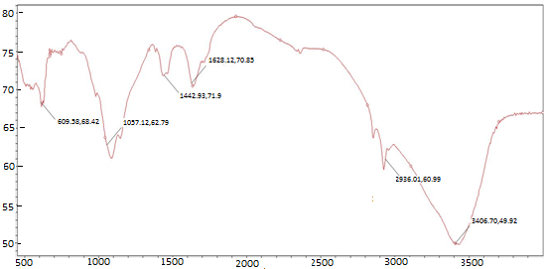

**Fig. 4 - IR spectra of crystals of the obtained nickel sulfate**

The nickel sulfate obtained as a result of large-scale laboratory tests, as noted earlier, does not contain metal impurities, and can be used as a raw material for obtaining nickel sulfate of reagent grade, special grade, which in turn confirms the technological significance of the tests carried out and the effectiveness of the technological scheme of the new technology for processing copper electrolyte (Figure 1).

**Conclusion.** The large-scale laboratory tests have shown the efficiency of the new technology of processing copper electrolyte and the possibility, along with obtaining marketable copper products: basic copper sulfate, copper oxide, copper sulfate, to expand the range of products of vitriol processing based on nickel - nickel sulfate.The results of large-scale laboratory tests can serve as initial data for planning and conducting subsequent production tests of a new technology of processing copper electrolyte.

**References**

1. Wang, Biao Liu , Xue-wen Wang , Yu-qi Meng , Xing-ming Wang , Ming-yu Wang Separation and recovery of Ni from copper electrolyte by crystallization of nickel ammonium sulfate double salt //Transactions of nonferrous metals. -Sociaty of China, 2022.- Vol. 32(11).- P. 3780-3789. DOI [10.1016/S1003-6326(22)66057-6](http://dx.doi.org/10.1016/S1003-6326(22)66057-6).
2. **Kholikulov D.B., Abdurahmonov S., Boltaev O.N., Matkarimov S.T.** Separation of metals from technological solutions. Copper production //International Journal of Emerging Trends in Engineering Research*.-* 2020. - Vol. 8(7). - P. 3557-3561. DOI 10.30534/ijeter/2020/110872020

3.Sokolov A.Ju., Shhelokova E. A., Voroncov K. A., Kasikov A. G. Kompleksnaja pererabotka otrabotannogo mednogo jelektrolita//Trudy Kol'skogo nauchnogo centra RAN.-2023.- T. 14(1) - S. 229-233. DOI 10.37614/2949-1215.2023.14.1.041. [in Russian]

4.Narembekova A., Tokenova Z.Sh. Al'ternativnaja tehnologija pererabotki med'soderzhashhih rastvorov//Trudy universiteta.- 2020. -№3 (80).- S.34-38. DOI 10.52209/1609-1825_2020_3_33.

[in Russian]

5.Kholikulov D., Boltaev O. Separation of Copper from Technological Solutions to the Production of Copper Sulphate // International Journal of Advanced Research in Science, Engineering and Technology. -2020. -Vol. 7(1). -P. 12626-12631.

6.Deng Z., Oraby E., Li H., Eksteen J. Extraction of Copper from Chalcopyrite Using Alkaline Glycine–Ammonia Solutions//Minerals.-2022.-Vol. 12(12): 1507. DOI 10.3390/min12121507.

7.Moazzami Y., Shafaei Tonkaboni S.Z., Gharabaghi M. Leaching Kinetics of Chalcopyrite Concentrate by Ionic Liquids // Iranian Journal of Materials Science and Engineering. -2022. -Vol. 19(4). DOI 10.22068/ijmse.2812

8.Sergeev S. Mednye problemy cvetnoj metallurgii // Sbornik nauchnyh trudov Kazahstana. – Almaty, 2010.-№ 3.- S. 1-3. [in Russian]

9. Harchenko E.M., Zhumashev K.Zh. Izuchenie nauchno-tehnologicheskih osnov sovmestnoj pererabotki otval'nyh mednyh shlakov i obrabotannogo mednogo jelektrolita // Vestnik JuUrGU. Serija «Metallurgija». -2011. -№ 36.- № 17.- S.18-22. [in Russian]

10. Sadykov R. R., Shulga E. V., Petrov A. F., Kotukhov S. B. Two-stage neutralization method to process copper-nickel sulfurous solutions of the Copper Plant, Polar Division of PC MMC Norilsk Nickel //Tsvetnye Metally.-2015.- Vol.6. -P. 54 - 59. DOI 10.17580/tsm.2015.06.11.

11. Liu X., He Y., Zhao Z., Chen X. Study on removal of copper from nickel-copper mixed solution by membrane electrolysis//Hydrometallurgy.-2018.-Vol.180.- P.153-157.

DOI 10.1016/j.hydromet.2018.07.019.

12.Omarov H.B., Әbsәt Z.B., Aldabergenova S.K., Muzapparov A.A., Umanova I.K. Sposob pererabotki mednogo jelektrolita: pat. 3082 Respublika Kazahstan. - № 2018/0029.2; zajavl. 15.01.2018; opubl. 10.09.2018, Bjul. № 34. [in Russian]

13.Bakeev M.I., Narembekova A., Zharmenov A.A., Zhumashev K.Zh., Turumbetov U.A. Sposob pererabotki mednogo jelektrolita: pat. 15985 Respublika Kazahstan. - № 2003/0815.1; zajavl. 16.06.2003; opubl. 15.07.2005, Bjul. № 7. [in Russian]

14.Omarov H.B., Absat Z.B., Aldabergenova S.K., Rahimzhanova N.Zh., Muzapparov A.A. Issledovanie processa osazhdenija mysh'jaka iz mednogo jelektrolita psevdobrukitom // Izvestija vuzov.Cvetnaja metallurgija.-2017.-№ 6. -S.11-19. DOI 10.17073/0021-3438-2017-6-11-19. [in Russian]

15.Spectral Database for Organic Compounds SDBS. URL: <http://sdbs.db.aist.go.jp/sdbs/cgi-bin/direct_frame_top.cgi> .Date of address: 27.12.2024

***Information about the authors***

Omarov K.B. - Doctor of Technical Sciences, Professor, Kazakh University of Technology and Business named after K.Kulazhanov, Astana, Kazakhstan, e-mail: [homarov1963@mail.ru](mailto:homarov1963@mail.ru);

Nurgaliyev N.U. - Candidate of Chemical Sciences, Associate Professor, Kazakh University of Technology and Business named after K.Kulazhanov, Astana„ Kazakhstan, e-mail:nurgaliev_nao@mail.ru;

Mostovoy A.S. - Candidate of technical sciences, Associate professor, Saratov State Technical University named after Y. Gagarin, Saratov, Russia, e-mail: mostovoy19@rambler.ru;

Absat Z. B. **-** Candidate of Chemical Sciences, Associate Professor of the Department of Chemical Technology and Petrochemistry of the Karaganda University named after Academician E.A. Buketov, Karaganda, Kazakhstan,e-mail: zaure.absat.76@mail.ru;

Алдабергенова С.К. - Candidate of Chemical Sciences, Associate Professor, Karaganda University named after Academician E.A. Buketov, Karaganda, Kazakhstan, e-mail: aldsau@mail.ru;

Nurtai Zh.T. - PhD, Associate Professor, Kazakh University of Technology and Business named after K.Kulazhanov, Astana, Kazakhstan, e-mail: zhadira_nurtai@mail.ru;

Zhunussova E.B. - Candidate of Technical Sciences, Associate Professor, Kazakh University of Technology and Business named after K.Kulazhanov, Astana, Kazakhstan, е-mail: tahmina.66@mail.ru;

Zhumabekova A.K. - Candidate of Chemical sciences, Associate Professor, Kazakh University of Technology and Business named after K.Kulazhanov, Astana, Kazakhstan, e-mail: zhumabekova_ak@mail.ru;

Issabayeva М.А. - Candidate of Chemical Sciences, Professor, Toraigyrov University, Pavlodar, Kazakhstan, e-mail: isabaeva.manar@mail.ru

***Сведения об авторах***

Омаров Х.Б. - доктор технических наук, профессор, Казахский университет технологии и бизнеса им. К.Кулажанова, Астана, Казахстан, e-mail: homarov1963@mail.ru;

Нургалиев Н.У. - кандидат химических наук, ассоциированный профессор, Казахский университет технологии и бизнеса имени К.Кулажанова, Астана, Казахстан, e-mail: nurgaliev_nao@mail.ru;

Мостовой А.С. - кандидат технических наук, ассоциированный профессор, Саратовский государственный технический университет имени Ю.А. Гагарина, Саратов, Россия, e-mail: mostovoy19@rambler.ru;

Абсат З.Б. - кандидат химических наук, ассоциированный профессор, Карагандинский университет им. академика Е.А.Букетова, Караганда, Казахстан, e-mail: zaure.absat.76@mail.ru;

Алдабергенова С.К. - кандидат химических наук, ассоциированный профессор,Карагандинский университет им. академика Е.А.Букетова, Караганда, Казахстан, e-mail: [aldsau@mail.ru](mailto:aldsau@mail.ru)

Нұртай Ж.Т. - доктор PhD, ассоциированный профессор, Казахский университет технологии и бизнеса имени К.Кулажанова, Астана, Казахстан, e-mail: zhadira_nurtai@mail.ru;

Жунусова Э.Б. - кандидат технических наук, ассоциированный профессор, Казахский университет технологии и бизнеса им. К.Кулажанова, Астана, Казахстан, e-mail: tahmina.66@mail.ru;

Жумабекова А.К. - кандидат химических наук, ассоциированный профессор, Казахский университет технологии и бизнеса им. К.Кулажанова, Астана, Казахстан, e-mail: [zhumabekova_ak@mail.ru](mailto:zhumabekova_ak@mail.ru);

Исабаева М.А. - кандидат химических наук, профессор, Торайгыров университет, Павлодар, Казахстан, e-mail: isabaeva.manar@mail.ru