проверить перед выпуском

МРНТИ 52.01.93

**TRANSFORMATION OF LABOR PROTECTION MECHANISMS IN HAZARDOUS PRODUCTION CONDITIONS: KAZAKHSTAN'S TRANSITION TO MODERN RISK-BASED APPROACHES**

**1A.R. Ensebayeva🖂** [[D:\Desktop\иконка.png](https://orcid.org/0000-0001-6970-8945)**,**](https://orcid.org/0000-0001-6970-8945) **1A.M. Kurmanov** [D:\Desktop\иконка.png](https://orcid.org/0009-0004-4068-9022) **, 2 D. Kazbekova** [D:\Desktop\иконка.png](https://orcid.org/0000-0001-6979-5479)**, 1Sh. Aitimova** [D:\Desktop\иконка.png](https://orcid.org/0000-0001-6736-1060,)**,**

**3L. Yedilbayeva** [D:\Desktop\иконка.png](https://orcid.org/0009-0009-4442-057X)

*1Republican Research Institute for labor protection of the Ministry of Labor and social protection of the population of the Republic of Kazakhstan, Astana, Kazakhstan,*

*2Institute of Industrial Ecological Sciences (IIES) of the University of Occupational and Environmental Health, Japan,*

*3Republican Research Institute for labor protection of the Ministry of Labor and social protection of the population of the Republic of Kazakhstan, Almaty, Kazakhstan*

Correspondent-author: [nel1212kz@gmail.com](mailto:nel1212kz@gmail.com)

The article is devoted to the analysis of problems and opportunities of increasing social guarantees for workers of hazardous industries in Kazakhstan. Particular attention is paid to the lack of a unified approach to workplace certification and assessment of working conditions, which leads to inconsistency and bias in assessing occupational risks. The current system is criticized for the lack of standardized criteria and insufficient control. The article offers recommendations on the development of new legislative acts for the standardization of workplace certification, professional development of occupational safety specialists and the creation of effective feedback mechanisms for employees. The introduction of a differentiated approach to social guarantees depending on industry risks and compliance of Kazakhstani standards with international requirements are also being considered. The economic aspects of the proposed changes and the need for cooperation between government, industry and workers to effectively implement safety measures and improve working conditions are discussed.

**Keywords:** social guarantees, harmful and dangerous working conditions, compensation, labor protection, certification of workplaces, working conditions.

**ТРАНСФОРМАЦИЯ МЕХАНИЗМОВ ОХРАНЫ ТРУДА В ОПАСНЫХ ПРОИЗВОДСТВЕННЫХ УСЛОВИЯХ: ПЕРЕХОД КАЗАХСТАНА К СОВРЕМЕННЫМ РИСК-ОРИЕНТИРОВАННЫМ ПОДХОДАМ**

**1А. Енсебаева🖂,  1А. Курманов, 2 Д. Казбекова , 1Ш. Айтимова,**

**3Л. Едильбаева**

*1Республиканский научно-исследовательский институт по охране труда Министерства труда и социальной защиты населения Республики Казахстан, Астана, Казахстан,*

*2Институт промышленных экологических наук (IIES) Университета гигиены труда и окружающей среды, Япония,*

*3Республиканский научно-исследовательский институт по охране труда Министерства труда и социальной защиты населения Республики Казахстан, Алматы, Казахстан,*

*e-mail:* [*nel1212kz@gmail.com*](mailto:nel1212kz@gmail.com)

Статья посвящена анализу проблем и возможностей повышения социальных гарантий работников опасных производств в Казахстане. Особое внимание уделено отсутствию единого подхода к сертификации рабочих мест и оценке условий труда, что приводит к непоследовательности и необъективности в оценке профессиональных рисков. Критикуется действующая система за отсутствие стандартизированных критериев и недостаточный контроль. В статье предлагаются рекомендации по разработке новых законодательных актов для стандартизации сертификации рабочих мест, повышению квалификации специалистов по охране труда и созданию эффективных механизмов обратной связи для работников. Также рассматривается внедрение дифференцированного подхода к социальным гарантиям в зависимости от отраслевых рисков и соответствие казахстанских стандартов международным требованиям. Обсуждаются экономические аспекты предложенных изменений и необходимость сотрудничества между правительством, промышленностью и работниками для эффективного внедрения мер безопасности и улучшения условий труда.

**Ключевые слова:** социальные гарантии, вредные и опасные условия труда, компенсации, охрана труда, аттестация рабочих мест, условия труда

**ҚАУІПТІ ӨНДІРІСТІК ЖАҒДАЙЛАРДА ЕҢБЕКТІ ҚОРҒАУ ТЕТІКТЕРІН ТРАНСФОРМАЦИЯЛАУ: ҚАЗАҚСТАННЫҢ ҚАЗІРГІ ЗАМАНҒЫ ТӘУЕКЕЛГЕ БАҒДАРЛАНҒАН ТӘСІЛДЕРГЕ КӨШУІ**

**1А.Р. Исабаева🖂, 1А. М. Курманов, 2Д.Б. Казбекова, 1Ш.Т.Айтимова,**

**3Л. Едильбаева**

*1Қазақстан Республикасы Еңбек және халықты әлеуметтік қорғау министрлігінің Еңбекті қорғау жөніндегі республикалық ғылыми-зерттеу институты, Астана, Қазақстан,*

*2Өндірістік экологиялық ғылымдар институты (iies) Еңбек және қоршаған ортаны қорғау Университеті, Жапония,*

*3Қазақстан Республикасы Еңбек және халықты әлеуметтік қорғау министрлігінің Еңбекті қорғау жөніндегі республикалық ғылыми-зерттеу институты, Алматы, Қазақстан,*

*e-mail:* [*nel1212kz@gmail.com*](mailto:nel1212kz@gmail.com)

Мақала Қазақстандағы қауіпті өндіріс қызметкерлерінің әлеуметтік кепілдіктерін арттыру мәселелері мен мүмкіндіктерін талдауға арналған. Жұмыс орындарын сертификаттауға және еңбек жағдайларын бағалауға бірыңғай көзқарастың болмауына ерекше назар аударылады, бұл кәсіби тәуекелдерді бағалауда сәйкессіздік пен біржақтылыққа әкеледі. Қолданыстағы жүйе стандартталған критерийлердің жоқтығы және бақылаудың жеткіліксіздігі үшін сынға алынады. Мақалада жұмыс орындарын сертификаттауды стандарттау, еңбекті қорғау мамандарының біліктілігін арттыру және жұмысшылар үшін тиімді кері байланыс тетіктерін құру үшін жаңа заңнамалық актілерді әзірлеу бойынша ұсыныстар берілген. Сондай-ақ, салалық тәуекелдерге байланысты әлеуметтік кепілдіктерге сараланған тәсілді енгізу және қазақстандық стандарттардың халықаралық талаптарға сәйкестігі қарастырылуда. Ұсынылған өзгерістердің экономикалық аспектілері және қауіпсіздік шараларын тиімді енгізу және еңбек жағдайларын жақсарту үшін Үкімет, өнеркәсіп және жұмысшылар арасындағы ынтымақтастық қажеттілігі талқыланады.

**Түйін сөздер:** әлеуметтік кепілдіктер, зиянды және қауіпті еңбек жағдайлары, өтемақылар, еңбекті қорғау, жұмыс орындарын аттестаттау, еңбек жағдайлары

**Introduction.** Occupational safety and health (OSH) have become critical components of modern labor policy, especially in sectors characterized by hazardous working conditions. The Republic of Kazakhstan, a nation with a significant workforce employed in industries such as mining, construction, and chemical production, faces unique challenges in ensuring the safety and well-being of its workers. Historically, Kazakhstan's approach to occupational safety has relied heavily on a list-based mechanism - an approach where specific professions or industries are designated as hazardous, entitling workers to certain predefined social guarantees, such as reduced working hours or additional compensation.

Occupational injuries and diseases constitute a significant concern, impacting employee health, productivity, and the overall reputation of organizations. Empirical research indicates that employee behavior is a crucial factor in workplace accidents; however, its relationship with organizational culture is frequently undervalued.

Although compulsory accident insurance systems, such as those established in Kazakhstan, are in place, these systems primarily emphasize compensation for damages rather than the prevention of injuries. Consequently, the relationship between organizational and behavioral factors and the frequency of injuries remains an area requiring further investigation, along with potential strategies for their prevention. Behavior in the workplace significantly influences occupational safety and health, as unsafe behaviors frequently result in accidents. These behaviors can be influenced by both individual and organizational factors.

The primary objective of this study is to investigate the behavioral factors that contribute to workplace injuries, with a specific emphasis on their sociological interpretation through the lens of organizational culture. This research aims to analyze survey data to identify key determinants of workplace injuries, evaluate how employee and managerial behaviors influence safety, and examine the relationship between safety culture and behavioral risks. By focusing on the interplay among these elements, the study underscores the critical role of organizational systems and individual actions in shaping workplace safety outcomes.

The scope of this article is deliberately constrained. Rather than providing a comprehensive analysis of the survey results, it concentrates on a singular aspect—namely, how behavior and safety culture contribute to occupational injuries. The object of this research pertains to workplace injury within organizational contexts, while its subject centers on employee behavior and its impact on occupational hazards within the framework of organizational culture.

In the period from 2021 to 2023, employers spent about 631 billion tenge on benefits and compensation for work in harmful and other unfavourable working conditions. At the same time, the number of employees working in harmful and/or hazardous labour conditions in 2023 increased by 2.5% compared to 2022. The most voluminous costs are incurred in the mining industry - 218.9 billion tenge [1].

However, the limitations of this approach have become increasingly evident. The list-based system, while offering broad protections, often lacks the flexibility needed to adapt to the evolving nature of occupational hazards and the specific risks faced by individual workers. In contrast, many developed countries have transitioned towards a more dynamic, risk-based approach, which allows for real-time assessment of working conditions and ensures that safety measures are tailored to the actual risks present in the workplace.

This paper aims to explore the ongoing transformation of Kazakhstan's occupational safety mechanisms, focusing on the shift from a traditional list-based model to a risk-oriented system. By comparing Kazakhstan's current framework with international best practices, this research highlights the benefits of adopting a risk-based approach to enhance worker safety and social protections. The study emphasizes the importance of fostering a culture of prevention, increasing transparency, and leveraging technological advancements to improve occupational health outcomes in hazardous industries.

The article addresses the challenges and opportunities in enhancing social guarantees for workers in hazardous industries in Kazakhstan. It highlights the need for a unified approach to workplace certification and objective assessment of working conditions. The current system is criticized for its lack of standardized evaluation criteria and insufficient control over certification processes. Recommendations include developing new legislative acts, improving occupational safety specialists' skills, and creating feedback mechanisms for employees. These measures aim to ensure fairer working conditions and reduce occupational diseases.

The absence of a unified approach to workplace certification and assessment of working conditions is a significant issue. This results in inconsistencies and a lack of objectivity in evaluating workplace hazards [2].

There are legal conflicts between different governmental bodies, such as the Ministry of Labor and Social Protection and the Ministry of Energy, which complicate the implementation of safe labor conditions.

Current methods for assessing the impact of working conditions on health and work duration are unreliable, leading to ineffective management of professional risks [2].

Introducing new laws to standardize workplace certification and evaluation criteria is crucial. This would help in creating a more consistent and fair system for assessing working conditions [3].

Enhancing the skills of occupational safety specialists through training and development programs is essential to improve the effectiveness of safety measures.

Feedback Mechanisms: Establishing channels for employees to provide feedback on working conditions can help identify issues and improve the system of social guarantees.

Implementing a differentiated approach to social guarantees based on the specific risks and conditions of different industries can lead to more tailored and effective solutions.

Increasing oversight and control over workplace certification processes can ensure compliance with safety standards and reduce occupational hazards [4].

Aligning Kazakhstan's occupational safety regulations with international standards can enhance the effectiveness of safety measures and reduce occupational injuries [4], [3].

While the proposed measures aim to improve working conditions and reduce occupational diseases, challenges remain. The effectiveness of these measures depends on the successful implementation and enforcement of new regulations. Additionally, the economic implications of these changes, such as the cost of implementing new safety measures and training programs, must be considered. The balance between economic growth and ensuring safe working conditions is a complex issue that requires careful consideration and collaboration between government, industry, and workers [5], [6].

The risk-based approach in the occupational safety management system allows you to form a system of preventive measures, moving from a reactive to a proactive (proactive) approach in occupational safety management, which is aimed at timely identification of hazards and risks and preventing their implementation in accidents or incidents [7].

The key objectives and essence of the innovations are as follows:

* the concentration of the entire occupational safety management system on the safety of the end user — the contractor;
* transition to a new proactive occupational safety management strategy focused on the prevention of hazards and the prevention of their implementation in accidents;
* shifting the center of decision-making and professional risk management as close as possible to the sources of danger;
* providing the employer with expanded powers to increase his responsibility for ensuring safe working conditions;
* the right of the employer to choose the necessary tools and methods for the rapid identification of hazards and risk management;
* a systematic approach to the legislative support of occupational safety management [7].

The transition to a risk-based model in Kazakhstan is not just a regulatory change but a fundamental shift in the philosophy of workplace safety. It aligns with broader global trends that prioritize proactive risk management, worker participation in safety processes, and the integration of automated assessment tools. This research contributes to the understanding of how such systemic changes can impact labor rights, workplace equity, and overall worker health in the face of socio-economic transformations.

**Materials and methods.** This article does not seek to present a comprehensive analysis of the survey results; instead, it concentrates on a specific aspect of the study: the sociological interpretation of behavior in the context of workplace injuries. This study employs a mixed-methods approach to investigate the behavioral and organizational factors that contribute to workplace injuries, with a specific emphasis on unsafe behavior as a systemic issue. The research integrates quantitative survey data with qualitative insights gathered from interviews, facilitating a comprehensive analysis of both individual and organizational influences on occupational safety. The methodology of this study is structured to investigate the behavioral factors that contribute to occupational injuries and diseases, emphasizing their interaction with organizational culture and systemic issues. The research is guided by the primary question: What behavioral factors contribute to workplace injuries and occupational diseases? Additionally, this study aims to examine how systemic deficiencies in safety culture influence employee behavior, how organizational conditions interact with personal risk factors, and which sociological frameworks most effectively elucidate the relationship between behavior and workplace safety.

The study posits the hypothesis that unsafe employee behavior is not solely attributable to individual errors but is significantly influenced by systemic inadequacies in safety culture and mentorship. To test this hypothesis, a mixed-methods approach was employed, integrating both qualitative and quantitative data collection and analysis.

The qualitative component involved semi-structured interviews with 27 occupational safety specialists, focusing on the use of personal protective equipment (PPE), the quality of safety training, and perceptions of safety culture. Responses were thematically analyzed using NVivo to identify key patterns and systemic issues. The quantitative component included a survey comprised a total of 1,543 participants, of whom 1,478 provided valid responses specifically pertaining to workplace injuries, with questions addressing the causes of unsafe behavior, adherence to safety protocols, and perceptions of workplace conditions. The demographic analysis reveals notable trends: 18% of respondents were female (266 workers), while 82% were male (1,212 workers). Participants were categorized into distinct age groups, with the majority situated within the 31-45 year range (570 respondents), followed by those aged 18-30 (391 respondents), 46-60 (473 respondents), and 61 years and older (92 respondents).

The research draws upon three theoretical frameworks to interpret its findings. The Theory of Planned Behavior (TPB) explores employee motivations by focusing on attitudes toward safety, subjective norms shaped by peer and managerial influence, and perceived behavioral control. The Human Error Theory categorizes unsafe actions into slips (unintentional lapses, such as forgetting to wear PPE), mistakes (misinterpretations or misunderstandings, such as misapplying safety protocols), and violations (deliberate rule-breaking). The Safety Culture Framework emphasizes the role of leadership, mentorship programs, and organizational support in cultivating a culture that prioritizes safety and minimizes risks.

By integrating these frameworks, the study provides a nuanced analysis of how unsafe behavior emerges within organizational systems. It highlights the importance of addressing both individual and systemic factors to improve safety outcomes. The findings underscore the necessity for interventions that extend beyond individual training, incorporating mentorship programs, leadership engagement, and organizational accountability to enhance workplace safety culture.

While existing studies focus on interventions like safety training or climate measurement, there is limited research on how organizational and individual behaviors intersect to form systemic risks.

According to Article 1 of the Labour Code of the Republic of Kazakhstan [8], «guarantees» are defined as means and conditions ensuring the realisation of employees' rights in the sphere of social and labour relations. As prescriptive guarantees for workers in heavy and harmful jobs, the Labour Code establishes the following requirements:

- reduction of working hours (art. 69);

- granting additional paid annual leave (art. 89);

- increased wages (art. 105);

- free provision of milk, special clothing and personal protective equipment (art. 182).

It is revealed that despite the transition to a risk-oriented model of labour protection, the regulatory policy retains a list approach, which does not meet modern social demands. Legislative regulation is not optimal, as the norms are scattered in various normative legal acts, such as:

- list No. 1 and No. 2 of industries and occupations with harmful working conditions (Government Decree No. 1930 of 19 December 1999) [9];

- rules for mandatory periodic certification of production facilities for working conditions (Order of the Minister of Health and Social Development of 28 December 2015 No. 1057) [10];

- lists of occupations entitling to reduced working hours and other benefits (Order of the Minister of Health and Social Development No. 1053 of 28 December 2015) [11];

- on Approval of the Rules for issuing to employees milk or equivalent food products and (or) specialised products for dietary (therapeutic and preventive) nutrition, special clothing and other personal protective equipment, providing them with means of collective protection, sanitary and household premises and devices at the expense of the employer's funds (Orders of the Minister of Health and Social Development No. 1054 and No. 1056 of 28 December 2015) [12];

- rules for the implementation of mandatory occupational pension contributions (Government Resolution No. 520 of 30 June 2023) [13].

In addition, industry standards and bylaws developed and approved by the relevant state bodies and organisations are in force.

Professions with additional paid annual leave by professions eligibility is total of 8,940 professions across 43 industries have been listed as eligible for additional paid annual leave. The leave is categorized into different durations (ranging from 6 to 36 days), which are allocated based on the nature of the hazardous working conditions and industry-specific risk factors.

There is a notable disparity in the number of days granted across industries, particularly for mining works and coal and shale industry have a balanced distribution, with some workers receiving up to 36 days of leave, reflecting the high-risk nature of these professions. Non-ferrous metallurgy has the highest number of professions eligible for additional leave (1,151 professions), indicating the significant occupational risks in these sectors. However, the majority of these professionals only receive 12 days of leave. Chemical Production also stands out with 1,030 professions eligible, with the most common leave duration being 12 days, which suggests that while the industry is acknowledged for its hazards, the compensation in leave days might not be proportionate to the level of risk [14].

***Disparities in additional paid leave allocation***

Longer leave allocations are rare and only a limited number of professions are granted the maximum of 36 days. For instance, mining works has only 7 professions that receive 36 days of leave. Coal and shale industry provide 36 days of leave to 15 professions out of a total of 181. Healthcare, despite being a high-risk environment, grants 36 days of leave to only 6 professions out of 189.

Across almost all sectors, the majority of workers are eligible for 12 days of additional paid leave. For example, black metallurgy has 591 professions receiving 12 days. Textile and light industry have 204 professions eligible for 12 days. Building materials production also provides 12 days of leave to 278 professions.

This pattern indicates a general under-provision of leave for potentially high-risk environments, suggesting that while the professions are recognized as hazardous, the compensation might be insufficient in addressing the occupational risks comprehensively.

***Professions with reduced working hours***

A total of 1,561 professions across different sectors are eligible for reduced working hours, which is a significant but relatively small proportion compared to those eligible for additional paid leave. Chemical production stands out with 329 professions eligible for reduced working hours, which reflects the high occupational hazards involved in chemical processing and manufacturing. Electrical production and healthcare are also notable, with 85 and 123 professions respectively, indicating a moderate level of occupational risk acknowledged in these sectors.

On the contrary, many other industries with significant numbers of professions eligible for additional leave (such as non-ferrous metallurgy and food industry) have much lower numbers of workers eligible for reduced working hours, indicating a potential inconsistency in how occupational risks are managed between different compensation mechanisms.

***Observations on list-based compensation mechanisms***

Certain sectors, such as forestry, woodworking, and jewelry production, do not have professions eligible for reduced working hours despite the clear hazardous nature of these work environments. This suggests that the list-based approach currently applied in Kazakhstan may overlook some aspects of occupational health risks when determining eligibility for specific types of compensation. The data reveals a lack of uniformity and possibly an arbitrary determination of compensation between additional paid leave and reduced working hours. For example, metallurgical production (particularly black metallurgy) has a large number of professions eligible for additional leave but lacks equivalent provisions for reduced working hours.

The results of the study of legal regulation of the EU countries showed that the majority of labour legislation norms are of imperative nature and are aimed at the implementation of ILO principles in local national regulations.

Of particular interest is the legal regulation of labour safety and health issues of the Kingdom of the Netherlands, through:

- the Act of the Kingdom of the Netherlands «On Working Time» of 23 November 1995 [14];

- act «On Working Conditions» [15] of 18 March 1999, which regulates the implementation of the working conditions policy through the assessment of occupational risks, as well as the fundamental conditions for the application of social protection measures.

In more detail, the issues of regulating the implementation of the legal rights of active workers in the field of occupational safety and health are disclosed in: Law on Financing of Social Insurance of 16 December 2004 [16] (disclosing the issues of financing of workers' insurance, together with the regulation of financing of national insurance schemes); Law on Work and Income Depending on Capacity of 10 November 2005 [17] (facilitating the performance or resumption of work in accordance with the working capacity of insured persons who are partially incapacitated and establishing the procedure for obtaining income for these persons, as well as for insured persons who are fully and permanently incapacitated

The experience of the Republic of Lithuania has shown that the issues of providing employees with social protection are regulated in the LC of 14 September 2016 No. XII-2603 [18], the Law on State Social Insurance Pensions of 18 July 1994 No. I-549 [19], the Law on Workers' Safety and Health of 2017, the Resolution of the Government of the Republic of Lithuania of 20 February 1995 No. 267 «On Approval of the Procedure for Calculation and Payment of Compensation for Special Working Conditions» [20], and ensure the implementation of ILO principles.

Thus, the provision of Article 39 «Assessment of the state of safety and health of workers» of the Law «On Safety and Health of Workers» regulates that the state of safety and health of workers is assessed depending on the compliance of the means of labour, working conditions in the enterprise with the requirements for safety and health of workers established by the normative legal acts on safety and health of workers by assessing the occupational risk at workplaces or other places of the enterprise where the worker may be during working hours.

Labour law relations in France are mainly regulated by the Labour Code (Code du Travail) 2016 [21] (amended as of 2024). This legal act is the most voluminous and covers virtually all conditions of labour activity and contains a number of norms and rules ensuring occupational health and safety for various industries. The Labour Code includes as annexes the conventions and recommendations of the International Labour Organization relating to the application of labour, which have been ratified by the French Republic.

Of interest is the regulation of the working hours of workers who work continuously in consecutive shifts in a continuous cycle, the effect of increasing coefficients for harmful working conditions from 0.5% to 2% of the risk category.

For example, in the USA this coefficient of allowance for work in hazardous labour conditions makes from 8 to 25 % of the rate, in Germany the size of allowances to wages - from 5 to 15 %. It should be noted that the final equivalent of the allowance is regulated by collective agreements or agreements between employers and trade unions. It should be noted that there are severe penalties for poor assessment of labour conditions, subjectivity of the expert.

Thus, the practice of advanced countries has shown the positive effect of providing social guarantees to workers employed in harmful and (or) hazardous working conditions on the basis of a risk-based approach based on the results of the assessment of working conditions. This aspect allowed to:

- increase the culture of safe labour;

- ensure transparency of the assessment;

- development of preventive measures aimed at reducing the impact of harmful production factors;

- increasing the participation of employers in the development of preventive measures;

- increasing the safety culture among employees;

- development of scientific potential.

According to the data provided by the European System of National and Regional Accounts [22] (ESA 2010), net social contributions include actual social contributions of employers, actual social contributions of households, imputed social contributions and additional social contributions of households. Charges for services under the social insurance programme are subtracted from the above items to obtain net social contributions. There are two types of social contributions paid by employers in favour of their employees: actual and imputed:

- employers' actual social contributions consist of payments made by employers in favour of their employees to insurers (social security funds, public and privately funded schemes). These payments cover statutory, customary, contractual and voluntary contributions in respect of insurance against social risks or needs;

- imputed employer social contributions are the equivalent of unfunded social benefits paid directly by employers to their employees or former employees and other eligible persons without involving an insurance company or an autonomous pension fund and without creating a special fund or a separate reserve for this purpose. Both of these types of payments made by the employer are treated in the national accounts as part of the remuneration of employees.

The review of regulatory norms applied in the provision of guarantees to workers employed in harmful and/or hazardous working conditions in developed countries, taking into account the risk-oriented approach, has shown the adherence of foreign governments to the standards of the International Labour Organization, striving for detailed regulation of certain issues related to the effectiveness of providing workers with social protection based on the results of occupational risk assessment. At the same time, the legislator determines that national legal acts define minimum standards, and gives priority to stimulating the development of social dialogue between employers and employees (employee representatives) by working out issues within the framework of employment agreements.

We also note that in the countries studied, instead of the usual medical and preventive nutrition, nutrition programmes are conducted, part of which includes information materials on proper nutrition. Workers and their families have access to appropriate meals at workplace food outlets, often with financial support from employers.

In addition, lawmakers have made it up to the discretion of the employer to determine the amount of a worker's allowance for hazardous working conditions. There is no set amount of hazard pay to which workers are entitled in the United States, nor is there a law requiring employers to pay hazard pay: both the amount of pay and the conditions under which it is paid are determined by the employer. The Fair Labor Standards Act [23] (FLSA) does not address hazard pay, except to require that it be included in a federal employee's regular rate of pay when calculating overtime pay. Some employers provide additional pay to employees who perform hazardous duty or physically demanding work. An employee generally receives hazardous duty pay only for the hours worked under hazardous conditions. For example, if an employee works an eight-hour shift and four of those hours are spent in an air-conditioned office and four hours are spent on a construction site in 100-degree heat, only the hours worked in the heat will be paid at the hazard pay rate.

In Germany, hazardous duty pay is paid to workers who have to work in dirty, damp or cold environments. The allowance is your own financial compensation for unfavourable working conditions. It is paid in addition to the basic salary stipulated in the employment contract. For the payment of the allowance, the characteristics of the profession and the conditions of the work tasks are taken into account: toxic and harmful substances; dust and dirt; rubbish; dirty sewage; extreme heat or cold; high humidity or high noise levels. Generally, the payment of a benefit demonstrates not only recognition from the employer, but is also a factor in attracting new employees to work in challenging environments. However, since the legislator does not regulate the specific amount of the allowance, it is determined by the terms of the labour or collective agreement or company contract and is usually paid for each hour of work in unfavourable conditions or may be a lump sum:

* for lighter cleaning work wearing gloves, the allowance is 5% of the basic wage;
* for work with respiratory masks - 10%;
* for cleaning rooms with unpleasant odours - 12%;
* for work involving contact with faeces or unusual contamination - 18%, while the allowance for work in hazardous conditions is subject to taxation and social security calculations.

The analysis highlights disparities in occupational safety benefits across industries. While many professions are eligible for additional paid leave, most receive only 12 days, which may not adequately reflect the risk exposure. Similarly, reduced working hours are unevenly distributed, with some high-risk industries lacking coverage. The findings suggest the need for a risk-based approach, where compensation is tied to the specific risks in each workplace. The current list-based system is insufficient to address the varied risks, and transitioning to a risk-based model could provide a fairer and more effective system of social guarantees. Analyzing the provided data on professions with hazardous or dangerous working conditions reveals significant disparities in the allocation of additional paid annual leave and eligibility for reduced working hours across different industries. Here's a breakdown highlighting the key findings (see fig 1).

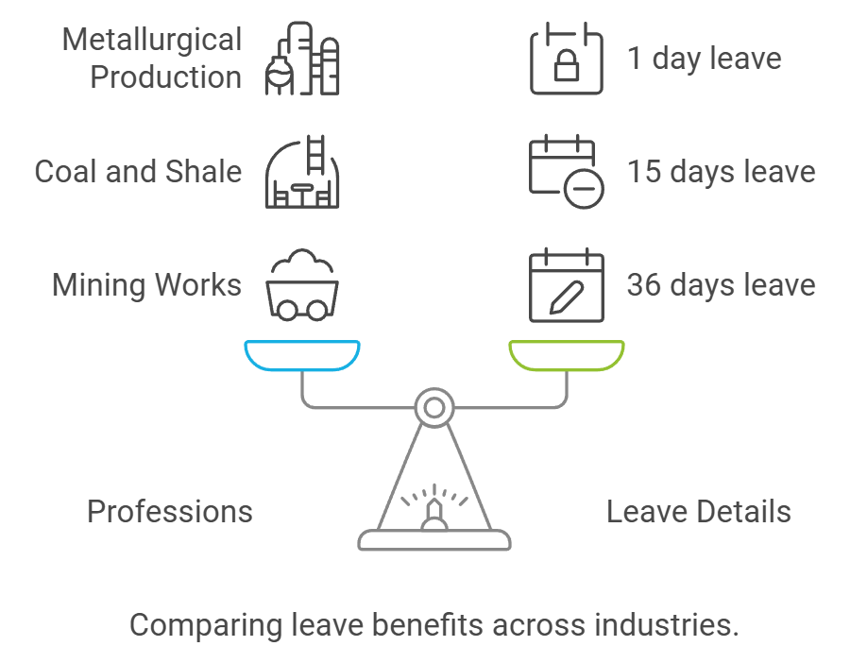

**Figure 1- Comparing leave benefits across industries**

**Results and discussion.** The regulatory analysis of provisions for guarantees to workers employed in heavy, hazardous, and dangerous conditions in Kazakhstan revealed several key insights, focusing on the so-called list-based approach. This approach defines guarantees based on pre-established lists of professions, highlighting limitations in adapting to contemporary labor conditions.

Under Article 1 of the Labor Code of the Republic of Kazakhstan, the concept of «guarantees» refers to the means, methods, and conditions by which the rights of workers in socio-labor relations are upheld. Prescriptive guarantees for workers in hazardous or heavy labor conditions are outlined in several provisions of the Labor Code (see fig2)

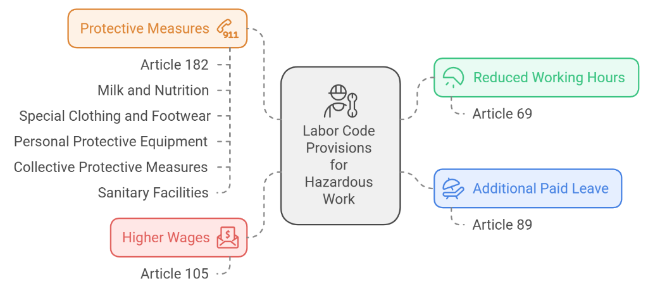

**Figure 2 - Social guarantees for employees working in hazardous labour conditions**

However, it should be noted that these multiple legal instruments create complexities in regulating safeguards for workers in hazardous conditions, making it difficult to ensure consistent protection. **(**see fig 3)

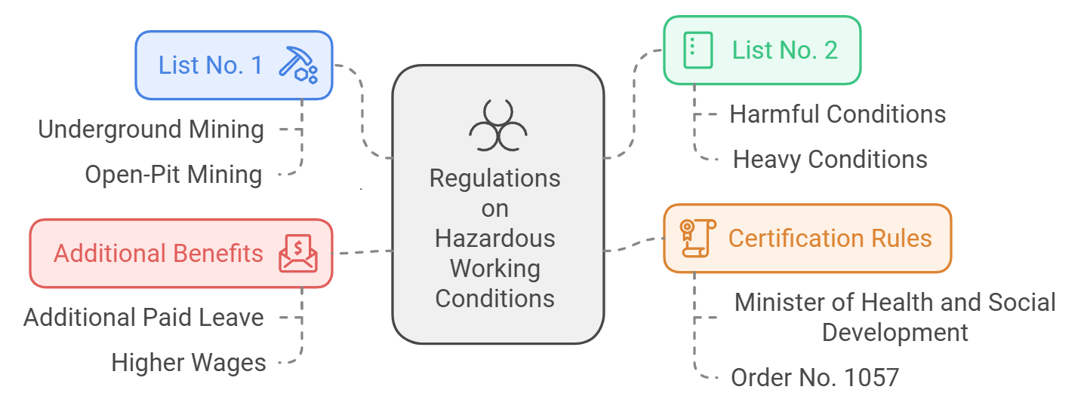

**Figure 3 - Legal instruments**

***Social-Economic Challenges and Legal Barriers***

The analysis identified socio-economic problems, legal barriers, and restrictions in providing guarantees to workers employed in hazardous conditions. Specifically, there are frequent complaints from workers whose professions are not included in the prescribed lists. Comparative analysis showed that some professions overlap, and discrepancies exist within the lists, making it difficult to generate detailed analytical data on expenses across professions.

The current practice revealed that a review of some types of social guarantees is necessary. For instance, representatives from the oil and gas sector suggested substituting milk with shubat or dietary supplements, indicating a shift towards more relevant forms of nutritional support.

Issues have also been identified in the assessment procedures of production facilities. Often, submitted documents contain inaccurate data, leading to erroneous managerial decisions and unnecessary economic costs. This issue is tied to the poor quality of labor assessments and the subjectivity of experts involved. In such cases, conscientious employers fulfill their social guarantee obligations based on collective agreements, which underscores the presence of legal barriers.

Experts, including representatives from the Republican Association of Mining and Metallurgical Enterprises, have argued for abandoning the list-based approach. With or without this approach, employers continue to face significant financial burdens related to providing social guarantees.

***International Comparisons.*** An analysis of international experiences showed that European Union countries have moved away from compensation systems for hazardous and dangerous working conditions, which remain in some post-Soviet states. EU countries avoid additional payments for hazardous work, not due to a lack of understanding of their motivational effect but based on ethical considerations - finding it inappropriate to financially incentivize workers to accept known risks.

Most European countries have implemented legislative measures to maintain workers' well-being, such as setting a statutory workday length, guaranteed paid leave, minimum wage, and employment security. In the USA, the Ethical Code of Industrial Hygienists [24] excludes financial rewards for hazardous work, advocating preventive measures instead. The US Occupational Safety and Health Act emphasizes the joint responsibility of employees and employers for ensuring safe working conditions.(see fig 4)

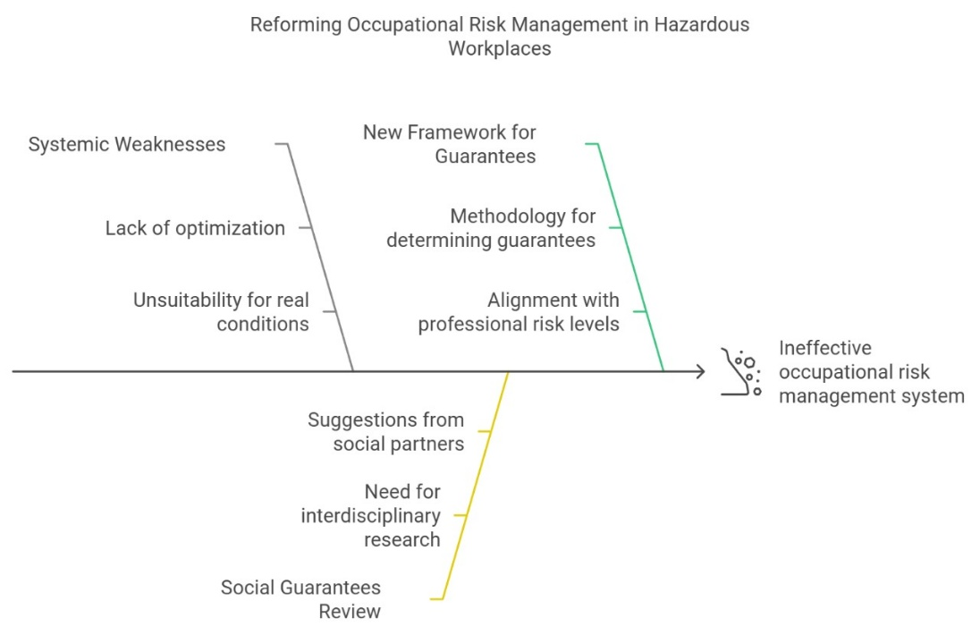

**Figure 4 - Transformation of the mechanism of social guarantees**

The results of the study are presented below, refer to table 1.

|  |  |
| --- | --- |
| **Category** | **Findings** |
| **List-based approach** | Limited adaptability to modern labor conditions. |
| **Socio-economic problems and legal barriers** | Frequent complaints from workers not included in prescribed lists; overlapping professions; discrepancies. |
| **Assessment procedures issues** | Inaccurate data in assessment documents; poor quality of labor assessments and subjectivity of experts. |
| **International comparison (EU vs. USA)** | EU countries avoid financial rewards for hazardous work, instead focusing on ethical considerations and preventive measures. |
| **Shift in nutritional support in hazardous conditions** | Shift from milk to shubat or dietary supplements in oil and gas sector to provide more relevant support. |

**Table 1: Key Insights from the Analysis of Occupational Safety Guarantees for Workers in Hazardous Conditions in Kazakhstan**

**Conclusions.** The current list-based system lacks optimization and is unsuitable for adapting to the actual conditions faced by workers in hazardous environments. There is a critical need for reform, moving towards a model that factors in real-time assessments of occupational risks. Revisiting the types of social guarantees offered is essential, particularly nutritional provisions like milk, to adapt these measures based on interdisciplinary research and the suggestions of social partners, considering international experiences. The research resulted in a proposal for a methodology to determine the volume of guarantees for workers in hazardous conditions based on occupational risk assessments. This risk-based approach will align social guarantees with the level of professional risk present in each workplace, aiming to provide equitable benefits tailored to the specific needs of each worker.

The analysis of the distribution of social guarantees across various industries in Kazakhstan highlights significant disparities that reflect the inefficiencies of the list-based approach. The data demonstrates a need for more granular, risk-oriented policies that can better accommodate the varying degrees of occupational hazards across sectors. By transitioning to a risk-based model, Kazakhstan can enhance workplace safety, ensure equitable treatment of workers, and foster a culture of proactive risk management.

This transformation requires regulatory reform, integration of advanced risk assessment technologies, and the establishment of a culture that values preventive measures over compensatory provisions. Moving forward, stakeholders, including employers, government agencies, and labor organizations, must collaborate to ensure that workers' rights and safety are prioritized, ultimately contributing to fairer and safer working environments.

The research of current practices in advanced countries with a high level of safe labour culture has shown the relevance of differentiating the workplace by the degree of occupational risk and the scope of social guarantees will depend on the degree of risk: high risk - full package of guarantees.

The level of protection varies from a minimum level corresponding to a low risk level to a maximum level at a very high risk level.

The new approach assumes that the type and scope of social guarantees will be differentiated according to the degree of occupational risk.

Thus, the integral assessment of occupational risks (IAOR) is based on a clear sequence of three indicators P1, P2 and P3. Where P1 is determined automatically by the results of individual risk assessment of each profession taking into account the specific weight of structural subdivisions, P2 - Automatically analysed information by integrating AIS «OTIB», HR.enbek.kz and stat.gov.kz, and P3 - determined by the results of a check-list containing 15 questions, placed in the ODA module of AIS «OTIB» by the employer, confirmed by the special organisation conducting the integral assessment of occupational risks.

Thus, automation of analysis and control of the results of the IAOR will allow solving a set of tasks: monitoring, analysis of indicators, forecasting of the main trends, modernisation of reporting, formation of a data bank, etc. This model provides for the automation of the processes of identifying potential recipients of social guarantees, minimising the risks associated with human participation in determining the class of working conditions. Since all necessary data are integrated from the systems of the state authorised labour body, employers. According to the results of the IAOR, social guarantees will be assigned only from the average class of labour conditions (3.2).

Effective management of occupational risks is impossible without transformation of the state mechanism of social guarantees in respect of persons employed in harmful working conditions. The essence of the new ideology is that all elements of the safe labour system should be interconnected and aimed at ensuring the implementation of the constitutional right of every citizen of the Republic of Kazakhstan to work in decent and safe working conditions.

It should be noted that the issue of integration of information systems of mining and metallurgical enterprises was considered by Galiev S.J., Galiev D.A., Uteshev E.T., Tekenova A.T. [25

], Edilbaeva L.I., Muzgina V.S., Mustapaev A.K. [26].

***Financing.*** *The article presents the results of the research obtained in the course of implementation of the scientific and technical programme «Transformation of the state mechanism of social guarantees in respect of persons employed in harmful working conditions in the modern context» (IRN BR22182673).*

**References**

1. Bureau of national statistics agency for strategic planning and reforms of the Republic of Kazakhstan ***//*** <https://stat.gov.kz/ru>. [in Russian]

2 Novikova & Logachova, 2018

<https://www.researchgate.net/publication/328605049_Social_guarantees_for_persons_employed_in_industry_on_labour_conditions>

3 Smatlayev et al., 2023 <https://www.doi.org/10.32523/2616-6844-2023-144-3-42-50>

4 Abikenova et al., 2023 <http://vestnik.kuef.kz/web/uploads/file-vestnik/355030862d39f301e86c59a3e880429a.pdf>

5 Рузанов et al., 2024 <https://sua.aesa.kz/main/article/view/222/192>

6 Kalkayeva & Moldakhmetova, 2022

[https://bulletin-law.kaznu.kz/index.php/journal/article/view/2663](https://bulletin-law.kaznu.kz/index.php/journal/article/view/2663 7)

[7](https://bulletin-law.kaznu.kz/index.php/journal/article/view/2663 7). Chencheva, O., Sukach, S., Rieznik, D., Petrenko, I., Lashko, Y., & Hladiuk, O. (2024). Modern concept of occupational safety and health management with a risk-based approach. Municipal Economy of Cities, 4(185), 221–227. <https://doi.org/10.33042/2522-1809-2024-4-185-221-227>

8. Labour code of the Republic of Kazakhstan dated 23 November, 2015 № 414-V.

9. Resolution of the Government of the Republic of Kazakhstan dated December 19, 1999, No. 1930 On the Approval of List No. 1 of Industries, Jobs, Occupations, Positions, and Indicators for Underground and Open-Pit Mining Work, Work with Particularly Hazardous and Particularly Difficult Working Conditions, and List No. 2 of Industries, Jobs, Occupations, Positions, and Indicators for Work with Hazardous and Difficult Working Conditions [in Russian] // <https://adilet.zan.kz/rus/docs/P990001930_/history>

10. Order of the Minister of Healthcare and Social Development of the Republic of Kazakhstan dated December 28, 2015, No. 1057 "On Approval of the Rules for Mandatory Periodic Certification of Production Facilities for Working Conditions"// <https://adilet.zan.kz/rus/docs/V1500012743>

11. Order of the Minister of Healthcare and Social Development of the Republic of Kazakhstan dated December 28, 2015, No. 1053 "On the Approval of the List of Industries, Workshops, Occupations, and Positions, as well as the List of Heavy Work, Work with Harmful and (or) Hazardous Working Conditions, Entitling Employees to Reduced Working Hours, Additional Paid Annual Leave, and Increased Wages, and the Rules for Granting These Benefits"// <https://adilet.zan.kz/rus/docs/V1500012731>.

12. Order of the Minister of Healthcare and Social Development of the Republic of Kazakhstan dated December 28, 2015, No. 1054 "On the Approval of the Rules for Providing Workers with Milk or Equivalent Food Products and (or) Specialized Products for Dietary (Therapeutic and Preventive) Nutrition, Special Clothing and Other Personal Protective Equipment, Collective Protective Equipment, Sanitary and Domestic Facilities, and Devices at the Employer's Expense"// <https://adilet.zan.kz/rus/docs/V1500012675>

13. Resolution of the Government of the Republic of Kazakhstan dated June 30, 2023, No. 520 "On the Approval of the Rules for Making Mandatory Professional Pension Contributions" // <https://adilet.zan.kz/rus/docs/P2300000520>.

14. Wet van 23 november 1995, houdende bepalingen inzake de arbeids- en rusttijden //<http://wetten.overheid.nl/jci1.3:c:BWBR0007671>.[in Dutch]

15. Act of 18 March 1999, containing provisions to improve working conditions (Working Conditions Act)<https://www.businesslegalconsultancy.com/en/act-of-march-18-1999-containing-provisions-to-improve-working-conditions-act-on-working-conditions-1/>

16.Law on Financing of Social Insurance of 16 December 2004 <http://wetten.overheid.nl/jci1.3:c:BWBR0017745>

17.Law on Work and Income Depending on Capacity of 10 November 2005 <http://wetten.overheid.nl/jci1.3:c:BWBR0019057>

18. Law of the Republic of Lithuania dated September 14, 2016, No. XII-2603 "On the Approval, Implementation, and Enforcement of the Labor Code" <https://e-seimas.lrs.lt/portal/legalAct/lt/TAD/bb10e743a97f11eb98ccba226c8a14d7?jfwid=kjtiqjlgg>. [in Russian]

19. Law of the Republic of Lithuania dated July 18, 1994, No. I-549

"On State Social Insurance Pensions"

<https://e-seimas.lrs.lt/portal/legalAct/lt/TAD/TAIS.420452?jfwid=mmceok8cw> [in Russian]

20. Resolution of the Government of the Republic of Lithuania dated February 20, 1995, No. 267

"On the Approval of the Procedure for Calculating and Paying Compensation for Special Working Conditions"

<https://e-seimas.lrs.lt/portal/legalAct/lt/TAD/TAIS.59421?jfwid=3d5v1wt4t>

21.Code du travail de la République française [in French] <https://www.legifrance.gouv.fr/codes/texte_lc/LEGITEXT000006072050>

22.European System of National and Regional Accounts // <https://ec.europa.eu/eurostat/statistics-explained/index.php?title=European_system_of_national_and_regional_accounts_-_ESA_2010>

23.Fair Labor Standards Act//

<https://www.dol.gov/agencies/whd/flsa#:~:text=The%20Fair%20Labor%20Standards%20Act%20(FLSA)%20establishes%20minimum%20wage%2C,%2C%20State%2C%20and%20local%20governments>.

24.Canons of Ethical Conduct and Interpretive Guidelines

<https://www.iloencyclopaedia.org/part-iii-48230/ethical-issues/item/1228-canons-of-ethical-conduct>

25.Galiev S.Zh., Galiev D.A., Uteshov E.T., Tekenova A.T. O hode cifrovizacii gorno-metallurgicheskogo kompleksa Kazahstana//Trudy- Nauchno-tehnicheskogo obespechenija

gornogo proizvodstva.-2019.- T.89.- S. 251-258 [in Russian]

26.Edil'baeva L.I., Muzgiga V.S., Mustapaeva A.K. Primenenie cifrovyh tehnologij dlja porvyshenija bezopasnosti gornyh porod// Trudy- Nauchno-tehnicheskogo obespechenija gornogo proizvodstva.- 2019.-T.89.-S.116-121 [in Russian]

***Information about the authors***

Yensebayeva А. - Candidate of Legal Sciences, Head of Socio-Legal Research Department, of the «Republican Scientific Research Institute for Occupational Safety and Health of the Ministry of Labor and Social Protection of the Republic of Kazakhstan»,Astana, Kazakhstan, е-mail: [nel1212kz@gmail.com](mailto:nel1212kz@gmail.com);

Kurmanov А. - Candidate of Economic Sciences, General Director of the «Republican Scientific Research Institute for Occupational Safety and Health of the Ministry of Labor and Social Protection of the Republic of Kazakhstan», Astana, Kazakhstan, е-mail: rniiot@rniiot.kz

Kazbekova D. - Institute of Industrial Ecological Sciences (IIES) of the University of Occupational and Environmental Health, Japan, е-mail: [kazbeken@med.uoeh-u.ac.jp](mailto:kazbeken@med.uoeh-u.ac.jp); Aitimova Sh. - Head of the Economic Measurement and Statistics Department of the «Republican Scientific Research Institute for Occupational Safety and Health of the Ministry of Labor and Social Protection of the Republic of Kazakhstan», Astana, Kazakhstan, е-mail: [aitimova_80@mail.ru](mailto:aitimova_80@mail.ru);

YedilbayevaL. ***-*** Candidate of Medicine, Leading Researcher, Branch «South» of the «Republican Scientific Research Institute for Occupational Safety and Health of the Ministry of Labor and Social Protection of the Republic of Kazakhstan»,Almaty, Kazakhstan, е-mail: [laura.ibragimovna@gmail.com](mailto:laura.ibragimovna@gmail.com)

***Сведения об авторах***

Енсебаева А. - кандидат юридических наук, заведующая отделом социально-правовых исследований «Республиканского научно-исследовательского института охраны труда и здоровья Министерства труда и социальной защиты населения Республики Казахстан», Астана, Казахстан, е-mail: [nel1212kz@gmail.com](mailto:nel1212kz@gmail.com);

Курманов А. - кандидат экономических наук, генеральный директор «Республиканского научно-исследовательского института охраны труда и здоровья Министерства труда и социальной защиты населения Республики Казахстан», Астана, Казахстан, е-mail: rniiot@rniiot.kz;

Казбекова Д. - Институт промышленных экологических наук (IIES) Университета гигиены труда и окружающей среды, Япония, е-mail: [kazbeken@med.uoeh-u.ac.jp](mailto:kazbeken@med.uoeh-u.ac.jp);

Айтимова Ш. - начальник отдела экономических измерений и статистики «Республиканского научно-исследовательского института охраны труда и здоровья Министерства труда и социальной защиты населения Республики Казахстан», Астана, Казахстан, е-mail:[aitimova_80@mail.ru](mailto:aitimova_80@mail.ru);

ЕдильбаеваЛ. ***-*** кандидат медицинских наук, ведущий научный сотрудник, филиал «Юг» «Республиканского научно-исследовательского института охраны труда и здоровья Министерства труда и социальной защиты населения Республики Казахстан»,Алматы, Казахстан, е-mail: [laura.ibragimovna@gmail.com](mailto:laura.ibragimovna@gmail.com)

ҒТАМР 52.45.19

**НАТРИЙ СУЛЬФИДІНІҢ ҚОСҚҰДЫҚ КЕН ОРЫНДАРЫНЫҢ ТОТЫҚҚАН ҚОРҒАСЫН-МЫРЫШ КЕНДЕРІНЕ ӘСЕРІН ЗЕРТТЕУ**

**А.Р. Мамбеталиева🖂** [D:\Desktop\иконка.png](https://orcid.org/0000-0003-1536-5259)**, А. Мухтаркызы**[D:\Desktop\иконка.png](https://orcid.org/0009-0002-6824-088Х) **, М.Р. Шаутенов**[D:\Desktop\иконка.png](https://orcid.org/0000-0002-0266-388)

*Satbayev University, Алматы, Казахстан*

**🖂**Корреспондент-автор: [a.mambetaliyeva@satbayev.university](mailto:a.mambetaliyeva@satbayev.university)

Тотыққан қорғасын-мырыш кендері өңдеудің күрделілігіне байланысты ұзақ уақыт бойы толық пайдаланылмады. Бірақ, қорғасын-мырыш сульфидті кендерінің тез сарқылуына байланысты тотыққан кендерді пайдалану тиімділігін арттыру қажет. Оксид кендерін алдын-ала байытудың әмбебап әдістерінің бірі - флотация. Дегенмен, қорғасын-мырыш оксидінің минералдарының гидрофильдік қасиетінің жоғары болуы, флотация әдісін қолдануды қиындатады, сонымен қатар мырыш иондарының беткі ерігіштігі, бұл процестің тиімділігін одан әрі төмендетеді. Бұл қиындықтарды жеңу үшін сульфидизация әдісінің маңызы жоғыры, ол тотыққан минералдардың беткі қасиеттерін өзгеретеді және флотацияға дайындайды.

Бұл жұмыста Қосқұдық кен орнының тотыққан кен сынамасындағы қорғасын минералдарын байыту тиімділігін арттыру мақсатында натрий күкіртін сульфидизатор ретінде қолданылуына ерекше мән беріледі. Қорғасын алуды барынша арттыру үшін натрий күкіртінің оңтайлы шығынын анықтау бойынша зерттеу жүргізілді. Негізгі қорғасын флотациясы кезінде бұл реагенттің басқа да металлдардың, оның ішінде алтын, күміс және мырыштың, бөлініп алынуына әсері зерттелді. Зерртеу нәтижесінде натрий күкіртінің шығыны 700 г/т болғанда қорғасынның байыту тиімділігі 10,8% - ға (34,3-тен 45,1% - ға дейін) артады. Алынған нәтижелер қорғасын-мырыш өнеркәсібінің тұрақты дамуын қамтамасыз етудегі өзекті болатын тотыққан кендерін өңдеу тиімділігін арттыруда негізгі параметрлерін анықтауға мүмкіндік береді.

**Түйін сөздер:** пайдалы қазбаларды байыту, флотация, тотыққан минералдар, қорғасын, байыту тиімділігі, фазалық талдау, күкіртті натрий.

**ИССЛЕДОВАНИЕ ВЛИЯНИЯ СУЛЬФИДИРОВАНИЯ С ПРИМЕНЕНИЕМ СЕРНИСТОГО НАТРИЯ НА ОКИСЛЕННЫЕ СВИНЦОВО-ЦИНКОВЫЕ РУДЫ МЕСТОРОЖДЕНИЯ КОСКУДУК**

**А.Р. Мамбеталиева🖂, А. Мухтаркызы, М.Р. Шаутенов**

*Satbayev University, Алматы, Қазахстан,*

*e-mail:* [*a.mambetaliyeva@satbayev.university*](mailto:a.mambetaliyeva@satbayev.university)

Окисленные свинцово-цинковые руды долгое время оставались недостаточно использованными из-за сложности их переработки. Однако в условиях быстрого истощения запасов свинцово-цинковых сульфидных руд возникает острая необходимость в повышении эффективности использования этих оксидных руд. Одним из наиболее универсальных методов предварительного обогащения оксидных руд является флотация. Однако свинцово-цинковые оксидные минералы обладают высокой гидрофильностью, что затрудняет их флотацию, а также они склонны к растворению ионов металлов на поверхности, что дополнительно снижает эффективность процесса. Для преодоления этих проблем важную роль играет сульфидизация, которая позволяет модифицировать поверхностные свойства окисленных минералов, делая их более пригодными для флотации.

В данной работе особое внимание уделяется влиянию сернистого натрия как сульфидизатора на эффективность обогащения свинцовых минералов в пробе окисленной руды с месторождения Коскудук. Было проведено исследование по определению оптимального расхода сернистого натрия для максимизации извлечения свинца. Дополнительно анализировалось влияние данного реагента на извлечение других металлов, таких как золото, серебро и цинк, в процессе основной свинцовой флотации. Полученные результаты позволяют определить ключевые параметры для повышения эффективности переработки оксидных руд, что актуально для обеспечения устойчивого развития свинцово-цинковой промышленности.

**Ключевые слова:** обогащение полезных ископаемых, флотация, окисленные минералы, свинец, эффективность обогащения, фазовый анализ, сернистый натрий.

**ON OXIDIZED LEAD-ZINC ORES OF THE KOSKUDUK DEPOSIT**

**INVESTIGATION OF THE EFFECT OF SULFIDATION USING SODIUM SULPHIDE ON OXIDIZED LEAD-ZINC ORES OF THE KOSKUDUK DEPOSIT**

**A.R. Mambetaliyeva🖂, А. Mukhtarkyzy, M. Shautenov**

*Satbayev University, Almaty, Kazakhstan,*

*e-mail:* [*a.mambetaliyeva@satbayev.university*](mailto:a.mambetaliyeva@satbayev.university)

Oxidized lead-zinc ores remained underused for a long time due to the complexity of their processing. However, in conditions of rapid depletion of reserves of lead-zinc sulfide ores, there is an urgent need to increase the efficiency of using these oxide ores. One of the most universal methods of pre-enrichment of oxide ores is flotation. However, lead-zinc oxide minerals have high hydrophilicity, which makes their flotation difficult, and they are also prone to dissolution of metal ions on the surface, which further reduces the efficiency of the process. To overcome these problems, sulfidization plays an important role, which makes it possible to modify the surface properties of oxidized minerals, making them more suitable for flotation.

In this work, special attention is paid to the effect of sodium sulfide as a sulfidizer on the efficiency of enrichment of lead minerals in a sample of oxidized ore from the Koskuduk deposit. A study was conducted to determine the optimal consumption of sodium sulfide to maximize lead recovery. Additionally, the effect of this reagent on the extraction of other metals, such as gold, silver and zinc, during the main lead flotation was analyzed. The results obtained allow us to determine the key parameters for improving the efficiency of processing oxide ores, which is important for ensuring the sustainable development of the lead-zinc industry.

**Keywords:** mineral enrichment, flotation, oxidized minerals, lead, enrichment efficiency, phase analysis, sodium sulfide.

**Кіріспе.** Өнеркәсіптік өндірісте мырыш пен қорғасын маңызды элемент, қорғасын ерекше қасиеттеріне байланысты (жоғары тығыздылығы, төмен балқу температурасы және жоғары икемділігі) аккумуляторлар, құрылыс материалдары және радиациядан қорғау жабдықтарын өндіру үшін шикізат ретінде кеңінен қолданылады. Жоғары беріктігі, тозуға және коррозияға төзімділігі бар мырыш негізінен металл бұйымдарын және легирленген материалдар мен құрғақ батареяларды өндіру үшін қолданылады [1].

Құрамында қорғасын-мырыш сульфидтері бар сульфидті кендер ұзақ уақыт бойы игерілуде, бірақ бай, оңай байытлатын кендер біртіндеп азайуда. Соңғы жылдары ресурстармен қамтамасыз етудің тенденциясының төмендеуі байқалуда, бұл өз кезегінде қорғасын мен мырышқа өсіп келе жатқан сұранысты қанағаттандыру мүмкіндігінің төмендеуіне әкеледі [2]. Дегенмен, қорғасын-мырыш кендерінің қоры ауқымды, бірақ олар минералдар қасиетінің күрделілігімен, ұсақ түйіршікті тау жыныстарының дақтарының болуымен, еритін тұздардың жоғары болуымен сипатталады, бұл олардың пайдаланылуын төмендетеді [3-6]. Сондықтан қорғасын мен мырыш тотықтарының ресурстарын өндірудің экологиялық тұрғыда таза, тиімді және үнемді технологияларын құруға бағытталған зерттеулер мен жобалар жүргізу қажет.

Пайдаланудың қарапайымдылығы, өзіндік құнының төмендігі сияқты артықшылықтары бар флотация тәсілі – қорғасын-мырыш кендерін алдын ала байытудың негізгі әдісі. Минералдардың гидрофильдік қасиетіне байланысты пайдалы қазбалардың флотациялық әдіспен байытуға әсер ететін негізгі фактор, қорғасын-мырыш тотыққан минералының бетінің гидрофильділігін төмендету үшін, әдетте, минералдың бетінде сульфидті қабыршықты қалыптастыру үшін, сульфидті қайта құру қолданылады, осылайша флотациялық байытуда тиімділікті арттыру мақсатында минералдың беткі қасиеттерін өзгертеді [7]. Сульфидизация әдістеріне негізінен беттік сульфидизация, күйдіру, механохимиялық және гидротермиялық сульфидизациялар жатады [8, 9]. Алайда, сульфидизацияның жоғары шығындары мен пайдалану қиындықтарына байланысты сульфидті күйдіру, механохимиялық және гидротермиялық сульфидизация өнеркәсіпте кеңінен қолданылмайды. Қазіргі уақытта өнеркәсіптік өндіріс негізінен қорғасын-мырыш тотыққан минералдарының бетін өңдеу үшін күкірт түзетін агенттерді пайдаланады. Сульфидті өңдеуден кейін тотыққан минералдардың бетінде пайда болатын сульфидті жұқа қабық борпылдақ және кеуекті құрылымға ие; ол тотыққан минералдардың гидрофобтылығын күшейте алғанымен, флотация процесінде кен целлюлозасын араластыру нәтижесінде пайда болатын ығысу күштерінің әсерінен сульфидті пленка десорбцияға бейім болады [10]. Флотациялық реагенттерді қосу тотыққан минералдардың бетіндегі сульфидизация жылдамдығын тиімді арттырады және сульфидті жұқа қабықтың бетіндегі механикалық беріктігін жақсартады, осылайша сульфидті агенттің сульфидтік әсерін күшейтеді [11]. Сонымен қатар, бақылау жұмысының дұрыс орындалуы үшін сульфидизациялау реагентінің мөлшеріне және суспензияның рН деңгейіне аса мән беру қажет [12].

Бұл жұмыста Қосқұдық кен орнының сынамасының заттық құрамының зерттеу нәтижелері және тоттыққан кендердегі реагенттің беттік флотациялық қасиетінің ашық тәжірибе нәтижелері ұсынылған.

**Материалдар мен әдістер.** Зерттеу нысаны – Қазақстандағы Қосқұдық кен орнының тотыққан қорғасын-мырыш кендері.

Қарастырылып отырған кендер мен байыту өнімдерінің заттық құрамы атомдық-абсорбциялық талдау, атомдық-эмиссиялық талдау, классикалық химиялық және фотометриялық талдау, талдау жұмыстарын жүргізуге арнайы дайындалған өкілдік сынамалардағы сынамалық гравиметриялық талдау тобы әдісімен анықталды.

Минералогиялық сипаттама үшін, орташа сынамалардан басқа, кенді минералдануы бар негізгі жыныстардың үлгілері таңдалды, олардан мөлдір тегістеуіштер мен жылтыратылған тегістеуіштер жасалды. Оларды зерттеу қазіргі заманғы жабдықта физика-химиялық зерттеулер зертханасында жүргізілді: OLUMPUS BX 51 POL микроскопы., simagis 2R-2C бейнекамерасын және SIAMS минералды талдауға арналған бағдарламалық жасақтаманы қолдануымен.

**Нәтижелер және талқылау.** Заттық құрамының зерттеу нәтижесінде қарастырылып отырған тотыққан кеннің сынамасында 0,82 - 0,85% қорғасын және 0,6 – 0,65% мырыш бар екені анықталды, мыс мөлшері төмен (0,02%) және өнеркәсіптік қызығушылық тудырмайды.

Кенде асыл металдардың мөлшері: 0,6 г/т деңгейінде алтын және 5,5 г/т деңгейінде күміс бар.

**1 - кесте. Қосқұдық кен орнының тотыққан кенін химиялық фазалық талдау нәтижелері**

|  |  |  |
| --- | --- | --- |
| **Компоненттердің атауы** | **Құрамы** | |
| абсолютті, % | салыстырмалы, % |
| Мырыштын бейімделу формасы: | | |
| *-* Суда еритін | *< 0,05* | *-* |
| *- Тотыққан* | *0,25* | *38,5* |
| *- Сульфидтер* | *0,08* | *12,3* |
| *- Ерімейтін* | *0,32* | *49,2* |
| Жиынтық | 0,65 | 100,0 |
| Қорғасынның бейімделу формасы: | | |
| *-* Құрамында оттегі бар | *0,54* | *65,8* |
| *- Галенит* | *0,14* | *17,1* |
| *-* Қалдық формалар | *0,14* | *17,1* |
| Жиынтық | 0,82 | 100,0 |
| Темірдін бейімделу формасы: | | |
| *- Сульфидтер* | *< 0,05* | *-* |
| *- Екі валентті Fe2+* | *3,06* | *48,6* |
| *- Үш валентті Fe3+* | *3,24* | *51,4* |
| Жиынтық | 6,30 | 100,0 |

1 - кестеде фазалық химиялық талдау нәтижелері көрсетілген және қарастырылып отырған сынама тотыққан түрге жатады, себебі қорғасын тотыққан және силикат қосылыстарымен есептегенде салыстырмалы құрамы 82,9% тең, ал мырыш - 87,7%. Темір толығымен дерлік тотыққан күйде екенін атап өтуге болады, өйткені темірдің сульфидті формалары өте аз – 0,05% (абсолютті құрамы).

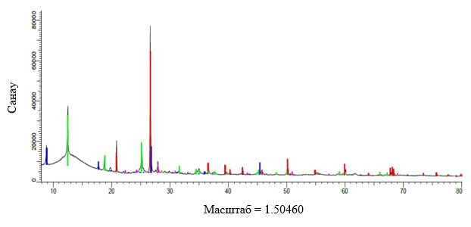

**1-сурет. Қосқұдық тотыққан кен сынамасының дифрактограммасы**

Қарастырылып отырған тотыққан кен сынамасына Bruker (Германия) D8-ADVANCE дифрактометрінде күрделі минералогиялық құрамына талдаулар жүргізілді. Қарастырылып отырған кен сынамасының бастапқы дифрактограммасының нәтижелері 1 – суретте, 2-кестеде-цифрлық түрде келтірілген.

**2 - кесте. Қосқұдық кен орнының тотыққан кенінің бастапқы сынамасының минералогиялық құрамы**

|  |  |
| --- | --- |
| **Негізгі минералдар мен комплекстер** | **Кендегі құрамы, %** |
| Қорғасын сульфидтері (галенит) | 0,16 |
| Қорғасынның тотыққан және қалдық түрлері | 0,89 |
| Мырыш сульфидтері (сфалерит) | 0,12 |
| Мырыштын тотыққан және қалдық түрлері | 1,07 |
| Мыс минералдары | 0,04 |
| Темір сульфидтері (пирит) | 0,05 |
| Темірдің тотыққан түрлері (гетит, гематит) | 4,51 |
| Слюда минералдары (альбит, мусковит, клинохлор және тб.) | 53,44 |
| Кварц | 30,95 |
| Басқалары | 8,77 |
| Барлығы | 100,00 |

Атап өтетін жағдай, кенді және байыту өнімдерін минералогиялық талдауы гидратталған материалдың жұқа шламдары мен суспензияларының барын және де сульфидті минералдардың оксидтермен (пирит гетит және гематит) алмасу процессінің кең таралғанын анықтады, ал қалған сульфидті минералдардың минералогиялық талдауда анықталағандарының көлемі флотациямен бөліп алынбайтын көлемде (5 мкм-ден аз).

Тотығу дәрежесі бойынша, құрылымдық-текстуралық сипаттамалары бойынша және қиылысу мөлшері бойынша қарастырылып отырған тотыққан кендері Қосқұдық кен орнының байытылуы қиын түрлеріне жатады.

Тотыққан кендердің флотациялық зерттеуі натрий күкіртінің режимін анықтаудан басталды. 2-суретте өткізілген тәжірибенің сызбасы көрсетілген. Тәжірибе кезінде алыған нәтижелер 3-кестеде көрсетілген.

Бақылау флотация, 6 мин

Қалдық

Негізгі флотация, 10 мин

Концентрат

Ұнтақтау 70%, -0,074 мм

Бастапқы сынама

**2- сурет. Натрий күкірттің флотация процесіне әсерін сынау бойынша ашық тәжірибелер сызбасы**

Алынған сынақ тәжірибелерінің нәтижелері негізінде реагенттердің келесі мөлшері ұсынылады:

- бутил ксантогенаты - 200 г/т;

- көбіктендіргіш (Т-80) – 60 г/т;

- бутил аэрофлоты – 60 г/т.

3-кесте. – Натрий сульфатын қолдана отырып, Қосқұдық (КО) кен орнының тотыққан кенінің бастапқы сынамасын флотациялау бойынша ашық тәжірибелердің нәтижелері

|  |  |  |  |  |  |  |  |  |  |  |  |  |
| --- | --- | --- | --- | --- | --- | --- | --- | --- | --- | --- | --- | --- |
| Өнімдердің атауы | Шығуы, % | Құрамы, % | | | | | Байыту дережесі | | | | | Байыту тиімділігі $ε-γ, Pb$ |
| Pb | Zn | Au * | Ag* | Fe | Pb | Zn | Au | Ag | Fe |
| *«0» тәжірибе; рН-8,68* | | | | | | | | | | | | |
| *Концентрат* | *4,6* | *4,92* | *1,20* | *7,44* | *60,0* | *6,69* | *26,40* | *8,80* | *58,00* | *50,80* | *4,90* | *21,80* |
| *Қалдық* | *95,4* | *0,66* | *0,60* | *0,26* | *2,80* | *6,28* | *73,60* | *91,20* | *42,00* | *49,20* | *95,10* |
| *Басты сынама* | *100,0* | *0,86* | *0,63* | *0,59* | *5,43* | *6,30* | *100,0* | *100,0* | *100,0* | *100,0* | *100,0* |
| Na2S – 200 г/т; pH – 9,30 | | | | | | | | | | | | |
| Концентрат | 4,60 | 7,12 | 1,20 | 7,75 | 60,50 | 6,34 | 38,9 | 8,80 | 59,00 | 51,90 | 4,60 | 34,30 |
| Қалдық | 95,40 | 0,54 | 0,60 | 0,26 | 2,70 | 6,30 | 61,10 | 91,20 | 41,00 | 48,10 | 95,40 |
| Басты сынама | 100,0 | 0,84 | 0,63 | 0,60 | 5,36 | 6,30 | 100,0 | 100,0 | 100,0 | 100,0 | 100,0 |
| Na2S – 300 г/т; pH – 9,40 | | | | | | | | | | | | |
| Концентрат | 4,50 | 7,86 | 1,20 | 8,07 | 62,00 | 6,28 | 42,60 | 8,70 | 60,30 | 52,00 | 4,50 | 38,10 |
| Қалдық | 95,50 | 0,50 | 0,59 | 0,25 | 2,70 | 6,30 | 57,4 | 91,30 | 39,70 | 48,00 | 95,50 |
| Басты сынама | 100,0 | 0,83 | 0,62 | 0,60 | 5,37 | 6,30 | 100,0 | 100,0 | 100,0 | 100,0 | 100,0 |
| Na2S – 400 г/т; pH – 9,57 | | | | | | | | | | | | |
| Концентрат | 4,40 | 8,52 | 1,20 | 8,22 | 68,20 | 6,24 | 45,00 | 8,60 | 61,20 | 55,70 | 4,40 | 40,60 |
| Қалдық | 95,60 | 0,48 | 0,59 | 0,24 | 2,50 | 6,30 | 55,00 | 91,40 | 38,80 | 44,30 | 95,60 |
| Басты сынама | 100,0 | 0,83 | 0,62 | 0,59 | 5,39 | 6,30 | 100,0 | 100,0 | 100,0 | 100,0 | 100,0 |
| Na2S – 500 г/т; pH – 9,61 | | | | | | | | | | | | |
| Концентрат | 3,10 | 13,0 | 1,48 | 12,6 | 112,9 | 6,20 | 46,90 | 7,40 | 65,80 | 65,50 | 3,10 | 43,80 |
| Қалдық | 96,90 | 0,47 | 0,59 | 0,21 | 1,90 | 6,30 | 53,10 | 92,60 | 34,20 | 34,50 | 96,9 |
| Басты сынама | 100,0 | 0,86 | 0,62 | 0,59 | 5,34 | 6,30 | 100,0 | 100,0 | 100,0 | 100,0 | 100,0 |
| Na2S – 700 г/т; pH – 9,81 | | | | | | | | | | | | |
| Концентрат | 3,10 | 13,4 | 1,40 | 11,1 | 103,9 | 5,96 | 48,2 | 7,10 | 59,60 | 60,20 | 2,90 | 45,10 |
| Қалдық | 96,90 | 0,46 | 0,59 | 0,24 | 2,20 | 6,31 | 51,80 | 92,90 | 40,40 | 39,80 | 97,10 |
| Басты сынама | 100,0 | 0,86 | 0,62 | 0,58 | 5,35 | 6,30 | 100,0 | 100,0 | 100,0 | 100,0 | 100,0 |
| Na2S – 1000 г/т; pH – 10,41 | | | | | | | | | | | | |
| Концентрат | 3,90 | 9,86 | 1,17 | 9,29 | 80,10 | 5,94 | 45,50 | 7,40 | 58,30 | 57,50 | 3,70 | 41,60 |
| Қалдық | 96,10 | 0,48 | 0,59 | 0,27 | 2,40 | 6,31 | 54,50 | 92,60 | 41,70 | 42,50 | 96,30 |
| Басты сынама | 100,0 | 0,85 | 0,61 | 0,62 | 5,43 | 6,30 | 100,0 | 100,0 | 100,0 | 100,0 | 100,0 |
| Na2S – 1500 г/т; pH – 10,86 | | | | | | | | | | | | |
| Концентрат | 9,00 | 3,50 | 0,69 | 2,31 | 23,30 | 6,14 | 37,40 | 10,20 | 34,70 | 39,00 | 8,80 | 28,40 |
| Қалдық | 91,00 | 0,58 | 0,60 | 0,43 | 3,60 | 6,30 | 62,60 | 89,80 | 65,30 | 61,00 | 91,20 |
| Басты сынама | 100,0 | 0,84 | 0,61 | 0,60 | 5,37 | 6,29 | 100,0 | 100,0 | 100,0 | 100,0 | 100,0 |
| Na2S – 2000 г/т; pH – 11,50 | | | | | | | | | | | | |
| Концентрат | 12,10 | 1,85 | 0,64 | 1,10 | 12,40 | 6,32 | 26,40 | 12,80 | 22,60 | 28,00 | 12,10 | 14,30 |
| Қалдық | 87,90 | 0,71 | 0,60 | 0,52 | 4,40 | 6,30 | 73,60 | 87,20 | 77,40 | 72,00 | 87,90 |
| Басты сынама | 100,0 | 0,85 | 0,60 | 0,59 | 5,37 | 6,30 | 100,0 | 100,0 | 100,0 | 100,0 | 100,0 |

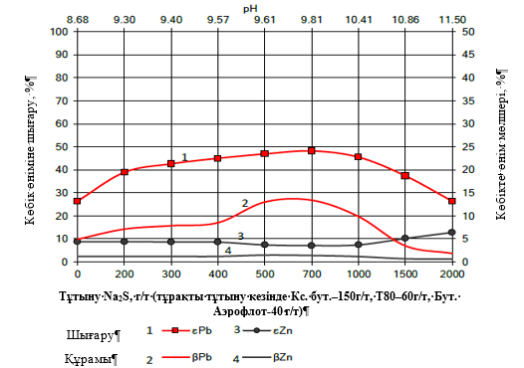

**2 - сурет. Натрий күкірттің мөлшері Қосқұдық кен орнының тотыққан кенінің бастапқы сынамасының Pb және Zn флотация көрсеткіштеріне әсері**

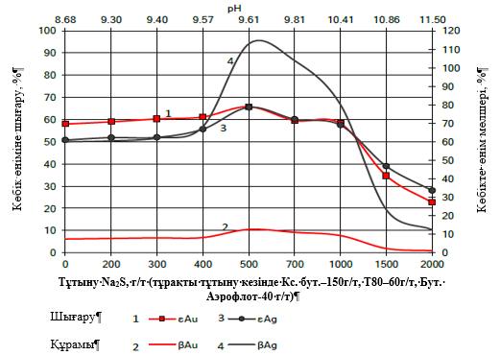

**3-сурет. Натрий күкіртінің мөлшері Қосқұдық кен орнының тотыққан кенінің бастапқы сынамасының Au және Ag флотация көрсеткіштеріне әсері**

3-суреттегі мәліметтерден натрий күкірттінің шығыны 200 г/т – ден 700 г/т-ға дейін артқан сайын қорғасынның байыту тиімділігі 10,8% - ға (34,3-тен 45,1% - ға дейін) артады, бұл ретте күміс пен алтынның байыту тиімділігі 60,2 және 59,6% -ға тең. Асыл металдар үшін натрий күкіртінің оңтайлы шығыны 500 г/т, күмістің байыту дәрежесі – 65,5 %, алтынның – 65,8%-ды көрсетті. Айта кету керек, сульфидизация мырыштың байыту көрсеткіштерін арттырмайды.

**Қорытынды.** Зерттеу Қосқұдық кен орнының тотыққан кенімен жүргізілді. Заттық құрамы бойынша орташа қорғасын мөлшері – 0,82 - 0,85%, мырыш – 0,6 – 0,65 %, күміс – 5,5 г/т және алтын – 0,6 г/т тең, мыс мөлшері - 0,02% және өнеркәсіптік қызығушылық тудырмайды.

Фазалық талдау нәтижесіне сәйкес, сынама тотыққан қосылыстарға жатады, себебі қорғасынның, тотыққан және силикат қосылыстарымен есептегенде, салыстырмалы құрамы 82,9% тең, ал мырыш - 87,7%.

Қосқұдық кен орнының тотыққан кендерін байыту кезінде негізгі реагенттердің шығындары анықталды: бутил ксантогенаты – 200 г/т; көбік түзуші (Т-80) – 60 г/т; бутил аэрофлоты – 60 г/т. Негізгі, бақылау флотациясының уақыты – 10 минут және 6 минутты құрады.

Ашық сынақ тәжірибелерінің нәтижесінде натрий күкіртінің шығыны шамамен 700 г/т болған кезде қорғасынның тиімділігі артады, ал күміс пен алтын үшін шамамен 500 г/т тең. Айта кету керек, сульфидизация мырыштың байыту көрсеткіштерін арттырмайды.

***Қаржыландыру.*** *Жұмыс Қазақстан Республикасы Білім және Ғылым министрлігінің ғылым комитеті қаржыландыратын АР 23489765 гранттық жобасы бойынша орындалды.*

**References**

1. Nayak A., Jena M.S., Mandre N.R., Beneficiation of Lead-Zinc Ores – A // Review. Mineral Processing and Extractive Metallurgy Review. -2021.-Vol.43(5). -P. 564 - 583.

DOI 10.1080/08827508.2021.1903459

1. Gavin M.M., Simon M. J., Timothy T.W. The world's lead-zinc mineral resources: Scarcity, data, issues and opportunities // [Ore Geology Reviews](https://www.sciencedirect.com/journal/ore-geology-reviews). -2017. -Vol. 80. -P. 1160-1190

DOI 10.1016/j.oregeorev.2016.08.010

1. Abkhoshk E., Jorjani E., Al-Harahsheh M.S., Rashchi F., Naazeri M., Review of the hydrometallurgical processing of non-sulfide zinc ores // Hydrometallurgy. -2014. - Vol.149. - P.153-167. DOI 10.1016/j.hydromet.2014.08.001
2. Liu W.G., Zhao L., Liu W.B., Zheng Y.X., Huang L.Y., Mao Y., Ding S.Y., Enhanced flotation of smithsonite from calcite based on the synergistic action of carboxylated chitosan and sodium carbonate // Adv. Powder Technol. -2023. -Vol. 34 (12):104261

DOI 10.1016/j.apt.2023.104261

5.Mehdilo A., Irannajad M., Zarei H., Flotation of zinc oxide ore using cationic and cationic-anionic mixed collectors // Physicochem. Probl. Miner. Process. -2013.-Vol. 49(1). -P. 145−156. DOI [10.5277/ppmp130114](http://dx.doi.org/10.5277/ppmp130114)

6. Maghfouri S., Hosseinzadeh M.R., Rajabi A., Choulet F., A review of major non-sulfide zinc deposits in Iran // Geosci. Front. -2018. –Vol. 9(1). -P.249-272. DOI [10.1016/j.gsf.2017.04.003](https://doi.org/10.1016/j.gsf.2017.04.003)

7. Yi Y.H., Peixuan Li, Zhang G., Feng Q.C., Han G., Stepwise activation of hemimorphite surfaces with lead ions and its contribution to sulfidization flotation // Sep. Purif. Technol. - 2022. –Vol. 299: 121679 DOI [10.1016/j.seppur.2022.121679](https://doi.org/10.1016/j.seppur.2022.121679)

8. Elizondo-Álvarez M.A., Uribe-Salas A., Nava-Alonso F., Flotation studies of galena (PbS), cerussite (PbCO3) and anglesite (PbSO4) with hydroxamic acids as collectors // Miner. Eng. -2020. - Vol. 155: 106456 [DOI 10.1016/j.mineng.2020.106456](https://doi.org/10.1016/j.mineng.2020.106456)

9. Xue J.W., Qu Y.B., Chen Y., Zhang C.H., Bu X.Z., Effective sulfide flotation of cerussite by using trithiocyanuric acid as a novel sulfurizing reagent // Miner. Eng. -2023.-Vol. 198: 108087 [DOI 10.1016/j.mineng.2023.108087](https://doi.org/10.1016/j.mineng.2023.108087)

10. Zhang S., Xian Y.J., Wen S.M., Liang G.Y., Enhancement of xanthate adsorption on lead-modified and sulfurized smithsonite surface in the presence of ammonia // Miner. Eng. -2022. -Vol. 189: 107872 DOI 10.1016/j.mineng.2022.107872

11. Li. Jialei; Pei Bin, Liu Zhicheng; Gao Xiang; Ning Shuai; Cai Zi, Liu Ruizeng, Applying the surface differences in the sulfophilic and oxyphilic affinities for reverse flotation separation of calcite from smithsonite // [Surfaces and Interfaces](javascript:void(0)). -2023. - Vol. 42: 103310

DOI 10.1016/j.surfin.2023.103310

12.Qian Wei, Liuyang Dong, Wenqing Qin, Fen Jiao, Zhongxu Qi, Cheng Feng, Dayong Sun, Long Wang, Shunyuan Xiao, Efficient flotation recovery of lead and zinc from refractory lead-zinc ores under low alkaline conditions // [Geochemistry](https://www.sciencedirect.com/journal/geochemistry). -2021. -[Vol. 81.(4](https://www.sciencedirect.com/journal/geochemistry/vol/81/issue/4)): 125769

DOI 10.1016/j.chemer.2021.125769

***Авторлар туралы мәліметтер***

Мамбеталиева А.Р. - PhD докторы, "Металлургия және пайдалы қазбаларды байыту" кафедрасының аға оқытушысы Satbayev University, Алматы, Қазақстан, e-mail: [a.mambetaliyeva@satbayev.university](mailto:a.mambetaliyeva@satbayev.university);

Мұұхтарқызы А. - "Металлургия және пайдалы қазбаларды байыту" кафедрасының магистранты Satbayev University, Алматы, Қазақстан, e-mail: [asel.muktarkyzy@mail.ru](mailto:asel.muktarkyzy@mail.ru);

Шаутенов М.Р. - техникалық ғылымдар кандидаты, доцент, "Металлургия және пайдалы қазбаларды байыту" кафедрасының профессоры Satbayev University, Алматы, Қазақстан, e-mail: m.shautenov@satbayev.universit

***Information about the authors***

Mambetaliyeva A.R. - PhD, Senior Lecturer at the Department of Metallurgy and Mineral Processing at Satbayev University, Almaty, Kazakhstan, e-mail: [a.mambetaliyeva@satbayev.university](mailto:a.mambetaliyeva@satbayev.university);

Mukhtarkyzy A. - Master at the Department of Metallurgy and Mineral Processing at Satbayev University, Almaty, Kazakhstan, e-mail: [asel.muktarkyzy@mail.ru](mailto:asel.muktarkyzy@mail.ru);

Shautenov M., Candidate of technical sciences, Professor at the Department of Metallurgy and Mineral Processing at Satbayev University, Almaty, Kazakhstan, e-mail: [m.shautenov@satbayev.university](mailto:m.shautenov@satbayev.university),