IRSTI 52.13.07

THERMAL AND CRYOGENIC FRACTURE INTERACTIONS IN GRANITE: FRACTURE TOUGHNESS TESTS FOR GEOTHERMAL DEVELOPMENT

¹D.T.Begaliyev, ¹N.M.Zhumagaliyev, ¹A.S.Kupeshova, ²A.T.Zholbasarova, ¹A.B.Kydrashov, ¹B.Zh.Burkhanov, ³A.R Abdiev
¹NJSC “West Kazakhstan Agrarian and Technical University named after Zhangir khan”,Uralsk, Kazakhstan,
²NJSC “Caspian State University of Technologies and Engineering named after S.Yessenov”, Aktau, Kazakhstan,
³Kyrgyz Mining and Metallurgical Institute named after academician U. Asanaliev, Bishkek, Kyrgyzstan

Corresponding-authors: dastan.begaliyev@wkau.kz, a.kydrashov@mail.ru

The use of liquid nitrogen (LN₂) as a freezing agent has been shown to help enhance the permeability of the rock, making it easier for fluids to pass through, which improves how much water or steam can flow from the reservoir. This is especially useful in Hot Dry Rock (HDR) systems. This study looks at how exposing granite to low temperatures affects its strength after it has been cooled down after being heated. Fracture Toughness Tests were done on granite samples after they were first baked at different temperatures from 100 °C to 400 °C before being quickly cooled with LN₂ to copy what happens when something gets suddenly cooled quickly.
The tested granite samples were taken from a place that is around 50 km away from Astana, in the Akmola region of Kazakhstan. Experimental measurements helped find important mechanical values like the maximum load the sample could handle, how much stress builds up at the tip of the crack, and how much energy it takes to make the sample break. The results show that using liquid nitrogen makes it much easier for cracks to start and spread in the sample, and doing LN₂ treatment at higher pre-treatment temperatures makes it happen even faster. A consistent decrease in both the stress intensity factor and fracture energy as the temperature went up could be seen. These findings show that using LN₂ to freeze and crack the rocks can be a useful way to help boost the flow of geothermal energy from certain types of hard rocks.
Keywords: geothermal energy, Kazakhstan, cryogenic fracturing, liquid nitrogen, fracture toughness test, intensity factor, fracture energy, granite, HDR( hot dry rocks).

ГРАНИТТЕГІ ТЕРМИЯЛЫҚ ЖӘНЕ КРИОГЕНДІК СЫНЫҚТАРДЫҢ ӨЗАРА ӘРЕКЕТТЕСУІ: ГЕОТЕРМИЯЛЫҚ ДАМУҒА АРНАЛҒАН СЫНЫҚТАРДЫҢ
БЕРІКТІГІН СЫНАУ

¹Д.Т. Бегалиев, ¹Н.М. Жумагалиева, ¹А.С. Купешова, ²А.Т. Жолбасарова, ¹А.Б. Кыдрашов,
Б.Ж. ¹Бурханов, ³А.Р. Абдиев
¹«Жәңгір хан атындағы Батыс Қазақстан аграрлық-техникалық университеті» КеАҚ ,Орал, Қазақстан,
²«Ш. Есенов атындағы Каспий технологиялар және инжиниринг университеті» КеАҚ, Ақтау, Қазақстан,
³Академик У. Асаналиев атындағы Қырғыз тау-кен металлургиялық институты, Бішкек, Қырғызстан,
e-mail:dastan.begaliyev@wkau.kz, a.kydrashov@mail.ru

Сұйық азотты (LN₂) мұздату агенті ретінде пайдалану геотермалды потенциалы бар тау жыныстарының өткізгіштігін арттыруға көмектесетіні дәлелденді. Бұл сұйықтықтардың өтуін жеңілдетеді және сол арқылы жер асты резервуарларынан су немесе бу шығу мүмкіндігін жақсартады. Ондай тау жыныстары әдетте ыстық құрғақ күйде болады (hot dry rock, HDR). Бұл зерттеу гранитті қыздырып, оны сұйық азотпен тез арада салқындатудан кейін оның беріктігіне қалай әсер ететінін қарастырады. Бұл жүргізілген сынақтар 100 °C-тан 400 °C-қа дейінгі әртүрлі температурада қыздырылған граниттерді қамтыды.
Сыналған гранит үлгілері Астанадан шамамен 50 км қашықтықта, Қазақстанның Ақмола облысында орналасқан жерден алынды. Эксперименттік өлшеулер гранит тастарының көтере алатын максималды жүктеуін, жарықшақтың ұшында қанша қысым жиналатыны және үлгіні бұзу үшін қанша энергия қажет болатыны сияқты маңызды механикалық мәндерді табуға көмектесті. Нәтижелер сұйық азотты пайдалану гранит тастарындағы жарықтардың пайда болуын және таралуын айтарлықтай жеңілдететінін, ал өңдеуге дейінгі жоғарырақ температурада қыздырылуы және сұйық азотқа батырылуы оны одан да жылдамырақ ететінін көрсетеді. Температура көтерілген сайын қысым қарқындылығы факторының да, сыну энергиясының да тұрақты төмендеуін байқауға болады. Бұл нәтижелер құрғақ ыстық тау жыныстарын мұздату және жару үшін LN₂ пайдалану қатты жыныстардың белгілі бір түрлерінен геотермалдық энергия ағынын арттырудың пайдалы әдісі болуы мүмкін екенін көрсетеді.
Түйін сөздер: геотермалды энергия, Қазақстан, криогендік жару, сұйық азот, жарықшаққа төзімділік сынағы, қарқындылық коэффициенті, жарықшақ энергиясы, гранит, HDR (құрғақ ыстық жыныстар).

ВЗАИМОДЕЙСТВИЕ ТЕРМИЧЕСКОГО И КРИОГЕННОГО РАЗРУШЕНИЯ ГРАНИТА: ИСПЫТАНИЯ НА ТРЕЩИНОСТОЙКОСТЬ ПРИ РАЗРАБОТКЕ ГЕОТЕРМАЛЬНЫХ МЕСТОРОЖДЕНИЙ

¹Д.Т. Бегалиев, ¹Н.М. Жумагалиева, ¹А.С. Купешова, ²А.Т. Жолбасарова,
¹А.Б. Кыдрашов, ¹Б.Ж. Бурханов, ³А.Р. Абдиев

¹НАО «Западно-Казахстанский аграрно-технический университет им. Жангир хана», Уральск, Казахстан,
²НАО «Каспийский университет технологии и инжиниринга им. Ш.Есенова»,Актау, Казахстан,
³Кыргызский горно-металлургический институт им. академика У.Асаналиева ,Бишкек, Кыргызстан,
e-mail:dastan.begaliyev@wkau.kz, a.kydrashov@mail.ru

Было доказано, что использование жидкого азота (LN₂) в качестве замораживающего агента помогает повысить проницаемость породы, облегчая прохождение жидкостей, что позволяет увеличить объем воды или пара, которые могут вытекать из резервуара. Это особенно полезно для горячих сухих горных пород (hot dry rock, HDR). В этом исследовании рассматривается влияние воздействия низких температур на прочность гранита после его охлаждения после нагрева. Испытания на трещиностойкость были проведены на образцах гранита после того, как они были сначала нагреты при различных температурах от 100 °C до 400 °C, а затем быстро охлаждены с помощью LN₂, чтобы воспроизвести термошок, когда что-то внезапно быстро охлаждается.
Протестированные образцы гранита были взяты из места, расположенного примерно в 50 км от Астаны, в Акмолинской области Казахстана. Экспериментальные измерения помогли определить важные механические параметры, такие как максимальная нагрузка, которую может выдержать образец, величина напряжения, возникающего на вершине трещины, и количество энергии, затрачиваемой на разрушение образца. Результаты показывают, что использование жидкого азота значительно облегчает образование и распространение трещин в образце, а обработка LN₂ при более высоких температурах предварительной обработки позволяет сделать это еще быстрее. С повышением температуры наблюдалось последовательное снижение коэффициента интенсивности напряжений и энергии разрушения. Эти результаты показывают, что использование LN₂ для замораживания и растрескивания горных пород может быть полезным способом увеличения потока геотермальной энергии из определенных типов твердых пород.
Ключевые слова: геотермальная энергия, Казахстан, криогенный разрыв, жидкий азот, испытание на устойчивость к разрушению, коэффициент интенсивности напряжений, энергия разрушения, гранит, HDR (горячие сухие породы).

Introduction. With the world looking to reduce emissions and use environmentally friendly energy, geothermal power has become vital for making this happen. Interest has grown in Hot Dry Rock (HDR) formations due to their ability to provide temperatures that range from 150 °C to over 500°C at depths of around 5000-6000 meters [1-4]. Innovative though they are, HDR systems do not work as well for business purposes due to their naturally low ability to transfer heat. As a result, it is important to apply new stimulation methods to unleash all the advantages of these reservoirs [5-9].
One popular trend now uses liquid nitrogen (LN₂) in what is known as cryogenic fracturing. LN₂-based stimulation uses the low temperature and pressure conditions at -196 °C to quickly contract high-temperature rock. The heat shock leads to the development of many small fractures that aid the movement of fluids within the rock [10-14]. Unlike traditional hydraulic fracturing which can lead to chemical pollution and wastes a lot of water, LN₂ stimulation is both cleaner and more sustainable. The brittleness of granite at low temperatures allows it to form many fractures, contributing to the overall development of complex systems [15-20].
This research focuses on checking how granite from the Akmola region in Kazakhstan responds when it is subjected to cryogenic fracturing. For our experiment, granite samples were first heated to different high temperatures and rapidly cooled with liquid nitrogen. Then, the fracture toughness was tested to measure the thermal damage done. Cracking behavior was investigated by using fracture energy and mode I stress intensity factor at different thermal conditions. This study aims to find better, more environmentally friendly ways to stimulate wells by examining the effectiveness of using liquid nitrogen on HDR geothermal reservoirs.
Materials and methods. Granite samples were collected from rocks that stick out of the ground not far from Vyacheslavka in Akmola, Kazakhstan. For the fracture toughness tests, the samples were made into a semicircular shape, which can be seen in Figure 1. Prior to testing, all the specimens were dried out in an oven for about 24 hours at 50 degrees to get rid of any moisture on their surface. They were then put in a furnace and heated for two hours at 100, 200, and 400 degrees Celsius. After heating, the samples were lowered straight into a liquid nitrogen bath for an hour to simulate exposure to cryogenic temperatures (such as those used in space). To make sure there was no more moisture left, the samples were dried again at 50 ⁰C for an hour. The fracture toughness tests were then carried out with the GCTS UCT-1000 testing machine, which you can see on the right in Figure 1.
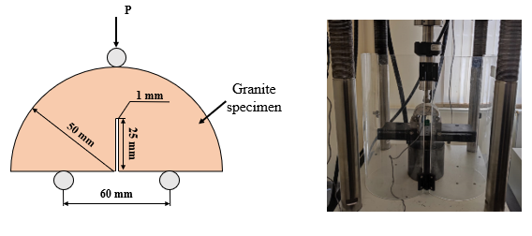
Fig. 1 - Granite specimen dimensions and setup

Results and discussion. The graph in Figure 2 shows the results of fracture toughness tests done on granite after subjecting them to different hot and cold temperatures. The sample only treated at 50 °C acted as the reference, and the other samples were heated to 100 °C, 200 °C, and 400 °C before being frozen in liquid nitrogen for one hour. Each test was duplicated twice to improve the reliability of the data and cut down on measurement mistakes. The specimens without any treatment reached their highest peak load at 50 °C, while peak load in the others became lower with both thermal and cryogenic treatment. With temperatures going up during preheating, more and larger microcracking was found. Elevated temperatures caused more damage to the material, which LN₂ only made worse, resulting in a drop in its ability to hold weight.
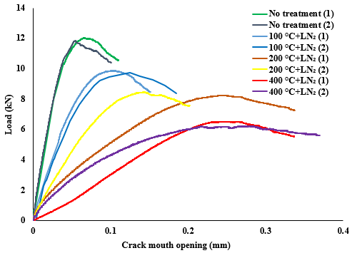
Fig. 2 - Load vs crack mouth opening curves from fracture toughness tests

The same fracture toughness test samples showed the load-displacement curves that can be seen in Figure 3. The untreated samples at 50 ⁰C had the biggest strengths and could handle more pressure in the experiments, since their graphs showed steeper curves. In contrast, when samples were put through a mix of heat and freezing, they were less strong when stretched and moved more before breaking, especially in the samples that were heated up to 400°C and then cooled down with liquid nitrogen. This behavior shows that over time, the material gets weaker because of things like expansion when it gets hot, the development of tiny cracks, and shrinkage when it gets cold. As these effects add up, the stone slowly gets softer and less sturdy, which then results in it being less able to hold up to tension.
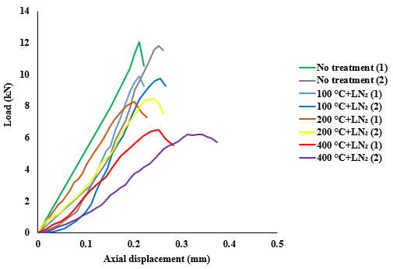

Fig. 3 - Load vs axial displacement curves after fracture toughness tests

The results of Figure 4 show the stress intensity factor results from fracture toughness tests, with each pre-treatment compared to the reference group preheated at 50 °C. When the pre-heating temperature is raised, the material strength is seen to decrease, indicated by a drop in peak stress intensity factors. In both experiments, the sharpest drop in the value of stress intensity factor was found under the 400 °C + LN₂ condition, with a value of 0.91 MPa·m¹ᐟ². Cooling the granite rapidly using LN₂ after heating it to a high temperature turned out to be the best type of experiment for inflicting internal damage on the sample. Matching results between both experiments and the trend seen support the accuracy of the findings.
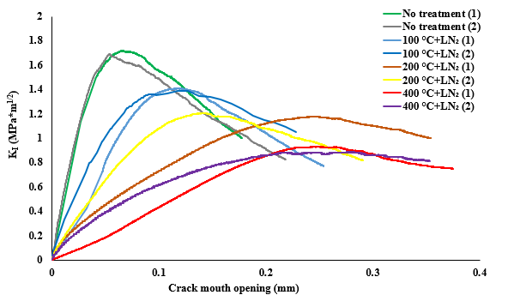

Fig. 4 - Mode I stress intensity factor vs crack mouth opening curves after fracture toughness tests

Figure 5 highlights the difference in mechanical behavior of granite when subjected to thermal and cryogenic loading, by using fracture energy as a measure. Fracture energy shows the total effort needed to break apart a sample of rock and is a sign of toughness. The best fracture-resistance was seen in the granite samples preheated only to 50 °C, as they were still largely intact and without damage.
Fracture energy was reduced by an average of 0.906 J when the granite was heated at 100 °C and then quickly cooled with LN₂ in the first two experimental trials. It seems that when rocks go through a brief heating period and then a sudden, extreme cooling, it causes internal fractures that lower the strength of the rock. If thermal pre-treatment is made more severe, the material becomes more vulnerable to cracking and breaking. Compressive tests for samples treated at 200 °C and then exposed to LN₂ resulted in a fracture energy of 0.939 J, showing that the material had grown more fragile.
Among all cases, the ones heated at 400°C and cooled with LN₂ showed the lowest fracture energy of 0.831 J. The significant change from the reference condition means that major internal damage and a loss of bonding between materials occurred as a result of the thermal and cryogenic stress during the test. All in all, the results clearly show that higher preheat temperatures before LN₂ treatment result in considerably softer granite, proving the method’s success in improving fracturing of rocks for geothermal use.
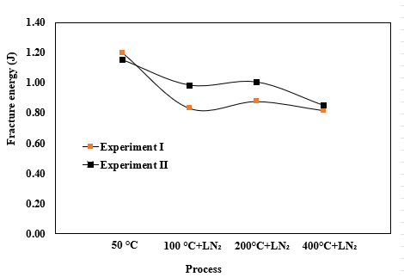
Fig. 5 - Fracture energy vs process after fracture toughness tests

Table 1 displays the fracture toughness results of granite specimens put through different thermal shock conditions. Without any treatment, the K_{I} factor was measured at 1.71 MPa·m¹ᐟ². Still, raising the temperature of the specimens and then suddenly lowering it with liquid nitrogen caused an obvious drop in their fracture toughness. There was a drop of 17.8% in the K_{I} value in both trials when the temperature was set to 100 °C and LN₂ was added. Significant decreases in content occurred at higher degrees of preheating. The first and second trials both saw decreases of 31.4% and 28.4% after using 200 °C + LN₂. Using 400 °C + LN₂ caused the most noticeable declines, with a change of 45.8% and 47.4% in trials 1 and 2, respectively. We clearly see a certain pattern in the results. A higher temperature during the preheating stage tends to bring down the fracture toughness of granite before it is treated with LN₂. The research confirms that the level of damage to rocks after LN₂ exposure increases along with the duration of preheating, showing a proper relationship between the damage caused by long-term exposure and high-temperature conditions.

Table 1 - Effect of increase in temperature along with LN₂ to the peak values of mode I intensity factor values

Specimen | Treatment | Peak value of K_{I} | Stepwise Difference | Difference from Baseline | Average value of K_{I} peaks
 |  | (MPa*m^{1/2}) | (%) | (%) | (MPa*m^{1/2})
1 | No | 1.72 | - | - | 1.71
2 | No | 1.69 | - | - | 1.71
1 | 100+LN₂ | 1.41 | -17.8 | -17.8 | 1.40
2 | 100+LN₂ | 1.39 | -17.7 | -17.7 | 1.40
1 | 200+LN₂ | 1.18 | -16.5 | -31.4 | 1.19
2 | 200+LN₂ | 1.21 | -13.1 | -28.4 | 1.19
1 | 400+LN₂ | 0.93 | -21.0 | -45.8 | 0.91
2 | 400+LN₂ | 0.89 | -26.5 | -47.4 | 0.91

Conclusion. Akmola granite samples were studied through an experimental process using liquid nitrogen (LN₂) temperatures to see how it affected preconditioned granite. The evaluation involved carrying out fracture toughness tests, checking the load-displacement curve, and getting readings of the fracture energy and stress intensity factors. The key findings from the study are as follows:
- Preheating over 400 °C with LN₂ caused a continuous reduction in load-bearing, and the group with the highest preheated temperature showed the least ability to support a high load.
- When materials were pre-treated at higher temperatures along with liquid nitrogen, the amount of fracture energy they absorbed reduced. Combining heat and cryogenic cracking greatly reduced the amount of effort required to overcome the resistance of the granite.
- Calculations of K_{I}, a standard measure for toughness, revealed that LN₂ makes cracks grow more effectively at higher preheating temperatures.
- All of the samples proved to fail in the same qualitative way during treatment under LN₂, still variations were noticed in the fracture energy and toughness at different temperature levels.
The results taken together show that exposing granite to heat and flash-freezing it significantly reduces its strength, making it a useful strategy for helping break up rocks in geothermal energy production.
Funding. This research was financially supported by Nazarbayev University (Funder Project Reference:021220CRP2022).
I would like to express my sincere gratitude to Dr. Sotirios Longinos for his valuable guidance, support, and insightful suggestions throughout the course of this research.

References

1. McDaniel B.W., Grundmann S.R., Kendrick W.D., Wilson D.R., Jordan S.W. Field applications of cryogenic nitrogen as a hydraulic fracturing fluid // SPE annual technical conference and exhibition. Society of Petroleum Engineers. - 1997. DOI 10.2118/38623-MS.
2. Anderson R.L., Ratcliffe I., Greenwell H.C., Williams P.A., Cliffe S. and Coveney P.V. Clay swelling-a challenge in the oilfield // Earth-Science Reviews. - 2010. - Vol. 98(3). - P. 201-216. DOI 10.1016/j.earscirev.2009.11.003.
3. Longinos S.N. and Hazlett R. Cryogenic fracturing efficacy in granite rocks: Fracture toughness and brazilian test differences after elevated temperatures and liquid nitrogen exposure // Geoenergy Science and Engineering.- 2025.- Vol. 244. -P. 213436. DOI 10.1016/j.geoen.2024.213436.
4. Dai F. and Xia K.W., 2013. Laboratory measurements of the rate dependence of the fracture toughness anisotropy of Barre granite // International Journal of Rock Mechanics and Mining Sciences.- 2013. - Vol. 60. - P.57-65. DOI 10.1016/j.ijrmms.2012.12.035.
5. Longinos S.N., Skrzypacz P. and Hazlett R. Cryofracturing effectiveness using liquid nitrogen on granite: Fracture toughness and Brazilian tests following freezing-thawing cycle// Results in Engineering.- 2024. - Vol. 21 (2): 101895. DOI 10.1016/j.rineng.2024.101895.
6. Zhuang D., Yin T., Li Q., Wu Y., Chen Y. and Yang Z.,. Fractal fracture toughness measurements of heat-treated granite using hydraulic fracturing under different injection flow rates // Theoretical and Applied Fracture Mechanics.- 2022.-Vol.119:103340. DOI 10.1016/j.tafmec.2022.103340.
7. Longinos S., Tuleugaliyev M., Begaliyev D. and Hazlett R., 2023. Effects of High Temperature and Liquid Nitrogen Cooling: A Case Study of granite rocks from Kazakhstan // CEST-18th International Conference on Environmental Science and Technology. – 2023. DOI 10.30955/gnc2023.00161.
8. Yang R., Hong C., Liu W., Wu X., Wang T., Huang Z. "Non-contaminating cryogenic fluid access to high-temperature resources: Liquid nitrogen fracturing in a lab-scale Enhanced Geothermal System // Renewable Energy. -2021. - Vol. 165. - P. 125-138. DOI 10.1016/j.renene.2020.11.006.
9. Ishida T., Aoyagi K., Niwa T., Chen Y., Murata S., Chen Q., Nakayama Y. Acoustic emission monitoring of hydraulic fracturing laboratory experiment with supercritical and liquid CO_{2 //} Geophysical Research Letters. - 2012. - Vol. 39(16): 16309. DOI 10.1029/2012GL052788.
10. Gallup D.L. Production engineering in geothermal technology: a review // Geothermics. - 2009. - Vol. 38(3). - P. 326–334. DOI 10.1016/j.geothermics.2009.03.001.
11. Begaliyev D. Laboratory investigation of cryofracturing potential to stimulate geothermal reservoirs in Kazakhstan / Doctoral dissertation, Nazarbayev University. - 2024.
12. Zhang D. and Tingyun Y. Environmental impacts of hydraulic fracturing in shale gas development in the United States // Petroleum Exploration and Development. - 2015. - Vol. 42(6). - P. 876-883. DOI 10.1016/S1876-3804(15)30085-9.
13. Yin T., Bai L., Li X., Li X. and Zhang, S. Effect of thermal treatment on the mode I fracture toughness of granite under dynamic and static coupling load // Engineering Fracture Mechanics. – 2018. -Vol. 199. - P. 143-158. DOI 10.1016/j.engfracmech.2018.05.035.
14. Cai C., Huang Z., Li G., Gao F., Wei J. and Li R. Feasibility of reservoir fracturing stimulation with liquid nitrogen jet // Journal of Petroleum Science and Engineering. - 1016. -Vol. 144. - P.59-65. DOI 10.1016/j.petrol.2016.02.033.
15. Longinos S.N., Begaliyev D. and Hazlett R. Experimental and simulation study of cryogenic stimulation of granites from Akmola region in Kazakhstan // Geomechanics for Energy and the Environment. - 2025. - Vol. 41. - P.100635. DOI 10.1016/j.gete.2024.100635.
16. Zhenlong G., Sun Q., Yang T., Luo T., Hailiang J., and Yang D. Effect of high temperature on mode-I fracture toughness of granite subjected to liquid nitrogen cooling //Engineering Fracture Mechanics. - 2021.- Vol. 252:107834. DOI 10.1016/j.engfracmech.2021.107834.
17. Breede K., Dzebisashvili K., Liu X., Falcone G. A systematic review of enhanced (or engineered) geothermal systems: past, present and future//Geotherm Energy.- 2013.-Vol.11-4) - P.2-27.DOI 10.1186/2195-9706-1-4.
18. Ge Z., Sun Q., Xue L. and Yang T. The influence of microwave treatment on the mode I fracture toughness of granite// Engineering Fracture Mechanics.-2021.-Vol.249:107768. DOI 10.1016/j.engfracmech.2021.107768.
19. Longinos S.N. Pore structure analysis by mercury intrusion and nitrogen adsorption after LN2 treatment: An experimental study for granite rocks in ‘O’field, Kazakhstan // Geoenergy Science and Engineering. – 2025. – Vo. 252. - P.213953. DOI 10.1016/j.geoen.2025.213953.
20. Zhang S. et al. Numerical and experimental analysis of hot dry rock fracturing stimulation with high-pressure abrasive liquid nitrogen jet // Journal of Petroleum Science and Engineering. - 2018. - Vol. 163. - P. 156-165. DOI 10.1016/j.petrol.2017.12.068.

Information about the authors
Begaliyev D.T.- NJSC “West Kazakhstan Agrarian and Technical University named after Zhangir khan”, master of technical sciences, Uralsk, Kazakhstan, dastan.begaliyev@wkau.kz;
Zhumagaliyeva N.M.- NJSC “West Kazakhstan Agrarian and Technical University named after Zhangir khan”, master of technical sciences, Uralsk, Kazakhstan, zhumagaliyeva.nurzhamal@inbox.ru;
Kupeshova A.S.- NJSC “West Kazakhstan Agrarian and Technical University named after Zhangir khan”, senior lecturer, Uralsk, Kazakhstan, kupeshova.altynay@mail.ru;
Zholbasarova A.T.- NJSC “Caspian State University of Technologies and Engineering named after S.Yessenov”, candidate of technical sciences, associate professor, Aktau, Kazakhstan, аkshyryn.zholbassarova@yu.edu.kz;
Kydrashov A.B.- NJSC “West Kazakhstan Agrarian and Technical University named after Zhangir khan”, PhD doctor, associate professor, Uralsk, Kazakhstan, a.kydrashov@mail.ru;
Burkhanov B.Zh.- NJSC “West Kazakhstan Agrarian and Technical University named after Zhangir khan”, candidate of technical sciences, associate professor, Uralsk, Kazakhstan, aruka73@mail.ru;
Abdiev A.R.- Kyrgyz Mining and Metallurgical Institute named after academician U.Asanalieva, doctor of technical sciences, professor, Bishkek, Kyrgyzstan, arstanbek.abdiev@kstu.kg.

ҒТАМР 52.47.19

ШТАНГАЛЫ СОРАПТАРМЕН ЖАБДЫҚТАЛҒАН ҰҢҒЫМАЛАРДЫҢ СОҢҒЫ ИГЕРУ САТЫСЫНДАҒЫ ЖҰМЫСЫН ДИАГНОСТИКАЛАУ ЖӘНЕ ТАЛДАУ ӘДІСТЕМЕСІ

¹М.Ж. Досжанов, ²Ю.А. Нифонтов, ³Ғ.Ж. Тасболат, ¹Е.Т. Қодар, ⁴Н.С.Сүлейменов, ¹Л. Бисенбайқызы, ¹А.М. Төлегенова
¹Қызылорда «Болашақ» университеті, Қызылорда, Қазақстан,
²Санкт-Петербург мемлекеттік теңіз техникалық университеті, Санкт-Петербург, Ресей,
³Қ. Құлажанов атындағы Қазақ технология және бизнес университеті, Астана, Қазақстан,
⁴Қорқыт Ата атындағы Қызылорда университеті, Қызылорда, Қазақстан

Корреспондент - автор: galymzhan_zh@mail.ru

Ұңғымалық штангалы сорғы қондырғылары (ШСҚ) аз дебитті және жоғары сулы қабаттарды игеру кезінде кеңінен қолданылатын, мұнай ұңғымаларының сенімді және үнемді пайдалану жабдығы болып табылады. Штангалы сорғылар көмегімен мұнай өндіру – олардың қарапайымдылығы, тиімділігі және сенімділігімен түсіндірілетін жасанды көтерудің ең кең таралған әдістерінің бірі. Алайда ШСҚ пайдалану кезінде күрделі факторлар жиі туындайды: сорғының қабылдауында жоғары газ құрамы, айдалатын сұйықтықтағы механикалық қоспалардың жоғары мөлшері, сорғы-компрессорлік құбырларда (СКҚ) парафиндер мен асфальт-шайыр заттарының шөгуі.
Бұл мақалада кен орындарын игерудің соңғы кезеңінде ШСҚ жұмысын кешенді диагностикалау әдіснамасы ұсынылған. Сулылығы жоғары шартты ұңғымаларға тән ақауларды анықтау үшін динамограммалар мен эхограммаларды талдауға ерекше назар аударылған. Қондырғылардың жұмысын оңтайландыру бойынша тәжірибелік ұсыныстар әзірленген, оларға газ бөлгіштерді қолдану және қабаттың түпкі аймағына гидроимпульстік әсер ету кіреді. Қазақстан кен орындарының жағдайына ұсынылған шешімдердің тиімділігін растайтын өндірістік зерттеулердің нәтижелері келтірілген.
Әдіснама қабатқа импульстік әсер етудің толық циклын бақылауға және мұнай өндіруді арттыру технологияларының тиімділігін талдауға мүмкіндік береді. Зерттеу нәтижелері кен орындарын игерудің соңғы кезеңінде ШСҚ пайдалану сенімділігін арттыруға және жабдықтың жөндеу аралық мерзімдерін ұзарту бойынша тәжірибелік маңызға ие.
Түйін сөздер: штангалы сорғы қондырғылары, диагностика, динамограмма, эхограмма, жоғары суланған ұңғымалар, газ құрамы, игерудің соңғы кезеңі.

МЕТОДИКА ДИАГНОСТИКИ И АНАЛИЗА РАБОТЫ СКВАЖИН, ОБОРУДОВАННЫХ ШТАНГОВЫМИ НАСОСАМИ, НА ПОЗДНЕЙ СТАДИИ РАЗРАБОТКИ

¹М.Ж. Досжанов, ²Ю.А. Нифонтов, ³Г.Ж. Тасболат, ¹Е.Т. Кодар, ⁴Н.С.Сулейменов,
¹Л. Бисенбайкызы, ¹А.М. Толегенова
¹Кызылординский университет «Болашак», Кызылорда, Казахстан,
²Санкт-Петербургский государственный морской технический университет, Санкт-Петербург, Россия,
³Казахский университет технологии и бизнеса имени К. Кулажанова, Астана, Казахстан,
⁴Кызылординский университет им. Коркыт Ата, Кызылорда, Казахстан,
е-mail: galymzhan_zh@mail.ru

Скважинные штанговые насосные установки (ШСНУ) являются надежным и экономичным эксплуатационным оборудованием нефтяных скважин, широко применяемым при разработке малодебитных и высокообводненных пластов. Добыча нефти при помощи штанговых насосов – один из самых распространенных способов искусственного подъема, что объясняется их простотой, эффективностью и надежностью. Однако при эксплуатации ШСНУ часто возникают осложняющие факторы: высокое газосодержание на приеме насоса, повышенное содержание механических примесей в откачиваемой жидкости, отложение парафинов и асфальтосмолистых веществ в насосно-компрессорных трубах (НКТ).
В данной статье предложена комплексная методика диагностики работы ШСНУ на поздней стадии разработки месторождений. Особое внимание уделено анализу динамограмм и эхограмм для идентификации специфических неисправностей, характерных для условий высокообводненных скважин. Разработаны практические рекомендации по оптимизации работы установок, включая применение газосепараторов и гидроимпульсного воздействия на призабойную зону пласта. Представлены результаты промысловых исследований, подтверждающие эффективность предложенных решений для условий казахстанских месторождений.
Методика позволяет проводить мониторинг полного цикла импульсных воздействий на пласт и анализировать эффективность применяемых технологий увеличения нефтеотдачи. Результаты исследований имеют практическую значимость для повышения эксплуатационной надежности ШСНУ и увеличения межремонтных периодов работы оборудования на завершающей стадии разработки месторождений.
Ключевые слова: штанговые насосные установки, диагностика, динамограмма, эхограмма, высокообводненные скважины, газосодержание, поздняя стадия разработки.

METODOLOGY FOR DIAGNOSING AND ANALYZING THE PERFORMANCE OF WELLS EGUIPPED WITH ROD PUMPS AT THE LATE STRAGE OF DEVELOPMENT

¹M.Zh.Doszhanov, ²I.A.Nifontov, ³G.Zh.Tasbolat, ¹E.T.Kodar, ⁴N.S.Suleimenov,
¹L. Bisenbaikyzy, ¹A.M. Tolegenova
¹Kyzylorda Bolashak University, Kyzylorda, Kazakhstan,
²Saint-Petersburg state marine technical University, Saint-Petersburg, Russia,
³K. Kulazhanov Kazakh University of Technology and Business, Astana, Kazakhstan,
⁴Korkyt Ata Kyzylorda University, Kyzylorda, Kazakhstan,
е-mail: galymzhan_zh@mail.ru

Sucker rod pump installations (SRPIs) are reliable and cost-effective production equipment for oil wells, widely used in the development of low-rate and highly water-cut reservoirs. Oil production using sucker rod pumps is one of the most common artificial lift methods, which is explained by their simplicity, efficiency, and reliability. However, during the operation of SRPIs, complicating factors often arise: high gas content at the pump intake, increased content of mechanical impurities in the produced fluid, deposition of paraffins and asphaltene-resinous substances in the tubing strings.
This article proposes a comprehensive methodology for diagnosing the operation of SRPIs at the late stage of field development. Special attention is paid to the analysis of dynamometer cards and echograms to identify specific malfunctions characteristic of highly water-cut wells. Practical recommendations have been developed for optimizing the operation of installations, including the use of gas separators and hydraulic pulse impact on the near-wellbore zone of the reservoir. The results of field studies confirming the effectiveness of the proposed solutions for the conditions of Kazakhstani fields are presented.
The methodology allows monitoring the full cycle of impulse impacts on the reservoir and analyzing the effectiveness of the applied technologies for enhanced oil recovery. The research results are of practical importance for improving the operational reliability of SRPIs and increasing the inter-repair periods of equipment operation at the final stage of field development.
Keywords: sucker rod pump installations, diagnostics, dynamometer card, echogram, highly water-cut wells, gas content, late stage of development.

Кіріспе. Қазіргі уақытта Қазақстандағы ірі мұнай кен орындарының едәуір бөлігі игерудің соңғы сатысында орналасқан, бұл кезең ұңғымалар өнімі құрамындағы судың жоғары мөлшерімен сипатталады. Ұңғыма өнімінің сулануы штанг колоннасында коррозиялық үдерістердің дамуына ықпал етеді, ал бұл процестер штангалы ұңғымалық сорап қондырғыларын пайдалану барысында туындайтын динамикалық ауыспалы жүктемелермен бірігіп, металл құрылымына деструктивті әсерін күшейтеді. ШСҚ қолдану шарттары мен оларды пайдалану тәжірибесі көрсеткендей, металл штангаларда шаршау үдерістерінің (динамикалық жүктемелер мен коррозияның бірлескен әсері) дамуына түрлі факторлар ықпал етеді, нәтижесінде тереңдік сорап жабдықтарының бұзылуы мен істен шығуына алып келеді. Мұндай факторларға ұңғыма өнімінің сулануы, ілеспе судың минералдану деңгейі, штанг колоннасының материалы, ұңғыма оқпанының еңіс бұрышы (үйкеліс пен коррозияның жиынтық әсері), сулануға бейімділік (ұңғыма үзіліспен жұмыс істеген жағдайда, сораптағы ағып кетулер немесе төгу клапанының болу), штангалардың жаңалығы және сорап жетегінің жұмыс режимі жатады [1,2].
Бұл зерттеу мұнай кен орындарын игерудің соңғы сатысында штангалы сорғы қондырғыларының (ШСҚ) жұмысын кешенді диагностикалау әдістемесін әзірлеуге арналған. Тақырыптың өзектілігі соңғы кезеңдегі игеруде жиі кездесетін жоғары сулану, газ факторының өсуі және қабат энергиясының төмендеуі сияқты қиындықтармен байланысты. Бұл факторлар ШСҚ жұмысына кері әсер етіп, өнімділікті төмендетеді және жабдықтың тозуын тездетеді.
Зерттеудің мақсаты - соңғы кезеңдегі ШСҚ жұмысын диагностикалауға және оңтайландыруға бағытталған кешенді әдістеме әзірлеу.
Зерттеу міндеттері: соңғы кезеңдегі негізгі техникалық қиындықтарды талдау (сулану, газ факторы, тозу), динамограмма мен эхограмма деректерін жинақтау және жүйелеу, газ бөлгіштерді қолдану тиімділігін бағалау, гидроимпульстік әсердің суланған қабаттарға әсерін зерттеу, алынған нәтижелер негізінде практикалық ұсыныстар әзірлеу.
Зерттеудің ғылыми жаңалығы динамограмма мен эхограммаларды біріктіретін интеграцияланған диагностикалық тәсілдің әзірленуінде жатыр.
Қазақстан үшін маңыздылығы - елімізде ірі мұнай-газ кен орындарының бірі Оңтүстік Торғай ойпаты ағымдағы кезеңде игерудің соңғы сатысында тұр, бұл жетілдірілген диагностика әдістерін қолдануды талап етеді.
Зерттеу нәтижелері ШСҚ жұмысын үздіксіз бақылау жүйесін құруға және жабдық ақауларын алдын алуға мүмкіндк береді. Бұл әсіресе қазіргі экономикалық жағдайда операторларға айтарлықтай үнемдеуге мүмкіндік береді.
Соңғы кезеңдегі игеруде ШСҚ диагностикасының тиімді әдістемесін әзірлеу мұнай өндіру тиімділігін арттырудың маңызды факторы болып табылады. Сондай-ақ жөндеу аралық кезеңін ұзарту және жабдықтың істен шығуын азайту өндірістік тұрғыдан ғана емес, ғылыми тұрғыдан да маңызды міндетке айналады. Жоғарыда аталған кен орнын зерттеу негізінде бірнеше ұңғымалардағы ШСҚ және ЭОСҚ (электр ортадан тепкіш сорғы қондырғы) сорғылар жүйесінің істен шығу себептеріне салыстырмалы талдау жүргізілді (1-сурет).
Талдау жүйесі жабдық сенімділігін арттыруға негізделген диагностика әдістерін жетілдіруге және ұңғымаларды игерудің соңғы кезеңінде тиімді басқару шешімдерін ұсынуға мүмкіндік береді.

1-сурет. Оңтүстік Торғай ойпаты кен орнындағы ұңғымалық сорғы жүйесі істен шығуының салыстырмалы көрсеткіші

Мұнай мен газ өндіруді оңтайландыру мақсатында ұңғымалардың жұмысын бақылау және талдау үшін динамограммалар қолданылады. Олар ақауларды уақытылы анықтап, жою бойынша белгіленген іс-шараларды дер кезінде жүзеге асыруға мүмкіндік береді. Мұндай ақауларға жеткілікті көңіл бөлінбеген жағдайда, олар айтарлықтай экономикалық шығындарға алып келуі мүмкін [3,4].
ШСҚ сорғылары келесі жағдайларда жарамсыз деп танылады:
- плунжер (бөлінбейтін сораптар үшін) ұзындығы кемінде 1200 мм болатын сорап-
компрессорлық құбырлармен (СКҚ) қосылған цилиндрге өтпеген жағдайда;
- плунжердің төлқұжатта көрсетілген нөмері мен өлшемі нақты мәндерге сәйкес
келмеген жағдайда; егер нөмері сәйкес сәйкес келмесе, бірақ өлшемі сәйкес келсе, пайдалану төлқұжатына нақты деректер енгізіледі;
- хром жабынының тұтастығы бұзылған жағдайда (қабыршақтану, сызаттар, жарықтар
және т.б.);
- сорап құрамында кем дегенде бір пайдаланылған бөлшек анықталған жағдайда;
- хромдау процесінен кейін цилиндр мен плунжер беттерінде дөрекі өңдеу іздері
байқалған жағдайда.
Ұңғымаларда жүргізілетін жұмыстардың сипаты көбінесе олардың пайдалану тәсіліне, ұңғымаға түсірілген жер асты жабдығының түріне, сондай-ақ жер асты және жер үсті жабдықтарының жұмыс істеу жағдайына байланысты. Ұңғымаларды пайдалану тәсілдері мен қолданылатын жабдықтар туралы білімсіз маман тек жұмысты орындай алмай қалады, сонымен қатар мұндай жұмыстар апатқа немесе жазатайым оқиғаға алып келуі мүмкін.
Аталған факторлар жер қойнауынан мұнайды неғұрлым толық өндіруді қамтамасыз етуге бағытталған кен орындарын игеру кезінде туындайтын ең өзекті ғылыми-техникалық мәселелердің бірі болып табылады. Бұл мәселені шешуді күрделендіретін жағдай – мұнай кен орындарының басым көпшілігінің игеру жұмыстарының кеш сатысында өтуі. Мұндай жағдайда ауқымды материалдық-техникалық және еңбек ресурстарын тарту қажеттілігі туындайды. Қазіргі уақытта көптеген кен орындарында мұнай өндіруді тұрақтандыру міндеті қойылып отыр. Өнімді қабаттар, негізінен, жоғары аймақтық және қабаттық біртексіздігімен, бастапқы мұнаймен қанығуы мен өткізгіштігінің төмендігімен, сондай-ақ кең көлемді су-мұнай аймақтарының болуымен сипатталады (2-сурет) [5,6].
Бұл зерттеу жұмысының әдіснамасы жүйелік талдау қағидаттарына негізделген. Зерттеу барысында ұңғыма жұмысының гидродинамикалық процестері кешенді түрде қарастырылып, динамограммалар мен эхограммалар талданып, олардың негізінде сорап қондырғысының тиімділігін арттыруға арналған инженерлік ұсыныстар әзірленді.

2-сурет. Ұңғымалардың өнімділігі және сұйықтықты көтеру биіктігі бойнша шекаралары

Әдеби шолу. Ұңғымалық штангалы сорап қондырғылары қарапайым құрылымымен, сенімділігі және қызмет көрсету тиімділігімен ерекшеленіп, мұнай өндірудің соңғы кезеңдерінде кеңінен қолданылады. 3-суретте арқан штангаларымен жабдықталған ұңғымалық сорап қондырғысының типтік схемасы көрсетілген. Қондырғы негізінен жер бетіндегі жетек, штангалар тізбегі және плунжерлі сораптан тұрады. Жетек қозғалысы штангалар арқылы ұңғыма түбіне беріледі де, плунжердің ілгерілемелі қозғалысын қамтамасыз етеді. Бұл жүйе мұнай қабатынан сұйықты жер бетіне шығару процесін жүзеге асырады.
Қазіргі таңда кен орындарын игеру объектілері бойынша мұнай қайтарымын арттырудың үшінші реттік әдістерін қолдануға қатысты ауқымды зерттеулер жинақталған. Алайда мұнай алуды арттыруға бағытталған бірқатар технологияларды қолдану жиі тиімсіз болып жатады, бұл көбінесе олардың нақты геологиялық-өндірістік жағдайларға жеткілікті бейімделмеуіне байланысты. Аталған әдістерді ұтымды пайдалану қажеттілігінің туаындауына байланысты, мұнай қорларын геологиялық-технологиялық тұрғыдан сәйкестендіру, құрылымдастыру жұмыстарын жүргізу және қалдық мұнай қорларын тиімді өндіру жүйелерін жетілдіру міндеті алға қойылды [7].
Аталған технологияларды қолдану әрбір нақты жағдайда мұнайды барынша өндіру және экономикалық тұрғыдан тиімділік қағидаларына негізделуі тиіс. Осыған орай, әрбір технологияны енгізбестен бұрын, кен орнын игерудің жан-жақты геологиялық-технологиялық талдауы, геологиялық және гидродинамикалық модельдеу, сондай-ақ нақты геологиялық-физикалық жағдайларға сәйкес технологияны қолданудың көп критерийлі бағалауы жүргізілуі қажет.
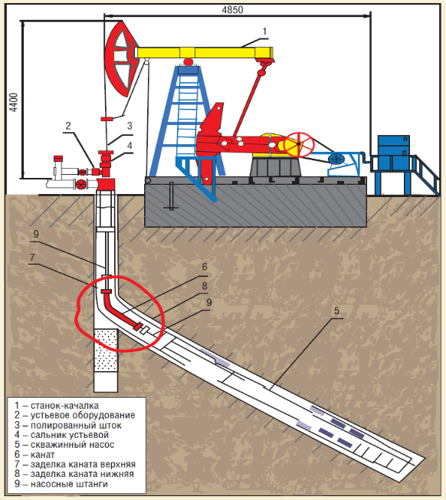

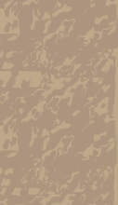

3-сурет. Арқан штангаларымен жабдықталған үңғымалық сорап қондырғысының типтік схемасы: 1-тербелмелі станок; 2-сағалық жабдық; 3-жылтырлатылған шток; 4-сағалық сальник; 5-ұңғымалық сорғы; 6-арқан; 7-арқанның жоғарғы бітеуі; 8-арқанның төменгі бітеуі; 9-сорғы штангалары.

Мұнай қорларын ұтымды өндіру үшін үңғыманың түп маңы аймағына тиімді әсер ету әдістерін әзірлеу және қолдану – қазіргі таңда маңызды міндеттердің бірі болып отыр. Бұл бағыттағы зерттеулер қалдық қорларды өндірудің тиімділігін арттырып, кен орындарын игерудің соңғы сатыларында мұнай бергіштікті жақсартуға мүмкіншілік береді.
Соңғы онжылдықта ШСҚ диагностикасы саласында цифрлық технологиялардың енуі айтарлықтай жетістіктерге қол жеткізді. Заманауи динамографтар мен эхолокациялық жүйелер нақты уақыт режимінде деректерді жинақтауға және өңдеуге мүмкіндік береді. Сонымен қатар, арнайы бағдарламалық жасақтамалар динамограммаларды автоматты түрде талдауға және ақауларды диагностикалауға мүмкіндік береді. Мысалы, искусственный интеллект негізіндегі жүйелер ШСҚ жұмысының аномалияларын алдын ала анықтай алады [8, 9].
Халықаралық тәжірибеде ШСҚ мониторингінің жаңа әдістері қолданыс табуда. АҚШ және Канадада бұл саладағы зерттеулер негізінен предиктивтік аналитикаға бағытталған. Осы мақсатта машиналық үйрену әдістері, сенсорлық желілер және бульттық деректерді талдау қолданылады. Осы технологиялардың тиімділігі бірқатар ірі мұнай компанияларымен расталған [10].
Қазақстандық зерттеулер негізінен жергілікті геологиялық-өндірістік ерекшеліктерге бағытталған. Соңғы жылдары гидродинамикалық модельдеудің жаңа әдістері әзірленді, олар ШСҚ жұмысын оңтайландыруға мүмкіндік береді. Дегенмен, әлі күнге дейін заманауи халықаралық тәжірибені желіктеу қажеттілігі сақталуда.
Осылайша, әдебиеттерді талдау көрсеткендей, ШСҚ диагностикасы саласындағы заманауи зерттеулер негізінен цифрлық технологияларды енгізуге бағытталған. Бұл бағыттағы жұмыстарды одан әрі жалғастыру, әсіресе Қазақстан жағдайына бейімделген әдістемелер әзірлеу өзекті мәселе болып табылады.
Материалдар мен әдістер. Бұл зерттеуде штангалы сорап қондырғыларының жұмысын диагностикалау үшін стандартты әдістер кешені қолданылды. Әдістемелік тұрғыда олар жеке аналитикалық блоктарға бөлініп, әрқайсысы нақты кезеңдер мен міндеттерді қамтыды.
Бақылау кезеңі.
Динамометрлік тексеру - плунжер жүрісінің күш-жүктеме диаграммаларын алу үшін жер бетіндегі жетек пен штангаларға орнатылған динамометрлер қолданылды.
Эхолокацияны өлшеу - плунжер қозғалысының нақты ұзындығы мен сорап цилиндрінің толу дәрежесін бағалау үшін эхолокациялық құрылғылар пайдаланылды.
Талдау кезеңі.
Алынған динамограммалар визуалды және сандық әдістермен талданды: қалыпты режим, газ әсері, сулану және механикалық ақаулардың белгілері сараланды.
Эхограммалар арқылы плунжер қозғалысының тұрақтылығы, жүріс ұзындығындағы өзгерістер және цилиндр толу коэффициентінің динамикасы анықталды.
Интерпретация кезеңі.
Динамометрлік және эхолокациялық деректер салыстырылып, газ құрамының артуы мен суланудың сорап тиімділігіне ықпалы есептелді.
Қолданылған әдістердің нәтижелері жүйелік талдау негізінде біріктіріліп, сорап қондырғыларының жұмысындағы әлсіз тұстар анықталды.
Зерттеу негізінен нақты өндірістік жағдайларда алынған деректерге сүйенді. Эмпирикалық материалды жинау үшін ай сайынғы динамограммалар, ұңғымадағы сұйық деңгейін өлшеу нәтижелері, сондай-ақ газ факторы бойынша сынамалар пайдаланылды. Бұл деректер нәтижелердің сенімділігін қамтамасыз етті.
Ұңғымадағы гидроимпульстік қондырғының жұмысын зерттеу және бақылау, сондай-ақ ақаулардың себептерін анықтау үшін штангалы тереңдік сораптармен жабдықталған ұңғымаларды зерттеуге арналған стандартты жабдық қолданылады. Себебі, технологиялық шектеулерге байланысты мұндай ұңғымаларда жалпы өндірістік өлшеу жабдықтарын пайдалану мүмкін емес [11].
Гидробұрылыс шамасын есептеу үшін тұрақталған жұмыс режиміне сәйкес келетін түптік қысымды тікелей немесе жанама әдістермен анықтау қажет.
Түптік қысымды тікелей өлшеу үшін диаметрі 22-25 мм болатын шағын габаритті ұңғымалық манометрлер қолданылады. Мұндай аспаптар штангалы сорапты қондырғының ұңғыма сағасындағы сорап-компрессорлық құбырларды эксцентрикалық ілу жағдайында планшайбадағы тесіктер арқылы болат сыммен аралық кеңістікке түсіріледі. Осы тәсілмен алынған түптік қысым мәліметтері ең сенімді болып табылады. Алайда, терең және иілген ұңғымаларда немесе құбырлар арасындағы саңылау тым тар болған жағдайда манометрдің қысылып қалуы немесе сымның үзілуі орын алуы мүмкін. Мұндай жағдайлардың алдын алу мақсатында гидроимпульстік қондырғының қабылдау патрубкасына бекітіліп, сорап-компрессорлық құбырлармен (СКҚ) бірге ұңғымаға түсірілетін, лифтілік ұңғымалық манометрлер деп аталатын арнайы аспаптар қолданылады. Бұл әдіс зерттеу нәтижелерінің жеткілікті сенімділігін қамтамасыз етеді, дегенмен лифтілік манометрді ұңғымаға түсіру және оны қайта шығару үшін көтеріп-түсіру операцияларын орындау қажеттілігімен байланысты. Осы себепті мұндай өлшеулер әдетте, ұңғымада кезекті жөндеу жұмыстары немес қондырғыны ауыстыру барысында жүргізіледі [12].
Нәтижелердің жоғары дәлдігіне қарамастан, бұл әдістердің еңбек сыйымдылығы мен технологиялық тиімсіздігіне байланысты олар кеңінен қолданыс таппаған. Осыған орай, түптік қысымды анықтаудың анағұрлым технологиялық тұрғыдан тиімді жолы - аралық кеңістіктегі сұйықтықтың динамикалық деңгейінің тереңдігін эхолоттар немесе толқын өлшегіштер арқылы өлшеу негізінде жүзеге асырылатын жанама әдістері болып табылады.
Аспаптың жұмыс принципі келесідей, аралық кеңістікке дыбыстық импульс жіберіледі, ол сұйықтық деңгейінен шығылысып, ұңғыма сағасына қайта оралады және қабылдаған сигналды тіркейтін құрылғымен байланысқан микрофон арқылы қабылданады. Бұл микрофон күшейткіш арқылы сигналдарды тіркеуші аспаппен қосылады. Динамикалық деңгейдің тереңдігі - диаграммада бастапқы импульс пен сұйықтық деңгейінен шағылған сигналға сәйкес келетін екі шыңның арақашықтығын өлшеу арқылы анықталады. Дыбыстық сигнал ұңғыма сағасынан сұйықтық деңгейіне дейінгі аралықты екі рет (бару және қайту) жүріп өтетіндіктен және газды ортада дыбыстың таралу жылдамдығы белгілі болған жағдайда, сұйық деңгейінің тереңдігі келесі қатынас бойынша есептеледі [13]:

$S=ϑ∙\frac{t}{2}$(1)
мұнда:
$S$ - сұйықтық деңгейінің тереңдігі;
$t$ - импульс берілген сәттен бастап шағылған сигналдың қайтып келу уақыты, бұл уақыт ішінде сигнал $2S$ жол жүреді;
$ϑ$ - аралық кеңістіктегі газ ортасында дыбыстың таралу жылдамдығы.
Мұндай әдіспен сұйық деңгейін анықтаудың бірқатар кемшіліктері бар.
Аралық кеңістіктегі дыбыс жылдамдығы $ϑ$ газдың қысымына, температурасына және тығыздығына тәуелді. $ϑ$ мәнін анықтаудағы қателік сұйық деңгейінің тереңдігін $S$ анықтаудағы нәтижеге тікелей әсер етеді.
Бір ұңғымада сұйықтықты өндірудің әртүрлі режимдеріне сәйкес бірнеше $S$ мәні өлшеніп, олардың орташа шамалары есептелген жағдайда, қателіктер азаяды, өйткені $ϑ$ мәніндегі жүйелі қате барлық өлшенген $S$ шамаларына бірдей әсер етеді.
Ұңғымааралық кеңістікте көбіктенген сұйықтықтың болуы деңгейден шағылған сигналдың анық қабылдануын қиындатады және бұл эхолот арқылы өлшеу әдісіне тән жалпы кемшілік болып табылады. Сондықтан өлшеу жүргізер алдында аралық кеңістіктен газды шығару жұмыстарын жүргізбеу аса маңызды, өйткені бұл сұйықтықтың көбіктенуіне алып келуі мүмкін. Алайда бұл талапты әрдайым сақтау мүмкін емес, себебі кейбір хлопушка түріндегі сағалық жабдықтарда арнайы бұрандалы тығынмен жабылатын ұңғыма сағасы плитасындағы тесіктер арқылы газ шығатын арналар қарастырылған. Сондай-ақ, сұйықтық алу режиміне сәйкес келетін түптік қысымды деңгей арқылы анықтау үшін, сұйық деңгейі мен ұңғыма түбі арасындағы сұйық бағанының орташа тығыздығын білу қажет екенін атап өткен жөн. Алайда бұл тығыздық сұйықтықтың сулану дәрежесіне және газ құрамына тәуелді болғандықтан, оны дәл анықтау едеәуір қиындық туғызады [14].
Қазіргі заманғы жоғары смезімтал эхолоттар СКҚ колоннасының әрбір муфтасынан шағылған сигналдарды тіркей алады. Мұндай жағдайда сұйықтық деңгейінің тереңдігі эхограммада сұйық деңгейіне сәйкес келетін сигналға дейінгі пик саны арқылы анықталады және бұл сан бір құбырдың ұзындығына көбейтіледі. Аспап муфталардың үстіңгі бөліктерінен шағылған сигналдарды электрлік сүзгілер көмегімен бөлуге, үлкен тереңдікте орналасқан муфталардан шағылған сигналдарды айқындауға, сондай-ақ үлкен тереңдіктер жағдайында сұйықтық деңгейінен шағылған негізгі сиганлды анықтауға мүмкіндік береді.
Хлопушкада немес оның бүйірлік тармағында шағылған сигналдарды қабылдауға арналған кварцты сезімтал микрофон орнатылады. Эхолоттардың кейбір конструкцияларында микрофонның орнына термофондар қолданылады. Микрофон дыбыстық сигналдарды электрлік сигналдарға түрлендіріп, оларды күшейткішке жібереді. Күшейткіште өлшенетін сигналды бөліп көрсету және кедергілерді басу үшін үш арналы сүзгі жүйесі қарастырылған. Сонымен қатар, күшейткіште сезімталдықты реттейтін құрылғы мен сигналды жазуға арналған цифрлық блок бар.
Хлопушка патрубогы аралық кеңістіктегі ысырманың фланецңне газды шығарусыз қосылады және 2,5 МПа-ға дейінгі қысымда өлшеулер жүргізуге мүмкіндік береді.
Сондай-ақ, сұйықтықты алу режиміне сәйкес келетін түптік қысымды деңгей бойынша анықтау үшін, сұйық деңгейі мен ұңғыма түбі арасындағы сұйық бағанының орташа тығыздығын білу қажет екенін атап өткен жөн. Бұл тығыздық сұйықтықтың сулану дәрежесіне және газ құрамына тәуелді болғандықтан, оны дәл анықтау едәуір қиындық туғызады [15,16].
Сипатталған кемшіліктерге қарамастан, заманауи технологиялар эхолокациялық өлшеулердің сенімділігін едәуір арттырды. Жоғары сезімтал эхолоттар күрделі сандық сүзгілерді және сигналдарды жинақтау алгоритмдерін қолданады, бұл сұйықтық деңгейінен алынған әлсіз пайдалы сигналды СКҚ муфталарынан немесе көбіктен туындаған күшті кедергілер аясынан бөліп алуға мүмкіндік береді. Негізгі жүйелі қателікті - дыбыс жылдамдығын (ϑ) дәл анықтамаудан туындайтын ауытқуды - азайту үшін озық әдістер белгілі тереңдіктегі шағылдырғышқа (мысалы, муфта немесе пакер) қатысты аспапты калибрлеуді ұсынады. Бұл нақты ұңғы жағдайларына сәйкес дыбыс жылдамдығын есептеуге және соңғы нәтиженің дәлдігін айтарлықтай арттыруға мүмкіндік береді.
Маңыздысы - эхолот деректерін жеке-дара қарастыруға болмайды. Ең дәл нәтижелер кешенді интерпретация кезінде алынады, яғни аспап көрсеткіштері ұңғы жұмысына қатысты басқа деректермен: динамограммалармен, дебитпен, сулану деңгейімен және газ факторы көрсеткіштерімен салыстырылады. Бұдан бөлек, аса маңызды ұңғыларда немесе эхолот деректерін мерзімді тексеру үшін эталондық өлшеу әдісі қолданылады, ол үшін түпке тереңдік манометрлері түсіріледі. Бұл әдіс сұйық бағанының деңгейі мен тығыздығы арқылы есептелуге байланысты қателіктерді айналып өтіп, түптік қысымды тікелей өлшеуге мүмкіндік береді.
Нәтижелер және талқылау. Бұл әдіс қондырғы жұмысының эхограммасын тіркеуге мүмкіндік береді және ол пластқа берілетін импульстік әсерлердің толық циклін бақылау мен талдау үшін де қолданылады. Қабатқа әсер ету цикліне имплозиялық және гидроимпульстік соққы түріндегі импульстардың белгілі бір тізбегі кіреді. Эхолотпен сигнал жазу уақыты 32 секундпен шектелген, бұл станок-тербелгіштің жылдамдығы 5 тербеліс/мин болған жағдайда қондырғы жұмысының толық циклін жазуға толық жеткілікті.
Қондырғы жұмысының бақылау динамометрия әдісі арқылы жүзеге асырылады. Динамограмма штангаларды орын ауысуына байланысты жылтыр штоктағы жүктеменің өзгеруін көрсетеді және осы мәліметтерді математикалық өңдеу нәтижесінде плунжердің нақты орын ауысуы анықталады (4-сурет). Динамограммаларды тіркеу үшін күшті өлшейтін тіркеуші аспаптар – динамометрлер қолданылады. Қолдануға ыңғайлы болу үшін олар эхолоттармен біріктірілген түрде шығарылады.

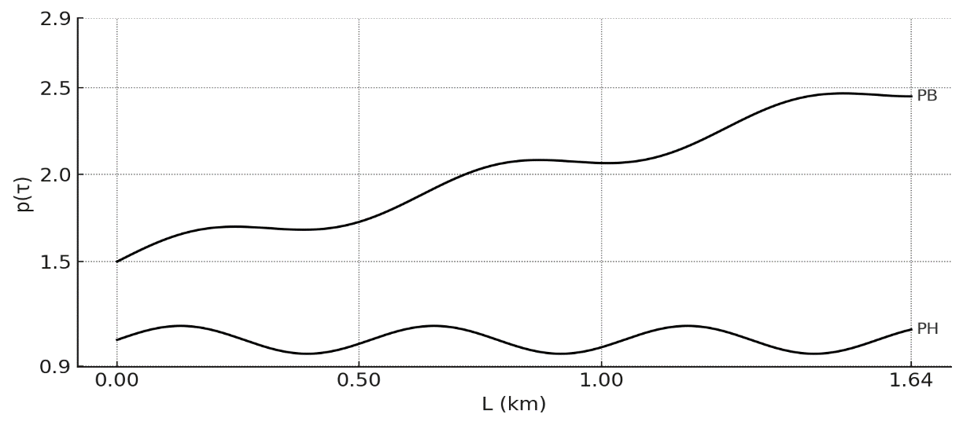
4-сурет. ШСҚ қалыпты жұмысы бойынша динамограмма көрсеткіші

Динамограмма арқылы анықталатын ШСҚ-дың ақаулықтары: қабылдау клапанындағы ағып кету; айдау клапанындағы ағып кету; газдың әсері; газдың әсерінен берілудің үзілуі; плунжердің тығыз орналасуы немесе қысыла қозғалуы; плунжердің төмен орналасуы; плунжердің жоғары орналасуы; плунжердің төмен жүріс соңында қысылы қозғалысы; плунжер жұбының тозуы; плунжердің цилиндрен толық шығуы; айдау клапанының жабылуының кешеуілдеуі; қабылдау клапанының жабылуының кешеуілдеуі; қабылдау және айдау клапан -
дарының жабылуының бір мезгілде кешеуілдеуі; қабылдау және айдау клапандарының бітеліп қалуы; құбырлардағы ағып кету; қабылдау клапанындағы ағып кетулер; айдау клапаны ашық, бірақ сұйықтық берілмейді; айдау клапанындағы ағып кету салдарынан берілудің үзілуі;
штангалардың плунжердің немесе айдау клапанының бұралып босап кетуі; плунжердің тығыз орналасуы.
Көп жағдайда сорғы жұмысына газдың әсері нәтижесінде ақаулықтар туындайды, бұл цилиндрдің толу коэффициентінің төмендеуіне алып келеді (5-сурет). Сорғы штангалы колоннасы арқылы көтерілетін сұйықтықтың құрамындағы бос газдың болуы скважина өнімділігі мен дебитінің төмендеуіне себеп болуы мүмкін, өйткені газ сорғы цилиндріндегі сұйықтық алуы тиіс көлемді толықтай немесе ішінара алып қояды.
Еркін газдың әсері кезінде динамограмма пішіні көбінесе, сорғы берілісі ұңғымадағы өнім ағынынан асып түсіп, сорғы қабылдауындағы қысым күрт төмендеген жағдайдағы динамограммаға ұқсас болады. Мұндай жағдайда ұңғыманы қысқа мерзімді тоқтатқаннан кейін қатарынан тіркелетін динамограммалардың пішініне мұқият талдау жасалады. Егер сорғының беру мөлшері ұңғыманың өнім ағысынан артық болса, онда ұңғыманы тоқтатқаннан кейінгі алғашқы динамограмма (6-сурет, динамограмма 1) сорғы цилиндрінің сору жүрісінде толық толуын көрсетеді. Ал кейіннен тіркелетін динамограммалар 2,3 және 4 біртіндеп еркін газдың әсеріне тән пішінді қабылдай бастайды. Пунктир сызықпен жоғарыда көрсетілген жағдайларға сәйкес келетін теориялық динамограмма белгіленген.

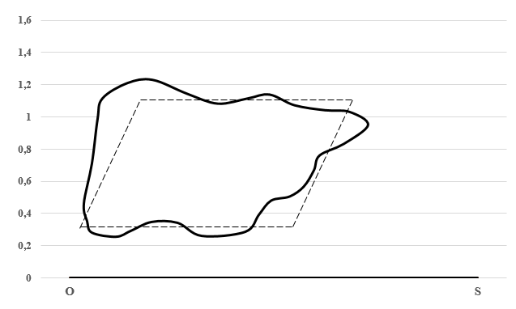
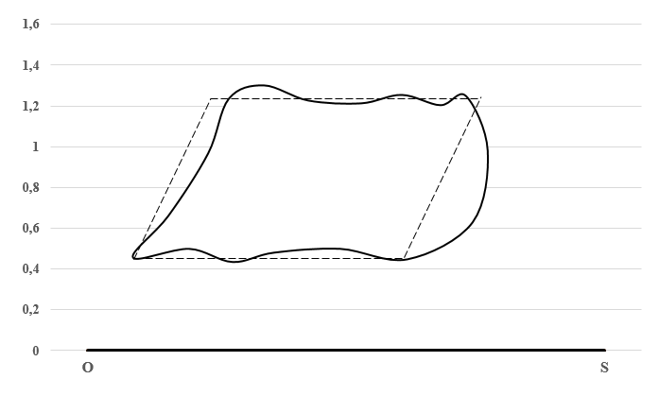

а) б)
5-сурет. Бос газдың әсері жағдайындағы динамограммалар
а - төмен қысымда газ қарқынды түрде бөлініп шығып, цилиндр көлемінің бір бөлігін алып қояды. Бұл жағдайда динамограмма «ішке қарай майысқан» және жұмыс аймағының көлемі азайған - бұл цилиндрдің толық толмауын және сұйықтық берілісінің төмендеуін көрсетеді; б - жоғары қысымда газ еріген күйде қалып, аздап ғана бөлінеді, сондықтан динамограмма формасы салыстырмалы түрде тұрақты, бірақ әлі де толымсыздық байқалады. Плунжер жүрісінің соңғы кезеңінде сұйықтық орнына газ толып, сорғы жұмысына кедергі келтіреді.

Мұндай мәселелерді шешудің бір жолы - газ сепараторларын қолдану болып табылады, бұл ұңғыма өнімділігін арттырып, сорғының бұзылу қаупін азайтады.

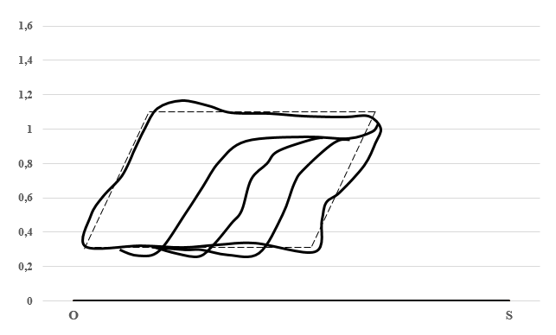

1
2
3
4

6-сурет. Сорғы берілісі ұңғыма өнімі ағыныан асып түсетін жағдайдағы типтік динамограммалар
1 - ұңғыманы тоқтатқаннан кейін сорудың жұмыс жүрісінде цилиндрдің қалыпты толуы. Ұңғыманы қысқа мерзімді тоқтатқаннан кейінгі бірінші сорап айналымы. Бұл кезде түптен сұйықтық толық көлемде келіп, цилиндр толық толады. Динамограммада бұл қалыпты теориялыққа жақын пішінмен сипатталады; 2,3,4 - бірінші динамограмма алынғаннан кейін белгілі уақыт аралығында тіркелген динамограммалар. Келесі айналымдарда сұйықтық көлемі азайып, оның орынна еркін газ көтеріле бастайды. Цилиндр іші ішінара сұйықтықпенғ ішінара газбен толады. 2→3 динамограмма пішіні біртіндеп тарылып, ішке қарай майысады, толымсыздық көрсетеді. 3→4 бұл газлифттік эффект немесе сору кезінде газдың көлем алып қоюы салдарынан пайда болатын құбылыс.

Сонымен қатар, эхограммалар мен динамограммаларды кешенді талдау тек қана типтік ақауларды анықтап қана қоймай, қолданылып жатқан технологиялық шешімдердің тиімділігін де бағалауға мүмкіндік береді. Мысалы, газ бөлгіштерді қолдану немесе станок-качалканың жұмыс режимін өзгерту динамограммада айқын өзгерістерге әкеледі: цилиндрдің толу коэффициенті артады, қисықтың формасы бірқалыпты болып, теориялық қисыққа жақындайды. Бұл еркін газдың әсерінің азайғанын және сұйықтық алудың тиімділігінің артқанын көрсетеді. Осылайша, қондырғы жұмысына мониторинг жүргізу әдістері ұңғыманы пайдалану технологиялық режимін оңтайландыруға және жүргізілген шаралардың нәтижелілігін бағалауға құнды ақпарат береді.
Ұсынылған әдістеменің тиімділігі өндірістік сынақтар кезінде расталды. Газ сепараторларын қолдану цилиндр толу коэффициентін 0,75-тен 0,92-ге дейін арттыруға мүмкіндік берді, бұл өнімділікті 18-22%-ға арттырды. Гидроимпульстік әсерлеу тәсілі қабаттың өткізгіштігін жақсартып, сұйықтық алу деңгейін 15%-ға дейін арттырды. Алынған нәтижелер ШСҚ диагностикасында интеграцияланған тәсілдің тиімділігін растайды.
Қорытынды. Қазіргі уақытта штангалы сорғы қондырғыларын (ШСҚ) пайдалану мұнай өндірудің басқа әдістерімен салыстырғанда әлемдік тәжірибеде ұңғымалар саны бойынша бірінші орында тұрады. Мысалы, АҚШ-та ұңғымалардың 86%-ы, ал Батыс Еуропада 90%-ы ШСҚ-мен жабдықталған. Дегенмен, практикада ШСҚ-ны пайдалану кезінде ұңғыма дебиті мен өнімділігінің төмендеуіне, жабдық элементтерінің тозуының артуына және экономикалық тиімділіктің азаюына әкелетін күтпеген жағдайларды болдырмай қалу мүмкін емес.
Жүргізілген зерттеу нәтижелері ШСҚ жұмысын диагностикалауда динамограмма мен эхограммаларды біріктіретін кешенді тәсілдің тиімділігін растады. Газ сепараторларын қолдану цилиндр толу коэффициентін 15-20% арттырып, ал гидроимпульстік әсерлеу сұйықтық алу деңгейін 15%-ға дейін жоғарылатты. Динамограммаларды талдау арқылы 30-дан астам түрлі ақауларды, соның ішінде клапандардың ағып кетуін, газ әсерін және механикалық бұзылуларды анықтауға болатындығы дәлелденді.
Зерттеу барысында әзірленген әдістемелерді өндіріске енгізу ШСҚ-ның жөндеу аралық мерзімін 25-30%-ға ұзартуға, апаттық тоқтауларды азайтуға және өндірістік шығындарды төмендетуге мүмкіндік береді. Алынған нәтижелер мұнай өндірудің соңғы кезеңінде ШСҚ-ны тиімді пайдаланудың жаңа мүмкіндіктерін ашады және оларды одан әрі жетілдіру бағыттарын анықтайды.

Әдебиеттер

1. Ананьев В.П., Потапов А.Д., Филькин Н.А. Специальная инженерная геология: Учебник / М.: Инфра-М. - 2016. -С.111-125. ISBN 978-5-16-010407-2.
2. Galeev A.S., ArslanovR.I., Suleymanov R.N., Filimonov O.V. Development of a method for wireless information transmission in wells equipped with sucker rod pump units //Journal of Physics: Conference Series. -2020. -Vol. 1661: 012003. DOI 10.1088/1742-6596/1661/1/012003.
3. Добров Э.М. Инженерная геология: Учебник / М.: Издательский центр «Академия». - 2008. -С.151-178. ISBN 978-5-7695-2890-3.
4. Коробейников А.Ф. Геология прогнозирование и поиск месторождений полезных ископаемых: Учебник для бакалавриата и магистратуры // Люберцы: Юрайт. -2016. -С.10-98. ISBN 978-5-4387-0175-0.
5. Кочеков М.А. Повышение эффективности эксплуатации штанговых насосных установок в высокообводненных скважинах. Автореферат дис..канд.тех. наук: 25.00.17.- Уфа,2014.- 132 с.
6. Мухаметзянов А.К., Чернышов И. Н., Липерт А. И., Ишемгужин С. Б. Добыча нефти штанговыми насосами/ - М.: Недра. -1993. -350 c. ISBN 5-247-02488-5.
7. Уразаков К.Р., Богомольный Е.И., Сейтпагамбетов Ж.С., Газаров А.Г. Насосная добыча высоковязкой нефти из наклонных обводненных скважин / М.: Недра. - 2003. -303 c. ISBN 5-8365-0121-1.
8. Ковшов В.Д., Сидоров М.Е., Светлакова С.В. Динамометрирование, моделирование и диагностирование состояния глубинной штанговой насосной установки // Известия вузов. Нефть и газ. -2011.- № 3. - С.26-30.
9. Fakher S., Khlaifat A., Hossain M.E. et al. A comprehensive review of sucker rod pumps’ components, diagnostics, mathematical models, and common failures and mitigations// Journal of Petroleum Exploration and Production Technology.-2021.-Vol.11(10).-P.3815–3839. DOI 10.1007/s13202-021-01270-7.
10. Гилаев Г.Г., Бахтизин Р.Н., Уразаков К.Р. Современные методы насосной добычи нефти: монография // Уфа: Восточная печать. -2016. - 410 с. ISBN 978-5-905220-72-1.
11. Ковшов В.Д., Сидоров М.Е., Светлакова С.В. Моделирование динамограмм на квазистационарных режимах работы ГШН //Известия вузов. Нефть и газ. -2015. -№ 4.- С.51-56.
12. Валовский В.М., Валовский К.В. Цепные приводы скважинных штанговых насосов/ М.: ОАО «ВНИИОЭНГ». -2004. -С.350-415. ISBN 5-88595-140-1.
13. Попов А.Л., Вихарев А.Н., Абанов А.Э., Теселкин М.В., Штанговые скважинные насосные установки: конструирование и расчет: учебное пособие/ Северный (Арктический) федеральный университет им. М.В. Ломоносова: САФУ. -2016.-С.37-72. ISBN978-5-261-01172-9.
14. Досжанов М.Ж., Жубанов О.Н., Султанбеккызы А. Вопросы математического моделирования процессов разработки трудоизвлекаемых и высоковязких запасов нефти// The Way of Science №1(1). -2014. -С.100-102. ISSN 2311-2158.
15. Досжанов М.Ж., Қойлыбаев Б.Н., КаражановаМ.К., Ахметов Д.А., Тасболат Г.Ж., Анализ развития трещин автогидроразрыва на нагнетательных скважинах//Научный журнал «Нефть и газ».-2021 -№1(121). -С.69-76. DOI 10.37878/2708-0080/2021-1.05.
16. Сейтжанов С.С., Тасболат Г.Ж., Сүлейменов Н.С., Танжариков П.А., ДосжановМ.Ж. Кен орнының сарқылуы жағдайында мұнай ұңғымасының көлденең учаскесінің ағымдағы ұзындығын анықтау әдісі//«ҚазТБУ хабаршысы».-2024.- №4(25).- Б.289-297. DOI 10.58805/kazutb.v.4.25-637.
References

1. Anan'ev V.P., Potapov A.D., Fil'kin N.A. Special'naja inzhenernaja geologija: Uchebnik / M.: Infra-M. - 2016. -S.111-125. ISBN 978-5-16-010407-2. [in Russian]
2. Galeev A.S., ArslanovR.I., Suleymanov R.N., Filimonov O.V. Development of a method for wireless information transmission in wells equipped with sucker rod pump units //Journal of Physics: Conference Series. -2020. -Vol. 1661: 012003. DOI 10.1088/1742-6596/1661/1/012003.
3. Dobrov Je.M. Inzhenernaja geologija: Uchebnik / M.: Izdatel'skij centr «Akademija». - 2008. -S.151-178. ISBN 978-5-7695-2890-3. [in Russian]
4. Korobejnikov A.F. Geologija prognozirovanie i poisk mestorozhdenij poleznyh iskopaemyh: Uchebnik dlja bakalavriata i magistratury // Ljubercy: Jurajt. -2016. -S.10-98. ISBN 978-5-4387-0175-0. [in Russian]
5. Kochekov M.A. Povyshenie jeffektivnosti jekspluatacii shtangovyh nasosnyh ustanovok v vysokoobvodnennyh skvazhinah. Avtoreferat dis..kand.teh. nauk: 25.00.17.- Ufa,2014.- 132 s. [in Russian]
6. Muhametzjanov A.K., Chernyshov I. N., Lipert A. I., Ishemguzhin S. B. Dobycha nefti shtangovymi nasosami/ - M.: Nedra. -1993. -350 c. ISBN 5-247-02488-5. [in Russian]
7. Urazakov K.R., Bogomol'nyj E.I., Sejtpagambetov Zh.S., Gazarov A.G. Nasosnaja dobycha vysokovjazkoj nefti iz naklonnyh obvodnennyh skvazhin / M.: Nedra. - 2003. -303 c. ISBN 5-8365-0121-1. [in Russian]
8. Kovshov V.D., Sidorov M.E., Svetlakova S.V. Dinamometrirovanie, modelirovanie i diagnostirovanie sostojanija glubinnoj shtangovoj nasosnoj ustanovki // Izvestija vuzov. Neft' i gaz. -2011.- № 3. - S.26-30. [in Russian]
9. Fakher S., Khlaifat A., Hossain M.E. et al. A comprehensive review of sucker rod pumps’ components, diagnostics, mathematical models, and common failures and mitigations// Journal of Petroleum Exploration and Production Technology.-2021.-Vol.11(10).-P.3815–3839. DOI 10.1007/s13202-021-01270-7.
10. Gilaev G.G., Bahtizin R.N., Urazakov K.R. Sovremennye metody nasosnoj dobychi nefti: monografija // Ufa: Vostochnaja pechat'. -2016. - 410 s. ISBN 978-5-905220-72-1. [in Russian]
11. Kovshov V.D., Sidorov M.E., Svetlakova S.V. Modelirovanie dinamogramm na kvazistacionarnyh rezhimah raboty GShN //Izvestija vuzov. Neft' i gaz. -2015. -№ 4.- S.51-56. [in Russian]
12. Valovskij V.M., Valovskij K.V. Cepnye privody skvazhinnyh shtangovyh nasosov/ M.: OAO «VNIIOJeNG». -2004. -S.350-415. ISBN 5-88595-140-1. [in Russian]
13. Popov A.L., Viharev A.N., Abanov A.Je., Teselkin M.V., Shtangovye skvazhinnye nasosnye ustanovki: konstruirovanie i raschet: uchebnoe posobie/ Severnyj (Arkticheskij) federal'nyj universitet im. M.V. Lomonosova: SAFU. -2016.-S.37-72. ISBN978-5-261-01172-9. [in Russian]
14. Doszhanov M.Zh., Zhubanov O.N., Sultanbekkyzy A. Voprosy matematicheskogo modelirovanija processov razrabotki trudoizvlekaemyh i vysokovjazkih zapasov nefti// The Way of Science №1(1). -2014. -S.100-102. ISSN 2311-2158. [in Russian]
15. Doszhanov M.Zh., Қojlybaev B.N., KarazhanovaM.K., Ahmetov D.A., Tasbolat G.Zh., Analiz razvitija treshhin avtogidrorazryva na nagnetatel'nyh skvazhinah//Nauchnyj zhurnal «Neft' i gaz».-2021 -№1(121). -S.69-76. DOI 10.37878/2708-0080/2021-1.05. [in Russian]
16. Sejtzhanov S.S., Tasbolat G.Zh., Sүlejmenov N.S., Tanzharikov P.A., DoszhanovM.Zh. Ken ornynyң sarқyluy zhaғdajynda mұnaj ұңғymasynyң kөldeneң uchaskesіnің aғymdaғy ұzyndyғyn anyқtau әdіsі//«ҚazTBU habarshysy».-2024.- №4(25).- B.289-297. DOI 10.58805/kazutb.v.4.25-637. [in Russian]

Авторлар туралы мәліметтер

Досжанов М.Ж. - техникалық ғылымдар докторы, профессор, Қызылорда «Болашақ» университеті, Қызылорда, Қазақстан, е-mail: doszhanov55@mail.ru;
Нифонтов Ю.А. - техника ғылымдарының докторы, профессор, Санкт-Петербург мемлекеттік теңіз техникалық университеті, Санкт-Петербург, Ресей, е-mail: nifontov@yandex.ru;
Тасболат Ғ.Ж. - техника ғылымдарының магистрі, сеньор-лектор, Қ. Құлажанов атындағы Қазақ технология және бизнес университеті, Астана, Қазақстан, е-mail: galymzhan_zh@mail.ru;
Қодар Е.Т. - техника ғылымдарының кандидаты, доцент, Қызылорда «Болашақ» университеті, Қызылорда, Қазақстан, e-mail: erdenkodar@inbox.ru;
Сүлейменов Н.С. - техника ғылымдарының кандидаты, Қорқыт Ата атындағы Қызылорда университеті, Қызылорда, Қазақстан, е-mail: nurzhan_suleymen@mail.ru;
Бисенбайқызы Л. - аға оқытушы, Қызылорда «Болашақ» университеті, Қызылорда, Қазақстан, e-mail: lyazzat84_bu@mail.ru;
Төлегенова А.М. - техника ғылымдарының магистрі, аға оқытушы, Қызылорда «Болашақ» университеті

Information about the authors

Doszhanov M. - Doctor of Technical Sciences, Professor, Kyzylorda Bolashak University, Kyzylorda, Kazakhstan, е-mail: doszhanov55@mail.ru;
Nifontov I. - Doctor of Technical Sciences, Professor, Saint-Petersburg state marine technical University, Saint-Petersburg, Russia, е-mail: nifontov@yandex.ru;
Tasbolat G. - Master of Technical Sciences, Senior Lecturer, K. Kulazhanov Kazakh University of Technology and Business, Astana, Kazakhstan, е-mail: galymzhan_zh@mail.ru;
Kodar E. - Candidate of Technical Sciences, Associate Professor, Kyzylorda Bolashak University, Kyzylorda, Kazakhstan, е-mail: erdenkodar@inbox.ru;
Suleimenov N.S. - Candidate of Technical Sciences, Korkyt Ata Kyzylorda University, Kyzylorda, Kazakhstan, e-mail: nurzhan_suleymen@mail.ru;
Bisenbaikyzy L. - Senior, Kyzylorda Bolashak University, Kyzylorda, Kazakhstan, е-mail: lyazzat84_bu@mail.ru;
Tolegenova A. - Master of Technical Sciences, Senior Lecturer, Kyzylorda Bolashak University, Kyzylorda, Kazakhstan, е-mail: smk_bolashak@mail.ru.

IRSTI 86.40

SAFETY ENGINEERING FOR WIND TURBINE HEIGHT OPERATIONS: A CRITICAL REVIEW OF ISO/OSHA/EN STANDARDS

¹L.M. Aktayeva, ¹A.M. Koshayeva , A.B.Bekmagambetov , ¹A.M.Rakhmetova , ¹E.A.Kulmagambetova , ²G.K.Daumova
¹Republican Research Institute for Occupational Safety, Astana, Kazakhstan,
²Kazakhstan Regional Branch of the Republican Research Institute for Occupational Safety, Ust-Kamenogorsk, Kazakhstan
Corresponding author: koshayeva12@gmail.com

The article examines the main standards that apply to high-altitude work in the wind energy industry. Such documents are necessary to regulate and ensure safety at all stages of the life cycle of "green" energy production, with special attention to be paid to the most hazardous areas of activity, including high-altitude work. Based on this, a critical analysis of the requirements and standards in the selected countries is carried out, the standards used and the percentage of uncountable cases in the process of high-altitude work at stations are compared. At the same time, each country adheres to the requirements of uniform international standards, but, if necessary, adopts its own requirements, specifically for certain types of stations, types of work, etc. In conclusion, a number of problematic aspects are put forward, the solution of which will contribute to increasing the level of safety at wind stations.
Keywords: wind energy, green energy, wind power plants, high-altitude work, standards, safety, labor protection, injuries.

ЖЕЛ ТУРБИНАЛАРЫНДАҒЫ ТЕХНИКАЛЫҚ ЖҰМЫСТАРДЫҢ ҚАУІПСІЗДІГІ: ISO/OSHA/EN СТАНДАРТТАРЫН ТАЛДАУ

¹Л.М. Актаева, ¹А.М.Кошаева, ¹ Ә.Б.Бекмағамбетов, ¹А.М.Рахметова, ¹ Э.А.Құлмағамбетова, ²Г.К.Даумова
¹Еңбекті қорғау жөніндегі Республикалық ғылыми-зерттеу институты, Астана, Қазақстан,
²Еңбекті қорғау жөніндегі Республикалық ғылыми-зерттеу институтының Шығыс-Қазақстан өңірлік бөлімшесі, Өскемен, Қазақстан,
e-mail: koshayeva12@gmail.com

Мақалада жел энергетикасы саласындағы биіктік жұмыстарына қолданылатын негізгі стандарттар қаралады. Мұндай құжаттар «жасыл» энергия өндірудің өмірлік циклінің барлық кезеңдерінде қауіпсіздікті реттеу және қамтамасыз ету үшін қажет, бұл ретте қызметтің неғұрлым қауіпті түрлеріне, оның ішінде биіктік жұмыстарына ерекше назар аударылады. Осы негізде таңдалған елдерде талаптар мен стандарттарға сыни талдау жүргізіледі, пайдаланылатын стандарттар салыстырылады және станциялардағы биіктік жұмыстары процесінде есептеуге жатпайтын жағдайлар пайызы салыстырылады. Бұл ретте әрбір ел бірыңғай халықаралық стандарттардың талаптарын ұстанады, бірақ қажет болған кезде арнайы станциялардың белгілі бір типтері, жұмыс түрлері және т.б. үшін өзінің жеке талаптарын қабылдайды. Қорытындысында жел станцияларындағы қауіпсіздік деңгейін арттыруға ықпал ететін бірқатар проблемалық аспектілер алға тартылады.
Түйін сөздер: жел энергиясы, жасыл энергия, жел электр станциялары, биіктік жұмыстары, стандарттар, қауіпсіздік, еңбекті қорғау, жарақаттар.

БЕЗОПАСНОСТЬ ТЕХНИЧЕСКИХ РАБОТ НА ВЕТРОВЫХ ТУРБИНАХ: КРИТИЧЕСКИЙ АНАЛИЗ СТАНДАРТОВ ISO/OSHA/EN

¹Л.М. Актаева, ¹А.М.Кошаева, ¹А.Б.Бекмагамбетов, ¹А.М.Рахметова, ¹Э.А.Кулмагамбетова, ²Г.К.Даумова
¹Республиканский научно-исследовательский институт по охране труда, Астана, Казахстан,
²Восточно-Казахстанское региональное отделение Республиканского научно-исследовательского института по охране труда, Усть-Каменогорск, Казахстан,
e-mail: koshayeva12@gmail.com

В статье рассматриваются основные стандарты, применимые к высотным работам в ветроэнергетической отрасли. Такие документы необходимы для регулирования и обеспечения безопасности на всех этапах жизненного цикла производства «зеленой» энергии, при этом особое внимание уделяется наиболее опасным видам деятельности, в том числе высотным работам. На этом основании проводится критический анализ требований и стандартов в выбранных странах, сравниваются используемые стандарты и процент не поддающихся подсчету случаев в процессе высотных работ на станциях. При этом каждая страна придерживается требований единых международных стандартов, но при необходимости принимает свои собственные требования, специально для определенных типов станций, видов работ и т. д. В заключение выдвигается ряд проблемных аспектов, решение которых будет способствовать повышению уровня безопасности на ветровых станциях.
Ключевые слова: ветровая энергия, зеленая энергия, ветровые электростанции, высотные работы, стандарты, безопасность, охрана труда, травмы.

Introduction. The popularity of using wind turbines is growing every year, this is due to the fact that wind energy has become one of the fundamental alternatives in energy production. Wind energy does not harm the environment, its production does not emit greenhouse gases and complies with the principles of the "green" economy, which all developing countries of the world strive to comply with. Thus, the government of many countries is currently moving away from the use of coal, oil, nuclear fuel and switching to the use of new, clean types of energy [1]. In this regard, there is a significant increase in the popularity of wind energy. Every year, the number of wind stations around the globe increases, their combined growth rate per year is about 11.6%.
At the same time, this growth is due to a number of factors, mainly the availability of financial and human resources that are used in the design and operation of installations, the achievements of scientific and technological progress, legislative support, as well as public assistance and assistance of numerous companies. However, with the development of a new industry, more precise standardization is required, as well as the development of new standards and requirements for both equipment and workers themselves. In the event of inaccuracies in these documents, violations or non-compliance with standards, some problems may arise.
With the increase in the number of wind power plants, the number of workers on them also increases, that is, the primary task should be labor protection and their health [2]. The duties and functions performed by workers at wind energy facilities are usually unique, this is due to the fact that in other industries there is no installation, assembly and maintenance of wind turbines [3]. The working environment is also unique, which provokes possible difficulties in the field of labor protection. Innovative work processes may contain new hazards that employees and administrative personnel must provide for and enshrine in the rules of conduct, as well as in the relevant documents (standards).
Wind energy is a new, modern direction in all countries, new workers may not fully understand what dangers await them when performing their duties. In addition, the technology in this area is developing quite rapidly, which can lead to a shortage of qualified personnel, and inexperienced workers create a great danger for themselves if they have not been trained and therefore can expose themselves to threats and violate safety installations.
Despite the fact that wind energy is considered quite useful for the environment, its production itself is not always useful and safe for workers. Often, at wind farms, employees can encounter dangers that ultimately lead to negative or fatal consequences. In this regard, the study and critical analysis of safety standards in this area is very relevant, since it is necessary to point out existing problem areas and maintain a high level of labor protection. Workplaces in this area must meet all safety requirements and not have a negative impact on the health of workers.
Daily, in order to reduce the possibility of negative and dangerous phenomena on personnel working at wind farms, their maintenance and inspection are carried out. It is organized under the safest conditions, since almost all wind turbines in developed countries have a short service life, and their manufacturers claim that the percentage of breakdowns is minimal, however, information about possible problems is presented poorly and incompletely, it is mainly supplemented during operation. Also, many workers point out that the danger in this area is at the same level as in any other industry. For example, falls from a height can occur both when working in the mining industry and when working on a wind turbine.
However, it is necessary to accept and take into account other specific conditions that may arise, for example, weather conditions or being in hard-to-reach areas. The combination of such conditions and the lack of experience and necessary qualifications of workers in the field of wind energy leads to problems with their health and safety in general. Over the past decade, according to experts, accidents at wind turbines have become more frequent, and their number is directly dependent on the number of new turbines, that is, the more turbines are built, the more accidents there are.
SWIF analyzes the number and basic information about accidents and incidents at various production facilities, including wind farms. Thus, since 1970, the number of accidents has reached 2,500 units, with most of them occurring in the last 3-5 years. On average, there are about 200 accidents per year that lead to negative consequences, and safety requirements are violated. However, not all accidents are fatal; for the same period since 1970, only 213 fatal cases were recorded. They mainly occurred during the construction or maintenance of wind turbines and turbines. Other cases occurred with workers in the transport sector, they were not directly related to the production of wind energy [4].
Also, since 2012, the company began recording data on the impact of wind turbines on human health, data on noise, vibration, etc. were analyzed. It is worth noting that not only workers suffer from such impacts, but also residents of nearby settlements. In recent years, 36 requests have been submitted and processed, in which people indicated that they have a negative impact from wind turbines. It is worth noting that every year the number of requests only increases, since in 2012 only 6 people sought help, and in 2023 already 12. Many scientists believe that these figures differ from the real ones, since wind turbines can have a more detrimental effect on both workers and residents of nearby settlements.
Based on this, a more detailed study of labor protection in the field of wind energy and an analysis of standards and requirements in various countries is needed.
Materials and мethods. In order to analyze the level of injuries and safety of high-altitude work at wind power plants, it is necessary to conduct a study of the standards that are used for labor protection in this area, consider possible risks, the number of injury cases, and formulate problematic aspects and directions that can be proposed to minimize possible risks and threats. As part of the scientific work, a critical analysis of the main safety standards of various countries was carried out, statistics of victims of accidents related to labor activities, including fatalities at wind power plants, were considered.
The purpose of this scientific article is to identify the existing methods of ensuring personnel safety at wind power plants in various countries, as well as to study possible problematic aspects [5].
At the same time, special methods of collecting information were used to achieve the goal: statistical analysis, with its help the number of injuries and other safety violations in the field of wind energy was considered; topographic method, with its help the location of wind power plants in a particular country was considered; monographic method, with its help the analysis of literature on the research topic is carried out, as well as the content of standards that are applied in this area, but in different countries.
Results and discussions. Currently, there are two main aspects that can cause problems in the field of labor protection and safety at wind farms. The first aspect is related to the fact that international regulations have not been developed properly, there are problems in standardization. The second aspect is related to the inexperience of workers and their low level of training and qualifications. Let's consider these aspects in more detail.
So, to begin with, it is worth paying attention to the training of workers in this area. As was said earlier, the wind energy industry began to actively develop relatively recently, in this regard, there is still no base of workers who would have significant experience and skills in the industry in question. Despite the fact that the number of jobs and graduates with similar training areas is growing every year, there is still a shortage of experts. The rapid development of the industry does not correspond to the speed of personnel training, many inexperienced workers can participate in the process of casing installations, turbines, which ultimately leads to safety violations and injuries [6]. The main reason that can lead to safety violations and injuries to workers with little experience is the lack of a single standard that would regulate the practical skills of workers in the wind energy sector. Currently, there are many different standards that define the rules of conduct for workers, but there is no common one that would regulate safety rules in the wind energy sector. Small companies do not have the necessary funds to train workers and familiarize them with various standards when working on land or at sea, in this regard, they have a low level of training and qualifications, which entails possible violations. Larger companies that have funds for training and familiarizing workers with all standards can often neglect this, since time is needed for training, and money can be directed to a more attractive direction.
However, all personnel who are at the wind farm are required to know the minimum safety requirements, which can be useful in various areas of work. Let's consider the safety requirements in more detail.
The first group of requirements relates to activities at height. In this case, the employee must know the safety precautions when working with turbines, take into account all the risks and dangers that he may encounter. He must also know the rules for handling personal protective equipment and the rules of conduct in an emergency. The employee must have rescue and evacuation devices. The second group of requirements includes the rules of conduct in the water, the employee must know how to move from a ship to a pier or to a wind turbine, how the global marine communication system is used, what personal protective equipment exists and how they are used in the water. The third group includes the rules for manual handling of goods, it includes knowledge of the methods of safe transportation of goods and special equipment for work, identifying aspects that can negatively affect health and cause injury, ways to prevent traumatic events and solve problems in the field of wind energy associated with improper movement of cargo and equipment [7]. The fourth is the standard rules for first aid, this includes knowledge and skills in providing assistance in case of injuries and illnesses, rules of conduct in emergency situations, methods of providing first aid to victims. The final group is behavior in case of fire hazard, workers must know the rules for preventing fires, be able to identify sources of ignition and quickly respond to a possible fire, assess the consequences of a fire. In general, it is worth noting that all companies operating in this industry strive to provide their employees with all the necessary knowledge, skills and abilities, with which they can not only perform assigned tasks, but also ensure a high level of safety. For this, special courses, training and retraining programs, training programs can be created, but at the same time, they are not always sufficient in full. According to scientists, in order to better improve the level of knowledge of personnel in the field of safety, it is necessary to create special courses on the basis of research institutes that would contain programs aimed at training workers in the wind energy sector. Within the framework of such programs, courses on the operation of turbines, their maintenance and safety at stations can be organized.
With the development of the wind energy sector, more and more experts in this field appear, with their help it is possible to reduce the shortage of unskilled personnel, transfer useful experience and information. Also, it is worth considering the creation of a special unified standard that will help in training new specialists. In addition, another solution for attracting highly qualified personnel may be their transition from other related industries. Such specialists will also be in demand in wind energy, since they will have experience and all the necessary knowledge. An example can be workers from the oil or gas sector, since their working conditions are similar to the area in question. All the presented conditions will have a positive impact on the wind energy industry in one way or another [8,9].
Next, it is worth moving on to considering specific requirements and standards that can be used in the field of labor protection in the framework of wind energy in different countries.
To begin with, it is worth paying attention and considering what standards in the field of safety of high-altitude work at a wind power plant are adopted in Kazakhstan. As in other developed countries, the government of Kazakhstan is aimed at developing a "green" economy, in this regard, a decision has also been made to develop the wind energy sector. Thus, with the help of investments of about 100 billion dollars, the development of a new type of energy in the country began in 2014. In order for the new industry to bring only a positive effect within the framework of the development program of the Republic of Kazakhstan and the joint project of the Ministry of Energy and Mineral Resources of the Republic of Kazakhstan, special sites for the construction of wind power systems (TPS) with a good wind climate, located in various regions of Kazakhstan were selected (Figure 1).

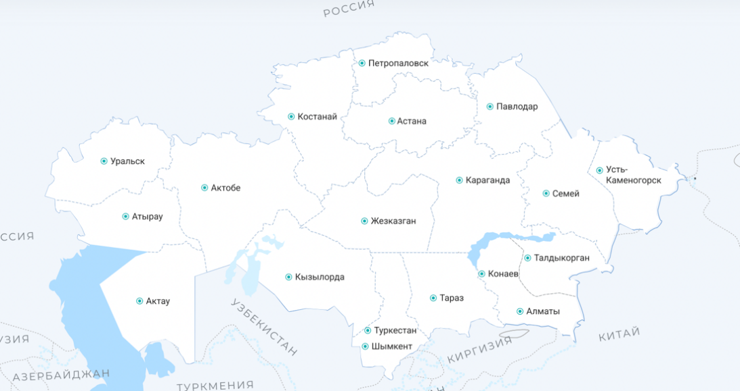

Fig. 1 - Location of wind turbines in the Republic of Kazakhstan

Also, as part of the study, energy scientists developed a special atlas, which indicates areas with the strongest wind flows. An approximate assessment of the wind energy resources of Kazakhstan is included in the atlas of the main winds, it indicates that in "50,000 sq. at a height of 80 meters on an area of ​​more than km, the average annual wind speed is more than 7 m / s. Thus, based on the presented data, investment projects were prepared, which were then implemented and thereby new wind stations were built. So, over time, their total capacity reached $ 3 billion per year. kWh, these stations can generate about 1000 MW of electricity. "Based on the indicators of the program, which is aimed at the development of this area, it follows that by 2030 the capacity of these installations should reach about $ 5 billion per year. kWh. Noticeable prospects are due to the fact that the Republic of Kazakhstan is rich in winds, it is necessary to use them in the right direction and produce "clean" energy.
According to some data, the theoretical wind generator of Kazakhstan amounted to about 1820 billion dollars kWh.hour per year. "Considering the power density of the wind power plant at the level of 10 MW / km2 and the presence of significant free spaces, it is possible to predict the possibility of installing a wind power plant capacity of several thousand MW in Kazakhstan. The average annual wind speed in the Dzungarian Gate area at a height of 50 meters is 9.7 m / s, and the wind flow density is about 1050 W / m2. This allows you to produce 4400 kW per year. Here, a special place is occupied by the electric power purpose. The availability of free space is about 1 billion dollars allows you to install a wind power plant capacity of several MW with an annual output of kWh electricity is required. Currently, a pilot thermal power plant with a capacity of 5 MW is being built in this area. If the experience is successful, the operational capacity of the thermal power plant can be increased to 50 MW."
As in other developed countries, wind energy does not cease to lose its momentum of development and in Kazakhstan, following foreign experience, more and more construction of new wind installations is planned, the first stations were launched in the capital of the Republic of Kazakhstan, then, having shown high results, construction continued in other areas, so stations were opened in Mangistau and Akmola regions [10]. Thus, currently in the Republic of Kazakhstan there are about 83 stations, the total capacity of which reaches 1410 MW.
In order to organize the work of these stations in the country, one of the leading and successful companies currently operates, VISTA INTERNATIONAL LLP. In 2014, it implemented the first project in the field of wind energy, so with its help, the Kordai wind power plant was put into operation. Today, this station is considered advanced, it is equipped with the most modern and innovative equipment, it also has the support of various ministries and departments, including the Ministry of Industry and New Technologies of the Republic of Kazakhstan (MIINT). To build the station, the company's employees considered numerous foreign experiences, to work out issues related to safety, equipment, technology, they adopted the experience of countries such as China, Holland and Germany. Studying the experience in foreign countries, calculating all the costs and logistics, a wind power plant was built in Kazakhstan. At the same time, it had a positive effect not only on the environment, but also provided an opportunity for the employment of a large number of citizens. Thus, based on this experience, other wind power plants were put into operation in the country. At the same time, the main aspect for their successful work remains occupational health and safety of high-altitude work. High-altitude work at wind farms is usually associated with the installation, maintenance and repair of equipment located at a considerable height, which requires special attention to safety issues. The main risks include falls from height, which can occur due to insufficient insurance, improper use of personal protective equipment or unexpected exposure to external factors such as strong wind or rain. For example, strong gusts of wind can lead to loss of balance and falls, which makes it necessary to take wind speed into account when planning work at height. It is also important to consider that low temperatures can cause frostbite and reduce the performance of employees, which requires them to be especially careful and use protective clothing. In addition, precipitation such as rain or snow can worsen the grip of shoes on the surface, increasing the likelihood of slips and falls [11]. Workers must be trained to recognize adverse weather conditions and take the necessary precautions, such as the use of special equipment and personal protective equipment. It is also worth noting that climate change as a result of global warming may increase the frequency of extreme weather events, which requires a revision of safety standards and adaptation of working practices at height.
Taking climate factors into account in the process of risk assessment and planning of work at wind farms is becoming essential to ensure the safety and health of workers, as well as to effectively perform tasks in a changing environment. An important aspect is the need for regular monitoring of meteorological conditions. The use of modern technologies, such as weather stations and weather forecasting systems, allows for early assessment of risks and the adoption of measures to minimize them. For example, if strong winds are expected, work at height may be suspended until conditions improve.
Practical risk analysis and assessment in the context of high-altitude work at wind farms in Kazakhstan require an integrated approach that takes into account both the specific conditions of the region and the general trends of the transition to a green economy. An important aspect is the identification of risks associated with working at height, including both physical and organizational risks. In order to assess how safety is organized at wind farms in the Republic of Kazakhstan, it is necessary to first analyze the total number of workers at all facilities (Figure 2).

Fig. 2 - Total number of personnel and those engaged in high-altitude work in the Republic of Kazakhstan, people

Thus, it can be noted that every year there is a steady increase in the number of personnel, while about 65% of the total number is engaged in high-altitude work, this is the personnel who are directly involved in servicing turbines, their repair and daily inspection. In order to ensure the safety of their activities in the field of labor protection, certain standards in the field of wind energy have been developed. Further, it is worth analyzing in more detail the content of the presented safety standards and identifying how rationally they are applied in practice. The first standard is the IEC 61400-2:2013 Standard for low-power wind turbines. Often, when characterizing wind turbines, many imagine huge turbines that are located at the height of a twenty-story building, however, over time, slightly different installations have also begun to gain popularity, they are slightly smaller in size, mainly such installations are located near residential buildings, while their power is also lower than that of large installations. Such devices are covered by the text of the IEC 61400-2:2013 standard "Wind turbines - Part 2: Low-power wind turbines" [12].
This standard is necessary to regulate the safety rules for handling such small installations. It specifies the requirements for the quality of materials, recommendations for the efficiency of their use, installation, maintenance, and operation rules. In addition, the standard contains safety requirements for the subsystems of these installations, including a description of how the protection mechanism is arranged, how the supporting structures, foundation, connections, and much more should be installed.
Next comes the ASTM D5741 standard, it is necessary to correctly select the surface and location of the wind turbine. In order for the installation to produce maximum power, it must be directed to the place where the strongest air flow is located. With the help of this standard, it is possible to estimate the wind at the surface and at a certain height. In addition, this standard defines the conditions under which the operation of turbines is possible, and which weather conditions are considered unsuitable for its maintenance. Also, this document can be applied in other areas of industry and in agriculture. To meet all the requirements, in accordance with the standard, the company must purchase special devices for changing. wind speed, temperature, etc., their presence guarantees the reliability of the result and the correct implementation of the theoretical aspects specified in this act.
Other standards, which are developed on the basis of consensus and can be applied to other areas, also make an important contribution to the development of wind energy. One of these is ISO 29404:2015 and ISO 29400:2015, they are necessary for the correct operation of offshore wind turbines. Such installations are considered the most complex, they are located in the open sea or ocean, and they also assume the highest efficiency [13].
Currently, in the Republic of Kazakhstan, it is planned to install similar wind turbines in the Caspian Sea, the frontal plans should assume that work in this area should be carried out only by experts in the field of wind energy, who are familiar with all the safety rules not only on the shore, but also in the water. In order to increase the level of safety in this case, knowledge of the ISO 29404:2015 Standard "Ships and marine technology - Offshore wind energy - Data flow within the supply chain" is required. This standard defines the content and format of messages that allow monitoring the physical movement of wind turbines, as well as their components, both during the construction phase and at the start of operation. These requirements and messages can be useful not only at the beginning of work on a wind farm, but also at the time of its breakdowns and maintenance. The ISO 29404:2015 standard can be used by all companies and their employees when performing activities with wind turbines, turbines and other components. However, the standard does not apply to substations. A slightly different ISO 29400:2015 Standard "Ships and marine technology - Offshore wind energy - Port and marine operations" is also necessary to ensure safety during work with offshore wind turbines. It defines the procedure for offshore operations, provides recommendations for the design of various installations associated with the deployment or repair of offshore helicopters. In particular, it contains requirements for the design and use of equipment, how systems and equipment are analyzed, methods and procedures for the safe execution of work on offshore wind turbines.
The next Standard is IEC 60076-16 Ed. 1.0 b:2011 for power transformers for wind turbines. Transformers are the main and indispensable component of each wind farm, they are necessary so that the generated energy obtained by wind can be converted into alternating current, which is then used in the central network. Such devices are covered by the IEC 60076-16 Ed. 1.0 b:2011 "Power transformers - Part 16: Transformers for wind turbines", despite the fact that basically all safety requirements concern high-altitude work performed with turbines, it is worth remembering that improper operation and maintenance of transformers can also lead to negative consequences for both workers and the population of the country [10].
The final standard that is used in this area is Standard AS 4959-2010 "Measurement, prediction and evaluation of noise from wind turbines", it also does not define safety requirements for high-altitude work, but is no less important, since it defines noise and vibration requirements, their excess can also have a negative impact on workers and residents of the country.
Thus, it can be said that in the Republic of Kazakhstan a large number of standards are used that are aimed at improving safety when working with wind turbines at height. However, despite this, injuries and other accidents occur. According to the National Statistics Bureau of the Republic of Kazakhstan and information from the Ministry of Labor and Social Protection of the Population of the Republic of Kazakhstan, over the past 10 years, about 18 thousand people have been injured in the industrial sector while performing assigned tasks. Of these, 2,356 people were injured from falling from a height, of which about 96 people were engaged in the maintenance and repair of wind turbines. A significant number of victims is due to the fact that many workers do not have sufficient knowledge and experience when working at wind farms and high-altitude work, do not comply with safety requirements and are not familiar with the applicable standards.
Let us consider the dynamics of injuries and deaths during high-altitude work at wind farms in the Republic of Kazakhstan (Figure 3).

Fig. 3 - Number of victims, including fatalities, during high-altitude work at wind farms in the Republic of Kazakhstan, people

That is, it can be said that about 0.4% of wind farm workers are injured and neglect safety requirements when performing high-altitude work. The most common cases of injury or death are falls from height, and falls from different heights and to different depths (in the case of wind farms located at sea) can cause harm to a person. In addition, injuries are also possible when falling on a flat surface of the same level. Falls account for more than 50% of all accidents during high-altitude work at wind farms. Similarly, falls from height and to depth can lead to fatal consequences.
Another group of factors that leads to injuries during high-altitude work is associated with damage to mechanisms; injuries occur when working with faulty turbine blades. Also, this group can include cuts and abrasions that occur when in contact with faulty tools, burns from contact with harmful substances. In addition, other types of injuries include those associated with improper actions or failure to use personal protective equipment (PPE) [14]. For example, in practice in the Republic of Kazakhstan there were cases of injury to a worker due to wear of a safety rope and slings.
In this case, it is worth saying that workers at wind farms in the Republic of Kazakhstan are aware that work is not provided for during bad weather, in this regard, injuries associated with wind and precipitation are quite rare. That is, measures in this area are being implemented in full and even those employees who have been hired quite recently are familiar with the standards in this area in detail.
The second country chosen for the analysis of safety standards was the United States. Thus, OSHA standards are currently being implemented in the country, they are rules that all organizations and employees in them must follow in order to protect themselves from emergency situations. They are based not only on theoretical aspects, they are based on practice and can be supplemented and improved. OSHA standards are divided into several groups: general industry, construction, marine transport, agriculture. They are mandatory for implementation throughout the country, but each state can offer its own requirements for safety and labor protection at wind farms, in particular.
It is worth saying that, unlike Kazakhstan, wind energy is much better developed in the USA, there are a large number of stations that are located both at sea and on land. Also, in the USA, in general, the "green" economy is better developed, the use of new types of energy for electricity production in the country began in the 1970s, when the government decided to combat the energy crisis with new technologies. Already in 1974, a special program was created that involved research in this area, and in 1980, the world's first wind farm was launched [15].
Today, in the USA there are about 9 of the largest wind farms in terms of capacity, they are located mainly in the states of California and Texas, but there are also a large number of small stations that are located in places with appropriate climatic conditions. Thus, the map of the location of wind turbines in the USA looks like this (Figure 4).

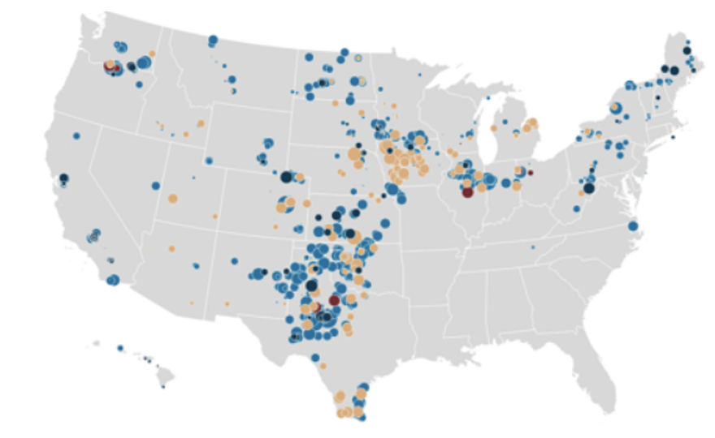
Fig. 4 - Location of wind farms in the USA

Based on the number of wind farms, it is worth noting that they employ significantly more workers than in the Republic of Kazakhstan and other European countries. Thus, according to statistics, in 2024, more than 131 thousand people worked in this sector, which is 11 thousand more than the previous year. That is, we can say that this industry in the United States is attractive for employment, while out of the total number, about 65-70% of workers are engaged in high-altitude work (Figure 5).

Fig. 5 - Total number of personnel and those engaged in high-altitude work in the USA, people

The increase in the number of workers in this sector is due to the fact that new wind farms have been launched and are planned to be launched in the country between 2022 and 2026. The continued growth in the number of stations entails the need for new labor. It is worth noting that labor protection in the United States is carried out quite well, employers adhere to the requirements of the OSHA standard and communicate them to their employees, who undergo annual recertification and pass exams on knowledge of safety standards.
Thus, according to OSHA standards, the following safety requirements apply to high-altitude work at wind farms in the United States:
1. "Maintain vertical and horizontal lift range limits. Before using the lift, operators must read and understand the manufacturer's instructions.
2. Control over power lines. Lift operators must be at least 10 meters away from the widest power lines.
3. Use of fall protection equipment. These include seat belts, shock-absorbing slings, and platform guards.
4. Stabilization of the lift. This is important, especially when working in windy conditions. At wind speeds over 64.4 kilometers per hour (40 miles per hour) or 48.3 kilometers per hour (30 miles per hour), if the work is related to the processing of materials, the employer is obliged to take measures to protect employees from the dangerous effects of the wind." In addition, the GWO (Global Wind Organisation) standard is also used, it includes requirements related to working at height, actions in case of fire hazard, first aid, survival at sea, and so on. The main requirement is that when working at high-rise facilities, workers must be equipped with special protective equipment, a fencing system, a network protection system must be provided, workers must be equipped with personal protective equipment. When performing repair work or servicing turbines at wind farms, workers must generally be guided by and adhere to OSHA standards, according to which special guards must be provided when working at height, and in their absence, each worker must have personal protective equipment. With the help of handrails or netting, as well as personal protective equipment, it is possible to avoid falls or other injuries [9].
Also, workers often get injured not only when directly working with turbines, but when climbing to them on fixed ladders. "When climbing a fixed ladder (not 20 feet long) on ​​these towers, a ladder equipped with a cage or well shall have a landing platform every 30 feet; a ladder not so equipped shall have a landing platform every 20 feet. Ladder safety devices may be used on wind towers longer than 20 feet in place of cage protection. In these cases, a landing platform is not required." These requirements are also set out in the OSHA standard.
However, despite the fact that there are safety requirements in the United States, similar to other countries, there are often unfavorable incidents, including injuries and fatalities. Thus, over the past 2024, there were 240 accidents and incidents in the United States that resulted in injuries to wind farm workers. Of these, 32 cases were associated with strong winds, 9 with lightning strikes, another 4 with tornadoes, cold snaps, storms and cyclones. Also, 35 cases were caused by safety violations, 9 cases with problems in electrical voltage. At the same time, the number of fatalities was 5 people (Figure 6). In this case, the percentage of injuries from the total number of workers at high-rise wind farms is about 0.3%.

Fig. 6 - Number of injured, including fatalities, during high-altitude work at wind farms in the USA, people

Based on the increase in injuries and accidents, wind energy companies are deciding to conduct additional training and instruction for employees. Since it is the training of new employees and monitoring their activities that will help to avoid falls, injuries and other injuries in the future. Also, it is important to monitor weather conditions: in 2024, a tornado destroyed about 10 turbines in the United States; in 2022, lightning struck several stations, which led to a fire and fatalities. Thus, we note that it is necessary to pay attention to safety in the field of labor protection in the event of various natural disasters, the evacuation of employees during a tornado or storm in particular [16].
Also, unlike the first example, where it was said that basically all workers do not have the proper qualifications and are quite young, the United States has an aging workforce. Many professions in the wind energy industry require not only physical strength, but also knowledge, including work at height, which includes turbine repair and other maintenance of wind turbines. This activity often has a negative impact on the health of the staff, and then on their productivity.
Thus, elderly and mature workers are no longer able to perform the assigned tasks, but at the same time, they have extensive experience, which increases their expertise in all matters. In this regard, to reduce the likelihood of accidents with elderly workers, it is necessary to develop a schedule so that they can rest and not receive additional stress. Also, it is necessary to give recommendations on changing professions, moving to administrative staff or to the company office.
The third example that will be considered in this work is the European experience. It is worth saying that the countries that prevail in the production of "clean" energy in Europe are Germany, Great Britain and Spain (Figure 7).
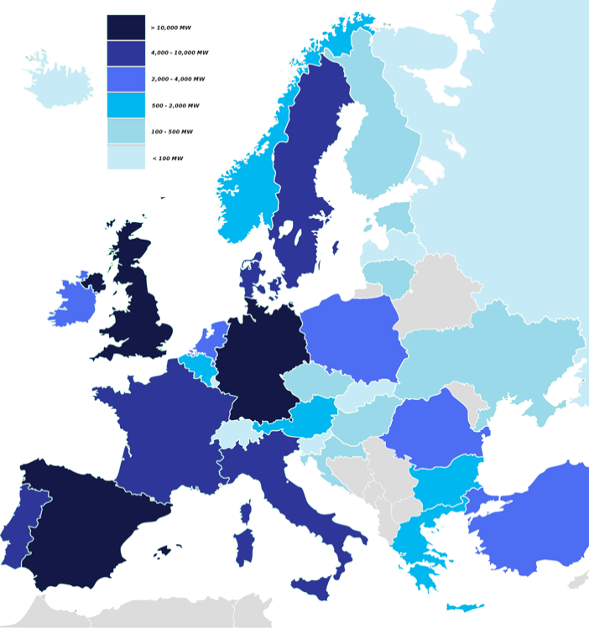

Fig. 7 - Wind farm locations in Europe

To begin with, let's look at the safety standards that are used in all European countries when performing high-altitude work at wind farms [17].
The first standard is the European standard EN 50308:2004 "Wind turbines. Protection measures. Requirements for design, operation and maintenance", it is considered the most complete, since it contains all the necessary labor protection conditions in the field of wind energy, and also considers all aspects from the moment of transportation of turbines to the place of their operation. Let's look at the main aspects of this standard:
1. The design of wind farms should be carried out in such a way as to reduce all possible risks to the health of workers and citizens.
2. The edges of turbines that are publicly accessible should not have sharp corners, uneven surfaces and should not cause injury to workers.
3. Operational control of the turbine should be carried out without climbing to it.
4. Control panels should be located in a place that prevents accidental actions or unintentional errors of personnel.
5. During repair work or maintenance of turbines, blocking and forced shutdown must be provided.
6. All safety measures must be observed to avoid accumulation of hazardous toxic substances, flammable or explosive gases in any areas of the wind turbine [8].
It can be said that this standard, unlike those discussed earlier, contains the most complete and detailed list of safety precautions; familiarization with this standard can reduce the level of injuries and other accidents at work. However, its requirements do not apply to installations that were put into operation before 2004.
Also, when working at wind farms in Europe, quality standards ISO 9001, ISO 14001 and OHSAS 1800 are actively used. These standards include general requirements for labor protection, quality management, management, however, they do not directly relate to wind energy, but manufacturers strive to comply with them. Specifically, the IEC 61400 series applies to wind turbines; this standard covers requirements for turbine design, reliability, service life, and installation. It contains requirements for all aspects of the design, construction, and operation of an offshore wind farm. This standard is necessary so that the turbines perform their functions as reliably as possible during operation. In addition, the National Institute for Occupational Safety and Health (NIOSH) operates in Europe, which was organized back in 2009, and courses and seminars are currently held on its basis, which are also useful for health protection. An example is the seminar "Making Green Workplaces Safe" within the framework of the "Prevention through Design" initiative. At such meetings, specific problems in the field of labor protection are discussed and new directions for minimizing risks in production are proposed. Thus, one of the new issues is the need for uniform standard codes for the entire life cycle of wind turbines [18].
In addition to this organization, the European Wind Energy Association (EWEA) operates in Europe. Its mandate includes training new employees, familiarizing them with safety rules in the industry and in specific areas, which helps reduce risks and injuries. The organization publishes all safety requirements that are relevant for managers and employees, with special attention paid to first aid procedures. EWEA documents contain requirements that relate to safety both on water bodies and on land. EWEA proposals and organization documents can be considered international and used for labor protection in other countries. Many organizations that install and operate wind turbines are also interested in developing and using safety standards. An example is RenewableUK, which has created its own labor protection forum, which contains various training courses, a description of currently available standards and requirements. In addition, the G9 Wind Energy Health and Safety Association (G9) has been created in Europe. Its main goal is safety and labor protection in the wind energy industry. To achieve the goal, the association's management allocates resources for conducting courses and training specialists, thereby reducing the risk of injuries and other unpleasant situations. This association, in addition to considering safety in the context of wind energy, also pays attention to offshore operations that are associated with wind turbines at sea or in the ocean and lifting operations that are associated with construction.
It is worth noting that despite a fairly wide list of requirements and standards in Europe, there is a shortage of articles on the safety of wind turbines in the marine space, and there are also no requirements for checking the durability of installations. For example, at present, a standard has not been developed that would apply to medium-sized turbines; standard requirements are used for them, similarly, there are no requirements for small wind turbines. Despite the fact that each company in this area is able to develop its own safety requirements, they need to be unified within the framework of national or international standards. Since with their help, safe work is possible.
As an example of a European country, it is worth considering the experience of Great Britain and identifying the number of injuries and other accidents when working at height. Thus, based on SafetyOn data, the following information was obtained on the total number of incidents at wind farms (Figure 8) [19].

Fig. 8 - Number of casualties, including fatalities, during high-altitude work at wind farms in the UK, people.

At the same time, according to statistics, the nature of accidents is not specified, whether they occurred while working at height during maintenance of wind turbines or not. However, the data show that work at stations has a high risk to the health and safety of personnel. Workers must understand that their health protection is exclusively in their hands, ignoring safety requirements cannot lead to positive consequences.
It is worth saying that the most common phenomenon that leads to injuries and other accidents is a turbine blade breakage. Fire comes in second place, on average, about 50 fires occur annually at various stations. At the same time, turbine operators do not conduct a sufficiently accurate inspection using mechanical means, which ultimately aggravates the situation. In this case, the number of victims is about 0.4% of the total number of workers.
Thus, in order to systematize the information presented in the conclusion, it is worthwhile to make a comparative analysis of the standards considered in different countries and draw conclusions regarding their effectiveness in application, comparing them with the general level of injuries and other accidents during high-altitude work at wind power stations (Table 1) [20].

Table 1 - Comparative analysis

Country | Standards | Problem areas | Number of injuries and accidents | Conclusion on the effectiveness of the standard
Republic of Kazakhstan | IEC 61400-2:2013  IEC 60076-16  ASTM D5741  ISO 29404:2015  ISO 29400:2015  AS 4959-2010 | 1.Lack of requirements for different types of wind turbines.  2.No mandatory safety training for young professionals.  3.Fragmentation of standards and lack of clear coordination between them create difficulties in their application. | 0.4% of all those engaged in high-altitude work | The most common cause of injury or death is a fall from a height.  The second group of factors - injuries occur when working with faulty turbine blades (cuts and abrasions).  Other types of injuries include those associated with improper actions or failure to use personal protective equipment (PPE). For example, in practice in the Republic of Kazakhstan there were cases of workers being injured due to wear of a safety rope and slings.
United States of America | OSHA Standard  GWO (Global Wind Organization) Standard | 1.Safety precautions for emergencies (storm, tsunami) are not fully developed.  2.Low level of awareness of risks among older workers. | 0.3% of all those engaged in high-altitude work | Injuries are associated with strong winds, lightning strikes, tornadoes, cold snaps, storms and cyclones. Also, most cases of injuries are caused by safety violations, problems with electrical voltage.
Europe (Great Britain) | European standard EN 50308:2004  ISO 9001  ISO 14001  OHSAS 1800 | 1.Lack of unified requirements for fire hazard.  2.There is a shortage of articles devoted to the safety of wind turbines in the marine space.  3.There are no requirements for checking the durability of installations. | 0.4% of all those engaged in high-altitude work | The most common occurrence that leads to injuries and other accidents is turbine blade failure, followed by fire.

That is, it can be said that the standards governing the performance of high-altitude work require constant updating and adaptation to modern conditions and technologies in all countries. In particular, the study highlights the current problems associated with the insufficient effectiveness of existing standards, which can lead to increased risks for workers at height [21].
Conclusions. Thus, based on the analysis of the number of injuries and accidents at heights within wind stations, we can identify some trends and main problem areas that are inherent in all the countries considered. The main problem is that technical progress in the wind energy industry is moving somewhat faster than the development of new safety standards, and therefore even experienced workers can be injured by improper operation, repair or maintenance of the turbine. It can also be argued that the hazards found in wind power plants are not too different from those that exist in other industries today (for example, falls from height, manual handling), however, it is necessary to take into account all the unique conditions that are present in the wind energy industry, and therefore the use of previously adopted safety standards and requirements for other industries is not always appropriate and effective.
In this regard, in order to reduce injuries and accidents in the work of wind turbines in the Republic of Kazakhstan, it is recommended to adopt the experience of standardizing the rules of both the United States and European countries.
It is necessary to create a specific standard that will specify all the requirements for labor protection, as well as standards for each group of wind turbines. For European countries, it is also recommended to practice actions in case of fires, since some principles of fire safety equipment of oil platforms and other energy facilities can also be applied to turbines. For the US, it is worth paying more attention to the occurrence of natural disasters and practicing storm safety rules with employees. For all countries, it is preferable to study and implement safety training for h igh-altitude work.
The basis can be the courses of the World Wind Organization (GWO). These standards include modules on working at height, fire safety, first aid, and other topics.
Funding. The article presents the results of scientific research obtained during the implementation of a scientific and technical programme within the framework of programme-targeted financing of the work of the Republican Research Institute for Occupational Safety and Health of the Ministry of Labour and Social Protection of the Population of the Republic of Kazakhstan (IRN BR22182667) on the topic "Working conditions and occupational risks: classification, categories and groupings in the context of the transition to the “Green Economy”".

Литература

- Бюро национальной статистики Агентства по стратегическому планированию и реформам республики Казахстан // Power technology. URL: https://stat.gov.kz/ru/industries/social-statistics/stat-medicine/spreadsheets/.-Дата обращения: 21.06.2025.
- Husseini T. Golden hour: the paramedics saving lives on offshore windfarms // Power technology. URL: https://www.power-technology.com/features/golden-hour-paramedics-saving-lives-offshore-windfarms/. -Дата обращения: 21.06.2025.
- Гордиенко Д., Мордвинова А., Шебеко Ю., Лагози А., Некрасов В. Пожарная безопасность морских стационарных платформ для добычи нефти и газа на континентальном шельфе // Инженерная защита научно-практический журнал. URL: http://territoryengineering.ru/bez-rubriki/pozharnaya-bezopasnost-morskih-statsionarnyh-platform-dlya-dobychi-nefti-i-gaza-na-kontinentalnom-shelfe/. -Дата обращения 21.06.2025.
- Лебедева Е.О., Матузова С.Ю. Особенности обеспечения индивидуальной безопасности при доставке персонала на нефтегазодобывающие платформы арктического шельфа // Международный научно-исследовательский журнал. -2014. - №1(20).- С.74-76.
- Wind energy's frequently asked questions (FAQ). URL: https://www.ewea.org/wind-energy-basics/faq/ -Дата обращения: 21.06.2025.
- Wu X., Hu Y., Li Y., Yang J., et al. Foundations of offshore wind turbines: A review // Renewable and Sustainable Energy Reviews. -2019. -Vol. 104. -P. 379–393. DOI 10.1016/j.rser.2019.01.012.
- BARD Offshore Wind Farm. -2023. URL: https://www.4coffshore. com/windfarms/bard-offshore-1-germany-de23. -Дата обращения: 21.06.2025.
- What if one of the key solutions to fighting climate change was in our ocean? /GWEC. -2021 URL: https://gwec.net/offshore-wind/. -Дата обращения: 21.06.2025.
- Global Offshore Wind Technical Potential/World Bank Group. -2023 URL: https://datacatalog.worldbank.org/search/dataset/0037787. -Дата обращения: 21.06.2025.
- International Renewable Energy Agency, International Standardisation in the Field of renewable Energy. -2013. URL: https://www.irena.org/-/media/Files/IRENA/Agency/Publication/2013/International_Standardisation_-in_the_Field_of_Renewable_Energy.pdf. - Дата обращения: 21.06.2025.
- International Qualification & Training Center. // GWO BST Occupational Safety Training. URL: https://iqtc-riga.com/. - Дата обращения: 21.06.2025.
- European Technology & Innovation Platform on Wind Energy (ETIP Wind). Strategic research and innovation agenda 2018 // European Technology & Innovation Platform on Wind Energy. -2018. URL: https://etipwind.eu/library/reports/.- Дата обращения: 21.06.2025.
- Ярош В. А., Ефанов А. В., Привалов Е. Е., Ястребов С. С. Электрические станции и подстанции. Часть II : лабораторный практикум /Директ-Медиа. - 2019. - 91 с. ISBN 978-5-4475-5320-3.
- Гурин С.И. Пропаганда охраны труда // Руководитель автономного учреждения. -2011. -№ 4.
- Energy Institute. -2023. URL: https://www.energyinst.org/technical/ publications/topics/offshore-safety/g9-2013-incident-data-report. - Дата обращения: 21.06.2025.
- Simone Peter. Women in wind energy // Women of Wind Energy Deutschland e.V. URL: http://www.womenofwindenergy.de. - Дата обращения: 21.06.2025.
- WindEurope. Health & safety in the wind industry. URL: http://www.ewea.org/policy-issues/health-and-safety/gwo-standards/. - Дата обращения: 21.06.2025.
- Moore J., Bullard N. BNEF Executive Factbook. Power, transport, buildings and industry, commodities, food and agriculture, capital //BloombergNEF. -2021. -100 p.
- RenewableUK. Health and safety on offshore windfarm // RenewableUK. URL: http://www.renewableuk.com/en. - Дата обращения: 21.06.2025.
- Offshore Wind Technical Potential. Analysis and Maps. URL: https://esmap.org/esmap_offshorewind_tech-potential_analysis_maps. - Дата обращения: 21.06.2025.
- Castro-Santos L., Diaz-Casas V. Floating offshore wind farms /Springer InternationalPublishing. -2016. - 193 p. DOI 10.1007/978-3-319-27972-5.

References

1.Bjuro nacional'noj statistiki Agentstva po strategicheskomu planirovaniju i reformam respubliki Kazahstan // Power technology. URL: https://stat.gov.kz/ru/industries/social-statistics/stat-medicine/spreadsheets/.-Data obrashhenija: 21.06.2025.[in Russian]
2. Husseini T. Golden hour: the paramedics saving lives on offshore windfarms // Power technology. URL: https://www.power-technology.com/features/golden-hour-paramedics-saving-lives-offshore-windfarms/.- Date of access:21.06.2025.
3.Gordienko D., Mordvinova A., Shebeko Ju., Lagozi A., Nekrasov V. Pozharnaja bezopasnost' morskih stacionarnyh platform dlja dobychi nefti i gaza na kontinental'nom shel'fe // Inzhenernaja zashhita nauchno-prakticheskij zhurnal. URL: http://territoryengineering.ru/bez-rubriki/pozharnaya-bezopasnost-morskih-statsionarnyh-platform-dlya-dobychi-nefti-i-gaza-na-kontinentalnom-shelfe/. -Data obrashhenija 21.06.2025. [in Russian]
4.Lebedeva E.O., Matuzova S.Ju. Osobennosti obespechenija individual'noj bezopasnosti pri dostavke personala na neftegazodobyvajushhie platformy arkticheskogo shel'fa // Mezhdunarodnyj nauchno-issledovatel'skij zhurnal. -2014. - №1(20).- S.74-76. [in Russian]
5. Wind energy's frequently asked questions (FAQ). URL: https://www.ewea.org/wind-energy-basics/faq/- Date of access: 21.06.2025.
6.Wu X., Hu Y., Li Y., Yang J., et al. Foundations of offshore wind turbines: A review // Renewable and Sustainable Energy Reviews. -2019. -Vol. 104. -P. 379–393. DOI 10.1016/j.rser.2019.01.012.
7. BARD Offshore Wind Farm. -2023. URL: https://www.4coffshore. com/windfarms/bard-offshore-1-germany-de23. - Date of access: 21.06.2025.
8. What if one of the key solutions to fighting climate change was in our ocean? /GWEC. -2021 URL: https://gwec.net/offshore-wind/. - Date of access: 21.06.2025.
9.Global Offshore Wind Technical Potential/World Bank Group. -2023 URL: https://datacatalog.worldbank.org/search/dataset/0037787. -Дата обращения: 21.06.2025.
10. International Renewable Energy Agency, International Standardisation in the Field of renewable Energy. -2013. URL: https://www.irena.org/-/media/Files/IRENA/Agency/Publication/2013/International_Standardisation_-in_the_Field_of_Renewable_Energy.pdf. - Date of access: 21.06.2025.
11. International Qualification & Training Center. // GWO BST Occupational Safety Training. URL: https://iqtc-riga.com/. - Date of access: 21.06.2025.
12. European Technology & Innovation Platform on Wind Energy (ETIP Wind). Strategic research and innovation agenda 2018 // European Technology & Innovation Platform on Wind Energy. -2018. URL: https://etipwind.eu/library/reports/.- Date of access: 21.06.2025.
13.Jarosh V. A., Efanov A. V., Privalov E. E., Jastrebov S. S. Jelektricheskie stancii i podstancii. Chast' II : laboratornyj praktikum /Direkt-Media. - 2019. - 91 s. ISBN 978-5-4475-5320-3. [in Russian]
14.Gurin S.I. Propaganda ohrany truda // Rukovoditel' avtonomnogo uchrezhdenija. -2011. -№ 4. [in Russian]
15.Energy Institute. -2023. URL: https://www.energyinst.org/technical/ publications/topics/offshore-safety/g9-2013-incident-data-report. - Date of access: 21.06.2025.
16. Simone Peter. Women in wind energy // Women of Wind Energy Deutschland e.V. URL: http://www.womenofwindenergy.de. - Date of access: 21.06.2025.
17.WindEurope. Health & safety in the wind industry. URL: http://www.ewea.org/policy-issues/health-and-safety/gwo-standards/. - Date of access: 21.06.2025.
18. Moore J., Bullard N. BNEF Executive Factbook. Power, transport, buildings and industry, commodities, food and agriculture, capital //BloombergNEF. -2021. -100 p.
19.RenewableUK. Health and safety on offshore windfarm // RenewableUK. URL: http://www.renewableuk.com/en. - Date of access: 21.06.2025.
20.Offshore Wind Technical Potential. Analysis and Maps. URL: https://esmap.org/esmap_offshorewind_tech-potential_analysis_maps.- Date of access: 21.06.2025.
21.Castro-Santos L., Diaz-Casas V. Floating offshore wind farms /Springer InternationalPublishing. -2016. - 193 p. DOI 10.1007/978-3-319-27972-5.

Information about the authors

Aktayeva L.M. – Doctor of Medical Sciences, General Director of the Republican Scientific Research Institute of Occupational Safety and Healt, RNIIOT of the Ministry of Health of the Republic of Kazakhstan Astana, Kazakhstan
e-mail: rniiot@rniiot.kz;
Koshayeva A.M. – Master of Technical Sciences, the RRIOSH of the Ministry of Health of the Republic of Kazakhstan, Astana, Kazakhstan, e-mail: koshayeva12@gmail.com;
Bekmagambetov A.B. - Higher law degree, candidate of legal sciences, associate professor, the RRIOSH of the Ministry of Health of the Republic of Kazakhstan, Astana, Kazakhstan, e-mail: Adilet1979@mail.ru;
Rakhmetova A.M. - Candidate of Medical Sciences, associate professor the RRIOSH of the Ministry of Health of the Republic of Kazakhstan, Astana, Kazakhstan, e-mail: ra_anar@mail.ru;
Kulmagambetova E. A. - Candidate of Chemical Sciences, the RRIOSH of the Ministry of Health of the Republic of Kazakhstan, Astana, Kazakhstan, e-mail: elya_kulmagambet@mail.ru;
Daumova G. K.- Candidate of Technical Sciences, associate professor, the RRIOSH of the Ministry of Health of the Republic of Kazakhstan, Ust-Kamenogorsk, Kazakhstan, e-mail: gulzhan.daumova@mail.ru.

Сведение об авторах
Актаева Л.М.- доктор медицинский наук, РГП на ПХВ «Республиканский научно-исследовательский институт по охране труда Министерства труда и социальной защиты населения Республики Казахстан», Астана, Казахстан, e-mail: rniiot@rniiot.kz ;
Кошаева А.М. - Магистр технических наук, РГП на ПХВ «Республиканский научно-исследовательский институт по охране труда Министерства труда и социальной защиты населения Республики Казахстан», Астана, Казахстан, e-mail: koshayeva12@gmail.com;
Бекмағамбетов А.Б. - кандидат юридических наук, ассоциированный профессор, РГП на ПХВ «Республиканский научно-исследовательский институт по охране труда Министерства труда и социальной защиты населения Республики Казахстан», Астана, Казахстан, e-mail: Adilet1979@mail.ru;
Рахметова А.М. - кандидат медицинских наук, доцент, РГП на ПХВ «Республиканский научно-исследовательский институт по охране труда Министерства труда и социальной защиты населения Республики Казахстан», Астана, Казахстан, e-mail: ra_anar@mail.ru;
Кульмагамбетова Э.А. - кандидат химических наук, РГП на ПХВ «Республиканский научно-исследовательский институт по охране труда Министерства труда и социальной защиты населения Республики Казахстан», Астана, Казахстан, e-mail: elya_kulmagambet@mail.ru;
Даумова Г.К. - кандидат технических наук, ассоцированный профессор, РГП на ПХВ «Республиканский научно-исследовательский институт по охране труда Министерства труда и социальной защиты населения Республики Казахстан», Усть - Каменогорск, Казахстан, e-mail: gulzhan.daumova@mail.ru.

ҒТАМР 52.13.17

АЛТЫНАЛМАС АҚ-ТЫҢ ТЕХНОЛОГИЯЛЫҚ СИПАТТАМАЛАРЫН БАҒАЛАУ НЕГІЗІНДЕ АЛТЫН КЕНДЕРІН РЕГРЕССИВТІК ЖӘНЕ КОРРЕЛЯЦИЯЛЫҚ БАЙЫТУ КӨРСЕТКІШТЕРІН БОЛЖАУ

А.У. Кожантов, Е.Х.Абен, С.С.Мырзахметов, Д.К. Ахметканов
Сәтбаев университеті, Алматы, Казахстан

Корреспондент-автор: a.kozhantov@satbayev.university

Мақалада «Алтыналмас» АК мысалында екі сатылы схема (гравитация және флотация) үшін олардың технологиялық сипаттамалары негізінде алтын кендерінің байыту көрсеткіштерін болжау зерттеледі. Кендердің технологиялық сипаттамаларының жоғары өзгермелілігі (Au құрамы, гранулометрия, минералдық құрамы, қаттылығы) байытудың түйінді көрсеткіштерінің: алтын алудың (ε,%), концентраттағы құрамының (β конц, г/т) және концентраттың шығуының (γ,%) елеулі ауытқуына әкеледі. Әдіснама Y = a + a X +... + a X түрінің үлгілерін құру үшін корреляциялық (Пирсон, Спирмен) және көптеген регрессиялық талдауды қамтиды. Маңызды байланыстар орнатылған: мысалы, бос алтынның үлесі алынумен (r = 0.85), ал кендегі Au құрамы концентраттың шығуымен (r = 0.72) қатты корреляцияланады. εΣ үшін R ² = 0.87 және 1.5% болжам қатесіне байланысты модель әзірленді. Өнеркәсіптік деректерге валидация дәлдікті растады (болжамның орташа ауытқуы εΣ - 1.44%). Нәтижелері байыту қондырғысының режимдерін оңтайландыру және ашық тәсілмен өндіру, кеннің сапасын басқару және Au алынуын бағалау үшін қолданылады.
Түйін сөздер: алтын кендері, байыту, болжау, регрессиялық модельдер, корреляциялық талдау, алтын алу, өндіру.

ПРОГНОЗИРОВАНИЕ ПОКАЗАТЕЛЕЙ РЕГРЕССИВНОЕ И КОРРЕЛЯЦИОННОЕ ОБОГАЩЕНИЯ ЗОЛОТОНОСНЫХ РУД НА ОСНОВЕ ОЦЕНКИ ИХ ТЕХНОЛОГИЧЕСКИХ ХАРАКТЕРИСТИК АО «АЛТЫНАЛМАС»

А.У. Кожантов, Е.Х. Абен, С.С.Мырзахметов, Д.К. Ахметканов
Satbayev University, Алматы, Казахстан,
е-mail: a.kozhantov@satbayev.university

В статье исследуется прогнозирование показателей обогащения золотоносных руд на основе их технологических характеристик для двухстадиальной схемы (гравитация и флотация) на примере АК «Алтыналмас». Высокая изменчивость технологических характеристик руд (содержание Au, гранулометрия, минеральный состав, твердость) приводит к значительным колебаниям ключевых показателей обогащения: извлечения золота (ε, %), содержания в концентрате (βконц, г/т) и выхода концентрата (γ, %). Методология включает корреляционный (Пирсона, Спирмена) и множественный регрессионный анализ для построения моделей вида Y = a₀ + a₁X₁ + ... + aₙXₙ. Установлены значимые связи: например, доля свободного золота сильно коррелирует с извлечением (r = 0.85), а содержание Au в руде - с выходом концентрата (r = 0.72). Для εΣ разработана модель с R² = 0.87 и ошибкой прогноза 1.5%. Валидация на промданных подтвердила точность (среднее отклонение прогноза εΣ - 1.44%). Результаты применимы для оптимизации режимов обогатительной установки и добыча открытым способоми, управления качеством руды и оценки извлекаемости Au.
Ключевые слова: золотоносные руды, обогащение, прогнозирование, регрессионные модели, корреляционный анализ, извлечение золота, добыча.

PREDICTION OF INDICATORS OF REGRESSIVE AND CORRELATION CONCENTRATION OF GOLD-BEARING ORES BASED ON ASSESSMENT OF THEIR TECHNOLOGICAL CHARACTERISTICS OF ALTYNALMAS JSC

A. Kozhantov, E. Aben, S. Myrzakhmetov, D. Akhmetkanov
Satbayev University, Almaty, Kazakhstan,
е-mail: a.kozhantov@satbayev.university

The article examines the forecasting of gold ore beneficiation indicators based on their technological characteristics for a two-stage scheme (gravity and flotation) using the example of JSC (Joint Stock Company) Altynalmas. High variability in the technological characteristics of ores (Au content, granulometry, mineral composition, hardness) leads to significant fluctuations in key enrichment indicators: gold extraction (ε,%), concentrate content (β conc, g/t) and concentrate yield (γ,%). The methodology includes correlation (Pearson, Spearman) and multiple regression analysis to build models of the form Y = a ₀ + a ₁ X ₁ +... + a ₙ X ₙ. Significant relationships have been established: for example, the proportion of free gold strongly correlates with extraction (r = 0.85), and the Au content in ore - with the yield of concentrate (r = 0.72). For εΣ, a model has been developed with R ² = 0.87 and a forecast error of 1.5%. Validation on industrial data confirmed the accuracy (the average deviation of the εΣ forecast is 1.44%). The results are applicable for optimization of the processing plant and open pit mining, ore quality management and Au recovery estimation.
Keywords: gold-bearing ores, beneficiation, forecasting, regression models, correlation analysis, gold extraction, mining.

Кіріспе. Алтын кендерін байытудың қазіргі заманғы технологиялары процестерді оңтайландыру және шығындарды азайту үшін түйінді көрсеткіштерді (Au алу, концентраттағы құрамы, шығу) нақты болжауды талап етеді. Алайда, гранулометрия, минералдық құрам және алтынның құрамы сияқты кендердің технологиялық сипаттамаларының (ТХ) жоғары кеңістіктік-уақыттық өзгермелілігі байыту тиімділігінің айтарлықтай ауытқуына алып келеді. Бұл әсіресе «Алтыналмас» АК кәсіпорындарында қолданылатын екі сатылы схемалар (гравитация + флотация) үшін өзекті.
Зерттеу негіздері - ТХ кенін корреляциялық және регрессиялық талдау негізінде байыту көрсеткіштерін болжаудың математикалық модельдерін әзірлеу. Жұмыста Au (β ₁) құрамын, бос алтын, сульфидтер үлесін және қаттылық параметрлерін қоса алғанда, өнеркәсіптік өлшеулер деректері пайдаланылды. Статистикалық мәнді тәуелділіктер анықталды: мысалы, алтынды (εΣ) алу еркін Au (r = 0.85) үлесімен күшті корреляцияланады. Нақты сынамаларда валидацияланған жоғары дәлдіктегі регрессиялық модельдер (R ² = 0.87, 1.5% болжау қатесі) құрылды.
Жұмыстың практикалық маңыздылығы байыту фабрикасының режимдерін жедел түзету, кен массасының сапасын басқару және кен орындарының жаңа учаскелері үшін Au алынуын бағалау мүмкіндігінен тұрады. Нәтижелер флотация (β ₅) қалдықтарындағы шығындарды барынша азайту және ашық тәсілмен өндіруді оңтайландыру үшін де қолданылады.
«Алтыналмас» АҚ кен орындарының технологиялық сипаттамалары негізінде концентратқа алтын алуды бағалау үшін ғылыми негізделген және верификацияланған болжамды модельді әзірлеу. Экстраполяция тәуекелдерін бағалау үшін алынған үлгілердің барабарлық саласын сандық анықтау. Байыту процестерін жедел жоспарлау үшін үлгілерді пайдалану бойынша практикалық ұсынымдар әзірлеу.
1.Кендердiң технологиялық сипаттамалары мен оларға сәйкес байыту көрсеткiштерiн қамтитын репрезентативтiк деректер базасын қалыптастыру.
2.Статистикалық маңызы бар болжамдарды іріктеу үшін корреляциялық талдау жүргізу.
3.Модельдер құру, тестілік іріктемеде олардың сапасын бағалау және салыстырмалы талдау жүргізу.
4.Жаңа деректердің модельдің барабарлық саласына сәйкестігін тексерудің ресми рәсімін енгізу.
Нысаналы айнымалымен статистикалық маңызы жоқ болжамдарды сүзу. Сандық ауыспалылар үшін таралудың қалыпты емес төзімді Спирменнің (ρ) корреляция коэффициенті есептеледі. Алдын ала болжам p-value <0,05 шартын орындау кезінде модельдеуге рұқсат етіледі.
Материалдар мен әдістер. Машиналық оқыту (Random Forest, Gradient Boosting, Нейрондық желілер) байытудың күрделі желілік емес процестері үшін көбінесе нақты болжамдар береді.
Минералогияны егжей-тегжейлі қараңыз: Сульфидтердің % -ын ғана емес, алтынның нақты жеткізуші минералдары, ашылу/сіңу дәрежесі туралы деректерді де қосыңыз.

γ2 + γ2 =1; β2 γ2 + β2 γ3 = β1 1; γ4+ γ5= γ3 ; β4 γ4 + β5 γ5= β3 γ3, (1)

мұндағы β2, β4 және β5 - флотация концентраттары мен қалдықтарындағы металдың құрамы.
Байыту өнімдерінің шығуының белгісіз мәндері (γ2γ3γ4 және γ5-ші) химиялық талдаулардың деректері бойынша белгілі формулалар бойынша анықталады. Алынған мәндер бойынша гравиоконцентрат, флотоконцетрат, байыту қалдықтарындағы, сондай-ақ жалпы концентраттағы металдардың қосымша технологиялық көрсеткіштері айқындалады.
Байыту қондырғысының берілген өнімділігі және ауысымына ашық тәсілмен өндіру кезінде (Qсм) олардағы байыту өнімдері мен металдың шығу көрсеткіштерін салмақтық бірліктермен анықтауға болады:

$g_{1}=\frac{g\text{\%}Q_{см}}{100}$, т (2)

${}_{1}=\frac{\text{\%}Q_{см}}{100{}_{1}}$, т (3)

Кен сапасының ауытқуының кен сапасының технологиялық жұмыстарға ауытқуына және ашық тәсілмен өндіруге әсерін айқындау үшін екі айдағы өңдеудің бастапқы деректері талдауға ұшырады. Бұл ретте әрбiр ақпарат массивi бойынша әрбiр ауысым және әрбiр ай бойынша жеке орташа мәнi, стандартты ауытқуы (δβ1) және стандартталған эксцесс айқындалған. Орташа мән деректердің орталық үрдісін, стандартты ауытқу - деректердің таралуын, ал эксцесс - қалыпты бөлу заңы білігі айырмашылықтарының маңыздылығын тексеру үшін өлшейді.
Алынған нәтижелерге жасалған талдау бастапқы кендегі металл құрамының вариациясының коэффициенттері өте жоғары екенін көрсетеді (β1) және бөліну өнімдері - бастапқы кендегі 42% гравиоконцентраттағы 85% дейін және флотоконцетраттағы 94% дейін. Қолда бар деректер олардың арасындағы корреляциялық байланыстың болуына талданды. Төрт регрессиялық модель қаралды: сызықтық; мультипликативті; экспоненциалды; керісінше [1, 2].
Мультипликативтік және экспоненциалдық модельдерде линеаризацияға логарифмдеу арқылы қол жеткізіледі. Модельдер параметрлері таңдалған сызықтан ауытқулардың ең аз квадраттары әдісін пайдалана отырып бағаланады.
Байыту қондырғысының регрессиялық талдауы және ашық тәсілмен өндіру негізінде мынадай тәуелділіктер алынды: концентраттың шығуының кеннің құрамындағы бастапқы металға тәуелділігі:

γк 1,27β1+0,35: r=0,61; R2=37,2% (4)

mβк = 128,2 mβ1 -211,4: r=0,86; R2=73,5% (5)

- концентраттың шығуының концентраттағы металдың құрамына тәуелділігі (, к):

${}_{к}=\frac{1}{0,002}$ βк +0,006; r=0,64; R2=41,4% (6)

- флотация қалдықтарындағы (βхв) металл құрамының оның кендегі құрамына тәуелділігі:

βхв = 0,84 β10,18; r=0,15; R2=2,3% (7)

- концентраттағы металл құрамының оның шығу шамасына тәуелділігі:

εх = 50,94 γк0,21; r=0,67; R2=44,4% (8)

- концентратқа металды алудың оның бастапқы кендегі құрамына тәуелділігі:

εх1 = 48,28 β10,27; r=0,56; R2=31,4% (9)

мұндағы r - корреляция коэффициенті; R2 - тәуелді айнымалының вариабельділігі тәуелсіз айнымалының өзгеруімен түсіндірілетінін көрсетеді.
Корреляция коэффициентінің мәндері мен R2 көрсеткіштері бойынша көрініп тұрғандай, флотация қалдықтарындағы металл құрамының өзгеруіне оның кендегі құрамының өзгеруімен әсері 0,15 корреляция коэффициенті кезінде 2,3% ғана бағаланады. Қалған тәуелділіктер елеулі болып табылады және техникалық-экономикалық негіздемеде пайдаланылуы мүмкін.
Металлды концентратқа алудың кендегі металл құрамының мәндерінің оның орташа мәнінен ауытқуынан тәуелділігін қарасақ, онда бұл тәуелділік елеулі 1.

εх11 = 19,04 (β1 β1 +10)0,6; r=0,56; R2=42,9% (10)

Осындай нәтиже бастапқы кендегі металл құрамын (db1) ескере отырып, қалдықтардағы металды алудың тәуелділігін қарастырғанда да алынады:

εхв = 10,5 δβ1 +3,33; r=0,97; R2=93% (11)

Тәуелділік бастапқы шикізаттың ауытқуының 1% -ға ұлғаюымен флотация қалдықтары бар металдың ысырабы 10,5% -ға өсетінін көрсетеді.
Металдың концентратқа шығуы бастапқы кеннің тербелісі ұлғайған кезде төмендейді:

${}_{к}=\frac{1}{0,004}$ δβ1 +0,006; r=0,86; R2=73,5% (12)
Алынған нәтижелер кен байытудың технологиялық көрсеткіштерінің техникалық-экономикалық негіздемесінде пайдаланылуы мүмкін және кен қоймаларында және байыту бункерлерінде өндірілген кен массасын орташаландыру технологиясын әзірлеу мен енгізуге және ашық тәсілмен өндіруге негіз болып табылады, бұл қайта өңдеуге жіберілетін кен массасы жүк ағындарының жоғары тұрақтылығын (саны мен сапасы бойынша) қамтамасыз етеді бұл өз кезегінде бірқатар оң салдарларға әкеледі: кеннен концентратқа пайдалы компоненттерді алу едәуір артады, концентраттардың сапасы едәуір артады, концентраттарды металлургиялық қайта өңдеу процестерін автоматтандыру үшін оң ұйымдастырушылық-технологиялық жағдайлар жасалады [3 - 5].
Асыл және түсті металдардың минералдық шикізатын қайта өңдеу технологияларының қазіргі жай-күйін талдау, сондай-ақ саланың болашақта жұмыс істеуінің жағдайлары мен болмысын (экономикалық, технологиялық, экологиялық және т.б.) бағалау бірінші ғасырдың екі ғасырында технологияларды құру саласындағы зерттеулердің мынадай негізгі бағыттарын перспективалы ретінде бөліп көрсетуге мүмкіндік береді [6 - 9];
Жеделдетілген электрондар энергиясын, селектроплазмалық сепарация мен басқа да энергетикалық әсерлерді пайдалану негізінде пайдалы қазбаларды ашу мен байытудың қағидатты жаңа тәсілдерін әзірлеу - коагуляция (флокуляция, агломерация, түйіршіктеу) процестерін пайдалана отырып, асыл металдарды кендер мен құмдардан алудың жаңа, оның ішінде кешенді тәсілдерін жасау заттармен және парафиндермен, оның ішінде адгезиялық белсенді тасымалдаушы-агрегаттарды пайдалана отырып [6 - 9]:
- амальгамация орнына галамация (сұйық галлий);
- ортадан тепкіш және басқа да алқаптарда байыту - радиометриялық және электростатикалық сепарациялаудың технологиялары мен техникалық құралдарын әзірлеу; - алтын, мыс және басқа да металдарды кедей кен және техногендік шикізаттан үймелеп және жерасты шаймалаудың рентабельді технологиясын сынау және өнеркәсіпке кеңінен енгізу;
- АГ-90, ФАС-3 түріндегі жоғары төзімді активтендірілген көмірді пайдалану негізінде асыл металдарды алу технологиясын әзірлеу және игеру;
- цианидтiң орнына уыттылығы аз алтын ерiткiштерiн, оның iшiнде бром мен құрамында йод бар ерiткiштердi зерттеу және қолдану. - ерiтiндiлер мен қойыртпақтардан асыл металдарды сорбциялау үшiн оңай регенерацияланған анионит жасау. - құрамында алтын бар шикізат, оның ішінде алтын-арсен концентраттарын қайта өңдеудің биогидрометалургиялық технологиясын әзірлеу және өнеркәсіптік игеру. - тұз технологиясының орнына цианидтерді залалсыздандырудың жаңа экологиялық қауіпсіз микробиологиялық тәсілдерін жасау. - улы пирометаллургиялық тәсілдерді пайдалануды төмендету үшін түсті және асыл металдар кендері мен концентраттарын сілтілендірудің автоклавты технологиясын сынау, қымбат - бағана үлгісіндегі аппараттарда кендерді флотациялаудың жаңа тәсілін әзірлеу;
- тиімді және экологиялық қауіпсіз флотациялық реагенттерді зерттеу және ауыстыру;
- биосорбциялар - ұсақ және алыс кен орындарын игеру үшiн модульдiк жылжымалы қондырғыларды әзiрлеу және дайындау - өңделетiн шикiзаттың сапасын бақылау мен басқарудың қазiргi заманғы компьютерлiк технологияларын жасау. Сарапшылардың бағалауы бойынша дәстүрлi технологияларды жетiлдiру және жаңа технологияларды құру iрi көлемi 5-10 мкм-ге дейiн және одан аз алтынды, атап айтқанда, қоршаған ортаға ең аз экологиялық әсер ететiн кедей және маңызды кендерден, үйiндiлерден, қалдықтар қоймаларынан тиiмдi алуға мүмкiндiк бередi. Ғылыми зерттеулердің белгіленген бағдарламасын табысты іске асыру отандық тау-кен және металлургия өнеркәсібінің техникалық деңгейін арттыруға және бірінші ғасырдың екі айында алтын өндірісін ұлғайтуға мүмкіндік береді [4 -7].
АҚШ мысалы ашық тәсілмен алтынның 85% (Канадада 10%) өндіріледі. Үймелеп сілтілеу арқылы кенді қайта өңдеу кезінде алынған металдың өзіндік құны әдеттегіден 2 есе төмен. Мысалы, үймелеп шаймалау басқа әдістермен (Bleiwas, 0,5) салыстырғанда оның төмен күрделі шығындарынан құрамында бір тонна кенге 1,5-ден 2012 г Au бар төмен сортты оксидті кендерден бағалы металдарды алудың неғұрлым тиімді әдісі болып табылады; Manning and Kappes, 2021). Қысыммен тотығу сульфидтерді сульфаттарға қышқылдандыру арқылы алтынды шығарады, бұл алтынды цианмен оңай шаймалауға мүмкіндік береді (Thomas and Pearson, 2019). Күйдіру негізінен оттегінің қатысуымен жоғары температурада көміртегі мен сульфидті жою мақсатында екі рет берік кендерді өңдеу үшін пайдаланылады (Li et al., 2021; Xiao et al., 2022) және қатты бөлшектерді, SO 2, CO, NO x шығарындыларын және мышьяк қосындыларын қоса алғанда, зиянды химиялық заттардың газ тәрізді шығарындыларымен бірге жүреді (Kasymova, 2019; Thomas and Cole, 2018). Оның үстіне, 2019 жылғы сынап шығарындыларын түгендеуге сәйкес, 824,3 тоннаға жуық жалпы әлемдік сынап шығарындыларының ең көп үлесі алтын өндіру мен өндіруге тиесілі (Yang et al., 2019) [8-10].
Алтын әдетте қатты кен орындарынан алынады, бірақ әлi де борпылдақ тұнбадан алынған металл үлесi аз. Құрамында алтын бар қатты кендер екі ашық (ашық) және жерасты тәсілімен өндіріледі. Ашық әдіспен өндіру Австралия мен АҚШ-тағы алтын өндірісінің басым бөлігі үшін қолданылатын ең қолайлы әдіс болып табылады [10 - 12].
Ашық тау-кен жұмыстары одан әрі өңдеу үшін шикізатты алудың неғұрлым қарапайым, жылдам және аз шығынды тәсілі болып саналады. Ресейдегі алтын өндіру операциялары да әдетте жер үсті, сондықтан ашық өндіру осы зерттеу үшін өндіру әдісі ретінде таңдалды. Осы бірлі-жарым процесс үшін деректер Norgate and Hake-ден (2012, 57.) алынды, өндіру процесіндегі негізгі кіріс факторлары тау-кен жабдықтарының жұмысына арналған дизель отыны (5,3 кг/т) және тау-кен жұмыстарына арналған жарылғыш заттар (1,7 кг/т) болып табылады. Тау-кен өнеркәсібі үшін дизель отынын өндіру процесін жабдықтар EU-28 көзделді [13].
Алтынның әлемдiк өндiрiсi соңғы 15-20 жылда, 2024 жылға дейiн үздiксiз - жылына шамамен 2-5% -ға өстi. Ең жоғары жылдық өндіру (3503,2 тонна) 2023 жылы жетті. Кейінгі жылдары өндіру 2300-2500т деңгейінде тұрақтанды. Au өндiрудiң өсу қарқынының қысқаруы көптеген факторлардың әсерiне байланысты. Бірінші кезекте алтынның нарықтық бағасының тұрақты төмендеуі байқалады: 2024 жылғы бір унция үшін 348,00 $ US-тан 2022 жылы 350,19-ға дейін. 1992-1996 жылдары алтынның тұрақсыз бағасы 2007 жылдың екінші жартысында күрт құлдыраумен (унциясы үшін 100 $ US жуық) өзгерді. және 2008 ж. Әлемдегі алтын өндіруші кәсіпорындардың тек 40% -ы ғана $300 US бағасымен өз шығындарын өтей алатын жағдайда, әлемдегі алтын өндірісінің айтарлықтай төмендеуі сөзсіз. 2007-2008 жылдары алтын бағасының құлдырауы оңтүстік және оңтүстік-шығыс Азиядағы Au сұранысының күрт төмендеуіне (валюталардың апатты девальвациясы салдарынан) және дамыған елдердің орталық банктерінің, оның ішінде Еуропалық орталық банктің қорларынан алтын ұсынысының ұлғаюына байланысты болды. 2024 жылы алтын бағасы өсті, ал 2025 жылы олардың одан әрі өсуі күтілуде, бірақ түрлі сценарийлерде бұл болжамдар унциясы үшін $2600-дан $5000-ға дейін болуы мүмкін. Көптеген алтын өндіру комбинаттарының рентабельділігінің төмендеуі, жабылған кеніштердің орнына Au өндіру бойынша жаңадан құрылатын қуаттар санының шектелуі осы жаһандық фактордың әсерінің салдары болды; кейбір кәсіпорындарда кондициялық кендер қорының сарқылуы және т.б. [14,15].
21 ғасырдың басында әлемдік алтын өндіру жылына 2500-2600 тоннаны құрайды. Ірі продуценттер (2001 ж.): Оңтүстік Африка (394 т.), АҚШ (335т.), Австралия (285т.), Индонезия (183т.), Қытай (173т.), Ресей (165т.), Канада (157т.), Перу (134т.), Өзбекстан (85т.), Гана (72т .). 2000-2024 жылдары әлемдік алтын өндіру: үрдістер және болжамдар//Тау-кен өнеркәсібі. – 2025. – № 3. - 45-52 С [14, 15].
Қазақстандағы алтын рудалары. Қазақстанда құрамында алтын бар отандық кендерді технологиялық типтеудің мынадай негізгі элементтері әзірленді. Технологиялық класс кендегі алтынның салыстырмалы құнына байланысты басқа ілеспе алтын пайдалы компоненттерінің салыстырмалы құнымен салыстыра отырып белгіленеді. Бастапқы шикізаттағы алтынның салыстырмалы құнының шамасына (CAu) қарай Қазақстанның барлық алтын кендері үш технологиялық класқа бөлінген: 1-ші - құрамында алтын бар кендердің өзі (Pau), олардағы алтын басты бағалы компонент (CAu > Cn, мұндағы n - алтыннан басқа әрқайсысы, кеннің бағалы компоненті) және бұл ретте алтынның салыстырмалы құны 75% шамасынан асады; 2-сынып - құрамында алтыны бар кешенді кендер (Pau (n)), онда алтын басты құнды құрауыш болып қалады (CAu > Cn), алайда оның салыстырмалы құны 50% -дан астам, бірақ 75% -дан кем; 3-сынып - алтын бағалы ілеспе компонент болып табылатын алтын кендері (Pn (au)) (CAu < 50%. аз оның құндылығы салыстырмалы).
Кенді қандай да бір технологиялық сыныпқа жатқызу зерттелетін шикізаттың кешенді сипаты туралы объективті түсінік береді және оны өңдеудің принципті сызбасын дұрыс анықтауға мүмкіндік береді. 1-ші технологиялық кластағы құрамында алтыны бар кендерді алтынды барынша шығаруды қамтамасыз ететін технология бойынша өңдеген орынды. Бұл жағдайда басқа бағалы компоненттерді шығару мүмкіндігінше алтын алу циклінің режимдерін елеулі түрде бұзбай, қалдықтардан немесе аралық байыту өнімдерінен жүзеге асырылады. Қосымша тауар өнiмiн алуға арналған шығыстар осы өнiмнiң құнымен өтелуге тиiс.
Құрамында алтыны 2-технологиялық кластағы кендер үшін құрамдастырылған технологиялық схемалар тиімді болып табылады, оларда алтынды алу технологиясы басқа бағалы компоненттерді алу технологиясының элементтерімен үйлеседі.
Құрамында алтыны 3-технологиялық кластағы кендер кеннің нақты пайдалы компоненттері үшін қолданылатын технологиялық схемалар бойынша, бірақ байыту немесе металлургиялық қайта өңдеу сатысында алтынды жылдам алу мүмкіндігін ескере отырып өңделуі тиіс. Осы технологиялық кластағы кендерді байыту технологиясы негізгі құнды компоненттерді барынша алуға бағытталған және өзінің ерекшелігі бар.
Кеннің технологиялық түрі кеннің технологиялық төзімділік дәрежесіне қарай белгіленеді. Кенді табанды немесе табанды емес санатқа жатқызуға мүмкіндік беретін негізгі жіктеу белгісі алтынның ашылу және ашылу дәрежесінің мәні болып табылады. Алтынның ашылуы мен ашылу дәрежесінің шекті мәні 90% және байытудың гравитациялық, флотациялық және гидрометаллургиялық әдістерінің комбинациясымен алынатын алтынның мөлшері 90% -дан төмен емес [14].
Кеннің технологиялық түрін мәні бойынша ашу сатысымен айқындау және алтынды ашу фазалық талдау нәтижелері негізінде жүзеге асырылады. Талдау мынадай схема бойынша жүргізіледі: салмағы 1,2 кг, ірілігі 95% кл. дейін ұсақталған кеннің сынамасы. - 0,074 мм, Шервуд әдісімен амальгамуют. Амальгамация қалдықтарын стандартты жағдайларда цианирлейді. Массасы 200 г кен сынамасы айналатын стақандарда NaCN (0,1 г/л) ерітіндісімен әктің (24 т кенге 2,5 кг) қатысуымен 1 сағат бойы үздіксіз сілтіленеді. Алтынды сілтілеу нәтижелері бойынша кеннің төзімділігі туралы қорытынды жасалады. Егер алтынның ашылу және ашылу дәрежесінің сомасы 90% және одан да көп болса, ал байытудың гравитациялық, флотациялық және гидрометаллургиялық әдістерінің комбинациясын қолдану алтынды 90% -дан астам алуға мүмкіндік берсе, онда зерттелетін кен төзімді емес - құрамында алтыны бар кендердің жеңіл багаждалған типіне жатады. Егер осы көрсеткіштердің бірі көрсетілген шекті мәннен аз болса, онда кендер құрамында алтыны бар кеннің тіреу типіне жатады.
Технологиялық әртүрлілік - алтын кендерінің келесі жіктеу бірлігі, ол төзімді кендер үшін төзімділік нысандарының сипатын және төзімсіз жеңіл айдалған кендер үшін алтынды алу технологиясын айқындау негізінде орындалады. Алтыны бар кеннің нақты технологиялық алуандыққа дейін тиесілігі байытудың ұтымды схемасын таңдауды іс жүзінде айқындайды, сондықтан, алтыны бар кенді типтеу тұрғысынан технологиялық алуандылық басты жіктеу бірлігі болып табылады, алтынды алудың технологиялық мүмкіндіктерін айқындайды [14, 15].
Жеңіл багаланған кендер үшін олардың технологиялық түрлері гравитациялық, флотациялық және гидрометаллургиялық байыту әдісімен байытылатын ірі класты алтынды ашу және ашу параметрлеріне байланысты анықталады. Бұл үшін бастапқы кеннің бірнеше сынамасы ұсақталады, байытудың көрсетілген әдістерінің ірілік шекараларына сәйкес келетін ірілік сыныптарына бөлінеді. Әрбір сынып амальгамуют, кек амальгамы циануют. Талдау нәтижелері бойынша алтынның ашылу және ашылу дәрежесі анықталады және осы шамалар мен ұсақтау ірілігі арасындағы тәуелділік белгіленеді. Алтынның ашылу және ашылу дәрежесі гравитациялық аппараттың жұмыс ірілігі шегінде 90% -дан астам болған кезде кенді құрамында алтын бар L1 түріне жатқызады. Осы ашу дәрежесіне жеткен кезде және флотациялық ірілікте алтынды ашу гравитациялық ірілікте басталатын жағдайда кенді құрамында алтын бар, кендерді гравитациялық және флотациялық байыту әдістерінің комбинациясымен жеңіл багаждайтын L2 түріне жатқызады. Алтынды ашу мен ашуға байытудың гравитациялық әдiсiмен байытудың iрi шегiнен төмен ұсақтау кезiнде ғана қол жеткiзiлген жағдайда, мұндай кендердi байытудың флотациялық әдiсiмен құрамында алтыны бар кендердi тез багаждалған - L3 түрiне жатқызады. Байытудың гравитациялық және флотациялық әдістерінің комбинациясын қолдану 90% -дан кем алтын алуды қамтамасыз еткен, ал олардың гидрометаллургиялық әдіспен комбинациясы ғана (циандау) алтынның 90% -дан астамын жоюға мүмкіндік берген жағдайда, кендер құрамында алтыны бар жеңіл багахувани кенін гидрометаллургиялық байытуды (циандау) пайдалана отырып, L4 түріне жатқызылады) [14, 15].
Нәтижелер және талқылау. Есептеулері мен кестелері бар бөлімнің ғылыми негізделген құрылымы: технологиялық сипаттамалар («Алтыналмас» АК ) негізінде алтын кендерінің байыту көрсеткіштерін математикалық модельдеу және болжау [13 - 15].
Негізгі нәтижелер және оларды верификациялау. Аналогтармен салыстыру және практикалық маңыздылығын негіздеу көрсеткіші - концентратқа алтынды алу (Y) үшін болжамды үлгілердің үш түрі әзірленіп, сынақтан өткізілді.
Әртүрлі үлгілердің тиімділігін салыстырмалы талдау.
Болжау үшін бір деректер жиынтығы пайдаланылды (n = 120 байыту тәжірибесі).
1.Көптеген сызықтық регрессия (базалық аналог) 0.65 ± 4.1% Au құрамы, арсенопирит құрамы (As), алтынның ірілігі. Сызықтық емес тәуелділіктер кезіндегі төмен дәлдік. Факторлардың синергиясын ескермейді.
Салыстырудан ұсынылған Модел машиналық оқыту (Random Forest) негізінде болжамның дәлдігі мен тұрақтылығы бойынша дәстүрлі статистикалық әдістер мен қарапайым ML алгоритмдерінен асып түседі. Тестілік іріктемедегі R ² = 0.89 детерминация коэффициенті Модел алу көрсеткішіндегі 89% дисперсияны түсіндіреді, бұл технологиялық процестер үшін жоғары нәтиже болып табылады.
2.Практикалық маңыздылығының негіздемесі. Тарихи деректерде байқаудан өткізу. Моделдің құндылығын растау үшін фабрика жұмысының соңғы тоқсанындағы деректерге ретроспективті тексеру жүргізілді. Кенді шихталау мен реагенттік режимді оңтайландыру үшін Моделді пайдалана отырып, қандай үнемдеуді алуға болатыны Моделделген. Орташа алу Au 87.5% 89.3% (болжам) +1.8% абсолюттік алу. Қалдықтардағы Au құрамы 0.98 г/т 0.85 г/т (болжам) -0.13 г/т шығындар. Бас коллектордың шығысы 85 г/т 78 г/т (болжам) ~ 8% реагенттерді үнемдеу.
Экономикалық әсерді есептеу (алу мысалында): Жылдық қайта өңдеу кезінде орташа құрамы 2 г/т 1 000 000 тонна кен.
Алу өсімі 1.8% қосымша береді: жылына 1 000 000 т * 2 г/т * 0.018 = 36 000 грамм алтын. Алтын құны грамына 60$ ~ болғанда, реагенттер мен энергияны үнемдеудi есептемегенде, өндiрудi арттырудан жылдық экономикалық тиiмдiлiк шамамен 2,16 млн. құрайды.
3.Қолданыстағы әдістермен байланыс және ғылыми үлесі аналогтардың шектеулері ·сызықтық регрессиядан айырмашылығы, біздің Модел (Random Forest) автоматты түрде айнымалылар арасындағы сызықтық емес өзара іс-қимылды ескереді (мысалы, алтын ірілігінің алынуға әсері тотыққан және сульфидті кендерде әр түрлі көрінеді). Қарапайым шешімдерінен айырмашылығы, Random Forest ансамбльдік әдісі деректердегі шуға төзімді және қайта оқытуға бейім емес, бұл жоғары вариабельді өнеркәсіптік деректер үшін өте маңызды. Практикалық іске асыру «Алтыналмас» АҚ геологиялық-технологиялық сынамалау дерекқорымен интеграцияланатын Python ортасында бағдарламалық модуль әзірленді. Кеннің жаңа партиясының параметрлерін (минералдық құрамы, ірілігі және т.б.) жүктеген кезде алу болжамын және көрсетілген дәлдікпен (1.8%±) бастапқы реагенттік режим бойынша ұсынымдарды алады.
Кен орындарындағы алтын рудаларының технологиялық сипаттамаларының (ЗР) жоғары кеңістіктік-уақыттық өзгергіштігін атап өту. Бұл негізгі байыту көрсеткіштерінің елеулі ауытқуына әкелетінін көрсету: алтынды алу (ε,%), концентраттағы алтынның құрамы (β конц, г/т), концентраттың шығымы (γ,%) [13, 14].
Мақсат қою болжамдау моделін әзірлеудегі келген кендерінің өлшенген технологиялық сипаттамалары негізінде екі сатылы байыту схемасы тиімділігінің негізгі көрсеткішін айқындау.
Байыту қондырғысында өңделетін алтын рудасы мен «Алтыналмас» АК ашық тәсілмен өндіру.
Компанияның нақты кен базасы үшін бірегей кеннің технологиялық жұмысы жоғары дәйектелген, болжамды цифрлық моделі. Бұл технологиялық процесті реактивті түзетуден проактивті оңтайландыруға көшуге мүмкіндік береді.
Болжамдаудағы «соқыр аймақтарды» төмендету. Әлемдік байыту фабрикаларының көпшілігі қарапайым деректермен жұмыс істейді. Біздің жүйе геологиялық барлау, минералогия және технологиялық сынақтар деректерін біріктіре отырып, технологиялық және қаржылық тәуекелдерді барынша азайта отырып, ұсақтау және флотациялау кезеңіне дейінгі шығыс көрсеткіштерін болжауға мүмкіндік береді.
Тікелей экономикалық пайда: Алудың нақты болжамы кендерді шихталауды, реагенттер шығысын және энергия тұтынуды оңтайландыруға мүмкіндік береді, бұл алтын унциясының өзіндік құнының төмендеуіне алып келеді, бұл жаһандық нарықтағы негізгі бәсекелестік көрсеткіш болып табылады.
Алтын алуды барынша көбейту және операциялық шығындарды барынша азайту үшін «Алтыналмас» АҚ алтын рудаларын байытудың технологиялық көрсеткіштерін болжаудың өзін-өзі зерделейтін жүйесін құру.
1.Концентратта алтынды алуды болжаудың жоғары дәлдіктегі (<2% нысаналы қателігі) регрессиялық моделін әзірлеу. Кендiң негiзгi технологиялық параметрлерiнiң (алтынның минералдық нысандары, оның iрi араласуы, кен минерал-серiктерiнiң құрамы, «зиянды» компоненттердiң - мышьяктың, көмiрлi заттың) алынуына әсерiн анықтау және сандық бағалау. Көпфакторлы регрессиялық Моделдер (сызықтық, сызықтық емес) мен машиналық оқыту Моделдерін (Random Forest, Gradient Boosting) құру және верификациялау.
2.Концентраттың сапасын болжау және кеннің қиын байытылатын түрлерін сәйкестендіру үшін корреляциялық Моделдер жасау. Кеннің технологиялық сипаттамалары мен концентрат пен қалдықтардағы алтынның құрамы сияқты көрсеткіштер арасындағы жасырын байланыстарды анықтау үшін корреляциялық талдау жүргізу. Кендер жіктеуішін олардың болжамды байытылуы негізінде технологиялық типтер бойынша әзірлеу.
3. Технологиялық процесті жедел жоспарлау және басқару үшін бағдарламалық құралды енгізу. Міндеттері технологиялық сынамалау деректерін енгізу және болжамды көрсеткіштерді алу үшін интуитивті түсінікті интерфейс әзірлеу.
Кенді ауыспалы шихталау және реагенттік режимді жедел түзету кезінде пайдалану үшін құралды кәсіпорынның технологиялық цикліне біріктіру.
Зерттеудің ғылыми жаңалығы мынада: «Алтыналмас» АҚ кен базасы үшін алғаш рет эмпирикалық-сипаттау тәсілінен деректердің толық циклі негізінде - жер қойнауынан концентратқа дейін байытудың технологиялық процесін сандық-болжамдық Моделдеуге кешенді көшу жүзеге асырылатын болады. Машинамен оқытудың алдыңғы қатарлы алгоритмдерімен классикалық статистикалық әдістерді (көптеген регрессия, факторлық талдау) синергетикалық біріктіретін гибридтік әдіснама ұсынылады. Бұл тек нақты болжамдар жасауға ғана емес, сонымен қатар дәстүрлі талдау үшін қол жетімсіз желілік емес және жасырын тәуелділіктерді анықтай отырып, әрбір технологиялық фактордың үлесін түсіндіруге мүмкіндік береді. Жаңалықтың негізгі элементі кеннің технологиялық типінің «цифрлық паспортын» әзірлеу және енгізу болып табылады. Бұл паспорт тек химиялық және минералогиялық құрамды ғана емес, сонымен қатар технологиялық мінез-құлықтың сандық дескрипторларын (мысалы, «ашу индексі», «реакциялық қабілеттілік коэффициенті») біріктіреді, бұл минералдық шикізаттың қасиеттерін формализациялаудағы жаңа сөз болып табылады. «Алтыналмас» АҚ шарттары үшін байытудың технологиялық тізбегінің «цифрлық қосарланысы» құрылады. Бұл статикалық Модел емес, жаңа деректердің түсуіне қарай үнемі нақтыланатын өзін-өзі оқытатын жүйе, бұл оның ұзақ мерзімді өзектілігін және компанияның зияткерлік активі ретінде өсіп келе жатқан құндылығын қамтамасыз етеді [15].
Технологиялық схема: екі сатылы (1-сурет - міндетті түрде схеманы қосыңыз): 1-кезең гидроциклон бастапқы кен (β₁, γ₁ = 100%) Мыналарға бөлінеді: Құм (ауыр фракция) - Гравиоконцентрат (β₂, γ₂). Ағызу (жеңіл фракция) (β₃, γ₃); 2-кезең флотация гидроциклонды (β₃, γ₃) ағызу Флотоконцентрат (β₄, γ₄) алу арқылы флотацияланады. Флотациялық қалдықтар (β ₅, γ ₅) - Үйіндіге жөнелтіледі.
Дайын өнім гравиоконцентрат (β₂, γ₂) + Флотоконцентрат (β₄, γ₄). Жиынтық шығу: γΣконц = γ ₂ + γ ₄. Жиынтық алу: εΣ = (β₂ γ₂ + β₄ γ₄) / β₁ 100%.
Материалдық теңгерім теңдеулері: Салмағы бойынша: γ₁ = γ₂ + γ₃ = γ₂ + (γ₄ + γ₅) = γ₂ + γ₄ + γ₅ = 100%.
Алтын бойынша: β₁ γ₁ = β₂ γ₂ + β₃ γ₃ = β₂ γ₂ + β₄ γ₄ + β₅ γ₅.
Кеннің зерттелетін технологиялық сипаттамалары (ТХ) (тәуелсіз айнымалылар) = X): β ₁ - бастапқы кендегі Au құрамы, г/т Гранулометриялық құрамы (класс% -X + Y мкм). Минералдық құрамы (сульфидтер%, еркін алтын%, балшықты минералдар%). Бонд бойынша қаттылық (Wi, кВт сағ/т). Кеннің тығыздығы, г/см ³.
Алтынның ашылу коэффициенті (минералогиялық талдау деректері бойынша%).
болжамды байыту көрсеткіштері (айнымалылар - Y):
εΣ - жиынтық алу Au,%.
βΣконц - аралас концентраттағы Au жиынтық құрамы, г/т;
γΣконц - концентраттардың жиынтық шығымы,%.
β ₅ - флотация қалдықтарындағы Au құрамы (шығынның негізгі көрсеткіші), г/т.
Деректерді талдау әдістері: Корреляциялық талдау (Пирсон/Спирмен): Жекелеген ТХ (X) және КПО (Y) арасындағы байланыстың күші мен бағытын анықтау үшін. r корреляция коэффициенті есептеледі.
Көптеген регрессиялық талдау: Түрдің математикалық үлгілерін құру үшін: Y = a0 + a1 X1 + a2 X2 + ... + an Xn. Ең аз квадраттар әдісі пайдаланылады [14, 15].
Кеннің технологиялық сипаттамалары (болжамдар) мен байытудың шығыс көрсеткіштері арасындағы тұрақты және статистикалық мәні бар жұп байланыстарды анықтау. Айнымалылардың сипаттамасы, болжамдар (X) сандық және сапалық технологиялық параметрлер. Сандық Au (г/т) құрамы, сульфидтер құрамы (%, мысалы, пирит), As, Cu, Sb құрамы, алтын сіңірілуінің ірілігі (мкм), ұсақтау кезінде алтын дәндерінің ашылу дәрежесі (%). Сапалық (номиналды) кеннің минералдық түрі (тотыққан, сульфидті, аралас), басым алтын түрі (арсенопиритте сіңірілген еркін).
Мақсатты технологиялық көрсеткіштер. Алтынды концентраттан алу (%), концентраттағы алтынның құрамы (г/т), қалдықтардағы алтынның құрамы (г/т).
Өлшемдерді таңдау сандық ауыспалылар үшін Пирсонның корреляция коэффициенті қолданылады (r). Маңыздылық критериі t-критерийдің көмегімен нөлдік гипотезаны (H₀=r=0) тексеру. Байланыс p-value<0.05 кезінде статистикалық маңызды болып саналады. Шектеулер және тексеру Пирсон әдісі байланыстың сызықтығына және таратудың қалыпты болуына сезімтал. Талдау алдында мыналар тексеріледі:
1. Сызықтық шашырау диаграммалары (scatter plots) арқылы көзбен шолу.
2. Қалыпты Шапиро-Уилка немесе Q-Q plots тестінің көмегімен.
Қалыпты бұзылған жағдайда Спирмен (ρ) коэффициенті пайдаланылады, ол қатаң сызықтық байланысты емес, монотонды бағалайды. Сапалы ауыспалылар үшін әртүрлі кен түрлері арасындағы реакцияның орташа мәндерін (мысалы, Au алу) салыстыру үшін дисперсиялық талдау (ANOVA) қолданылады. Маңыздылық өлшемі F-тестіндегі p-value <0.05 кем дегенде екі топ арасында статистикалық маңызды айырмашылықтар бар екенін көрсетеді.
Түсіндіру логикасы: Біз тек кез келген байланыстарды іздеп қана қоймай, одан әрі регрессиялық модельдеу үшін тұрақты және статистикалық мәні бар (p <0.05) жауап қатумен корреляцияны көрсететін болжамдарды ғана іріктейміз, бұл ретте байланыс күші (| r | немесе | ρ |) практикалық мәнге ие болуы тиіс (мысалы, | r |> 0.5).
2.Регрессиялық талдау: болжамды модельді құру кезеңнің болжамдар жиынтығы (X ₁, X ₂,... негізінде мақсатты көрсеткіштің (Y) мәнін болжауға мүмкіндік беретін математикалық модель құру... Xₙ). Айнымалылардың сипаттамасы және модельді таңдау логикасы: Тәуелді айнымалы (Y): Үздіксіз шама (мысалы, Au алу, %). Тәуелсіз айнымалылар (X): Корреляциялық талдау кезеңінде іріктелген болжамдар.
Модельді құру әдістемесі мен кезеңдері: 1. Деректерді дайындау: Категориялық айнымалыларды кодтау: Сапалық болжамдар (кен түрі) One-Hot Encoding (жалған айнымалыларды жасау) әдісінің көмегімен сандық түрге түрлендіріледі. Масштабқа сезімтал әдістер үшін (мысалы, тұрақтандырумен регрессия) барлық сандық болжамдар стандартталады.
Базалық модель: Көптеген сызықтық регрессия.
Теңдеу: Y = β-β + β-β + X + β-₂ +... + β-β + X + ε
Бұл бастапқы нүкте. Болжамдар мен жауап қатулар арасындағы байланыс сызықтық және аддитивті деп болжанады.
Егер сызықтық емес деп ұйғарылса (шашырау диаграммаларында көрінетіндер): полиномиалдық регрессия (X², X³ мүшелерін қосу). Жалпыланған аддитивті модельдер (GAM). Егер болжамдар көп болса немесе олар қатты корреляцияланса (мультиколлинеарлық) жоталы регрессия (Ridge) немесе Лассо (Lasso). Лассо сондай-ақ шамалы коэффициенттерді нөлге теңдей отырып, белгілерді іріктеуді орындайды.
4.Детерминация коэффициенті (R²) модельмен түсіндірілген жауап дисперсиясының үлесін көрсетеді. Шектеу: R² әрқашан жаңа, тіпті кездейсоқ болжамдар қосылғанда өседі.
Түзетілген R² (Adjusted R²) әртүрлі алдын ала болжамдармен үлгілерді салыстыру үшін негізгі критерий. Ақпаратсыз айнымалыларды қосқаны үшін «айыппұл» есепке алады. Егер түзетілген R²> 0.7 (мән пән аумағы бойынша өзгеруі мүмкін) болса, үлгі барабар болып саналады.
Жалпы модельдің статистикалық маңыздылығы: F-тестінің көмегімен тексеріледі (p-value <0.05).
Жеке коэффициенттердің статистикалық маңыздылығы әрбір β үшін t-тест (p-value <0.05) тексеріледі. Елеусіз коэффициенттер (константадан басқа) модельді қайта қарауға себеп. [4, 5, 9, 11].
Үлгілердің барабарлығын бағалау R² детерминация коэффициенті (түсіндірілген дисперсия үлесі). Стандартты бағалау қатесі (SEE). F-Фишер критерийі (жалпы модельдің маңыздылығын тексеру). Стьюденттің t-критерийі (жекелеген коэффициенттердің маңыздылығын тексеру). Қалдықтарды талдау (қалыпты, гомоскедастикалық).
Кеннің жаңа үлгісі модель оқытылған деректерге қатысты қаншалықты «лақтырыс» болып табылатынын көрсетеді. Жоғары леверидж дегеніміз модель интерполяциялау емес, экстраполяциялайды, бұл сенімсіз.
1.Модель үшін леверидждің (h *) критикалық мәні есептеледі.
2.Болжау кезінде кеннің жаңа партиясы үшін оның левериджі автоматты түрде есептеледі.
3.Егер жаңа үлгідегі леверидж> h * болса, жүйе ескерту береді: "Болжам сенімсіз. Үлгі үлгінің барабарлық аумағынан тыс. Қосымша технологиялық сынақ қажет".
Өзгеретін технологиялық параметрлерді есепке алу: Модельге кеннің сипаттамалары ғана емес, сонымен қатар негізгі басқарылатын технологиялық параметрлер (тартудың ірілігі, негізгі реагенттердің шығыны) енгізіледі. Бұл әр түрлі кен үшін ғана емес, сондай-ақ шикізаттың әрбір жаңа түрі үшін оңтайлы жағдайларды анықтай отырып, фабрика жұмысының әртүрлі режимдері үшін де жауап қайтару беттерін құруға және шығаруды болжауға мүмкіндік береді.
Әдіснама 1. Қолданыстағы геологиялық блоктық модельдің атрибуциясы. Үлгінің әрбір блогына (полигонға) Au құрамынан басқа технологиялық параметрлердің болжамды мәндері (минералдық түрі, алтынның болжамды ірілігі, арсенопириттің құрамы және т.б.) беріледі. Сыналмаған блоктар үшін мәндерді болжау барлау ұңғымалары бойынша деректер негізінде геостатистика (кригинг) әдістерімен жүзеге асырылады.
2.Толассыз болжам. Құрылған регрессиялық модельді пайдалана отырып, модельдің әрбір блогы үшін алтынды алудың болжамды көрсеткіші есептеледі. Нәтижесінде блокты алу моделі (Recovery Model) алынады.
Тау-кен геологиялық қызметі үшін құрал алады: тау-кен жұмыстарын оңтайландыру: Күрделі байытылатын кендердің шикіқұрамға түсуін барынша азайта отырып, блоктарды өңдеу жүйелілігін мазмұны бойынша ғана емес, болжамды байыту бойынша да жоспарлау.
3.Регрессиялық модельдер мен қазіргі заманғы машиналық оқыту алгоритмдерін салыстырмалы талдау. Әдісті таңдауды негіздеудің негізгі мәселесі.
Салыстырмалы талдау хаттамасы (Benchmarking). Кросс-валидацияның бірдей рәсімімен бір деректер жиынында (n = 120) мынадай алгоритмдерді салыстыру жүргізілді сыныбы нақты алгоритмдер көптеген сызықтық регрессия 0.65 ± 4.1 жоғары тек сызықтық байланыстарда ғана тиімді. Полиномиалдық регрессия (2-ші дәреже) 0.74 ± 3.5 орташа сызықсыздықты ұстайды, бірақ қайта оқытуға бейім.
Салыстырмалы талдау қорытындылары классикалық регрессиялар дәлме-дәл жоғалады, бірақ олардың қарапайымдылығы мен түсіндірілуі оларды негізгі факторларды бастапқы талдау және түсіну үшін пайдалы етеді.

1-кесте. Бастапқы деректер статистикасы (мысал)
Сипаттама: Орташа мәндер, стандартты ауытқулар (SD), кеннің негізгі ТХ және үшін N өнеркәсіптік өлшеулер немесе ашық тәсілмен өндіруге арналған эксперименттер бойынша минимумдар мен максимумдар көрсетілген.
Өлшем | Өлшем бірлігі | Орташа | SD | Min | Max | Саны (N)
β₁ (берілген кен) | г/т | 3.15 | 0.82 | 1.40 | 5.60 | 50
% класс -75+45 мкм | % | 22.5 | 5.1 | 12.0 | 35.0 | 50
% сульфидтер | % | 8.7 | 2.3 | 4.0 | 14.0 | 50
% сульфидтер | % | 8.7 | 2.3 | 4.0 | 14.0 | 50
Wi (қаттылығы) | кВт ч/т | 12.8 | 1.5 | 9.5 | 15.5 | 50
% свободного Au | % | 65.2 | 12.4 | 35.0 | 85.0 | 50
εΣ (игріп алу) | % | 86.7 | 4.2 | 75.3 | 92.5 | 50
βΣконц | г/т | 45.2 | 12.5 | 25.0 | 75.0 | 50
γΣконц | % | 5.8 | 1.3 | 3.2 | 8.5 | 50
β₅ (қалдықтар) | г/т | 0.42 | 0.15 | 0.18 | 0.85 | 50

2-кесте. Жұптық корреляция коэффициенттерінің матрицасы (r) (маңызды байланыстардың мысалы)
Сипаттама қандай ТХ неғұрлым күшті әсер ететінін көрсетеді. r күшті байланысқа жақын, к - әлсіз. - p < 0,05 кезінде, - p < 0,01 кезінде маңызды.

Тәуелсіз (X) | Тәуелді (Y) | r | p-value (мәні)
β₁ (берілген кен) | εΣ | 0.15 | 0.302
β₁ (берілген кен) | βΣконц | 0.72 | <0.01
β₁ (берілген кен) | γΣконц | 0.38 | 0.008
β₁ (берілген кен) | β₅ | 0.68 | <0.01
% еркін құрамы Au | εΣ | 0.85 | <0.01
% сульфидтер | βΣконц | 0.65 | <0.01
Wi (қаттылығы) | γΣконц | 0.52 | 0.001
% класс -75+45 мкм | β₅ | 0.78 | <0.01

Регрессиялық үлгілерді құру (мысалы εΣ):
1) Неғұрлым корреляцияланған және технологиялық маңызды болжамдар (X) іріктеп алынды:% бос Au (X1), β ₁ (X2),% сульфидтер (X3).
2) Көптеген сызықтық регрессия теңдеуі құрылды: εΣ = a0 + a1 X1 + a2 X2 + a3 X3.
3) Коэффициенттер есептелді (гипотетикалық деректер негізінде болжамды мәндер): εΣ = 52.3 + 0.41 (% своб. Au) + 1.8 β₁ - 0.95 (% сульф.).
4) Үлгіні бағалау: R ² = 0.87 (алу вариациясының 87% үлгімен түсіндіріледі).
SEE = 1.5% (Болжамның стандартты қатесі ~ 1.5%). F-статистика = 85.6 (p < 0.001) - модель статистикалық маңызы бар. t-статистикасы: a1 = 7.2 (p < 0.001), a2 = 3.1 (p = 0.004), a3 = -4.8 (p < 0.001) - барлық коэффициенттер маңызды.
Интерпретация: Еркін алтын үлесінің және рудадағы Au құрамының артуы сульфидтердің бөлінуін ұлғайтады, құрамының артуы (бәлкім, жұқа жабылған немесе берік алтын есебінен) бөлінуді азайтады [12, 14].

3-кесте. Болжау нәтижелері және нақты мәндері (5 сынама үшін мысал)
Сипаттама: Бақылау сынамаларында модельді валидациялау (модельді құруға қатыспаған).

Сынамалар | факт. ε_Σ (%) | болжам ε_Σ (%) | ауытқу (абс.) | ауытқу (%) | факт. β₅ (г/т) | болжам β₅ (г/т)
V-1 | 88.2 | 87.6 | 0.6 | 0.68% | 0.38 | 0.41
V-2 | 79.5 | 81.1 | 1.6 | 2.01% | 0.67 | 0.62
V-3 | 91.0 | 89.8 | 1.2 | 1.32% | 0.24 | 0.27
V-4 | 85.7 | 84.3 | 1.4 | 1.63% | 0.49 | 0.52
V-5 | 82.1 | 83.4 | 1.3 | 1.58% | 0.58 | 0.55
орташа ауытқу |  | 1.22 | 1.44% |  | 0.07 г/т

1. Кендердің түйінді технологиялық сипаттамалары (Au құрамы, гранулометрия, минералогия, қаттылық) мен олардың екі сатылы схема бойынша байыту көрсеткіштері (алу, концентраттағы құрамы, шығымы, қалдықтардағы шығындары) арасында статистикалық маңызды байланыстар орнатылған.
2. Практика үшін қолайлы дәлдікпен болжауға мүмкіндік беретін барабар регрессиялық модельдер (Au, R ² = 0.87, SEE = 1.5% алу моделінің мысалында) әзірленді (1.44% алу болжамының орташа ауытқуы).
3. Модельдер мыналар үшін пайдаланылуы мүмкін: Әртүрлі ТХ бар кен партияларын байытудың күтілетін нәтижелерін жедел болжау [14, 15].
Байыту қондырғысының режимін оңтайландыру және түсетін кеннің сапасына байланысты ашық тәсілмен (гидроциклон, флотация) өндіру.
Өндіру және жоспарлау сатысында кен орнының жаңа блоктарынан немесе учаскелерінен алтынның ықтимал алынуын бағалау.
Ашық тәсілмен (blending) өндіруге берілетін кен массасының сапасын басқару [12, 15].
Қорытынды. Алтын алу көрсеткіштеріне статистикалық елеулі әсер ететін кендердің түйінді технологиялық сипаттамалары белгіленген. Байланыстың ең үлкен тығыздығы бос алтын құрамының арасында байқалады. Технологиялық параметрлер кешеніне (X η, X ₁ байланысты алтынды (Х₂) алуды болжау үшін регрессиялық Моделдер әзірленіп, верификацияланды... Xₙ). Ең жақсы дәлдікке R² детерминация коэффициентінің көмегімен қол жеткізілді, бұл Моделдің барлығын және оның болжамға жарамдылығын растайды.
Кейбір факторлар арасында мультиколлинеарлық бар екенін анықтаған жұптық корреляциялар матрицалары жасалды және талданды. Бұл қайталанатын белгілерді жоюға және қорытынды болжамдық Моделдердің орнықтылығын арттыруға мүмкіндік берді. Әрбір технологиялық фактордың байытудың шығыс көрсеткіштеріне әсер ету дәрежесі сандық бағаланды. 1% -ға өзгеріс өзге де тең жағдайларда алтын алудың % -ға өзгеруіне әкелетіні анықталды.
Әзiрленген бағдарламалық-әдiстемелiк кешен толық ауқымды сынақтар жүргiзудiң қажеттiлiгiнсiз технологиялық сынамалау деректерi негiзiнде «Алтыналмас» АҚ кенiнiң жаңа партиялары үшiн күтiлетiн алтынды алуды жедел болжауға мүмкiндiк бередi.
Жұмыс нәтижелері «Алтыналмас» АҚ байытқышын геологиялық-технологиялық картаға түсіру бөліміне енгізуге ұсынылды. Кен учаскелерінің технологиялық әлеуетін алдын ала бағалау. Кен ағындарының шикіқұрамын қалыптастыру және орташалау схемасын оңтайландыру. Өндіру және өндіру көлемін болжамды алу көрсеткіштерін ескере отырып жоспарлау. Моделдерді пайдалану бағалаудың бастапқы сатыларында қымбат тұратын және ұзақ мерзімді металлургиялық сынақтардың санын қысқарту есебінен материалдық-уақытша ресурстарды үнемдеуге мүмкіндік береді.
Салынған Моделдер «Алтыналмас» АҚ кен орындарының технологиялық сипаттамалары мәндерінің зерделенген диапазоны шегінде валидті. Оларды минералдық құрамы түбегейлі өзгеше кендерге экстраполяциялау дұрыс нәтиже бермеуі мүмкін.
Болжамның дәлдігі бастапқы деректердің сапасымен және репрезентативтілігімен шектеледі. Сынамада жүйелі қателіктердің болуы немесе сынаманың біртекті болмауы болжамның сенімділігін төмендетуі мүмкін.
Моделдер физикалық-химиялық емес, статистикалық сипатта болады. Олар бақыланатын тәуелділіктерді сипаттайды, бірақ байыту технологиясын түбегейлі өзгерту кезінде оларды қолдануды шектеуі мүмкін алу процестерінің терең тетіктерін ашпайды.
Моделге технологиялық процестің динамикалық параметрлері енгізілмеген, олар да түпкілікті нәтижеге әсер етеді.
Факторлар арасындағы күрделі өзара іс-қимылды есепке алу және дәлдікті арттыру үшін сызықтық емес және машиналық болжау әдістерінің қолданылуын зерттеу. Пайдаланудың жаңа деректерінің түсуіне қарай моделдер параметрлерін автоматты түрде түзетуге қабілетті бейімделу жүйесін әзірлеу.

Әдебиеттер

1. Дауренбекова А. Н., Кожантов А.У. Основы горной технологии / Учебное пособие. Алматы: КазНИТУ имени К. И. Сатпаева. -2017. - 174с. ISBN 978-601-323-073-3.
2. Кожантов А.У. Открытая разработка комплексных месторождений для взаимосвязанных процессов горного производства (при добыче комплексных полезных ископаемых из недр земли). Авторская монография. // Издательский центр «Polytech» имени Т. Кенеева. -2025. -104 с. ISBN 978-601-323-571-4.
3. Lozinsky V., Falshtinsky V. Kozhantov A., Kieush L., Sayk P. Increasing the underground coal gasification efficiency using preliminary electromagnetic coal mass heating// IOP Conference Series: Earth and Environmental Science. -2024.-Vol.1348 (1) :012045. - P.1-13 p. DOI 10.1088/1755-1315/1348/1/012045.
4. Sayk P., Lozinsky V., Anisimov O., Akimov O., Kozhantov A., Mamaykin O. Managing the process of underground coal gasification // Scientific Bulletin of the National Medical University. -2023. -Vol.6. -P. 25-30. DOI 10.33271/nvngu/2023-6/025.
5. Rakishev B.R., Auezova A.M., Kuttybaev A.E., Kuttybayev A., Kozhantov A.U. Specifications of the rock massifs by the block sizes // Науковий вісник НГУ. - 2014. -№6. –P. 22–27.
6. Kadivar S., Akbari H., Vahidi E. Assessing the environmental impact of gold production from double refractory ore in a large-scale facility// Science Total Environment. -2023 –-Vol.20 (905):167841. DOI 10.1016/j.scitotenv.2023.167841.
7. Bolatova A., Kuttybayev A., et al. Use of mining and metallurgical waste as a backfill of worked-out spaces// News of the national academy of sciences of the republic of kazakhstan. Series of geology and technical sciences. -2022. –Vol.1(451). –P. 33–38. DOI 10.32014/2022.2518-170x.137.
8. Lutsenko S., Hryhoriev Y., Peregudov V., Kuttybayev A., Shampykova A. Improving the methods for determining the promising boundaries of Iron Ore Open pits// E3S Web of Conferences. -2021. -Vol. 280: 01005. DOI 10.1051/e3sconf/202128001005.
9. Liu W, Deng X, Han S, Chen X, Li X, Aibai A, Wu Y, Wang Y, Shan W, Li Z, et al. Pyrite textures and compositions in the Dongbasitao gold deposit, northwest China: implications for gold ore formation and mineralization processes// Minerals. -2023. –Vol. 13(4):534. DOI 10.3390/min13040534.
10. Mussin A., Imashev A., Matayev A., Abeuov Y., Shaike N., Kuttybayev A. Reduction of ore dilution when mining low-thickness ore bodies by means of artificial maintenance of the mined-out area// Mining of Mineral Deposits. -2023. -Vol. 17(1). -P. 35-42. DOI 10.33271/mining17.01.035.
11.San Millan-Castillo R., Morgado E., Goya-Esteban R. On the use of decision tree regression for predicting vibration frequency response of handheld probes// IEEE Sensor Journal. -2020. -Vol.20 (8). -P.4120-4130. DOI 10.1109/JSEN.2019.2962497.
12. Park S., Choi Y., Park H-S. Simulation of shovel-truck haulage systems in open-pit mines by considering breakdown of trucks and crusher capacity//Korean Society for Rock Mechanics and Rock Engineering. -2014. Vol. 24 (1). -P. 1-10. DOI 10.7474/TUS.2014.24.1.001.
13. Choi Y, Nguyen H, Bui X-N, Nguyen-Thoi T, Park S. Estimating ore production in open-pit mines using various machine learning algorithms based on a truck-haulage system and support of internet of things// Natural Resources Research. -2021. -Vol.30. -P.1141-1173. DOI 10.1007/s11053-020-09766-5.
14. Spyridon Mathioudakis, George Xiroudakis, Evangelos Petrakis and Emmanouil Manoutsoglou

Alluvial Gold Mining Technologies from Ancient Times to the Present// Mining.- 2023.-Vol.3(4)-P/618-644.DOI 10.3390/mining3040034.
15. Lutsenko S., Hryhoriev Y., Kuttybayev A., Imashev A., Kuttybayeva A. (2023). Determination of mining system parameters at a concentration of mining operations// Series of geology and technical sciences. -2023. -Vol. 1(457). -P. 130-140. DOI 10.32014/2023.2518-170x.264.

References

1. Daurenbekova A. N., Kozhantov A.U. Osnovy gornoj tehnologii / Uchebnoe posobie. Almaty: KazNITU imeni K. I. Satpaeva. -2017. - 174s. ISBN 978-601-323-073-3. [in Russian]
2. Kozhantov A.U. Otkrytaja razrabotka kompleksnyh mestorozhdenij dlja vzaimosvjazannyh processov gornogo proizvodstva (pri dobyche kompleksnyh poleznyh iskopaemyh iz nedr zemli). Avtorskaja monografija. // Izdatel'skij centr «Polytech» imeni T. Keneeva. -2025. -104 s. ISBN 978-601-323-571-4. [in Russian]
3. Lozinsky V., Falshtinsky V. Kozhantov A., Kieush L., Sayk P. Increasing the underground coal gasification efficiency using preliminary electromagnetic coal mass heating// IOP Conference Series: Earth and Environmental Science. -2024.-Vol.1348 (1) :012045. - P.1-13 p. DOI 10.1088/1755-1315/1348/1/012045.
4. Sayk P., Lozinsky V., Anisimov O., Akimov O., Kozhantov A., Mamaykin O. Managing the process of underground coal gasification // Scientific Bulletin of the National Medical University. -2023. -Vol.6. -P. 25-30. DOI 10.33271/nvngu/2023-6/025.
5. Rakishev B.R., Auezova A.M., Kuttybaev A.E., Kuttybayev A., Kozhantov A.U. Specifications of the rock massifs by the block sizes // Науковий вісник НГУ. - 2014. -№6. –P. 22–27.
6. Kadivar S., Akbari H., Vahidi E. Assessing the environmental impact of gold production from double refractory ore in a large-scale facility// Science Total Environment. -2023 –-Vol.20 (905):167841. DOI 10.1016/j.scitotenv.2023.167841.
7. Bolatova A., Kuttybayev A., et al. Use of mining and metallurgical waste as a backfill of worked-out spaces// News of the national academy of sciences of the republic of kazakhstan. Series of geology and technical sciences. -2022. –Vol.1(451). –P. 33–38. DOI 10.32014/2022.2518-170x.137.
8. Lutsenko S., Hryhoriev Y., Peregudov V., Kuttybayev A., Shampykova A. Improving the methods for determining the promising boundaries of Iron Ore Open pits// E3S Web of Conferences. -2021. -Vol. 280: 01005. DOI 10.1051/e3sconf/202128001005.
9. Liu W, Deng X, Han S, Chen X, Li X, Aibai A, Wu Y, Wang Y, Shan W, Li Z, et al. Pyrite textures and compositions in the Dongbasitao gold deposit, northwest China: implications for gold ore formation and mineralization processes// Minerals. -2023. –Vol. 13(4):534. DOI 10.3390/min13040534.
10. Mussin A., Imashev A., Matayev A., Abeuov Y., Shaike N., Kuttybayev A. Reduction of ore dilution when mining low-thickness ore bodies by means of artificial maintenance of the mined-out area// Mining of Mineral Deposits. -2023. -Vol. 17(1). -P. 35-42. DOI 10.33271/mining17.01.035.
11.San Millan-Castillo R., Morgado E., Goya-Esteban R. On the use of decision tree regression for predicting vibration frequency response of handheld probes// IEEE Sensor Journal. -2020. -Vol.20 (8). -P.4120-4130. DOI 10.1109/JSEN.2019.2962497.
12. Park S., Choi Y., Park H-S. Simulation of shovel-truck haulage systems in open-pit mines by considering breakdown of trucks and crusher capacity//Korean Society for Rock Mechanics and Rock Engineering. -2014. Vol. 24 (1). -P. 1-10. DOI 10.7474/TUS.2014.24.1.001.
13. Choi Y, Nguyen H, Bui X-N, Nguyen-Thoi T, Park S. Estimating ore production in open-pit mines using various machine learning algorithms based on a truck-haulage system and support of internet of things// Natural Resources Research. -2021. -Vol.30. -P.1141-1173. DOI 10.1007/s11053-020-09766-5.
14. Spyridon Mathioudakis, George Xiroudakis, Evangelos Petrakis and Emmanouil Manoutsoglou

Alluvial Gold Mining Technologies from Ancient Times to the Present// Mining.- 2023.-Vol.3(4)-P/618-644.DOI 10.3390/mining3040034.
15. Lutsenko S., Hryhoriev Y., Kuttybayev A., Imashev A., Kuttybayeva A. (2023). Determination of mining system parameters at a concentration of mining operations// Series of geology and technical sciences. -2023. -Vol. 1(457). -P. 130-140. DOI 10.32014/2023.2518-170x.264.

Автор туралы мәліметтер

Кожантов А.У.- т.ғ.к., Сәтбаев университеті, Алматы, Қазақстан, e-mail: a.kozhantov@satbayev.university;
Абен Е.Х. -т.ғ.к., қауымдастырылған профессор, Сәтбаев университеті, Алматы, Қазақстан, e-mail: y.aben@satbayev.university;
Мырзахметов С.С. - т.ғ.к., қауымдастырылған профессор, Сәтбаев университеті, Алматы, Қазақстан, e-mail: s.myrzakhmetov@satbayev.university;
Ахметканов Д.К. - т.ғ.к., қауымдастырылған профессор, Сәтбаев университеті, Алматы, Қазақстан, e-mail: d.akhmetkanov@satbayev.university.

Information about the authors

Kozhantov A.- Candidate of Technical Sciences, Satbayev University, Almaty, Kazakhstan, e-mail: a.kozhantov@satbayev.university;
Aben Y. - Candidate of Technical Sciences, Associate Professor of Satbayev University, Almaty, Kazakhstan, e-mail: y.aben@satbayev.university;
Myrzakhmetov S. - Candidate of Technical Sciences, Associate Professor of Satbayev University, Almaty, Kazakhstan, e-mail: s.myrzakhmetov@satbayev.university;
Akhmetkanov D. - Candidate of Technical Sciences, Associate Professor of Satbayev University, Almaty, Kazakhstan, e-mail: d.akhmetkanov@satbayev.university.

ҒТАМР 52.13.17

МИНЕРАЛДЫҚ ШИКІЗАТТЫҢ ЭКОНОМИКАЛЫҚ СИПАТТАМАЛАРЫН ЕСКЕРЕ ОТЫРЫП, ТАУ-КЕН ЖҰМЫСТАРЫНЫҢ НЕГІЗГІ КЕЗЕҢДЕРІНІҢ СТРАТЕГИЯСЫН ТАҢДАУ

А.У.Кожантов, Е.Х.Абен, С.С.Мырзахметов,Д.К. Ахметканов
Сәтбаев университеті, Алматы, Казахстан

Корреспондент-автор: a.kozhantov@satbayev.university

Мақалада негізгі және қосалқы (ілеспе) пайдалы компоненттерді өндіру кезінде алынған барлық түпкілікті өнімдердің құнын және осы өнімдерді өндіруге жұмсалатын шығындарды ескере отырып, қорлардың жай-күйін бағалау ұсынылған, ілеспе пайдалы қазбаларды пайдалануға тартудың экономикалық тиімділігі - калькуляциялық блоктың 1 тоннасын өндіруге және қайта өңдеуге жұмсалатын шығындарға есептелген, қарастырылып отырған пайдалы қазбаны қайта өңдеу кезінде өндірілген түпкілікті өнім құнының қатынасына тең жағдай коэффициенті. Мысал ретiнде Жайрем полиметалл және марганец кен орнының базасында келтiрiлген және күрделi кен орындарында тау-кен жұмыстарын дамытуды, өндiрудiң толықтығын және көп компоненттi кендердiң қажеттi сапасын қамтамасыз ететiн әзiрленген әдiстеменi сынау нәтижелерi алынды. Кешендi кен орындарын игеру кезiнде жер қойнауын пайдалану талаптарын толық қанағаттандыратын тау-кен жұмыстарын дамыту бағытын негiзделген таңдау тиiмдiлiкке неғұрлым елеулi әсер ететiнi анықталды. Көп компонентті кендердің әртүрлі типтері мен сорттарын іріктеу және игеру кезінде күрделі кен орындарын таңдау және игеру тәртібі үшін ашудың ең төменгі коэффициентінің критерийін пайдалануға жол берілмейді.
Кен орындарын кешенді игерудің экономикалық тиімділігін бағалау әдістемесі жай-күйінің коэффициенті (К_{с}) негізінде әзірленді. Осы коэффициент барлық түпкілікті өнім құнының (негізгі және ілеспе компоненттерден) 1 тонна кенді өндіруге және қайта өңдеуге арналған шығындарға қатынасы ретінде есептеледі.
Күрделі көп компонентті кен орындарын игерудің толықтығы мен рентабельділігін арттыру үшін әдістемені енгізу.
Оңайлатылған өлшемдерге негізделген қолданыстағы тәсілдер (мысалы, ашудың ең төменгі коэффициенті) барлық бағалы компоненттерді оңтайлы алуды қамтамасыз етпейді және экономикалық әлеуетті жоғалтуға әкеледі.
Барлық пайдалы қазбаларды экономикалық бағалау негізінде тау-кен жұмыстарын дамыту стратегиясын оңтайландыру.
Тау-кен жұмыстарының бағытын негiздi таңдау жекелеген техникалық параметрлердi барынша азайтуға қарағанда жалпы тиiмдiлiкке көбiрек әсер ететiнi анықталды. Бұл жер қойнауын ұтымды пайдалану қағидаттарының сақталуын қамтамасыз етеді. Жайрем полиметалл және марганец кен орнында қорларды алу толықтығы, көп компонентті кендердің қажетті сапасы, ілеспе пайдалы қазбаларды пайдалануға тартудың экономикалық орындылығы.
Түйін сөздер: карьер бөлімі, кондиционды коэффициенті, карьер, ашық игеру, пайдалы қазбалар, қайта өңдеу.

ВЫБОР ОСНОВНЫХ ЭТАПОВ ГОРНЫХ РАБОТ С УЧЕТОМ ЭКОНОМИЧЕСКИХ ХАРАКТЕРИСТИК МИНЕРАЛЬНОГО СЫРЬЯ

А.У. Кожантов, Е.Х.Абен, С.С.Мырзахметов, Д.К. Ахметканов
Satbayev University, Алматы, Казахстан,
е-mail: a.kozhantov@satbayev.university

Экономическая эффективность вовлечения в эксплуатацию попутных полезных ископаемых, по которым в статье представлена оценка состояния запасов с учетом стоимости всех конечных продуктов, полученных при производстве основных и попутных (сопутствующих) полезных компонентов, и затрат на производство этих продуктов - коэффициент состояния, равный отношению стоимости конечной продукции, добытой при переработке рассматриваемого полезного ископаемого, рассчитанный на затраты на добычу и переработку 1 тонны калькуляционного блока. В качестве примера получены результаты испытаний разработанной методики, приведенной на базе Жайремского полиметаллического и марганцевого месторождения и обеспечивающей развитие горных работ а сложных месторождениях, полноту добычи и необходимое качество многокомпонентных руд. Установлено, что более значительный эффект на эффективность оказывает обоснованный выбор направления развития горных работ, полностью удовлетворяющий требованиям недропользования при освоении комплексных месторождений. При отборе и разработке различных типов и сортов многокомпонентных руд не допускается использование критерия минимального коэффициента вскрытия для порядка выбора и разработки сложных месторождений.
Методика оценки экономической эффективности комплексной разработки месторождений разработана на основе коэффициента состояния (Кс). Данный коэффициент рассчитывается как отношение стоимости всей конечной продукции (от основных и сопутствующих компонентов) к затратам на добычу и переработку 1 тонны руды.
Внедрение методики для повышения полноты и рентабельности разработки сложных многокомпонентных месторождений.
Существующие подходы, основанные на упрощенных критериях (например, минимальный коэффициент раскрываемости), не обеспечивают оптимальное получение всех ценных компонентов и приводят к потере экономического потенциала.
Оптимизация стратегии развития горных работ на основе экономической оценки всех полезных ископаемых.
Установлено, что обоснованный выбор направления горных работ оказывает большее влияние на общую эффективность, чем минимизация отдельных технических параметров. Это обеспечит соблюдение принципов рационального использования недр. Полнота извлечения запасов на Жайремском полиметаллическом и марганцевом месторождении, необходимое качество многокомпонентных руд, экономическая целесообразность вовлечения в эксплуатацию попутных полезных ископаемых.
Ключевые слова: разрез карьера, коэффициента норма качества и, борта карьера, открытая разработка, полезные ископаемые, переработка.

SELECTION OF THE MAIN STAGES OF MINING OPERATIONS TAKING INTO ACCOUNT THE ECONOMIC CHARACTERISTICS OF MINERAL RAW MATERIALS

A. Kozhantov, E. Aben, S. Myrzakhmetov, D. Akhmetkanov
Satbayev University, Almaty, Kazakhstan,
е-mail: a.kozhantov@satbayev.university

Economic efficiency of utilization of associated minerals, for which the article presents an estimate of the state of reserves, taking into account the cost of all final products obtained during the production of basic and associated (by-product) useful components, and production costs of these products - a condition coefficient equal to the ratio of the value of the final product extracted during processing of the mineral under consideration, calculated for the cost of extraction and processing of 1 ton of the calculation unit. As an example, the results of testing the developed methodology presented on the basis of the Zhayremskoye deposit and ensuring the development of mining operations in complex deposits, the completeness of production and the required quality of multicomponent ores were obtained. It has been established that a more significant effect on efficiency is exerted by a reasonable choice of the direction of development of mining operations, which fully meets the requirements of subsoil use in the development of complex fields. When selecting and developing various types and grades of multicomponent ores, it is not allowed to use the criterion of the minimum opening factor for the procedure for selecting and developing complex deposits.
The methodology for assessing the economic efficiency of integrated field development was developed on the basis of the condition coefficient (Kc). This ratio is calculated as the ratio of the cost of all final products (from the main and related components) to the cost of mining and processing 1 ton of ore.
Implementation of a methodology to improve the completeness and profitability of development of complex multi-component fields.
Existing approaches based on simplified criteria (for example, a minimum rate of disclosure) do not provide optimal receipt of all valuable components and lead to a loss of economic potential.
Optimization of mining development strategy based on economic evaluation of all minerals.
It has been established that a reasonable choice of mining direction has a greater impact on the overall efficiency than minimizing individual technical parameters. This will ensure compliance with the principles of rational use of subsoil. Completeness of reserves recovery at Zhayremskoye deposit, required quality of multicomponent ores, economic feasibility of associated mineral resources utilization.
Keywords: quarry section, coefficient of air conditioning, sides of the quarry, open-pit mining, minerals, processing.

Кіріспе. Зерттеудің әдістемелік негізі кешенді кен орындарын игерудің экономикалық тиімділігін бағалауға арналған коэффициенті аталатын интегралдық көрсеткішке негізделген. Бұл әдістеме тек математикалық-экономикалық тәсілді ұсынумен шектелмей, оның іс жүзіндегі қолдану алгоритмін, бастапқы деректердің көздерін және оңтайландыру процедураларын егжей-тегжейлі сипаттайды. Пайдалы компоненттердің экономикалық шекті шығындарды қамтамасыз етеді. Негізгі және ілеспе (сопутствующих) компоненттерді, сондай-ақ оларды алуға жұмсалатын шығындарды және пайдалы қазбаларды пайдалану тиімділігін қоса алғанда, барлық түпкілікті өнімнің құнына негізделген қорлар сапасының нормаларын экономикалық бағалау сапа нормасының коэффициентін қолдана отырып жүзеге асырылуы мүмкін. Осы коэффициент белгілі бір блок шегінде өндірілетін пайдалы қазбаның 1 тоннасынан алынатын дайын өнім құнының өндіру және қайта өңдеу шығындарына қатынасын білдіреді. Есептеу формуласы компоненттердің мазмұны, сапа коэффициенттері және алу коэффициенттері, сондай-ақ тасымалдау және қайта өңдеу шығындары сияқты көптеген параметрлерді қамтиды, соның арқасында компаниялар әзірлеуді жалғастыру, өндірістік процестерді оңтайландыру және инфрақұрылымға инвестициялар салу қажет [1, 2]:

$k_{k}=\frac{0,\text{01}α_{1i}k_{к}ε_{\text{оi}}ε_{i}(Ц_{\text{мi}}−C_{\text{мi}})}{C_{Д}}$, (1)

мұнда α_{1i} - қорлардағы і-компоненттің үлесі (пайызбен);
k_{k} - пайдалы қазбаларды өндіру кезінде олардың сапасының өзгеруін көрсететін коэффициент (үлеспен);
_{оi}, _{i} - қайта байыту және металлургиялық қайта өңдеу кезінде пайдалы компоненттерді алу коэффициенттері (үлестерде);
с_{мi} - байыту өнімін (концентратты) металлургиялық кәсіпорынға дейін тасымалдаудың жиынтық құны және бір тонна үшін теңгемен көрсетілген соңғы өнімнің (металдың) бір тоннасының өзіндік құнындағы металлургиялық өңдеу құны;
Ц_{мi}- алынатын түпкілікті өнім (і-түрі) құнының тоннасына теңгемен көрсетілген шамасы.
c_{д} - байыту фабрикасына дейін өндіруге, тасымалдауға және бір тонна өндірілген пайдалы қазбаны байытуға жұмсалатын жалпы шығындар.

$k_{\text{kd}}=\frac{\sum_{i=1}^{n}{Ц_{i}}}{\sum_{i=1}^{n}{{\text{ci}}_{\text{пр}}}}≥1$,
немесе
$k_{\text{kd}}=\frac{\sum_{i=1}^{n}{0,\text{01}К_{К_{i}}}ε_{\text{оi}}α_{1i}\left(Ц_{\text{мi}}−c_{\text{мi}}\right)}{(c_{d}+c_{\text{об}})}$ , (2)

мұнда с_{об} - алынған минералдық шикізаттың бір бірлігінің сипаттамасын жақсартуға күтілетін шығындар.
Кенді белгілі бір блоктан (немесе 1 тоннасынан) алынатын барлық түпкілікті өнімнің құндылығының осы блокты өндіруге және қайта өңдеуге кеткен жалпы шығындарға қатынасы ретінде анықталады. Бұл көрсеткіш негізгі және ілеспе пайдалы компоненттерді кешенді есепке алуға мүмкіндік береді.
Нәтижесінде, жалпы жағдайда сапа нормасының коэффициентін:
$k_{\text{kd}}=\frac{\sum_{i=1}^{n}{0,\text{01}k_{k_{i}}ε_{\text{обi}}α_{1i}(Ц_{р\text{.}\text{мi}}−c_{\text{мi}}−E_{H}к_{\text{мi}})}}{c_{Д}+c_{\text{об}}+Е_{н}к_{\text{рi}}},$ (3)

мұнда α_{1i} - қорлардағы і-компоненттің құрамы,%;
k_{к} - өндіру кезінде пайдалы қазба сапасының өзгеру коэффициенті, өлшемсіз көрсеткіш;
_{обi}, _{мi} - байыту және металлургиялық қайта өңдеу кезінде i-компонентті алу коэффициенттері тиісінше мөлшерсіз, бірлік үлесі;
с_{м i}- концентратты металлургиялық кәсіпорынға дейін тасымалдауға және оны қайта өңдеуге жұмсалатын шығындар, бір тонна өнімнің өзіндік құнында (теңге/тонна), тг/т;
с_{д} - өндіруге, байыту фабрикасына дейін тасымалдауға және байытуға жұмсалған жалпы шығындар, өндірілген ресурс құнының үлесінде;
Ц_{мi} - i-компоненттің түпкілікті өнімінің бағасы, теңге/тонна.
Тау-кен байыту комбинатының қызмет ету мерзімін ұзарту үшін оның қуатын арттырусыз қорларды қайта өңдеудің орындылығын бағалау мына формула бойынша жүргізіледі [2, 3]:

$k_{\text{kd}}=\frac{0,\text{01}k_{\text{кА}}ε_{\text{обА}}α_{А}Ц_{А}+0,\text{01}k_{\text{кБ}}ε_{\text{обБ}}α_{Б}Ц_{Б}}{c_{д}+c_{\text{об}}}$ (4)

Теңдеуге тиісті мәндерді қою арқылы мыналарды аламыз:
$k_{\text{kd}}=\frac{0,\text{01}⋅0,\text{602}⋅5,\text{01}⋅\text{22},\text{23}+0,\text{01}⋅0,\text{525}⋅3,\text{04}⋅\text{38},7}{0,\text{18}+0,\text{084}⋅5,\text{05}+0,\text{075}⋅\text{11},\text{56}}=0,\text{87}$
яғни, барлық қорлар жиынтығында кондициялық емес болып шығады. Алайда жиынтық қорларды құрайтын блоктарда пайдалы компоненттердің құрамы әртүрлі және оларды жеке бағалау орынды. Мұны әрбір блок немесе шекаралық жағдайлар үшін жеке сапа нормасының коэффициентін есептей отырып жасауға болады.

$k_{\text{kd}}=\frac{0,\text{01}α_{i}k_{к}ε_{\text{обi}}ε_{\text{мi}}(Ц_{\text{мi}}−C_{\text{мi}})}{C_{Д}}$ (5)
Мысалға, мыс компоненті үшін:

$k_{\text{kd}}=\frac{0,\text{01}⋅0,7\text{\%}⋅0,\text{802}⋅5,\text{15}⋅1,\text{07}⋅(\text{20}\text{ dollar }−2,\text{14}\text{dollar})}{2,8\text{ dollar }}=0,\text{197}$

$k_{\text{kd}}=\frac{0,\text{01}⋅0,7\text{\%}⋅0,\text{892}⋅5,\text{36}⋅0,\text{46}⋅(\text{20}\text{ dollar}−2,\text{14}\text{ dollar })}{2,8\text{ dollar}}=0,\text{098}$

Тау-кен байыту кәсіпорнының қуатын кеңейтпей, оның қызмет ету мерзімін ұзарту мақсатында осы қорларды қайта өңдеуге тартуды бағалауды [3, 4]:

$k_{\text{kd}}=\frac{0,\text{01}k_{\text{кА}}ε_{\text{обА}}α_{А}Ц_{А}+0,\text{01}k_{\text{кБ}}ε_{\text{обБ}}α_{Б}Ц_{Б}}{c_{д}+c_{\text{об}}}$ (6)
$$k_{\text{kd}}=\frac{0,\text{01}⋅0,\text{603}⋅2,\text{76}⋅0,7⋅\text{14},\text{82}+0,\text{01}⋅0,\text{525}⋅3,\text{54}⋅0,8⋅\text{25},8}{0,4+0,\text{573}}=\frac{0,\text{173}+0,\text{383}}{0,\text{973}}=0,\text{571}$$
$k_{\text{kd}}=\frac{\sum_{i=1}^{n}{0,\text{01}К_{К_{i}}}ε_{\text{обi}}α_{i}\left(Ц_{\text{мi}}−c_{\text{мi}}\right)}{(c_{Д}+c_{\text{об}})}$

$k_{\text{kd}}=\frac{0,\text{01}⋅0,\text{602}⋅3,\text{04}⋅0,7⋅\text{14},\text{82}+0,\text{01}⋅0,\text{525}⋅4,\text{86}⋅0,\text{15}⋅\text{25},8}{0,\text{43}+0,\text{33}}=\frac{0,\text{189}+0,\text{0987}}{0,\text{76}}=\frac{0,\text{287}}{0,\text{76}}=0,\text{378}$ (7)
$k_{\text{kd}}=\frac{0,\text{01}α_{i}k_{к}ε_{\text{обi}}ε_{\text{мi}}(Ц_{\text{мi}}−C_{\text{мi}})}{C_{D}}$, (8)

мұндағы α_{i} - қорлардағы i-компоненттің құрамы, %;
k_{к} - өндіру кезінде пайдалы қазба сапасының өзгеру коэффициенті, бірлік үлесі;
_{обi}, _{мi} - байыту және металлургиялық қайта бөлу кезінде пайдалы і-компонентті алу коэффициенті, бірлік үлесі;
$C_{м_{i}}$- байыту өнімін (концентратты) металлургия зауытына дейін тасымалдауға және түпкілікті өнім (металл) тоннасының өзіндік құнындағы металлургиялық қайта бөлуге арналған шығындар сомасы, dollar/т;
С_{D} - байыту фабрикасына дейін өндіру, тасымалдау және өндірілген пайдалы қазбаның бірлігін байыту шығындарының сомасы, dollar /т;
$Ц_{м_{i}}$- түпкілікті i-өнімнің алынатын құндылығы, dollar /т;
C_{об} - байыту өнімін (концентратты) металлургия зауытына дейін тасымалдауға және түпкілікті өнім (металл) тоннасының өзіндік құнындағы металлургиялық бөлуге жұмсалған шығындар сомасы, dollar /т;
C_{Д} - өндірілген пайдалы қазбаның бірлігін байытуға жұмсалатын алдағы шығындар, dollar/т;
Ц_{i} - 1 т өндірілетін пайдалы қазбадан негізгі және і-ші ілеспе пайдалы компонентті алу кезінде алынатын түпкілікті өнімнің алынатын құндылығы;
V_{i} - ашудың жиынтық көлемі;
P_{i} - игеру басталғаннан і жылға дейін өндірілген пайдалы қазбаның жиынтық көлемі;
с_{i.пр} - баланстан тыс қорларды алудың алдағы шығындарының өтімділігі;
C - тау-кен массасының кейбір көлемін әзірлеу;
Р_{s} - пайдалы қазба қорлары, s-сорты (типі);
с_{i} - аршу жұмыстарына жұмсалған шығындарды өтеусіз өндіруге жұмсалған шығындар сомасы, dollar /т;
с_{в} - аршу жыныстарының бірлігін жоюға арналған шығындар, dollar /м³;
V_{B} - аршу жұмыстарының көлемі, м³;
Д - оны сатудан күтуге болатын жиынтық кірістер (пайдалар), онда олардың С/D қатынасы салынған шығындарды пайдалану дәрежесін сипаттайды;
k - кеннің түрлері мен сорттарының саны;
Z_{pj}- жұмыс аймағының j-жағдайы үшін р-көкжиектегі шығын коэффициенті;
Z_{ji}- i-ші қима үшін р-көкжиек түбінің j-ші контурында да қайталанады;
k_{ВС.кос} - ашу коэффициентінің рұқсат етілген мәні;
- жиынтық құндылығы, оны өндіруге жол берілетін тұйықтау шығындары ретінде қабылданатын 1 т кешенді кендерден алынған дайын өнім түріндегі барлық компоненттердің [4, 5].
Материалдар мен әдістер. Зерттеу пайдалы қазбалар қорларын игерудің экономикалық тиімділігін бағалауға негізделеді. Құрал ретінде көрсеткішке негізделген әдіс қолданылады - сапа нормасы және (Кк) [1]. Бұл коэффициент зерттелетін блокта өндірілген бір тонна кеннен алынған түпкілікті өнім құнының оны өндіру мен қайта өңдеудің жиынтық шығындарына арақатынасы ретінде айқындалады. Мұндай тәсіл қайта өңдеу кезінде негізгі ресурстарды да, ілеспе пайдалы компоненттерді де пайдалану тиімділігін жан-жақты талдауға мүмкіндік береді.
$$k_{\text{KД}}=\frac{0,\text{01}k_{\text{кА}}ε_{\text{обА}}α_{А}Ц_{А}+0,\text{01}k_{\text{кБ}}ε_{\text{обБ}}α_{Б}Ц_{Б}}{c_{д\text{.}\text{пр}}+c_{\text{об}\text{.}\text{пр}}}$$
(9)
Минералдық ресурстарды кешенді есепке алу кезінде графоаналитикалық әдісті пайдалана отырып тау-кен жұмыстарын жүргізудің неғұрлым ұтымды бағытын айқындау кен орнында анықталған пайдалы қазбалардың немесе кен қорларының әрбір түрі үшін де сапа нормасының коэффициентін есептеуге негізделеді. Тау-кен жұмыстарын дамыту бағытын оңтайландыру графоаналитикалық әдіс келесі ретпен карьерді тереңдетудің әрбір ықтимал бағыты үшін (1-суреттегі a, b, c, ... ж сызықтары) әрбір кен түрі бойынша өндіруге жарамды кен көлемі анықталды. Алынған көлемдерге сәйкес кен түрінің коэффициентіне көбейтіліп, тең кондициялы көлемдері көрінді. Бұл әртүрлі компоненттерді бір экономикалық өлшемге келтіруге мүмкіндік береді. Карьердің көлденең қимасындағы пайдалы қазбалардың көлемін талдағаннан кейін тереңдетудің түрлі бағыттары кезінде және оларды тиісті коэффициенттерге көбейту сапа нормасы және тау-кен жұмыстарын ұйымдастырудың барынша тиімді нұсқасы анықталады, ол ресурстарды барынша тиімді пайдалануға және өндіру тиімділігін арттыруға мүмкіндік береді. Соңғы қадам ретінде әрбір тереңдету бағыты үшін аршу жұмыстарының көлемі (V) мен шығындары (C) бағаланды. Ең төменгі көбейтіндісін ұсынатын бағыт тау-кен жұмыстарын дамытудың оңтайлы бағыты ретінде таңдалды.
А.И. Арсентьев әзірлеген әдістен айырмашылығы критерийі бойынша минералдық ресурстарды кешенді пайдалану кезінде графаналитикалық әдіспен тау-кен жұмыстарын дамытудың оңтайлы бағытын айқындаудың мәні мынада. Кен орнындағы пайдалы қазбалардың әрбiр түрi, кен түрлерi үшiн немесе кондициялар жобасының нұсқалары бойынша шектелген кен қорлары үшiн де сапа нормасының коэффициентiн анықтайды. Карьердің көлденең қимасында тереңдетудің барлық ықтимал бағыттары бойынша карьердің жұмыс аймағы шаблонының көмегімен пайдалы қазбалардың көлемі әрбір түрі бойынша жеке өлшенеді. Өлшенген көлемдер пайдалы қазбаның осы түрі үшін де сапа нормасын тиісті коэффициентке көбейтеді және содан кейін карьердің жұмыс аймағының әрбір жағдайы үшін қосылады.
Алынған деректер бойынша үдемелі мәндердің көмекші кумулятивтік кестесі Р k =$\sum_{s=1}^{k}{\text{Ps}}k_{\text{КД}}$ , Н карьерін тереңдету кезеңдеріне байланысты құрылады.

$\sum_{s=1}^{k}{{Psk}_{\text{KД}}}=f(H)$ , (10)
Оқшаулағыштарды сапа нормасы мен оське тең құру үшін ординатты тең сегменттерге бөледі және Р1, Р2,..., Pn көлденең сызықтарын жүргізеді. Олардың белгілі бір сапа нормасына сәйкес келетін пайдалы қазбалар көлемінің тәуелділігін көрсететін кестелермен қиылысу нүктелері өндіру тереңдігін білдіреді. Бұл нүктелер көлденең қимаға көшіріледі (1-суретті қараңыз), тиісті сапа нормасына сәйкес келетін пайдалы қазбалар көлемдерінің бірдей мәндерінің белгісі бойынша қосылады және тереңдетудің барлық ықтимал бағыттары үшін алынатын пайдалы қазбалардың тең көлемін көрсететін оқшаулау сызықтарын алады [4- 6].
Бұдан әрі біздің зерттеулеріміз көмір қасиеттерінің вариациялары мен электромагниттік өрістің сипаттамаларын ескере отырып, көмір қабаттарын қыздыру процестерін неғұрлым егжей-тегжейлі талдау және жетілдіру мақсатында тереңдетілуі мүмкін.
Қосымша, бұл зерттеу төбе және табан жыныстарындағы жылу ысыраптарын ескере отырып, көмір массасын қыздыру процесінің тиімділігін арттыруға, сондай-ақ жиілік, қуат және сәулелендіргіштің нысаны сияқты электромагниттік өріс параметрлерін оңтайландыруға бағытталуы мүмкін. Осы мақсаттарға қол жеткізу үшін температуралық режимді неғұрлым дәл болжау және реттеу үшін сандық әдістерді пайдалана отырып, көп параметрлік талдауды ескеретін неғұрлым күрделі математикалық модельді әзірлеу қажет. Зерттеудің қисынды аяқталуы есептік деректерді эксперименттік тексеруді және көмір массасын қыздырудың оңтайлы шарттарын анықтауды қамтитын зертханалық және далалық эксперименттер болады. Заманауи анықтамалық шешім қабылдау (Surpac Systems, Micromine, Datamine) k -коэффициенті әртүрлі даму сценарийлерін салыстыру үшін сандық негіз ретінде қызмет етеді. Техникалық шешімдерді таңдау тікелей экономикалық нәтижелерге байланысты. Кен орнын жоғары дәлдікпен экономикалық бағалауға мүмкіндік береді.
Карьердің көлденең қимасы (1-суретті қараңыз) аршу жұмыстарының өзіндік құны бойынша айтарлықтай ерекшеленетін тау-кен және басқа да аймақтарды бөле отырып, аршу жыныстарын тасымалдау қашықтығына және игеру тереңдігінің деңгейіне байланысты аймақтарға бөлінеді. Әрбір бөлінген аймақ үшін аршу жыныстарын өндіруге арналған шығындар есептеледі.
Дәстүрлі тәсілдермен (мысалы, тек ашу коэффициентін минимизациялау) салыстырмалы талдау жүргізілді. Ашу коэффициентінің төмендігіне ғана негізделген тәсіл (1a-сурет) жоғары құнды, бірақ алу қиын орналасқан кен блоктарын игеруден бас тартуға әкеп соғуы мүмкін, бұл өз кезегінде экономикалық жоғалуына себеп болады.
Карьерді тереңдетудің барлық ықтимал бағыттары желілерінің пайдалы қазбалардың тең кондициялы көлемдерінің оқшаулағыштарымен қиылысында карьердің жұмыс аймағының шаблонының көмегімен аршу жыныстарының көлемін өлшейді және оларды жоюға жұмсалатын тиісті шығындарға көбейтеді.
Карьерді тереңдетудің әрбір кезеңі үшін c_{B}V_{B}. ең төменгі мәндеріне сүйене отырып, оның оңтайлы бағыты айқындалады.
Егер аршу жұмыстарының шығындарындағы айырмашылық аз болса, оларды елемеуге болады және ұтымды бағыт аршу жұмыстарының ең аз көлемі бойынша таңдалады.
1-суретте карьердің көлденең қимасы берілген, ол аршу жыныстарын тасымалдау қашықтығы мен өндіру тереңдігіне қарай аймаққа бөлінеді (аршу жыныстарын жою жөніндегі жұмыстарға айтарлықтай әртүрлі шығыстармен сипатталатын таулы және басқа аймақтарға). Бөлінген аймақтардың әрқайсысы үшін аршу жыныстарын алуға арналған шығындар есептеледі. Аршу жыныстарының көлемін анықтау және оларды жоюға жұмсалатын жиынтық шығындарды есептеу үшін карьерді тереңдетудің барлық ықтимал бағыттарының сызықтарын пайдалы қазбалардың тең кондициялы көлемдерінің оқшаулағыштарымен қиып өту жүргізіледі. Ол үшін карьердің жұмыс аймағының трафареті пайдаланылады.

а
б
в
г
д
е
ж
φ
№1
в₁
г₀
№2
№3
г₂
г₃
г₄
з
1
2
3
4
5
6
7
8
P₀
P₁
P₂
Р₃
P₄
б
б
в
г
д

е
ж
φ
№1
г₀
№2
№3
ж₁
е₃
е₄
φ
з
1
2
3
4
5
6
7
8
₀
P₁k_{кд}
ж₂
P₂k_{кд}
P₃k_{кд}
P₄k_{кд}
ж₁
ж₂

1-сурет. Үлгілік карьердің көлденең қимасы
а, б, в, г, д, е, ж, з - тереңдетудің ықтимал бағыттарының сызықтары; φ - карьердің жұмыс борты еңісінің бұрышы; Р₀, Р₁ ,Р₂ ,Р₃ ,Р₄ - пайдалы қазба көлемдерінің оқшаулау желісі; г₀в₁г₂г₃г₄ - тереңдету-1 бағытындағы сызық; Р₁k_{кд}, Р₂k_{кд} Р₃k_{кд},Р₄k_{кд} - пайдалы қазбалардың тең кондициялы көлемдерінің оқшаулағыштары; ж₁ж₂е₃е₄ - 2-тереңдету бағытының сызығы

Кешенді кен орнын игеру шарттары үшін екі қағидат бойынша тереңдету бағыты айқындалды: 1а-суретте - оның сапасын (Р₁ . . . , Р₄) және пайдаланыла бастағаннан бастап ашудың ең төменгі орташа коэффициентін (г₀в₁г₂г₃г₄ - сызығы) ескермегенде пайдалы қазбалар көлемдерінің оқшаулау сызықтары негізінде - 1б-суретте - пайдалы қазбалардың тең кондициялы көлемдерінің оқшаулау сызықтарына негізделген ұсынылған әдіс бойынша (Р₁k_{кд},….Р₄k_{кд}) және алу үшін c_{B}V_{B} ең аз мәндері,
Көрсетілген әдістер бойынша анықталған тереңдету бағыттарының сызықтарын салыстыру қорлар сапасының нормасы бағытты таңдауға елеулі әсер ететінін көрсетеді. Бірінші жағдайда тереңдету сызығы кен денесі бойынша өтеді. 1-бағыт үшін V=f(P) функциясының графигі осы параметр кезінде аз көлемді куәландыра отырып, 2-бағыт үшін төмен орналасқан, Алайда, c=(Ц) функциясының графигінде 1-тереңдету бағыты үшін функциясының жағдайы 2-бағыт үшін жоғары, бұл осы бағыттағы үлкен шығындарды көрсетеді.
Тереңдету бағыттарын айқындау нәтижелерін бағалау үшін екі бағыт үшін V = f (Р) және c = f (Ц) (2-сурет) функцияларының графиктері құрылған.
Бұл 1-шi тереңдетудi бағыттау кезiнде өнiмге бiрдей шығындарға қол жеткiзу үшiн 2-шi тереңдетудi бағыттауға қарағанда уақыт бойынша ерте де үлкен салымдарды жүзеге асыру қажеттiгiн куәландырады.
V₁=f(P)
V₂=f(P)
С₁=f(Ц)
С₂=f(Ц)
V - аршу жұмыстарының көлемі;
С - пайдалы қазбаны өндіруге және байытуға арналған шығындар сомасы;
Р - пайдалы қазбаны жылдық өндіру;
Ц - өндірілген пайдалы қазбадан алынатын түпкілікті өнімнің құндылығы.
2-сурет. Уақытқа немесе басқа да нәтижелерге байланысты нәтижелдің жинақталған шамасын көрсететін модельдеу графигі

Екінші суретте уақытқа немесе басқа параметрлерге байланысты біршама нәрсенің (бұл жағдайда - өндірілген пайдалы қазбаның) жинақталған (жиынтық) шамасын көрсететін: V-аршу жұмыстарының көлемі; С-пайдалы қазбаны өндіруге және байытуға арналған шығындар сомасы; Р-пайдалы қазбаны жылдық өндіру; Ц-өндірілген пайдалы қазбадан алынатын түпкілікті өнімнің құндылығы. График, мысалы, тереңдетудің 1 және 2 бағытындағы қазбалардың өткен метрі - бұл пайдалы қазбаларға қол жеткізу үшін тау-кен қазбаларын қазып игеру өнімділігін дамыту.
Нәтижелер және талқылау. Аршу коэффициентін игеру басталғаннан бастап орташа ең төменгі критерийді пайдаланған кезде тереңдету бағытының таңдалған сызығы пайдалы қазбалар қорларының ең жоғары көлеміне бейім екені белгілі, көбінесе жұмыс борттары шекті жағдайларға жеткен нүктелерде, яғни аршу жұмыстарының қарқынды түрде игеру керек [5, 6].
Есептеулер мынаны көрсетті: тек негізгі компонент бойынша есептегенде, кейбір шекаралық блоктар k <1.0 көрсеткішіне ие болды (экономикалық тиімсіз). Алайда, ілеспе компоненттерді есепке алу кезінде осы блоктардың k >1.2-ге дейін өскені байқалды, бұл оларды кешенді игерудің экономикалық орындылығын растады. Осылайша, минералдық ресурстарды кешенді пайдалану кезінде тау-кен жұмыстарын дамытудың оңтайлы бағытын айқындау тәсілдерінің бірі пайдалы қазбалардың тең кондициялы көлемдерінің құруға негізделген графоаналитикалық әдіс болып табылады. Графоаналитикалық талдау арқылы анықталған тау-кен жұмыстарын дамытудың оңтайлы бағыты жай техникалық параметрлерді минимизациялау негізінде таңдалған бағытпен салыстырғанда, жоба бойынша таза келтірілген құнды шамамен 15%-ға арттыруға мүмкіндік беретіні көрсетілді.
Бұл ретте жұмыс аймағын басқару тәсілдері академик К.Н. Трубецкий жүйелендірген және 1-кестеде көрсетілген жалпы заңдылықтарға сәйкес келеді. Негізгі реттеуші фактор ретінде карьерлердің даму деңгейін және олардың кеңістікте орналасуын басқару болып табылады. Жоғарыда көрсетілгендей, бұл фактор кемердің алға жылжу жылдамдығымен және тау-кен жұмыстарының тереңдеу қарқынымен айқындалады. Ұсынылған нақты алгоритмдермен, дереккөздермен және есептеу процедураларымен қамтамасыз етілген, бұл оны қайталауға және басқа да кешенді кен орындарына қолдануға мүмкіндік береді. Көрсетілген коэффициент (k) және оны пайдаланатын графоаналитикалық әдіс көп компонентті кен орындарын игеру стратегиясын негіздеу үшін тиімді және іс жүзінде қолданылатын құрал ретінде дәлелденді.

1-кесте. Өндіру режимдерін оңтайландыру және тұрақты өнімділікті қамтамасыз ету кезінде терең карьерлердегі жұмыс саласын бақылау тәсілдері

Тау-кен жұмыстарының режимін реттеу әдістері | Жұмыс кеңістігін қалыптастыруды басқару тәсілдері | Тау-кен геометриялық есептеулер кезінде борттың орнын ауыстыру тәртібі
1 | 2 | 3
а) тау-кен жұмыстарын төмендету бағытының өзгеруі | 1. Дайындық қазбасын салу орнын және жұмыс алаңының параметрлерін таңдау | Тұрақты жылдамдықпен барлық бағыттар бойынша үздіксіз орын ауыстыру
а) тау-кен жұмыстарын төмендету бағытының өзгеруі | 2. Кен денесіне қатысты фронт жағдайын және жұмыс бағытын таңдау
в) кен орнын игерудің жалпы тәртібін өзгерту | 1. Жұмыс аймағын тереңдету | 1. Борт учаскесінде тереңдігі бойынша және жоспарда тұрақты жылдамдықпен үздіксіз орын ауыстыру
в) кен орнын игерудің жалпы тәртібін өзгерту | 2. Жұмыстардың алаңдық дамуы
в) кен орнын игерудің жалпы тәртібін өзгерту | 3. Кезеңдік қазып-игеру
в) кен орнын игерудің жалпы тәртібін өзгерту | 4. Оқшауланған карьер-учаскелермен өңдеу | 2. Борттың немесе оның учаскесінің кезең-кезеңмен жылжуы
с) Кен массасын алу орнының карьер ауданы бойынша өзгеруі | 1. Жоспарда кемер учаскелерін өңдеу | 1. Тереңдігі бойынша және жоспарда ауыспалы жылдамдықпен борт учаскесін жылжыту  2. Борт учаскесін кезең-кезеңмен ауыстыру
с) Кен массасын алу орнының карьер ауданы бойынша өзгеруі | 2. Борттар учаскесін биіктігі бойынша өңдеу
с) Кен массасын алу орнының карьер ауданы бойынша өзгеруі | 3. Борттар мен кемерлер учаскелерін консервациялау
d) өңделетін борттардың конструкциясы мен еңісінің өзгеруі | 1. Жұмыс алаңдарының жобалық енін өңдеу | 1. Шоғырлану аймақтарын өңдеу
d) өңделетін борттардың конструкциясы мен еңісінің өзгеруі | 2. Ауыспалы ені бар алаңдармен өңдеу | 2. Шоғырлану аймақтарын өңдеу
d) өңделетін борттардың конструкциясы мен еңісінің өзгеруі | 3. Тік бортпен өңдеу | 3. Тік бортты жылжыту

Тау-кен техникалық сипаттамаларға негізделген және таңдалған әдіспен айқындалатын берілген даму векторы кезінде мүмкін болатын карьердің әлеуетті өнімділігі ең жоғары экономикалық қайтарымға қол жеткізуге мүмкіндік береді, тау-кен техникалық факторлар мен сипатталған әдісті қолдана отырып, тау-кен жұмыстарын дамытудың айқындалатын бағыты негізінде есептелген карьердің қол жеткізілетін өнімділігі ең жоғары экономикалық тиімділікті қамтамасыз етеді. Графоаналитикалық талдау коэффициентінің максималды мәнін сақтай отырып, қазып алу ісін жүргізудің оңтайлы бағытын анықтауға мүмкіндік берді, бұл ресурстарды жалпы қазып алу коэффициентін арттыруға әкелді [5, 6].
Қорытынды. Тереңдетудің оңтайлы бағытын анықтаудың ұсынылған графоаналитикалық әдісін қолдану саласын атап өткен жөн. Темір жол көлігін пайдаланған жағдайда көлік схемасын ескере отырып, карьерді дамыту стратегиясын қалыптастыруға қойылатын талаптар ескерілмейді. Циклдық-ағынды технологияны қолдану кезінде нұсқалық есептеулер жүргізу талап етіледі. Дегенмен, бұл талдау процесінде анықталған қолданыстағы критерилиалды тәуелділіктер мен негізгі заңдылықтарды жоймайды [5, 6, 7].
Жоғары көрсеткіштер мен тиімділікке қол жеткізуге әсер ететін түйінді фактор көп компонентті кен орындарын пайдалану кезінде ресурстарды ұтымды пайдалану қағидаттарына толық сәйкес келетін тау-кен процестерінің даму бағытын дұрыс айқындау болып табылады.
Көп компонентті кендердің әртүрлі типтері мен сорттарын селективті өндіру және қайта өңдеу жағдайларында кешенді кен орындарын игеру кезінде ашу коэффициентінің ең төменгі критерийі тау-кен жұмыстарын дамытудың ұтымды тәртібін таңдау үшін пайдаланылмайды, өйткені ол пайдалы қазбаларды өндіруге және қайта өңдеуге жұмсалатын шығындардағы айырмашылықтарды және тауарлық өнімнің бірнеше түрін алуды ескермейді бірдей емес құндылық.
Минералдық ресурстарды кешенді игеру кезінде карьердегі тау-кен жұмыстарын дамытудың оңтайлы бағытын айқындау әдістерінің бірі - бұл бірдей сапа нормасымен пайдалы қазбаларды өндірудің тең көлемін көрсететін оқшаулағыштарды құруға негізделген графоаналитикалық тәсіл. Дәстүрлі тәсілдерге қарағанда кешенді кен орындарын игеру шарттарында тиімдірек екендігі салыстырмалы талдау арқылы көрсетілді.
Көрсетілген суреттерде тау-кен жұмыстары басталғаннан бері тау-кен қазбаларын төсеудің екі әртүрлі учаскесі (бағыты) үшін жинақталған өндірілген пайдалы қазбалардың жиынтық көлемін көрсетеді. Бұл кесте олардың тиімділігін, игеру жылдамдығын және таңдалған уақыт аралығындағы жалпы өндіруге жалпы үлесін көрнекі бағалауға мүмкіндік береді. Басқа кен орындарына бейімдеу үшін нарықтық бағалар мен өңдеу технологияларының өзгеруіне сезімталдықты талдау жүргізу ұсынылады [8 - 11].

Әдебиеттер

1. Шитарев В.Г., Салманов О.Н. Параметры карьеров при комплексном использовании недр. // Недра. -1990. - 112 с. ISBN: 5-247-00778-6.
2. Кожантов А.У. Открытая разработка комплексных месторождений при взаимосвязанных процессов горного производства (при добыче комплексных полезных ископаемых из недр земли). // Монография. - Алматы: НАО КазНИТУ им. К.И. Сатпаева. - 2025. - 134 с. ISBN 978-601-323-571-4.
3.Гурьевский Б.А., Мустафина А.М., Долгов Ю.Ф., Евсин В.Г., Каратаев М.М. Скоростное строительство и освоение глубоких карьеров. // Алма-Ата. - 1977. - 255с.
4. Кенжебаев А. Комплексное обеспечение рационального недропользования при открытой разработке крутопадающих залежей. Дис… докт.техн.наук: 05.15.03.- // Алматы, 1997. - 381с.
5. Трубецкой К.Н. и др. Справочник - Открытые горные работы / М. Недра. - 1994. -590c. ISВN 5 -900697-01-0
6. Дауренбекова А. Н., Кожантов А.У. Основы горной технологии. //Учебное пособие. Алматы: КазНИТУ имени К.И. Сатпаева. -2017.–174с. ISBN 978-601-323-073-03
7. Дауренбекова А. Н., Кожантов А.У. Тау-кен технологиясының негіздері: Оқу құралы. //Алматы: Қ.И.Сәтбаев атындағы ҚазҰТЗУ. - 2017. - 161 б. ISBN 978-601-323-056-6
8. Liu J. B., Dai H. Y., Wang H., Shynar A. and Madimarova G. Three-Dimensional Geological Modeling of Mining Subsidence Prediction Based on the Blocks // Advanced Materials Research. - 2014.- Vol.905.- P. 697-701. DOI 10.4028/www.scientific.net/AMR.905.697.
9. Lozynskyi V, Falshtynskyi V, Kozhantov A, Kieush L and Saik P. Increasing the underground coal gasification efficiency using preliminary electromagnetic coal mass heating // IOP Conf. Ser. Earth Environ. Sci. - 2024.- Vol.1348(1): 012045. 012045 DOI 10.1088/1755-1315/1348/1/012045.
10. Sayk P., Lozinsky V., Anisimov O., Akimov O, Kozhantov A., Mamaikin O. Managing the process of underground coal gasification // Naukovyi Visnyk Natsionalnoho Hirnychoho Universytetu - 2023. - № 6. - P. 25-30. DOI 10.33271/nvngu/2023-6/025
11.Rakishev B.R., Auezova A.M., Kuttybaev A.E., Kozhantov A.U. Specifications of the rock massifs by the block sizes// Naukovyi Visnyk Natsionalnoho Hirnychoho Universytetu. - 2014. -№ 6. - P. 22-27.

References

1. Shitarev V.G., Salmanov O.N. Parametry kar'erov pri kompleksnom ispol'zovanii nedr. // Nedra. -1990. - 112 s. ISBN: 5-247-00778-6. [in Russian]
2. Kozhantov A.U. Otkrytaja razrabotka kompleksnyh mestorozhdenij pri vzaimosvjazannyh processov gornogo proizvodstva (pri dobyche kompleksnyh poleznyh iskopaemyh iz nedr zemli). // Monografija. - Almaty: NAO KazNITU im. K.I. Satpaeva. - 2025. - 134 s. ISBN 978-601-323-571-4. [in Russian]
3. Gur'evskij B.A., Mustafina A.M., Dolgov Ju.F., Evsin V.G., Karataev M.M. Skorostnoe stroitel'stvo i osvoenie glubokih kar'erov. // Alma-Ata. - 1977. – 255 s. [in Russian]
4. Kenzhebaev A. Kompleksnoe obespechenie racional'nogo nedropol'zovanija pri otkrytoj razrabotke krutopadajushhih zalezhej. Dis… dokt.tehn.nauk: 05.15.03.- // Almaty, 1997. - 381s. [in Russian]
5. Trubeckoj K.N. i dr. Spravochnik - Otkrytye gornye raboty / M. Nedra. - 1994. -590c. ISVN 5 -900697-01-0/ [in Russian]
6. Daurenbekova A. N., Kozhantov A.U. Osnovy gornoj tehnologii. //Uchebnoe posobie. Almaty: KazNITU imeni K.I. Satpaeva. -2017.–174s. ISBN 978-601-323-073-03/ [in Russian]
7. Daurenbekova A. N., Kozhantov A.U. Tau-ken tehnologijasynyң negіzderі: Oқu құraly. //Almaty: Қ.I.Sәtbaev atyndaғy ҚazҰTZU. - 2017. - 161 b. ISBN 978-601-323-056-6. [in Kazakh]
8. Liu J. B., Dai H. Y., Wang H., Shynar A. and Madimarova G. Three-Dimensional Geological Modeling of Mining Subsidence Prediction Based on the Blocks // Advanced Materials Research. - 2014.- Vol.905.- P. 697-701. DOI 10.4028/www.scientific.net/AMR.905.697.
9. Lozynskyi V, Falshtynskyi V, Kozhantov A, Kieush L and Saik P. Increasing the underground coal gasification efficiency using preliminary electromagnetic coal mass heating // IOP Conf. Ser. Earth Environ. Sci. - 2024.- Vol.1348(1): 012045. 012045 DOI 10.1088/1755-1315/1348/1/012045.
10. Sayk P., Lozinsky V., Anisimov O., Akimov O, Kozhantov A., Mamaikin O. Managing the process of underground coal gasification // Naukovyi Visnyk Natsionalnoho Hirnychoho Universytetu - 2023. - № 6. - P. 25-30. DOI 10.33271/nvngu/2023-6/025
11.Rakishev B.R., Auezova A.M., Kuttybaev A.E., Kozhantov A.U. Specifications of the rock massifs by the block sizes// Naukovyi Visnyk Natsionalnoho Hirnychoho Universytetu. - 2014. -№ 6. - P. 22-27.

Автор туралы мәліметтер

Кожантов А.У. - т.ғ.к., Сәтбаев университеті, Алматы, Қазақстан, e-mail: a.kozhantov@satbayev.university;
Абен Е.Х. - т.ғ.к., қауымдастырылған профессор, Сәтбаев университеті, Алматы, Қазақстан, e-mail: y.aben@satbayev.university;
Мырзахметов С.С. - т.ғ.к., қауымдастырылған профессор, Сәтбаев университеті, Алматы, Қазақстан, e-mail: s.myrzakhmetov@satbayev.university;
Ахметканов Д.К. – т.ғ.к., қауымдастырылған профессор, Сәтбаев университеті, Алматы, Қазақстан Республикасы, e-mail: d.akhmetkanov@satbayev.university.

Information about the authors

Kozhantov A.- Candidate of Technical Sciences, Satbayev University, Almaty, Kazakhstan, e-mail: a.kozhantov@satbayev.university;
Aben Y. - Candidate of Technical Sciences, Associate Professor of Satbayev University, Almaty, Kazakhstan, e-mail: y.aben@satbayev.university;
Myrzakhmetov S. - Candidate of Technical Sciences, Associate Professor of Satbayev University, Almaty, Kazakhstan, e-mail: s.myrzakhmetov@satbayev.university;
Akhmetkanov D. - Candidate of Technical Sciences, Associate Professor of Satbayev University, Almaty, Kazakhstan, e-mail: d.akhmetkanov@satbayev.university.

ҒТАМР 52.31.01

ПАЙДАЛЫ ҚАЗБАЛАР КЕН ОРЫНДАРЫНДАҒЫ КҮРДЕЛІ ҚҰРЫЛЫМДЫ КЕН БЛОКТАРЫН ИГЕРУ ҮДЕРІСІНДЕ ШИКІЗАТ САПАСЫН БАСҚАРУ

¹Т.С. Ибырханов, ²А.И. Ибырханова
¹КеАҚ «Қ.И. Сәтбаев атындағы Қазақ ұлттық техникалық зерттеу университеті», Алматы, Қазақстан,
² Әбілқас Сағынов атындағы Қарағанды техникалық университеті, Қарағанды, Қазақстан

Корреспондент-автор: ibir.tem@mail.ru

Соңғы жылдары кен өндіру өнеркәсібінде айрықша маңызды жаңартулар жүзеге асты. Заманауи ғылыми-техникалық прогресс жер қойнауын пайдалану саласын да айналып кеткен жоқ. Инновациялық көп функцияналды ақпараттық жүйелерді белсенді енгізу пайдалы қазбаларды өндіру мен өңдеуге тікелей қатысты секторларға да, сондай-ақ кен орындарын жобалау және модельдеу салаларына да әсер етті.
Қазақстан халқына Жолдауында Қасым-Жомарт Тоқаев елімізде геологиялық барлау мен пайдалы қазбаларды өндіруді дамыту үшін кен өндіру өнеркәсібіне қатысты бірқатар маңызды шараларды ұсынды.
Сондықтан қорларды ұтымды әрі үнемді пайдалану үстінен қатаң бақылау орнату, сондай-ақ түпкілікті қаржылық нәтижеге бағдарланған тау-кен жұмыстарын үздіксіз және икемді жоспарлау - дамыған елдердің әлемдік нарығындағы қатаң бәсеке мен өзгермелі конъюнктура жағдайында табысты қызметтің негізі. Бүгінде кен өндіруші кәсіпорындарға технологиялық дамудың әлемдік деңгейіне жылдам шығу қажет. Әлемдік экономикадағы терең өзгерістер геология-барлау және кен өндіру компанияларының жұмысына көптеген жаңашылдықтарды әкелуде. Қазіргі күрделі жағдайда тау-геологиялық бейіндегі ұйымдар үшін оңтайлы стратегия - тиімділікті арттыру: шығындарды жан-жақты қысқарту әрі жөнелтілетін кеннің сапасын бір мезгілде өсіру.
Кен өндіру өнеркәсібінің аса маңызды міндеті - тауарлық өнімнің талап етілетін сапасына қол жеткізуге жағдай жасау, жоғалтуларды болдырмау немесе барынша азайту және өңдеуге түсетін материалдағы бағалы компонентті толық алуды қамтамасыз ету. Күрделі құрылымды кен блоктары бар кен орындарын игеру жағдайында бұл міндет түбегейлі мәнге ие, өйткені мұндай кен орындарының минералдық шикізатын өңдеу едәуір материалдық шығындарды талап етеді; өндірілетін массаның сапалық көрсеткіштерінің тұтынушы талаптарынан болар-болмас ауытқуының өзі де кен орнын игерудің жалпы теріс экономикалық нәтижелеріне алып келуі мүмкін. Сондықтан күрделі құрылымды кен блоктарынан өндірілетін шикізат сапасын басқару - өзекті ғылыми-практикалық міндет.
Түйін сөздер: кен орны, күрделі құрылым, пайдалы қазба, кен массасы, сапаны басқару жүйесі, тауарлық өнімнің сапасы, жер қойнауын ұтымды және кешенді игеру.

УПРАВЛЕНИЕ КАЧЕСТВОМ СЫРЬЯ ПРИ РАЗРАБОТКЕ СЛОЖНОСТРУКТУРНЫХ РУДНЫХ БЛОКОВ МЕСТОРОЖДЕНИИ ПОЛЕЗНЫХ ИСКОПАЕМЫХ

¹Т.С.Ибырханов ,²А.И. Ибырханова
¹НАО «Казахский национальный исследовательский технический университет им. К.И. Сатпаева», Алматы, Казахстан,
²Карагандинский технический университет им. Абылкаса Сагинова, Караганда, Казахстан,
e-mail: ibir.tem@mail.ru

За последние годы горнодобывающая промышленность претерпела особенно значимые обновления. Современный научно-технический прогресс не обошел и сферу недропользования. Активное внедрение инновационных многофункциональных информационных систем затронуло как сектора, непосредственно связанные с добычей и переработкой полезных ископаемых, так и сферы проектирования и моделирования месторождении полезных ископаемых.
В послании народу Казахстана Касым-Жомарт Токаев предложил ряд значимых мероприятий в горнодобывающей промышленности для развития геологоразведки и добычи полезных ископаемых в нашей стране.
Поэтому строгий контроль за рациональным и экономным использованием запасов, а также непрерывное и гибкое планирование горных работ, ориентированное на конечный финансовый результат, это основа прибыльной деятельности в условиях жесткой конкуренции и изменчивой конъюнктуры мирового рынка развитых стран. Сегодня горно добывающим предприятиям необходим стремительный выход на мировой уровень технологического развития. Глубокие изменения в мировой экономике приносят в работу геологических и горнодобывающих компаний множество нововведений. В текущих сложных условиях оптимальная стратегия для организаций горногеологического профиля повышение эффективности: всестороннее сокращение издержек при одновременном росте качества отгружаемой руды.
Важнейшей задачей горнодобывающей промышленности является обеспечение условий достижения необходимого качества товарной продукции, исключить или минимизировать потери и обеспечить полное извлечение полезного компонента поступающей на переработку. Применительно к условиям разработки месторождений сложноструктурных рудных блоков эта задача будет принципиальной, так как переработка минерального сырья таких месторождений связана со значительными материальными затратами, даже малейшее отклонение качественных характеристик добываемой массы от требований потребителя может привести к отрицательным экономическим результатам разработки месторождения в целом, поэтому управление качеством добываемого сырья в сложноструктурных рудных блоков является актуальной научно-практической задачей.
Ключевые слова: месторождение, сложноструктурные, полезное ископаемое, рудная масса, система управления качеством, качество товарной продукции, рациональное и комплексное освоение недр.

ORE QUALITY MANAGEMENT IN THE MINING OF COMPLEX-STRUCTURED
ORE BLOCKS AT MINERAL DEPOSITS

¹T.S. Ibyrkhanov, ²A.I.Ibyrkhanova
¹K.I.Satpayev Kazakh National Research Technical University, Almaty, Kazakhstan,
²Abylkas Saginov Karaganda Technical University, Karaganda, Kazakhstan,
e-mail: ibir.tem@mail.ru
Over the past few years, the mining industry has undergone especially significant updates. Modern scientific and technological progress has not bypassed the field of subsoil use (the mineral resources sector). The active introduction of innovative, multifunctional information systems has affected both the sectors directly involved in the extraction and processing of mineral resources and the areas concerned with the design and modeling of mineral deposits.
In his Address to the People of Kazakhstan, Kassym-Jomart Tokayev proposed a number of important measures in the mining industry to advance geological exploration and mineral extraction in our country.
Therefore, strict oversight of the rational and economical use of reserves, as well as continuous and flexible mine planning oriented toward the ultimate financial result, form the foundation of profitable operations amid fierce competition and the volatile conditions of global markets in developed economies. Today, mining enterprises must make a rapid leap to a world-class level of technological development. Profound changes in the global economy are bringing numerous innovations into the work of geological and mining companies. In the current challenging environment, the optimal strategy for mining-geological organizations is to boost efficiency: comprehensive cost reduction while simultaneously improving the quality of ore delivered.
A paramount task for the mining industry is to create the conditions necessary to achieve the required quality of marketable products, eliminate or minimize losses, and ensure full recovery of the valuable component in the material fed to processing. In the context of developing deposits composed of complex-structured ore blocks, this task is fundamental, since processing mineral raw materials from such deposits entails substantial costs; even the slightest deviation in the quality characteristics of the mined material from customer requirements can lead to negative economic outcomes for the deposit’s development as a whole. Therefore, managing the quality of raw materials extracted from complex-structured ore blocks is a pressing scientific and practical challenge.
Keywords: deposit, complex structure, mineral resource, ore mass, quality management system, quality of commercial products, rational and comprehensive development of subsoil.

Кіріспе. Минералды шикізаттың талап етілетін сапасын қамтамасыз ету-тау-кен өндірісінің шешуші міндеті, әсіресе күрделі құрылымды кен орындарын игеру кезінде.
Мұндай жағдайда өндірілген масса көрсеткіштерінің тұтынушы талаптарынан шамалы да ауытқуы өндіру мен өңдеудің экономикалық тиімділігін жойып жіберуі мүмкін. Осындай жағдайларда сапаны басқару стратегиялық сипат алып, бір уақытта руда массасындағы құнды компоненттердің үлесін арттыруға және байыту фабрикасына тұрақты сападағы ағын қалыптастыруға бағытталған жүйелі тәсілді талап етеді. Сонымен қатар, пайдалы қазбаларды игеру кезеңіндегі жалпы ағынды тауарлық өнім сапасын арттыру, ілеспе компоненттерді пайдалануға ендіру, сондай-ақ қалдықтар мен аумақпен ұтымды жұмыс істеу арқылы өсіруге болады.
Сондықтан, берілген жұмыстың мақсаты-күрделі құрылымды кен орындары үшін ағын сапасының тұрақтылығына, өндірудің экономикалық тиімділігін арттыруға бағытталған минералды шикізат сапасын басқару жүйесінің құрылымы мен құралдарын негіздеу және сипаттау болып табылады.
Материалдар мен әдістер. Жер қойнауындағы пайдалы қазбалардың шығын мөлшерін азайтуы арқылы толық өндіру мәселесі пайдалы қазба кен орнын игеру объектілерінің цифрлық модельдерін жетілдіру міндеттерін одан әрі өзектендіреді.
Зерттеудің әдіснамалық негіздер және зерттеу әдістері.
Зерттеу әдіснамасы күрделі геологиялық-құрылымдық әртектілік жағдайында минералдық шикізат сапасын басқару тұжырымдамасына негізделеді.
Ол төмендегі қағидалар мен тәсілдерді қамтиды:
- геостатистикалық модельдеу қағидаттары;
- селективті игеру және табиғи-технологиялық аймақтарға бөлу тұжырымдамасы;
- сапаны онлайн-бақылау және жүк ағындарын жедел басқару әдістері;
- геоақпараттық модельдеу және кенорындардың блоктық 3D-модельдері әдістері;
- жер қойнауын кешенді игеру және сапаға бағытталған өндіруді басқару қағидаттары.
Қорлардың қозғалысын есепке алуды геологиялық және маркшейдерлік қызметтер өндіру барысында үздіксіз жүргізеді. Кен өндіруде, өндірістік, эксплуатациялық барлау жұмыстары кезінде туындайтын, сондай-ақ кондицияларды түзетуге байланысты қорларды қайта есептеу нәтижесінде пайда болатын өзгерістердің барлығын цифрлық модельге енгізеді [1,2].
Геометаллургиялық тәсіл пайдалы қазба сапасын басқару жүйесінің «қаңқасы» ретінде көрінеді: ол геологиялық әртектілікті, технологиялық көрсеткіштерді және өндіру/араластыруды жоспарлауды өзара ұштастырып, байыту фабрикасын шикізатпен тұрақсыз қамтамасыз ету тәуекелін төмендетеді; жақындағы шолулар геометаллургиялық карталаудың және оны гранулометриялық бақылау модельдерімен ықпалдастырудың шешуші рөлін атап өтеді [3,4].
Карьердің шекараларын айқындайтын негізгі фактор - өнеркәсіптік санаттағы барланған руда қорларының кеңістіктегі орналасуы болып табылады. Қазіргі кондициялық бақылау сынама алудың сапасына, жарылыстан кейін жыныс массивінің ығысуын ескеруге және іріктеу шекараларын дәл анықтауға шоғырланады. Іріктеу кезіндегі қателері мен бағалаудың шартты ығысуы - «сапа жоғалтуларының» басты көздері болып саналады [5].
Жерасты және қуаты аз (жұқа) күрделі құрылымды кен денелері үшін негізгі тренд - шағын габаритті өздігінен жүретін техника қолданылатын таңдамалы қазып алу және қабаттап іріктеу; бұл кеннің ыдыратуын азайтып, кондициялық кеннің шығымын арттырады [6,7].
Пайдалы қазбалардың сенсорлық сұрыптау (XRT/XRF/HIS және т.б.) алдын ала байыту мен фабрикаға берілетін шикізат сапасын тұрақтандырудың тиімді құралы ретінде орнықты. Шолулар мен қолданбалы зерттеулер құрамның айтарлықтай жақсарғанын және фабрикаға түсетін жүктеменің азайғанын көрсетеді. Бірқатар жағдайларда алынымның/өнімділіктің ~5-20% деңгейінде артқаны тіркелген [8-10].
Пайдалы қазбаларды араластыруды оңтайландыру кезінде "сапа терезелерін" бір уақытта ұстап тұру, ауытқуларды азайту және шығындарды тұрақтандыру үшін көп өлшемді data-driven модельдеріне (NSGA-II, кеңейтілген мат элементтері, цифрлық егіздерге) ауысады [11,12].
Машиналық оқыту сапаны бағалау мен болжауды күшейтеді: ML-регрессорлары және қашықтан зондтау (ДЗЗ) әдістері блок-модельдерді нақтылауға және «кен/қоршаушы жыныс» бойынша жедел жіктеуді жүзеге асыруға көмектеседі. ML әдістерін классикалық геостатистикалық модельдермен салыстыру бірқатар кен орындарында MAPE/RMSE көрсеткіштері бойынша артықшылық беретінін көрсетеді [13-15].
Жерасты өндіруде ресурстық және құрамдық бақылау модельдерін жедел («on the fly») жаңарту (model updating) тәжірибеге айналып келеді. Жедел сынама деректері, өндірістік метрикалармен және байыту фабрикасының кері байланысын біріктіреді [16].
Орыс тіліндегі әдебиеттерде көбіне алдын ала аудандастыруға, кен дайындауды жетілдіруге және сапаны басқарудың кешенді жүйелеріне (блоктық модельдер, сорттар бойынша іріктеу, шығын азайту) басымдық беріледі [17-19].
Кен орны карьерді қалыптастыру селективтіліктің және жөнелтілетін кен сапасының қажетті деңгейін қамтамасыз ететін кезеңділікті (кезектер/фазалар) әрі уақытша контурларды көздейді. Қабылданған шешімдер маркшейдерлік және геомониторинг жұмыстары барысында, пайдалану кезіндегі кері байланыс нәтижелері негізінде, сондай-ақ тау-кен-геологиялық жағдайлар өзгерген кезде нақтыланады.
Кен орны карьерлерінің 3D блок моделінің фрагментінде төмендегі шартты белгілер (1-суретте) қолданылған:
- кондициялық блок - сапалық көрсеткіштері талапқа сай келетін, негізгі өндіруге жататын руда бөлігі;
-автосамосвалға тиелетін кондициялық құрамды блок - өндіру барысында тікелей қазылып, автосамосвалдарға тиеп фабрикаға жөнелтілетін кондициялық руда бөлігі;
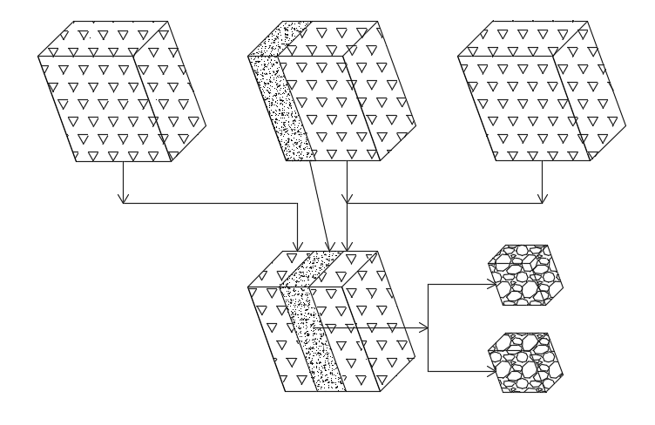
- кондициялық емес құрамды қабат - сапалық көрсеткіштері нормативтен төмен, бірақ кондициялық рудамен реттелген түрде араластыру арқылы жалпы рудалық массаның талап етілетін сапасын қамтамасыз ету үшін пайдаланылатын қабат.

1-сурет. Күрделі құрылымды кен блоктарын игеру кезінде шикізат сапасын басқарудың ұсынылған үдерісінің схемасы
Кен орны моделінің 3D блок моделінің фрагменті:
- кондициялық блок,
- автосамосвалға тиелетін кондициялық құрамды блок,
- кондициялық емес құрамды қабат.

Карьерді қалыптастыру селективтіліктің және жөнелтілетін кен сапасының қажетті деңгейін қамтамасыз ететін кезеңділікті (кезектер/фазалар) әрі уақытша контурларды көздейді. Қабылданған шешімдер маркшейдерлік және геомониторинг жұмыстары барысында, пайдалану кезіндегі кері байланыс нәтижелері негізінде, сондай-ақ тау-кен-геологиялық жағдайлар өзгерген кезде нақтыланады.
Карьерді қалыптастыру селективтіліктің және жөнелтілетін кен сапасының қажетті деңгейін қамтамасыз ететін кезеңділікті фазалар әрі уақытша контурларды көздейді. Қабылданған шешімдер маркшейдерлік және геомониторинг жұмыстары барысында, пайдалану кезіндегі кері байланыс нәтижелері негізінде, сондай-ақ тау-кен-геологиялық жағдайлар өзгерген кезде нақтыланады.
Карьердің қалыптасуын тиелетін кеннің селективтілігі мен сапасының қажетті деңгейін қамтамасыз ететін кезеңділікті, фазаларды және уақыт контурларын көздейді. Қабылданған шешімдер маркшейдерлік және геомониторинг барысында, пайдаланудың кері байланысының нәтижелері бойынша және тау-кен-геологиялық жағдайлары өзгерген кезде нақтылауға жатады.
Өндірілетін шикізаттың сапасын басқарудың негізгі мақсаты өзара байланысты және өзара тәуелді екі міндетті шешу болып табылады:
- өндірілетін және өңдеуге берілетін кен массасындағы бағалы компоненттердің құрамын арттыру;
- байыту фабрикасына кеннің түсетін сапасы бойынша тұрақты пайдалы қазбаның ағынын қалыптастыру.
Осы міндеттерді бірлікте шешу кен орны массивінде жүргізілген егжей-тегжейлі геологиялық зерттеулердің негізінде минералдық шикізаттың әртүрлі технологиялық түрлерін сұрыптау арқылы мүмкін. Қатты пайдалы қазбалардың бірқатар кен орындары бойынша жүргізілген зерттеулер нәтижелері көрсеткендей, технологиялық операцияларды орындауға және минералдық шикізат сапасын басқару үдерістеріне байланысты шығындардың өсуі тау-кен кәсіпорнының шикізат өнімінің құнының артуымен толық өтеледі.
Идеяны іске асырудың негізгі шарты лицензиялық жер қойнауындағы учаскесін игеру кезеңінде шикізат өнімінің құнының өсуі есебінен жиынтық дисконтталған ақша ағынының едәуір артуы; оған, соның ішінде, тауарлық өнім сапасының жоғары болуы, өндірілген шикізатты кешенді пайдалануы, ілеспе пайдалы қазбаларды өндіру, жинақталған және ағымдағы қалдықтарды пайдаланымға тартуы, аумақтарды рекультивациялау және жер қойнауын әрі қоршаған ортаны қорғау шараларын қамтамасыз етуі жатады [20-22].
Бір типтегі қатты пайдалы қазбалардың жер қойнауында пайда болу жағдайларының айтарлықтай айырмашылығына байланысты, сондай-ақ кен орны шегінде олардың сапасының үлкен өзгергіштігіне байланысты сапаны басқарудың бірыңғай жүйелерін құру орынсыз екенін есте ұстаған жөн.
Мұндай жүйелерді ұқсас белгілері бойынша (пайдалы қазбалардың түрі, құнды компоненттердің үлесі, минералдар мен негізгі жыныстардың минералдануы, генезисі және т.б.) біріктірілген кен орындары топтары бойынша дифференциалды түрде игеру тиімдірек. Ал содан кейін, осыны ескере отырып, негізінен физикалық-техникалық және физикалық-химиялық геотехнологияларды біріктіруге негізделген кен орнын игеру үйлесіміне сүйене отырып әдісін анықтау қажет.
Мысал ретінде алынған рудалы кен орнының блоктық геологиялық-құрылымдық 3D моделінің фрагментінен (2-сурет) жыныс массивінде пайдалы компоненттің барлық жерде кездесетіні, бірақ оның үлесі бойынша біртекті емес екені байқалады.

2 - сурет. Кен орны моделінің 3D блок моделінің фрагменті:
- құрамы А%-дан жоғары сапалы кен, - құрамында А% > PI >B% бар жақсы сапалы кен, - құрамында B% > PI > C% бар жақсы сапалы кен, - құрамында < С% және бос жынысы бар
стандартты емес кен, , тақыр бөгеттер, - геологиялық бұзылулар

Нәтижелер және талқылау. Осы зерттеулердің негізінде кен орнын игеру үшін келесі сапаны басқару жүйесі ұсынылады.
Карьер алаңын табиғи-технологиялық аймақтарға бөлу (рудалы, руда-жынысты және жынысты), бұл өндірілетін минералдық шикізаттың сапа жөніндегі жобалық көрсеткіштерін дифференцияланған түрде айқындауға және минералдануы жоғары рудалы аймақтарда тау-кен жұмыстарын қарқынды жүргізуге мүмкіндік береді. Сонымен қатар, талап етілетін орташа сапа көрсеткіштеріне қол жеткізу үшін белгілі бір рудалану аймағында қопарылған рудалық массаның көлемін икемді басқару мүмкіндігі туындайды. Бұдан бөлек, тау-кен жұмыстарының бағытын жоспарлы басқару қазу техникасының біртекті ортада жұмыс істеуіне жағдай жасап, қазу тереңдігін оңтайландыруға және, тиісінше, жабдықтың өнімділігін арттыруға мүмкіндік береді.
Рудалық массаның бірлік бөлігінің сапалық сипаттамаларын анықтау нәтижелерінің сенімділігіне қойылатын талап жоғары, өйткені кондициялық және некондициялық пайдалы қазбалардың құрамы арасындағы айырма салыстырмалы түрде шағын. Сондықтан қозғалыстағы тау-кен массасының беті бойынша тікелей өлшеу жүргізетін радиометриялық бақылау-өлшеу кешенін орнату қажет; бұл автосамосвалға тиеу кезінде руданың пайдалы компонентінің құрамын тікелей анықтауға мүмкіндік береді [23, 24].
Бір автосамосвалды тиеу барысында арнайы (XRT/XRF/HIS және т.б.) жабдықтың көмегімен өлшеулер жүргізіліп, әр автосамосвал кузовындағы құнды компоненттің орташа құрамы айқындалады; бұл көрсеткіш мониторда бейнеленеді, содан кейін автосамосвалға түсіру орны беріледі:
- рудалық массадағы кондициялық құнды компоненттің құрамы борттық құрамнан жоғары болса - байыту фабрикасының орташалау қоймаларына;
- құрамы борттық кондициялық құрамнан төмен, бірақ өнеркәсіптік құрамнан жоғары болса - кейінгі перспективалық пайдалану үшін қоймаға жинақтауға;
- құрамы борттық кондициялық құрамнан төмен рудалық масса арнайы үйіндіге жіберіледі [25].
Осылайша, пайдалы кен орнын игеру кезінде тау-кен массасы ағындарының сапалық сипаттамаларын басқарудың ұсынылған схемасы 3-суретте келтірілген және осындай мүмкіндіктер береді:
- карьер алаңын табиғи - технологиялық аймақтарға (рудалы, руда-жынысты, жынысты) бөлу негізінде жер қойнауынан пайдалы қазбаларды өндірудің жобалық көрсеткіштерін дифференцияланған түрде айқындау және тау-кен жұмыстары фронтының дамуының ұтымды бағытын жоспарлау;
- тау-кен жұмыстарының даму жоспарын жасағанда технологиялық көрсеткіштер мен пайдалы қазбалардың алыну көрсеткіштерін нақтылау;
- нақты өндірілген тау-кен массасы ағындарын, құрамындағы құнды компоненттерге қарай, жекелеген технологиялық түрлерге бөлу;
- нақты уақыт режимінде технологиялық сорттар бойынша және жалпы карьер көлемінде рудалық масса өндіру көлемдері туралы техникалық есептер алу;
- тау-кен жұмыстары фронтының даму бағытын, тау-кен-көлік кешенінің жұмыс режимін және жүк ағындарының сипаттарын өзгерту жөніндегі басқарушылық шешімдерді дер кезінде қабылдау.
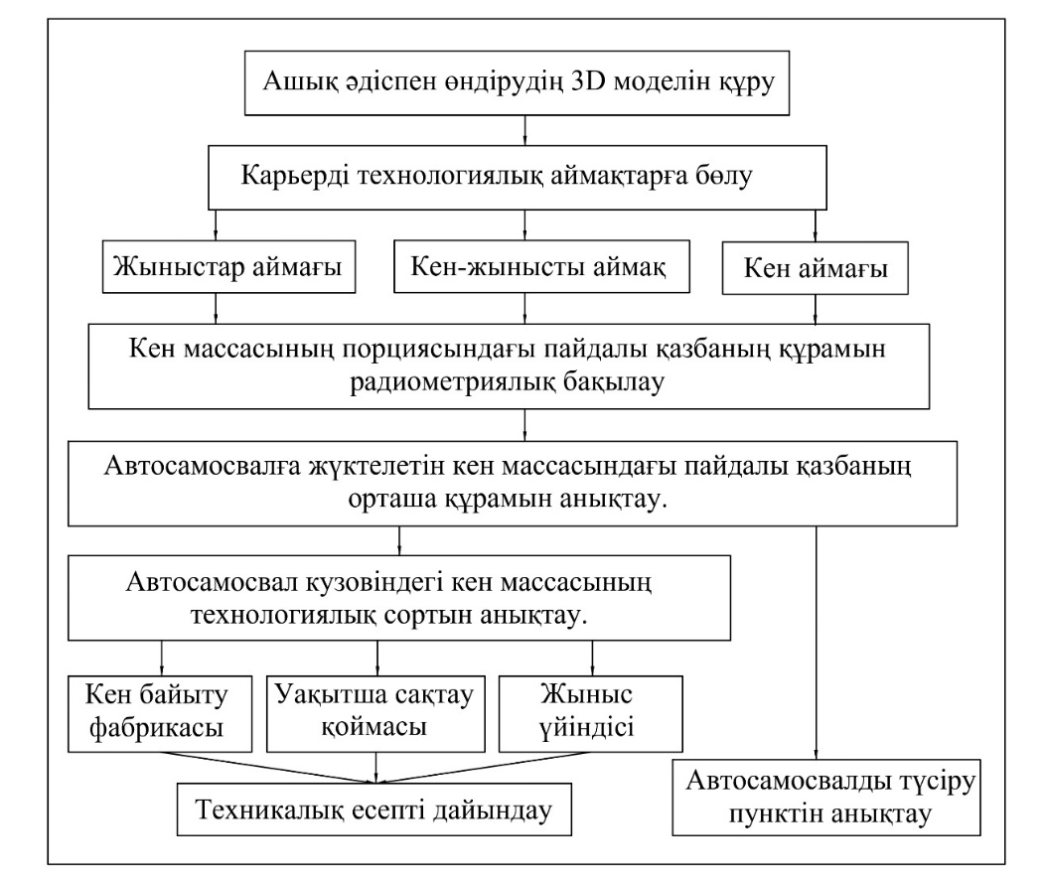
3 - сурет. Кен орнын игеру кезіндегі минералды шикізат ағындарының сапалық сипаттамаларын бақылау блок - схемасы

Қорытынды. Осылайша, жаһандық сын-қатерлер мен тәуекелдер жағдайында тау-кен техникалық жүйелердің тұрақты дамуын қамтамасыз ету және күрделі құрылымды қатты пайдалы қазбалар кен орнын игеру кезінде жоғары экономикалық нәтижелерге қол жеткізу үшін, осы мақалада баяндалған қағидаттар негізінде минералдық шикізат сапасын басқару мәселесін шешу жер қойнауын пайдаланудың, сондай-ақ жер қойнауындағы ресурстарды (георесурстарды) игерудің барлық кезеңдеріндегі маңызды міндет болып табылады.
Тереңде жатқан күрделі құрылымды кен орындарының қорларын кешенді игеру әдіснамасының одан арғы дамуы кәсіпорынның тау-кен-техникалық жүйесін тау-кен жұмыстарының даму үрдісі жағдайында қызмет ету шарттарының өзгеруіне бейімдеуге бағытталған жаңашыл шешімдерді әзірлеу және іске асыру барысында негізгі технологиялық үдерістердің өзара байланысын және оларды есепке алу тәсілдерін зерттеу қажеттілігімен байланысты.
Әдебиеттер

- Ракишев Б.Р. Полное извлечение кондиционных руд из сложноструктурных блоков за счет частичного примешивания некондиционных руд // Записки Горного института. - 2024. - Т. 270. - С. 919-930. ISSN 2411-3336, 2541-9404.
- Ракишев Б.Р. Новые определения естественного и трансформированного месторождения полезного ископаемого и этапы их эксплуатации // Горный информационно-аналитический бюллетень. -2023. -№ 8. - С. 165-177. DOI 10.25018/ 0236_1493_2023_8_0_165.
- Frenzel M., Baumgartner R., Tolosana-Delgado R., Gutzmer J. Geometallurgy: Present and Future // Elements. -2023. -Vol. 19 (6). -P. 345-351. DOI 10.2138/gselements.19.6.345.
- Anvari K., Benndorf J., A Review of Developments Within the Last Decade // Mining. -2025. -Vol. 5(3): 38. DOI 10.3390/mining5030038.
- Potakey N. E., Ortiz J. M., A review of grade control methods in open cast mining // Predictive Geometallurgy and Geostatistics Lab, Queen’s University, Annual Report. -2022. -Vol. 04. - P. 59-70.
- Рогизный В.Ф., Хромов В.М., Карпухина М.В. Технологии селективной выемки маломощных рудных тел с применением малогабаритного самоходного оборудования // Горная промышленность. - 2020. - № 1. - С. 34-41. ISSN 1609-9192, 2587-9138.
- Желябовский Ю.Г. Система подземной разработки с селективной выемкой руды // Золото и технологии. -2020. - №4 (46).- С.36-40.
- Peukert D., Xu C., Dowd P. A Review of Sensor-Based Sorting in Mineral Processing: The Potential Benefits of Sensor Fusion // Minerals. -2022. -Vol.12 (11): 1364. DOI 10.3390/min12111364.
- Owais A. Improving Sustainability and Efficiency in Ore Sorting with Sensors // AZoMining. -2023.
- dos Santos E.G., de Brum I.A.S., Ambrós W.M. Sensor-based Sorting using De-XRT Sensor Applied to a Greenfield Copper Ore Project in Southern Brazil // IgMin Research a BioMed & Engineering. -2025. -Vol 3(4). - P.201-205. DOI 10.61927/igmin299.
- Xiang J., Chen J., Zhang A., Zhao X., Zhuo S., Yang S. Multi-Objective Ore Blending Optimization for Polymetallic Open-Pit Mines Based on Improved Matter - Element Extension Model and NSGA-II // Mathematics. -2025. -Vol. 13 (11):1843. DOI 10.3390/math13111843.
- Luo J., Gu Q., Chen L., Li X., Li P. Multi-objective optimization for ore blending schemes in the open-pit phosphate mine using an improved NSGA-II algorithm // Green and Smart Mining Engineering. -2025. -Vol. 2 (1). -P. 42-56. DOI 10.1016/j.gsme.2024.12.004.
- Maniteja M., Samanta G., Gebretsadik A., Tsae N.B., Rai S.S., Fissha Y., Okada N., Kawamura Y. Advancing Iron Ore Grade Estimation: A Comparative Study of Machine Learning and Ordinary Kriging // Minerals. -2025. -Vol. 15(2):131. DOI 10.3390/min15020131
- Thiruchittampalam S., Banerjee B. P., Glenn N. F., Raval S. A systematic review of machine learning-based remote sensing data analysis for geological and mined materials characterization//European Journal of Remote Sensing. -2025. -Vol. 58 (1): 2524622. DOI 10.1080/22797254.2025.2524622.
- Marquina-Araujo J., Cotrina-Teatino M., Mamani-Quispe J., Noriega-Vidal E., Vega-Gonzales J., Cruz-Galvez J. Copper Ore Grade Prediction using Machine Learning Techniques in a Copper Deposit // Journal of Mining and Environment. -2024. -Vol. 15 (3). -P. 1011-1027. DOI 10.22044/jme.2024.14032.2617.
- Prior Á., Jorg B. Mueller U. Resource and Grade Control Model Updating for Underground Mining Production Settings // Mathematical Geosciences. -2021. -Vol. 53. P.757-779. DOI 10.1007/s11004-020-09881-2.
- Пыталев И.А., Доможиров Д.В., Симаков Д.Б., Борисенко Е.В. Управление качеством минерального сырья путем обоснования технологии и параметров подготовки к выемке пород природных массивов при открытой геотехнологии // Известия Тульского государственного университета. Науки о земле. -2023. -№ 4. -С.472-483.
- Кантемиров В.Д., Яковлев А.М., Титов Р.С., Тимохин А.В. Совершенствование методов рудоподготовки минерального сырья при освоении сложноструктурных месторождений // Горная Промышленность. -2022. -№1S. С. 63-70. DOI 10.30686/1609-9192-2022-1S-63-70.
- Мальцев Е. Н., Комплексная система управления качеством руды в условиях реального горнодобывающего предприятия // Золотодобыча для профессионалов: специалистов, руководителей, инвесторов. -2018. URL: https://zolotodb.ru/article/11888/.
- Трубецкой К. Н., Захаров В. Н., Каплунов Д. Р., Рыльникова М. В. Эффективные технологии использования техногенных георесурсов - основа экологической безопасности освоения недр // Горный журнал. -2016. -№ 5. - С. 34-40. DOI 10.17580/gzh.2016.05.03.
- Трубецкой К.Н. Развитие ресурсосберегающих и ресурсовоспроизводящих геотехнологий комплексного освоения месторождений полезных ископаемых // ИПКОН РАН. -2014. -196 c. ISBN 978-5-91177-082-2.
- Каплунов Д.Р., Комплексное освоение недр - основное направление проектирования разработки рудных месторождений // Горный информационно-аналитический бюллетень (научно-технический журнал). -2014, -№ 1. -С. 347-357.
- Федянин С. Н. О возможности разделения пород и руд месторождения Мурунтау рентгенорадиометрическим способом // Сборник научно-технических статей, Ташкент, Фан. - 1997. - С. 135-141.
- Еремин А.М. Научное обоснование возможности предварительного обогащения золотосульфидных руд и разработка технологии рентгенорадиометрической сортировки (на примере месторождения Кокпатас): дис. канд. техн. наук: 25.00.22./ ВНИПИ промтехнологии, Москва. - 2010. 138 c.
- Рыльникова М. В., Швабенланд Е.Е. Особенности управления качеством рудной массы при разработке сложноструктурных месторождений апатитовых руд с применением комбайновой выемки // Рациональное освоение недр. - 2019. -№ 2(3). - С. 80-86.

References

1. Rakishev B.R. Polnoe izvlechenie kondicionnyh rud iz slozhnostrukturnyh blokov za schet chastichnogo primeshivanija nekondicionnyh rud // Zapiski Gornogo instituta. - 2024. - T. 270. - S. 919-930. ISSN 2411-3336, 2541-9404. [in Russian]
2. Rakishev B.R. Novye opredelenija estestvennogo i transformirovannogo mestorozhdenija poleznogo iskopaemogo i jetapy ih jekspluatacii // Gornyj informacionno-analiticheskij bjulleten'. -2023. -№ 8. - S. 165-177. DOI 10.25018/ 0236_1493_2023_8_0_165. [in Russian]
3. Frenzel M., Baumgartner R., Tolosana-Delgado R., Gutzmer J. Geometallurgy: Present and Future // Elements. -2023. -Vol. 19 (6). -P. 345-351. DOI 10.2138/gselements.19.6.345.
4. Anvari K., Benndorf J., A Review of Developments Within the Last Decade // Mining. -2025. -Vol. 5(3): 38. DOI 10.3390/mining5030038.
5. Potakey N. E., Ortiz J. M., A review of grade control methods in open cast mining // Predictive Geometallurgy and Geostatistics Lab, Queen’s University, Annual Report. -2022. -Vol. 04. - P. 59-70.
6. Rogiznyj V.F., Hromov V.M., Karpuhina M.V. Tehnologii selektivnoj vyemki malomoshhnyh rudnyh tel s primeneniem malogabaritnogo samohodnogo oborudovanija // Gornaja promyshlennost'. - 2020. - № 1. - S. 34-41. ISSN 1609-9192, 2587-9138. [in Russian]
7. Zheljabovskij Ju.G. Sistema podzemnoj razrabotki s selektivnoj vyemkoj rudy // Zoloto i tehnologii. -2020. - №4 (46).- S.36-40. [in Russian]
8.Peukert D., Xu C., Dowd P. A Review of Sensor-Based Sorting in Mineral Processing: The Potential Benefits of Sensor Fusion // Minerals. -2022. -Vol.12 (11): 1364. DOI 10.3390/min12111364.
9. Owais A. Improving Sustainability and Efficiency in Ore Sorting with Sensors // AZoMining. -2023.
10.dos Santos E.G., de Brum I.A.S., Ambrós W.M. Sensor-based Sorting using De-XRT Sensor Applied to a Greenfield Copper Ore Project in Southern Brazil // IgMin Research a BioMed & Engineering. -2025. -Vol 3(4). - P.201-205. DOI 10.61927/igmin299.
11.Xiang J., Chen J., Zhang A., Zhao X., Zhuo S., Yang S. Multi-Objective Ore Blending Optimization for Polymetallic Open-Pit Mines Based on Improved Matter - Element Extension Model and NSGA-II // Mathematics. -2025. -Vol. 13 (11):1843. DOI 10.3390/math13111843.
12. Luo J., Gu Q., Chen L., Li X., Li P. Multi-objective optimization for ore blending schemes in the open-pit phosphate mine using an improved NSGA-II algorithm // Green and Smart Mining Engineering. -2025. -Vol. 2 (1). -P. 42-56. DOI 10.1016/j.gsme.2024.12.004.
13.Maniteja M., Samanta G., Gebretsadik A., Tsae N.B., Rai S.S., Fissha Y., Okada N., Kawamura Y. Advancing Iron Ore Grade Estimation: A Comparative Study of Machine Learning and Ordinary Kriging // Minerals. -2025. -Vol. 15(2):131. DOI 10.3390/min15020131
14. Thiruchittampalam S., Banerjee B. P., Glenn N. F., Raval S. A systematic review of machine learning-based remote sensing data analysis for geological and mined materials characterization//European Journal of Remote Sensing. -2025. -Vol. 58 (1): 2524622. DOI 10.1080/22797254.2025.2524622.
15.Marquina-Araujo J., Cotrina-Teatino M., Mamani-Quispe J., Noriega-Vidal E., Vega-Gonzales J., Cruz-Galvez J. Copper Ore Grade Prediction using Machine Learning Techniques in a Copper Deposit // Journal of Mining and Environment. -2024. -Vol. 15 (3). -P. 1011-1027. DOI 10.22044/jme.2024.14032.2617.
16. Prior Á., Jorg B. Mueller U. Resource and Grade Control Model Updating for Underground Mining Production Settings //Mathematical Geosciences. -2021. -Vol. 53. P.757-779. DOI 10.1007/s11004-020-09881-2.
17. Pytalev I.A., Domozhirov D.V., Simakov D.B., Borisenko E.V. Upravlenie kachestvom mineral'nogo syr'ja putem obosnovanija tehnologii i parametrov podgotovki k vyemke porod prirodnyh massivov pri otkrytoj geotehnologii // Izvestija Tul'skogo gosudarstvennogo universiteta. Nauki o zemle. -2023. -№ 4. -S.472-483. [in Russian]
18. Kantemirov V.D., Jakovlev A.M., Titov R.S., Timohin A.V. Sovershenstvovanie metodov rudopodgotovki mineral'nogo syr'ja pri osvoenii slozhnostrukturnyh mestorozhdenij // Gornaja Promyshlennost'. -2022. -№1S. S. 63-70. DOI 10.30686/1609-9192-2022-1S-63-70. [in Russian]
19. Mal'cev E. N., Kompleksnaja sistema upravlenija kachestvom rudy v uslovijah real'nogo gornodobyvajushhego predprijatija // Zolotodobycha dlja professionalov: specialistov, rukovoditelej, investorov. -2018. URL: https://zolotodb.ru/article/11888/.[in Russian]
20. Trubeckoj K. N., Zaharov V. N., Kaplunov D. R., Ryl'nikova M. V. Jeffektivnye tehnologii ispol'zovanija tehnogennyh georesursov - osnova jekologicheskoj bezopasnosti osvoenija nedr // Gornyj zhurnal. -2016. -№ 5. - S. 34-40. DOI 10.17580/gzh.2016.05.03. [in Russian]
21. Trubeckoj K.N. Razvitie resursosberegajushhih i resursovosproizvodjashhih geotehnologij kompleksnogo osvoenija mestorozhdenij poleznyh iskopaemyh // IPKON RAN. -2014. -196 c. ISBN 978-5-91177-082-2. [in Russian]
22. Kaplunov D.R., Kompleksnoe osvoenie nedr - osnovnoe napravlenie proektirovanija razrabotki rudnyh mestorozhdenij // Gornyj informacionno-analiticheskij bjulleten' (nauchno-tehnicheskij zhurnal). -2014, -№ 1. -S. 347-357. [in Russian]
23. Fedjanin S. N. O vozmozhnosti razdelenija porod i rud mestorozhdenija Muruntau rentgenoradiometricheskim sposobom // Sbornik nauchno-tehnicheskih statej, Tashkent, Fan. - 1997. - S. 135-141. [in Russian]
24. Eremin A.M. Nauchnoe obosnovanie vozmozhnosti predvaritel'nogo obogashhenija zolotosul'fidnyh rud i razrabotka tehnologii rentgenoradiometricheskoj sortirovki (na primere mestorozhdenija Kokpatas): dis. kand. tehn. nauk: 25.00.22./ VNIPI promtehnologii, Moskva. - 2010. 138 c. [in Russian]
25. Ryl'nikova M. V., Shvabenland E.E. Osobennosti upravlenija kachestvom rudnoj massy pri razrabotke slozhnostrukturnyh mestorozhdenij apatitovyh rud s primeneniem kombajnovoj vyemki // Racional'noe osvoenie nedr. - 2019. -№ 2(3). - S. 80-86. [in Russian]

Авторлар туралы мәліметтер

Ибырханов Т.С. - докторант, КеАҚ «Қ.И. Сәтбаев атындағы Қазақ ұлттық техникалық зерттеу университеті», Алматы, Қазақстан, e-mail: ibir.tem@mail.ru;
Ибырханова А.И. - докторант, Әбілқас Сағынов атындағы Қарағанды техникалық университеті, Қарағанды, Қазақстан, e-mail: i.altynay33@gmail.com;

Information about the authors

Ibyrkhanov T.S. - doctoral student, the NJSC «Kazakh National Research Technical University named after K.I. Satpayev», Almaty, Kazakhstan, e-mail: ibir.tem@mail.ru;
Ibyrkhanova A.I.- doctoral student, Abylkas Saginov Karaganda Technical University, Karaganda, Kazakhstan, e-mail: i.altynay33@gmail.com.

ҒТАМР 52.47.19
МҰНАЙГАЗ КЕН ОРЫНДАРЫН ИГЕРУДІҢ ТИІМДІ ИННОВАЦИЯЛЫҚ ӘДІСТЕРІН ЗЕРТТЕУГЕ АНАЛИТИКАЛЫҚ ШОЛУ

Б.М.Нұранбаева, А.М. Жұматай

Caspian University, Алматы, Казахстан

Корреспондент-автор: bulbulmold@gmail.com

Мақалада мұнай-газ өнеркәсібінде цифрландыру шешімдерінің қарқынды және кеңінен қолданысқа иә болуына байланысты құрылымдық трансформация сатысында кен орындарын игерудің заманауи әдістеріне арналған ғылыми материалдарға аналитикалық шолу жүргізілді.
Зерттеу барысында «цифрлық кен орны» тұжырымдамасының негізгі элементтерін, өндірістік деректерді интеграцияланған басқару, өндірістегі үрдістерді автоматтандыру, сонымен қатар оны оңтайландыру рөлін, оның ішінде мұнай бергіштік коэффициентін арттыруға бағытталған технологиялық шешімдерді талданды. AVIST цифрлық платформасының функционалдық мүмкіндіктері және оның интеллектуалды жүйелерді, модельдеу құралдарын және деректерді өңдеу архитектурасын біріктіру маңыздылығы Қарақұдық кен орнында жүзеге асырылған пилоттық жобаның материалдары негізінде ашылып көрсетілді.
Мақалада жүргізілген шолу нәтижелерінің нәтижесіні көрсеткендей мұнай-газ саласындағы цифрландырудың өзекті бағыттарын айқындап, инновациялық технологияларды өнеркәсіптік деңгейде енгізу арқылы оның тиімділігін бағалауға мүмкіндік береді. Алынған тұжырымдар жоғары қолданбалы мәнге ие және қазіргі өндірістік процестерді жаңғыртуға бағытталған тәжірибелік шешімдер үшін әдістемелік негіз бола алады.
Түйін сөздер: кен орын, игеру, цифрландыру, зерттеу, аналитикалық шолу.

АНАЛИТИЧЕСКИЙ ОБЗОР ИССЛЕДОВАНИЙ ЭФФЕКТИВНЫХ ИННОВАЦИОННЫХ МЕТОДОВ РАЗРАБОТКИ МЕСТОРОЖДЕНИЙ
НЕФТИ И ГАЗА
Б.М.Нуранбаева, А.М.Жұматай

Caspian University, Алматы, Казахстан,

e-mail: bulbulmold@gmail.com

В статье проведен аналитический обзор научных материалов, посвященных современным инновационным методам разработки месторождений на стадии структурной трансформации, в которые решения цифровизации связаны с интенсивным и широким применением в нефтегазовой отрасли.
Исследование направлено на анализ ключевых элементов концепции «цифрового месторождения», интегрированного управления производственными данными, роли автоматизации и оптимизации процессов, а также технологических решений, направленных на повышение коэффициента нефтеотдачи. Раскрыты функциональные возможности цифровой платформы AVIST и ее значение в интеграции интеллектуальных систем, средств моделирования и архитектуры обработки данных на основе материалов пилотного проекта, реализованного на месторождении Каракудык.
Результаты проведенного обзора позволяют оценить эффективность внедрения инновационных технологий на промышленном уровне с определением актуальных направлений цифровизации нефтегазовой отрасли. Полученные выводы имеют высокую прикладную ценность и могут служить методологической основой для практических решений, направленных на модернизацию современных производственных процессов.
Ключевые слова: месторождение, разработка, цифровизация, исследования, аналитический обзор.

ANALYTICAL REVIEW OF RESEARCH ON EFFECTIVE INNOVATIVE METHODS FOR DEVELOPING OIL AND GAS FIELDS
B.Nuranbaeva, A.Zhumatai
Caspian University, Алматы, Казахстан,
e-mail: bulbulmold@gmail.com

The article provides an analytical review of scientific materials devoted to modern innovative methods of field development at the stage of structural transformation, in which digitalization solutions are associated with intensive and widespread use in the oil and gas industry.
The article provides an analytical review of scientific materials devoted to modern innovative methods of oil and gas field development. The study focuses on analyzing the key elements of the “digital field” concept, integrated production data management, the role of automation and process optimization, as well as technological solutions aimed at increasing oil recovery rates. The functional capabilities of the AVIST digital platform and its importance in the integration of intelligent systems, simulation tools, and data processing architecture are revealed based on materials from a pilot project implemented at the Karakudyk field.
The results of the review allow us to assess the effectiveness of the implementation of innovative technologies at the industrial level and identify the current trends in the digitalization of the oil and gas industry. The conclusions drawn are of high practical value and can serve as a methodological basis for practical solutions aimed at modernizing contemporary production processes.
Keywords: field, development, digitalization, research, analytical review.

Кіріспе. Жыл сайын дәстүрлі мұнай қоры таусылып, оның сапасы нашарлайды. Бұл, ең алдымен, кен орындарының жоғары өндірілуіне және өндірілетін өнімнің жоғары сулануына байланысты. Бұл факт қазіргі өнеркәсіп үшін қиын алынатын қорларды дамытуға жаңа міндеттер қояды, оларды қолданыстағы өндіріс технологияларымен дамыту тиімсіз. Қазіргі уақытта тұтқырлығы жоғары және өте тұтқырлы мұнайды өндіруге көбірек көңіл бөлу өзекті мәселелердің бірі.
Дәстүрлі қорлардың сарқылуы. Жыл сайын көмірсутектердің күрделі, өткізгіштігі төмен және алынуы қиын қорлары игерілуде. Бұл мұнай мен газ өндіруді арттырудың жаңа тәсілдерін іздеуді талап етеді.
Тиімділік және оны арттыру. Дәстүрлі әдістер енді әрқашан табысты өндірісті қамтамасыз ете бермейді. Инновациялық технологиялар шығындарды оңтайландыруға, ұңғыма өнімділігін арттыруға және өндіріс шығындарын азайтуға мүмкіндік береді.
Цифрландыру мен автоматтандыру. Қазіргі мұнай-газ өнеркәсібі жинақталған ғылыми деректерді жан-жақты талдау мен жалпылауды қажет ететін цифрлық егіздерді, зияткерлік кен орындарының жүйелерін, заттар интернетін (IoT) және жасанды интеллектті белсенді түрде енгізуде.
Экологиялық мәселелер және тұрақты даму. Ең маңызды міндет - инновациялық және экологиялық таза технологиялардың көмегімен мүмкін болатын кен орындарын пайдалану кезінде қоршаған ортаға әсерді барынша азайту.
Әлемдік энергияның ауысуы. Таза энергияға жаһандық көшу жағдайында мұнай-газ саласы бәсекеге қабілеттілігін арттыру үшін көмірсутектерді өндіру және өңдеу технологияларын жетілдіру арқылы бейімделуі керек.
Зерттеудің мақсаты - мұнай-газ секторы қызметінің негізгі аспектілеріне, атап айтқанда, кен орындарын игеру және игеру саласындағы заманауи технологиялық шешімдердің әсерін талдау. Өнеркәсіптік тәжірибеде қолданылатын озық тәжірибелер мен олардың кең таралуына кедергі келтіретін кедергілер қарастырылады.
Көмірсутек ресурстары көптеген ондаған жылдар бойы жаһандық энергия балансының негізгі элементі болып қала берді. Дегенмен, қазіргі заманғы мұнай-газ өнеркәсібі қол жетімді қорларды азайтуды, операциялық шығындарды арттыруды және қоршаған ортаны реттеу талаптарын күшейтуді қоса алғанда, бірқатар маңызды міндеттерді талап етеді [1]. Мұндай жағдайларда қоршаған ортаға әсерді азайта отырып, көмірсутектерді барлау және өндіру процестерінің тиімділігін арттыруға бағытталған инновациялық технологияларды енгізудің маңыздылығы артады [2].
Авторлардың пікірі [3] саланың тұрақты және бәсекеге қабілетті дамуын қамтамасыз етудегі цифрландыру, автоматтандыру және интеллектуалды жүйелердің рөлін атап көрсетеді.
Инновациялық технологиялық шешімдерді пайдалану өндіріс шығындарын айтарлықтай азайтуға және экологиялық тәуекелдерді азайтуға көмектеседі. Осылайша, нақты уақыт режимінде деректерді өңдеу арқылы сенсорлық бақылау жүйелері мен аналитикалық жүйелерді енгізу жабдықтың жұмыс параметрлерін жылдам бақылауға, төтенше жағдайлардың алдын алуға және технологиялық процестерді оңтайландыруға мүмкіндік береді [4].
Жұмыста [5] авторлар автоматтандырылған жүйелер мен роботтық қондырғыларды пайдалану, әсіресе шалғай немесе экстремалды нысандарда, соның ішінде теңіз платформаларында жұмыс қауіпсіздігін арттырады.
Өнеркәсіптің дамуындағы заманауи тенденциялар көмірсутектердің дәстүрлі көздерінен дәстүрлі емес көздеріне көшуді болжайды. Маңызды назар аударатын нысандардың бірі - ауыр мұнай, ол барланған әлемдік қорлардың шамамен 70% құрайды [6]. Дегенмен, оны алу техникалық күрделіліктің жоғарылауымен байланысты. Қазіргі уақытта буды ынталандыру технологиялары кеңінен қолданылады, олардың тиімділігі 30% -дан аспайды, ал мұнайдың айтарлықтай көлемі жер қойнауында қалады. Осыған байланысты тиімділігі 55% жетуі мүмкін ауаны айдау [7] сияқты балама әдістерге қызығушылық артып келеді.
Мұнай қабаттарына ауа айдау - бу стимуляциясынан бірқатар артықшылықтарға ие перспективалы және экологиялық таза технология. Ол мұнай өндіру құнын төмендетуге көмектеседі, су мен табиғи газды тұтынуды азайтады және көміртегі ізін азайтады. Мысалы, Шыңжаң кен орнында ауаны айдау құны буды пайдаланатын ұқсас операциялар құнының шамамен 60% құрайды. Бұл технология жобалардың экономикалық табыстылығын арттыруға, энергетикалық қауіпсіздікті нығайтуға және көмірсутегі ресурстарын дамытуда төмен көміртекті шешімдерді ілгерілетуге көмектеседі. Дегенмен, мұндай жобаларды жүзеге асыру өндірісті басқаруға кешенді көзқарасты және геологиялық, техникалық және экологиялық параметрлерді қатаң ескеруді талап етеді. Тәжірибе [8] көрсеткендей, мұндай бастамалардың табыстылығы 20%-дан аспайды, бұл көптеген факторларға, соның ішінде процестердің күрделілігіне, тәжірибелік базаның болмауына және деректердің толық болмауына байланысты.
Мұнайдың [9] ауыр фракцияларының тотығуымен бірге жүретін термохимиялық процестерді зерттеу үш температуралық режимді анықтауға мүмкіндік береді - төмен, орташа және жоғары. Коксты жоғары температурада жағуға назар аударылғанымен, төмен және орташа температурадағы тотығу процестері әлі де аз зерттелген. Мұндай реакциялар кезінде пайда болатын жылу әсерлерін және олардың қабаттағы температураны жоғарылату әлеуетін зерттеу әсіресе өзекті болып көрінеді.
Материалдар мен әдістер. Тұтқырлығы жоғары мұнайдың тотығу үрдісі жүретін температура диапазоны үш негізгі кезеңді ажыратуға мүмкіндік береді: төмен, орташа және жоғары температура тотығуы. Отандық және шетелдік зерттеушілер жүргізген жұмыстардың көпшілігі жоғары температурада болатын процестерге, негізінен алынған коксты жағуға байланысты. Сонымен қатар, негізінен сапалық сипатта болатын төмен және орташа температура жағдайында шикі мұнай компоненттерінің тотығу реакцияларына қатысты зерттеулер оттегі шығынын және тотығу өнімдерінің құрамын зерттеумен шектеледі. Сонымен қатар, зерттеулер мен әдебиеттерде төмен және орташа температуралық тотығудың жылулық сипаттамаларын объективті бағалауға мүмкіндік беретін жүйелі эксперименттік деректер жетіспейді. Бұл осы жағдайларда бөлінетін энергия өнімді қабатқа термиялық әсер ету үшін жеткілікті болуы мүмкін бе деген белгісіздікке әкеледі. Сонымен қатар, геологиялық және стратиграфиялық факторлардың (қабат қысымы, қабат суының болуы, кеуектілік, сазды минералдардың мөлшері және т.б.) термиялық тотығу процестеріне және ауыр мұнайдың тотығу кезіндегі жылу бөліну дәрежесіне әсері туралы мәселе ашық күйінде қалып отыр.
Осыған байланысты [3] қабат жағдайларының (қысым, қанықтылық, кеуектілік және тау жыныстарының құрамы) термиялық тотығу әдістерінің тиімділігіне әсері маңызды болып қала береді. Жылдам технологиялық трансформация жағдайында мұнай-газ саласы прогрессивті шешімдерді үнемі бақылауды және енгізуді талап етеді. Жаңа тенденцияларды терең түсіну және өзгермелі энергия нарығына бейімделу ғана тұрақты даму стратегияларын қалыптастыруға мүмкіндік береді.
«Ақылды» кен орындарының [4] тұжырымдамаларын құру үшін цифрлық модельдерді пайдалану ерекше маңызға ие. Математикалық модельдеу өндірістік процестердің әртүрлі элементтерін бір жүйеге біріктіреді, бұл технологиялық тізбектерді тереңірек талдауға ғана емес, сонымен қатар басқару шешімдерін жылдам қабылдауға мүмкіндік береді. Қазіргі жағдайда деректерді талдау, процестерді визуализациялау және жүйенің мінез-құлқын болжау тиімді кен орындарын басқарудың ажырамас құрамдас бөліктеріне айналуда.
Schlumberger, Roxar және Petroleum Experts ұсынатын бағдарламалық жүйелер бұрғылауды жоспарлау мен жабдықты таңдаудан бастап өндіру мен ұңғымаларды жоюды оңтайландыруға дейінгі кен орнын [5] игерудің өмірлік циклінің барлық кезеңдерін қамтиды. Олар өндіріс параметрлерін үздіксіз бақылауға, қабат қысымын басқаруға және техникалық қызмет көрсетуді уақтылы жоспарлауға мүмкіндік береді, осылайша операциялық және ұзақ мерзімді тиімділікті қамтамасыз етеді.
BP жобаларындағы өндірістің 2-3%-ға артуы және Shell-дегі 5 миллиард долларлық экономикалық тиімділік сияқты практикалық мысалдар мұнай мен газды цифрландырудың тиімділігін көрсетеді. Дегенмен, үлкен көлемдегі деректерді талдау және түсіндіру, үлгілерді үнемі жаңарту және нәтижелердің сенімділігін қамтамасыз ету тек техникалық шешімдерді ғана емес, сонымен қатар ұйымдастырушылық күш-жігерді де қажет етеді. Кәдімгі операцияларды автоматтандыру терең талдау үшін ресурстарды босатады, бұл өз кезегінде стратегиялық негізделген басқару шешімдеріне ықпал етеді.
Нәтижелер және талқылау. Еліміздегі мұнай-газ саласының дамуына қазіргі кезеңіне стратегиялық даму бағыттарын айқындайтын инновациялық және цифрлық технологиялардың елеулі әсерімен сипатталады. Технологиялық прогресті интенсификациялау жағдайында инновациялық тенденцияларды үнемі бақылау, оларды аналитикалық түсіндіру және басқару шешімдеріне айналдыру негізгі міндеттерге айналады. Бұл процестерді [10,11] жүйелі қабылдау ресурс тиімділігін, экологиялық тұрақтылықты арттыру және энергия нарығының өзгеретін талаптарына бейімделу үшін қажет.
Саланы цифрландырудың маңызды бағыттарының бірі мұнай-газ орындарын кешенді модельдеуді дамыту болып табылады. Бұл тәсіл геологиялық, геофизикалық, гидродинамикалық және өндірістік үлгілерді қабаттар мен ұңғымалардың әрекетін кешенді бағалауға және болжауға мүмкіндік беретін бір цифрлық жүйеге біріктіруді қамтамасыз етеді. Бұл тәсілді [12, 13] жүзеге асыру ауыстыру өмірлік циклінің барлық кезеңдерінде - жобалаудан бастап жабуға дейін негізделген операциялық және стратегиялық шешімдер қабылдауға ықпал етеді.
Іс жүзінде жетекші халықаралық компаниялар интеграцияланған модельдер мен цифрлық қосарлану негізіне белсенді түрде Petrel, Roxar RMS және IPM Suite сияқты бағдарламалық жүйелер көп параметрлі оңтайландыруға, есептеулерді автоматтандыруға және күрделі процестерді визуализациялауға мүмкіндік береді және кен орындарға енгізуге, сонымен қатар бұл оның өнімділікті арттыруға, шығындарды азайтуға және инвестицияның қайтарымдылығын жақсартуға көмектесетіндігін атап көрсетеді.
Атап айтқанда, BP жүзеге асырған цифрлық трансформация цифрлық қосарлануға негізделген икемді басқару жүйесін енгізу есебінен күнделікті өндірістің 2-3%-ға артуына әкелді. Аталған модельдеу платформаларының тиімділігі нақты жағдайлармен расталады. Авторлардың [7, 14] Shell өзінің цифрлық кен орнының архитектурасын енгізгеннен кейін кірістің 5 миллиард АҚШ долларына өскенін атап өтті. Мұндай нәтижелер цифрлық инвестициялардың экономикалық орындылығын және интеграцияланған шешімдердің өзектілігін көрсетеді. Әлемдегі жетекші мұнай-газ өндіруші компаниялар интеграцияланған модельдеу әдістерін тәжірибеде белсенді қолдана бастады және мұндай тәсілдің жоғары тиімділігін ескере отырып, жарияланған есептері бойынша «цифрлық кен орны» бағдарламасын енгізу мұнай өндірудің тәуліктік көлемін 2-3 % арттырған. Осындай құралдарды Shell компаниясы да қолданған, нәтижесінде шамамен 5 млрд доллар қосымша табыс алған. Бірақ та интеграцияланған модельдеуді іс жүзінде жүзеге асыру бірқатар қиындықтарды тудырады. Негізгі мәселелердің бірі деректердің үлкен көлемін түсіндірудің күрделілігі және өндіріс көрсеткіштерінің динамикасына байланысты үлгілерді үнемі жаңарту қажеттілігі туындайды. Бұл қиындықтарды жою үшін [15,16] адам факторын барынша азайтатын және болжамның дәлдігін арттыратын деректерді жинау, алдын ала өңдеу және тексерудің автоматтандырылған жүйелерін енгізу орынды.
Перспективалы бағыттардың бірі сыни параметрлерді жылдам талдауға, ауытқуларды анықтауға және адаптивті басқару сценарийлерін ұсынуға қабілетті интеллектуалды шешімдерді қолдау жүйелерін дамыту болып табылады. Мұндай жүйелерді модельдеумен [11, 13] біріктіру баламалы стратегияларды бағалауға мүмкіндіктер ашады (сценарийлік талдау), бұл өндірістің тұрақтылығын арттыру және тәуекелдерді азайту үшін өте маңызды.
2012-2014 жылы пилоттық жоба аясында Қарақұдық кен орнында AVIST пайдалану айтарлықтай экономикалық нәтиже берді [17]. 3,7 миллион доллар инвестиция арқылы шамамен 17 миллион доллар болжамды пайда алынды, бұл мұнай өндіруді басқарудағы цифрлық технологиялардың жоғары табыстылығын растайды.
Аймақтық тәжірибеде цифрлық шешімдерді интеграциялаудың мысалы ретінде ЛУКОЙЛ Оверсиз үшін ITPS компаниялар тобы әзірлеген Қазақстандағы Қарақұдық кен орнында AVIST платформасын енгізуді келтіруге болады. Бұл жүйе нақты уақыт режимінде телеметриялық ақпаратты жинауды, оны [15] цифрлық модельге түрлендіруді және бір басқару порталының интерфейсі арқылы кейінгі визуализацияны қамтамасыз етеді.
Бұл мәселені шешудің тиімді жолы - жылдам әрекет ететін жүйесі құру. Мұндай жүйенің негізгі функционалдығы кен орнының жай-күйін және оны игеру үрдістерін сипаттайтын негізгі көрсеткіштерді бақылауды, сондай-ақ ықтимал мәселелер туралы проактивті (алдын ала) сигналдарды беруді қамтамасыз етеді. Соның ішінде «ЛУКОЙЛ Оверсиз» болып табылатын Қазақстандағы «Қарақұдық» кен орнында «Parma-Telecom» (ITPS Group) жеке әзірлеген AVIST платформасы қолданылады. Бұл платформаның көмегімен өндірістік жүйелерден телеме-триа деректерін жылдам жүктеу үшін автоматтандырылған интерфейстер жасауға мүмкіндік берді, интеграцияланған модель және оның жеке құрамдас бөліктері бойынша есептеулердің нәтижелік таттарының визуализациясы және оларды бір басқару порталында жариялау конфигурацияланды.
AVIST интеграциялық платформасы арқылы кен орнынды цифрлық модельдеу және басқаруға мүмкіндік береді: бұл жүйенің негізгі мақсаты - мұнай өндірудің тиімділігін арттырып, технологиялық үдерістерді оңтайландыру және нақты уақыт режимінде шешім қабылдау.
AVIST платформасы арқылы цифрлық кен орны архитектурасында келесі стратегиялық рөлдерді атқарады:
1. Деректерді бірыңғай орталықта біріктіру. Кен орнындағы геологиялық, гидродинамикалық, технологиялық және өндірістік мәліметтер платформаның бірыңғай базасында жинақталады, бұл ақпараттық оқшаулықты жояды.
2. Өндірісті басқарудың интеграцияланған контуры. Платформа ұңғылардың, сорғы-жабдықтардың, мұнай жинау жүйелерінің жұмысын бақылау және басқару процестерін автоматтандырады.
3. Операциялық тиімділікті арттыру. Жасанды интеллект элементтері мен аналитикалық алгоритмдер мұнай бергіштің коэффициентін арттыруға, су-мұнай қатынасын (WOR) төмендетуге, жоспарсыз тоқтаулар санын азайтуға мүмкіндік береді.
Сонымен қатар. AVIST негізіндегі аналитика ұңғы қорының жұмысын болжауға, өндіру жоспарын түзетуге және мұнай бергіштікіті арттырудың (EOR) әдістерін оңтайландыру кезінде таңдауға мүмкіндік береді.
Еліміздегі мұнайгаз саласының ерекшеліктеріне байланысты, AVIST платформасының бірнеше артықшылықтары айқындауға болады: сулануы жоғары ұңғыларды тиімді басқару; ұңғы жұмысының күрделі режимдерін модельдеу; тепе-теңдік және динамикалық модельдер негізіндегі мұнай бергіштік әдістерінің тиімділігін болжау; өндірістік тәуекелдерді алдын ала анықтау; жоғары деректер көлемімен (Big Data) жұмыс істеу қабілеті. Бұл платформа сондай-ақ қазақстандық мұнай кәсіпорындарының цифрлық трансформация стратегияларымен үйлесімді, бірнеше кен орындарында пилоттық және өнеркәсіптік деңгейде қолданылып жүр (1-кесте).

Кесте 1 - Қолданылатын цифрлық платформалар

Платформа | Қызметтері | Шектеулері
AVIST  (ҚР жобаларында кең таралған) | Кен орнын моделдеу, өндірісті оңтайландыру, ұңғыны нақты уақыт режимінде бақылау | Деректердің сапасына тәуелді; кейбір күрделі EOR сценарийлері шектелген
Schlumberger Delfi / Petrel | Геомодельдеу, динамикалық симуляция, EOR сценарийлерін болжау | Лицензия құны жоғары; мамандарды оқыту қажет
Honeywell, Aspen HYSYS | Қондырғыларды симуляциялау, үрдістерді цифрландыру | Кен орын емес, технологиялық процестерге бағытталған
Cognite Data Fusion | Үлкен деректерді интеграциялау, IoT, цифрлық қосарлану (Digital Twin) | Толық енгізу үшін инфрақұрылым қажет
Oniq / Sensorless жүйелері | Жабдықтарды болжау диагностикасы, жөндеу интервалын оңтайландыру | Ұңғымалық деңгейдегі модельдеу шектелуі мүмкін

AVIST интеллектуалды платформасы өндіріс деректерінің дәстүрлі интеграциясынан тыс әлеуетті көрсетеді. Оның негізгі функционалдығы мұнай өндіруші активтерді белсенді басқару тұжырымдамасын жүзеге асыруды қолдайтын болжамды аналитика мен сценарийлік модельдеуді қамтиды. Бұл өз кезегінде жабдықтың тоқтап қалуын азайтуға, пайдалану тиімділігін арттыруға және саладағы экологиялық мақсаттарға қол жеткізуге көмектеседі. Жүйемен қамтамасыз етілген [11-13] өндірістік процестерді жан-жақты шолу энергия саласындағы цифрлық трансформацияның маңыздылығын атап көрсете отырып, негізделген басқару шешімдерін қабылдауға мүмкіндік береді (2-кесте).

2-кесте. Цифрлық платформалардың қызметтері мен шектеулері

Платформа | Мүмкіндіктері | Шектеулері
CMG (IMEX, GEM, STARS) | Химиялық, жылулық, газ EOR симуляциясы;  көпфазалы ағынның нақты моделі | Құны жоғары; қуатты серверді талап етеді
Eclipse/ INTERSECT | Резервуарлық модельдеу, CO₂ EOR, көпкомпонентті модель | Пайдалану күрделі;  оқытуды қажет етеді
Petrel | Геомодельдеу, ұңғы траекториясы, интеграция | Real-time мониторинг шектеулі
AVIST  (ITPS Group) | Операциялық тиімділікті бақылау, өндірісті оңтайландыру | Күрделі EOR симуляциясына арналмаған
Kappa  (Saphir, Topaze) | Ұңғыманы талдау, қысым қайта түсуі, well-test | Резервуардың толық модельдерін жасамайды

Атап айтқанда, «LUKOIL Oversiz» компаниясында AVIST енгізу ұңғымалардың жағдайын нақты уақыт режимінде бақылауға мүмкіндік берді. Бұл триггерлердің жұмысын, қабат қысымының өзгеруін және жұмыс режимдерінің ауысуын қоса алғанда, өзара тәуелді параметрлерді ескеретін статикалық модельдерден динамикалық модельдеуге көшуді бастады. Жетілдірілген аналитика әртүрлі жұмыс сценарийлері үшін негізгі параметрлерді есептеуге, инфрақұрылымдағы «кедергілерді анықтауға және өнімді тасымалдау және дайындау процестерін оңтайландыруға мүмкіндік берді. Платформа сонымен қатар [14-18] өндірісті интенсификациялау және өндіріс көлемін қысқа мерзімді болжау үшін оңтайлы шешімдерді таңдау үшін қолданылады.
«Теңізшевройл» (ТШО) компаниясы жасанды интеллектті өндірістік процестерге біріктіруді көздейтін цифрлық трансформация стратегиясын жүзеге асыруда. Бұл [19] бағыт Солтүстік Каспий «Oil and Gas Atyra» 21-ші көрмесі аясында ұсынылды, онда цифрлық шешімдер тиімділікті арттыруға ғана емес, сонымен қатар персоналдың қауіпсіздігін арттыруға және экологиялық тәуекелдерді барынша азайтуға арналғаны баса айтылды.
Бұл стратегия цифрлық мәдениетті дамытуға және қызметкерлерді оқытуға ерекше көңіл бөледі. Цифрландыру бұрғылау мен өндіруден бастап көмірсутектерді өңдеу мен экспорттауға дейінгі бүкіл өндірістік [20-23] циклді қамтиды, яғни басымдықтардың қатарында жабдыққа болжамды техникалық қызмет көрсету, цифрлық қосарлану және автоматтандырылған басқару жүйелері бар.
2020 жылдан бастап ТШО интеллектуалды өндіріс жүйелерін, ұшқышсыз платформаларды және толықтырылған сандық технологияларын белсенді түрде енгізуде. Бұл [24-25] шешімдер операциялық тұрақтылықты арттыруға бағытталған «Future Rescent» және «Supply Design Management жобаларында қолданылады.
Негізгі жетістіктердің бірі Теңіз кен орнында 2023 жылы аяқталған технологиялық кешеннің цифрлық қосарлану құру болды. Бұл құрал шығындарды азайтуды, табыстылықты арттыруды және қоршаған ортаға әсерді азайтуды қамтамасыз ете отырып, сценарийлерді талдауға және процестерді оңтайландыруға мүмкіндік береді.
Су ресурстарын басқару саласында да инновациялар енгізілді: су өлшегіш көрсеткіштерін оқуға арналған автоматтандырылған жүйелер деректерді қолмен жинаудан бас тартуға, операциялардың дәлдігі мен қауіпсіздігін арттыруға мүмкіндік берді. Сонымен қатар, жұмысқа рұқсат берудің (ePTW) электронды жүйесіне көшу ішкі процестерді жеделдетіп, операциялардың ашықтығын арттыруға мүмкіндік берді. Жаңа жүйенің тиімділігінің мысалы ретінде КТЛ-5 технологиялық желісін күрделі жөндеу болды, оның барысында 33 мыңнан астам электронды рұқсаттар берілді [26].
Авторларда [23-26] машиналық оқыту және үлкен деректерді талдау әдістерін қолдану ТШО-ға нарықтық және технологиялық жағдайлардың өзгеруіне бейімделудің дәлірек стратегияларын әзірлеуге, шығындарды азайтуға және өндірістік қызметтің тиімділігін арттыруға мүмкіндік берді.
Осылайша, интеграцияланған цифрлық шешімдерді қолдану тек ағымдағы үрдіс қана емес, сонымен қатар жаһандық трансформациялар жағдайында мұнай-газ саласының тұрақтылығын қамтамасыз етудің маңызды элементі, сондай-ақ заманауи технологияларды енгізу арқылы мұнай-газ саласын жаңғырту тұрақты дамудың негізгі бағыты болып табылады, шектеулі ресурстар, экологиялық тәуекелдер және өсіп келе жатқан тиімділік талаптары жағдайында өзекті мәселелерді шешуге ықпал етеді.
Қорытынды. Мұнай-газ салаасындағы өндірістік процестерді цифрландыру саласындағы заманауи жетістіктер кен орындарын пайдалану тәсілдерінде сапалы өзгерістерге әкелді. Заттар интернеті (IoT) технологиялары, интеграцияланған модельдеу және жасанды интеллект алгоритмдері арқылы жұмыс істейтін «интеллектуалды» деп аталатын кен орындарының қалыптасуы саладағы елеулі трансформациялық өзгерістерді көрсетеді. Бұл шешімдер операциялық тиімділікті арттырып қана қоймайды, сонымен қатар шығындарды азайтуға, өнеркәсіптік қауіпсіздік көрсеткіштерін жақсартуға және технологиялық және экологиялық тәуекелдерді азайтуға көмектеседі.
Қарақұдық кен орындарында цифрлық платформалар мен интеллектуалды жүйелерді енгізу мысалында қол жеткізілген оң нәтижелер мұндай бастамалардың жоғары практикалық маңыздылығын растайды. Өндірістік процестерді оңтайландыру, жабдықтың сенімділігін арттыру және тоқтап қалуды азайту арқылы экономикалық қайтарымды және өндірістік қызметтің тұрақтылығын арттыруға, экологиялық мәселелерді шешуге болады.
Жүргізілген зерттеулерге талдау бойынша еліміздегі кен орындарындың мұнай бергіштікті арттыру (EOR) технологияларын таңдауды оңтайландыру үшін бірқатар негізгі нәтижелерді айқындауға мүмкіндік болады және негізгі параметрлер бойынша талданған, зерттелген статистикаға сүйеніп жасалынды, осының нәтижесінде операторларға нақты кен орнынға EOR әдісін дәл таңдауға мүмкіндік береді. AVIST платформасы еліміздегі кейбір кен орындарында қолданылады, нәтижесінде операциялық тиімділікті бақылауда жақсы, алайда күрделі EOR симуляцияларын орындау үшін қосымша модульдер қажет етеді.
Жаһандық энергетика саласының жұмыс істеуінің жылдам өзгеретін жағдайларын ескере отырып, бизнес-процестердің цифрлық трансформациясы стратегиялық басымдық мәртебесіне ие болуда. Цифрлық шешімдерді біріктіру компанияларға өзгермелі нарық талаптарына икемді бейімделуге мүмкіндік береді, тұрақтылықты, технологияны және қоршаған ортаны қорғауды жан-жақты жақсартуды қамтамасыз етеді. Мұндай инновациялық тәсілдерді енгізуді жалғастыру мұнай-газ саласының орта және ұзақ мерзімді перспективада даму векторын айқындайтыны сөзсіз, оны жаңғырту мен экологиялық бейімделуге ықпал етеді. Жаңа технологиялардың бірегей интеграциясы және мұнай-газ инжинирингін цифрландыру саласында ұзақ мерзімді перспективада негізділігін арттыру және болашақтың цифрлық экономикасын арттыру үшін цифрлық технологиялардың болашағы бар.

Әдебиеттер

- Boukelia T.E., Bouraoui A., Laouafi A., Djimli S., Kabar Y. 3E (Energy-Exergy-Economic) comparative study of integrating wet and dry cooling systems in solar tower power plants // Energy. -2020. -Vol. 200: 117567. DOI 10.1016/j.energy.2020.117567.
- Khalili Y., Ahmadi M. Reservoir Modeling & Simulation: Advancements, Challenges, and Future Perspectives // Journal of Chemical and Petroleum Engineering (JChPE). -2023. - Vol. 57(2). - P. 343-364. DOI 10.22059/jchpe.2023.363392.1447.
- Кондратьев А.А. Цифровая трансформация в нефтегазовой сфере // Международный научный журнал «Вестник науки». -2023. -№11(68). -T.2. -C. 804-821.
- Campbell-Phillips Sh. A Critical Assessment of Digital Oilfield Implementations in the Middle-East // International Journal of Recent Engineering Science. -2020. - Vol.7(3). - P. 71-84. DOI 10.14445/23497157/IJRES-V7I3P114.
- Moore G., Mehta R., Ursenbach M., Ursenbach M. Air injection for oil recovery // Journal of Canadian Petroleum Technology. - 2002. - Vol. 41(8) - P. 16-19.
- Ник Л. Блокчейн в нефтегазовой отрасли России: неизбежен/Нефтянка. -2017. URL: http://neftianka.ru/blokchejn-v-neftegazovoj-otrasli-rossii-neizbezhen/. -Қаралған күні: 26.08.2025.
- Сулоева С.Б., Мартынатов В.С. Особенности цифровой трансформации предприятий нефтегазового комплекса // Организатор производства. - 2019. - Т. 27. № 2. - С. 27-38. DOI 10.25987/VSTU.2019.26.70.003.
- Liu X., Wang Y., Zhang J. AI-Generated Content in Digital Marketing: Opportunities and Challenges//Journal of Marketing. -2023. -Vol. 87. -P. 30-48.
- Петров А.А. Сериков И.Д. Краткий обзор мирового опыта применения теплового метода увеличения нефтеотдачи // Евразийский научный журнал. - С. 278-279.
- Shuai Zh., Wanfen P., Mikhail A.V. Thermal behavior and kinetics of heavy crude oil during combustion by high pressure differential scanning calorimetry and accelerating rate calorimetry // Journal of Petroleum Science and Engineering. -2019. -Vol. 181(1): 106225. DOI 10.1016/j.petrol.2019.106225.
- Айдарбаев A. Как «КазМунайГаз» совершает свою четвёртую промышленную революцию // Forbes Kazakhstan. -2021. -С.22–28. URL: https://forbes.kz/articles/kak_kmg_provodit_svoyu_chetvertuyu_promyishlennuyu_revolyutsiyu. -Қаралған күні: 26.08.2025.
- Mahdieh Z. Data Analysis and Management in the Oil & Gas Industry//Inernational conference of new technologies in oil, gas and petrochemical engineering in Iran. -2024. DOI 10.13140/RG.2.2.28184.92165.
- Schlumberger, Chevron и Microsoft объединятся для цифровизации нефтяной отрасли/TACC. -2019. URL: https://tass.ru/ekonomika/6900650. -Қаралған күні: 26.08.2025.
- Фастович В.В. Влияние искусственного интеллекта на повышение эффективности управления в нефтегазовой отрасли // Финансы и управление. -2025. -№ 2. -С. 157-173. DOI 10.25136/2409-7802.2025.2.74575.
- Федосимов C. Универсальная платформа AVIST – эффективное решение для нефтегазодобывающих предприятий/ITPS. -2015. URL: https://itps.com/press/article/universalnaya_platforma_avist_effektivnoe_reshenie_dlya_neftegazodobyvayushchikh_predpriyatiy/?utm_source=chatgpt.com. -Қаралған күні: 29.01.2015.
- Anshu S., Gurdeep S.R., Diem H.B., Parvinder P.S. Aging Midstream Supply Chain in the Oil and Gas Industry: Issues and AI-Based Solutions // Journal of Energy and Development. -2024. -Vol. 49(2). DOI 10.56476/jed.v49i2.25.
- Karakudukmunay hits one record after another: article in Oil&Gas of Kazakhstan magazine/ITPS. -2014. URL: https://itps.com/en/press/publications/2014_08_20-karakudukmunay_hits_one_record_after_another/. -Қаралған күні: 26.08.2025.
- Akpe T.A., Shuaibu I.N., Bolarinwa S., Henry O.I. Balancing plant safety and efficiency through innovative engineering practices in oil and gas operations // Global Journal of Advanced Research and Reviews. - 2024. -Vol. 2(1). - P. 023–046. DOI 10.58175/gjarr.2024.2.1.0029.
- В Тенгизшевройл рассказали, как используется искусственный интеллект. URL:https://www.tengizchevroil.com/ru/operations/2024/04/06/how-artificial-intelligence-is-used-in-tengizchevroil. -Қаралған күні: 26.08.2025.
- Mechergui A., Onumaegbu I., Ekpenyong D. Optimizing gas fields using integrated asset modeling: OML58 Upgrade case study // SPE Nigeria Annual International Conference and Exhibition. - 2017: SPE-189071-MS. DOI 10.2118/189071-MS.
- Красеньков С.В. Развитие цифровых технологий в нефтегазодобывающей отрасли / Специальные системы и технологии. URL: https://sst.ru/press/expert-articles/the-development-of-digital-technology-in-the-oil-and-gas-industry/. -Қаралған күні: 26.08.2025.
- Азиева Р.Х. Мониторинг результатов цифровой трансформации в нефтегазовой отрасли // Естественно-гуманитарные исследования. - 2022. - № 40(2). - С. 21-29.
- Как «КазМунайГаз» совершает свою четвёртую промышленную революцию. -2021. URL: https://sknews.kz/news/view/forbes.kz-kazmunaygaz-voshel-v-epohu-chetvertoy-promyshlennoy-revolyucii. -Қаралған күні: 26.08.2025.
- Шахназарян А. Возраст «цифре» не помеха: старейшее месторождение «ЭмбаМунайГаз» переходит на новые технологии/Ulys Media. -2023. URL: https://ulysmedia.kz/analitika/23556-vozrast-tsifre-ne-pomekha-stareishee-mestorozhdenie-embamunaigaz-perekhodit-na-novye-tekhnologii/. -Қаралған күні: 26.08.2025.
- Презентация проекта «Интеллектуальное месторождение»/КазГерМунай. -2018. URL: https://kgm.kz/ru/news/prezentaciya-proekta-intellektualnoe-mestorozhdenie. -Қаралған күні: 26.08.2025.
- Халбашкеев А. Месторождения Казахстана уходят в «цифру» // Добывающая промышленность: Центральная Азия. -2023. URL: https://dprom.kz/trendy/myestorozhdyeneya-kazahstana-uhodyat-v-tsefru/. -Қаралған күні: 26.08.2025.

References

- Boukelia T.E., Bouraoui A., Laouafi A., Djimli S., Kabar Y. 3E (Energy-Exergy-Economic) comparative study of integrating wet and dry cooling systems in solar tower power plants // Energy. -2020. -Vol. 200: 117567. DOI 10.1016/j.energy.2020.117567.
- Khalili Y., Ahmadi M. Reservoir Modeling & Simulation: Advancements, Challenges, and Future Perspectives // Journal of Chemical and Petroleum Engineering (JChPE). -2023. - Vol. 57(2). - P. 343-364. DOI 10.22059/jchpe.2023.363392.1447.
- Kondrat'ev A.A. Tsifrovaya transformatsiya v neftegazovoi sfere // Mezhdunarodnyi nauchnyi zhurnal «Vestnik nauki» - 2023. - №11(68). -T.2. -S. 804-821. [in Russian]
- Campbell-Phillips Sh. A Critical Assessment of Digital Oilfield Implementations in the Middle-East // International Journal of Recent Engineering Science. -2020. - Vol.7(3). - P. 71-84. DOI 10.14445/23497157/IJRES-V7I3P114.
- Moore G., Mehta R., Ursenbach M., Ursenbach M. Air injection for oil recovery // Journal of Canadian Petroleum Technology. - 2002. - Vol. 41(8) - P. 16-19.
- Nik. L. Blokchein v neftegazovoi otrasli Rossii: neizbezhen/Neftyanka. -2017. URL: http://neftianka.ru/blokchejn-v-neftegazovoj-otrasli-rossii-neizbezhen/. -Date of access: 21.09.2023. [in Russian]
- Suloeva S.B. Martynatov V.S. Osobennosti tsifrovoi transformatsii predpriyatii neftegazovogo kompleksa //Organizator proizvodstva. - 2019.-T. 27.- № 2.-S.27-38. DOI 10.25987/VSTU.2019.26.70.003.
[in Russian]
- Liu X., Wang Y., Zhang J. AI-Generated Content in Digital Marketing: Opportunities and Challenges//Journal of Marketing. -2023. -Vol. 87. -P. 30-48.
- Петров А.А. Сериков И.Д. Краткий обзор мирового опыта применения теплового метода увеличения нефтеотдачи // Евразийский научный журнал. - С. 278-279.
- Shuai Zh., Wanfen P., Mikhail A.V. Thermal behavior and kinetics of heavy crude oil during combustion by high pressure differential scanning calorimetry and accelerating rate calorimetry // Journal of Petroleum Science and Engineering. -2019. -Vol. 181(1): 106225. DOI 10.1016/j.petrol.2019.106225.
- Aidarbayev A. Kak «KazMunaiGaz» sovershaet svoyu chetvertuyu promyshlennuyu revolyutsiyu (data obrashcheniya 29.09.2021) // Forbes Kazakhstan. - 2021. - S.22–28. URL: https://forbes.kz/articles/kak_kmg_provodit_svoyu_chetvertuyu_promyishlennuyu_revolyutsiyu. -Date of access: 26.08.2025. [in Russian]
- Mahdieh Z. Data Analysis and Management in the Oil & Gas Industry// Inernational conference of new technologies in oil, gas and petrochemical engineering in Iran. -2024. DOI 10.13140/RG.2.2.28184.92165.
- Schlumberger, Chevron i Microsoft ob"edinyatsya dlya tsifrovizatsii neftyanoi otrasli/ TACC. -2019. URL: https://tass.ru/ekonomika/6900650. -Date of access: 20.03.2024. [in Russian]
- Fastovich V.V. Vliyanie iskusstvennogo intellekta na povyshenie effektivnosti upravleniya v neftegazovoi otrasli // Finansy i upravlenie. -2025. -№ 2. -S. 157-173. DOI 10.25136/2409-7802.2025.2.74575. [in Russian]
- Fedosimov S. Universal'naya platforma AVIST -effektivnoe reshenie dlya neftegazodobyvayushchih predpriyatij/ITPS. -2015. URL: https://itps.com/press/article/universalnaya_platforma_avist_effektivnoe_reshenie_dlya_neftegazodobyvayushchikh_predpriyatiy/?utm_source=chatgpt.com. -Date of access: 29.01.2015. [in Russian]
- Anshu S., Gurdeep S.R., Diem H.B., Parvinder P.S. Aging Midstream Supply Chain in the Oil and Gas Industry: Issues and AI-Based Solutions // Journal of Energy and Development. -2024. -Vol. 49(2). DOI 10.56476/jed.v49i2.25.
- Karakudukmunay hits one record after another: article in Oil&Gas of Kazakhstan magazine/ITPS. -2014. URL: https://itps.com/en/press/publications/2014_08_20-karakudukmunay_hits_one_record_after_another/. -Date of access: 26.08.2025.
- Akpe T.A., Shuaibu I.N., Bolarinwa S., Henry O.I. Balancing plant safety and efficiency through innovative engineering practices in oil and gas operations//Global Journal of Advanced Research and Reviews. - 2024. -Vol. 2(1). - P. 023–046. DOI 10.58175/gjarr.2024.2.1.0029.
- V Tengizshevroil rasskazali, kak ispol'zuetsya iskustvennyi intellekt. URL: https://www.tengizchevroil.com/ru/operations/2024/04/06/how-artificial-intelligence-is-used-in-tengizchevroil. -Date of access: 06.04. 2024. [in Russian]
- Mechergui A., Onumaegbu I., Ekpenyong D. Optimizing gas fields using integrated asset modeling: OML58 Upgrade case study // SPE Nigeria Annual International Conference and Exhibition. - 2017: SPE-189071-MS. DOI 10.2118/189071-MS.
- Krasen'kov S.V. Razvitie tsifrovykh tekhnologii v neftegazodobyvayushchei otrasli // Spetsial'nye sistemy i tekhnologii. URL: https://sst.ru/press/expert-articles/the-development-of-digital-technology-in-the-oil-and-gas-industry/. -Date of access: 20.03.2024. [in Russian]
- Azieva R.Kh. Monitoring rezul'tatov tsifrovoi transformatsii v neftegazovoi otrasli // Estestvenno-gumanitarnye issledovaniya. -2022. -№ 40(2). - S. 21-29. [in Russian]
- Kak «KazMunaiGaz» sovershaet svoyu chetvertuyu promyshlennuyu revolyutsiyu. -2021. URL:https://sknews.kz/news/view/forbes.kz-kazmunaygaz-voshel-v-epohu-chetvertoy-promyshlennoy-revolyucii. -Date of access: 29.09.2021. [in Russian]
24.Shahnazryan A. Vozrast «tsifre» ne pomekha: stareishee mestorozhdenie «EmbaMunaiGaz» perekhodit na novye tekhnologii/ Ulys Media.-2013 URL: https://ulysmedia.kz/analitika/23556-vozrast-tsifre-ne-pomekha-stareishee-mestorozhdenie-embamunaigaz-perekhodit-na-novye-tekhnologii/. -Date of access: 28.11.2023. [in Russian]
25. Prezentatsiya proekta «Intellektual'noe mestorozhdenie». URL: https://kgm.kz/ru/news/prezentaciya-proekta-intellektualnoe-mestorozhdenie. –Date of access: 26.10.2018. [in Russian]
26. Halbashkeev A. Mestorozhdeniya Kazakhstana ukhodyat v «tsifru» // Dobyvayushchaya promyshlennost': Tsentral'naya Aziya. -2023. URL: https://dprom.kz/trendy/myestorozhdyeneya-kazahstana-uhodyat-v-tsefru/. -Date of access: 16.05.2023. [in Russian]

Авторлар туралы мәліметтер

Нұранбаева Б.М. - химия ғылымдарының кандидаты, қауымдастырылған профессор, Caspian University, Алматы, Қазақстан, e-mail: bulbulmold@gmail.com;
Жұматай А.М. - магистрант, Caspian University, Алматы, Қазақстан, e-mail: zhumatay.ansar7@gmail.com.

Information about the authors

Nuranbaeva B.M. - Ph.D. in Chemistry, Associate Professor, Caspian University, Almaty, Kazakhstan, e-mail: bulbulmold@gmail.com;

Zhumatai A.M. - Master's student, Caspian University, Almaty, Kazakhstan, e-mail: zhumatay.ansar7@gmail.com.

МРНТИ 87.53.13

ВЛИЯНИЕ ВНЕДРЕНИЯ ИЗМЕЛЬЧИТЕЛЕЙ ПИЩЕВЫХ ОТХОДОВ НА ЭКОСИСТЕМУ КАЗАХСТАНА

¹Д. С.Хайриев, ²А.К.Мукатай, ^{3,4}Ж.Т.Даулетжанова
¹ТОО «RedSeven» Астана, Казахстан,
²ТОО «Офис Коммерциализации» Астана, Казахстан,
³ТОО «Институт химии угля и технологии», Астана, Казахстан,
⁴Казахский университет технологии и бизнеса им. К. Кулажанова, Астана, Казахстан

Корреспондент-автора: kaliyeva_zhanna@mail.ru

В условиях роста доли органической фракции в составе ТКО и ограниченных возможностей полигонного захоронения актуализируются технологии, позволяющие перераспределить потоки пищевых отходов из твердых коммунальных отходов в систему водоотведения. В статье рассматривается технология измельчителей пищевых отходов (ИПО) как элемент интегрированного управления органическими отходами и городскими сточными водами. Цель работы - обобщить международный опыт применения ИПО и оценить потенциальные экологические эффекты и инфраструктурные ограничения при внедрении технологии в Казахстане. Методологическая основа включает анализ научных публикаций и отчетов международных организаций, сопоставление сценариев обращения с органикой (полигон/раздельный сбор/компостирование/анаэробное сбраживание/передача через ИПО) и качественную оценку влияния на парниковые выбросы, нагрузку на систему очистки сточных вод и ресурсный потенциал (биогаз, извлечение питательных веществ).
Ключевые слова: пищевые отходы, измельчители пищевых отходов, твердые коммунальные отходы, канализационные сточные воды, очистные сооружения, анаэробное сбраживание, биогаз, экологическая оценка жизненного цикла.

ТАМАҚ ҚАЛДЫҚТАРЫН ҰСАҚТАҒЫШТАРДЫ ЕНГІЗУДІҢ ҚАЗАҚСТАН
ЭКОЖҮЙЕСІНЕ ӘСЕРІ

¹Д.С.Хайриев, ²А.К.Мукатай , ^{3,4}Ж. Т.Даулетжанова
¹«RedSeven» ЖШС, Астана, Қазақстан,
² «Офис Коммерциализации» ЖШС, Астана, Қазақстан,
³ «Көмір химиясы және технологиясы институты» ЖШС, Астана, Қазақстан,
⁴Қ. Құлажанов атындағы Қазақ технология және бизнес университеті, Астана, Қазақстан,
e-mail: kaliyeva_zhanna@mail.ru

Қатты тұрмыстық қалдықтардың құрамындағы органикалық үлестің өсуі және полигондық көму мүмкіндіктерінің шектелуі жағдайында органикалық қалдықтарды басқарудың орнықты технологиялары маңызды бола түсуде. Бұл мақалада тамақ қалдықтарын ұсақтағыштар (ИПО) технологиясы органикалық қалдықтар ағынын қатты қалдықтар жүйесінен кәріз жүйесіне ауыстыратын интеграцияланған шешім ретінде қарастырылады. Зерттеудің мақсаты - ИПО қолданудың халықаралық тәжірибесін жинақтап, технологияны Қазақстанда енгізу кезіндегі ықтимал экологиялық тиімділіктер мен инфрақұрылымдық шектеулерді бағалау. Әдістемелік негіз ретінде ғылыми жарияланымдар мен халықаралық ұйымдардың есептеріне шолу жасалды, органиканы өңдеудің әртүрлі сценарийлері (полигон, бөлек жинау, компосттау, анаэробты ашыту, ИПО арқылы тасымалдау) салыстырылды және парниктік газдар шығарындыларына, кәріз желілеріне/тазарту құрылыстарына түсетін жүктемеге, сондай-ақ ресурстық әлеуетке (биогаз, қоректік элементтерді қалпына келтіру) ықпалдары сапалық тұрғыда талданды. Нәтижелер ИПО енгізу тұрмыстық қалдықтардағы тағам фракциясын азайтып, полигондардағы метан түзілуін төмендетуге мүмкіндік беретінін көрсетеді. Сонымен бірге ағынды сулардағы органикалық жүктеме (БПК/ХПК, майлар) артып, тазарту құрылыстарының жеткіліксіз қуаты жағдайында технологиялық тәуекелдер туындауы ықтимал. Қорытындыда ИПО технологиясын кезең-кезеңімен, пилоттық аумақтардан бастап енгізу, кәріз желілері мен тазарту құрылыстарының өткізу қабілетін алдын ала бағалау, сондай-ақ анаэробты ашыту жобаларымен үйлестіру және нормативтік базаны жаңарту қажеттігі негізделеді.
Түйін сөздер: тамақ қалдықтары, тамақ қалдықтарын ұсақтағыш, қатты тұрмыстық қалдықтар, кәріз ағынды сулары, тазарту құрылыстары, анаэробты ашыту, биогаз, өмірлік циклді бағалау.
IMPACT OF INTRODUCING FOOD WASTE DISPOSERS ON KAZAKHSTAN’S ECOSYSTEM
¹D.S.Khairiev, ²A. K.Mukatai, ^{3,4}Zh.T.Dauletzhanova
¹LLP “RedSeven”, Astana, Kazakhstan,
²LLP “Commercialization Office”, Astana, Kazakhstan,
³LLP “Institute of Coal Chemistry and Technology”, Astana, Kazakhstan,
⁴K. Kulazhanov Kazakh University of Technology and Business, Astana, Kazakhstan,
e-mail: kaliyeva_zhanna@mail.ru
The growing share of organics in municipal solid waste (MSW) and the limited capacity of landfilling make source-level solutions for biodegradable waste increasingly relevant. This paper reviews food waste disposers (FWDs) as an element of integrated management of household organics and municipal wastewater. The aim is to synthesize international evidence on environmental benefits and infrastructure constraints and to outline the key considerations for potential implementation in Kazakhstan. The methodology combines a literature review of peer-reviewed studies and institutional reports with scenario-based comparison of common organic waste pathways (landfilling, separate collection, composting, anaerobic digestion, and diversion via FWDs into sewer systems). The analysis focuses on expected changes in greenhouse gas emissions, the organic load to sewer networks and wastewater treatment plants (BOD/COD and fats), and resource recovery opportunities such as biogas production and nutrient recycling. The reviewed evidence suggests that diverting food waste away from landfills can reduce methane formation and lower the MSW organic fraction, while co-treatment with sewage sludge may improve energy recovery where anaerobic digestion is available. At the same time, widespread FWD adoption can increase the organic and hydraulic loads on sewerage infrastructure and treatment processes, which may pose operational risks in systems with limited capacity. The paper concludes that Kazakhstan should consider phased, pilot-based deployment coupled with capacity assessments of sewer networks and wastewater treatment plants, alignment with anaerobic digestion projects, and updates to technical and regulatory requirements.
Keywords: food waste; food waste disposers; municipal solid waste; municipal wastewater; wastewater treatment plants; anaerobic digestion; biogas; life cycle assessment.

Введение. В условиях нарастающих экологических проблем, связанных с переработкой и утилизацией органических отходов, а также ограниченными возможностями полигонного захоронения, особую актуальность приобретают технологии, обеспечивающие устойчивое обращение с биологически разлагаемыми компонентами ТКО. Одним из таких решений является использование измельчителей пищевых отходов (ИПО), способных сократить нагрузку на систему сбора и транспортировки отходов, а также уменьшить долю органики, направляемой на полигоны. Кроме того, внедрение ИПО может повысить эффективность очистных сооружений при условии модернизации инфраструктуры, а также снизить углеродный след и объёмы метановых выбросов.
В работах посвящённых Казахстану, подчёркивается системный характер отходообразования и слабая эффективность традиционного полигонного сценария. Так, У.Б. Аскарова связывает рост негативного воздействия ТБО с недостаточной развитостью инфраструктуры переработки и утилизации, что усиливает экологические риски и требует модернизации подходов к обращению с отходами [1]. В близком ключе Г.А. Джалилова описывает «антропогенную эпоху ТКО» на примере Казахстана, акцентируя накопительный эффект коммунальных отходов и необходимость перехода от захоронения к более управляемым технологиям переработки [2]. Эти работы задают контекст: пищевые отходы следует рассматривать не как “фоновую” фракцию ТКО, а как приоритетный объект управления из-за высокой биодеградируемости и влияния на эмиссии при захоронении. Переход к более эффективным моделям обращения с пищевыми отходами требует количественной базы. В этом отношении полезны данные о морфологическом составе ТКО и доле пищевой фракции в городских системах, включая Алматы, представленные в источнике [3]. Несмотря на давность публикации, подобные табличные сведения важны для обоснования актуальности темы, а также для постановки задач исследования (оценка масштаба органической фракции, оценка потенциального эффекта перераспределения потоков органики). В связке с обзорными работами по Казахстану [1,2] источник [3,4] позволяет аргументировать, что именно органическая/пищевая фракция формирует значимую долю массы ТКО и способна определять экологические последствия выбранной схемы обращения. Заметный пласт литературы посвящён экономике и политике управления пищевыми отходами - прежде всего в России, как более “регуляторно оформленном” примере в регионе. А.П. Епишов систематизирует подходы государственной политики в сфере переработки и утилизации пищевых отходов, показывая, что институциональные механизмы (стимулы, ответственность участников цепочки, инфраструктурные решения) определяют практические сценарии и темпы внедрения технологий [5]. Л.К. Субракова рассматривает экономику обращения с пищевыми отходами, подчёркивая роль издержек логистики, сортировки/раздельного сбора и переработки, а также вопрос распределения затрат между участниками системы [6]. Эти источники важны для вашей темы тем, что внедрение измельчителей пищевых отходов (ИПО) – это не только технологический выбор домохозяйства, но и элемент управленческой модели, влияющий на финансовые параметры муниципальной системы: смещение органики из потока ТКО в поток сточных вод меняет структуру затрат и “ответственность” между операторами ТКО и водоканалом. Для Казахстана экономическая рамка раскрыта в работах, оценивающих политику сокращения ТБО и отношение населения к мерам управления отходами. Так, С.С. Калиева и соавторы применяют метод условной оценки (CV) для экономической оценки политики по сокращению ТБО в РК, что позволяет обосновывать управленческие решения через готовность общества поддерживать изменения и через оценку эффектов политики [7]. В практическом поле близкую тематику развивает Т.В. Петросянц, предлагая эколого-экономическую оценку и варианты утилизации пищевых отходов в РК [8]. В совокупности [7] и [4] задают важный для вашей статьи вывод: выбор технологии (включая ИПО) должен обсуждаться не только через экологические аргументы, но и через применимость в конкретных институциональных условиях Казахстана (готовность платить, приоритеты модернизации инфраструктуры, управляемость реализации).
Отдельное направление исследований касается переработки органической фракции, включая пищевые отходы, через анаэробное сбраживание и получение биогаза. Для обоснования технологической логики (и для разделов “Материалы и методы” / “Результаты и обсуждение”) ключевые источники - публикации А.Я. Ванюшиной и Д.А. Даниловича. В части 1 они позиционируют анаэробное сбраживание как базовую (ключевую) технологию обработки осадков городских сточных вод и обсуждают её роль в современных системах водоотведения [9]. В части 2 развивают тему, описывая технологические аспекты и значимость процесса для устойчивости очистных сооружений (энергоэффективность, управление осадком, интеграция в общую схему) [10]. Для статьи это принципиально: внедрение ИПО фактически увеличивает долю легкоразлагаемой органики, поступающей в систему водоотведения, а значит, повышает актуальность технологий обработки осадков (включая метантенки) и переводит вопрос ИПО из “санитарно-бытового удобства” в плоскость оптимизации работы городских очистных сооружений. На уровне экспериментальной/прикладной проработки переработки пищевых отходов внутри Казахстана важной выглядит работа С.Б. Жапаровой и соавторов о термофильном сбраживании бытовых пищевых отходов [11]. Термофильный режим в целом рассматривается как потенциально более интенсивный по скорости процессов и по санитарной безопасности продукта, но требующий более строгого управления параметрами и энергоснабжения. Привлечение [11] позволяет вашей статье опираться не только на концептуальные схемы, но и на региональную научную базу, показывающую реализуемость биогазовых решений для пищевых отходов. Это особенно полезно при обсуждении сценариев, где ИПО рассматриваются как инструмент “подведения” органики к последующей анаэробной переработке (на очистных сооружениях или на специализированных объектах), при условии технической готовности инфраструктуры.

На рисунке 1 представлен сравнительный анализ выбросов CO₂-эквивалента при различных способах утилизации пищевых отходов.

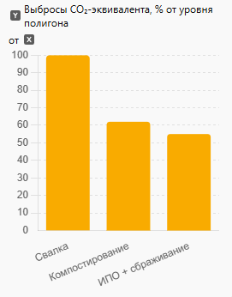

Рис. 1 - Сравнительный углеродный след при утилизации пищевых отходов: свалка, компостирование, ИПО + сбраживание

В более прикладной плоскости исследование проведем сравнение капитальных и операционных затрат муниципалитетов до и после установки ИПО. Анализ сводит экономическую эффективность к времени окупаемости, составляющему в среднем от 2,5 до 4 лет, при условии получения побочных продуктов в виде биогаза.

Таблица 1 - Сравнительный анализ методов утилизации пищевых отходов

 | Показатель | Свалка | Компостирование | ИПО + сбраживание
1 | Средняя стоимость утилизации (USD/т) | 40–80 | 30–60 | 20–50
2 | Среднее время разложения | Месяцы–годы | 2–6 месяцев | 10–20 дней
3 | Потенциал энергопроизводства | Нет | Ограниченный (тепло) | Высокий (биогаз)
4 | Углеродный след (CO₂-экв.) | 100% | 62% | 55%

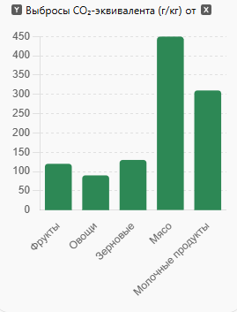
На рисунке 2 показано различие в выбросах парниковых газов в зависимости от метода переработки отходов рассматривается роль ИПО в рамках «зелёной сертификации» жилищных комплексов. Авторы подчёркивают, что наличие ИПО в проекте способствует увеличению «зеленого рейтинга» и может использоваться как критерий устойчивого домостроения.

Рис. 2 - Сравнение выбросов парниковых газов при различных методах утилизации пищевых отходов

Таким образом, анализ источников [1-11] показывает, что современная дискуссия об обращении с пищевыми отходами в регионе строится вокруг трёх взаимосвязанных блоков: (i) экологическая необходимость сокращения полигонного захоронения органики и управления ТКО как антропогенным фактором [1,2]; (ii) экономико-институциональная реализуемость и принятие населением, определяющие выбор технологий и механизмов внедрения [5-8]; (iii) технологическая база переработки органики (особенно анаэробное сбраживание) как ключевой элемент устойчивой системы, связанной как с сектором отходов, так и с сектором водоотведения [10-11]. При этом источники указывают и на исследовательский разрыв, который ваша статья может закрыть: недостаточно проработан именно “стык” систем ТКО и водоотведения в условиях Казахстана — от обоснования доли пищевой фракции и мотивации выбора технологии [3,4] до оценки готовности городской инфраструктуры и институциональных механизмов согласования интересов операторов ТКО и водоканала [5-7]. Это делает актуальным последующее исследование, в котором внедрение ИПО оценивается не изолированно, а как часть комплексной модели управления органическими отходами с учётом технических и экономических ограничений конкретных городов Казахстана.
Материалы и методы. Использование измельчителей пищевых отходов (ИПО) в условиях урбанизированной среды Казахстана представляет собой как перспективную экологическую инициативу, так и вызов для устаревшей инфраструктуры. Их внедрение оказывает разностороннее влияние на коммунальные и экологические системы, включая твёрдые бытовые отходы (ТБО), канализационные сети, очистные сооружения и климатические показатели.
С одной стороны, ИПО позволяют перерабатывать органическую фракцию ТБО на месте, что снижает общий объём вывозимых отходов на 20-25% и способствует уменьшению загрязнения на полигонах. Учитывая, что в структуре ТБО до 60% приходится на органику, установка ИПО в 50% домохозяйств Казахстана способна перераспределить до 1,5 млн тонн органических отходов в канализационную систему. Это приводит к значительному снижению массы гниющих отходов, уменьшению выбросов метана, сокращению популяции грызунов и насекомых и снижению расходов на вывоз мусора, особенно в малых городах.
С другой стороны, перераспределение органики в канализационные стоки повышает нагрузку на систему водоотведения. Согласно расчётам, биохимическая потребность в кислороде (BOD5) в сточных водах может возрасти на 20–40%, что требует дополнительной мощности аэротенков, повышения аэрационной производительности и реконструкции иловых площадок. На фоне того, что в более чем 20 городах Казахстана степень износа очистных сооружений превышает 70-90%, риск перегрузки инфраструктуры возрастает. В Таразе, где отсутствуют КОС, сточные воды сбрасываются через временные отстойники, что усугубляет угрозу вторичного загрязнения окружающей среды.
Проведённый анализ показал, что только 36% сточных вод в Казахстане очищаются безопасно, в соответствии с национальными или местными стандартами. Для сравнения, в странах с высоким уровнем экологической эффективности, таких как Сингапур, Нидерланды или Южная Корея, этот показатель превышает 99%. Таким образом, при внедрении ИПО в Казахстане необходима синхронизация технологических и нормативных мер с национальной программой «Зелёный Казахстан».
Положительные климатические эффекты внедрения ИПО включают снижение выбросов CO₂ и CH₄ с полигонов, потенциал повторного использования органики для производства биогаза, а также переработку иловых осадков в компост или удобрения. В крупных городах возможно применение технологий анаэробного сбраживания для энергетической утилизации измельчённых отходов. Это позволит интегрировать ИПО в круговую экономику и систему устойчивого водоснабжения.
Тем не менее, внедрение ИПО требует комплексного подхода. Необходимо: модернизировать существующие КОС и проектировать новые с учётом будущих органических нагрузок; обновить СНиП и СанПиН с включением норм эксплуатации ИПО; предусмотреть стандарты технической эксплуатации, запрещающие сброс волокнистых и жиросодержащих отходов; обучить операторов КОС новым требованиям; проводить просветительскую работу среди населения о правилах эксплуатации ИПО.
По данным моделирования, установка ИПО в половине городских домохозяйств позволит: снизить общий объём ТБО до 4-4,25 млн тонн в год (против текущих 5,5 млн тонн); сократить частоту вывоза мусора на 30-50%; переработать до 1 млн тонн органических отходов на КОС с возможностью получения биоудобрений или метана; сократить выбросы парниковых газов с полигонов на 20-30%.
Однако потенциальные риски включают засоры в устаревших трубах, биообрастание и заиливание канализации, увеличение энергозатрат на очистку сточных вод, а также вероятность эвтрофикации водоёмов при сбросе недоочищенных стоков.
Таким образом, внедрение ИПО при текущем состоянии очистных сооружений требует поэтапного, научно обоснованного внедрения с обязательным технико-экономическим обоснованием. При выполнении необходимых модернизационных мер использование ИПО может стать ключевым элементом повышения экологической эффективности городов Казахстана и интеграции в международные климатические инициативы. В Казахстане проведено множество исследований, посвящённых анализу и очистке канализационных (сточных) вод. Ниже представлена таблица с ключевыми публикациями, организациями и направлениями исследований.
В Республике Казахстан в последние годы наблюдается рост научного интереса к оценке состояния сточных вод, их очистке и воздействию на окружающую среду. Исследования охватывают как лабораторные анализы состава канализационных стоков, так и оценку состояния инфраструктуры, разработку инновационных методов очистки и определение токсикологического профиля иловых осадков.
Наиболее активно мониторинг качества сточных вод осуществляется на крупных объектах, таких как ГКП "Тоспа Су" (г. Алматы), где функционирует современная лаборатория, оснащённая химическим, бактериологическим, гидробиологическим и физико-химическим отделениями. Регулярный контроль осуществляется по таким показателям, как температура, pH, содержание нефтепродуктов, тяжёлых металлов, взвешенных веществ и микробиологическая нагрузка.
Проблемы с очисткой промышленных сточных вод остаются актуальными. По данным ЮКГУ им. М. О. Ауэзова, многие предприятия не справляются с технологическими нормативами по очистке, что связано с изношенным оборудованием, отсутствием современных технологий, а также с нехваткой квалифицированных специалистов. В качестве перспективных решений рассматриваются внедрение мембранных биореакторов, фотокаталитической очистки и реагентной коагуляции.
Анализ, опубликованный на платформе CyberLeninka и в других академических источниках, свидетельствует о том, что в некоторых городах степень износа канализационных очистных сооружений достигает 90%. Например, в Кокшетау, Сарань, Риддере и Аркалыке изношенность КОС превышает допустимые эксплуатационные пределы, что ограничивает возможность приема дополнительных органических нагрузок от ИПО.
Применение инновационных решений в Казахстане представлено, в частности, технологией нитри-денитрификации на основе природного цеолита Чанканайского месторождения, которая успешно используется в ряде объектов Астаны и улучшает процессы биологической очистки. Также проводятся токсикологические исследования иловых осадков с целью оценки класса опасности, в том числе методом определения LD50 и биотестирования на модельных организмах.
Таким образом, существующий научный и практический задел показывает, что Казахстан обладает достаточным потенциалом для модернизации очистных сооружений с ориентацией на приём сточных вод, насыщенных органикой, включая переработанные ИПО отходы. Однако реализовать этот потенциал возможно лишь при синхронизации технологических, нормативных и образовательных изменений на всех уровнях.

Таблица 2 - Основные направления исследований и мониторинг канализационных масс в Казахстане

№ | Направление исследования | Описание | Примеры и результаты
1. | Лабораторный анализ сточных вод | Изучение физико-хими- ческих и биологических  параметров сточных вод для оценки их состава и степени загрязнения. | В лаборатории ДГКП "Тоспа Су" проводится анализ сточных вод на всех стадиях очистки, включая химической, бактерио-логический и физико-химичес-  кий и физико-химический контроль.
2. | Оценка состояния очистных сооружений | Анализ технического сос-тояния и эффективности  работы канализационных очистных сооружений. | В Казахстане очистные сооружения установлены в 62 из 89 городов, однако в некоторых городах износ сооружений превышает 90%.
3. | Разработка и внедрение новых технологий очистки | Исследование и примене –  ние современных методов  и материалов для повышения эффективнос-ти очистки сточных вод. | В Астане применена технология нитри-денитрификации с использованием цеолита Чанканайского месторождения, что улучшило процессы биологической очистки.
4. | Токсикологические исследования иловых осадков | Оценка токсичности иловых осадков для определения их класса опасности и способов утилизации. | Проведены эксперименты по определению LD50 и установлению степени токсич-  ности иловых отходов на теплокровных животных.
5. | Анализ промышленных сточных вод | Изучение состава и методов очистки сточных вод, образующихся в результате промышлен-ной деятельности. | Рассмотрены методы очистки промышленных сточных вод, включая предварительную, биохимическую и доочистку, а также проблемы утилизации отходов очистки.

Экологические и санитарные эффекты внедрения ИПО

Внедрение измельчителей пищевых отходов в масштабах городских агломераций Казахстана имеет значительные экологические, санитарные и климатические последствия. Одним из ключевых преимуществ технологии является снижение доли органических компонентов в структуре твёрдых бытовых отходов. По результатам моделирования, в случае установки ИПО в 50% домохозяйств объём органической фракции ТБО может быть уменьшен на 30-60% в зависимости от потребительских привычек населения и структуры питания.

Это приводит к следующим положительным последствиям: сокращается масса отходов, направляемых на полигоны, уменьшается частота вывоза мусора, снижается уровень выбросов метана, образующегося при анаэробном разложении органики, а также сокращается популяция грызунов и насекомых в зоне хранения ТБО. Учитывая, что в Казахстане до 90% отходов по-прежнему захораниваются, интеграция ИПО представляет собой важный элемент стратегии декарбонизации и устойчивого обращения с отходами.

Однако перераспределение органики из ТБО в сточные воды требует готовности канализационной и очистной инфраструктуры. Основными рисками являются увеличение BOD и COD показателей на 20-40%, рост иловой нагрузки, потенциальные засоры и биообрастание в трубопроводах при недостаточной пропускной способности, особенно в системах с гофрированными трубами или в населённых пунктах с септиками и выгребными ямами.

Для минимизации рисков и обеспечения адаптивности инфраструктуры в таких городах, как Астана, Алматы и Шымкент, возможно проведение следующих мероприятий: увеличение мощности аэротенков, внедрение систем анаэробного сбраживания органики с получением биогаза, обновление СНиП и СанПиН с учётом новых органических нагрузок, а также внедрение фильтрации тонкой очистки перед выпуском в водоёмы.

Экологический и климатический эффект заключается также в снижении объёмов сжигаемой органики, уменьшении выбросов CO₂ и NOₓ, а также возможности повторного использования сточных вод для орошения или технических нужд при условии их качественной очистки. ИПО могут стать элементом городской системы замкнутого цикла, где органика поступает в биогазовые реакторы, а затем возвращается в виде энергии и удобрений.

Необходимые меры по успешному внедрению включают: проведение пилотных региональных проектов, формирование нормативной базы, экономическое стимулирование (в том числе субсидии на покупку ИПО), просветительскую работу среди населения и обучение персонала очистных станций. Эти шаги должны быть включены в реализацию стратегии «Зелёный Казахстан».

Таким образом, при условии технической готовности и согласованной политики на государственном и муниципальном уровнях, массовое внедрение ИПО способно существенно улучшить экологическую ситуацию в стране, повысить эффективность обращения с органикой и сформировать элементы циркулярной экономики в жилищно-коммунальном хозяйстве.
Результаты и обсуждение. Моделирование снижения нагрузки на полигоны и выбросов парниковых газов. Анализ структуры твёрдых бытовых отходов (ТБО) в Казахстане показывает, что ежегодно формируется около 5–6 млн тонн ТБО, из которых от 40% до 60% составляют органические пищевые отходы. Внедрение измельчителей пищевых отходов (ИПО) в 50% домохозяйств позволяет перераспределить существенную долю органики в сточные воды, что приводит к ряду социально-экологических эффектов.

№ | Показатель | До внедрения ИПО | После внедрения ИПО (50% домов) | Изменение
1 | Органические отходы в ТБО | 2,5-3млн тонн/год | ~1,25–1,5 млн тонн/год | -50%
2 | Общий объём ТБО | 5,5 млн тонн | 4-4,25 млн тонн | -20-25%
3 | Частота вывоза мусора | Высокая (1-3 р/нед) | Снижена на 30–50% | -
Примечание: если ИПО установлены в 50% домохозяйств
Таблица 3 - Потенциал сокращения объёма ТБО при массовом внедрении ИПО

Помимо этого, сокращение объёма органики на полигонах позволяет уменьшить выбросы метана (CH₄) на 20-30%, что позитивно влияет на климатическую политику страны и способствует выполнению обязательств по Парижскому соглашению. Снижение затрат на транспортировку отходов может достигать 20-50%, особенно в малых и средних городах, что делает технологию ИПО экономически привлекательной для муниципалитетов.
С другой стороны, перераспределение органики из ТБО в канализационные стоки увеличивает нагрузку на очистные сооружения. При 100% установке ИПО суточный показатель BOD₅ (биохимическая потребность в кислороде) может увеличиться на 20-40%, а общее количество перерабатываемой органики на КОС - на 1,2-1,5 млн тонн. Это приводит к необходимости увеличения аэротрофных мощностей, пересмотра параметров иловых площадок и внедрения энергоэффективных технологий очистки, таких как мембранные реакторы и анаэробное сбраживание с получением биогаза.
Экологический эффект может быть дополнительно усилен за счёт интеграции ИПО в биометанизационные комплексы. Биогаз, получаемый из переработанной органики, может быть использован для генерации электроэнергии, отопления или как транспортное топливо, тем самым снижая углеродный след и обеспечивая устойчивое использование ресурсов.
В целом, расчёты показывают, что при внедрении ИПО в 50% домохозяйств:
Таблица 4 - Результаты эффективности при 50% охвата применения ИПО
№ | Эффект | Оценка
1 | Снижение объёма свалок | -1,5 млн тонн/год (в среднем)
2 | Снижение метановых выбросов | -20-30% от текущих выбросов с полигонов
3 | Снижение затрат на транспортировку отходов | -20-50% (особенно в малых городах)
4 | Потенциал переработки на КОС в органические удобрения | до 1 млн тонн/год

Тем не менее, существующие инфраструктурные ограничения требуют учёта ряда факторов: высокий уровень износа КОС (до 90% в ряде городов), отсутствие централизованной канализации в более чем 30% населённых пунктов, правовой вакуум в части применения ИПО в нормативных документах (СНиП, СанПиН).
Таким образом, полноценное внедрение ИПО и реализация связанных экологических выгод возможны только при параллельной модернизации водоотводных и очистных систем, актуализации нормативной базы и запуске региональных программ по устойчивому обращению с отходами. При выполнении этих условий, Казахстан способен достигнуть значительного прогресса в области декарбонизации, ресурсосбережения и устойчивого развития коммунальной инфраструктуры.
Сточные воды - это воды, загрязненные отходами разного происхождения. В большинстве случаев это бытовые и производственные отходы.
«В рейтинге IMD используется показатель «Безопасно очищенные сточные воды», который рассчитывается как процент населения страны, подключенного к очистным сооружениям. При расчете данного показателя используется база данных ЦУР. Индикатор направлен на отслеживание процентной доли сточных вод из различных источников (домохозяйства, сфера услуг, промышленность и сельское хозяйство), которые очищаются в соответствии с национальными или местными стандартами. В рейтинге IMD 2023 Казахстан по данному показателю занял 56 место со значением 35,7% (при этом стоит учитывать, что использовались данные за 2020 год). Лидирующие позиции заняли следующие страны: Сингапур (100%), Нидерланды (99,8%), Катар (99,5%), Южная Корея (99,5%) и Германия (99,3%). Замыкают рейтинг такие страны, как Таиланд (24,4%), Колумбия (21,3 %) и Монголия (10,4%)», – сообщили авторы исследования. «При этом наибольший процент очистки сточных вод имеют такие страны, как Кувейт, Сингапур, Андорра, Гибралтар и Катар (все страны имеют стопроцентную очистку). Многие развивающиеся страны обрабатывают менее 10% (Малави, Сенегал, Мали). Казахстан проводит безопасную очистку 36% сточных вод».
В ходе проведённого научного исследования обоснована высокая экологическая и инфраструктурная значимость применения измельчителей пищевых отходов (ИПО) как эффективного инструмента управления органической фракцией твёрдых коммунальных отходов (ТКО) в условиях урбанизированной среды. Анализ современных технических решений, зарубежного и казахстанского опыта, а также результаты моделирования показали, что внедрение ИПО позволяет существенно сократить объёмы органики, поступающей на полигоны, снизить выбросы парниковых газов, уменьшить расходы на транспортировку и повысить санитарное состояние городской среды.
Мета-анализ продемонстрировал, что успешное внедрение ИПО требует многоуровневой поддержки - от нормативно-правового регулирования и модернизации инфраструктуры до формирования потребительской культуры и мотивации. Анализ зарубежных практик (США, Германия, Япония, Швеция) показал, что ключевым фактором является интеграция ИПО в комплексную систему обращения с отходами, где технологии утилизации и очистки сочетаются с просветительской деятельностью и государственной политикой по поддержке устойчивого развития.
Моделирование показало, что при оснащении измельчителями до 50% домохозяйств Казахстана возможно перерабатывать до 1,5 млн тонн органических отходов ежегодно. Это позволит снизить общий объём ТКО на 20-25%, одновременно сократив нагрузку на полигоны и канализационные очистные сооружения. Таким образом, технология ИПО способна сыграть роль катализатора экологической модернизации коммунальной отрасли страны. Вместе с тем, исследование выявило ряд ограничений: изношенность сетей водоотведения, дефицит производственных мощностей КОС, низкий уровень нормативной готовности, а также ограниченное знание потребителей о правилах эксплуатации ИПО. Эти факторы могут замедлить масштабирование технологии и вызвать риски вторичного загрязнения или засоров в системах водоотведения.
Выводы. На основании проведённого анализа установлено, что органическая фракция ТКО составляет до 50-60% от их общего объема, а переработка этих отходов на месте образования посредством ИПО позволяет значительно сократить массу и объём твёрдых отходов, направляемых на полигоны, тем самым снижая потребность в их транспортировке и утилизации.
Для реализации проекта необходимо:
- разработать и утвердить нормативно-технические регламенты, санитарные и строительные требования к установке и использованию ИПО в жилом и коммерческом фонде;
- инициировать интеграцию ИПО в национальные и региональные программы по обращению с отходами, устойчивому городскому развитию и декарбонизации экономики;
- создать механизмы государственной поддержки - субсидии, налоговые льготы, кредитные линии и участие в программах «зелёного финансирования»;
Комплексная реализация вышеперечисленных мер позволит не только повысить эффективность системы обращения с органическими отходами, но и обеспечить экологическую и санитарную безопасность, снизить антропогенную нагрузку на окружающую среду и создать устойчивую модель городской среды. Внедрение ИПО при соблюдении технических, нормативных и организационных условий способно стать неотъемлемым элементом стратегии перехода Республики Казахстан к принципам циркулярной экономики, устойчивого потребления и ресурсосбережения, а также повысить качество жизни населения в долгосрочной перспективе.
Примечание: В процессе подготовки статьи использовались инструменты искусственного интеллекта, в том числе языковая модель GPT-4, предоставляемая OpenAI Модель использовалась исключительно для помощи в редактуре текста и структурировании научного изложения.

Литература

1. Аскарова У.Б., Мустафаева Р.М. Проблемы утилизации твердых бытовых отходов и их влияние на экологию в Казахстане // Актуальные проблемы гуманитарных и естественных наук.- 2014.- № 8(2).- С. 12-14.
2. Джалилова Г.А. Антропогенная эпоха твердых коммунальных отходов// Известия Санкт-Петербургского государственного технологического института (технического университета). - 2013. -№ 19 (45). - С. 93–97.
3. Байдалинова А.С., Байгиреева Ж.З., Ниязбекова Ш.У. Экономические аспекты управления пищевыми отходами в Казахстане: проблемы, тенденции и перспективы//Л.Н. Гумилев атындағы Еуразия Ұлттық университетінің Хабаршысы.- 2025.-№ 2.-С.143-162.
DOI 10.32523/2789-4320-2025-2-143-162.
4. Козлов Г.В., Ивахнюк Г.К. Морфологический состав твердых коммунальных отходов по регионам мира в xx и начале XXI века (обзор)// Известия Санкт-Петербургского государственного технологического института (технического университета), Серия Экология и системы жизнеобеспечения. -2014.- № 24 (50).- С. 58-66.
5. Епишов А.П. Государственная политика в сфере переработки и утилизации пищевых отходов в России // Вестник Российского экономического университета им. Г.В. Плеханова.- 2022.- № 6.- С. 17-23. DOI 10.21686/2413-2829-2022-6-17-23.
6. Субракова Л.К. Экономика обращения с пищевыми отходами в России // Вестник Воронежского государственного университета. Серия: Экономика и управление.- 2021.- № 1.- -С. 37- 48. DOI 10.17308/econ.2021.1/3322.
7. Калиева С.С. и др. Экономическая оценка политики по сокращению ТБО в Республике Казахстан с использованием метода условной оценки (CV) // Вестник университета «Туран». 2024. - № 3. - С. 23-34. DOI 10.46914/1562-2959-2024-1-3-23-34.
8. Петросянц Т.В. Эколого-экономическая оценка и утилизация пищевых отходов в РК // Вестник науки.- 2023.-№ 12(69).-С.1050-1054.
9. Ванюшина А.Я., Данилович Д.А. Анаэробное сбраживание - ключевая технология обработки осадков городских сточных вод (часть 1) // Водоснабжение и санитарная техника. 2013.- № 10. С. 58-65.
10. Данилович Д.А., Ванюшина А.Я. Анаэробное сбраживание - ключевая технология обработки осадков городских сточных вод (часть 2) // Водоснабжение и санитарная техника.- 2013. -№ 11. С. 50-57.
11. Жапарова С.Б., Баязитова З.Е., Курманбаева А.С. и др. Термофильное сбраживание бытовых пищевых отходов // Вестник Карагандинского университета. -2022.- №107(3).- С.56-66. DOI 10.31489/2022BMG3/56-66.

References

1. Askarova U.B., Mustafaeva R.M. Problemy utilizacii tverdyh bytovyh othodov i ih vlijanie na jekologiju v Kazahstane // Aktual'nye problemy gumanitarnyh i estestvennyh nauk.- 2014.- № 8(2).- S. 12-14. [in Russian]
2. Dzhalilova G.A. Antropogennaja jepoha tverdyh kommunal'nyh othodov// Izvestija Sankt-Peterburgskogo gosudarstvennogo tehnologicheskogo instituta (tehnicheskogo universiteta). - 2013. -№ 19 (45). - S. 93–97. [in Russian]
3. Bajdalinova A.S., Bajgireeva Zh.Z., Nijazbekova Sh.U. Jekonomicheskie aspekty upravlenija pishhevymi othodami v Kazahstane: problemy, tendencii i perspektivy//L.N. Gumilev atyndaғy Eurazija Ұlttyқ universitetіnің Habarshysy.- 2025.-№ 2.-S.143-162.
DOI 10.32523/2789-4320-2025-2-143-162. [in Russian]
4. Kozlov G.V., Ivahnjuk G.K. Morfologicheskij sostav tverdyh kommunal'nyh othodov po regionam mira v xx i nachale XXI veka (obzor)// Izvestija Sankt-Peterburgskogo gosudarstvennogo tehnologicheskogo instituta (tehnicheskogo universiteta), Serija Jekologija i sistemy zhizneobespechenija. -2014.- № 24 (50).- S. 58-66. [in Russian]
5. Epishov A.P. Gosudarstvennaja politika v sfere pererabotki i utilizacii pishhevyh othodov v Rossii // Vestnik Rossijskogo jekonomicheskogo universiteta im. G.V. Plehanova.- 2022.- № 6.- S. 17-23. DOI 10.21686/2413-2829-2022-6-17-23. [in Russian]
6. Subrakova L.K. Jekonomika obrashhenija s pishhevymi othodami v Rossii // Vestnik Voronezhskogo gosudarstvennogo universiteta. Serija: Jekonomika i upravlenie.- 2021.- № 1.- -S. 37- 48. DOI 10.17308/econ.2021.1/3322. [in Russian]
7. Kalieva S.S. i dr. Jekonomicheskaja ocenka politiki po sokrashheniju TBO v Respublike Kazahstan s ispol'zovaniem metoda uslovnoj ocenki (CV) // Vestnik universiteta «Turan». 2024. - № 3. - S. 23-34. DOI 10.46914/1562-2959-2024-1-3-23-34. [in Russian]
8. Petrosjanc T.V. Jekologo-jekonomicheskaja ocenka i utilizacija pishhevyh othodov v RK // Vestnik nauki.- 2023.-№ 12(69).-S.1050-1054. [in Russian]
9. Vanjushina A.Ja., Danilovich D.A. Anajerobnoe sbrazhivanie - kljuchevaja tehnologija obrabotki osadkov gorodskih stochnyh vod (chast' 1) // Vodosnabzhenie i sanitarnaja tehnika. 2013.- № 10. S. 58-65. [in Russian]
10. Danilovich D.A., Vanjushina A.Ja. Anajerobnoe sbrazhivanie - kljuchevaja tehnologija obrabotki osadkov gorodskih stochnyh vod (chast' 2) // Vodosnabzhenie i sanitarnaja tehnika.- 2013. -№ 11. S. 50-57. [in Russian]
11. Zhaparova S.B., Bajazitova Z.E., Kurmanbaeva A.S. i dr. Termofil'noe sbrazhivanie bytovyh pishhevyh othodov // Vestnik Karagandinskogo universiteta. -2022.- №107(3).- S.56-66. DOI 10.31489/2022BMG3/56-66. [in Russian]

Сведения об авторах

Хайриев Д. С. - директор ТОО «RedSeven», Астана, Казахстан, e-mail: d.hairiev@gmail.com;
Мукатай А. К. - директор ТОО «Офис Коммерциализации», Астана, Казахстан, e-mail: ablay.m.k@gmail.com;
Даулетжанова Ж. Т. - доктор PhD, доцент Казахского университета технологии и бизнеса им. К. Кулажанова, Астана, ведущий научный сотрудник ТОО «Институт Химии угля и технологии», Астана, Казакстан e-mail: kaliyeva_zhanna@mail.ru.

Information about the authors

Khayriev D. S. - director of «RedSeven» LLP, Astana, Kazakhstan, e-mail: d.hairiev@gmail.com;
Mukatai Ablaikhan Karimgazyuly ​​– Director of «Commercialization Office» LLP, Astana, Kazakhstan, e-mail: ablay.m.k@gmail.com;
Dauletzhanova Zhanna Taumuratovna - PhD Doctor, Technology, Kazakh University of Technology and Business named after K. Kulazhanov, Leading Researcher of LLP "Institute of Coal Chemistry and Technology", Astana, Kazakhstan, e-mail: kaliyeva_zhanna@mail.ru.

МРНТИ 52.01.76

БЕЛАРУСЬ РЕСПУБЛИКАСЫНДАҒЫ ЗИЯНДЫ ЖӘНЕ ҚАУІПТІ ЕҢБЕК ЖАҒДАЙЛАРЫ

Л.М. Актаева, Ә.Б. Бекмағамбетов, А.М. Рахметова, Э.А. Құлмағамбетова,
А.О. Абжаппарова, ¹Н.Б. Әбдрахманова, Н.Т. Сағындықова
Қазақстан Республикасы Еңбек және халықты әлеуметтік қорғау министрлігінің
Еңбекті қорғау жөніндегі республикалық ғылыми-зерттеу институты ШЖҚ РМК, Астана, Қазақстан

Корреспондент - автор: elya_kulmagambet@mail.ru

Денсаулыққа қауіпті жағдайларда жұмыс істейтін қызметкерлер үшін әлеуметтік кепілдіктер тақырыбы Беларусь Республикасында өзекті болып табылады және егжей-тегжейлі қарауды қажет етеді. Мұндай жағдайларда жұмыс істеу денсаулыққа ауыр зардаптарға әкелуі мүмкін, бұл мұндай жұмысшылар үшін қосымша қорғауды қамтамасыз етуді қажет етеді.
Бұл жұмыста зиянды және қауіпті еңбек жағдайларында жұмыс істейтін адамдар үшін Беларусь заңнамасында қарастырылған әлеуметтік кепілдіктердің негізгі түрлері қарастырылады.
Өтемақы, қысқартылған жұмыс уақыты, медициналық тексерулер мен еңбек жағдайлары, сондай-ақ кәсіптік аурулар немесе жарақаттар туындаған жағдайда құқықтық қорғау және төлемдер мәселелеріне ерекше назар аударылады.
Зерттеу барысында қолданыстағы әлеуметтік қорғау жүйесінің күшті жақтары да, қызметкерлердің қауіпсіздігі мен денсаулығын тиімдірек қамтамасыз ету үшін оны жетілдірудің мүмкін жолдары да анықталды.
Түйін сөздер: әлеуметтік қорғау, еңбек жағдайы, кепілдіктер, зиянды және қауіпті еңбек жағдайлары, өтемақылар

ВРЕДНЫЕ И ОПАСНЫЕ УСЛОВИЯ ТРУДА В РЕСПУБЛИКЕ БЕЛАРУСЬ

Л.М.Актаева, А.Б. Бекмагамбетов, А.М. Рахметова, Э.А. Кульмагамбетова,
А.О. Абжаппарова, Н.Б. Абдрахманова, Н.Т. Сагиндикова
РГП на ПХВ Республиканский научно-исследовательский институт по охране труда
Министерства труда и социальной защиты населения Республики Казахстан, Астана, Казахстан,
e-mail:elya_kulmagambet@mail.ru

Тема социальных гарантий для работников, трудящихся в условиях, опасных для здоровья, является актуальной в Республике Беларусь и требует детального рассмотрения. Работа в таких условиях может иметь серьезные последствия для здоровья, что делает необходимым обеспечение дополнительной защиты для таких работников.
В данной работе рассматриваются основные виды социальных гарантий, предусмотренные белорусским законодательством для людей, трудящихся во вредных и опасных условиях труда.
Особое внимание уделяется вопросам компенсаций, сокращенного рабочего времени, медицинских обследований и условий труда, а также правовой защите и выплатам в случае возникновения профессиональных заболеваний или травм.
В ходе исследования выявлены как сильные стороны существующей системы социальной защиты, так и возможные пути её совершенствования для более эффективного обеспечения безопасности и здоровья работников.
Ключевые слова: социальная защита, условия труда, гарантии, вредные и опасные условия труда, компенсации.

HARMFUL AND DANGEROUS WORKING CONDITIONS IN THE REPUBLIC OF BELARUS

L.M. Aktayeva, A.B. Bekmagambetov, A.M. Rakhmetova, E.A. Kulmagambetova,
A.O. Abzhapparova, N.B. Abdrakhmanova, N.T. Sagindykova
¹RSE at the National Research Institute for Occupational Safety of the Ministry of Labor and Social Protection of the Population of the Republic of Kazakhstan, Astana, Kazakhstan,
e-mail:elya_kulmagambet@mail.ru

The topic of social guarantees for workers working in conditions dangerous to their health is relevant in the Republic of Belarus and requires detailed consideration. Working in such conditions can have serious health consequences, which makes it necessary to provide additional protection for such workers.
This paper examines the main types of social guarantees provided by the Belarusian legislation for people working in harmful and dangerous working conditions.
Special attention is paid to compensation, shorter working hours, medical examinations and working conditions, as well as legal protection and payments in case of occupational diseases or injuries.
The study identified both the strengths of the existing social protection system and possible ways to improve it to better ensure the safety and health of employees.
Keywords: social protection, working conditions, guarantees, harmful and dangerous working conditions, compensation

Кіріспе. Қазіргі өндірісте салауатты және қауіпсіз еңбек жағдайларын толық қамтамасыз ету көбінесе қол жетпейтін идеал болып табылады. Сондықтан қауіпсіз технологияларды енгізу мүмкін емес немесе экономикалық тұрғыдан қолайсыз жерлерде өндірістік әлеуметтік-техникалық жүйелердегі адам факторын есепке алу зиянды және қауіпті жағдайларда жұмыс істегені үшін өтемақы ұсыну жолымен жүреді.
Біздің елімізде зиянды және (немесе) қауіпті еңбек жағдайларында жұмыс істегені үшін өтемақы жүйесі жұмыс күшінің ықтимал және нақты тозу қаупін өтеу қажет деген ережеге сүйене отырып құрылды. Өндірістік жағдайлар жұмыскердің денсаулығына кері әсер ететіні белгілі жай.
Сондықтан, бұл жағдайда жұмыс күшінің нақты тозуы қалыпты еңбек жағдайымен, жұмыс қабілеттілігі мен денсаулығының жоғалуымен салыстырғанда ертерек белең алады деп саналады. Негізінде бұл жүйеге КСРО-да қалыптасқан қағидалар тірек болған.
Зиянды және (немесе) қауіпті еңбек жағдайларында жұмыс істегені үшін берілетін өтемақының жалпы сипаттамасы. ТМД елдерінде ол бұрынғы күйінде қызмет етеді немесе оның функциялары ұжымдық-шарттық реттеу тетігі арқылы жүзеге асырылуда. Зиянды өтеу мәселелерін шешуде Беларусь Республикасы Конституциясының 46, 47, 61-баптары [1] және Беларусь Республикасы Еңбек кодексінің нормалары [2] құқықтық негіз болып табылады. Еңбек кодексінің 11-бабының 7-тармағына сәйкес қызметкер әлеуметтік сақтандыруға, зейнетақымен қамсыздандыруға және кәсіптік ауруы, еңбек жарақаты, мүгедектігі жағдайында айтулы кепілдіктерге құқылы. 226-баптың 13-тармағында жұмыскердің өмірі мен денсаулығына келтірілген зиянды өтеу міндеті белгіленген, ал 224-бапқа сәйкес жұмыс беруші жұмыскердің өндірістегі жазатайым оқиғалардан және кәсіптік аурулардан сақтандырылуы міндеттелген [3].
Материалдар мен әдістер. Қысқартылған жұмыс күні және қосымша демалыс. Беларусь Республикасының Еңбек кодексінің 113 бабына сәйкес еңбек жағдайлары зиянды және (немесе) қауіпті жұмыстарда жұмыс істейтін қызметкерлер үшін жұмыс уақытының қысқартылған ұзақтығы – аптасына 36 сағаттан аспайтын болып белгіленеді. Қысқартылған жұмыс күні уақытпен қорғау функциясын орындайды - зиянды факторлардың әсер ету уақытын азайту, жұмысшыларды олардың әрекет ету аймағынан шамалы уақытқа алшақтату арқылы жұмысшыларға зиянды еңбек жағдайларының әсер етуін төмендетеді
Нәтижесінде жұмыс күшінің артық шығыны азаяды, оның қалпына келтірілуі жеңілдейді.
Қосымша демалыс уақытпен оңалту функциясын орындайды - берілген демалыс кезеңінде (негізгі демалыспен бірге) қызметкер еңбек міндеттерін орындау мүмкіндіктерін қалпына келтіруі керек.
Қазіргі уақытта өтемақылардың осы түрлерін қолдану шарттарын реформалау бойынша, олар бүгінгі күннің нақты талаптарына жауап беруі, ұйымдардағы еңбек жағдайларының жай-күйімен тығыз байланысты болуы, жұмыс беруші мен қызметкерлерді еңбек жағдайларын жақсартуға ынталандыру тетігінің элементіне айналуы үшін қарқынды жұмыс жүргізілуде. Бұл норма Беларусь Республикасының Еңбек кодексіне енгізілген өзгерістерге сәйкес қолданысқа енгізіледі [4].
Көрсетілген өтемақылар жұмыскерлерге еңбек жағдайлары бойынша жұмыс орындарын аттестаттаумен міндетті байланыста берілетін болады.
Ерекше еңбек жағдайларына байланысты жұмысы үшін жасына байланысты зейнетақы. Жалпы, зейнетақының бұл түріне жұмсалған шығындар жалпы зейнетақы жүйесі қаражатының 4,5 - 5% немесе еңбек зейнетақыларына жұмсалған шығыстардың 5,5 - 5% құрады. Мерзімінен бұрын зейнетақыға арналған шығыстар еңбек зейнетақыларын (жалпы зейнетақы жүйесінің қаражаты) төлеуге арналған халықты әлеуметтік қорғау қорының қаражатынан қаржыландырылады.
Ерекше (зиянды және қауіпті) еңбек жағдайларына байланысты жасына байланысты мерзімінен бұрын зейнетақымен қамсыздандыруды ұсынудың құқықтық базасы «Зейнетақымен қамсыздандыру туралы» Беларусь Республика Заңының 12-16-бабы болып табылады [5]. Мұндай зейнетақы еңбек жағдайлары бойынша жұмыс орындарын аттестаттау негізінде тағайындалады және меншік нысанына қарамастан барлық ұйымдар мен басқа шаруашылық жүргізуші субъектілер үшін бірыңғай процесс болып табылады. Қазіргі уақытта ерекше еңбек жағдайларында жұмыс істегені үшін жасына байланысты зейнетақы алуға құқық беретін өндірістердің, жұмыстардың, кәсіптердің, лауазымдар мен көрсеткіштердің жаңа тізімдері қолданысқа енгізілді [6].
Жоғары мөлшерде еңбекақы төлеу. Зиянды және (немесе) қауіпті еңбек жағдайлары бар жұмыстарда істейтін жұмыскер жоғары мөлшерде еңбекақы төлемін алуға құқылы.
Біріншіден, Беларусь Республикасы қызметкерлерінің Бірыңғай тарифтік сеткасын қолдану тәртібі туралы нұсқаулыққа сәйкес [7], жұмыстың технологиялық түрлері, экономикалық қызмет түрлері және де жұмысы зиянды және (немесе) қауіпті жағдайларда атқарылады деп ұйғарылатын салалар бойынша орындалатын жұмыстардың технологиялары мен күрделілігіне, өндіріс түрі мен салалық тиістілігіне қарай жұмысшылардың тарифтік ставкаларын (жалақыларын) арттыру коэффициенттері белгіленеді. Бұл норма жанама түрде аумақтарды залалсыздандыру кезінде, химиялық өндірістерде, суды тазарту және хлорлау кезінде, мұнай өнімдерін, резеңке және пластмасса бұйымдарын, шыны талшықты, тау-кен өнеркәсібінде және т. б. өндіруде, сондай-ақ жекелеген жұмыстарды жүргізу кезінде, мысалы, дефектоскопиямен, қол еңбегімен және т. б. байланысты зиянды өндірістік факторлардың әсеріне байланысты жұмыстарға қатысты.
Екіншіден, жұмыс орындарын аттестаттау нәтижелері бойынша еңбек жағдайларына олардың зияндылық дәрежесіне қарай тарифтік ставкалар мен лауазымдық төлемақыларға қосымша ақылар белгіленеді.
Зиянды және ауыр еңбек жағдайларында жұмыс істегені үшін ең аз кепілдендірілген қосымша ақының мөлшерін айқындау кезінде БР Үкімет кеңесі белгілейтін бірінші разрядты тарифтік ставка қолданылады. Жалға алушының ең төменгі кепілдендірілген төлемдерден төмен қосымша төлем мөлшерін белгілеуге құқығы жоқ. Жалға алушы бірінші разрядты тарифтік мөлшерлемені БР мин мөлшерінен асатын мөлшерде қолданған жағдайда, қосымша төлем сомаларын есептеу жалға алушы қолданатын бірінші разрядты тарифтік мөлшерлемеден өнімнің (жұмыстардың, көрсетілетін қызметтердің) өзіндік құнына толық көлемде төленген қосымша төлем сомаларын жатқыза отырып жүргізіледі.
Емдік-профилактикалық тамақтану. Кейбір өндірістерде қолайсыз өндірістік факторлардың адам ағзасына әсерін әрдайым техникалық шаралар, жеке және ұжымдық қорғаныс құралдары, еңбек пен демалысты ұйымдастыру арқылы жол бермеу мүмкін болмайды. Мұндай жағдайларда олардың әсері емдік-профилактикалық тамақ, сүт немесе оған теңестірілген тамақ өнімдерін беру жолдарымен бәсеңдетіледі немесе жойылады.
Сүт беру мәселелері зиянды заттармен жұмыс істеу кезінде жұмысшыларды сүтпен немесе оған теңестірілген азық-түлікпен тегін қамтамасыз ету ережелерімен [8] және профилактикалық мақсатта жұмыс істеу кезінде сүт немесе оған теңестірілген тамақ өнімдерін пайдалану көрсетілген зиянды заттардың тізімімен реттеледі [9].
Жұмыскерлерді сүтпен тегін қамтамасыз ету мәселелерін шешкен кезде зиянды заттармен жұмыс істеуге қызметкердің олармен байланысын анықтайтын кез-келген кәсіби қызмет, оның ішінде оларды өндіру, қолдану, сақтау, тасымалдау, пайдалану, жөндеу және тазарту, технологиялық жабдықтар, ыдыстар, қондырғы, қорғаныс құралдары және басқа да өндірістік процестер, сондай-ақ I және II класты жұмыстарға сәйкес келетін жұмыс орнындағы белсенділігі бар ашық радионуклидті көздермен жұмыс істеу кіретінін есте ұстаған жөн.
Нәтижелер және талқылау. Қазіргі кезеңдегі проблемалар. Соңғы жылдары өтемақыны пайдаланатын жұмысшылар саны көптеген позициялар бойынша тұрақты өсу тенденциясына ие, бұл Беларусь Республикасының өнеркәсібінде жиі кездеседі.
Қазіргі уақытта ең көп қолданылатын өтемақылардың бірі ретінде қарастыруға болатын зиянды және ауыр еңбек жағдайларында жұмыс істегені үшін қосымша ақы алатын жұмысшылар саны артып келеді. Өтемақының осы түрін пайдаланатын жұмыскерлердің үлес салмағы 2011 жылдан бастап 1,5 есе өсті.
Беларустағы қазіргі жағдай қолданыстағы өтемақы тетіктерін сақтау еңбек жағдайларын жақсартуға елеулі кедергілердің бірі болып табылады деп есептеуге мүмкіндік береді. Қолданыстағы экономикалық механизм өндірістік орта факторларының жақсаруын және осы негізде кез-келген өтемақыны пайдаланатын жұмысшылар санының, сондай-ақ байланысты шығындардың азаюын ынталандырмайды. Сондықтан өтемақы жүйесі кәсіпорындарды аса күйзелтпейді, олардың жұмыстарының экономикалық көрсеткіштеріне әсері де шамалы. Жұмысшылар да, жұмыс берушілер де жеңілдіктердің жоғалуына әкелетін еңбек жағдайларын жақсартқысы келмейді - жұмысшылар негізгі жалақыға қандай да бір қосымша алуға қанағаттанады, ал жұмыс берушілер оларды кадрларды тарту және бекіту мақсатында жиі пайдаланады.
Өтемақы (компенсация) жүйесінің елеулі кемшілігі - жұмысшыларды өндірістік орта факторларының қолайсыз әсерінен әлеуметтік қорғау мәселесін тұтастай шешпестен, бұл еңбек жағдайларын жақсарту жөніндегі қызметті ынталандырмайтындығы. Бұл қолайсыз еңбек жағдайлары жұмыс істеп тұрған және жаңадан іске қосылған кәсіпорындарда айтарлықтай дәрежеде сақталатынын түсіндіреді.
Бұл жүйені шамадан тыс орталықтандыру жауапкершілікті азайтады және жұмыс берушінің дербестігін шектейді. Өтемақы берудің құқықтық негізі болып табылатын кәсіптердің, лауазымдардың, жұмыстардың, өндірістердің тізімдері мен тізімдері белгілі бір жұмыс орнындағы еңбек жағдайларын бағалаудың объективтілігімен әлсіз байланысты, сондықтан өтемақылар, әдетте, еңбек жағдайындағы өзгерістерді ескермей, ресми негізде беріледі.
Еуроодақтық бірде-бір елде жарты ғасырға жуық уақыттан бері мұндай жүйе жоқ. Жаһанданудың ғаламдық процестері олардың әлеуметтік жүйелерінің құқықтық және әкімшілік құрылымдарын технологиялар мен экономиканың дамуымен сәйкестендіруге мәжбүрлейді. Қазір денсаулық қайтарымсыз инвестиция ретінде қарастырылмайды – еңбек қауіпсіздігі мен еңбекті қорғауға салынған инвестициялар адами капиталдың өсуіне апарады және қазіргі мен болашақ ұрпақтың өмірлік әлеуметтік табысына айналады. Еңбекті қорғауға және оның қауіпсіздігін арттыруға барынша көп инвестиция салатын елдер ең жоғары еңбек өнімділігіне және бәсекеге қабілетті экономикаға ие екендігі анықталды.
Ғаламдық ауқымдағы бәсекелестіктің өсуі жұмыс берушілердің еңбекті қорғау шараларының құнын, нақты өтемақыларды қосқанда, барынша азайтуға ұмтылуына мәжбүр жағдайға алып келеді. Бұл объективтi түрде iс-шараларды мақсатты әзiрлеу қағидаларын белгiлеудi, жарақаттану мен сырқаттанушылықтың алдын алу жөнiндегi шығыстарды әрбiр жеке субъектiге қатысты бақылау қажеттiлiгiн көздейдi.
Альтернативтік нұсқа ретiнде өндірістік қауіп-қатерге қарсы денсаулық сақтау үшін алдын алу шараларын қабылдау керісінше әдептiлік болып есептеледi. Ал оған жұмыскерлердің зиянды және қауіпті жағдайларда жұмыс істеуден бас тартуға құқылылығы туралы шыншыл ақпарат жатады, оларға қатысты санкцияларға тыйым салынады. Бұл норма ХЕҰ-ның «Еңбек қауіпсіздігі және еңбекті қорғау және еңбек ортасы туралы» № 155 конвенциясында бекітілген және тиісінше біздің заңнамамызда қолданылады [10].
Жұмыс берушiнiң қызметi жұмыскерлердiң денсаулығы мен еңбек қабiлетiн сақтауды көздейді және сақтандыру шығындары мен жұмыскерлерге өтемақыны төмендету жолымен өндiрiстiң тиiмдiлiгiн арттыруға бағытталған. Бұл ұйғарымдар үнемді көзқарас тұрғысынан шаралар таңдауға әсер етеді және де жеке жұмысшы үшін оңтайлы шараларды бүкіл кәсіпорын үшін тиімді шаралармен қалай теңестіруге болатыны жайлы көбінесе дилемма туындатады. Жұмыскерлердi қорғаныш құралдарымен, емдеу және денсаулықты нығайту жөнiндегi қызметтермен қамтамасыз ету сақтандыру төлемдерiне бөлінетін қаражатты үнемдеу жолымен шығындарды азайтуға мүмкiндік береді. Оңалту шаралары мен сақтандыру төлемдерiнiң арасындағы тәуелді байланыс жұмыс берушi мен жұмыскерлердiң өкiлдi органдары арасындағы тарифтiк шарттарда белгiленуi мүмкiн. Жұмыс орны бойынша денсаулық сақтау бағдарламаларын жасау арқылы жұмыс берушi зиянды өндiрiстiк факторлардың әсерiн өтеуге қатысуы мүмкiн. Оларды жоспарлау және iске асыру ұстанымдары мемлекеттiк деңгейде әзiрленген. Iске асырылған бағдарламалардың көпшiлiгiн бағалау олардың тиiмдiлiгi жоғары екендiгiн көрсетедi.
Батыс елдерінде тамақтану бағдарламалары біздің елімізде қабылданған емдік-профилактикалық тамақтанудың аналогы болып табылады, олар көбінесе жалпы денсаулық сақтау бағдарламаларының бір бөлігі болады. Тамақтану мәселелеріне байланысты ақпараттық материалдар парақшалар, жазбаша хаттар, плакаттар, бюллетеньдер және электрондық пошта хабарламалары түрінде жұмыскерлерге де, олардың отбасы мүшелеріне де таратылады. Отбасы мүшелерінің талғамдарын қалыптастыратын отбасы әйелдері болғандықтан, олар арнайы сабақтар мен семинарларға шақырылады. Осыған орай, тамақтану орындарында диетологтың ұсынымдарында көрсетілген тиісті тамақтардың жұмыскерлер үшін қол жетімді болуы маңызды. Көптеген жұмыс берушілер жұмыста тамақтану пункттерін ішінара немесе толық субсидиялайды.
Тәуекелді (қатерді) регламенттеудің тағы бір бағыты қатерлі ісікке шалдығуға соқтыратын қауіпті салаларды көрсету болып табылады. Болжамдарға сай, алдағы онжылдықта көптеген индустриялық елдерде қатерлі ісік аурулары өлім-жітімнің негізгі себебіне айналуы мүмкін. Жұмыс берушілермен канцерогендік заттарға шалдыққан қызметкерлерге толық медициналық тексеру жүргізіледі, олардың жұмысқа қабілетсіздік туындауы мен өлім себептеріне талдау жасалады. Зиянды факторлармен күресу жұмыс орнында әлеуетті канцерогендердің әсерін болдырмауды немесе мүмкіндігінше олардың әсерін азайтуды, сондай-ақ канцерогенді материалдарды нақты таңбалауды және осындай материалдарды пайдалану, сақтау және жою ережелеріне жұмысшыларды ұдайы оқытуды қамтиды.
Дамыған елдердегі қабылданған сақтандыру жүйелерінде өндірісте жарақат алған немесе кәсіптік ауруға шалдыққан жұмыскерлерге медициналық көмек көрсетіледі немесе ақшалай өтемақы төленеді. Алайда, әртүрлі мемлекеттерде қабылданған жүйелер арасында олардың бағыныштылығына, қолданылу аясына, сақтандыру жәрдемақыларын төлеу тәртібіне, жазатайым оқиғалардың алдын алуда мудделілік дәрежесіне және техникалық қамтамасыз етуге қатысты айырмашылықтар орын алады. АҚШ әр штатының тәуелсіз сақтандыру жүйесі бар, және онда жеке сақтандыру компаниялары рөлдерінің маңызы зор. Францияда, керісінше, сақтандыру жүйесі толығымен мемлекетке бағынады және еңбекті қорғау мәселелерімен айналысатын әкімшілік органдар жүйесінің бөлігі болып табылады.
Германияда зиянды және (немесе) қауіпті еңбек жағдайларында еңбектену нәтижесінде денсаулыққа зиян келтіргені үшін кепілдіктер белгілеу сақтандыру институты аясында жүзеге асырылады. Өндірістегі жарақаттану мен кәсіптік аурушаңдыққа қатысты мәселелерді реттеу мен шешуді сақтандыру компаниялары кәсіптік одақтармен тығыз байланыста бола тұра, өздерінің мойындарына алады. Жазатайым оқиғалардан сақтандыру жүйесі – бұл заңмен белгіленген бес әлеуметтік сақтандыру саласының бірі. Бұл өз ережелері мен нормаларын қабылдауға, алдын-алу шараларын нақтылауға және қалыптастыруға құқығы бар жеткілікті тәуелсіз жүйе.
1970 жылы қабылданған АҚШ-тың өндірістік қауіпсіздік және денсаулық актісі (Тhe US Occupational Safety and Health Act) жұмыс берушілер мен жұмысшылардың қауіпсіз және салауатты еңбек жағдайларына қол жеткізу ісінде дербес, бірақ өзара байланысты жауапкершіліктері мен құқықтарының болуын қарастырады. Соңғы онжылдықта АҚШ-та денсаулыққа қауіп дәрежесін бағалау (HRA) танымалдылыққа ие болды. Бұл жұмыскерлердің денсаулықтарын сақтаудың маңыздылығын түсінуіне және басшылықтың осы мақсатқа жетудегі іс-әрекеттердің қажеттілігін түсінуіне ықпалын тигізеді. Онымен «өмір сүру нормасы» деп аталатын халықтың белгілі санаты үшін бағдар ретінде оңтайлы өмір сүру ұзақтығы анықталады. Мұнда нақты адамның ерекшеліктерін ескеретін жеке ұстаным қолданылады. Мәселен, қалыпты қан қысымы және қандағы холестерин деңгейі төмен, жақсы генетикалық тарихы бар, физикалық жаттығулармен айналысатын және жұмыс орнында қауіпсіздік талаптарын орындайтын адам, белгілі бір жұмыс орнының қауіптілігіне қарамастан, тәуекел дәрежесінің жақсы бағасын ала алады. HRA жүргізу жауапкершілігі әдетте еңбекті қорғау бойынша жауапты басшыға жүктеледі. Қазіргі уақытта бұл мәселелермен жұмысшылар мен жұмыс берушілердің мүдделерін білдіретін қоғамдық ұйымдар немесе екі жақты еңбекті қорғау комитеттері көбірек айналысады. Осыған байланысты біз сонымен қатар еңбекті қорғау комитеттері («Еңбекті қорғау туралы» Беларусь Республикасы Заңының жобасына сәйкес ұсынылатын) институтына үлкен үміт артамыз.
Еңбекті қорғау жөніндегі іс-шараларды өткізу үшін соттар жұмыскердің пайдасына өтемақы тағайындаған жұмыскерлердің еңбекке қабілеттілігінен айырылу жағдайлары сөзсіз дәлел болып табылады. Егер жұмыскердің мерзімінен бұрын зейнетке шығуын оның еңбекке қабілеттілігін қолайсыз жағдайлардағы жұмысқа байланысты жоғалту салдары екеніне сот жұмыс берушіні жауапты деп тапқан болса да. Мұндай дәлел жұмыскерлерге келтірілген зиянның салдарынан ақшалай өтемақы төленген жағдайларға да қатысты. Егер жарақат пен сырқаттанудың жұмысқа қатыстылығын дәлелдеуге болатын болса, онда жұмыс берушілер заң бойынша медициналық көмек пен табыстың азаюына жауапты. Бұл көмек жүйесі ауыр жарақаттар мен ауруларға шалдыққан жұмысшыларға қатысты оңды, себебі бұл жерде еңбек жағдайларының рөлі айдан анық. Сондықтан да жұмыскер, сот органдарының көмегінсіз, өз орнына тезірек орала алуы үшін жұмыс беруші уақтылы және тиімді емдеуге мүдделі.
Айта кететін жай, бұрынғы КСРО мен Шығыс Еуропа елдері Еуропалық Одаққа кірген кезде, зиянды және (немесе) қауіпті жағдайларда жұмыс істегені үшін өтемақы беруге қатысты құқықтық нормалар жойылады, өйткені олар қолданыстағы еңбекті қорғау идеологиясына қайшы келеді. Бұл, әдетте, кәсіподақтар тарапынан қандай да бір ауқымды акциялар мен шерулердің болуына апармайды. Ал бізде болса, сол бұрынғыдай зиянды жағдайда жұмыс істейтін адамның қосымша өтемақы алмауы мүмкін емес деп саналады. Біраз уақыт бұрын Ресей Федерациясының Вологда қаласындағы бірқатар кәсіпорындарда еуропалық еңбекті қорғау жүйелерін енгізу бойынша эксперимент жүргізілген болатын [11]. Онда жұмыс жағдайлары түбегейлі жақсарды, бірақ жұмысшылардың өтемақылары бәрібір сақталған.
Болашақ перспективалар. Қазіргі уақытта Беларусь Республикасында жазатайым оқиғалардан және кәсіптік аурулардан сақтандыру жүйесі аясында қолданылатын қағидаттарға зиянды және (немесе) қауіпті жағдайларда еңбектенгені үшін өтемақы жүйелеріне бағдарланған бағытқа байланысты еңбек саласындағы саралаудың негізгі критерийі кәсіптік тәуекелдер болып есептеледі.
Жұмыскердің осы жағдайда болуы оған нақты өндірістік жағдайларға тән кәсіби тәуекелдердің тұрақты әсер ету мүмкіндігін анықтайды. Сондықтан белгілі бір өндірістермен және технологиялық процестермен тығыз байланыста өтемақы жүйесін құру шынайы болып көрінеді.
Бұл жағдайда қаралып отырған өндірістік қызмет Беларусь Республикасы Еңбек және әлеуметтік қорғау министрлігінің 2006 жылғы 29 наурыздағы № 38 [11] қаулысымен (бұдан әрі – Тізбе) бекітілген «зиянды және (немесе) қауіпті жағдайлары бар жұмыс түрлері» тізбесімен регламенттелген жұмыстармен сәйкестендірілуі тиісті. Осы негіздемелік құжатқа толығырақ тоқталу керек.
Елде қолданылатын салаларды, экономикалық қызмет түрлерін, өндірістер мен жұмыс түрлерін жіктеу қағидаттары «Халық шаруашылығы салалары» жалпыодақтық жіктеуішінде (ХШСЖК) және болашақта ХШСЖК ауыстыруға тиіс «Экономикалық қызмет түрлері» (ЭҚЖК) Беларусь Республикасының жалпымемлекеттік жіктеуішінде белгіленген. Бұл жіктеуіштер Беларусь Республикасының техникалық-экономикалық және әлеуметтік ақпаратты жіктеу мен код беру бірыңғай жүйесінің (ТЭӘА БККЖ) құрамдас бөлігі болып табылады. ЭҚЖК әзірлеу Еуропалық одақтың экономикалық қызмет түрлерінің жіктеуішіне (ЕОҚК) негізделген.
Қазіргі уақытта ел экономикасының қолданыстағы статистикасы ХШСЖЖ негізделеді, өндірістегі жазатайым оқиғалардан және кәсіптік аурулардан әлеуметтік сақтандыру тарифтері де ХШСЖЖ бөлінісінде белгіленеді; Жұмыстар мен жұмысшы кәсіптерінің бірыңғай тарифтік-біліктілік анықтамалығы (БТБА) мен Басшылар, мамандар және өзге де қызметшілер лауазымдарының біліктілік анықтамалығының (БА) көптеген бөлігі де ХШСЖЖ ескере отырып қалыптастырылған.
Барлық белгілі жіктеуіштер, әдетте, қарапайым жүйеден күрделі жүйеге дейінгі мақсаттар мен нәтижелердің иерархиялық құрылымымен құрылады және сәйкесінше объектілердің белгілі бір жиынтығының ағаш діңгегі тәрізді құрылымы болып табылады. Бұл құрылымның жоғарғы жағында біртұтас жіктеу - тамыр түйіні (Тізімдегі түбір түйіні, мысалы, «02 Металл өңдеу өндірісі») болады. Ол осы классификацияның барлық объектілеріне қатысты. Түбірден төмен орналасқан түйіндер жіктелетін объектілердің жалпы жиынтығының ішкі жиындарына жататын барынша нақты жіктеулер болып табылады.
Әзірленген Тізімде әлемдік тәжірибеде қабылданған жіктеудің иерархиялық әдісі және код берудің сериялық-реттік әдісі қолданылады. Жіктеу тереңдігі 3 деңгейлі болады. Толық код ұзындығы 7 сандық ондықты қамтиды. Жіктеу деңгейіне байланысты жіктеу объектілерін код беру екі, төрт және жеті белгілермен жүзеге асырылады:
1-ші деңгей (бөлім) - кәсіптердің (мамандықтардың) біліктілік сипаттамаларын жалпылаудың салалық деңгейі – БТБА және БА шығарылымдарының атаулары негізінде тұжырымдалған айдарлар болып табылады, белгілеу екі-цифрлық топтан тұрады (мысалы, «02 Металл өңдеу өндірісі»);
2-ші деңгей (топ) - кәсіптердің (мамандықтардың) біліктілік сипаттамаларын жалпылаудың өндірістік деңгейі - БТБА және БА шығарылымдары бөлімдерінің атаулары, топтың белгіленуі бөлімнің белгіленуінен және топ нөмірінен тұрады, яғни алдыңғы деңгейге қатысты тағы екі-цифрлық топпен толықтырылады (мысалы, «0201 Құю (металл) жұмыстары»);
3-ші деңгей (кіші топ) - зиянды және қауіпті еңбек жағдайлары бар жұмыс түрі, кіші топтың белгіленуі алдыңғы деңгейдің белгіленуінен және реті бойынша берілген нөмірді білдіретін үш-цифрлық топтан тұрады (мысалы, «0201001 Автоклавтарға қызмет көрсету»).
Кез-келген жіктеуіштің, классификацияның негізгі қағидасы - бір сыныпқа жатқызылған бірліктер әр түрлі топтар мен сыныптарға жатқызылған бірліктерге қарағанда бір-бірінен аз ерекшеленеді. Бұл жағдайда жиынтық бірлігі болып зиянды және (немесе) қауіпті еңбек жағдайлары бар жұмыс түрі табылады. Бірліктерді сыныпқа біріктіру жіктеудің негізі ретінде қызмет ететін белгілі бір жіктеу белгісі бойынша жүзеге асырылады. Тізімде жіктеудің негізгі тұғырнамасы болып еңбек жағдайлары белгілерінің салалық және өндірістік ортақтығы табылады. Зиянды және қауіпті еңбек жағдайлары бар жұмыс түрлерін бөлу БТБА және БА тиісті шығарылымдарына топтастырылған кәсіптердің біліктілік сипаттамаларын талдау негізінде жүргізілді. Осылайша, Беларусь Республикасы экономикасының барлық салаларының зиянды және (немесе) қауіпті жағдайлары бар өндірістердің барлық түрлері мен жұмыс түрлерін толық қамтуға мүмкіндік туды. Бұл - сапалық қасиет, сондықтан жіктеудің негізі бола алады.
Біздің экономикамызды жалпы әлемдік экономикалық жүйеге интеграциялау қажеттілігі еңбекті қорғау саласындағы қызметті ретке келтіру жөніндегі бірыңғай қағидаттарды ұстану қажеттігін талап етеді. Оның градиенті (белгілі шаманың ең жоғары өсім бағыты) өндірістегі жазатайым оқиғалардан және кәсіптік аурулардан әлеуметтік сақтандыру жүйесі аясында жұмыс беруші мен жұмыскердің еңбек жағдайларын жақсартуға қызығушылығын арттыру мен зиянды және қауіпті жағдайларда жұмыс істегені үшін өтемақы жүйесінен болашақта мүлдем бас тартуға мүмкіндік беретін жалпы тетіктерді біркелкі пайдалануға бағытталуы тиіс. Экономикалық дамыған елдерде қабылданған нормаларға жақындау кезең-кезеңімен жүргізілуі мүмкін. Өтемақы жүйесін реформалаудың бірінші кезеңі жоғарыда аталған Тізбенің қолданысқа енгізілуімен байланысты өткізілді.
Беларусь Республикасы Еңбек кодексінің 225-бабында көзделген еңбек жағдайлары бойынша өтемақы алуға құқығы бар жұмыскерлердің кәсіптері мен санаттарының тізбелері өтемақылардың барлық түрлері үшін әзірленбеген, ал қолданыстағылары (№1, № 2 Тізімдерді қоспағанда) бір-бірімен байланысты емес және өзгеріске ұшыраған нормативтік құқықтық құжаттар мен өндіріс жағдайларына сәйкестендірілмеген. Сондықтан, осы Тізімді енгізе отырып, кепілдіктер мен өтемақылардың бүкіл жүйесін ретке келтіру мүмкіндігі туындайды, бұл оны зиянды және (немесе) қауіпті жағдайларда жұмыс үшін өтемақының барлық түрлері белгіленуі ықтимал өндірістерді, жұмыс түрлерін жіктеуге арналған жүйе құраушы құжат ретінде қарастыруға мүмкіндік береді. Зиянды және (немесе) қауіпті еңбек жағдайлары бар салалардағы, өндірістердегі, жұмыс түрлеріндегі жүргізілетін жүйелеу жұмыстары осындай жағдайларда жұмыс үшін кепілдіктер мен өтемақылар беруде бірегей ұстанымды қамтамасыз етуге мүмкіндік береді.
Екінші кезеңге деген қажеттілік өтемақылардың (компенсациялар) барлық жиынтығын ретке келтіруге ұмтылумен негізделеді. Қазіргі уақытта берілетін өтемақылар жұмыскермен осыған дейін оның қай түрінің алылғанына қарамастан берілуі мүмкін, бұл олардың орнын өтеу(компенсациялық) функциясын айшықтаудын орнына бұлыңғыр етеді. Сонымен қатар, барлық өтемақылар бір тізбекке қосылуы керек, мұнда компенсациялардың кейбіреулерін қолдану фактісі бұрын басқа қандай өтемақылар берілгеніне байланысты болады. Ол үшін өтемақының әр түрі бойынша нормативтік шектеулер мен критерийлер әзірленіп, енгізілуі керек. Егер өндірістік ортаның параметрлері белгіленген критерийлерден асып кетсе, туындайтын жаңа тәуекелдерді өтеу негізгі өтемақыларды толықтыруға арналған кейбір өтемақылар түріндегі бонустарды қолдану арқылы жүзеге асырылады. Бұл кезеңде кейбір өтемақыларды өзгелеріне, соның ішінде ақшалай баламаға ауыстыру тетіктері ұсынылуы керек.
Еңбек жағдайлары бойынша жұмыс орындарын аттестаттау мұндағы өтемақылардың өздерін беру құқығын негіздеудің және оларды кешендеу көлемін белгілеудің бірден бір тетігі болып табылады. Дегенмен, қолданыстағы тәжірибе көрсеткендей, жұмыс орындарын аттестаттауды осылайша ұғыну оның негізгі - еңбек жағдайларын жақсарту мақсатында өндірісті талдау мән-мағынасын кемітеді. Оны өтемақылардың барлық түрлеріне қатысты қарау олардың шама-шарықсыз өсіп келе жатқан берілу көлемін шектеу үшін уақытша шара ретінде ғана қызмет ете алады.
Сондықтан, соңғы, үшінші кезеңде өндірістік тәуекелдерді алдын ала (превентивтік) өтеуден зиянды және (немесе) қауіпті еңбек жағдайларында жұмыс істейтін жұмыскерлердің әлеуметтік сақтандыру қағидаттарына сәйкес денсаулықтың нақты зақымдануын атаулы өтеуге көшу қажет. Еңбек зияндылығы мен қауіптілік дәрежесі сақтандыру тарифтерінің мөлшерін атаулы белгілеу кезінде барабар көрініс табуы тиіс.
Қорытынды. Жоғарыда айтылғандарды қорытындылай келе, өтемақы берудің заманауи ұстанымы зиянды және (немесе) қауіпті еңбек жағдайларының әсерін өтейтін барлық механизмдердің әрекеттесуін біріктіру және ортақ жүйеге байланыстыру болып табылатынын атап өткен жөн. Сондықтан Беларусь Республикасындағы мемлекеттік кепілдіктер мен өтемақылар жұмысшыларға зиянды және (немесе) қауіпті жағдайларда еңбектенгені үшін өтемақы беру профилактикалық сипатта емес, өз мақсатына өндірістік жарақаттану мен кәсіптік сырқаттанушылықты алдын ала болжайтын, анықтайтын, ескертетін сипатта болуы тиіс.
Мақалада «Қазақстан Республикасы Еңбек және халықты әлеуметтік қорғау министрлігінің Еңбекті қорғау жөніндегі республикалық ғылыми - зерттеу институты» ШЖҚ РМК-ның ғылыми - зерттеу жұмыстарын бағдарламалық - нысаналы қаржыландыру шеңберінде «Қазіргі контексте зиянды еңбек жағдайларында жұмыспен қамтылған адамдарға қатысты әлеуметтік кепілдіктердің мемлекеттік тетігін трансформациялау» (ЖТН BR 22182673) тақырып бойынша ғылыми-техникалық бағдарламаны іске асыру барысында алынған ғылыми зерттеулердің нәтижелері ұсынылған.

Әдебиеттер

1. Конституция Республики Беларусь 1994 года Беларусь (с изменениями и дополнениями, принятыми на республиканских референдумах 24 ноября 1996 г., 17 октября 2004 г. и 27 февраля 2022 г. - 2022.
2. Трудовой кодекс Республики Беларусь: принят Палатой представителей 26 июля 1999 г., № 296 - 3 (с изменениями и дополнениями по состоянию на 01.01.2025 г.): одобр. Советом Республики 30 июня 1999 г. -1999.
3. Указ Президента Республики Беларусь «О страховой деятельности» от 25 августа 2006 г. № 530 // Национальный реестр правовых актов Республики Беларусь (НРПА РБ). -2006. -№ 143,1/7866.
4. Закон Республики Беларусь «О внесении изменений и дополнений в Трудовой кодекс Республики Беларусь» от 20 июля 2007 г. №272-З // Звезда. - 2007.
5. Закон Республики Беларусь «О пенсионном обеспечении» от 17 апреля 1992 г. № 1596 – XII // Ведомости Верховного Совета Республики Беларусь. -1992. -№ 17. -С. 275.
6. Список производств, работ, профессий, должностей и показателей на подземных работах, на работах с особо тяжелыми условиями труда, занятость которых дает право на пенсию по возрасту и за работу с особыми условиями труда (Список № 1), Список производств, работ, профессий, должностей и показателей на работах с вредными и тяжелыми условиями труда, занятость которых дает право на пенсию по возрасту и за работу с особыми условиями труда (Список № 2): утверждены Советом Министров Республики Беларусь от 25 мая 2005 г. № 536 // НРПА РБ. -2005. - № 87, 5/ 16012.
7. Инструкция о порядке применения Единой тарифной сетки работников Республики Беларусь: утверждена постановлением Министерства труда и социальной защиты Республики Беларусь от 20 сентября 2002 г. № 123 (действует в ред. постановления Министерства труда и социальной защиты Республики Беларусь от 22 декабря 2006 г. № 162 // НРПА РБ. -2007. - № 43, 8/15743.
8. Постановление Советом Министров Республики Беларусь «О бесплатном обеспечении работников молоком или равноценными пищевыми продуктами при работе с вредными веществами» от 27 февраля 2002 г. № 260 // НРПА РБ. -2002. -№ 29, 5/10048.
9. Перечень вредных веществ, при работе с которыми в профилактических целях показано употребление молока или равноценных пищевых продуктов: утвержден постановлением Министерства труда и социальной защиты Республики Беларусь и Министерства здравоохранения Республики Беларусь от 19 марта 2002 г. № 34/12 // НРПА РБ. -2002. -№43, 8/7942.
10. Закон Республики Беларусь «О ратификации Конвенции 155 «О безопасности и гигиене труда и производственной среде» Международной организации труда» от 5 мая 1999 г. // НРПА РБ. -1999. -36, 2/28.
11. Волошина Т.Н., Грицкевич И.И., Кляуззе В.П. Предоставление доплат за работу во вредных и опасных условиях. / Минск: НИИ труда. -2006. ISBN 985-6793-06-8.

References

1. Konstitucija Respubliki Belarus' 1994 goda Belarus' (s izmenenijami i dopolnenijami, prinjatymi na respublikanskih referendumah 24 nojabrja 1996 g., 17 oktjabrja 2004 g. i 27 fevralja 2022 g.. - 2022. [in Russian].
2. Trudovoj kodeks Respubliki Belarus': prinjat Palatoj predstavitelej 26 ijulja 1999 g., №296 – 3 (s izmenenijami i dopolnenijami po sostojaniju na 01.01.2025 g.): odobr. Sovetom Respubliki 30 ijunja 1999 g. -1999. [in Russian].
3. Ukaz Prezidenta Respubliki Belarus' «O strahovoj dejatel'nosti» ot 25 avgusta 2006 g. № 530 // Nacional'nyj reestr pravovyh aktov Respubliki Belarus' (NRPA RB). -2006. -№ 143,1/7866. [in Russian].
4. Zakon Respubliki Belarus' «O vnesenii izmenenij i dopolnenij v Trudovoj kodeks Respubliki Belarus'» ot 20 ijulja 2007 g. №272-Z // Zvezda. - 2007. [in Russian].
5. Zakon Respubliki Belarus' «O pensionnom obespechenii» ot 17 aprelja 1992 g. № 1596 – XII // Vedomosti Verhovnogo Soveta Respubliki Belarus'. - 1992. - № 17. – S. 275. [in Russian].
6. Spisok proizvodstv, rabot, professij, dolzhnostej i pokazatelej na podzemnyh rabotah, na rabotah s osobo tjazhelymi uslovijami truda, zanjatost' kotoryh daet pravo na pensiju po vozrastu i za rabotu s osobymi uslovijami truda (Spisok № 1), Spisok proizvodstv, rabot, professij, dolzhnostej i pokazatelej na rabotah s vrednymi i tjazhelymi uslovijami truda, zanjatost' kotoryh daet pravo na pensiju po vozrastu i za rabotu s osobymi uslovijami truda (Spisok № 2): utverzhdeny Sovetom Ministrov Respubliki Belarus' ot 25 maja 2005 g. № 536 // NRPA RB. – 2005. - № 87, 5/ 16012. [in Russian].
7. Instrukcija o porjadke primenenija Edinoj tarifnoj setki rabotnikov Respubliki Belarus': utverzhdena postanovleniem Ministerstva truda i social'noj zashhity Respubliki Belarus' ot 20 sentjabrja 2002 g. № 123 (dejstvuet v red. postanovlenija Ministerstva truda i social'noj zashhity Respubliki Belarus' ot 22 dekabrja 2006 g. № 162 // NRPA RB. – 2007. - № 43, 8/15743. [in Russian].
8. Postanovlenie Sovetom Ministrov Respubliki Belarus' «O besplatnom obespechenii rabotnikov molokom ili ravnocennymi pishhevymi produktami pri rabote s vrednymi veshhestvami» ot 27 fevralja 2002 g. № 260 // NRPA RB. – 2002. - № 29, 5/10048. [in Russian].
9. Perechen' vrednyh veshhestv, pri rabote s kotorymi v profilakticheskih celjah pokazano upotreblenie moloka ili ravnocennyh pishhevyh produktov: utverzhden postanovleniem Ministerstva truda i social'noj zashhity Respubliki Belarus' i Ministerstva zdravoohranenija Respubliki Belarus' ot 19 marta 2002 g. № 34/12 // NRPA RB. - 2002. - №43, 8/7942. [in Russian].
10. Zakon Respubliki Belarus' «O ratifikacii Konvencii 155 «O bezopasnosti i gigiene truda i proizvodstvennoj srede» Mezhdunarodnoj organizacii truda» ot 5 maja 1999 g. // NRPA RB. - 1999. - 36, 2/28.[ in Russian].
11. Voloshina T.N., Grickevich I.I., Kljauzze V.P. Predostavlenie doplat za rabotu vo vrednyh i opasnyh uslovijah. / Minsk: NII truda. - 2006. ISBN 985-6793-06-8. [in Russian].

Авторлар туралы мәліметтер

Актаева Л.М. - медицина ғылымдарының докторы, Қазақстан Республикасы Еңбек және халықты әлеуметтік қорғау министрлігінің Еңбекті қорғау жөніндегі республикалық ғылыми-зерттеу институты» ШЖҚ РМК (ҚР ЕХӘҚМ РҒЗИ), Астана, Қазақстан, e-mail: rniiot@ rniiot.kz;
Бекмағамбетов Ә.Б. - заң ғылымдарының кандидаты, қауымдастырылған профессор, Қазақстан Республикасы Еңбек және халықты әлеуметтік қорғау министрлігінің Еңбекті қорғау жөніндегі республикалық ғылыми-зерттеу институты» ШЖҚ РМК (ҚР ЕХӘҚМ РҒЗИ), Астана, Қазақстан, e-mail: Adilet1979@mail.ru;
Рахметова А.М. - медицина ғылымдарының кандидаты, доцент, биомониторинг және еңбек гигиенасы бөлімінің басшысы, «Қазақстан Республикасы Еңбек және халықты әлеуметтік қорғау министрлігінің Еңбекті қорғау жөніндегі республикалық ғылыми-зерттеу институты» ШЖҚ РМК, Астана, Қазақстан, e-mail: ra_anar@mail.ru;
Құлмағамбетова Э.А. - химия ғылымдарының кандидаты, «Қазақстан Республикасы Еңбек және халықты әлеуметтік қорғау министрлігінің Еңбекті қорғау жөніндегі республикалық ғылыми-зерттеу институты» ШЖҚ РМК, Астана, Қазақстан, e-mail: elya_kulmagambet@mail.ru;
Абжаппарова А.О. - экономика ғылымдарының магистрі, «Қазақстан Республикасы Еңбек және халықты әлеуметтік қорғау министрлігінің Еңбекті қорғау жөніндегі республикалық ғылыми-зерттеу институты» ШЖҚ РМК, Астана, Қазақстан, e-mail: ms.aybope@mail.ru;
Әбдрахманова Н.Б. - тіршілік қауіпсіздігі және қоршаған ортаны қорғау ғылымдарының магистрі, «Қазақстан Республикасы Еңбек және халықты әлеуметтік қорғау министрлігінің Еңбекті қорғау жөніндегі республикалық ғылыми-зерттеу институты» ШЖҚ РМК, Астана, Қазақстан, e-mail: nazgul122@mail.ru;
Сагиндикова Н.Т. - техника және технология ғылымдарының магистрі, «Қазақстан Республикасы Еңбек және халықты әлеуметтік қорғау министрлігінің Еңбекті қорғау жөніндегі республикалық ғылыми-зерттеу институты» ШЖҚ РМК, Астана, Қазақстан, e-mail: nursag79@mail.ru.

Information about the authors

Aktayeva L.M. - Doctor of Medical Sciences, The Republican Scientific Research Institute of Occupational Safety and Healt, RNIIOT of the Ministry of Health of the Republic of Kazakhstan Astana, Kazakhstan, e-mail: rniiot@ rniiot.kz;
Bekmagambetov A.B. - higher law degree, candidate of legal sciences, Associate Professor, RRIOSH of the Ministry of Health of the Republic of Kazakhstan, Astana, Kazakhstan, e-mail: Adilet1979@mail.ru;
Rakhmetova A.M. - Candidate of Medical Sciences, Associate Professor, RRIOSH of the Ministry of Health of the Republic of Kazakhstan, Astana, Kazakhstan, e-mail: ra_anar@mail.ru;
Kulmagambetova E. A. -Ph.D., RRIOSH of the Ministry of Health of the Republic of Kazakhstan, Astana, Kazakhstan, e-mail: elya_kulmagambet@mail.ru;
Abzhapparova A. - m.sc. in economics, RRIOSH of the Ministry of Health of the Republic of Kazakhstan, Astana, Kazakhstan, e-mail: ms.aybope@mail.ru;
Abdrakhmanova N.B.- Master's Degree in Life Safety and Environmental Protection, the Research Institute of the Ministry of Health of the Republic of Kazakhstan, Astana, Kazakhstan, e-mail: nazgul122@mail.ru;
Sagindikova N. T. - Master of Engineering and Technology, the Research Institute of the Ministry of Health of the Republic of Kazakhstan, Astana, Kazakhstan, e-mail: nursag79@mail.ru.

ҒТАМР 52.47.17

АНИЗОТРОПИЯ МЕН ҚАБАТТЫҢ ДЕФОРМАЦИЯЛАНУЫ ЖАҒДАЙЫНДАҒЫ КӨЛДЕНЕҢ ҰҢҒЫМАНЫҢ ДЕБИТІ

М.Д. Бисенгалиев, Ж.К.Зайдемова, Ж.Б. Шаяхметова, А.С. Каримова,
Г.Е. Имангалиева, Ж.У.Икласова

С.Өтебаев атындағы Атырау мұнай және газ университеті, Атырау, Қазахстан

Корреспондент-автор: e-mail: maks_bisengali@mail.ru

Мақалада деформацияланатын коллекторы бар шекті изотропты айналмалы қабатта орналасқан көлденең ұңғымаға стационарлық ағынның аналитикалық және сандық талдауы ұсынылған. Өткізгіштіктің өзгеруіне жыныстардың деформация әсерін ескеретін модель жасалды, бұл ұңғыма ағынының дебитін нақтырақ бағалауға мүмкіндік берді Көлденең ұңғыма оқпанының ұзындығының, оның шатыр мен түбіне қатысты орналасуының, қабат қалыңдығың, сондай-ақ ұңғымалар батареясының жұмысындағы интерференцияның әсері зерттелді.
Оқпан ұзындығының қабат қалыңдығына белгілі бір қатынасы кезінде көлденең ұңғымаға ағын тік көрсеткіштерден асып түсетіні анықталды. Оңтайлы әдіс – бұл ағынға кедергі минималды болатын қабаттың симметриялы ашылуы.
Жыныстардың түріне байланысты коллектордың деформациялануы дебитті 21,6%-ға дейін төмендете алатыны көрсетілген. Алынған тәуелділіктер мен графоталдау арақатынастары көлденең ұңғымалардың жобалық параметрлерін оңтайландыру және пайдаланудың әртүрлі кезеңдерінде кен орындарын игеруге техникалық-экономикалық бағалау жүргізу үшін пайдаланылуы мүмкін.
Түйінді сөздер: көлденең ұңғыма, деформацияланатын коллектор, сұйықтық ағыны, өткізгіштік, гидродинамикалық модель, интерференция, параметрлерді оңтайландыру.

ДЕБИТ ГОРИЗОНТАЛЬНОЙ СКВАЖИНЫ С УЧЁТОМ АНИЗОТРОПИИ И ДЕФОРМИРУЕМОСТИ ПЛАСТА

М.Д. Бисенгалиев, Ж.К.Зайдемова, Ж.Б. Шаяхметова, А.С. Каримова, Г.Е. Имангалиева. Ж.У.Икласова
Атырауский университет нефти и газа им. Сафи Утебаева, Атырау, Казахстан,
e-mail: maks_bisengali@mail.ru

В статье представлен аналитический и численный анализ стационарного притока к горизонтальной скважине, расположенной в конечном изотропном круговом пласте с деформируемым коллектором. Разработана модель, учитывающая влияние деформации породы на изменение проницаемости, что позволило получить более реалистичные оценки дебита скважин. Исследовано влияние длины горизонтального ствола, его положения относительно кровли и подошвы, мощности пласта, а также интерференции при работе батареи скважин.У становлено, что при определённом соотношении длины ствола к мощности пласта приток к горизонтальной скважине превышает показатели вертикальной. Оптимальным является симметричное вскрытие пласта, при котором сопротивление притоку минимально.
Показано, что деформируемость коллектора способна снижать дебит до 21,6% в зависимости от типа породы. Полученные зависимости и графоаналитические соотношения могут использоваться для технико-экономической оценки и оптимизации параметров горизонтальных скважин при проектировании и эксплуатации месторождений нефти и газа.
Ключевые слова: горизонтальная скважина, деформируемый коллектор, приток флюида, проницаемость, гидродинамическая модель, интерференция, оптимизация параметров.
FLOW RATE OF A HORIZONTAL WELL TAKING INTO ACCOUNT ANISOTROPY AND DEFORMABILITY OF THE FORMATION

M.D. Bissengaliyev, Zh.K. Zaidemova, Zh.B. Shayakhmetova, A.S. Karimova,

G.T. Imangalieva, Zh.U. Iklassova

Safi Utebaev Atyrau University of Oil and Gas, Atyrau, Kazakhstan,

e-mail: maks_bisengali@mail.ru

The article presents an analytical and numerical analysis of steady-state inflow to a horizontal well located in a finite isotropic circular formation with a deformable reservoir. A model has been developed that takes into account the effect of rock deformation on permeability changes, which has made it possible to obtain more realistic estimates of well flow rates. The influence of the length of the horizontal wellbore, its position relative to the roof and floor, the thickness of the formation, and interference during the operation of a well battery are investigated.
It has been established that at a certain ratio of the length of the wellbore to the thickness of the formation, the inflow to a horizontal well exceeds that of a vertical well. Symmetrical opening of the formation is optimal, as it minimizes resistance to inflow.
It has been shown that the deformability of the reservoir can reduce the flow rate by up to 21.6%, depending on the type of rock. The obtained dependencies and graphical-analytical ratios can be used for technical and economic evaluation and optimization of horizontal well parameters in the design and operation of oil and gas fields.
Keywords: horizontal well, deformable reservoir, fluid inflow, permeability, hydrodynamic model, interference, parameter optimization.

Кіріспе. Әлемдік ғылыми басылымдарда көлденең ұңғымалардың өнімділігін анықтауға арналған формулалар белгілі, олар [1- 4] және т.б. еңбектерде ұсынылған. Бұл формулалардың барлығы сұйықтықты сүзудің тұрақты режимі үшін жазық есептерді шешуде және қабаттың деформациялануын есепке алмай, тігінен (к_{z}) және көлденеңінен (к_{r}) өткізгіштік теңдігі жағдайында шығарылды. Көптеген зерттеушілер [5-9] қабат бойындағы бойлық ұңғымаларға қолданған кезде қабаттың анизотропиясын ескеру міндетті деп санайды.
Біртекті анизотропты қабаттар жағдайлары үшін белгілі ағын формулаларының модификацияларын қабаттың тиімді өткізгіштік коэффициентін енгізу арқылы алуға болады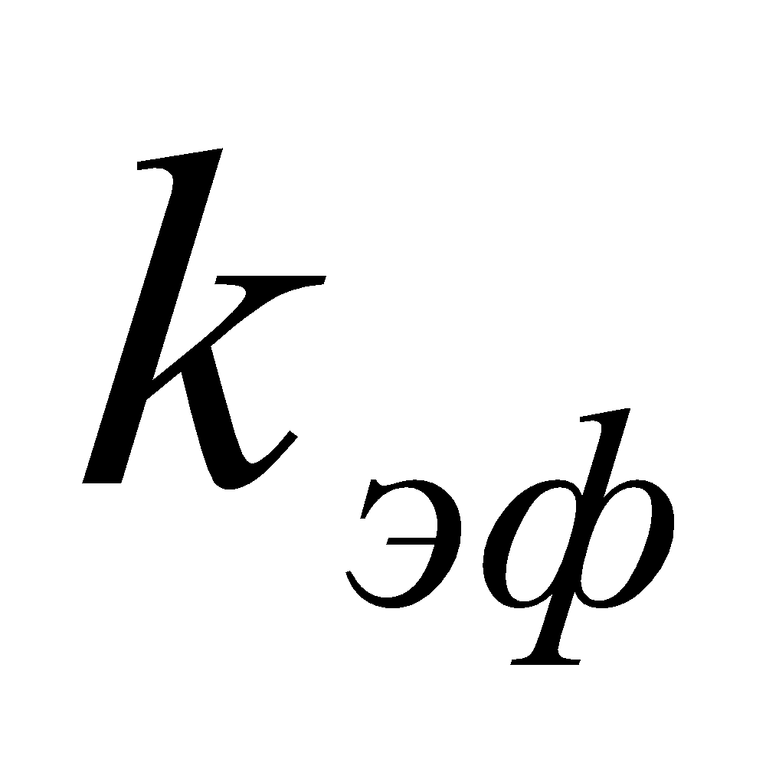=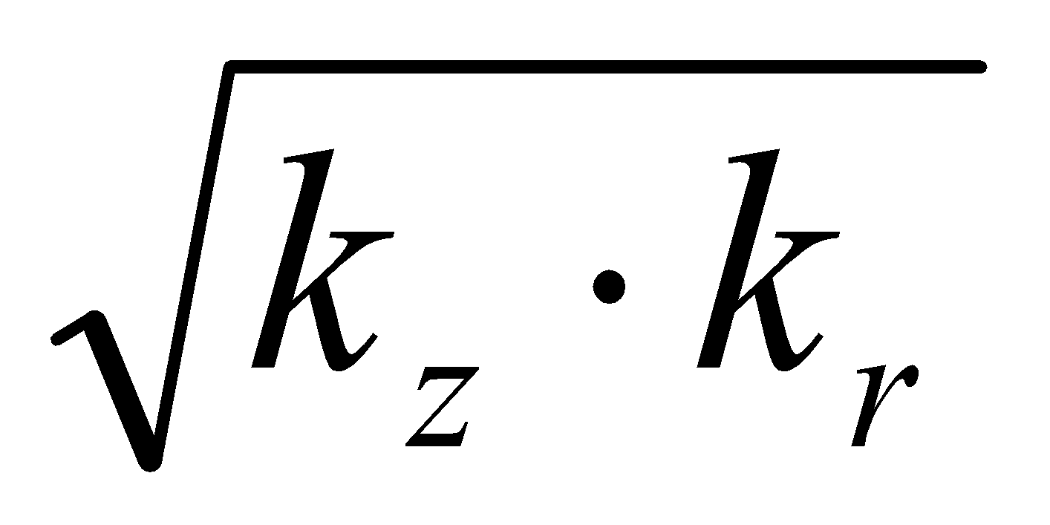 [5,7,8].
Дөңгелек біртекті анизотропты деформацияланатын қабатта көлденең ұңғымаға ағынды анықтау кезінде, анизотропия мен қабаттың деформациялануы көлденең ұңғыма ағынына жеке және біріктірілген әсерінің сандық бағасы беріледі.
Егер 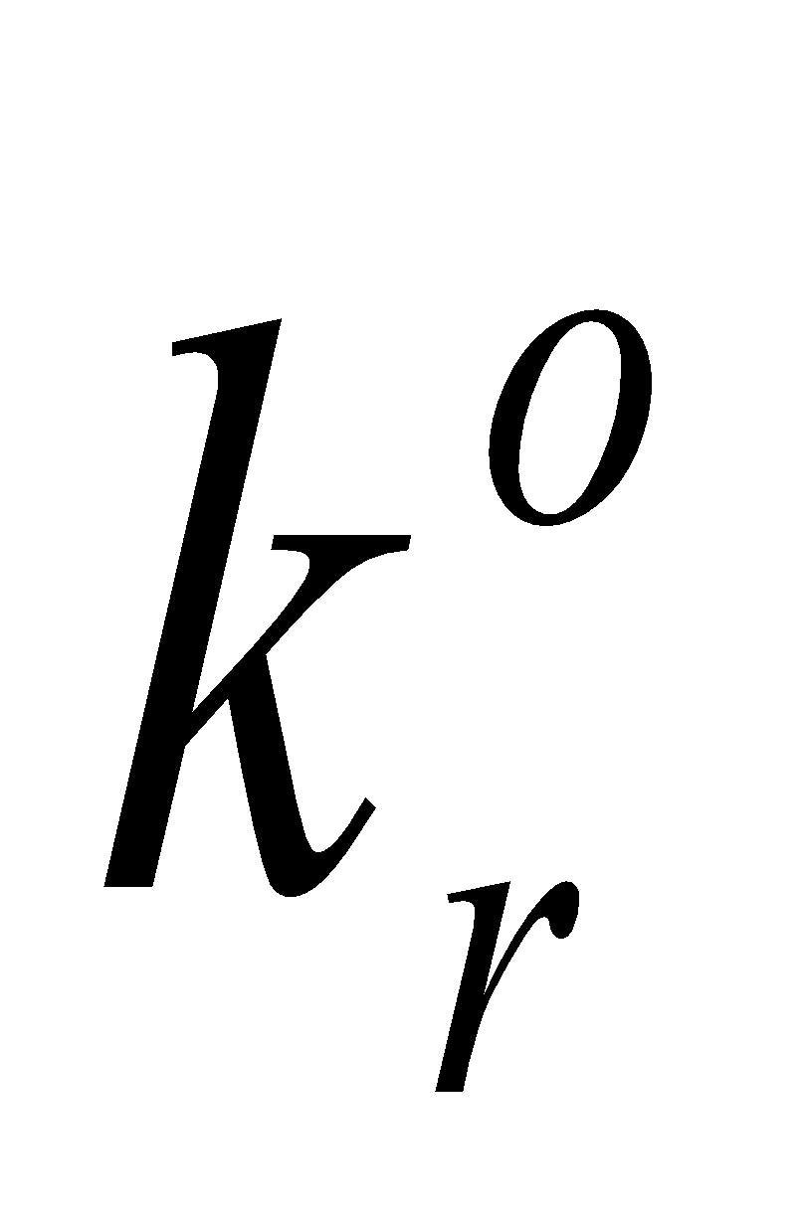және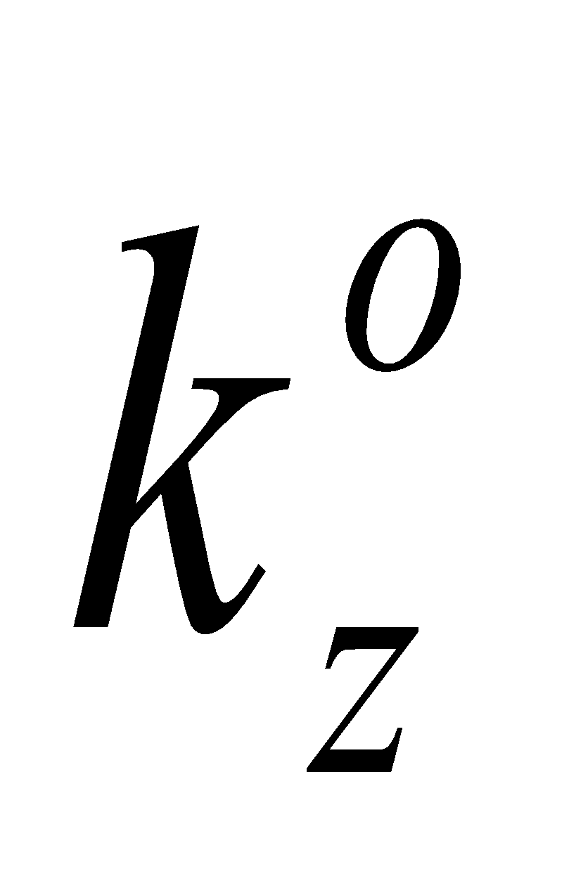- бастапқы қабат қысымындағы қабаттың өткізгіштігінің мәндері радиалды және тік бағытта болса, және қысымға байланысты өткізгіштіктің өзгеру заңы әрбір координата үшін бірдей болса, біз мынаны аламыз:

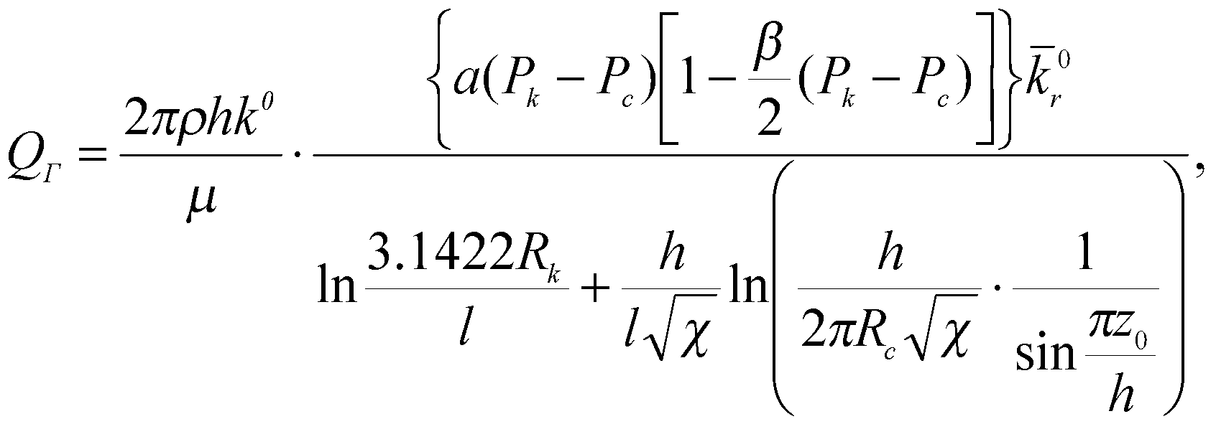 (1)
мұндағы, 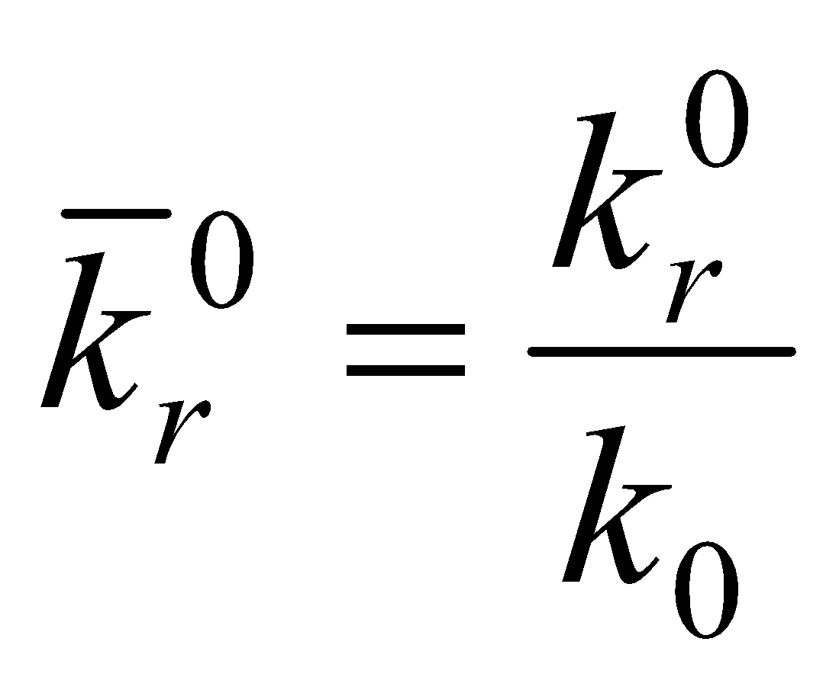; 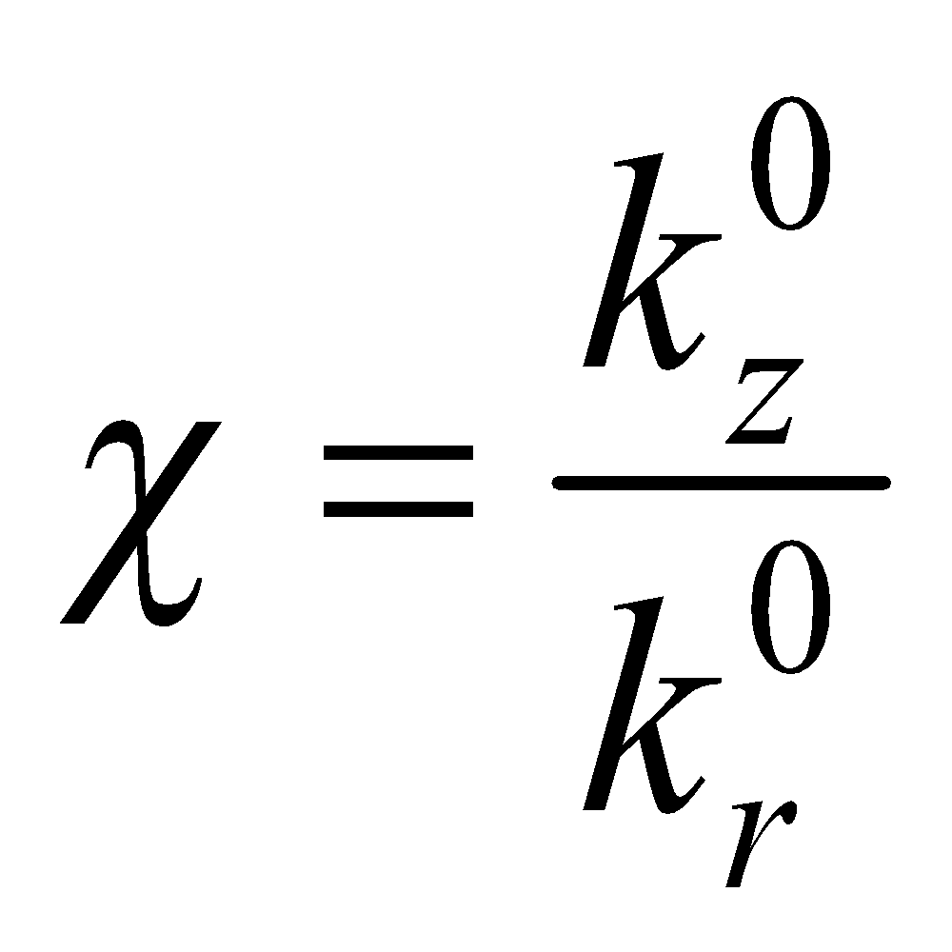;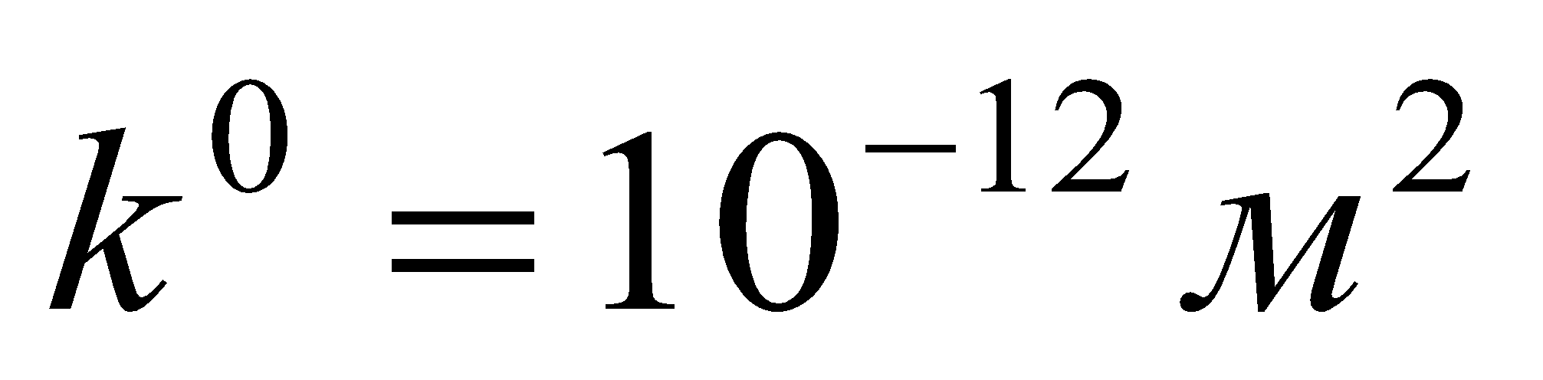– өткізгіштік, бұл 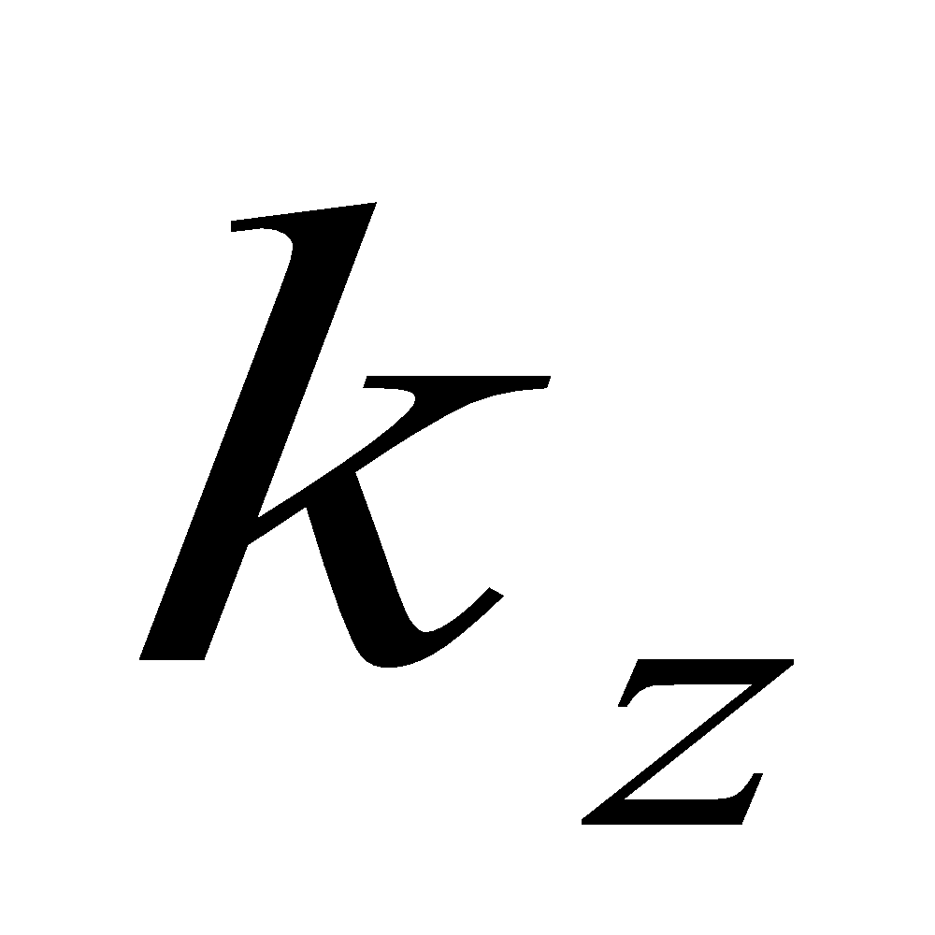 және қатынасының ұңғымаға түсетін суға әсерін өлшемсіз бағалауға мүмкіндік береді;  және – сұйықтықтың тығыздығы мен тұтқырлығы;  және  – қабат пен ұңғыма контурының радиустары; 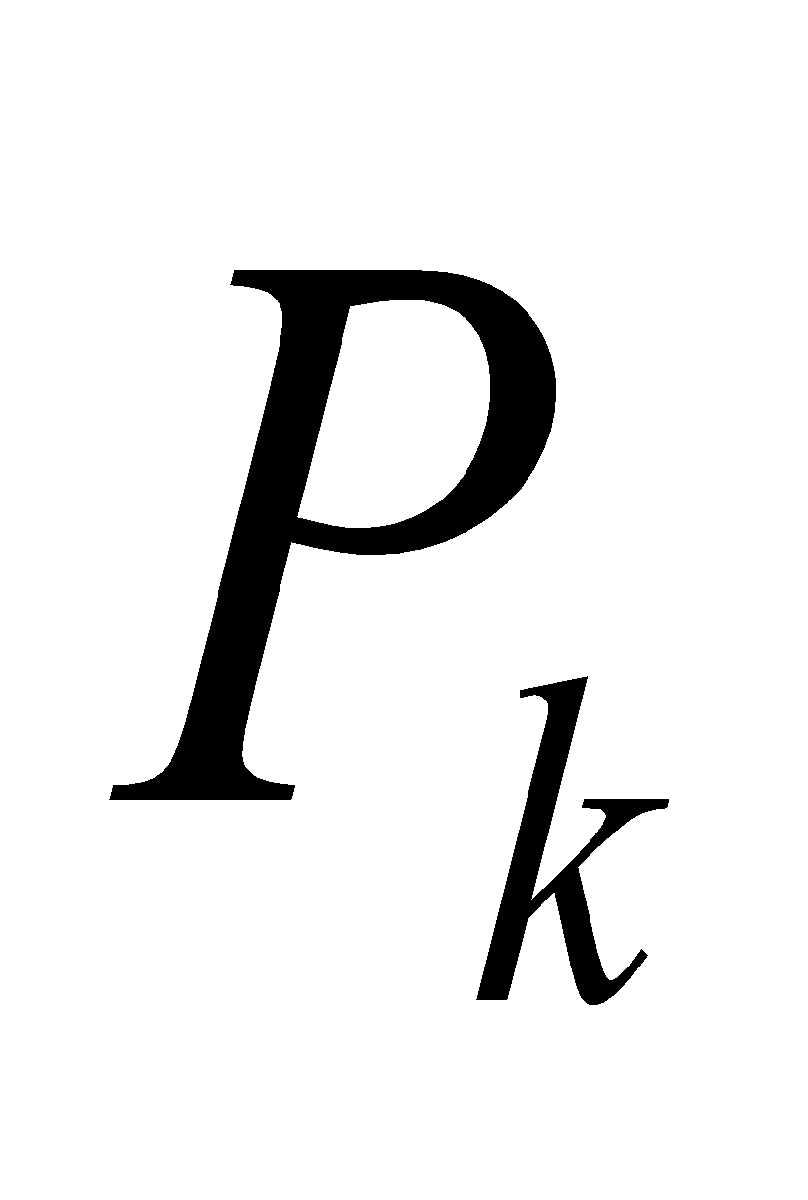 және  – қабат контурындағы және ұңғыма түбіндегі қысым функциясының мәндері;  – қабат қалыңдығы; – көлденең оқпанның ұзындығы; 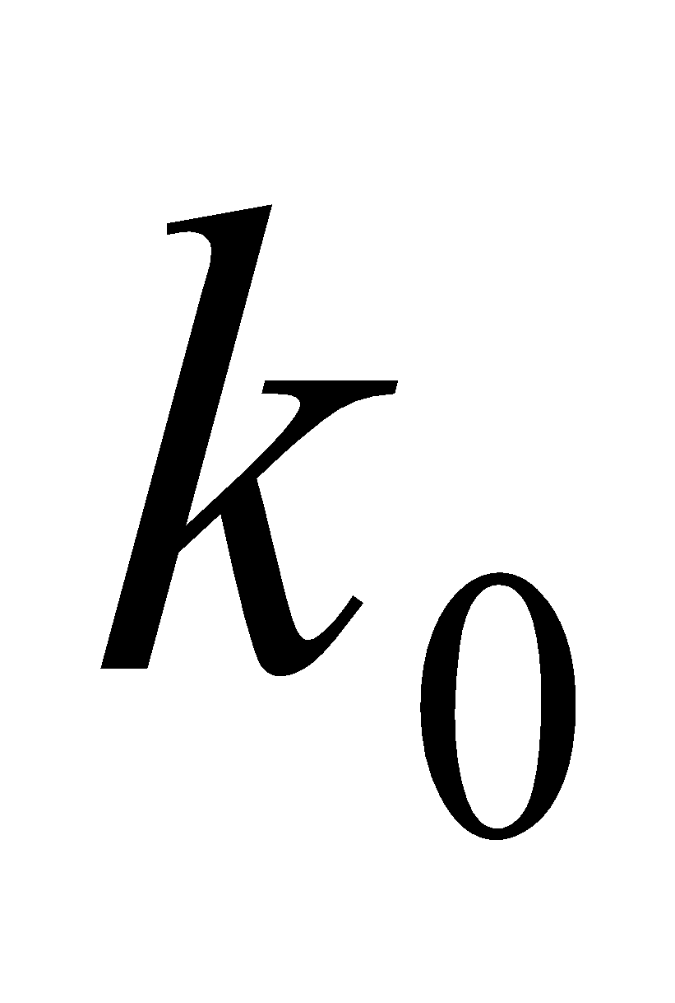 – қабаттың контурындағы қысым кезіндегі өткізгіштік; 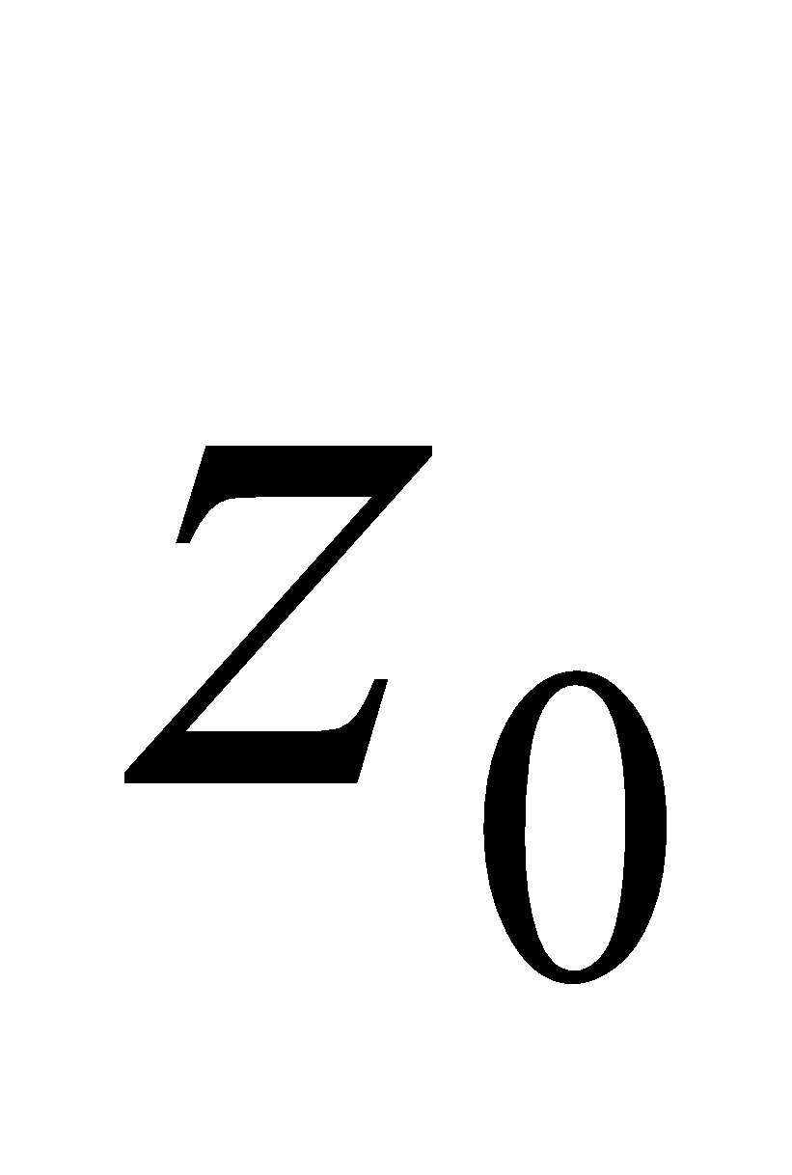– ұңғыма оқпанынан қабаттың түбіне дейінгі қашықтық; және – жұмыстан белгілі қабат жыныстарының деформациясы процесінде өткізгіштіктің өзгеруін сипаттайтын коэффициенттер [5].
Материалдар мен әдістер. Қабат жыныстарының анизотропиясы мен деформациялануының ағынға әсерін бағалау үшін (1) формула бойынша есептеулер орташа және нашар сұрыпталған құмтастардан, жұқа және ұсақ түйіршікті, далалық шпатты мен кварцты (кварц 25-60%) алевриттермен, орташа кеуекті (10-20%) саз мөлшері 20-35% болатын, қалыңдығы 7,5 м және 60 м болатын қабаттардағы көлденең оқпанның ұзындығы 3000 м дейін болатын ұңғымалар үшін жүргізілді, бұл үшін = 0,958899 и =0,0096465.
Есептеу нәтижелерін талдау қабаттың өткізгіштік анизотропиясы көлденең ұңғымалардың өнімділігіне теріс және оң әсер етуі мүмкін екенін көрсетеді.
Изотропты қабаттың өткізгіштігіне тең көлденең өткізгіштігі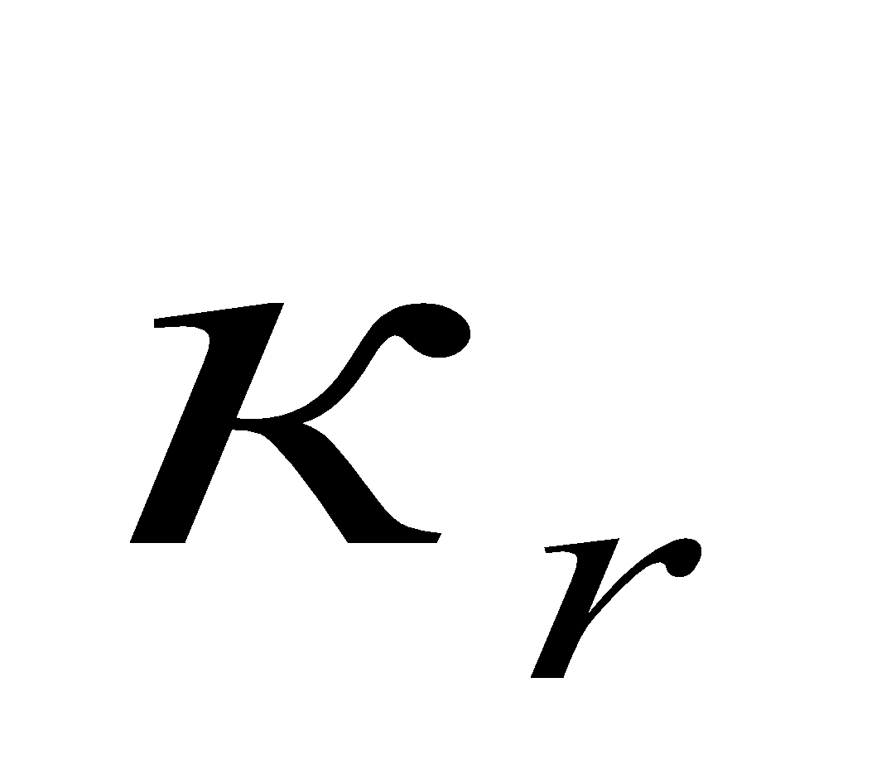бар қабатта көлденең ұңғыманың дебиті 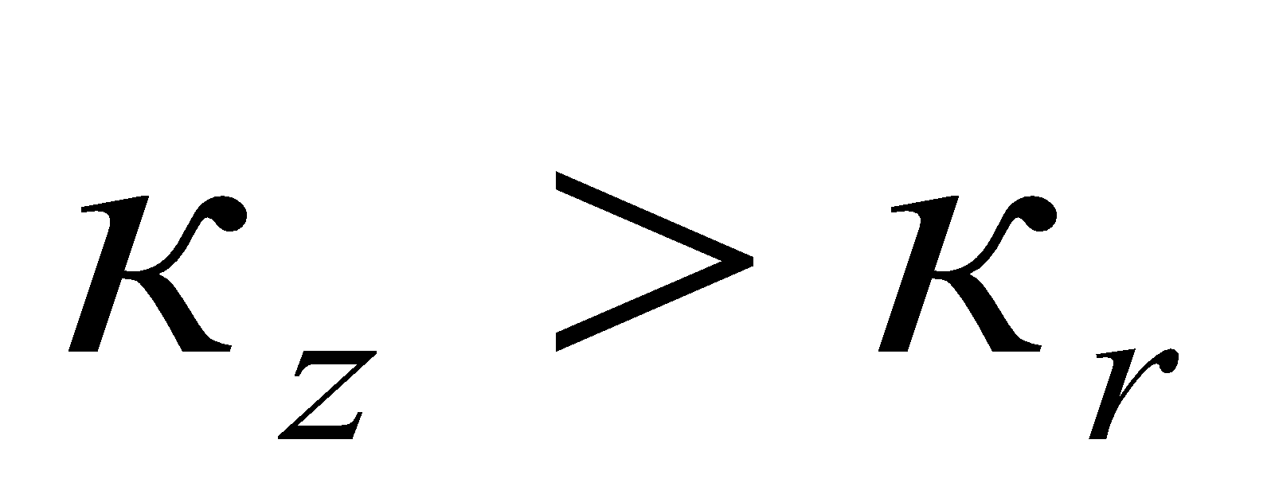кезінде біртекті қабатта бірдей ұңғыманың дебитінен үлкен және 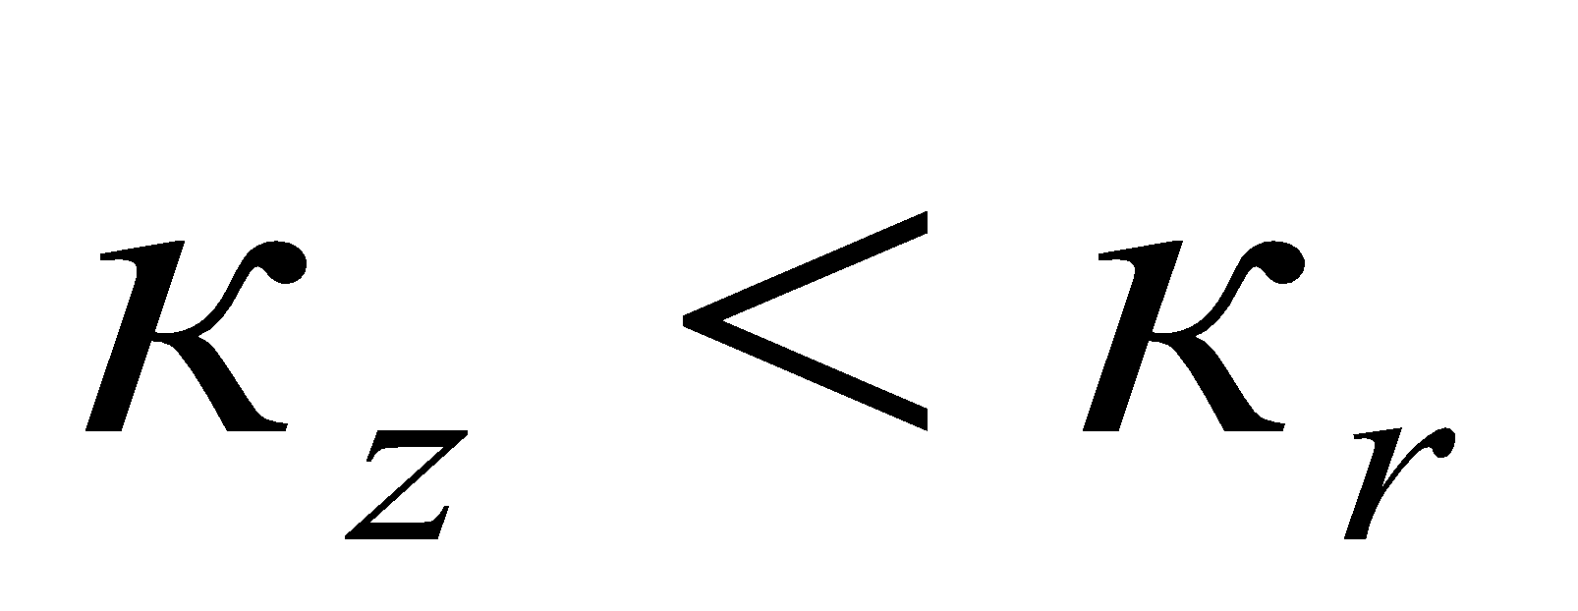кезінде аз болады (1-кесте: қабаттың қуаты h=7,5 м және 1-суреттегі 1-5 қисықтар h=60 м кезінде).

1-кесте. Қалыңдығы h=7,5 м болатын қабаттағы тік өткізгіштіктің көлденең ұңғымаға қатынасының әртүрлі мәндері кезінде көлденең оқпанның ұзындығына байланысты ұңғыма өнімділігінің өзгеруі

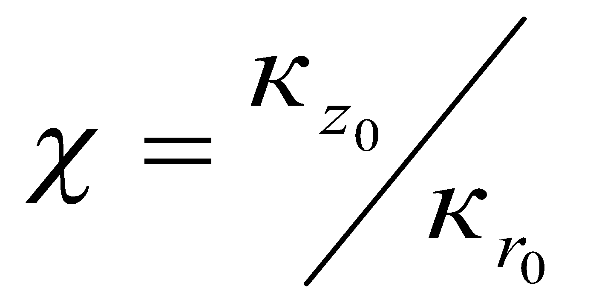  Ұңғыма  оқпаны ұзындығы, l, м | 0,2 | 0,5 | 1,0 | 2,0 | 5,0
50 | 35,35 | 38,39 | 39,94 | 40,87 | 41,88
100 | 43,95 | 46,26 | 47,37 | 48,11 | 48,7
300 | 61,73 | 63,19 | 63,86 | 64,22 | 64,67
500 | 73,37 | 74,8 | 75,37 | 75,7 | 76,04
1000 | 97,52 | 98,96 | 99,09 | 99,31 | 99,66
1500 | 119,57 | 120,68 | 121,14 | 121,37 | 121,71
2000 | 142,06 | 143,19 | 143,71 | 144,06 | 144,31
2500 | 166,14 | 167,38 | 167,95 | 167,31 | 168,6
3000 | 192,7 | 194,09 | 194,72 | 195,12 | 195,46

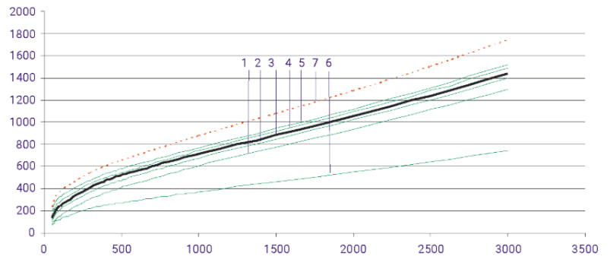

1-сурет. Ұңғыманың өнімділігі көлденең оқпан ұзындығының функциясы ретінде әртүрлі тік өткізгіштік мәндерінде:
1-5 – сәйкесінше χ=0.2; 0.5; 1,0; 2.0; 5,0 и h=60 м; 6 – χ=2; h=60 м;
7 – χ=5; h=60 м; жыныстардың деформациясын ескермегенде

Кез келген қалыңдықтағы қабаттарда анизотропияның ұңғыма өнімділігіне әсері бірдей заңдылыққа бағынады және тік және көлденең өткізгіштіктердің арақатынасына қарамастан, көлденең ұңғыма оқпанының ұзындығының артуымен азаяды (2-сурет).

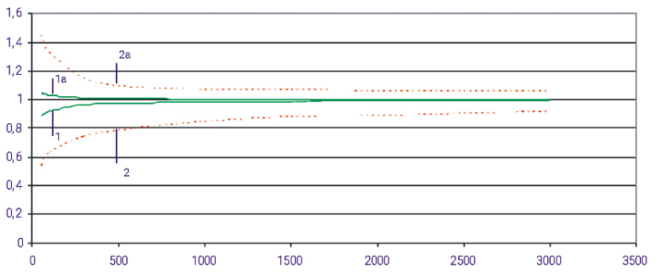

2-сурет. Анизотропты және изотропты қабаттардағы дебиттердің көлденең ұңғыма оқпанының ұзындығына қатынасы:
1; 2 – χ=0.2; 1а; 2а – χ=5; ----- қабат қалыңдығы h=60 м; h=7.5 м

Алайда, анизотропияның ағынға әсер ету дәрежесі қабаттың қалыңдығына айтарлықтай байланысты. Жұқа қабаттарда бұл әсер соншалықты маңызды емес, сондықтан оны іс жүзінде ескермеу мүмкін. Осылайша, қалыңдығы 7,5 м болатын қабатта, есептеулер үшін қабылданған шарттарда, 0,2-ден 5-ке дейінгі диапазонда, көлденең оқпан ұзындығы 50 м болатын ұңғыманың дебиті изотропты қабаттағы ұқсас ұңғыманың дебитімен салыстырғанда тек 1,49-4,86%-ға өзгереді, ал көлденең оқпан ұзындығы 3000 м-ге дейін ұлғаюымен ол одан да көп 0,04-
0,38% мәніне дейін төмендейді (1 және 1a қисықтары).
Үлкен қалыңдықтағы қабаттарда, әсіресе көлденең оқпанның ұзындығының аз мәндерінде ұңғыманың өнімділігі анизотропияға тәуелді, сондықтан оның әсерін елемеуге болмайды. Қабат қалыңдығы 60 м және көлденең оқпанның ұзындығы 50 м болғанда, ұңғыма өнімділігі  мәнге байланысты 45,0-47,0%-ға өзгереді. Көлденең ұңғыма оқпанының ұзындығы 3000 м-ге дейін ұлғаюымен бұл өзгеріс 4,35–7,30%-ға дейін төмендейді, абсолютті мәнде ұңғыма ағынының дебиті өзгеруі үлкен болады (2 және 2a қисықтары).
Тік өткізгіштігі төмен қабаттардағы көлденең ұңғыманың дебитінің төмендеуі көлденең оқпан ұзындығының ұлғаюына байланысты болуы мүмкін. Осылайша, қалыңдығы бірдей 60 м және =0,2 болатын біртекті және анизотропты қабаттардағы ұңғымалардың дебиті, егер анизотропты қабаттағы көлденең ұңғыма оқпаны изотропты қабаттағы ұзындығы 1500 м ұңғымадан 340 м ұзын болса, тең болады.
Сондай-ақ, гидравликалық жаруды қолдана отырып, ұңғыма оқпанына перпендикуляр жарықтар жасау арқылы тік өткізгіштігі төмен қабаттардағы көлденең ұңғымалардың дебитін арттыруға болады.
Сондай-ақ, біз қарастырған ұңғыма оқпанының дөңгелек қабатта орналасу сұлбасында көлденең өткізгіштіктің төмендеуі көлденең ұңғыманың өнімділігіне тік өткізгіштіктің ұқсас өзгеруіне қарағанда әлдеқайда көп әсер ететінін атап өткен жөн. Біркелкі қабаттағы ұңғыманың өнімділік кестесін сәйкестендіру арқылы бұған көз жеткізу оңай (1-суреттегі 3 қисық; 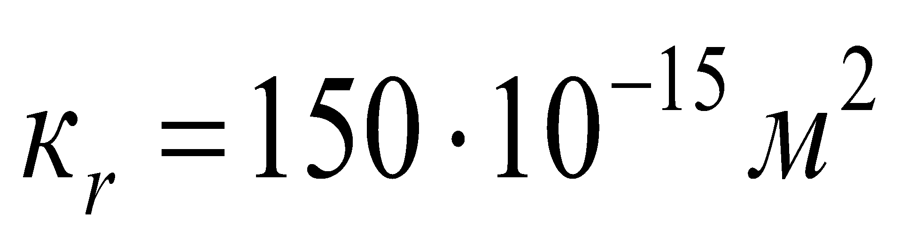) анизотропты қабаттардағы ұқсас графиктермен және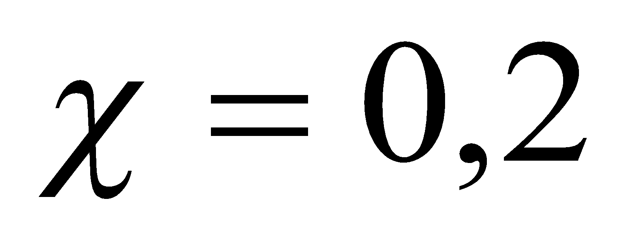 (2 қисық) және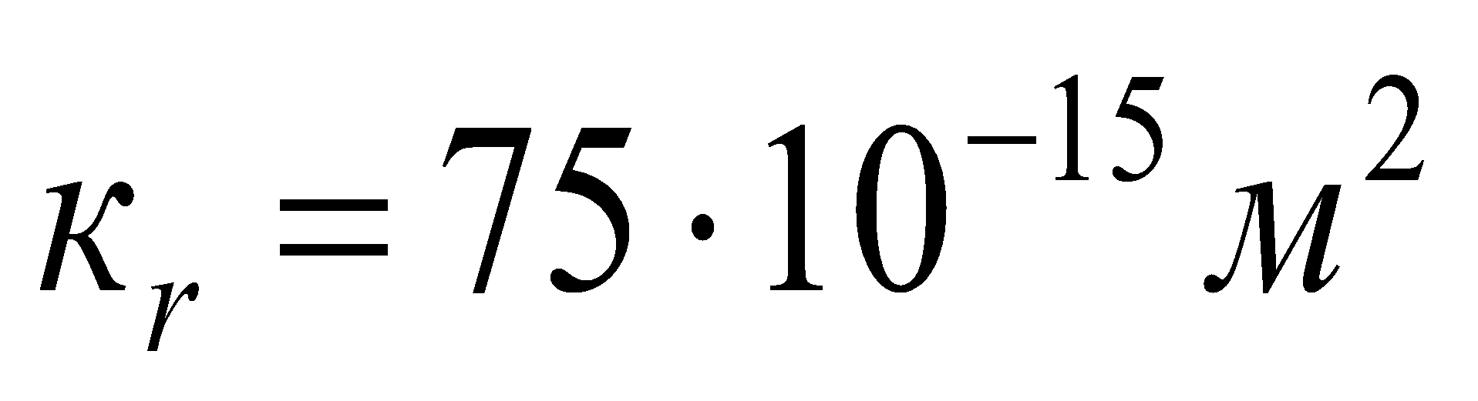; 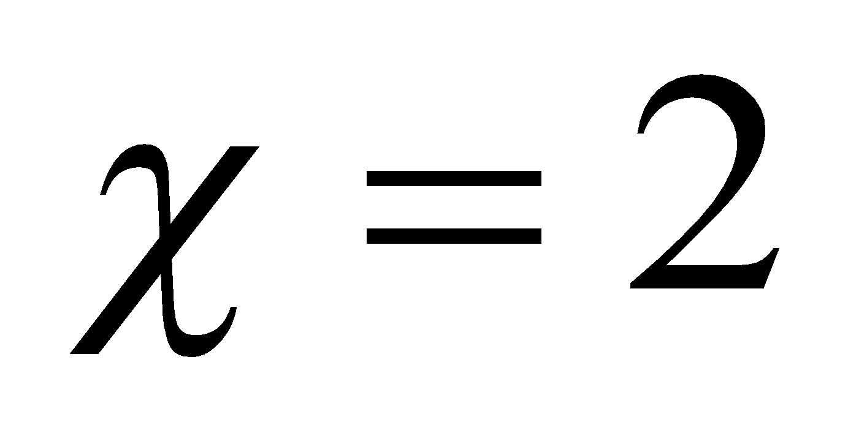; (6 қисық).
Жыныстардың деформациялануының көлденең ұңғыманың өнімділігіне әсерін бағалау үшін деформацияланбайтын жыныстармен қабаттарда бұрғыланған әртүрлімәндері бар ұңғымалар үшін жоғарыда сипатталғандарға ұқсас есептеулер жүргізілді. Алынған нәтижелерді 1-суретте көрсету үшін (7-қисық) қалыңдығы 60 м, және =5 деформацияланбайтын қабаттағы ұңғымаға тәуелділік 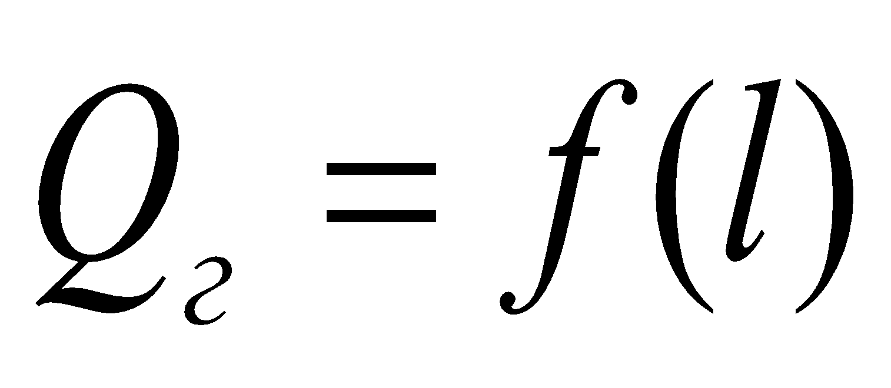 салынған. Ұқсас деформацияланатын қабат үшін 7-қисықты 5-қисықпен салыстыру көлденең ұңғымалардың өнімділігін есептеу қабаттың жыныстарының деформациялануын ескермей, жоғары нәтиже беретіндігін көрсетеді.
Ақырында, көлденең және жетілген тік ұңғымалардың дебиттері салыстырылды, олар ұқсас қабаттардың барлық қалыңдығын көрсетеді. Зерттеу барысында көлденең ұңғымалар үшін өнімділік коэффициенттерінің 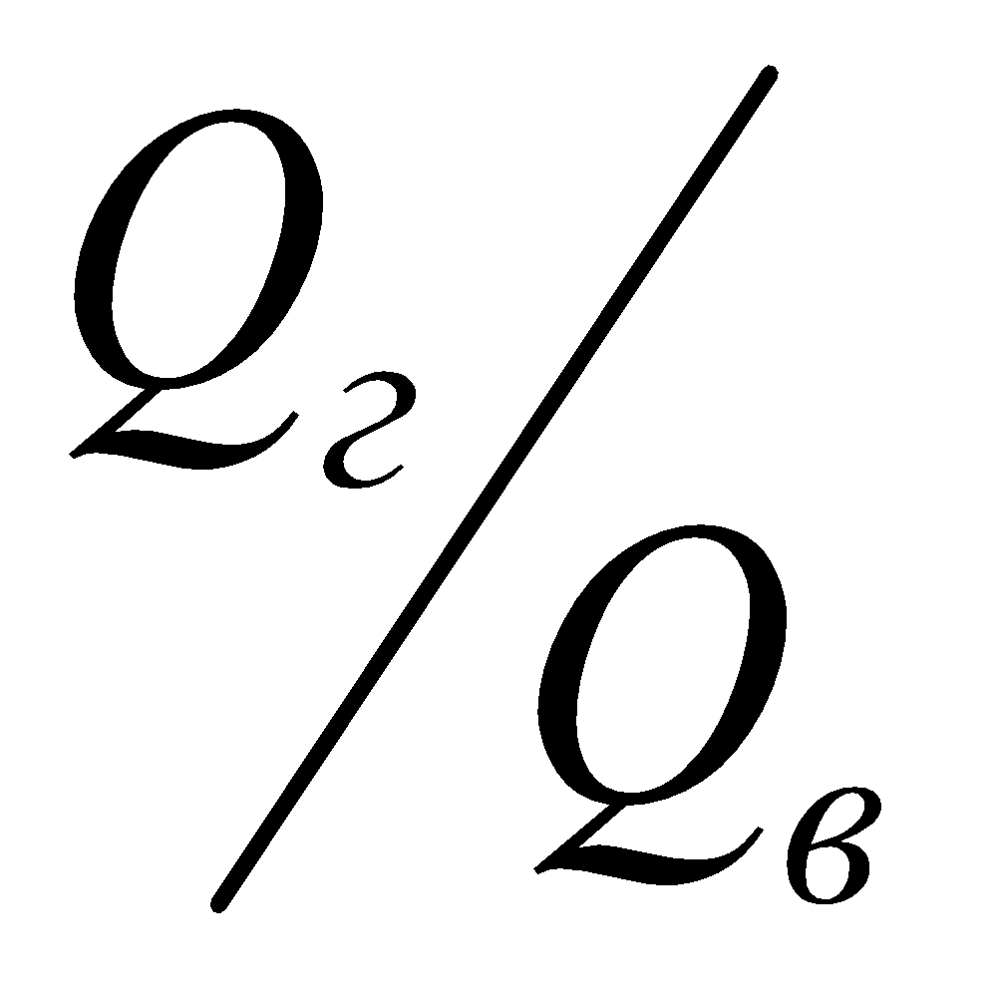қатынасында кез-келген тік және көлденең өткізгіштік коэффициенттері жұқа қабаттарда әлдеқайда жоғары екендігі белгілі.
Қарапайым мысалда анизотропия тензорының осьтері координаталық,  және  осьтерге сәйкес келеді делік (3-сурет). Сонда мәселе келесі теңдеуді шешу үшін:

, (2)

мұндағы, 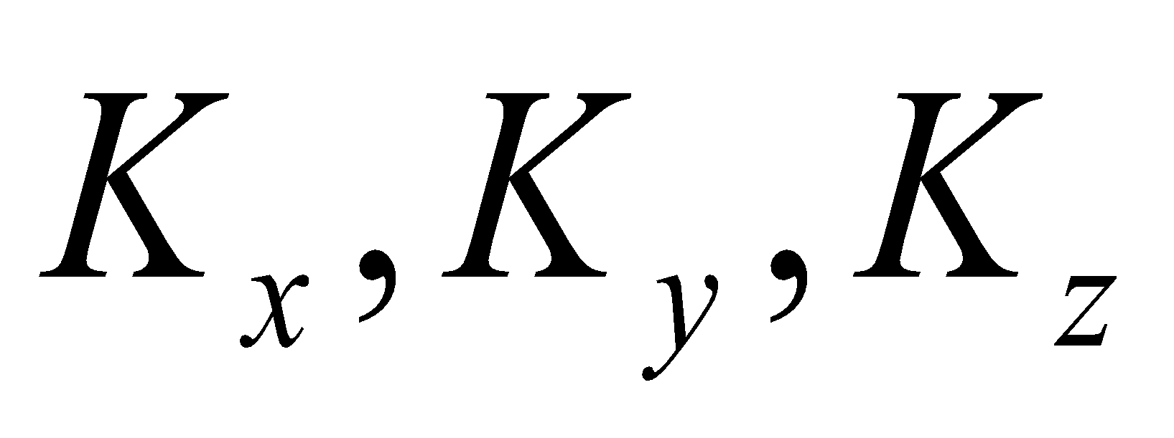 – , және осьтер бағытына сәйкес өткізгіштік мәндері бастапқы қабаттық қысым кезінде;  – Дирак функциясы;  – Хевисайдтың бірлік функциясы.

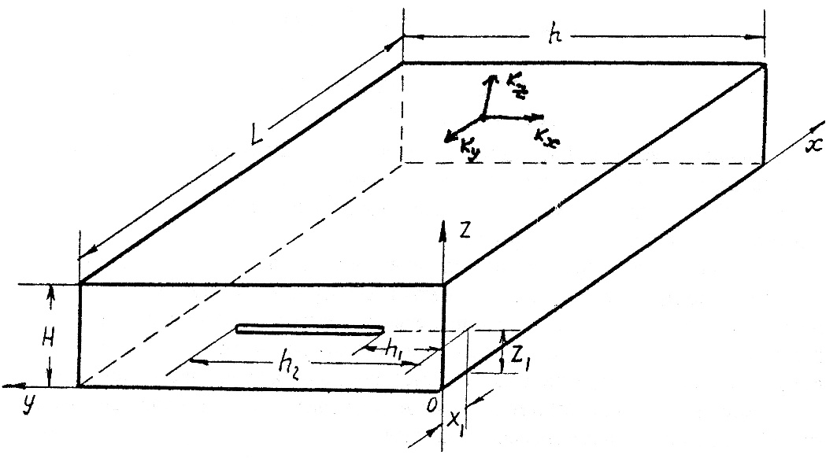

3-сурет. Көлденең сызықтық ағыны бар қабат элементі

Соңғы шегінде Фурье түрлендіру косинусын екі рет қолдану және өңдеу формулалары келесідей: Есепті шешу үшін ұсынылған алгоритмді қолдана отырып, кезіндегі сұйықтық ағынына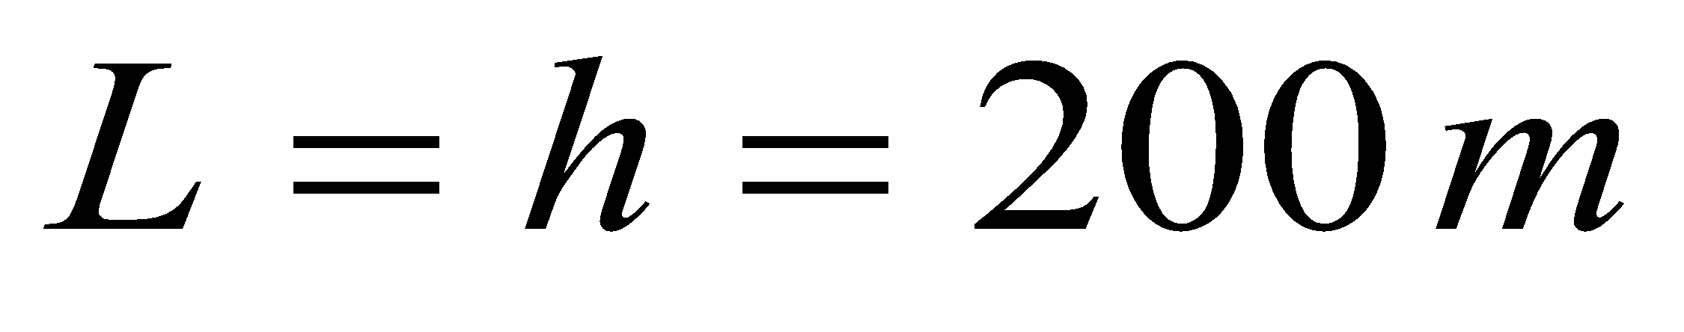,  қабат өткізгіштігінің анизотропия мәндерінің өзгеруінің әсерін анықтау үшін көптүрлі есептеулер жүргізілді. Тікбұрышты пішінді қабат элементіндегі көлденең ұңғыманың орналасуының әртүрлі нұсқалары үшін зерттеулер жүргізілді.
Нәтежелер жене талқылау. Біз әртүрлі факторлардың сүзу кедергілеріне әсер етуінің салыстырмалы тәуелділіктерін берілген параметр үшін ерікті кедергінің ең кішіге қатынасы түрінде ұсындық, бұл координатасы 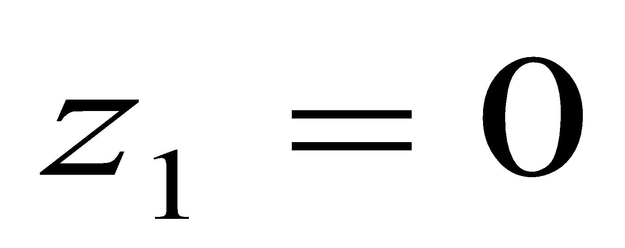қабат элементіне көлденең ұңғыма сүзгісін орналастыру кезіндегі фильтрация кедергісінің бірдей кедергіге қатынасын бейнелейді, бірақ сүзгінің шатырға және негізге қатысты симметриялы орналасуымен, яғни 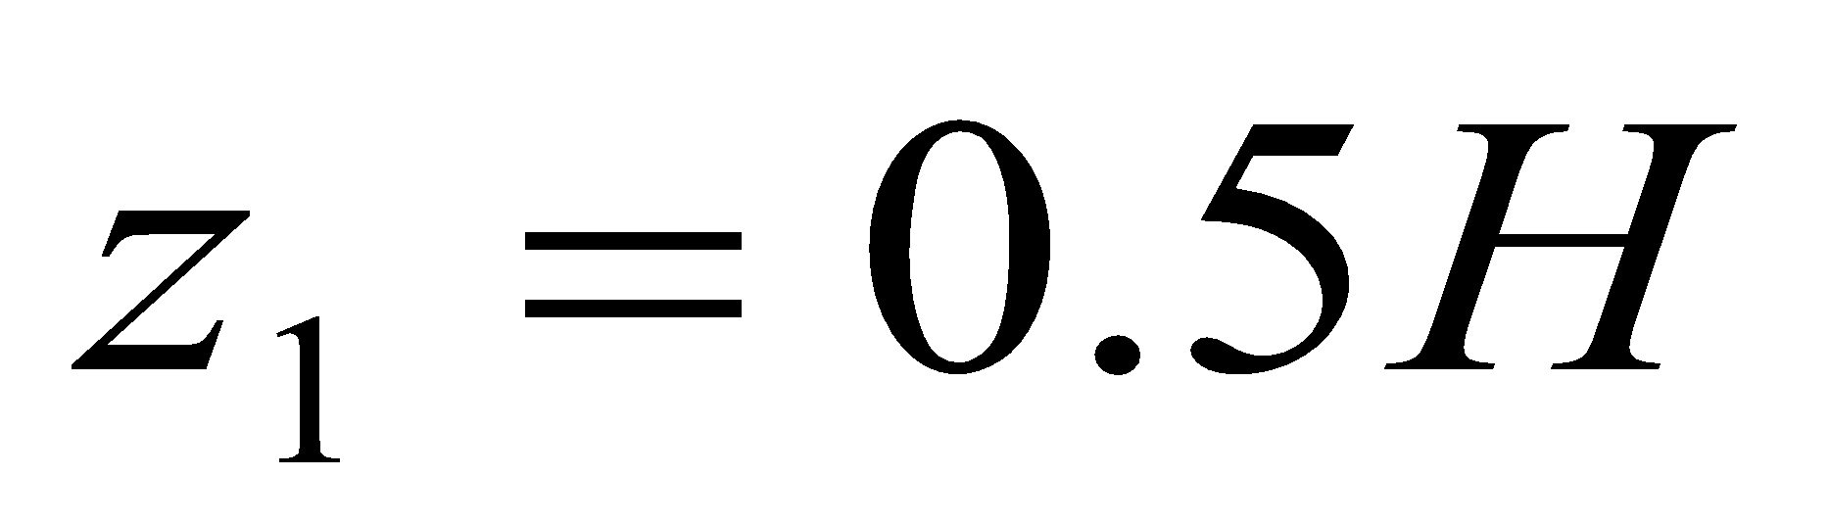кезінде, яғни, сүзгі 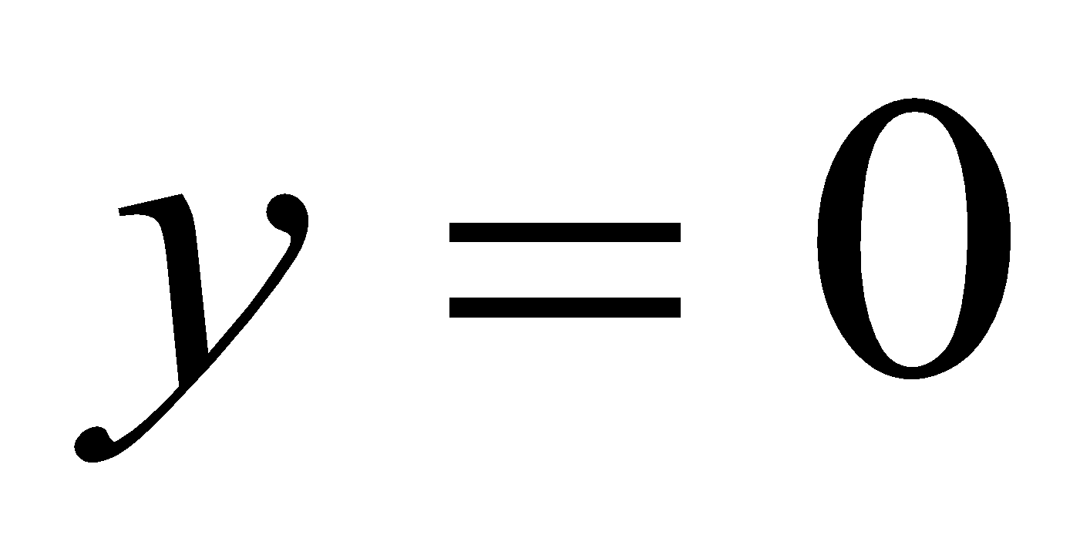 координатасынан басталғанда, сүзгінің ортасы қабат элементінің тік симметрия осіне сәйкес келген кезде сүзгіні симметриялы орналастыру. Бұл жағдайда нұсқалар үшін өткізгіштік коэффициенті келесідей болды: 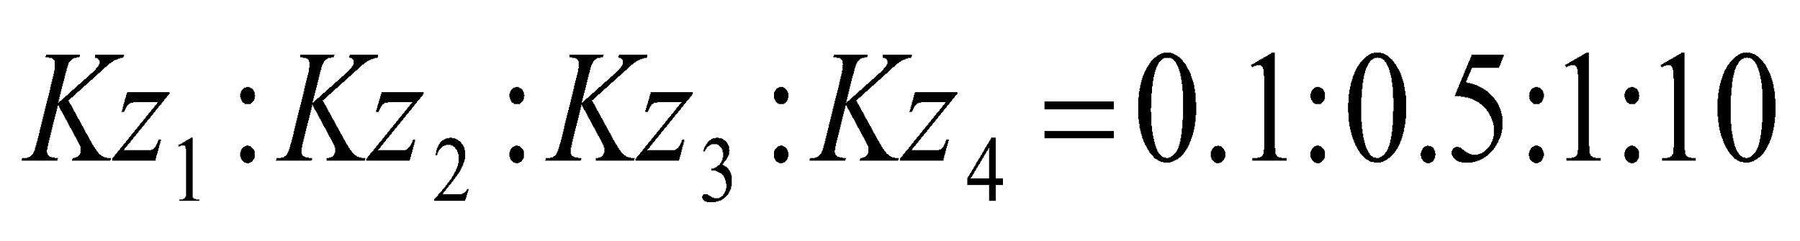. Осылайша, қарастырылған нұсқалардың үшіншісі біртекті қабатты, біріншісі және екіншісі тік өткізгіштігі нашарлаған нұсқаларды, ал төртіншісі жақсартылған тік өткізгіштікті білдіреді. Көріп отырғанымыздай, қабатты түбінде ашу көлденең ұңғымаға сұйықтық ағынына сүзілу кедергісін айтарлықтай арттырады. Сүзілуге ​​кедергінің абсолютті өсуі ашылу дәрежесіне және тік өткізгіштікке айтарлықтай байланысты. Қабаттың ашылу дәрежесі неғұрлым жоғары болса, сүзгінің тік жазықтықтағы орналасуы мен тік өткізгіштігінің әсері соғұрлым аз болады. Сонымен, қарастырылған нұсқалардағы 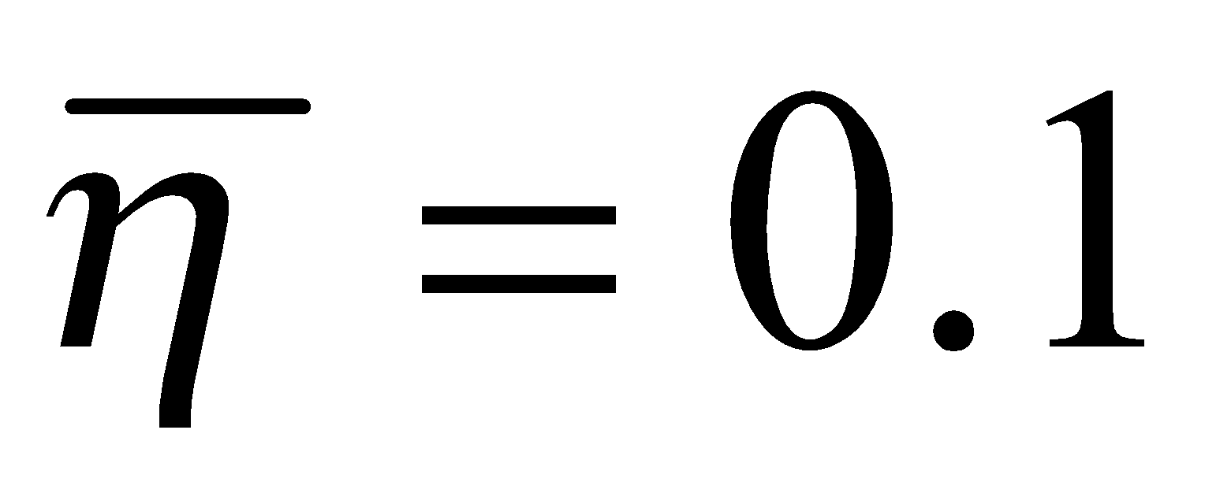 және 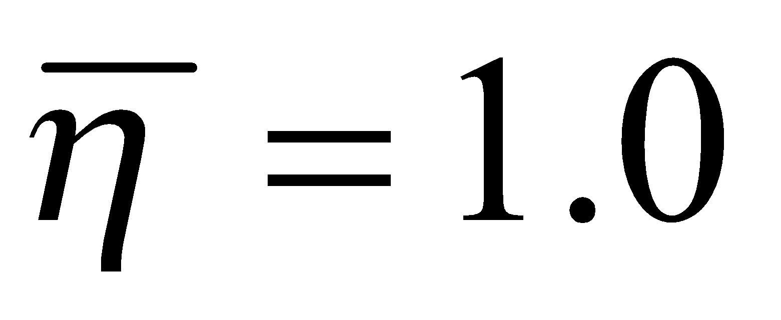 максималды айырмашылықтар сәйкесінше 60% және 18,5%-дан асты. Тік өткізгіштіктің әсері біртекті қабатпен салыстырғанда оңай орнатылады. Тігінен өткізгіштіктің нашарлауы әрқашан сүзу кедергісінің өсуіне оның біркелкі өсуіне қарағанда көбірек әсер ететіні анықталды.
Бұл симметриялы ашылу кезіндегі  кедергі минималды болуына және оның төмендеуі асимметриялық ашылу кезіндегі төмендеу жылдамдығынан асып түсуіне байланысты. Сонымен қатар, бірдей тәуелділіктер анықталды, бірақ өткізгіштіктің әртүрлі мәндері үшін. Бұл жағдайда нұсқалардың өткізгіштіктерібір-бірімен келесідей байланысты болды: 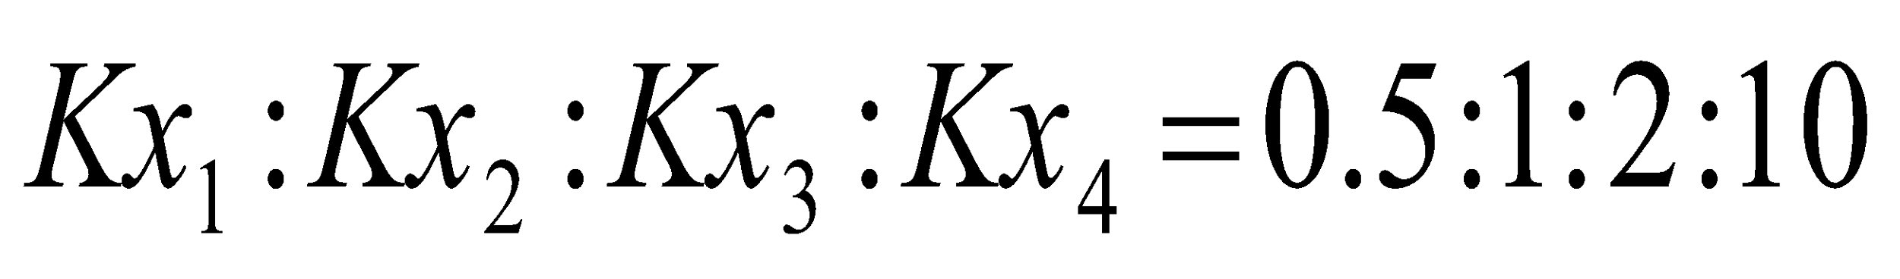. Зерттеу барысында қабаттың өткізгіштігінің нашарлауы және бұл жағдайда оның біркелкі өсуіне қарағанда айтарлықтай үлкен әсер етеді. Жалпы алғанда, бұл жағдайда бұрын қарастырылған нұсқаның сапалық сипаттамалары сақталады. Сонымен қатар, зерттелген көлденең ұңғымаға ағынға салыстырмалы кедергіге 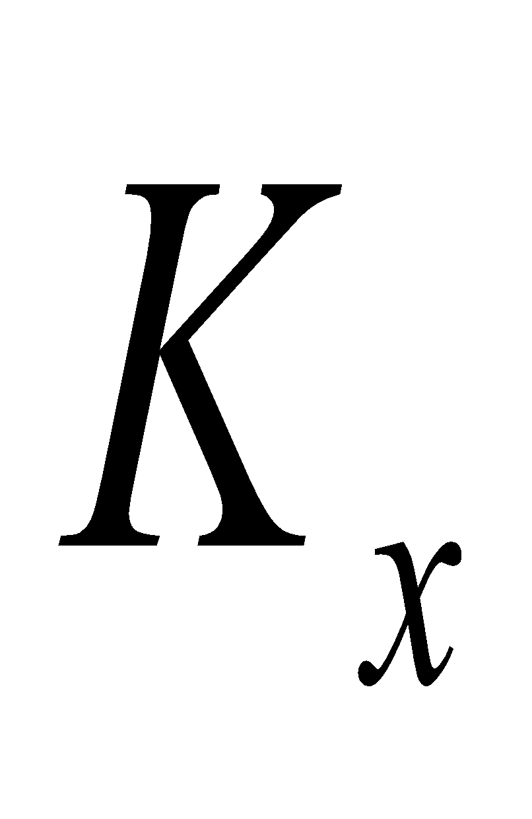 сандық әсері 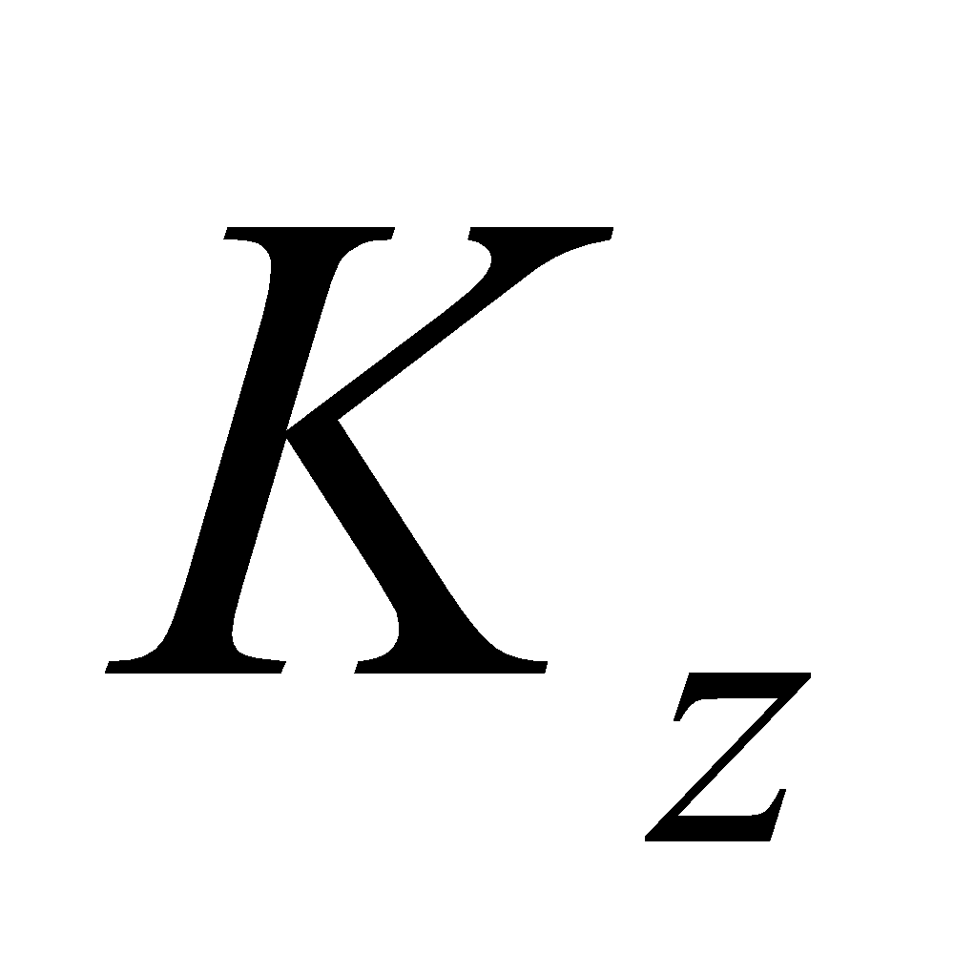-ға қарағанда айтарлықтай төмен.
Жүргізілген жұмыс барысында көлденең ұңғымаға ағын кедергісі басқа тең жағдайларда біртекті қабаттың кедергісіне берілген кедергінің қатынасы ретінде салыстырмалы түрде ұсынылатыны анықталды. Көріп отырғаныңыздай, әсер айтарлықтай және неғұрлым көп болса, қабаттың салыстырмалы соғұрлым ашылуы аз болады (). Қарастырылып отырған процеске қабат қимасындағы көлденең ұңғының орналасуы да .айтарлықтай әсер етеді . Осылайша, қарастырылып отырған мысалдағы минималды ашылу 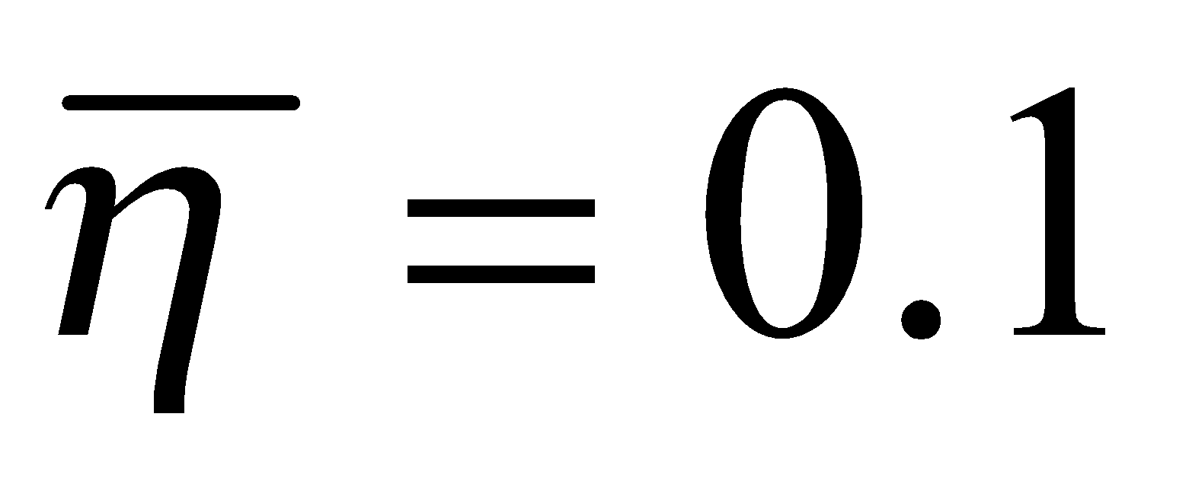және максималды анизотропия 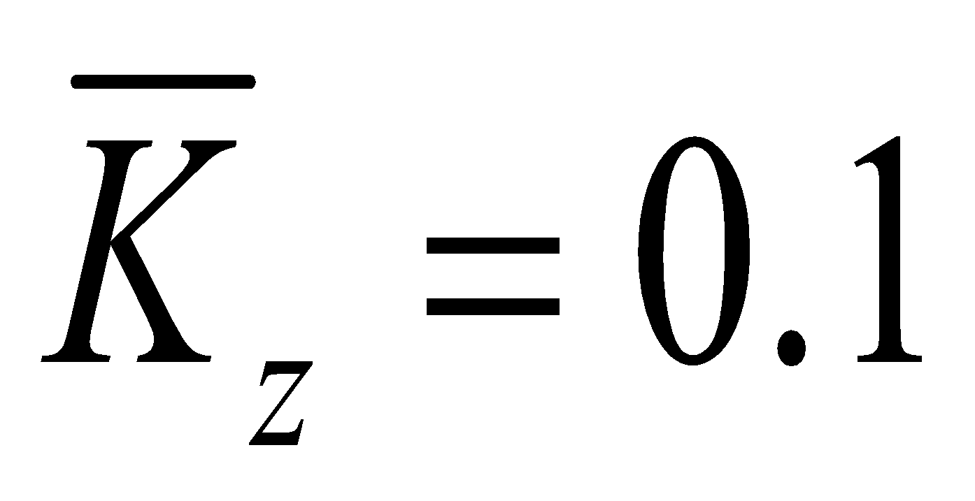 болғанда, осі бойымен өткізгіштіктің нашарлауы 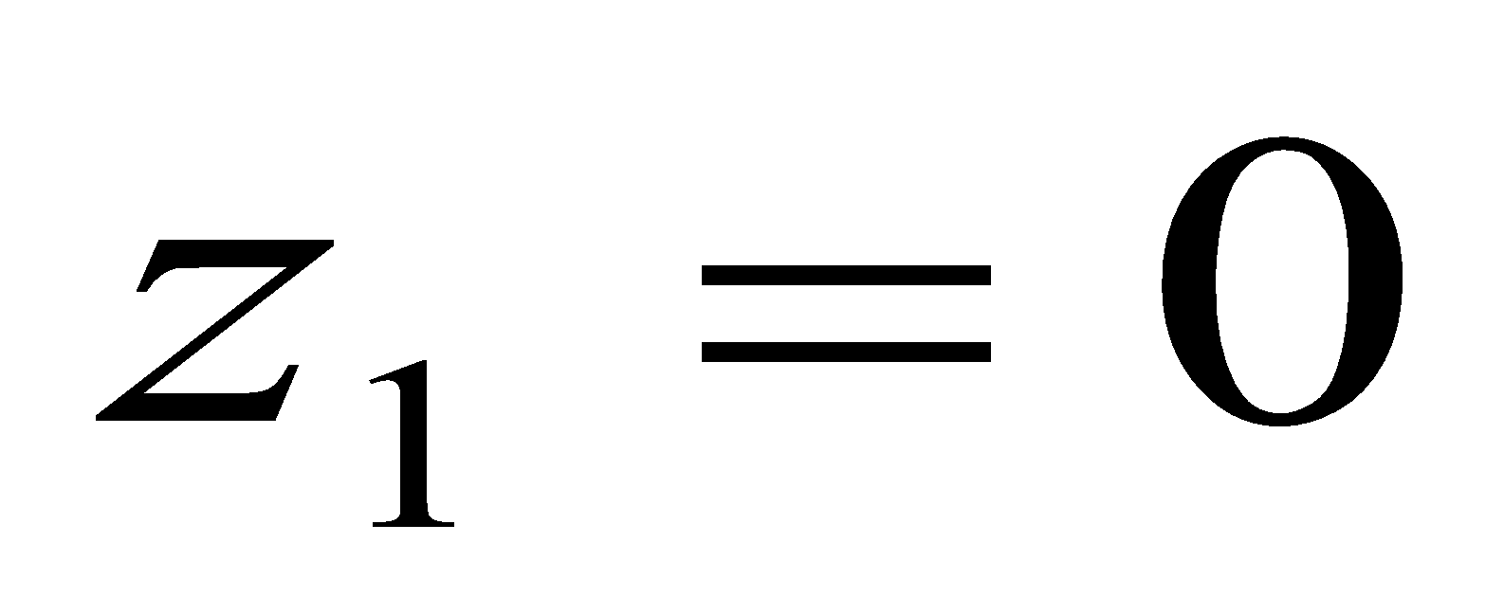 болатын біртекті қабатпен салыстырғанда сүзілу кедергісін 93%-ға, ал болатын қабатпен салыстырғанда 51%-ға арттырады. 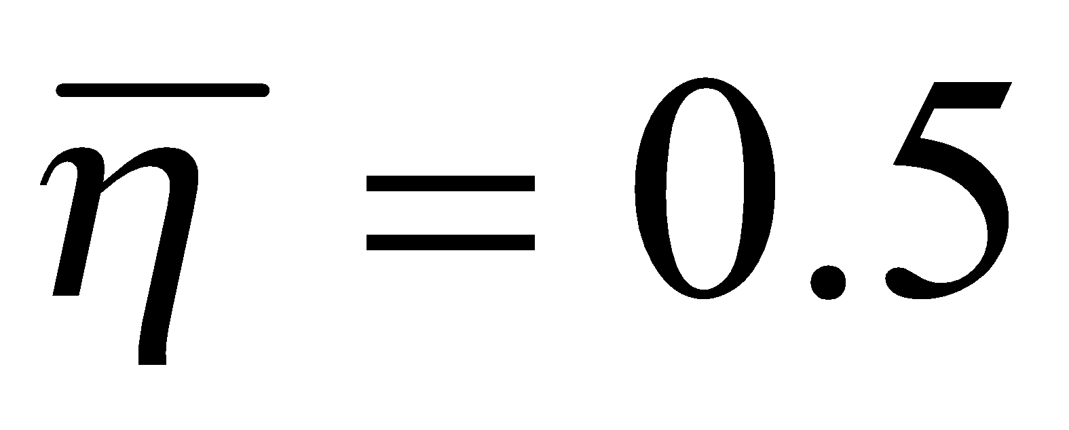және сол алдыңғы анизотропия кезінде көлденең ұңғымаға сұйықтық ағынына кедергінің байқалған жоғарылауы сәйкесінше 47% және 20% құрады.
Берілген қисықтарды талдау бойындағы анизотропияның сүзілу кедергісіне айтарлықтай әсерін көрсетеді. Сонымен, 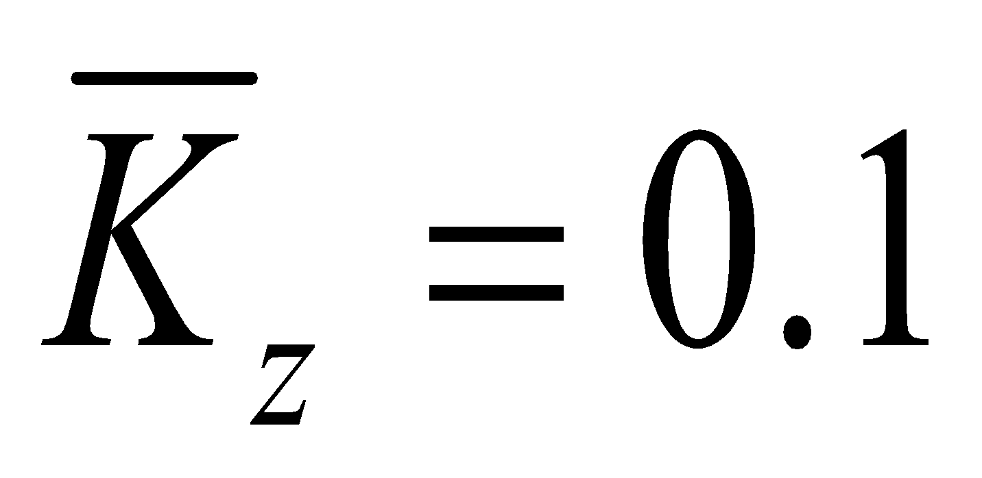 және 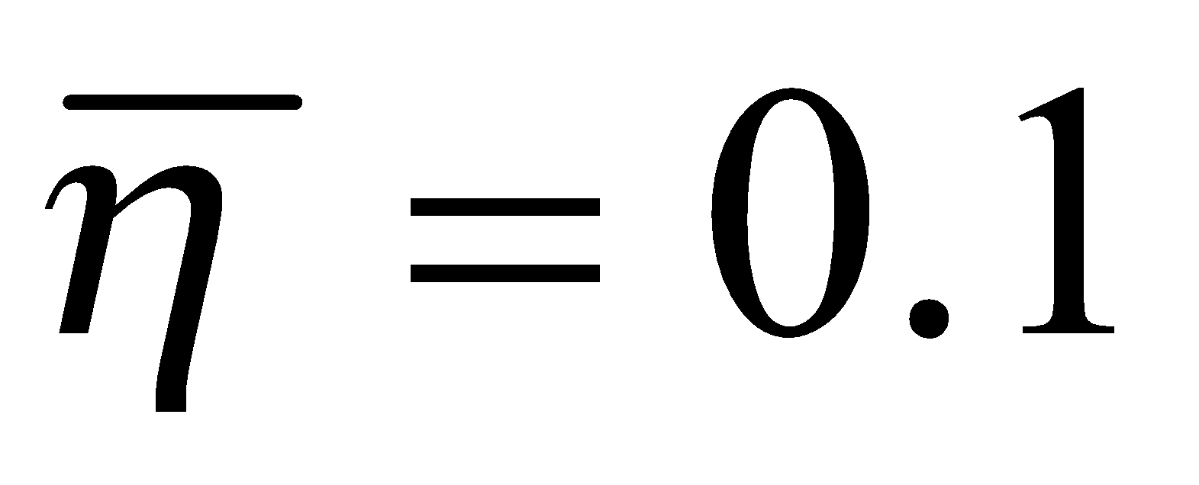 кезінде сүзілу кедергісі жоғары болады: , z₁=0 кезінде 68.7%-ға, кезінде 60,5%-ға жоғары. Бұрынғыдай, өткізгіштіктің төмендеуінің зерттелетін мөлшеріне оның біркелкі өсуіне қарағанда біршама үлкен әсер бар. Бұл жағдайда әсер ашылу дәрежесіне де тән.
Біріншісі 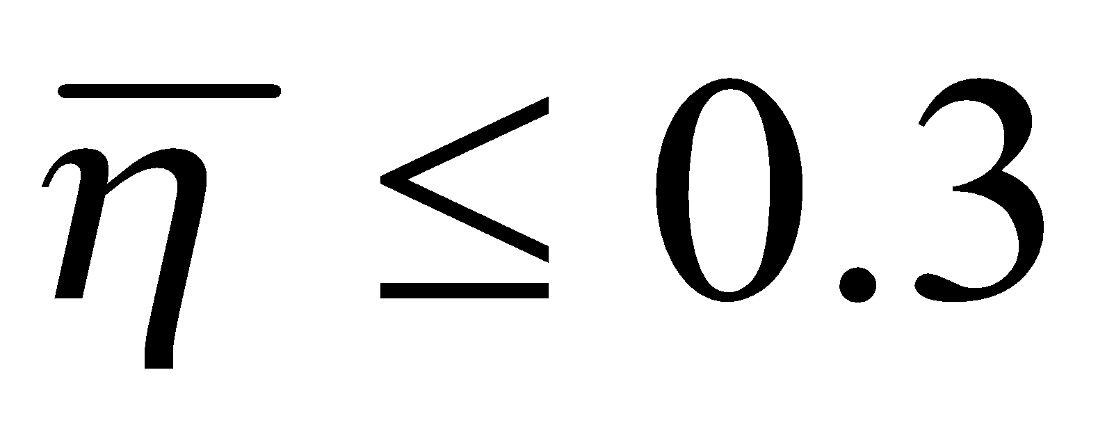аралығын қамтиды, мұндағы өзгеріс кедергінің күрт өзгеруіне әкеледі. Екінші бөлім 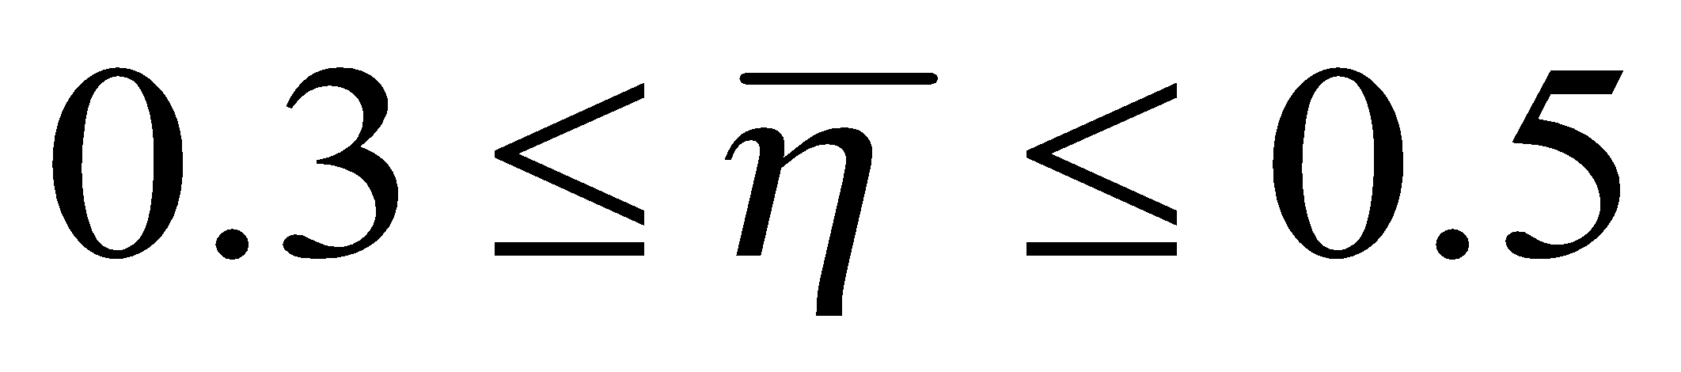аралығын қамтиды, мұнда әсер айтарлықтай. Соңында, 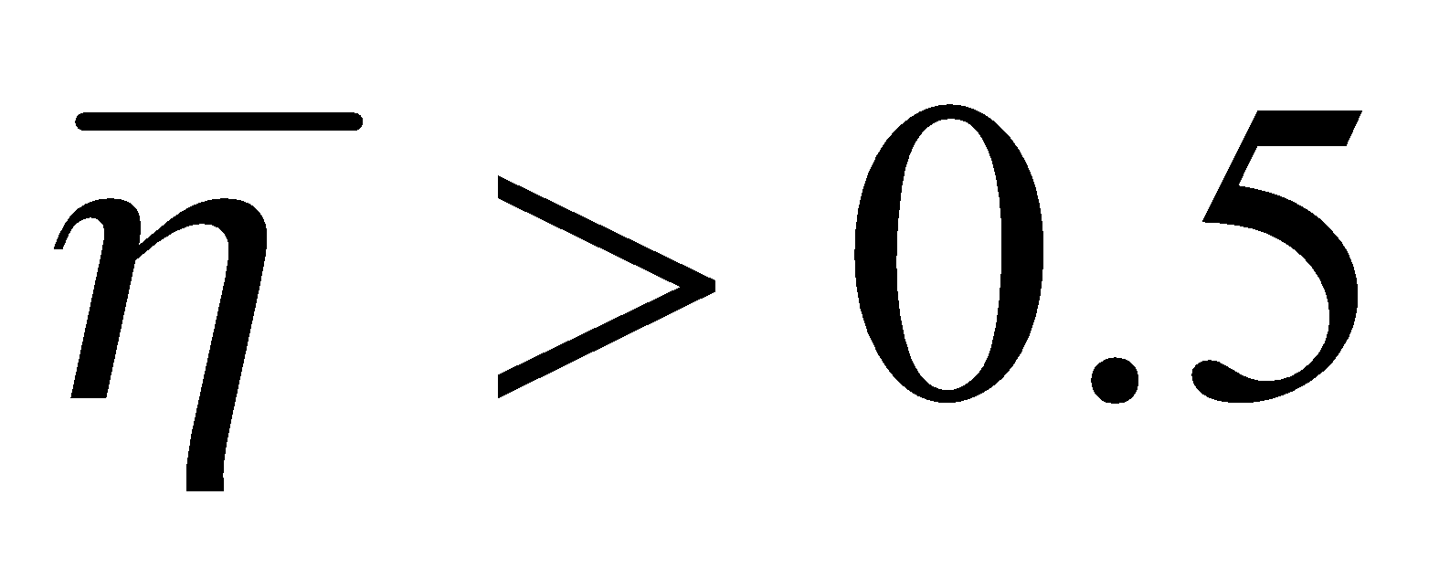аралығында, ашылуосі бойымен анизотропты өткізгіштігі бар қабаттағы көлденең ұңғымаға сұйықтық ағынының мөлшеріне аз әсер етеді.
Әрі қарай, жоғарыда қарастырылған процесс зерттеледі, бірақ ось бойымен өткізгіштігі анизотропты “”қабатта. Мұнда сүзу кедергісі салыстырмалы түрде, 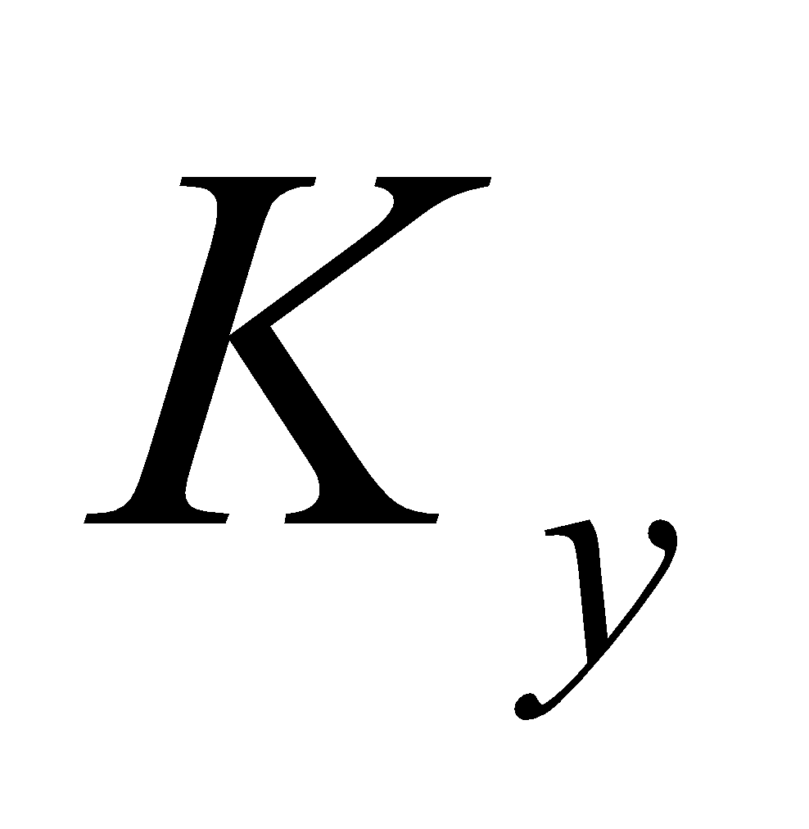кезіндегі кедергінің біртекті түзілімнің кедергісіне қатынасы ретінде беріледі (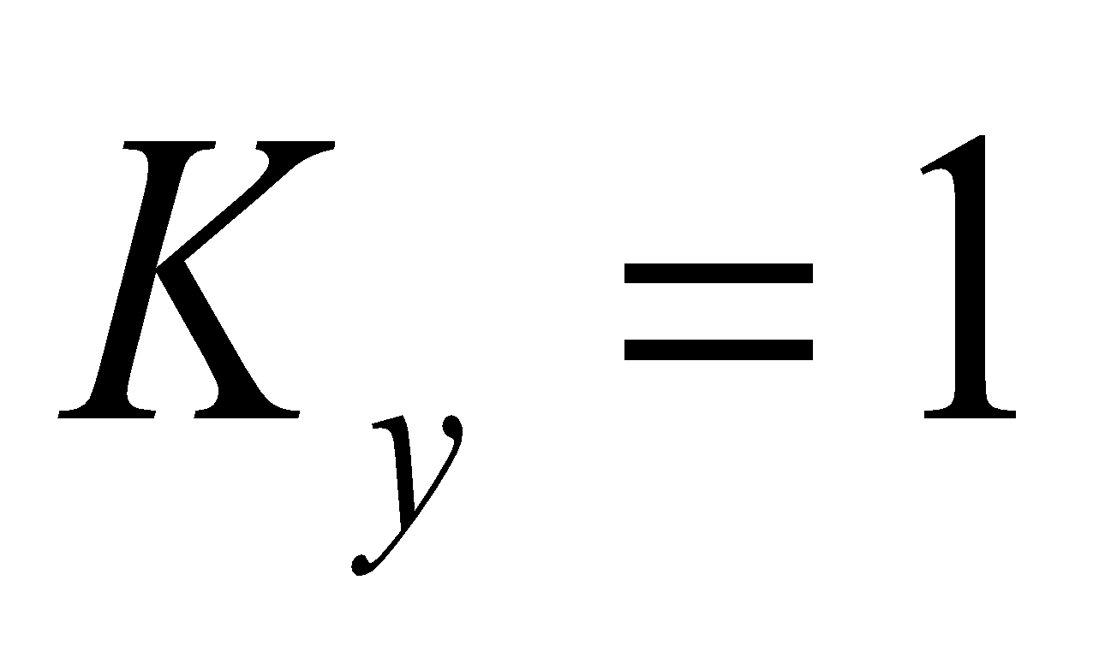). Зерттеу барысында. бір сипатты жағдай, қабаттың толық ашылуымен, қарамастан, өзгергіштігінің әсері жоғалады. Жалпы, ізденіс кезінде деректерін салыстыра отырып, қарастырылып отырған процеске әсері өткізгіштігі бойынша анизотропияның басқа түрлеріне қарағанда әлдеқайда аз екенін көруге болады. Жүргізілген зерттеулер барысында қабаттың оның бүйірлік шекараларына қатысты симметриялы ашылуы бар көлденең ұңғыманың жұмысына анизотропияның әсері зерттелді. Бұл мақалада сол тапсырма қарастырылады, бірақ қабаттың асимметриялық ашылуы үшін. Бұл зерттеуде асимметрияның шекті дәрежесін талданды, онда сүзгі ағынының басталуы координаттар жүйесінің басталуымен сәйкес келеді, яғни x=0x = 0x=0 координаты бар қабат элементінің бүйір беті. Алынған нәтижелерді симметриялы ашуға арналған есептеу деректерімен салыстыру симметриялы емес ашу кезінде анизотропияның фильтрация процесіне әсері симметриялық жағдайға қарағанда әлдеқайда күштірек көрінетінін көрсетті.
Жалпы, 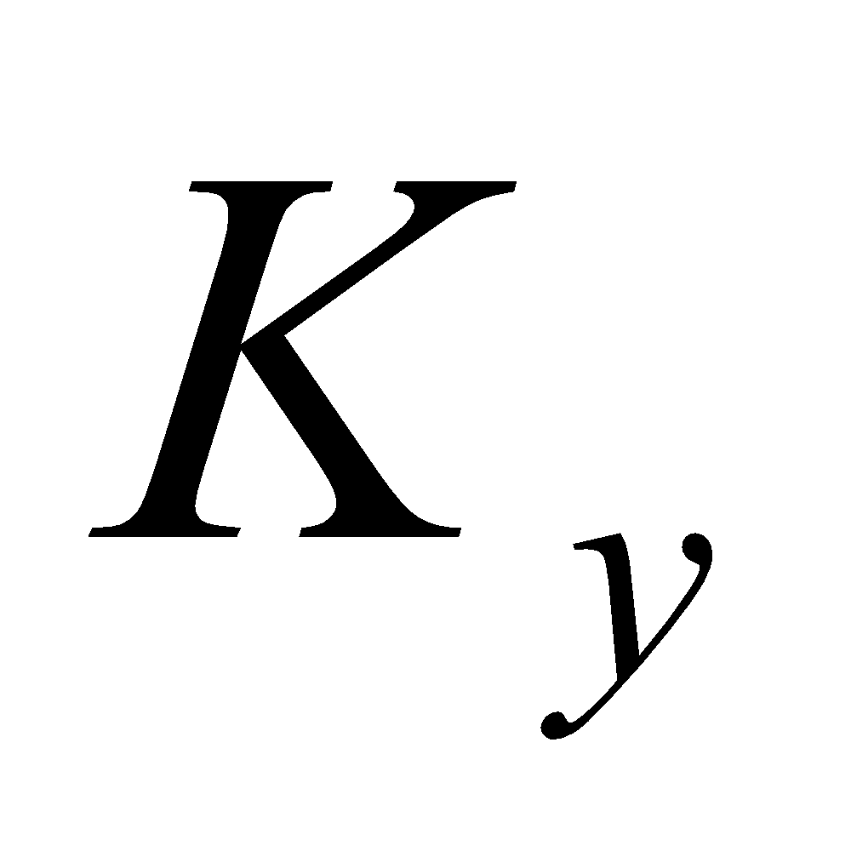 әсері, бұрынғыдай, басқа екі бағыттағы анизотропияларға қарағанда аз.
Жүргізілген зерттеулер барысында қабаттың ашылуының симметрия дәрежесінің көлденең ұңғыма ағынының сүзілу кедергісіне әсері анықталды. Алынған тәуелділіктер симметриялық кедергіге асимметриялық ашу кезіндегі қарсылықтың қатынасы ретінде берілген. Осылайша, есептелген мәндердің әрқайсысы симметриялық жағдаймен салыстырғанда асимметриялық ашу кезінде көлденең ұңғымаға ағын гидродинамикалық кедергісінің жоғарылау дәрежесін көрсетеді. Жалпы алғанда, анизотропияның әртүрлі дәрежелерінде, сондай-ақ осы параметрлердің шекті мәндерінде қарастырылған шарттарда асимметриялық ашылу әсері +36%-дан -10% аралығында өзгерді. Оң мәндер көлденең көлденең ұңғыма оқпанының қабат шатырына қарай жылжыған кезде кедергі жоғарылауын сипаттайды, ал теріс мәндер түбіне қарай жылжу кезінде оның төмендеуін сипаттайды. Бұл ағынды желілерінің қайта бөлінуіне және қабаттың қабырғаларына жақын қысым градиентінің өзгеруіне байланысты, бұл дренаж аймағының пішініне және ұңғыманың тиімділігіне айтарлықтай әсер етеді.
Қорытынды: Анизотропты өткізгіштігі бар жолақ тәрізді қабатқа енген көлденең ұңғыманың өнімділігін сұйықтықты үш өлшемді сүзгілеу кезінде оның өту дәрежесін ескере отырып анықтау үшін есептеу әдісі ұсынылады. Көлденең ұңғыманың өнімділігі ашу дәрежесі мен симметриясына, сондай-ақ қабат өткізгіштігінің анизотропиясына айтарлықтай тәуелді екені анықталды. Ақырғы изотропты және анизотропты деформацияланатын қабаттағы горизонталь ұңғымаға ағынның әзірленген математикалық моделі сүзу процестерін неғұрлым дәл сипаттауды қамтамасыз ететін гидродинамикалық және геомеханикалық факторлардың өзара әсерін ескереді. Жыныстардың деформациялануы дебитке айтарлықтай әсер ететіні көрсетілген: коллектордың қысылуының жоғарылауымен ұңғыманың өнімділігі қабаттың қасиеттеріне байланысты 21,6%-ға дейін төмендеуі мүмкін. Көлденең ұңғыма оқпанының оңтайлы гидродинамикалық жағдайы - бұл ағынға кедергі ең аз және ең жоғары дебит қамтамасыз етілетін қабаттың симметриялы ашылуы. Анизотропия мен деформацияның бірлескен әсері дебиттің өткізгіштікке сызықтық емес тәуелділігіне әкеледі, бірақ ағынның негізгі сапалық заңдылықтары сақталады. Алынған аналитикалық тәуелділіктер мен графоталдау қатынастары көлденең ұңғымалардың жобалық параметрлерін оңтайландыру және пайдаланудың әртүрлі кезеңдерінде кен орындарын игеруге техникалық-экономикалық бағалау жүргізу үшін пайдаланылуы мүмкін.

Әдебиеттер

- Sun E., Yang W., Peng Q., Meng P., Mu S. The Productivity Model of Horizontal Well Considering Acidification Effect in Anisotropic Reservoirs//of Engineering and Technology.- 2020.-Vol.8(1).-P.19-32. DOI 10.4236/wjet.2020.81003.
- Roland I Nwonodi. A novel model for predicting the productivity index of horizontal/vertical wells based on Darcy's law, drainage radius, and flow convergence // Heliyon. -2024.-Vil.10(13): e25073. DOI 10.1016/j.heliyon.2024.e25073.
- Xinyang Guo, Shiging Cheng, Wenpreng Bai, Dingning Cai, Zexuan Xu, Yang Wang Productivity Prediction of Multilateral Horizontal Wells in Low-Permeability Gas Reservoirs Under Two-Phase Flow Conditions // Available to Purchase. Paper presented at the 58th U.S. Rock Mechanics/Geomechanics Symposium, Golden, Colorado, USA, June 2024.Paper Number: ARMA-P.0185. DOI 10.56952/ARMA-2024-0185.
4. Корепанов С.К. Прогнозирование размещения горизантальных и наклонно направленных скважин в зависимости от особенности геологического строения низкопрницаемого пласта ЮС-2// Недропользование. - 2024. - Т.24(4).- С.186-193. DOI 10.15593/2712-8008.2024.4.2.
5.Мухаметгалиев И.Д. Развитие технологий и технических средств бурения наклонно-направленных и горизонтальных скважин//Инфра-Инженерия. - 2024.-108 с. ISBN 978-5-9729-1737-2.
6. Wenqi Ke et al. A Transient Productivity Prediction Model for Horizontal Wells Coupled with Oil and Gas Two-Phase Seepage and Wellbore Flow//Processes.-2023.-Vol.11(7).-P.1-22. DOI 10.3390/pr11112012.
7. Попов И.П.,Томилов А.А, Казанцев Г.В., Инновационные технологии разработки нефтяных и газовых месторождений // Тюменский государственный нефтегазовый университет // Нефтепромысловое дело. - 2015. - №7. - С.19-22.
8. Li L., Xie M., Liu W., Dai J., Feng S., Luo D., Wang K., Gao Y., Huang R. A New Productivity Evaluation Method for Horizontal Wells in Offshore Low-Permeability Reservoir Based on Modified Theoretical Model//Processes. -2024.- Vol.12(12):2830. DOI 10.3390/pr12122830.
9. Шаяхметова Ж.Б., Бисенгалиев М.Д., Тулегенова О.Ш., Каримова А.С. Исследование стационарного притока к горизонтальной скважине в деформируемом коллекторе // Нефть и газ. - 2025. - № 3(147).- С.188-199.DOI: 10.37878/2708-0080/2025-3.19.

References
1. Sun E., Yang W., Peng Q., Meng P., Mu S. The Productivity Model of Horizontal Well Considering Acidification Effect in Anisotropic Reservoirs//of Engineering and Technology.- 2020.-Vol.8(1).-P.19-32. DOI 10.4236/wjet.2020.81003.
2. Roland I Nwonodi. A novel model for predicting the productivity index of horizontal/vertical wells based on Darcy's law, drainage radius, and flow convergence // Heliyon. -2024.-Vil.10(13): e25073. DOI 10.1016/j.heliyon.2024.e25073.
3. Xinyang Guo, Shiging Cheng, Wenpreng Bai, Dingning Cai, Zexuan Xu, Yang Wang Productivity Prediction of Multilateral Horizontal Wells in Low-Permeability Gas Reservoirs Under Two-Phase Flow Conditions // Available to Purchase. Paper presented at the 58th U.S. Rock Mechanics/Geomechanics Symposium, Golden, Colorado, USA, June 2024.Paper Number: ARMA-P.0185. DOI 10.56952/ARMA-2024-0185.
4. Korepanov S.K. Prognozirovanie razmeshhenija gorizantal'nyh i naklonno napravlennyh skvazhin v zavisimosti ot osobennosti geologicheskogo stroenija nizkoprnicaemogo plasta JuS-2// Nedropol'zovanie. - 2024. - T.24(4).- S.186-193. DOI 10.15593/2712-8008.2024.4.2. [in Russian]
5.Muhametgaliev I.D. Razvitie tehnologij i tehnicheskih sredstv burenija naklonno-napravlennyh i gorizontal'nyh skvazhin//Infra-Inzhenerija. - 2024.-108 s. ISBN 978-5-9729-1737-2. [in Russian]
6. Wenqi Ke et al. A Transient Productivity Prediction Model for Horizontal Wells Coupled with Oil and Gas Two-Phase Seepage and Wellbore Flow//Processes.-2023.-Vol.11(7).-P.1-22. DOI 10.3390/pr11112012.
7. Popov I.P., Tomilov A.A., Kazancev G.V., Innovacionnye tehnologii razrabotki neftjanyh i gazovyh mestorozhdenij // Tjumenskij gosudarstvennyj neftegazovyj universitet // Neftepromyslovoe delo. - 2015. - №7. - S.19-22. [in Russian]
8. Li L., Xie M., Liu W., Dai J., Feng S., Luo D., Wang K., Gao Y., Huang R. A New Productivity Evaluation Method for Horizontal Wells in Offshore Low-Permeability Reservoir Based on Modified Theoretical Model//Processes. -2024.- Vol.12(12):2830. DOI 10.3390/pr12122830.
9. Shajahmetova Zh.B., Bisengaliev M.D., Tulegenova O.Sh., Karimova A.S. Issledovanie stacionarnogo pritoka k gorizontal'noj skvazhine v deformiruemom kollektore // Neft' i gaz. - 2025. - № 3(147).- S.188-199.DOI: 10.37878/2708-0080/2025-3.19. [in Russian]

Авторлар туралы мәлметтер

Бисенгалиев М.Д. - техника ғылымының кандидаты, профессор, С.Өтебаев атындағы Атырау мұнай және газ университеті, Атырау, Казахстан, e-mail: maks_bisengali@mail.ru;

Зайдемова Ж.К. - кандидат технических наук, профессор, С.Өтебаев атындағы Атырау мұнай және газ университеті, Атырау, Казахстан, e-mail:b.n.m.99@list.ru;

Шаяхметова Ж.Б. - техника ғылымының кандидаты, қауымдастырылған профессор, С.Өтебаев атындағы Атырау мұнай және газ университеті, Атырау, Казахстан, e-mail: zhanar6688@mail.ru;
Каримова А.С. - техника ғылымының кандидаты, қауымдастырылған профессор, С.Өтебаев атындағы Атырау мұнай және газ университеті, Атырау, Казахстан, e-mail: akmaral0167@mail.ru;
Имангалиева Г.Е. - техника ғылымының кандидаты, қауымдастырылған профессор, С.Өтебаев атындағы Атырау мұнай және газ университеті, Атырау, Казахстан, e-mail: gulnar-imangalieva@mail.ru;
Икласова Ж. - техника ғылымының кандидаты, ассоциированный профессор, С.Өтебаев атындағы Атырау мұнай және газ университеті, Атырау, Казахстан, e-mail: janna_ua@mail.ru.

Information about the authors

Bissengaliyev M.D. - Ph., professor, S. Utebaev Atyrau University of Oil and Gas, Atyrau, Kazakhstan, e-mail: maks_bisengali@mail.ru;
Zaidemova Zh.R. -Ph., Professor, S. Utebaev Atyrau University of Oil and Gas, Atyrau, Kazakhstan, e-mail: b.n.m.99@list.ru;
Shayakhmetova Zh.B.- Ph., Associate Professor, S.Utebaev Atyrau University of Oil and Gas, Atyrau, Kazakhstan, e-mail: zhanar6688@mail.ru;
Karimova A.S. - PhD, Associate Professor, S.Utebaev Atyrau University of Oil and Gas, e-mail: akmaral0167@mail.ru;
Imangalieva G.E.- Ph., Associate Professor, S.Utebaev Atyrau University of Oil and Gas, Atyrau, Kazakhstan, e-mail: gulnar-imangalieva@mail.ru;
Iklassova Zh.U. - Ph. Sci, Associate Professor, S.Utebaev Atyrau University of Oil and Gas, Atyrau, Kazakhstan, e-mail: janna_ua@mail.ru.

