Part 1

Query 1



Query 3

Query4

Query5

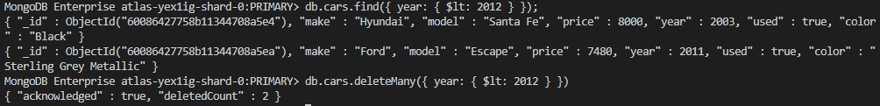

Query6



Query7

Part 2

