# 



GDD

1. Game Overview
   1. Game Concept

A single player clicker game. A monster is chasing humans.

1. Gameplay and Mechanics
   1. Gameplay

Click the humans to make them scream. Click upgrades to make your monster generate more screams from the humans.

* 1. Mechanics

Screams are calculated by the UI machine and pay for upgrades to the monster.

Upgrades use multipliers to increase click amount and clicks per second.

1. Story, Setting and Character
   1. Story and Narrative – 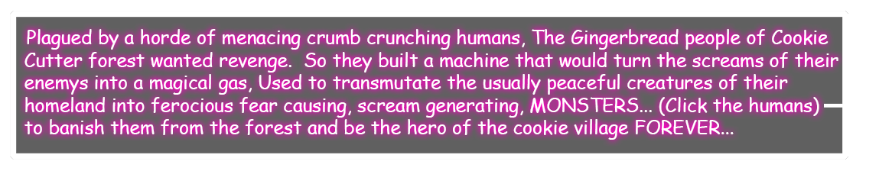

Game World

* + 1. Cookie Cutter forest,
    2. A village for Gingerbread people.
    3. Spooky trees.
    4. Magical forest.

1. Interface
   1. Visual System. The HUD is a flying machine that has a scream meter, buttons for upgrades and animations of moving parts
   2. Control System – The player controls the game by clicking on the humans and clicking on the HUD buttons for upgrades.
2. Game Art – The key assets are:

Parallax scrolling backgrounds .

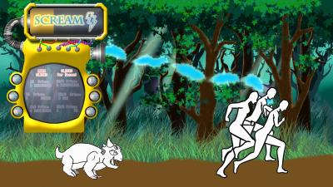

HUD Machine with flying animation and transparent screens.

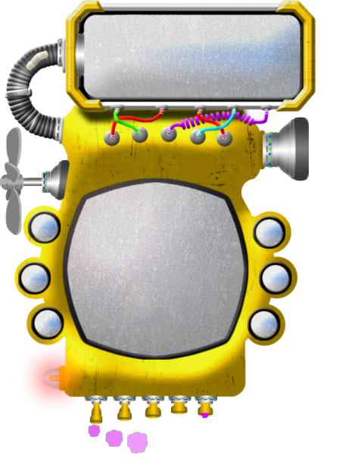

Monster Character with run animation.



Human Character with run animation.



Title And Credits menu screens

Title

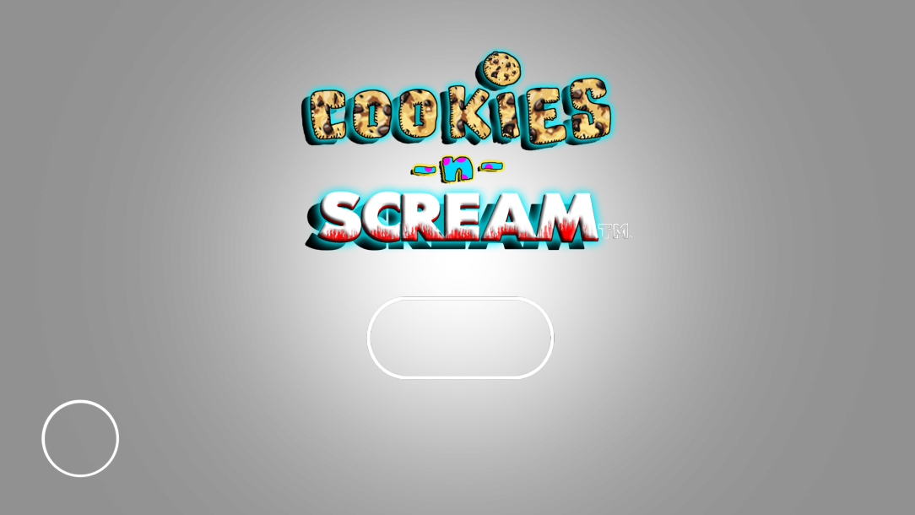

Credits

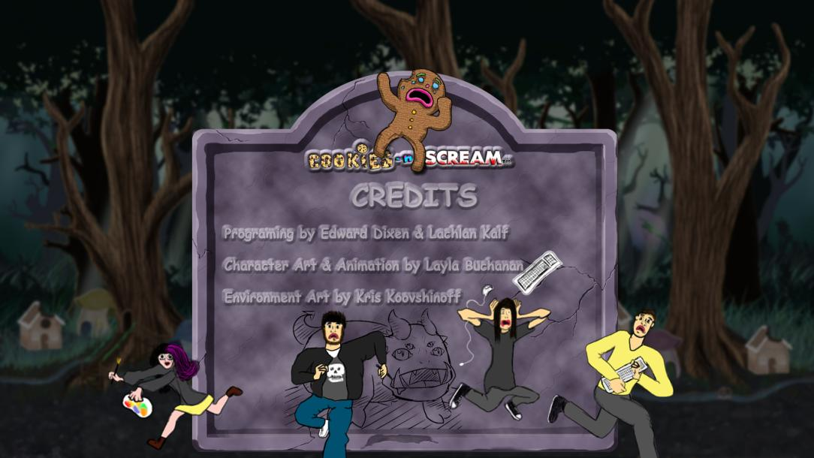

Buttons:

Play

Exit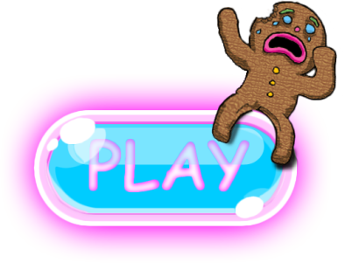

Credits