**Q2**

**For the enzyme reaction:**

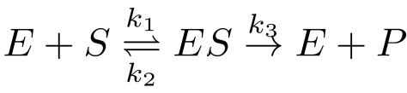

**8.1**

Using the law of mass action, we know that:

$$\left\{\begin{aligned}k_{1}= \frac{\left[ES\right]}{\left[E\right]\left[S\right]} \\ k_{2} = \frac{\left[E\right]\left[S\right]}{\left[ES\right]} \\ k_{3} = \frac{\left[E\right]\left[P\right]}{\left[ES\right]}\end{aligned}\right.$$

According to the rate law:

$$rate_{k_{1}}=k_{1}\left[E\right]\left[S\right]=\left[ES\right]$$

$$rate_{k_{2}}=k_{2}\left[ES\right]=\left[E\right]\left[S\right]$$

$$rate_{k_{3}}=k_{3}\left[ES\right]=\left[E\right]\left[P\right]$$

Then write **the rate of changes** using the rate law:

$$\frac{d\left[E\right]}{dt}=rate_{k_{2}}+rate_{k_{3}}-rate_{k_{1}}=k_{2}\left[ES\right]+k_{3}\left[ES\right]-k_{1}\left[E\right]\left[S\right]=\left[E\right]\left[S\right]+\left[E\right]\left[P\right]-\left[ES\right]$$

$$\frac{d\left[S\right]}{dt}=rate_{k_{2}}-rate_{k_{1}} =k_{2}\left[ES\right]-k_{1}\left[E\right]\left[S\right] =\left[E\right]\left[S\right]-\left[ES\right]$$

$$\frac{d\left[P\right]}{dt}=rate_{k_{3}} = k_{3}\left[ES\right] =\left[E\right][P]$$

$$\frac{d\left[ES\right]}{dt}=rate_{k_{1}}-rate_{k_{2}}-rate_{k_{3}}=k_{1}\left[E\right]\left[S\right]-k_{2}\left[ES\right]-k_{3}\left[ES\right]=\left[ES\right]-\left[E\right]\left[S\right]-\left[E\right]\left[P\right]$$

**8.2**

The code is written in the file “8_2 code.py”, and the running result is shown as below:

I also write a multi-thread program to simulate the enzyme reaction and do the validation. The running result is shown as below (the code is in “simulation.py”):

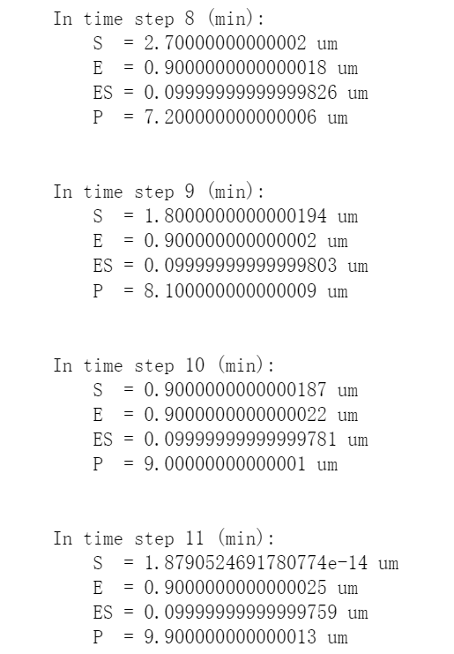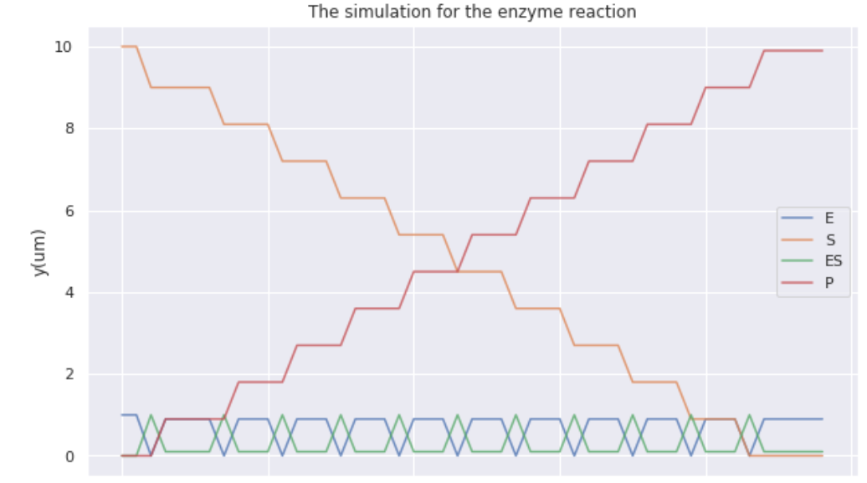

The reaction will reach balanced in the ${11}^{th}$ minute.