Honors Petition: Effects of Varying Manufacturing Settings and Materials on 3D Print Properties

Larsen M Hale
Liberty University
ENGR 330: Mechanics of Materials
Dr. Marcos Lugo
May 6, 2026

Testing Ideology 2
3D printing and Settings 2
Tensile Tests 3
Equipment 5
Testing Parameters 7
Results 9
Infill Styles 9
Infill Densities 10
Perimeter Number (Wall Thickness) 10
Material Selection 10
Practical Takeaways 11
Material Selection 11
Wall Thickness 12
Infill 12
Lessons Learned 12
References 14

Effects of Varying Manufacturing Settings and Materials on 3D Print Properties
3D printing becomes more relevant both to individual consumers and to the industrial manufacturing sector each year. As the long-standing stigmas against it—which caused many professionals to disregard it as relevant—fall away and it is used in a wider gamut of applications, it has become important for students and professionals alike to develop an understanding of the technology’s capabilities. Although I have used 3D printing extensively for some time, I felt it necessary to explore the limitations and effects of some vital print settings and the properties of available materials to make more efficient use of the resources at my disposal. Using the first portion of this class’s content led me to gain such an understanding by conducting an experimental stress-strain analysis of 3D-printed tensile test members in varying setting configurations.

Testing Ideology

3D printing and Settings
3D printing (or Additive Manufacturing) is a relatively new method of manufacturing. Fundamentally, it is any process of creating a part by joining material to itself rather than removing it. There exists significant variation in the mechanisms by which 3D printers accomplish this, but the most used 3D printing technology is FDM or Fused Deposition Modeling 3D printing. This is the process of drawing many stacked cross-sectional shapes of molten thermoplastic by way of a computer-controlled nozzle system. While a print can indeed be a simple stack of its solid cross-sections, that process takes exceedingly long and often provides unnecessarily over-kill properties, so the vast majority of 3D prints make use of something called infill, a 3-dimensional lattice structure which fills the bulk of the volume of a part. To maintain the structure, shape, and appearance of the part, the outer edges of each cross-section are outlined with a certain number of walls or perimeters, loops of plastic defining the outer edge of the part.

Figure 1
A diagram of the internal structure of 3D-printed parts
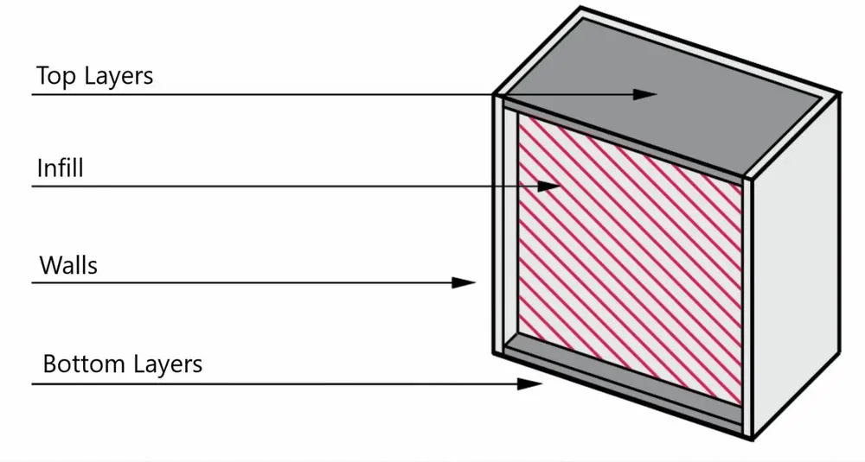
(Wall Thickness (3D Printing): How to Make It Perfect, 2023)

Tensile Tests
A simple method for learning the material properties of a specimen is the tensile test. Some mechanism exerts equal and opposite forces on either end of a member to place it in tension and, as the force is applied over time, measurements of the force and elongation of the member are made until the member fails. The force input is divided by the cross-sectional area at the beginning of the test to obtain engineering stress, and the elongation is divided by the gage length of the member to obtain strain. The two values are charted against one another in a graph, from which we can obtain all sorts of material properties.
Figure 2
A stress-strain graph of the tensile test for ABS Specimen 1
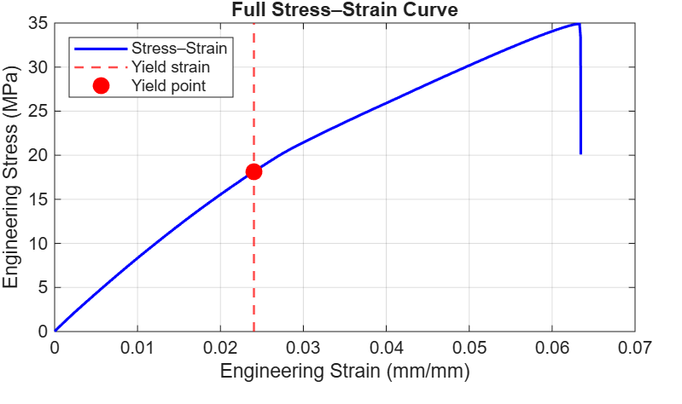

Several important properties can be taken from a graph like this. The ultimate tensile strength is the largest value of force that the member can withstand without breaking, and it corresponds to the highest value of engineering stress in the graph. The modulus of elasticity of a material is the amount of stress the material withstands relative to strain; the stress required to stretch it out to twice its original length. This tells us how difficult or easy it is to bend or stretch the material, and it is represented by the slope of the line left of the yield point, as seen in Figure 2. The modulus of resilience of a material is the quality of how much impact it can withstand without permanently deforming (or yielding). This is quantified as the area beneath the stress-strain curve from 0 strain to the yield strain. It effectively represents the ‘springiness’ of a material—its ability to bend and come back to normal.
There are several engineering standards for tensile testing plastic. This research endeavor followed the guidelines of ASTM D638, specifically using its dimensions for a dog-bone style tensile test member (Type-1).
Figure 3
The 3D-modeled Type-1 sample which was used to manufacture all specimens tested.
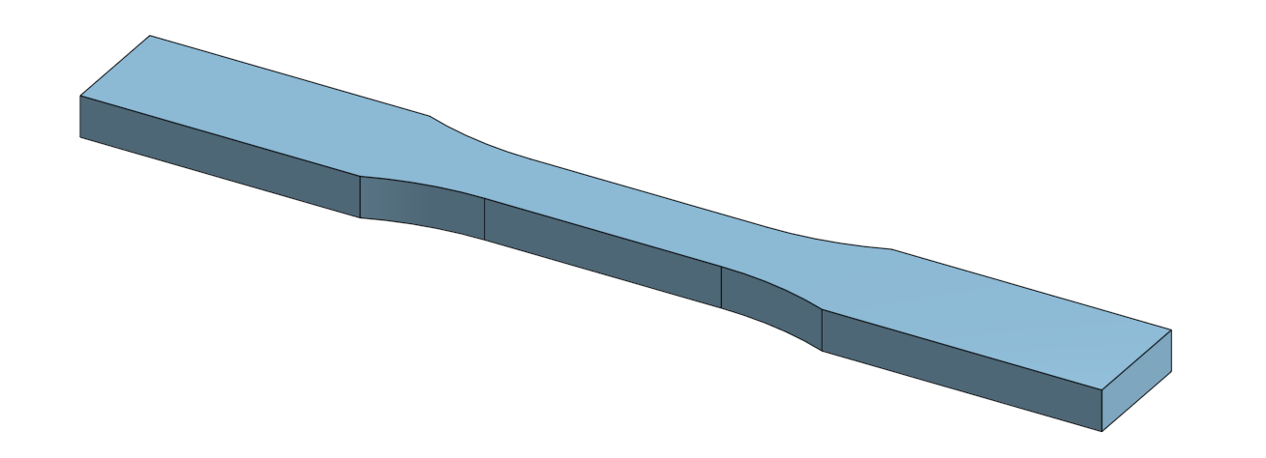

Equipment
To test these important material qualities and become a more informed user of 3D-printing technology, I tested 3D-printed and tensile tested 45 different specimens using Liberty University’s School of Engineering research equipment.

Demoss 3D Print Lab
To manufacture all of the test specimens, I made use of the Demoss 3D-Print Lab. The lab used Bambulab model P1S 3D printers with hardened steel nozzles and their own material printing settings to make sure that the parts printed consistently. This process took over a month and a half to complete and was one of a few bottlenecks to the timing of this research. The team was very helpful, categorizing the parts by marking them with the material they were made from with a marker and keeping things very organized.

Instron Tensile Testing Machine
At the university’s Center for Engineering Research and Education (CERE), students have access to an Instron 5982 Universal Testing Machine. The machine is simple but powerful; driven by strong motors in its base, it can raise or lower a cross-member within its large frame and measure how far the cross member travels, as well as the tensile or compressive force being applied to the instruments which can be installed in its base and on its cross-member. It can very precisely take measurements of these inputs (force and displacement) and track them to perform a variety of tests based on which instruments the user installs on the machine. In this instance, a set of vice-grip-like jaws were set in place on the cross-member and base to firmly hold on to either end of the tensile specimens as the machine tore them asunder. Data is tracked and neatly organized by the built-in software and exported in PDF and excel .csv files for later processing.

Processing Software—MATLAB
While the Instron Universal Testing Machine is very capable, its software in the simple manner that I used it does not process the stress-strain data any further than neatly organizing the force and displacement of the specimen over time, so post-processing of the data was necessary to firstly organize and secondly better understand the results of the experimentation. To handle the first part of this processing, I enlisted the help of the Claude Sonnet 4.6 AI model to collaboratively create a MALAB live script capable of reading one of the .CSV files generated by the Instron and calculate the desired values (Ultimate Tensile Strength, Modulus of Resilience, etc.) for each specimen’s data. This process went exceedingly well and, with only a few iterations and corrections to the AI’s assumptions for how to handle certain data, we created an elegant and fast-running program to calculate and chart all the values I tested.
The software uses several interesting techniques, but among the most important is the 0.2% offset, a common practice in materials science and engineering to determine the yield stress of a stress-strain test. After calculating the slope of the elastic region of the data, a second line is drawn next to the true curve, offset by a strain value of 0.002 (0.2%) and at the same slope as the elastic region. Where the straight line meets the true stress-strain curve is the yield point, where the material—if stretched any further—would not return to its original state from being stretched but rather be permanently deformed.
Figure 4
A stress-strain graph of ABS Specimen 1 with a superimposed 0.2% offset line.
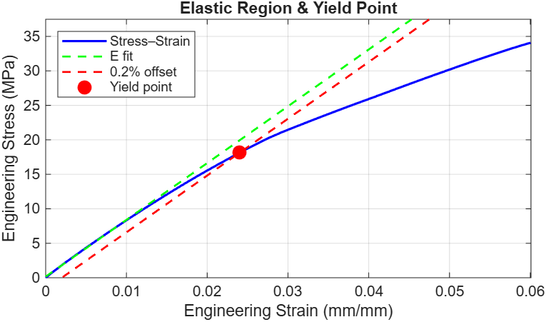
Finding the yield strength also lets us calculate the modulus of resilience, giving us even more of an understanding of the specimen’s behavior.

Testing Parameters
The experimental procedure defined, we now explore what properties of 3D printed parts there are to change and discover the trends within. With the many aspects of 3D printing often being an overwhelming introduction to the use of the technology, I sought to choose the most widely applicable variables with the greatest effect on most prints.

Materials
There are hundreds of FDM-3D-Printable materials available to consumers, but a very small number of them make up a huge portion of the materials used worldwide. Among the 3 most used materials are ABS, PLA, and PETG plastic. Each of these are widely available thermoplastics although, while ABS and PETG (and especially its cousin PET) have been used for decades in things like LEGO building bricks and plastic beverage bottles, PLA plastic has only really been popularized as a material since it was discovered to be so favorable for 3D printing because of how easy it is to print neatly. Selecting the right material for a part can, at times, be as important as the original design of the part and the other settings applied to the print. I selected these three filaments for testing because they are so important to the market and are available for student use in the Demoss 3D printing Lab.

Setting selections and index values
Most 3D-slicing software (programs which turn 3D CAD files into instructions for a 3D printer to follow and construct the part) come equipped with dozens of settings. Many of these settings change only very high-level or niche behaviors in the construction of a part and are, over time, becoming more obscured from the user as certain settings become ‘givens’, but infill, perimeters (or walls), and material are relevant enough to each part that they are almost universally known and changed print-to-print; they are the most important settings to understand.
To properly test the effects of changing these values, I decided on 15 different configurations of settings to be applied to all three materials, giving me 45 specimens to print, test, and analyze. I gave these setting configurations each their own index number, and their properties are as follows:
Table 1
A table of the index values of the specimens and their printing properties
Index Value | Infill Type | Infill Concentration | Index Value | Infill Type | Infill Concentration | Index Value | Infill Type | Infill Concentration
1 | N/a | 100% | 6 | Cubic | 10% | 11 | Grid | 25%
2 | N/a | 0% | 7 | Cubic | 25% | 12 | Cubic | 10%
3 | N/a | 0% | 8 | Gyroid | 10% | 13 | Cubic | 25%
4 | Grid | 10% | 9 | Gyroid | 25% | 14 | Gyroid | 10%
5 | Grid | 25% | 10 | Grid | 10% | 15 | Gyroid | 25%
The first three index values are more conceptual as tests. Index 1 should be an analog to a non-3D printed part which can help us to assess how much using 3D printing can weaken the material compared to other manufacturing methods. Indexes 2 and 3 test the direct impact of only the perimeter thickness on the part’s properties by excluding the infill from the print. The rest of the values test different combinations of the lattice structure used to generate the infill and the density of the infill within the part, along with the thickness of the perimeter of the part. Since the settings for perimeters do not change the thickness of the top and bottom of a part, I was sure to make the top and bottom thickness of the print (see Figure 1) the same as the perimeter thickness to ensure that the part was uniform throughout.

Speed of Testing
During testing, it was discovered that the operating speed of the Universal Testing Machine can have a slight impact on the manner of failure of certain specimens. As this experimental procedure is somewhat crude, tests were not repeated for consistency, but the properties observed during testing are only very minimally affected by the mode of failure of the specimens and analysis of failure is outside the scope both of Mechanics of Materials and this particular research project, so the data is assumed to be accurate and sufficient for the goal of this research: to inform the reader of how selecting settings for 3D prints affects their parts. Once this behavior was observed, all subsequent tests (approximately 70% of them) were made with a speed of 5 mm / minute.

Results

Infill Styles
Three styles of infill were tested in this experiment: Grid, Cubic, and Gyroid. Grid infill is what it sounds like: after drawing the outline of the cross-sectional area of the part, the rest of the part is filled in with a straight, square grid. Cubic is similar but extended into the third dimension; the lines drawn on each layer ultimately stack into a 3D tiling of uniform cubes. Gyroid is also a 3D lattice, but it is made of a stacked series of sinusoidal curves which interweave to support a part in every direction evenly.
There was little variation in the Ultimate Tensile Strengths (UTSs), Modulus’s of Elasticity (MoEs), Modulus’s of Resilience (MoRs), and Yield Strengths (YSs) of the specimens tested based on which infill style was used. Of the three, Cubic infill had the highest average value for all three of these metrics.

Infill Densities
Much like the small variation seen between styles, different density of infill (measured in percentage; the volume filled with the infill lines) had little effect on the UTS and MoE of the specimens. The values for UTS and MoE increased with the infill percentage at a rate explainable by the increased cross-sectional area of the inner volume, since more material to stretch means a more difficult task in stretching. This said, both the MoR and YS of each specimen were greater with a greater infill density.

Perimeter Number (Wall Thickness)
Increasing the thickness of the perimeter of the print causes an increase in all of the properties measured in this testing. UTS and MoE were both about 25% greater in prints with 3 perimeters (a 1.8mm wall thickness) than in prints with 2 perimeters (1.2 mm thick walls). YS saw only a small change with 3 perimeters, being only about 15% greater, while the average MoR was nearly identical.

Material Selection
Material Selection saw the greatest variation in the properties of the specimens of any factor tested. This was to be expected but nonetheless highlights the importance of the engineering skill of materials science and of exploring the materials available to create a part. Of the three filament types tested (ABS, PLA, and PETG), PLA had the greatest UTS, MoE, and YS, while PETG had the greatest MoR. In the case of MoE, PLA had an average value of 428 MPa, 44% higher than the lowest average: PETG with 240.17 MPa.

Practical Takeaways
3D printing has increasingly clear importance to many areas of the Engineering industry and knowing how to use it well as a student will prepare any engineer to be better equipped to solve the real-world problems we work and serve to fix. This research has better informed my understanding of many important factors to consider when preparing a part to be 3D printed.

Material Selection
This is the most influential selection to make for any 3D printed part. Lots of the advantages of 3D printing technology come from the ability to use it in such diverse applications, but in the same way the advent of 3D printing actually invites brand new technologies and exploration of obscure ones because of the way that it allows engineers to approach the same problems from new angles. An especially important example of the usefulness of 3D printing to influence new designs is the expanded use of compliant mechanisms: mechanisms which rely on the elastic deformation of one or several of the parts to repeatedly function. For this reason, a material like PETG which has a higher Modulus of Resilience once 3D printed is desirable because it can more comfortably deal with being deformed over and over. I have personally made use of this property of PETG with something I use every day: my wallet, which uses a compliant mechanism by bending around and compressing my cards and cash in place.
Figure 5
A single-piece wallet/money clip holding several cards in place by the force from elastically deforming it.
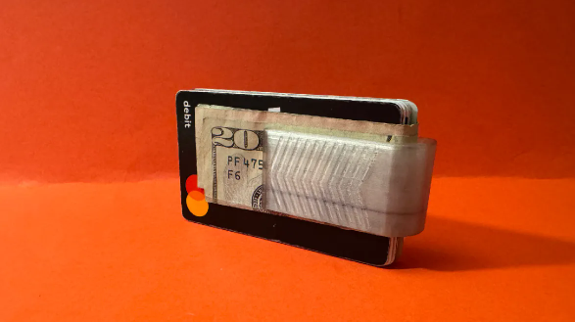
With the experimental data in mind, we can infer that it is good to use PLA for applications where rigidity and stability are important, but not for things which experience much impact, as its MoR is fairly low. Along the same lines, we can tell that ABS works well as a middle-ground between PLA and PETG in terms of its properties since it lies between the two on average. There are, of course, other factors important to the selection of materials, such as the glass point or melting point of the plastic, but this testing does not do well to inform us of those factors.

Wall Thickness
Wall thickness is a simple way to bump up the strength of a part. Since many of the forces applied to most parts create concentrated stresses on the surfaces of the part, it is important that the area there has enough material to support the higher stresses without causing the part to fail. For small parts especially, perimeters have a greater effect on the structure of the part, as the smaller the surface area-to-volume ratio is, the more volume of the part is next to the perimeters and thus filled by the wall thickness and not infill. There are also important aesthetic reasons to have 3 or more walls, as it makes the part less transparent which can, at times, be desirable and gives the part a uniquely ‘quality’ feel.

Infill
Infill has less of an effect on the strength and general properties of a print than many members of the 3D printing community tend to lend it. Generally, selecting cubic infill and using only as much as seems necessary to support the outside surface of a print is enough to fulfill the needs of many parts which can be 3D printed.

Lessons Learned
The process of putting this research together has been incredibly challenging and rewarding. Things not mentioned which brought about the difficulty of this assignment include the shutting down of the required equipment for most of the semester, the need to be trained on the use of the Instron Universal Testing Machine, and the need for collaboration with some friends of mine to be able to conduct the research in a safe and efficient manner. Ultimately, this project has taught me how to be a better student, grow as an engineer, and work professionally with setbacks which came up along the way, all of which I am very humbled to have been taught so well.
From an engineering perspective, the scientific truth that nothing is as simple as it seems rings true constantly throughout this research process. One lesson in particular which I hope to take into the future is the establishment of all testing procedures before any testing occurs. This was a lesson I learned from my inconsistency with the testing speed; had I tested for a good speed and used it for all the specimens, the data may have revealed some trends that I otherwise have missed due to error in my testing. I would love to redo or expand on this research in the future, so that is certainly something I would be interested in nailing down.
It is second nature to most to assume that ‘plastic is plastic’ or that something like the infill of a part would ‘obviously’ have an outsized effect, but learning from experience in this manner would help any engineer to better use their tools and more effectively help the world. I believe firmly that the ultimate purpose of engineering is to use the hard work and accumulated knowledge of the people who have come before us to improve the lives of our peers and those who will come after us. I am pleased to think that 3D printing is a tool which will—soon and quickly—spread out this practice so that many more people can learn, grow, and share ideas to make the world an ever better reflection of the love we are called to share with one another. Having examined the parameters and properties tested in this research and come to conclusions which advance the use of 3D printing makes me proud to say that I’ve contributed to that goal.

References
Wall Thickness (3D Printing): How to Make It Perfect. (2023, January 10). FacFox Docs. https://facfox.com/docs/kb/wall-thickness-3d-printing-how-to-make-it-perfect
‌

