Bellman Conservation Law-based Large-Scale Pedestrian Flow
Control via Passage Direction and Entrance-Rate Optimization in
Metropolitan Tourism Hotspots
Bingyu Wei, Cuiling Li, Rongyong Zhao, Zhengyang Shi, Yuxin Cai, and Lingchen Han

Abstract—Open scenic areas and large event venues can develop dense pedestrian flows that are hard to evaluate before an event. Existing practice still relies heavily on empirical rules and post-event review, which leaves limited support for comparing control plans before deployment. In these settings, managers mainly choose passage directions, such as one-way, bidirectional, or closed, and adjust time-varying entrance release rates. Existing models rarely optimize these two controls together. This paper develops a macroscopic crowd-control model based on the Hughes continuum framework. Local admissible direction sets represent one-way, bidirectional, and closed passages, while anisotropic mobility tensors encode channel-guidance effects. Internal channel entrance-rate controls are added so that one policy specifies both passage directions and release rates. We then solve the mixed discrete-continuous problem with a Hierarchical Constrained Mixed-variable Black-box Optimization (HCMBO) algorithm. In a simplified scenic-platform scenario, the model reproduces multi-stage movement, channel guidance, and direc- tion constraints. Under a weighted objective combining efficiency, safety exposure, load balance, waiting, and smoothness, HCMBO gives the lowest mean score within the tested budget. Its mean objective is about 3.9% lower than TPE-Mixed BO and lower than the other tested baselines. These results give a simulation- based basis for comparing routing and entrance-release strategies in open public spaces.
Index Terms—Crowd dynamics modeling, crowd flow control, mixed-variable black-box optimization.

I. INTRODUCTION

L
ARGE-SCALE crowd gatherings can threaten public safety when local congestion grows into a stampede risk [1], [2]. Holiday tourism, public events, and sports gatherings place short, intense pedestrian loads on core urban areas [3], [4], [5]. This motivates crowd-control models that can compare routing and entrance-release strategies before an event, rather than relying only on field experience and post-event review [6], [7].
Crowd motion at large events depends on individual speeds, destinations, route preferences, visible paths, obstacles, and density feedback [4], [8], [9]. At the aggregate level, these fac- tors appear as destination-oriented flow, passage convergence, bottleneck queuing, and responses to direction rules [10], [11]. In open scenic areas, visitors often move through stages: entering the site, touring along a main corridor, choosing lateral exit passages, and returning through lower streets [12]. Static capacity analysis and single shortest-path models do not
Bingyu Wei, Cuiling Li, Rongyong Zhao, Yuxin Cai, and Lingchen Han are with Tongji University, Shanghai, China.
Zhengyang Shi is with Huangpu Public Security Bureau, Shanghai, China.

capture these stage changes or the congestion shared across routes.
This study focuses on open scenic areas, waterfront sight- seeing platforms, and historic commercial districts, where pedestrian routes often remain open and partially reversible. Unlike enclosed venues such as stadiums and subway stations with well-defined boundaries [13], [14], such areas consist of open spaces, main tourist corridors, multiple lateral con- necting passages, and return flow lines. In these settings, visitors typically undergo a continuous behavioral chain of “entry–touring along the main corridor–choosing passages to leave–returning” [15]. Their movement is therefore governed jointly by spatial geometry, control regulations, and historical behavioral preferences [16]. Taking the Shanghai Nanjing East Road–Bund area as a concrete example, visitors approach the Bund from Nanjing East Road, ascend to the Bund sightseeing platform via multiple stepped passages, tour along the water- front, then exit through several southern passages and return along lower streets. This scenario can be abstracted as the typical “Bund sightseeing platform–multi-stepped passage” crowd flow scenario. Three operational issues follow from this layout. Direction settings on one passage can reorganize flow elsewhere. Behavioral transitions between the main tourist corridor and lateral passages make single origin–destination models insufficient. Local congestion and global route choice also feed back into each other, so a control change in one passage may redistribute loads in nearby areas.
Existing large-scale event security management practices typically integrate system dynamics, system coupling, and system safety theory, combined with high-risk zone delineation and historical crowd behavior patterns, to formulate a series of control measures [19], [20]. These measures include deploying security personnel at critical locations, erecting temporary barriers for isolation and diversion, implementing one-way organization on key passages, and applying batch release in core areas [21], [22]. For instance, during major holidays, the Shanghai Bund area adopts batch release, passage direction regulation, south-entry north-exit routing, and reduction of head-on conflicts [23]; similarly, Nanluoguxiang main street in Beijing implements one-way passage measures (south entry, north exit) during peak periods [24], consistent in control mechanism with the Shanghai Bund approach.
Current practice in high-pedestrian-flow urban areas still de- pends on manual experience and static contingency plans [25]. Many schemes do not quantify how passage direction, entrance capacity, and phase-dependent route preference change density

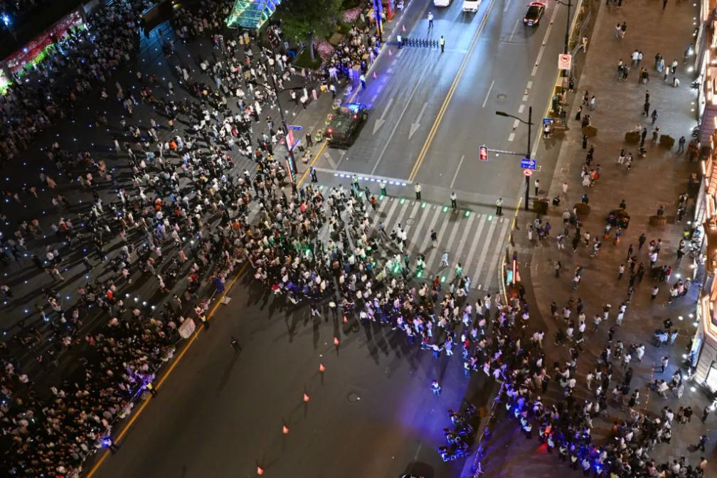
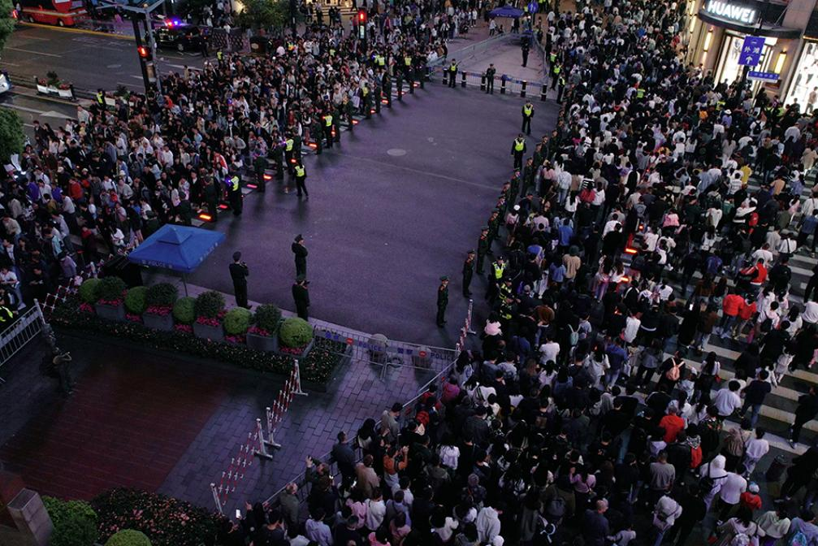
(a) (b)

Fig. 1. Field-control context of the Shanghai Nanjing East Road–Bund area. (a) Large-scale holiday crowd under one-way passage organization; image source:
[17]. (b) Entrance-capacity control at a main visitor inflow location; image source: [18].

evolution. Single-point statistics and local density monitoring make it hard to follow the coupling among direction rules, entrance metering, local optimal directions, density evolution, and exit-load distribution [26]. In open scenic areas, ignoring route preference and phase transition can misjudge passage load and high-risk locations. Simulation-optimization studies often treat the crowd model as a black-box evaluator, so the search does not use the structure in passage geometry, one- way rules, internal entrance capacities, or subpopulation routes [27], [28]. Existing work also rarely separates mechanism di- agnostics from strategy-level management objectives, although evacuation-model verification studies emphasize component- level testing and emergent-behavior validation [29].
We propose a macroscopic crowd modeling and control optimization framework for the “Bund sightseeing platform– multi-stepped passage” open scenic area scenario. The frame- work connects multi-stage pedestrian movement, passage di- rection management, geometric guidance, and entrance release control in one simulation-and-optimization workflow. It com- pares candidate strategies under limited simulation budgets, rather than relying only on empirical rules or post-event assessment.
This paper makes four contributions.
1) We formulate a multi-stage, multi-route macroscopic model for the open scenic-area class represented by the Bund sightseeing platform and its connected passages. Unlike single-origin–destination or single- potential Hughes-type formulations, the model lets entry, sightseeing, exit, return movement, and route redistribu- tion arise through shared congestion.
2) We develop a Bellman–conservation-law operator that combines hard direction rules, anisotropic mobility guid- ance, and internal entrance-rate metering. This uni- fied macroscopic operator represents one-way, two-way, and closed channels, channel pre-alignment, open-but- metered entrances, and upstream waiting under mass- consistent dynamics.
3) We establish an evaluation protocol that separates behavioral-mechanism diagnostics from strategy-level

management objectives. The protocol first checks whether direction constraints and geometric guidance behave as intended, and then compares policies by efficiency, high-density exposure, load balance, entrance waiting, and control smoothness.
4) We design a hierarchical constrained mixed-variable black-box optimization framework (HCMBO) for joint direction and entrance-rate control. The method exploits the direction–capacity structure and uses unified high- fidelity rechecking to compare candidate policies under the tested budget.
II. RELATED WORK
A. Massive Crowd Management and Control
Crowd management studies in urban centers have mainly used boundary regulation, facility layout, and decision-making models [30], [31]. Zhong et al. [32] designed boundary control strategies for urban traffic-flow networks and proved conver- gence to uncongested states under disturbances through Lya- punov analysis [33]. Wadoo and Kachroo [34] used advection and diffusion control to prevent blocking and shock waves in one-dimensional evacuation. Qin [35] proposed a unit sliding- mode controller based on integral barrier Lyapunov functions for multi-directional disturbance propagation. Zhu et al. [36] combined policy learning and neural networks to adjust inflow rates and free-flow speeds in heterogeneous corridors.
Infrastructure-based regulation has also been studied. Ob- stacle placement can change outflow, velocity, and local density in merging areas [25], [37]. Yang et al. [38], [39] used Model Predictive Control (MPC) to optimize barrier lengths at subway bottlenecks and later included entrance limiters, gates, and escalator directions. Carmona and Paricio- Garcia [40] proposed dynamic exit-choice recommendations using multinomial Logit models, but the approach depends on discrete speed instructions (e.g., “stop,” “walk,” “run”) transmitted through electronic wristbands [41], which are hard to deploy in open urban areas.
Other studies use optimization and reinforcement learning. Liao et al. [42] formulated fence layout as subset selection.

Subsequent work [28] used LSTM features and Proximal Policy Optimization (PPO) [43] for real-time entrance-flow regulation. Differential Evolution (DE) [44] has been used to optimize guardrail layout and flow guidance in scenarios such as Chengdu East Railway Station, with average travel time and crowd pressure as objectives [45].
B. Macroscopic Crowd Modeling
Macroscopic crowd models treat pedestrian flows as contin- uous media, offering computational efficiency and analytical tractability compared to microscopic approaches. Henderson [46] first applied fluid dynamics to pedestrian traffic in the early 1970s, comparing crowd motion to the behavior of gas or fluid particles.
Hughes [47] pioneered a first-order continuum theory for pedestrian flow, in which walking speed depends on local density through a fundamental diagram, and movement direc- tion follows the steepest-descent path of a potential function representing the remaining travel time to exits. The model links congestion and route choice through this potential. Ling et al. [48] generalized the Hughes formulation and solved it with a weighted essentially non-oscillatory (WENO) scheme for the conservation law and a fast-sweeping method for the eikonal equation.
Several extensions modify the density, perception, and con- straint terms in macroscopic models. Colombo et al. [49] proposed nonlocal flux models that replace pointwise den- sity with a neighborhood-averaged quantity in the velocity function to account for anticipatory behavior. Later work included anisotropic perception fields and wall or obstacle boundary effects, together with high-resolution schemes and well-posedness results for architectural domains [50]. Maury et al. [51] introduced a projection model for the hard in- compressibility constraint, formulating the actual velocity as a least-squares projection of the desired velocity onto the set of feasible non-overlapping configurations. The same idea was later recast as a Wasserstein gradient flow with density constraints [52], using the Jordan–Kinderlehrer–Otto (JKO) scheme [53] to keep density below its upper bound.
To overcome non-physical behaviors such as supersonic information propagation that may arise in first-order models, Aw and Rascle [54] introduced a second-order model based on a generalized momentum conservation law that preserves anisotropy. The Aw–Rascle (AR) framework was subsequently adapted to pedestrian flows [55], where the congestion pres- sure term successfully reproduces characteristic phenomena including stop-and-go waves and spontaneous lane formation.
Beyond the classical Hughes-type framework, extensions have incorporated control and guidance mechanisms relevant to crowd management. Anisotropic formulations using mobil- ity tensors have been developed to represent channel geome- tries and directional preferences [56], [57], allowing for con- tinuous geometric guidance without explicit prohibition. Con- strained Hamilton-Jacobi-Bellman (HJB) formulations have been employed to model strict directional constraints such as one-way corridors, with the Bellman optimality principle pro- viding a natural framework for unifying anisotropic geometric guidance with discrete directional constraints.

Despite these advances, existing approaches often treat control parameters as fixed or manually tuned. The joint optimization of discrete channel direction configurations and internal entrance capacity profiles remains underexplored, par- ticularly for large-scale urban pedestrian zones with multiple behavioral stages and heterogeneous route choices.

III. METHODOLOGY
A. Problem Definition and Overall Framework
We address a multi-channel crowd management problem in open scenic areas. The proposed method combines a Bellman– conservation-law crowd dynamics model [47], [48] with a joint direction-capacity control formulation. The controllable management variable is defined as
z = (s, q) ∈ Z, (1)
where s denotes the discrete direction states of the channels, and q denotes the time-varying internal entrance capacity pro- file. The behavioral preference parameter ˆ and the geometric guidance parameter η0 are treated as fixed model inputs. For a given control variable z, the lower-level simulator returns density fields, velocity fields, entrance waiting, and realized channel throughputs. The upper-level optimizer then evaluates efficiency, safety, load balance, waiting, and smoothness met- rics, and searches for a better control policy under a limited simulation budget. The overall method framework is shown in Fig. 2.
We model direction rules and entrance capacities as coupled controls. The direction configuration s changes the local feasible direction set, whereas the entrance capacity q changes the realized admitted flux at channel entrances. Together, they affect channel loading, high-density exposure, and upstream waiting. We therefore formulate crowd management as a mixed-variable simulation-based optimization problem, rather than solving direction selection and capacity assignment as two independent subproblems [28], [58], [59].

B. Bellman–Conservation-Law Crowd Dynamics
1) Conservation Law and Speed Function: We consider a bounded two-dimensional domain Ω ⊂ R2 representing the pedestrian walking area. Let Ωw ⊂ Ω denote the walkable region, ρ(x, t) the total crowd density, and v(x, t) the local mean velocity. Mass conservation is governed by
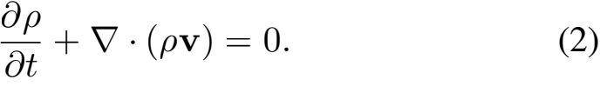
The speed magnitude is determined by local congestion. We adopt the Greenshields-type speed function
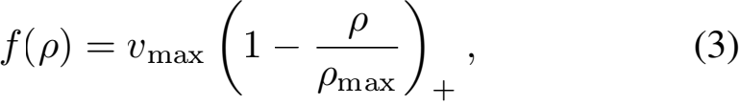
where vmax is the free-flow speed, ρmax is the maximum admissible density, and (·)+ denotes nonnegative truncation. This function captures the feedback that pedestrians move close to free-flow speed in low-density regions and slow down as density approaches congestion.






4
Direction
configuration s
+1: forward one-way
-1: reverse one-way 0: bidirectional
∅: closed
Entrance-rate
control q
Piecewise admissible rates
qc (t),qc— (t)

2. Control Variables
Joint control variable
z=(s ,q)

geometry

1. Scenario and
Model Params
Walkable domain
Ω w and channel

Obstacles and
internal entrances
Behavioral
preference p
Geometric
guidance
parameter η 0

Weighted objective
J = Σk=1 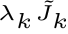

4. Performance
Evaluation
Efficiency J 1 travel time
Safety J2
density exposure
Load balance
J3=Var(Rc)
Waiting J4
Smoothness J5

select z∗

5. Upper-level HCMBO Optimizer
Feasible
1 dscatnids
 | 2 | Capacity map  q = Ts(x)
 | 3 Sx[0d,1]d
 | 4 simulit-ionell.
 | 5 | Final re-eval.
Best policy under
limited simulation
budget

3. Crowd Dynamics Simulator
Bellman-Conservation Solver S(z;p,η 0)
  A         | (a) Multi-stage / multi-route density de- composition  ρ = Σ o Σ r ρo,r  (b) Total density and speed update  Density-dependent speed f(ρ) decreases with ρ  (c) Direction constraints and guidance Allowed directions U(x;s)  Anisotropic metric M(x;η 0)  (d) Constrained Bellman equation  Compute potential and optimal direction  (e) Finite-volume conservation update Advance ρo,r using upwind fluxes  (f) Internal entrance flux control  Actual flux capped by qc (t)  Simulation Outputs   Density field ρ(x,t)  Potential field  ϕ(x,t)   Velocity field v(x,t)  Entrance wait  blocking B    Channel  throughput  Rc  (g) Stage transition update  Route switching governed by p
A
feedback update z = (s , q)
Fig. 2. Method framework for joint direction and entrance-rate optimization. Fixed scenario inputs, behavioral preferences, and geometric guidance parameters define the lower-level Bellman–conservation-law crowd simulator. The controllable direction configuration and entrance-rate profile are jointly evaluated by efficiency, safety, load-balance, waiting, and smoothness objectives, and are updated by the upper-level HCMBO optimizer.

The classical Hughes model assumes that all movement directions are feasible and isotropic [47]. This assumption is insufficient for crowd management scenarios involving one- way rules, temporary closures, entrance metering, and channel- axis alignment. The following subsections introduce admissi- ble direction sets, anisotropic mobility tensors, and internal entrance capacity control into the Bellman–conservation-law framework.
2) Multi-Stage Multi-Route Density Decomposition: Visi- tors in open scenic areas usually experience several behavioral stages, such as entry, touring, exit, and return. To represent this behavior chain, the total density is decomposed into stage– route subpopulations:
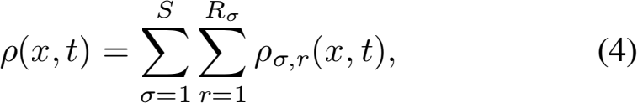
where σ denotes the behavioral stage and r denotes the route type within that stage. All subpopulations share the speed function f(ρ) determined by the total density, but they have different target regions, potential functions, and velocity directions.
For subpopulation (σ, r), the density evolves according to
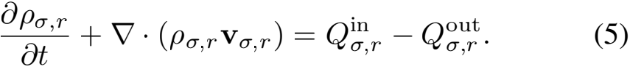
If pedestrians in subpopulation (σ, r) complete the current stage in target region Gσ,r and switch to next-stage route k with probability ˆ(σ,r)→k , the transition term is
Q(σ,r)→ (σ+1,k)(x, t) = ˆ(σ,r)→k κσ,r χGσ,r (x)ρσ,r (x, t), (6)
where κσ,r is the stage-switching rate, with dimension of inverse time, and χGσ,r is the indicator function of the

completion region. The parameter ˆ represents historically inferred or scenario-given route preferences and is fixed in the optimization problem [12], [15], [16].

C. Direction Constraints and Geometric Guidance

1) Direction Configuration Variable: Let the direction state
of channel c be
sc ∈ {+1, —1, 0, 。}, (7)
where +1, —1, 0, and 。 denote reference forward one-way, reference reverse one-way, bidirectional, and closed states, respectively. If τc (x) is the reference tangent direction of channel c, the local admissible direction set in the channel region is defined as
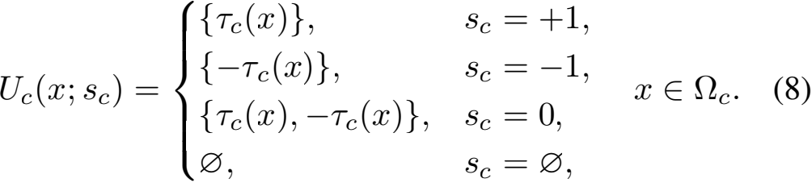
Thus, sc changes the local feasible direction set. A closed channel has no admissible direction, a one-way channel retains only one reference tangent, and a bidirectional channel retains both opposite tangential directions.
2) Anisotropic Mobility Tensor: The admissible set U(x;s) represents hard feasibility, but it does not capture the soft geometric guidance induced by narrow channels. Pedestrians approaching a channel often pre-align with the channel axis before entering it. To represent this effect, an anisotropic mo- bility tensor M(x;η0 ) is introduced [50], [56], [57]. Equiva- lently, it is the inverse of a local travel-cost metric. For channel

c, let τc and nc denote its tangent and normal directions. The mobility tensor is defined as
Mc (x;η0 ) = βc (η0 τc τc + nc nc) , η0 ≥ 1, (9)
where βc is a channel weight and η0 controls the mobility preference strength along the channel axis. Larger η0 increases tangential mobility, equivalently reducing the effective cost of tangential motion and promoting upstream pre-alignment. The parameter η0 is fixed and is not optimized as a control variable.
3) Constrained Bellman Equation: Given U(x;s) and M(x;η0 ), the potential function ϕ(x, t) represents the min- imum remaining cost to the corresponding target region. The discrete Bellman update is

The excess demand (Ac(t) — Ac(t))+ remains upstream
and is recorded as waiting or queueing mass. This treatment changes channel usage and risk distribution while preserving the mass balance of the conservation-law update.

E. Numerical Solver and Simulation Operator
The walkable region, obstacles, channel areas, and inter- nal entrance interfaces are discretized on a uniform two- dimensional grid. At each time step, the total density is first computed from all stage–route subpopulations and used to update f(ρ). For each subpopulation, the admissible direc- tion set and mobility tensor are then constructed, and the corresponding discrete Bellman equation is solved. After the

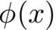 = u 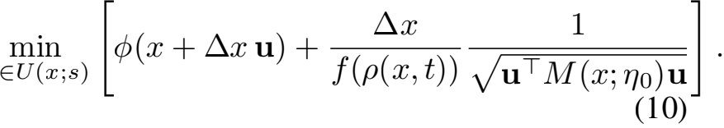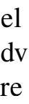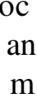i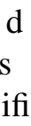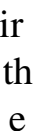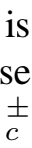r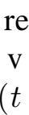i[]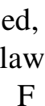in,al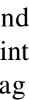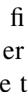s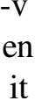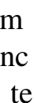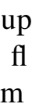
The optimal direction is applied to update the subpopulation densities.
For any feasible control variable z = (s, q), the complete

u* (x, t) = arg min(···), (11)
u∈U(x;s)
and the velocity is
v(x, t) = f(ρ(x, t))u* (x, t). (12)
For the multi-stage multi-route model, each subpopulation (σ, r) uses its own target-specific potential ϕσ,r while sharing the same total-density congestion feedback. Thus, direction rules, geometric guidance, and density-dependent congestion are coupled in a single Bellman–conservation-law model.

D. Internal Entrance Capacity Control
Direction rules alone cannot represent the management action in which a channel is open but its entrance must be metered [58], [59], [60]. For each channel, we introduce maximum internal entrance rates
q = {qc(t), qc— 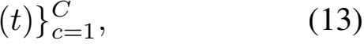
where qc(t) and qc— (t) denote the maximum admitted rates
at the reference forward and reverse entrances of channel c. These controls act on internal channel entrance fluxes rather than on external boundary inflows. In physical units, both
the attempted flux Ac(t) and the capacity bound qc(t) are
entrance flow rates measured in ped/s.
The direction state and entrance capacity must satisfy the hard consistency constraints
sc = +1 ⇒ qc— (t) = 0,
sc = —1 ⇒ qc(t) = 0,
(14)
sc = 。 ⇒ qc(t) = qc— (t) = 0, sc = 0 ⇒ qc(t) + qc— (t) ≤ q-c.
Let Ac(t) be the attempted entrance flux induced by free
movement. The actually admitted flux is
A c(t) = min{Ac(t), qc(t)}. (15)
When Ac(t) > 0, the flux across the internal entrance is
scaled by
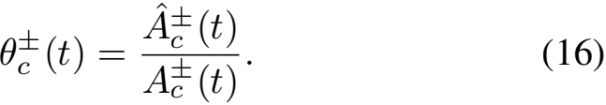

numerical workflow defines a lower-level simulation operator
(ρ,ϕ, v, B, R) = S(z;ˆ,η0 ), (17)
where B records entrance waiting or blocking and R = (R1,..., RC ) records realized cumulative throughputs of the channels. The channel balance metric below is computed from the realized throughputs Rc , not from the prescribed capacity
limits qc (t).
F. Evaluation Metrics and Optimization Objective
1) Efficiency, Safety, and Load Balance: Following re- cent passenger-flow-control and crowd-evacuation simulation- optimization studies [37], [40], [60], the total travel time metric is T
J1 (z) =  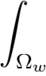 ρ(x, t) dx dt. (18)
The high-density exposure metric is
J2 (z) = 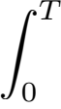 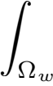 1ρ(x,t)>ρsafe dx dt. (19)
The safety threshold is the density above which exposure is counted, and is fixed at ρsafe = 3.5 ped/m2 in both the four- channel and Bund scenarios. Let
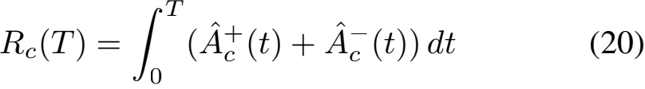
be the realized cumulative throughput of channel c. The channel load imbalance is
J3 (z) = Var(R1 (T),..., RC (T)). (21)

2) Entrance Waiting and Control Smoothness: Entrance waiting is penalized as
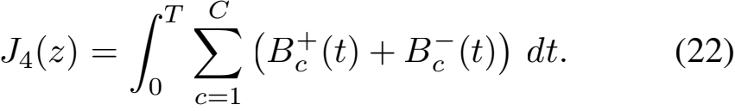
For piecewise-constant capacity profiles, smoothness is mea- sured by
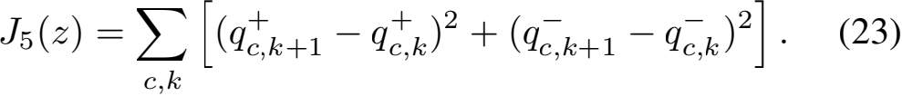

Here k indexes the capacity-control time segment. J4 dis- courages excessive entrance metering that creates upstream queues, while J5 discourages abrupt high-frequency changes in capacity profiles [41], [58], [59], [60].
3) Normalization and Scalar Objectives: The raw metrics above have different physical units and numerical scales. Therefore, the reported scalar objectives are computed from dimensionless normalized quantities. Let
Mref = M0 + Min , Te = T,
where M0 is the initial crowd mass, Min is the cumulative external inflow during [0, T], and Te is the evaluation horizon. Let |Ωw | be the walkable area, Rtot = Σ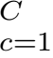 Rc (T), and
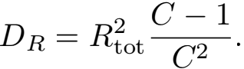
The basic normalized terms are
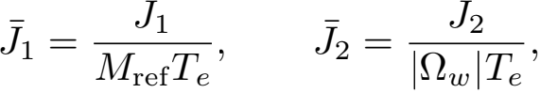
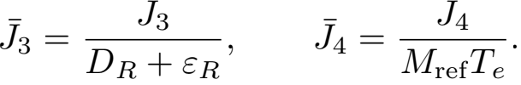
For segmented entrance-rate profiles, the smoothness term is normalized by the corresponding entrance-rate bounds:
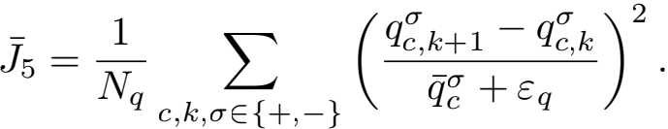
Here Nq is the number of active finite differences, q-c is the
reference upper bound of the corresponding entrance, and εR and εq only avoid zero denominators. Thus, J-1 is a relative system-residence measure. The term J-2 is the average hard exposure or soft safety-risk intensity over the walkable space- time domain [7]. The term J-3 is zero for perfectly balanced realized channel use and approaches one when all realized channel throughput concentrates on one channel.
The reported terms use scale factors
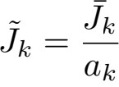 . (24)
The main experiments use
(a1 , a2 , a3 , a4 , a5 ) = (1, 10 −3 , 1, 1, 1).
terms and should not be read directly as space-time percent- ages; the basic normalized value is 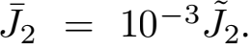 Given weights λ = (λ1,...,λ5 ), the scalarized objective is
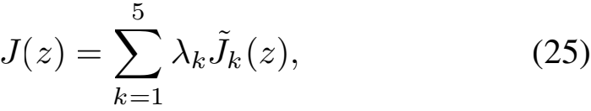
with the main-experiment setting
(λ1 ,λ2 ,λ3 ,λ4 ,λ5 ) = (1, 1, 1, 1, 0.1).
and the optimization problem is
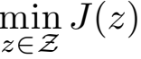, z = (s, q). (26)

TABLE I
RAW UNITS OF THE OBJECTIVE TERMS AND THEIR NORMALIZERS
Normalizer (same unit)
Raw unit
Reported
Term
J1 | ped·s | MrefTe (ped·s) | dimensionless
J2 | m2 ·s | |Ωw|Te (m2·s) | dimensionless
J3 | ped2 | DR (ped2) | dimensionless
J4 | ped·s | MrefTe (ped·s) | dimensionless
J5 | (ped/s)2 | (q-c)2 (ped/s)2 | dimensionless

The paper solves this fixed-weight scalarized management problem. Different weights can represent different manage- ment preferences, but the algorithm itself does not depend on one specific objective~ term being independently optimal. Although J, J(3) , and Jk are dimensionless ranking quan- tities, their interpretation is anchored by the normalization above [45], [61]. When physical interpretation is needed, the experiments also report raw or ratio-based diagnostics such as channel-flow shares, system mass, and density peaks. Table I lists the physical units of the raw objective terms and their normalizers; in each case the term~ and its normalizer share the same unit, so every reported Jk is dimensionless.
For mechanism-verification experiments and fixed-strategy diagnostic experiments that only test direction rules, geometric guidance, or fixed entrance-rate responses, we use the reduced three-term objective
J(3) (z) = λ 1 1 (z) + λ2 2 (z) + λ3 3 (z). (27)
In these experiments, the entrance-waiting term 4 is either reported only as a diagno~stic quantity or is not applicable, and the smoothness term J5 is meaningful only for segmented capacity-profile optimization. Equivalently, reduced-objective experiments use λ4 = λ5 = 0. The numerical values of J and J(3) are not compared across experiment groups.

G. Hierarchical Constrained Mixed-Variable Black-Box Opti- mization
Since s is discrete, q is continuous or piecewise continuous, and each objective evaluation requires the expensive simula- tor S, the resulting problem is an expensive mixed-variable black-box optimization problem [62], [63], [64]. We propose HCMBO, a Hierarchical Constrained Mixed-variable Black- box Optimization method, to exploit the structural relation between direction variables and capacity variables.
1) Direction Candidates and Capacity Parameterization:
HCMBO first generates a direction candidate set Scand sat- isfying operational and connectivity constraints. For a fixed direction configuration s, the entrance capacity profile is rep- resented by a low-dimensional continuous vector x ∈ [0, 1]d and mapped to the actual capacity control by
q = Ts (x), x ∈ [0, 1]d. (28)
The mapping Ts automatically applies direction masks, ca- pacity upper bounds, closure constraints, and smoothness restrictions. For example, if a channel is set to reference forward one-way, the reverse entrance capacity is set to zero; if a channel is closed, both directional capacities are set to zero. Thus, the optimizer searches in the continuous x-space

while all candidates are mapped to capacity profiles consistent with the discrete direction configuration.
2) Structured Capacity Search: For each direction candi- date s, HCMBO performs structured search in the correspond- ing capacity parameter space. The search uses previously eval- uated samples to construct surrogate information for objective values and feasibility, and preferentially selects capacity candi- dates that satisfy constraints and may improve the incumbent objective. This hierarchical design avoids blind sampling in the full mixed-variable space and separates discrete direction structure from continuous capacity structure.
Multi-fidelity evaluation can be used during search. Low- or medium-fidelity simulations help identify clearly poor capacity profiles, whereas high-fidelity simulations are reserved for final candidate rechecking and ranking. To avoid discarding good long-horizon strategies due to short-horizon bias, low- fidelity results are used only as auxiliary evaluation signals and do not directly determine the final optimum.
3) High-Fidelity Rechecking and Final Selection: All fi- nalist candidates are re-evaluated under a unified high-fidelity setting. Let CHF be the candidate set selected for high-fidelity rechecking. The final output is
z* = arg min JHF (z). (29)
z∈CHF
This mechanism prevents surrogate error, low-fidelity bias, or intermediate search ranking from directly becoming the final performance claim.
Algorithm 1 gives the reproducible HCMBO procedure used in the experiments. The loop terminates after the finite opti- mization budget has been allocated across direction candidates, and the reported optimum is selected only after the high- fidelity rechecking stage.
Compared with generic mixed-variable optimization, HCMBO uses the dependence between direction choices and feasible capacity profiles. Once s is fixed, the mapping Ts removes capacity variables that conflict with the selected direction rules and bounds the remaining entrance-rate profiles. This reduces invalid candidates and allocates the simulation budget to policies that satisfy the operational constraints.

IV. NUMERICAL EXPERIMENTS
We validate the proposed model and optimizer on a four- channel scenic-platform scenario abstracted from the Bund sightseeing platform setting. The scenario consists of an inflow region, a Bund sightseeing platform and exit region, a central wall, and four connecting channels: upper, middle, lower- middle, and bottom channels. Throughout this paper, channel denotes a model flow entity indexed by c, whereas passage refers to a real-world walkway at the Bund site that a channel abstracts. The experiments are organized as mechanism val- idation, directional-response analysis, entrance-rate response, horizontal optimizer comparison, and HCMBO ablation.

A. Experimental Setup
The domain is discretized on a 128 × 96 grid. To report results in physical units, simulation quantities are mapped

Algorithm  Control | 1 HCMBO for Joint Direction and Entrance-Rate
Require: Direction constraints Ωs ; simulator S ; objective J;
gate-rate bounds q-; budget B ; initial design size n0 ; pool size
P; LCB coefficient β; high-fidelity shortlist size K. Ensure: Best high-fidelity policy z ∗ .
1: Generate Scand by enumerating s ∈ Ωs and retaining only configurations satisfying open-channel and connectivity
constraints.
2: Rank Scand using the prescribed priority templates and direction proxy score, and then truncate it to the
direction-candidate limit.
3: Set bs = ⌊B/|Scand |⌋ and assign one extra evaluation to the first B mod |Scand | directions.
4: Initialize the global evaluation log D ← ∅ .
5: for all s ∈ Scand do
6: Construct Ts : [0, 1]ds → q by applying the direction mask, gate bounds q-, and time segmentation.
7: Initialize Ds ← ∅ and generate Xs from high-, medium-, and low-rate profiles plus random fill-up points.
8: for all x ∈ Xs do
9: if |Ds | < bs then
10: Evaluate z = (s, Ts (x)) with the optimization-fidelity simulator and append (x, z, J(z)) and feasibility
metrics to Ds and D.
11: end if
12: end for
13: while |Ds | < bs do
14: Let xsest be the evaluated point with the lowest objective in Ds.
15: Draw Ps from P uniform samples in [0, 1]ds and
max(4, ⌊P/4⌋) Gaussian perturbations of xsest , clipped to [0, 1]ds .
16: Set the kernel length scale ℓs = max{0.18, 1/√ds }.
17: for all u ∈ Ps do
18: Estimate ˆs (u) by weighted averaging with wi (u) = exp(-∥xi - u∥2/(2ℓs)) over
(xi , zi , Ji ) ∈ Ds.
19: Set ˆs (u) = min{1, min(xi,zi, Ji)∈Ds ∥u - xi ∥2 /√ds }.
20: Compute as (u) = ˆs (u) - β std(Ds )ˆs (u).
21: end for
22: Select xnext ← arg minu∈Ps as (u).
23: Evaluate znext = (s, Ts (xnext )) and append the result to Ds and D.
24: end while
25: end for
26: Select the top K unique controls CHF from D by the optimization-fidelity objective.
27: for all z ∈ CHF do
28: Re-evaluate z under the unified high-fidelity simulator setting to obtain JHF (z).
29: end for
30: return z ∗ = arg minz∈CHF JHF (z).

through a representative calibration based on three reference scales: a grid cell size of ∆x = 1.0 m, so that the domain spans 128 m × 96 m; a free-flow walking speed of 1.5 m/s; and a jam density of 5.0 ped/m2. The induced time step is then ∆t = 0.2 s, and pedestrian counts follow by integrating density over physical area, so that a fully occupied cell holds ρmax ∆x2 = 5 ped. As a coherence check, a fully packed domain of this size would hold at most ρmax × 128 × 96 ≈ 6.1 × 104 ped, which bounds all reported pedestrian counts. These physical units are adopted only for readability and reflect a representative assumption; they do not represent any

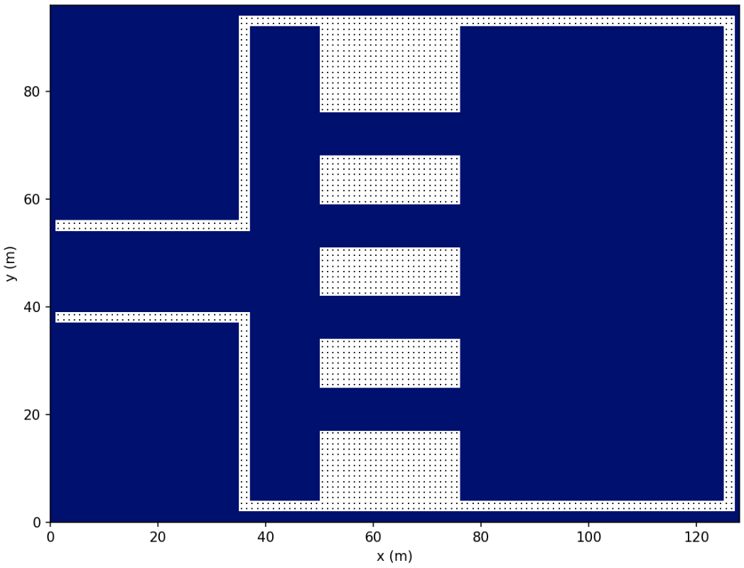

Fig. 3. Four-channel scenic-platform simulation scenario used in the numer- ical experiments.

specific venue.
The channel width is 4 m, and the controlled internal entrance interface width is 16 m. The free-flow speed is vmax = 1.5 m/s, the maximum density is ρmax = 5.0 ped/m2 , the initial density is ρinit = 2.2 ped/m2 , and the CFL factor is 0.9.
Mechanism and response experiments use the corresponding validation horizons. The optimizer comparison uses high- fidelity rechecks with 1600 simulation steps, a horizon of 320 s (i.e. ∆t = 0.2 s), and Bellman updates every five steps. Final optimizer rankings are based on the high-fidelity objective in Section III-F. Unless otherwise stated, optimization experi- ments are ranked by the full five-term scalar objective J after high-fidelity rechecking.
Mechanism-validation, directional-response, fixed-rate re- sponse, and supplementary transfer dia~gnostics~ use the re- duced objective J 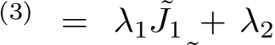J2 + λ3 J3. For these reduced-objective experiments, J4 is only~ an entrance-waiting diagnostic or is not applicable, and J5 is not applicable. Equivalently, λ4 = λ5 = 0. Therefore, the numerical values of J and J(3) should not be compared across experiment groups. Comparisons are meaningful only within the same objective definition, normalization rule, and weight setting. A high-fidelity best candidate is called feasible if the density-cap removal mass is no more than 2% of the reference mass.
Unless otherwise stated, cumulative flow, waiting mass, unreleased attempted flow, and system mass are reported in pedestrians (ped), obtained by integrating density over the physical cell area. Mass-time quantities are reported in ped·s. Counterflow area-time is reported in m2·s. Channel-flow shares are computed from realized cumulative channel throughputs, Rc (T)/ Σj Rj (T). Scalar objectives and normalized terms are dimensionless. Raw cumulative quantities are rounded to three significant digits in the text, while tables retain four decimals for dimensionless objective terms.

B. Mechanism Validation
We first verify whether the two local modeling components have the intended behavioral meanings. The fixed anisotropic mobility tensor M(x;η0 ) should reshape the channel attraction domain and induce entrance pre-alignment, whereas the admis- sible direction set U(x;s) should remove prohibited directions and reroute flow through feasible channels. When M is applied to the middle channel, its flow share increases from 48.78% in the baseline to 100.00%. When a one-way rule excludes the originally dominant middle-channel direction, the middle- channel share becomes zero and the flow is redistributed to the upper, lower-middle, and bottom channels with shares 19.25%, 68.76%, and 12.00%, respectively. For the bidirectional val- idation case, we use two diagnostic quantities. The reverse- direction mass time is
RMT 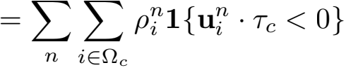∆x2 ∆t,
which measures the cumulative reverse-direction mass-time (in ped·s) moving against the prescribed channel direction. The counterflow area-time is
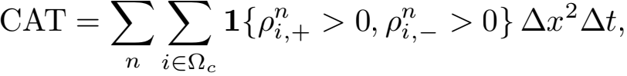
which measures the cumulative area-time (in m2·s) during which opposite-direction subpopulations coexist in the same channel region. In the baseline bidirectional inflow test, the westbound middle-channel share, RMT, and CAT are 73.18%, 3.33 × 103 ped·s, and 2.43 × 103 m2·s, respectively. After imposing the eastbound one-way rule, all three quantities are reduced to zero.
Fig. 4 compares guidance applied to different channels. In each case, the dominant flow channel and local density hotspot move with the guided channel. This supports using the Bellman–conservation-law simulator as the lower-level evaluator for subsequent strategy optimization.
C. Directional-Control Response
We next examine whether the discrete direction configura- tion s creates nontrivial system-level trade-offs. The response experiment uses thirteen interpretable direction settings: an all-free baseline, four single-entry cases, four single-return cases, and four one-channel-closure cases. The direction code is ordered as [T, M, LM, B], where E, W, F, and X denote eastbound entry, westbound return, bidirectional free channel, and closure.
Fig. 5 and Table II show that no single direction configura- tion dominates all objectives. This directional-response exper- iment summarizes the three reported te~rms by~J(3) ; since no entrance-capacity curve is optimized, J4 and J5 are not used for ranking. C8 (SR-LM, EEWE) obtains the lowest reduced objective J(3) = 0.5102, which is only 0.84% lower than th~e all-free baseline C1. C1 gives the lowest safe~ty exposure J2 = 0.00785, C3 gives the best efficiency t~erm J1 = 0.3141, and C9 gives the best load-balance term J3 = 0.1138. This non-monotonic response makes manual rule selection from a small set insufficient and motivates automatic mixed-variable optimization.

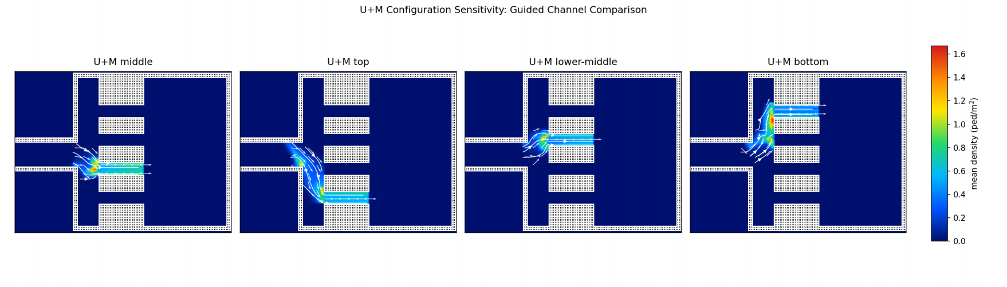

Fig. 4. Spatial transferability of the combined U +M mechanism. Moving the controlled channel induces corresponding migration of dominant flow channels, streamlines, and density hotspots.

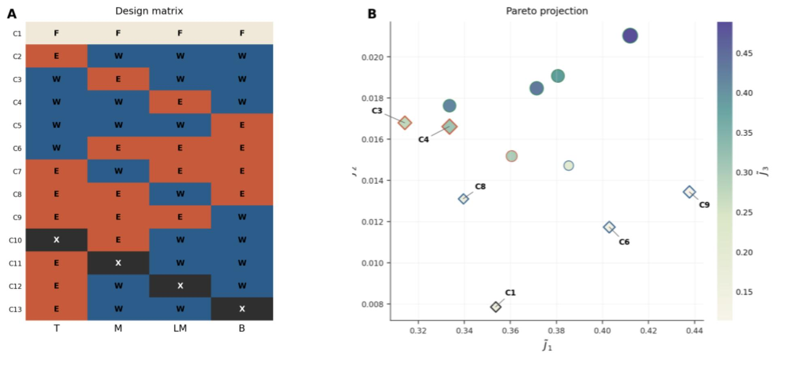
Fig. 5. Directional-control design matrix and objective-space trade-off. Color encodes J(3), and diamonds indicate non-dominated cases.

TABLE II
NON-DOMINATED DIRECTIONAL-CONTROL CASES

Case | Policy | Code | ~  J1 | ~  J2 | ~  J3 | J(3) | Main  characteristic
C1 | BSL | FFFF | 0.3535 | 0.00785 | 0.1531 | 0.5145 | Lowest exposure
C3 | SE-M | WEWW | 0.3141 | 0.01680 | 0.2741 | 0.6049 | Best efficiency but risk-
C4 | SE-LM | WWEW | 0.3335 | 0.01662 | 0.3131 | 0.6632 | concentrated  Efficient but  load-imbalanced
C6 | SR-T | WEEE | 0.4029 | 0.01174 | 0.1335 | 0.5482 | High return  throughput
C8 | SR-LM | EEWE | 0.3395 | 0.01311 | 0.1576 | 0.5102 | Lowest reduced
C9 | SR-B | EEEW | 0.4377 | 0.01344 | 0.1138 | 0.5649 | objective  Most balanced  channel loads
All objective terms in this table are dimensionless scaled normalized quan- tities. The reduced objective uses λ4 = λ5 = 0 and is used only for directional-response diagnosis; it is not directly comparable with the full five- term objective in Table IV.

D. Entrance-Rate Response
Direction rules alone cannot represent the case in which a channel remains open but its internal entrance must be

metered. We therefore fix [T, M, LM, B] = [F, E, W, F] and scan four internal entrance-rate levels: no limit, high, medium, and low. The rate upper bound acts on internal entrance crossing flow. When attempted flow exceeds the upper bound, only the admitted flow crosses the interface, and the unreleased attempted flow remains upstream as waiting mass. The entrance binding-time ratio is defined as the fraction of time steps in which attempted entrance flow exceeds the rate upper bound and creates unreleased attempted flow. The unreleased attempted flow is

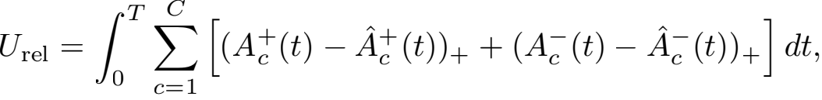
in pedestrian-equivalent demand (ped-eq.); because held-back mass re-attempts the interface at later steps, Urel is a cu- mulative time integral of repeatedly denied demand rather than an instantaneous queue length, and may exceed the number of distinct waiting pedestrians. Its demand ratio is rrel = Urel 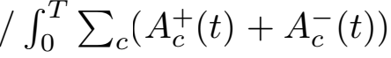dt. This scan is a fixed- rate diagnostic experiment rather than a final optimizer-ranking experiment; the table therefore reports J(3) , treats entrance

TABLE III
RESPONSE UNDER INTERNAL ENTRANCE-RATE UPPER-BOUND LEVELS

Level | ~  J1 | ~  J2 | ~  J3 | J(3) | Urel | rrel | Binding  ratio
No limit | 0.6274 | 0.174 | 0.8838 | 1.6851 | 0.00 | 0 | 0.000
High | 0.6262 | 0.358 | 0.8814 | 1.8652 | 965.60 | 70.8% | 0.605
Medium | 0.6228 | 0.443 | 0.8620 | 1.9276 | 1317.04 | 82.6% | 0.666
Low | 0.6181 | 0.466 | 0.8493 | 1.9337 | 1711.56 | 92.1% | 0.721
Urel is reported in pedestrian-equivalent demand (ped-eq.), a cumulative time integral of denied entrance demand and not an instantaneous queue length. The safety column is a scaled normalized safety term, not a direct space-time percentage.

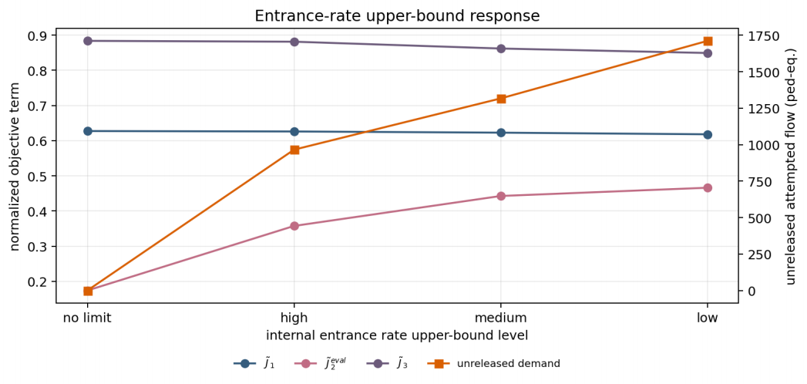
Fig. 6. Objective-term response under internal entrance-rate upper-bound levels. Tightening the upper bound changes safety exposure, load balance, and unreleased attempted flow; the latter is reported in pedestrian-equivalent demand (ped-eq.).

waiting as a diagnostic quantity, and sets the smoothness contribution to zero because each policy uses a fixed rate level. Table III and Fig. 6 show that tightening the rate upper bound does not simply improve safety. From the no-limit case to the low level, unreleased attempted flow increases from 0 to 1.71 × 103 ped-eq., corresponding to rrel = 92.1% of attempted entrance demand. The binding ratio incr~eases from
0 to 0.721, and the scaled normalized safety term J2 increases from 0.174 to 0.466. Thus, q is a genuine continuous control variable that changes system response and must be optimized jointly with s.

E. Horizontal Optimization Comparison
The horizontal comparison evaluates Prior Baseline, Ran- dom Search, Pure Simulated Annealing, Enumeration plus Differential Evolution, TPE-Mixed BO, and HCMBO. All optimizers use B = 400 candidate evaluations and top-10 high-fidelity rechecks over seeds 11, 23, 37, 51, and 73. The final HCMBO data are taken from the G7-D mainline, whereas the other baselines are taken from the G6 horizontal comparison under the same high-fidelity protocol.
Table IV reports the smallest mean, median, and best objective for HCMBO, together with the highest feasible rate among the tested methods. Its mean objective is 3.9% lower than TPE-Mixed BO, since (2.7403-2.6338)/2.7403 = 3.9%. Because this is a normalized scalar objective, the percentage reduction reflects the fixed-weight management score, not a direct reduction in travel time or density exposure alone. In paired comparisons, HCMBO has a lower objective than TPE- Mixed BO in four of five seeds, with an average objective

TABLE IV
HIGH-FIDELITY PERFORMANCE UNDER THE FULL FIVE-TERM
DIMENSIONLESS OBJECTIVE

Method | Mean objective | Std. | Median | Best Worst | Feasible  rate
HCMBO | 2.6338 | 0.3106 | 2.5065 | 2.4495 3.1851 | 100%
TPE-Mixed BO | 2.7403 | 0.2475 | 2.6288 | 2.5180 3.1345 | 80%
Pure SA | 2.9248 | 0.1386 | 2.9203 | 2.7468 3.1049 | 60%
Random Search | 3.0112 | 0.1319 | 2.9797 | 2.8821 3.2287 | 40%
Enum-DE | 3.0597 | 0.1932 | 3.1004 | 2.7329 3.2500 | 40%
Prior Baseline | 5.4774 | 0.0000 | 5.4774 | 5.4774 5.4774 | 0%
The reported objective is the full dimensionless scalar objective J =
Σk=1 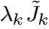 after unified high-fidelity rechecking. These values are not
directly comparable with the reduced diagnostic objective J(3) in Tables II, III, and VII.

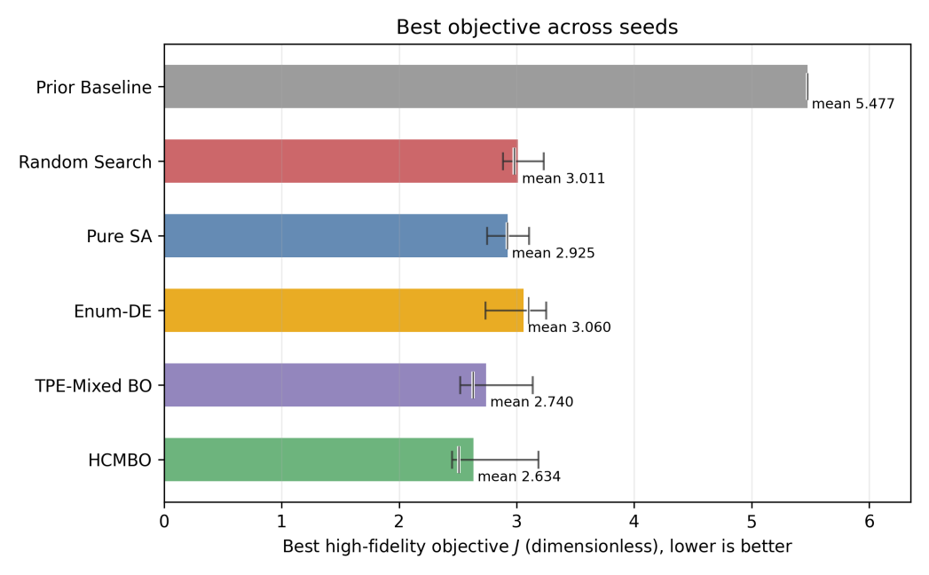

Fig. 7. Best high-fidelity full objective J across seeds. The objective is dimensionless and lower is better. Range bars show the seed-wise spread, and the short vertical mark indicates the median.
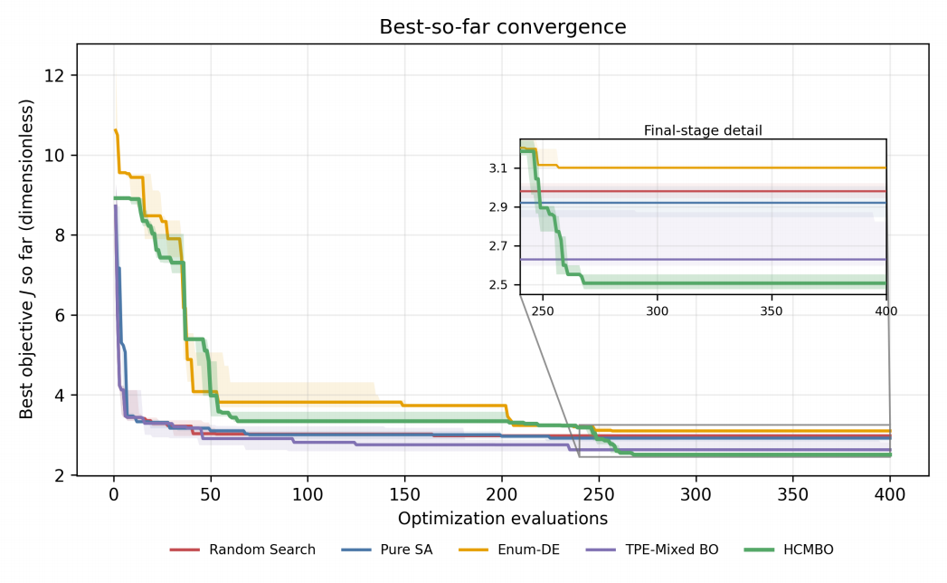

Fig. 8. Best-so-far convergence curves under the same 400-evaluation budget. The inset highlights the final-stage separation among methods.

difference of -0.1066. It is also lower than Random Search in all five seeds and lower than Pure SA and Enum-DE in four of five seeds. The remaining high HCMBO objective is mainly caused by a larger safety-exposure term, so later versions should add more explicit safety constraints during search.
Figs. 7–9 compare the seed-wise objectives, convergence traces, and selected entrance-rate profiles. TPE-Mixed BO decreases quickly in the early evaluations, whereas HCMBO

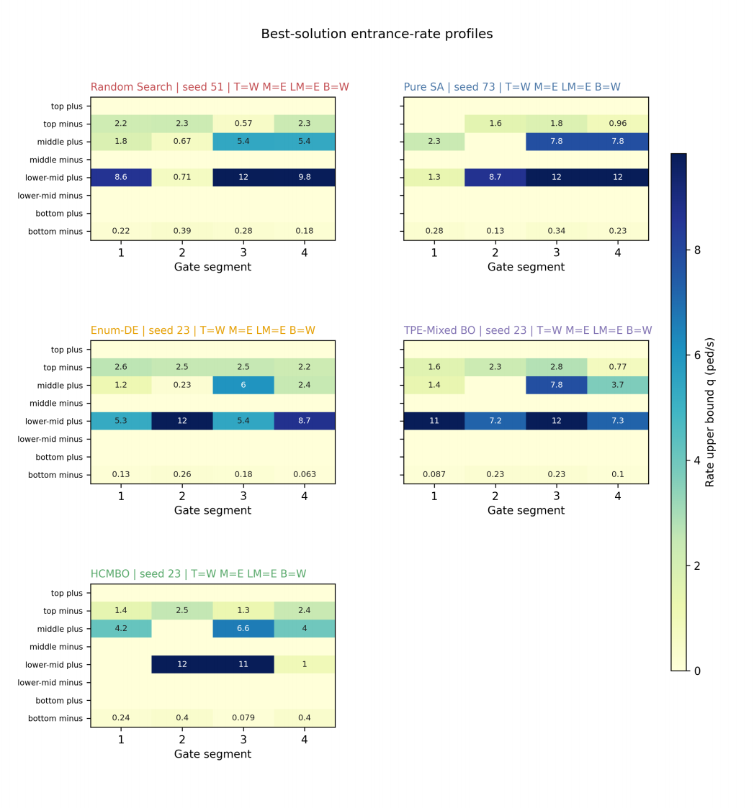
Fig. 9. Best-solution entrance-rate profiles for Random Search, Pure SA, Enum-DE, TPE-Mixed BO, and HCMBO. The common direction structure is [T, M, LM, B] = [W, E, E, W] for several methods, but the segment-wise rate allocations differ substantially.

continues to reduce the best-so-far objective during the middle and late stages. The control profiles indicate that methods with the same direction code can still choose different segment-wise rate allocations, leading to different final objectives.

F. HCMBO Ablation
The ablation experiments test the contribution of each control and search component. Optimizing only directions with a fixed high rate gives a best high-fidelity objective of 3.3751, and optimizing only rates under prior directions gives 3.3140; both are higher than the joint optimization result. Short- horizon low-fidelity hard screening raises the best objective to 2.9441 and selects an infeasible best candidate, because early simulations do not reliably capture long-horizon en- trance waiting and load redistribution. Removing the entrance- waiting penalty slightly lowers the scalar objective to 2.6015, but increases unreleased attempted flow to approximately 1.30 × 104 ped-eq. The waiting term should therefore remain in the management objective.
Table V shows that the final HCMBO mainline has the lowest scalar objective among the tested variants. Queue- aware LCB and RF-style constrained BO reduce unreleased attempted flow to approximately 9.64 × 103 ped-eq., but their scalar objective increases to 2.6162. Thus, queue information is useful for executable and safety-aware extensions, whereas the final mainline should retain structured direction-wise rate search as the primary budget allocation mechanism.

TABLE V
SEARCH-MECHANISM ABLATION UNDER SEED 23

Variant | Best Feasible objective rate | ~  J2 | Unreleased  flow  (ped-eq.) | Main meaning
HCMBO | 2.4495 100% | 1.6759 | 1.02×104 Structured  direction-wise rate search
Queue-aware LCB | 2.6162 100% | 1.8521 | 9.64×103 Queue-aware acquisition
RF-style  constrained BO | 2.6162 100% | 1.8521 | 9.64×103 Constraint  surrogate variant
Adaptive racing | 2.6561 100% | 1.9474 | 1.28×104 Stage-wise budget  concentration
Adaptive racing | 2.6683 100% | 1.7862 | 1.06×104 Combined racing
+ queue-aware Trust-region search | 3.0317 100% | 1.9224 | and queue signal  1.59×104 Local trust-region  search
Unreleased flow is the cumulative unreleased attempted entrance flow over the full horizon, in pedestrian-equivalent demand (ped-eq.); it integrates repeatedly denied demand and is not an instantaneous queue length.

G. Transfer Validation on a Bund-Inspired Scenario
The preceding experiments use a standardized four-channel platform scenario to verify modeling mechanisms and opti- mization behavior under controlled conditions. As a supple- mentary validation, we further construct a simplified abstract scenario inspired by the spatial form of the Shanghai Bund waterfront. This experiment does not claim to reproduce all architectural details of the real site. Instead, it preserves the Bund sightseeing platform, the lateral passage connections, the major inflow location, and the dominant movement direction, so as to examine whether an HCMBO-derived policy can still change the load distribution in a more realistic spatial outline. The computational grid has resolution 512 × 224. Because this scenario preserves the real Bund outline, its physical scale is calibrated from georeferenced control points that match the scene coordinates to satellite latitude and longitude; a four- point affine fit gives 0.435 m per scene unit with sub-1.5 m residual, which corresponds to a physical cell size of about 1.75 m. The 512 × 224 grid therefore spans approximately
894 m × 391 m, the induced time step is ∆t ≈ 0.44 s, and pedestrian counts again follow by integrating density over physical area (a cell area of about 3.0 m2 ). Pedestrians enter from the outer-side entrance, pass through the middle connecting channels, and move toward the Bund sightseeing platform and its central target region. The inflow-rate multi- plier is 3.0, corresponding to an actual inflow rate of about 3.35 ped/s; the maximum density is ρmax = 4.0 ped/m2 , and the stage-switching rate is κσ,r = 32 in simulation time units. The experimental channels channel_1, channel_2, channel_3, and channel_4 correspond to the locally named Bund Passages 3, 4, 5, and 6, respectively. Both the controlled and uncontrolled groups use 1600 steps over a physical horizon of about 698 s. For the controlled group, the transferred entrance-rate bounds are multiplied by a capacity- scale factor of 3, providing a less restrictive entrance-capacity setting.
The controlled group uses the best HCMBO policy obtained

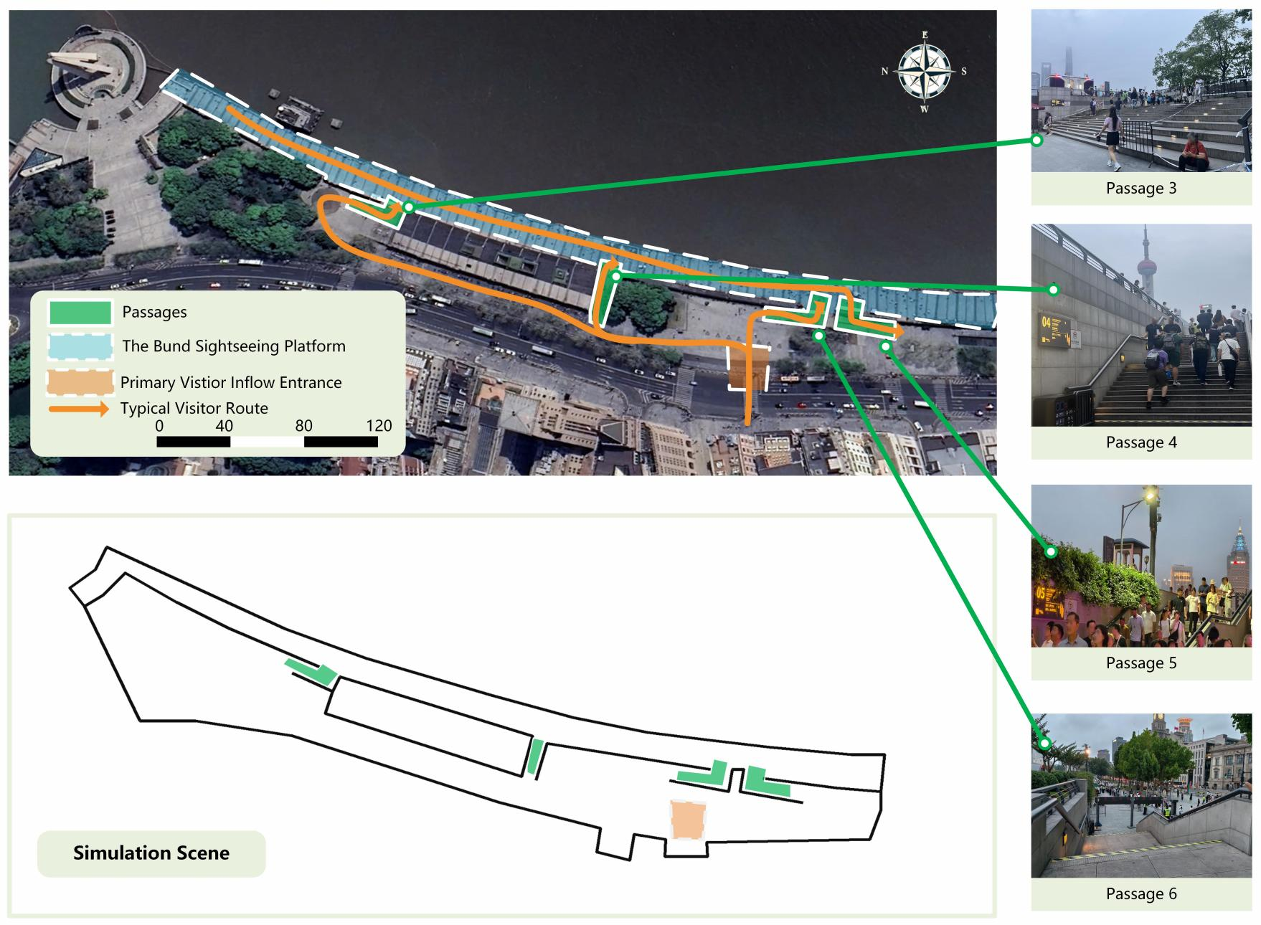
Fig. 10. Real Bund scene and its simplified simulation abstraction. The abstraction retains the Bund sightseeing platform boundary, the main entrance, and the passage connections used for control validation. The satellite basemap was obtained from Google Maps. The right-side local photographs were shot in the Shanghai Bund waterfront passage area by the Tongji Public Safety Experimental Team, June 21, 2026.

TABLE VI
EFFECTIVE ENTRANCE-RATE UPPER BOUNDS IN THE BUND TRANSFER
EXPERIMENT

Experimental channel | Local Entrance side  passage name | Segment 1  (ped/s) | Segment 2  (ped/s)
channel_1 | Bund Passage Forward 3 entrance | 3.45 | 8.38
channel_1 | Bund Passage Reverse 3 entrance | 3.17 | 0.00
channel_2 | Bund Passage Forward 4 entrance | 8.38 | 2.36
channel_2 | Bund Passage Reverse 4 entrance | 0.00 | 0.00
channel_3 | Bund Passage Forward 5 entrance | 0.00 | 0.00
channel_3 | Bund Passage Reverse 5 entrance | 3.57 | 6.95
channel_4 | Bund Passage Forward 6 entrance | 5.28 | 3.03
channel_4 | Bund Passage Reverse 6 entrance | 3.09 | 2.96

from the multi-direction high-fidelity recheck. Its reduced high-fidelity objective in the optimization stage is 0.7350, and its direction structure leaves the upper and lower channels bidirectional while assigning opposite dominant directions to the two middle channels. Table VI reports the effective two-segment entrance-rate upper bounds after applying the capacity-scale factor of 3. The rate upper bounds are measured in ped/s.
Table VII compares the controlled and uncontrolled groups

under the same high-fidelity protocol. It separates dimension- less normalized terms from raw simulation diagnostics. The reduced objective J(3) decreases from 1.0140 to 0.7410, cor- responding to an absolute reduction of approximately 0.2730 and a relative reduction of 26.9~%. The largest reduction comes from the load-balance term J3 , which~decreases by 51.9%, from ~0.6043 to 0.2908. In contrast, J1 increases by 8.7% and J2 increases by 25.7%. This indicates that the transferred policy changes how pedestrians use the channels, rather than merely reducing all density values uniformly.
The channel-flow shares in Table VIII further explain this reduction. In the uncontrolled group, 82.30% of the channel flow concentrates on channel_4, i.e., Bund Passage 6. After applying the HCMBO policy, the flow is redistributed mainly to channel_2 and channel_3, whose combined share reaches approximately 91.34%.
Fig. 11 visualizes the density evolution at approximately 22, 153, 393, and 654 s. Both groups initially form a local density concentration near the right-side target region of the Bund sightseeing platform, reflecting the same inflow and target-attraction structure. At later stages, the uncontrolled case remains more concentrated around the terminal channel and the adjacent Bund sightseeing platform area, whereas the controlled case develops a more stable flow band through the middle-channel group. This visual evidence is consistent with the channel-share statistics and confirms that the main effect of the HCMBO policy is load redistribution across channels.

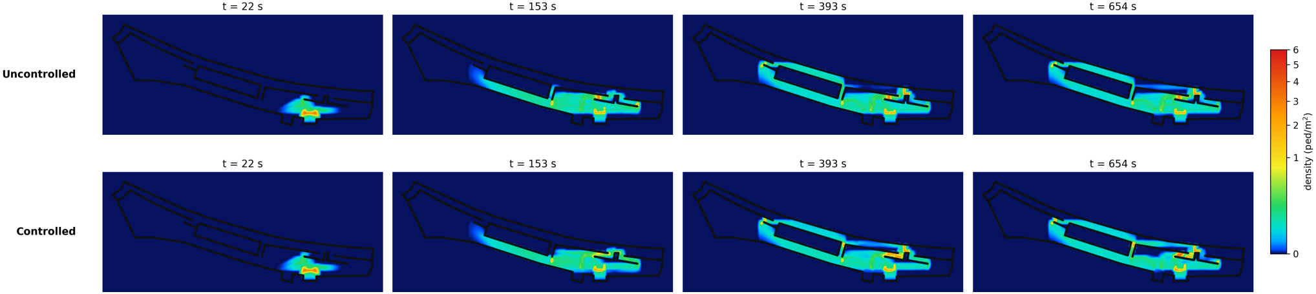

Fig. 11. Density evolution comparison between uncontrolled and controlled cases at approximately 22, 153, 393, and 654 s. The controlled policy redistributes the later-stage flow from the terminal channel toward the middle-channel group.

TABLE VII
CONTROLLED AND UNCONTROLLED RESULTS IN THE BUND TRANSFER
EXPERIMENT

Dimensionless term | Controlled Uncontrolled Relative change
J(3) ~  J~1 J~2 J3 | 0.7410 1.0140 -26.9%  0.4145 0.3813 +8.7%  0.0357 0.0284 +25.7%  0.2908 0.6043 -51.9%
Raw diagnostic | Controlled Uncontrolled Unit
Final cumulative sink flow Final cumulative inflow  Final system mass  Peak density maximum  Domain-mean density (incl. empty space)  Attempted entrance flow  Actual entrance flow  Unreleased attempted flow |  | 1.33×103  2.32×103  1.53×103 ≈ 4.0  3.47×10-3  1.49×103  1.13×103 364 | 1.67×103  2.34×103  1.20×103 ≈ 4.0  3.21×10-3  –  –  – | ped  ped  ped  ped/m2  ped/m2  ped-eq. ped  ped-eq.
Sink flow, inflow, system mass, and actual entrance flow are pedestrian counts (ped). Attempted and unreleased entrance flow are cumulative pedestrian- equivalent demand (ped-eq.): they integrate repeatedly denied demand over the horizon and may exceed the number of distinct waiting pedestrians. Entries marked - are not applicable because the uncontrolled case activates no internal metering interface. The domain-mean density is averaged over the full walkable domain, including empty space, and is therefore much smaller than the local peak.

TABLE VIII
CHANNEL-FLOW SHARES IN THE BUND TRANSFER EXPERIMENT

Channel | Local name | Controlled | Uncontrolled
channel_1  channel_2  channel_3  channel_4 | Bund Passage 3 | 2.83% | 0.32%
 | Bund Passage 4 | 30.38% | 1.35%
 | Bund Passage 5 | 60.96% | 16.03%
 | Bund Passage 6 | 5.83% | 82.30%
Channel-flow shares are computed as Rc(T)/ Σ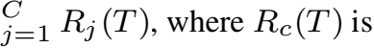 the realized cumulative admitted throughput of channel c during the simulation horizon.

The transfer experiment exposes a trade-off. Compared with the uncontrolled ~group, the controlled group has a higher efficiency term (J1 increases from 0~.3813 to 0.4145) and a slightly higher safety-exposure term (J2 increases from 0.0284 to 0.0357). Its cumulative sink flow is also smaller (1.33×103 versus 1.67×103 ped), and its final system mass is larger (1.53×103 versus 1.20×103 ped). The transferred HCMBO policy therefore should not be read as a uniform safety or efficiency improvement. Under the present reduced-objective weights, it lowers J(3) mainly by redistributing channel load,

while giving up part of exit throughput and travel efficiency. The capacity-scale factor of 3 reduces unreleased attempted flow to 364 ped-eq., but it does not remove the efficiency cost. A deployment-oriented version should add explicit throughput constraints and waiting upper bounds, and should test several objective-weight settings before selecting a policy.

V. CONCLUSION
This paper proposed a macroscopic crowd-management framework for open pedestrian zones with passage-direction rules, geometric guidance, multi-stage route behavior, and internal entrance-rate control. The framework couples a crowd- flow simulator with HCMBO so that direction settings and entrance-rate profiles can be optimized under a limited simu- lation budget.
The experiments indicate that the two local modeling components behave as intended and that direction control and entrance-rate control are not interchangeable. Direction settings create non-monotonic trade-offs among efficiency, safety exposure, and load balance. Entrance-rate limits change unreleased attempted flow, binding-time ratios, and local risk patterns. Across five random seeds with unified high-fidelity rechecking, HCMBO gives the lowest mean full management objective among the tested baselines, with a 3.9 percent lower fixed-weight score than TPE-Mixed BO and a 100 percent feasible rate. The ablation study attributes this result to joint direction-rate optimization, avoiding hard short-horizon screening, and structured direction-wise rate search.
The Bund-inspired transfer experiment indicates that an HCMBO-derived policy can alter flow organization in a sim- plified real-world spatial abstraction. The reduced objective decreases by 26.9 percent because the policy redistributes flow away from the dominant terminal channel and improves load balance across the middle-channel group. The same policy also produces higher residual mass, lower exit throughput, and unreleased attempted entrance flow. The transfer result supports mechanism transfer and load redistribution, but it is not a deployable plan for the Bund area.
The study has several limitations. The experiments use simplified geometries, fixed objective weights, and finite random seeds. One HCMBO seed still has relatively high safety exposure. The model also does not yet include real crowd calibration, online demand updates, or executable field constraints. Future work should address these limits before operational deployment, especially by adding stronger safety

and throughput constraints and by testing multiple demand and weight settings.

ACKNOWLEDGMENT
This research was supported by the National Natural Sci- ence Foundation of China (No. 72374154) and the 20th Experimental Teaching Reform Special Foundation of Tongji University (No. 0800104347). The authors deeply appreciate this support.

REFERENCES
[1] P. Charalambous, J. Pettre, V. Vassiliades, Y. Chrysanthou, and N. Pelechano, “Greil-crowds: Crowd simulation with deep reinforcement learning and examples,” ACM Trans. Graph., vol. 42, no. 4, p. Article 137, 2023.
[2] H. Jiang, X. Zhang, Y. Dong, and J. Wang, “Data-driven predictive modeling of citywide crowd flow for urban safety management: A case study of beijing, china,” Journal of Forecasting, vol. 44, no. 2, pp. 730– 752, 2025.
[3] D. Shi, J. Li, Q. Wang, J. Chen, R. Lovreglio, J. T. Y. Lo, and J. Ma, “Modeling and simulation of crowd dynamics at evacuation bottlenecks during flood disasters,” Transportation Research Part E: Logistics and Transportation Review, vol. 198, p. 104064, 2025.
[4] R. Zhao, D. Wang, Y. Wang, C. Han, P. Jia, C. Li, and Y. Ma, “Macro- scopic view: Crowd evacuation dynamics at t-shaped street junctions using a modified aw-rascle traffic flow model,” IEEE Transactions on Intelligent Transportation Systems, vol. 22, no. 10, pp. 6612–6621, 2021.
[5] B. L. Zhou, X. O. Tang, and X. G. Wang, “Learning collective crowd behaviors with dynamic pedestrian-agents,” International Journal of Computer Vision, vol. 111, no. 1, pp. 50–68, 2015.
[6] T. Bosse, M. Hoogendoorn, M. C. A. Klein, J. Treur, C. N. van der Wal, and A. van Wissen, “Modelling collective decision making in groups and crowds: Integrating social contagion and interacting emotions, beliefs and intentions,” Autonomous Agents and Multi-Agent Systems, vol. 27, no. 1, pp. 52–84, 2013.
[7] H. Liang, L. Yang, J. Du, C.-W. Shu, and S. C. Wong, “Modelling crowd pressure and turbulence through a mixed-type continuum approach,” Transportmetrica B: Transport Dynamics, vol. 12, no. 1, p. 2328774, 2024.
[8] Z. Shahhoseini and M. Sarvi, “Pedestrian crowd flows in shared spaces: Investigating the impact of geometry based on micro and macro scale measures,” Transportation Research Part B: Methodological, vol. 122, pp. 57–87, 2019.
[9] C.-Z. T. Xie, J. Xu, B. Zhu, T.-Q. Tang, S. Lo, B. Zhang, and Y. Tian, “Advancing crowd forecasting with graphs across microscopic trajectory to macroscopic dynamics,” Information Fusion, vol. 106, p. 102275, 2024.
[10] N. W. F. Bode, M. Chraibi, and S. Holl, “The emergence of macroscopic interactions between intersecting pedestrian streams,” Transportation Research Part B: Methodological, vol. 119, pp. 197–210, 2019.
[11] F. Bourdin, “Splitting scheme for a macroscopic crowd motion model with congestion for a two-typed population,” Networks and Heteroge- neous Media, vol. 17, no. 5, pp. 783–801, 2022.
[12] L. Y. Wang and W. X. Huang, “Visitors’ consistent stay behavior pat- terns within free-roaming scenic architectural complexes: Considering impacts of temporal, spatial, and environmental factors,” Frontiers of Architectural Research, vol. 13, no. 5, pp. 990–1008, 2024.
[13] X. Yang, R. Zhang, F. Pan, Y. Yang, Y. Li, and X. Yang, “Stochastic user equilibrium path planning for crowd evacuation at subway station based on social force model,” Physica A: Statistical Mechanics and its Applications, vol. 594, p. 127033, 2022.
[14] J. Zhong, T. Cheng, W. L. Liu, P. Yang, Y. Lin, and J. Zhang, “An evolutionary guardrail layout design framework for crowd control in subway stations,” IEEE Transactions on Computational Social Systems, vol. 10, no. 1, pp. 297–310, 2023.
[15] P. X. Liu, X. Xiao, J. Zhang, R. H. Wu, and H. L. Zhang, “Spatial config- uration and online attention: A space syntax perspective,” Sustainability, vol. 10, no. 1, 2018.
[16] A. M. Caldeira and E. Kastenholz, “Spatiotemporal tourist behaviour in urban destinations: a framework of analysis,” Tourism Geographies, vol. 22, no. 1, pp. 22–50, 2020.

[17] Jingmin Zhitongche Shanghai, “Tourism, shopping festival, and com- mercial markets bring overlapping visitor flows: Shanghai huangpu police implement holiday security measures,” Tencent News. [Online]. Available: https://news.qq.com/rain/a/20240503A05LRO00, May 2024, (in Chinese). Accessed: Jun. 25, 2026.
[18] L. Yin, “Instantaneous visitor flow in the core bund scenic area reaches 71,000; police activate crowd-guidance measures,” China News Service, Chinanews.com. [Online]. Available: https://www.chinanews.com.cn/tp/ hd2011/2019/10-03/906114.shtml, Oct. 2019, (in Chinese). Accessed: Jun. 25, 2026.
[19] M. Haghani, M. Coughlan, B. Crabb, A. Dierickx, C. Feliciani, R. van Gelder, P. Geoerg, N. Hocaoglu, S. Laws, R. Lovreglio, Z. Miles, A. Nicolas, W. J. O’Toole, S. Schaap, T. Semmens, Z. Shahhoseini, R. Spaaij, A. Tatrai, J. Webster, and A. Wilson, “A roadmap for the future of crowd safety research and practice: Introducing the swiss cheese model of crowd safety and the imperative of a vision zero target,” Safety Science, vol. 168, p. 106292, 2023.
[20] J. Zhong, D. Li, W. Cai, W.-N. Chen, and Y. Shi, “Automatic crowd navigation path planning in public scenes through multiobjective differ- ential evolution,” IEEE Transactions on Computational Social Systems, vol. 11, no. 1, pp. 905–918, 2024.
[21] H. Gu, S. Kim, and M. Jung, “Data-driven urban planning for proactive crowd management: Lessons from the 2022 seoul halloween crowd crush,” Cities, vol. 168, pp. 1–14, 2026.
[22] K. Rezaee, M. R. Khosravi, H. Attar, V. G. Menon, M. A. Khan, H. Issa, and L. Qi, “Iomt-assisted medical vehicle routing based on uav-borne human crowd sensing and deep learning in smart cities,” IEEE Internet of Things Journal, vol. 10, no. 21, pp. 18 529–18 536, 2023.
[23] Shanghai Municipal Public Security Bureau Huangpu Branch, “Notice on the issuance of the “Implementation Plan for Safety Management of Key Areas such as the Bund and Nanjing Road for the 2023 New Year”,” 2022, (in Chinese).
[24] CCTV, “Beijing dongcheng police take multiple measures to handle large crowds at nanluoguxiang,” Oct. 2021, (in Chinese).
[25] H. Yu, N. Jiang, M. Li, X. Jia, J. Shi, E. Wai Ming Lee, and L. Yang, “Regulating multi-directional passenger flow: Impact of obstacle po- sition and flow level on pedestrian merging process,” Tunnelling and Underground Space Technology, vol. 157, p. 106336, 2025.
[26] D. Wu and H. Diao, “Optimization of security police deployment and scheduling for large-scale events,” Xitong Gongcheng Lilun yu Shijian (Syst. Eng. — Theory & Pract.), vol. 42, no. 03, pp. 789–800, 2022, (in Chinese).
[27] N. Molyneaux and M. Bierlaire, “Controlling pedestrian flows with moving walkways,” Transportation Research Part C: Emerging Tech- nologies, vol. 141, p. 103672, 2022.
[28] X. C. Liao, W. N. Chen, X. Q. Guo, J. Zhong, and D. J. Wang, “Drift: A dynamic crowd inflow control system using lstm-based deep reinforcement learning,” IEEE Transactions on Systems, Man, and Cybernetics: Systems, vol. 55, no. 6, pp. 4202–4215, 2025.
[29] E. Ronchi, D. Nilsson, E. D. Kuligowski, R. D. Peacock, and P. A. Reneke, “Assessing the verification and validation of building fire evacuation models,” Fire Technology, vol. 52, no. 1, pp. 197–219, 2016.
[30] H. M. Al-Ahmadi, I. Reza, A. Jamal, W. S. Alhalabi, and K. J. Assi, “Preparedness for mass gatherings: A simulation-based framework for flow control and management using crowd monitoring data,” Arabian Journal for Science and Engineering, vol. 46, no. 5, pp. 4985–4997, 2021.
[31] L. Feng and E. Miller-Hooks, “A network optimization-based approach for crowd management in large public gatherings,” Transportation Research Part C: Emerging Technologies, vol. 42, pp. 182–199, 2014.
[32] R. X. Zhong, Y. P. Huang, C. Chen, W. H. K. Lam, D. B. Xu, and A. Sumalee, “Boundary conditions and behavior of the macroscopic fundamental diagram based network traffic dynamics: A control systems perspective,” Transportation Research Part B: Methodological, vol. 111, pp. 327–355, 2018.
[33] R. Zhao, Q. Liu, Q. Hu, D. Dong, C. Li, and Y. Ma, “Lyapunov-based crowd stability analysis for asymmetric pedestrian merging layout at t- shaped street junction,” IEEE Transactions on Intelligent Transportation Systems, vol. 22, no. 11, pp. 6833–6842, 2021.
[34] S. A. Wadoo and P. Kachroo, “Feedback control of crowd evacuation in one dimension,” IEEE Transactions on Intelligent Transportation Systems, vol. 11, no. 1, pp. 182–193, 2010.
[35] W. Qin, “Unit sliding mode control for disturbed crowd dynamics system based on integral barrier lyapunov function,” IEEE Access, vol. 8, pp. 91 257–91 264, 2020.
[36] Y. Zhu, D. Zhao, and H. He, “Optimal feedback control of pedestrian flow in heterogeneous corridors,” IEEE Transactions on Automation Science and Engineering, vol. 18, no. 3, pp. 1097–1108, 2021.

[37] Y. Zhou, M. Zhong, Z. Li, X. Xu, F. Hua, and R. Pan, “Simulation- based adaptive optimization for passenger flow control measures at metro stations,” Simulation Modelling Practice and Theory, vol. 138, p. 103021, 2025.
[38] X. Yang, B. Shi, G. Zhang, and Y. Li, “Optimization modeling of automatic crowd regulation at bottlenecks of subway system: A model predictive control approach,” Physics Letters A, vol. 531, p. 130180, 2025.
[39] X. Yang, G. Zhang, B. Shi, C.-Z. Xie, and B. Zhang, “Partition inde- pendent control and collaborative optimization of high-density crowd in subway stations,” Chaos, Solitons & Fractals, vol. 200, p. 117108, 2025.
[40] M. A. Lopez-Carmona and A. Paricio-Garcia, “Crowd evacuation man- agement with optimal time-multiplexed exit-choice recommendations through simulation optimization,” Advanced Theory and Simulations, vol. 7, no. 7, p. 2400265, 2024.
[41] M. A. Lopez-Carmona and A. Paricio Garcia, “Linear and nonlinear model predictive control (mpc) for regulating pedestrian flows with discrete speed instructions,” Physica A: Statistical Mechanics and its Applications, vol. 625, p. 128996, 2023.
[42] X. C. Liao, W. N. Chen, X. Q. Guo, J. Zhong, and X. M. Hu, “Crowd management through optimal layout of fences: An ant colony approach based on crowd simulation,” IEEE Transactions on Intelligent Transportation Systems, vol. 24, no. 9, pp. 9137–9149, 2023.
[43] J. Schulman, F. Wolski, P. Dhariwal, A. Radford, and O. Klimov, “Prox- imal policy optimization algorithms,” arXiv preprint arXiv:1707.06347, 2017.
[44] K. Price, R. M. Storn, and J. A. Lampinen, Differential Evolution: A Practical Approach to Global Optimization. Springer Publishing Company, Incorporated, 2014.
[45] W. L. Liu, Y. Chen, X. Li, J. Zhong, R. Chen, and H. Jin, “Automatic optimization of guidance guardrail layout based on multi-objective evolutionary algorithm,” Complex System Modeling and Simulation, vol. 4, no. 4, pp. 353–367, 2024.
[46] L. F. Henderson, “The statistics of crowd fluids,” Nature, vol. 229, no. 5284, p. 381–383, 1971.
[47] R. L. Hughes, “A continuum theory for the flow of pedestrians,” Transportation Research Part B: Methodological, vol. 36, no. 6, pp. 507–535, 2002.
[48] L. Huang, S. C. Wong, M. Zhang, C.-W. Shu, and W. H. K. Lam, “Revisiting hughes’ dynamic continuum model for pedestrian flow and the development of an efficient solution algorithm,” Transportation Research Part B: Methodological, vol. 43, no. 1, p. 127–141, 2009.
[49] R. M. COLOMBO, M. GARAVELLO, and M. LECUREUX-
MERCIER, “A class of nonlocal models for pedestrian traffic,” Math- ematical Models and Methods in Applied Sciences, vol. 22, no. 04, p. 1150023, 2012.
[50] B. Raimund, G. Paola, I. Daniel, and V. Luis Miguel, “A non-local pedestrian flow model accounting for anisotropic interactions and do- main boundaries,” Mathematical Biosciences and Engineering, vol. 17, no. 5, p. 5883–5906, 2020.
[51] B. Maury and J. Venel, “A mathematical framework for a crowd motion model,” Comptes Rendus Mathematique, vol. 346, no. 23, p. 1245–1250, 2008.
[52] B. Maury, A. Roudneff-Chupin, F. Santambrogio, and J. Venel, “Han- dling congestion in crowd motion modeling,” Networks and Heteroge- neous Media, vol. 6, no. 3, p. 485–519, 2011.
[53] R. Jordan, D. Kinderlehrer, and F. Otto, “The variational formulation of the fokker–planck equation,” SIAM Journal on Mathematical Analysis, vol. 29, no. 1, p. 1–17, 1998.
[54] A. Aw and M. Rascle, “Resurrection of ”second order” models of traffic flow,” SIAM Journal on Applied Mathematics, vol. 60, no. 3, p. 916–938, 2000.
[55] J.-P. Lebacque, S. Mammar, and H. Haj-Salem, “The aw–rascle and zhang’s model: Vacuum problems, existence and regularity of the solutions of the riemann problem,” Transportation Research Part B: Methodological, vol. 41, no. 7, p. 710–721, 2007.
[56] E. Cristiani, F. S. Priuli, and A. Tosin, “Modeling rationality to control self-organization of crowds: An environmental approach,” SIAM Journal on Applied Mathematics, vol. 75, no. 2, pp. 605–629, 2015.
[57] F. Priuli, A. Tosin, and E. Cristiani, “On the control of self-organized systems: The case of pedestrian flows,” in Proceedings of the 5th Inter- national Conference on Pedestrian and Evacuation Dynamics, 2015.
[58] Z. Jiang, W. Fan, W. Liu, B. Zhu, and J. Gu, “Reinforcement learning approach for coordinated passenger inflow control of urban rail transit in

peak hours,” Transportation Research Part C: Emerging Technologies, vol. 88, pp. 1–16, 2018.
[59] J. Liu, L. Hu, X. Xu, and J. Wu, “A queuing network simulation optimization method for coordination control of passenger flow in urban rail transit stations,” Neural Computing and Applications, vol. 33, no. 17, pp. 10 935–10 959, 2021.
[60] H. Hu, R. Zhang, Y. Hao, Y. He, and Z. Liu, “Optimization model for passenger flow control and service capacity allocation in subway station pedestrian facility networks,” Sustainability, vol. 17, no. 21, p. 9816, 2025.
[61] R. T. Marler and J. S. Arora, “Survey of multi-objective optimization methods for engineering,” Structural and Multidisciplinary Optimiza- tion, vol. 26, no. 6, pp. 369–395, 2004.
[62] H. M. Sheikh and P. S. Marcus, “Bayesian optimization for mixed- variable, multi-objective problems,” Structural and Multidisciplinary Optimization, vol. 65, no. 11, p. 331, 2022.
[63] J. C. Ramirez, R. Le Riche, O. Roustant, G. Perrin, C. Durantin, and A. Gliere, “A comparison of mixed-variables bayesian optimization ap- proaches,” Advanced Modeling and Simulation in Engineering Sciences, vol. 9, no. 1, p. 6, 2022.
[64] K. Dreczkowski, A. Grosnit, and H. Bou-Ammar, “Framework and benchmarks for combinatorial and mixed-variable bayesian optimiza- tion,” in Advances in Neural Information Processing Systems 36, 2023.
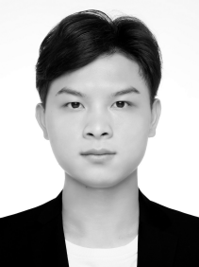
Bingyu Wei received the B.E. degree from Tongji Univer- sity, Shanghai, China, in 2023, where he is currently pur- suing the Ph.D. degree in control science and engineering. His research interests include pedestrian behavior, crowd stability, and computer vision.


Cuiling Li received the B.E. degree in automation from Northwestern Polytechnical University, China, the M.E. degree in automation from Lanzhou University of Tech- nology, China, and the Ph.D. degree in systems engineer- ing from Tongji University, China, in 1998, 2002, and 2007, respectively. Her research interests include pedes- trian dynamics, crowd stability, and artificial intelligence.


Rongyong Zhao received the B.E. degree in mechanical science from Jinan University, China, the M.E. degree in mechanical automation from Lanzhou University of Technology, China, and the Ph.D. degree in control theory and engineering from Tongji University, China, in 1999, 2002, and 2005, respectively. He is currently an Asso- ciate Professor with Tongji University, Shanghai, China. His research interests include pedestrian dynamics, crowd evacuation, and computer vision.

Zhengyang Shi is currently a senior engineer with Huangpu Public Security Bureau, Shanghai, China. His research interests include large-scale pedestrian-crowd safety, large language models, and artificial intelligence. He has published more than ten SCI papers in related fields and holds several authorized patents.


Yuxin Cai received the B.E. degree from China University of Petroleum (Beijing), China, in 2024. He is currently pursuing the master’s degree in digital information at Tongji University, Shanghai, China. His research interests include pedestrian anomaly detection, public safety, and computer vision.


Lingchen Han received the B.E. degree from Shang- hai Polytechnic University, Shanghai, China, in 2024. He is currently pursuing the master’s degree in digital information at Tongji University, Shanghai, China. His research interests include pedestrian anomaly detection, crowd stability, and computer vision.

