Avi Load Balancer (NSX ALB)
Architecture Overview & Production Monitoring Metrics
Reference note for a Python + MongoDB monitoring tool

1. The mental model
Avi splits cleanly into a control plane and a data plane. Almost every confusion about Avi dissolves once you know which plane a component lives in.
- Control plane = the Controller (the brain). It holds config, serves the UI / REST API, and collects analytics. It never touches production traffic.
- Data plane = the Service Engines (SEs) (the muscles). They terminate SSL, inspect HTTP, pick a backend, and forward packets. They make no policy decisions on their own.
Controllers and SEs talk to each other over a management network: config flows down, metrics and logs stream up.

2. Architecture diagram
The diagram below maps the full traffic path (top to bottom) with the key metrics shown inside each component box. The Controller sits on the side because it governs everything but is not in the traffic path.
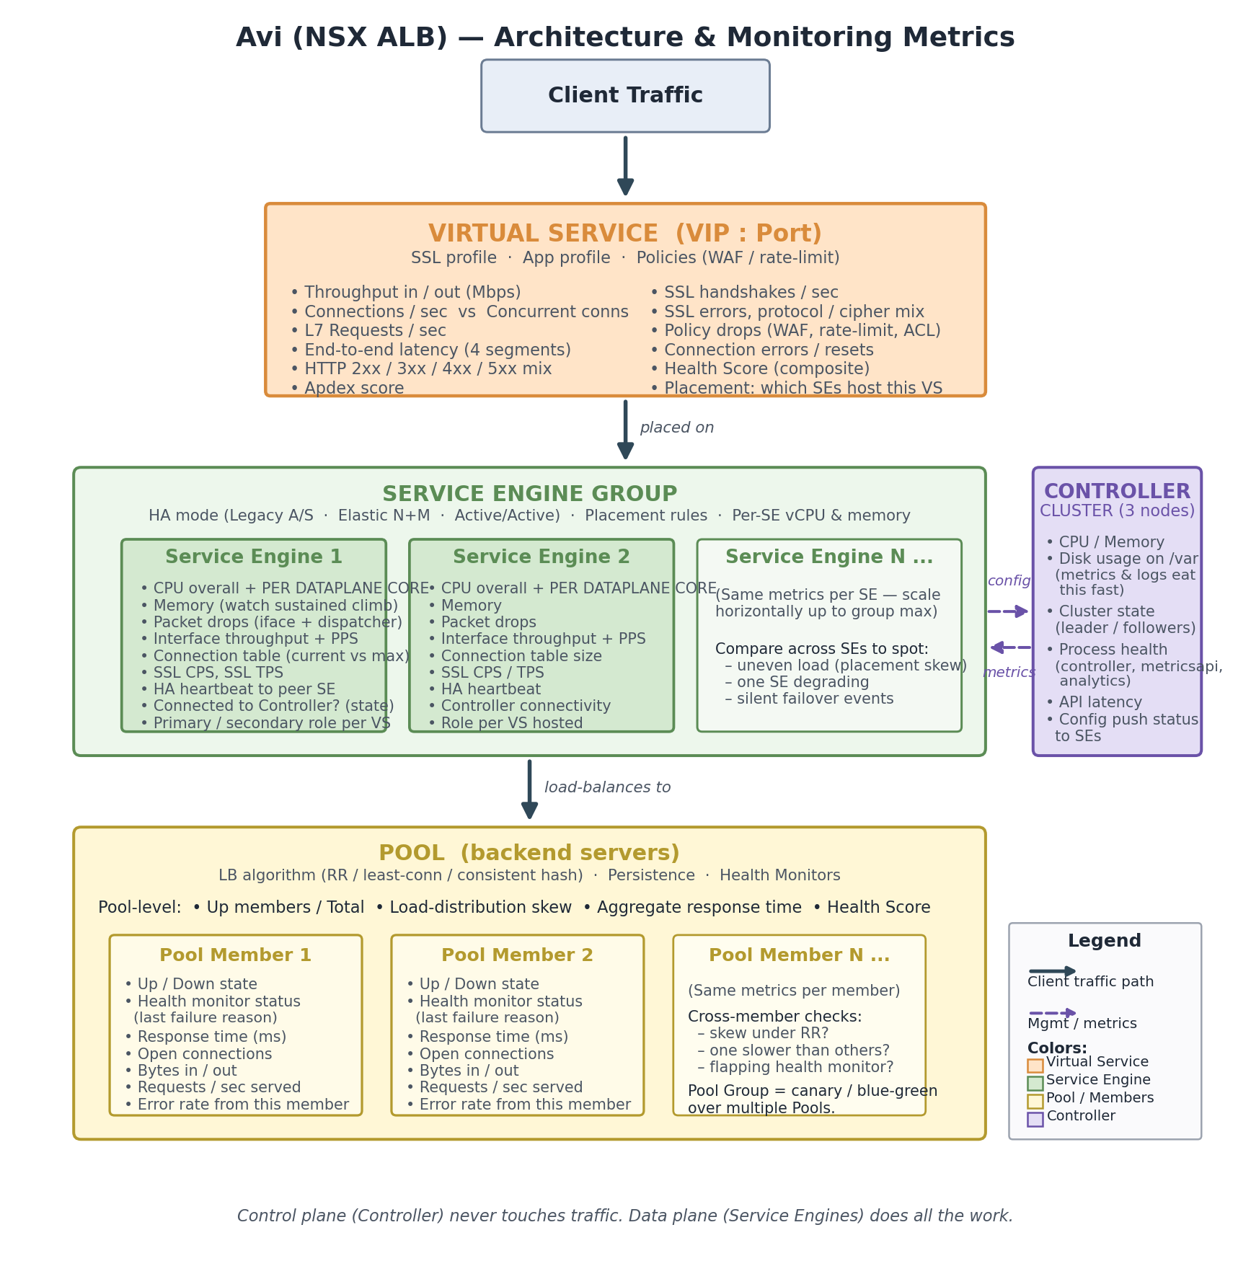

3. The components, one by one

3.1 Controller
Typically deployed as a 3-node cluster (one leader, two followers) for HA. Responsibilities:
- Stores all configuration and analytics.
- Serves the UI, REST API, and CLI.
- Pushes config down to Service Engines.
- Aggregates metrics streamed up from SEs.
Relevant to your stack: the Controller internally uses MongoDB to store configuration and analytics, so the data model will feel familiar when you start poking at the API.

3.2 Service Engines (SEs)
Service Engines are VMs (or containers, or bare metal) that actually do load balancing. One SE typically runs multiple Virtual Services.
Inside the SE, a dataplane process (historically se_dp) pins to CPU cores for packet processing. This is why CPU-per-core on an SE matters far more than overall CPU average — if one dispatcher core is pegged, that core’s traffic suffers even when the box looks 50% idle overall.

3.3 Service Engine Groups (SE Groups)
An SE Group is a template plus a pool of SEs that share common properties: HA mode, max SE count, vCPU / memory per SE, attached networks, placement rules. A Virtual Service is assigned to an SE Group, not to a specific SE — Avi then places it on SE(s) within the group.

HA modes (each changes what ‘normal’ looks like on dashboards)
- Legacy Active/Standby — classic 1:1 pairing. Simple, wasteful of capacity.
- Elastic HA N+M — N active SEs plus M buffer SEs; on failure, a buffer takes over. Good balance of efficiency and failover speed.
- Elastic HA Active/Active — all SEs active; a VS can be placed on multiple SEs with traffic distributed via ECMP / BGP or scale-out. Highest throughput, most complex.

3.4 Virtual Services (VS)
A Virtual Service is what clients actually connect to — a VIP + port + protocol — along with associated profiles (TCP/UDP, SSL, HTTP), policies (WAF, rate-limit, redirects), and a Pool (or Pool Group) of backends. If you’ve used F5, a VS is roughly the equivalent of a virtual server.
A VS is a logical object. It gets placed on one or more SEs within its SE Group, and Avi can move a VS between SEs for failover or scale-out.

3.5 Pools and Pool Members
A Pool is a set of backend servers behind a VS, plus an LB algorithm (round robin, least connections, consistent hash, etc.) and one or more health monitors (ping, TCP, HTTP, custom scripts).
A Pool Group is a set of pools used for blue/green, canary, A/B, and priority-based failover. Useful to recognize because skewed traffic across pools in a Pool Group is often by design (e.g. a 95/5 canary split), not a bug.

4. Important note on the API you are using
You are calling VMware Aria Operations, not the native Avi Controller API
Endpoint: https://{internal_address}/suite-api/api/resources/stats/latest
This URL pattern (/suite-api/…) belongs to VMware Aria Operations (formerly vRealize Operations / vROps). You are pulling Avi metrics through Aria’s management pack for Avi, not directly from the Avi Controller.
Implications you need to design around:

- Different data shape. Aria identifies everything as ‘resources’ with a resourceKind (e.g. AviVirtualService, AviServiceEngine, AviPool) and a resourceId (UUID). Metrics are referenced by statKey strings, not by Avi’s native metric names.
- Polling lag. Aria collects from Avi on an interval (typically 5 minutes). ‘Latest’ in /stats/latest means ‘latest that Aria has pulled’, not real-time. Treat these as near-real-time, not live.
- Reduced metric surface. You only see what the Avi management pack exposes to Aria, which is a subset of the native Avi analytics. Things like per-dataplane-core CPU or detailed latency breakdowns may be aggregated or missing.
- Aria is an abstraction layer. If Aria itself is unhealthy (collector down, adapter broken), your monitoring goes blind even when Avi is fine. Monitor the Aria adapter health as its own tier.
- Authentication & pagination. Aria uses token auth (/suite-api/api/auth/token/acquire) and returns paged results — plan for both from day one.
Practical first steps: call /suite-api/api/adapterkinds to confirm the Avi adapter is present, then /suite-api/api/resources?resourceKind=AviVirtualService (and the equivalent for SE, Pool, PoolMember, ServiceEngineGroup) to inventory resources, then /suite-api/api/resources/{id}/statkeys to enumerate which metrics each kind exposes. That tells you the real catalogue you can monitor.
Worth checking with the Avi team: whether you can also get direct access to the Avi Controller API (/api/analytics/metrics/collection) for the metrics Aria doesn’t expose — some shops use Aria for rolled-up dashboards and the native API for deeper diagnostics.

5. Metrics by layer — what to collect and why
Think in four layers, plus one composite indicator Avi gives you for free.

5.1 Controller health
If the Controller is sick, you lose visibility and config-change ability — but traffic keeps flowing. That’s an important reassurance when the Controller has a bad day.
Metric | Why it matters in Production Support
CPU, Memory | Baseline load; sudden jumps usually correlate with API hammering or analytics backlog.
Disk usage on /var | Metrics and logs eat disk fast. Disk-full on a Controller = silent monitoring outage. Alert early (70%) and hard (85%).
Cluster state | Is there a leader? Are followers in sync? Split-brain or no-leader = control plane broken.
Process health | controller, metricsapi, analytics processes alive and responsive.
API response latency | If you’re polling the API hard, rising latency means you’re starving yourself; back off or batch.
Config push status | SEs that are out of sync with Controller config are ticking time bombs for incidents.

5.2 Service Engine health
This is the layer that fails most interestingly in production.
Metric | Why it matters in Production Support
CPU overall + per dataplane core | Per-core is the one that actually predicts pain. An SE averaging 40% overall CPU can still drop packets if one dispatcher core is at 100%.
Memory | SEs hold connection tables and SSL session state in memory. Watch for sustained climb, not just level.
Packet drops (interface + dispatcher) | Non-zero and rising is always worth investigating — usually a capacity, NIC, or dispatcher-pinning issue.
Interface throughput + PPS | In and out, per interface. Compare against SE rated capacity and the underlying NIC / host.
Connection table size (current vs max) | Running out of connection slots causes weird, hard-to-diagnose application failures.
SSL CPS and SSL TPS | SSL handshakes are expensive. CPS spikes burn CPU fast; a sudden spike often points to client-side bug or an attack.
SE-to-SE HA heartbeat | Silent heartbeat issues cause phantom failovers. Watch latency and loss on the heartbeat path.
Controller connectivity / SE state | Is the SE connected to Controller? Is it primary or secondary for each VS? State flaps = unstable placement.

5.3 Virtual Service metrics
This is where SREs and app owners usually care most, because a VS maps to an application.
Metric | Why it matters in Production Support
Throughput in / out (Mbps) | Baseline and peak by time-of-day; enables capacity planning and spots sudden traffic shifts.
Connections per second (CPS) | New connection rate. Spikes burn SE CPU and SSL resources.
Concurrent connections | Different failure mode from CPS — long-lived connections fill connection tables rather than burning CPU.
Requests per second (L7) | For HTTP VSes, the real app-load metric.
End-to-end latency (4 segments) | Avi splits latency into client RTT, SE processing, server RTT, application response time. Gold for blame assignment — you can say ‘the LB is fine, the app added 400 ms’ with data behind you.
HTTP 2xx / 3xx / 4xx / 5xx mix | Response-code distribution is your fastest app-health signal. Watch the ratio, not just absolute 5xx count.
SSL handshakes / sec + SSL errors | Certificate problems, cipher mismatches, client retries — all surface here first.
Policy drops | WAF blocks, rate-limit drops, ACL denies. Spikes here may be attacks, or a legitimate change breaking policy.
Connection errors / resets | TCP RSTs from clients or backends often point to MTU, idle-timeout, or backend crash issues.
Health Score + Apdex | Composite at-a-glance numbers. Good for dashboards, not a replacement for raw metrics.

5.4 Pool and Pool Member metrics
Metric | Why it matters in Production Support
Up members / Total members | Headline pool health. One down under load = degraded; two down in a three-member pool = incident.
Member up/down state + last health-monitor failure reason | The ‘why’ matters as much as the ‘what’ — 404 on health URL vs. TCP timeout vs. cert failure are three different problems.
Response time per member | Slow-member detection. A member that’s up but slow is often the worst production experience.
Open connections per member | Reveals persistence misconfig or capacity mismatch between members.
Bytes in / out, requests/sec per member | Used for load-distribution skew checks — see row below.
Load-distribution skew | Derived metric: if round-robin is configured and one member is taking 80% of traffic, something is wrong (persistence, weights, flapping peer, or a capacity mismatch).
Error rate from a specific member | Helps you distinguish ‘the app is broken’ from ‘one node is broken’.

5.5 Composite: Health Score and Apdex
Avi computes a Health Score (0–100) for Virtual Services, Pools, Pool Members, and Service Engines. It is a composite of performance, anomaly, resource, and security sub-scores.
It is not a substitute for raw metrics — composites hide detail — but it is a great first-pass signal for dashboards and alerting. A VS dropping from 90 to 60 tells you ‘something changed here, go look.’ Pair it with Apdex (for L7 services) and you have two strong at-a-glance numbers for an overview dashboard.

6. Practical advice for the monitoring tool

6.1 Scope the real metric catalogue before coding
Because you are going through Aria, do not assume Avi’s native metric list applies. Enumerate once: list resource kinds, list resources per kind, list statkeys per resource. Save this output — it becomes your source of truth for what’s monitorable. Then choose the subset you actually care about (typically 15–25 statkeys cover 95% of production-support needs).

6.2 Decide your cardinality budget in Mongo early
Per-VS, per-pool-member, per-SE, per-minute metrics get voluminous fast. Pick a retention tier strategy before you start, not after. A reasonable default:
- 1-minute resolution retained for 7 days (hot, queryable by ops).
- 5-minute resolution retained for 30 days (warm, for trending).
- Hourly roll-ups retained for 1 year (cold, for capacity planning).
In Mongo terms, consider a time-series collection (native since Mongo 5.0) keyed by resource_id with metric and timestamp — it gives you automatic bucketing and much smaller on-disk footprint than a rolled-your-own schema.

6.3 Separate polling from alerting
Make the collector a dumb pipeline: fetch → normalize → store. Alerting rules read from Mongo and are stateless where possible. This lets you replay, re-aggregate, and test rules without touching the collector.

6.4 Watch the monitoring tool itself
Add a few meta-metrics: successful poll count per resource, last-successful-poll age, Aria API error rate, and collector lag. Your first production incident in this tool will be ‘we lost visibility but nobody noticed for 2 hours.’ Instrument against that.

6.5 Ask the Avi team three questions
- Which tenants and clouds exist? Multi-tenant Avi scopes everything; if missed, your tool will silently only see one tenant.
- Which HA mode is each SE Group in? It shapes what ‘normal’ looks like per VS (traffic on 1 SE vs. spread across N).
- Can we also have a read-only user on the Avi Controller as a fallback? Useful when Aria is down, and for the metrics Aria doesn’t expose.

7. Quick glossary
Metric | Why it matters in Production Support
Controller | 3-node cluster running the control plane; config, UI, API, metrics aggregation.
Service Engine (SE) | Data-plane VM/container/bare-metal that handles actual traffic.
Service Engine Group | Template + pool of SEs sharing HA mode, sizing, networks, placement rules.
Virtual Service (VS) | Client-facing VIP + port + profiles + policies + pool. Maps to an application.
Pool | Backend servers behind a VS, plus LB algorithm, persistence, and health monitors.
Pool Group | A set of pools for canary / blue-green / A-B / priority failover.
Pool Member | Individual backend server inside a Pool.
VIP | Virtual IP — the address clients connect to for a VS.
Health Score | Avi-computed composite (0–100) across performance, anomaly, resource, security.
Apdex | Application Performance Index, computed for L7 services — user-satisfaction proxy.
Aria Operations / vROps | VMware’s monitoring platform. The /suite-api endpoint lives here, not in Avi.

