**FORMAN CHRISTIAN COLLEGE (A CHARTERED UNIVERSITY)**



**Computer Organization and Assembly Language – COMP 300 B**

**Spring 21**

**Lab - 02**

**Muhammad Sameed Gilani - 231488347**

**You should attach the lab / assignment handout as second page of this report.**

**From third page onwards following headings should be included:**

* **Introduction**
  + **Should carry information of all major library functions.**
* **Your logic / algorithm in simple English. Bullet points are appreciated.**
* **Your code**
* **Screen shots of at least three outputs of your code with appropriate inputs.**
* **References**

**INTRODUCTION**

To make the binary cell, I used 3 AND gates, 2 NOT gates, a SR flip flop and several input/output pins. They are the basic building block to make a RAM. They can Write and Read a 1-bit value.

To make the 3x8 Decoder, I used 8 AND gates, 3 NOT gates and several input/output pins. A decoder selects only 1 of its outputs, depending on its inputs. In this case, depending on the 3-bit input it would select 1 of outs 8 outputs.

To make the 8x4 RAM I used, 32 Binary cells and a 3x8 Decoder (both made previously), 4 OR gates and several input/output gates. This RAM could Read and Write a 4-bit value.

**LOGIC**

* I first made a binary cell, following what we learnt from a previous lecture. Then I made a sub-circuit of it.
* Then I made a 3x8 Decoder. By first making a truth table for it and then using it to make the circuit. Then I made a sub-circuit of it.
* Then for the RAM, it would have 8 rows and 4 columns, in total consisting of 32 binary cells.
* I laid out the sub-circuits of the binary cells in that format and the decoder too.
* Each row of binary cells would have a common select input line, connecting to one of the decoders outputs. 8 rows of binary cells, connecting to each of the 8 decoders outputs.
* The decoder has 3 input pins connecting for input of a 3-bit value. And an enable input.
* Each column of binary cells would have a common input line. In total 4 input lines, connecting to 4 separate input pins.
* All of the binary cells have the same Read/Write input.
* Each column of Binary cells, have their output lines connecting to an OR gate. 4 columns, each connecting to their own OR gate, creating a 4-bit output.
* This completed the 8x4 ram. Which can Read/Write 4-bit values.

**OUTPUTS**

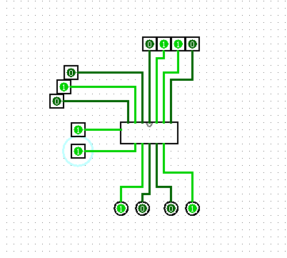 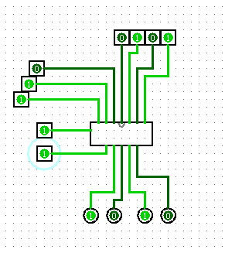 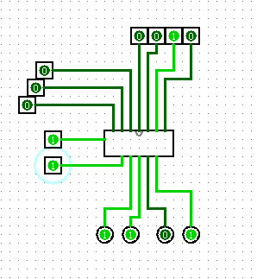

NOTE:

* I forgot to add the sub-circuit for the whole RAM in the logism file. I’ve only made the sub-circuit here for the output simulation, for ease of displaying the inputs and outputs.
* The RAM was complementing the ouput. Which could have been fixed by adding NOT gates at the inputs.  
  I believe this issue is caused by a mistake in the construction of the binary cell. However, I’m not completely sure.