**FORMAN CHRISTIAN COLLEGE (A CHARTERED UNIVERSITY)**



**Computer Organization and Assembly Language – COMP 300 B**

**Spring 21**

**Lab - 03**

**Muhammad Sameed Gilani - 231488347**

**You should attach the lab / assignment handout as second page of this report.**

**From third page onwards following headings should be included:**

* **Introduction**
  + **Should carry information of all major library functions.**
* **Your logic / algorithm in simple English. Bullet points are appreciated.**
* **Your code**
* **Screen shots of at least three outputs of your code with appropriate inputs.**
* **References**

**INTRODUCTION**

To make the 4x8 Register File, I used 8 registers, with 4bit width, 1 3x8 Decoder, 8 8x1 Mux, 8 splitters and several input/output pins.

A register is used to retain data and provide it when we need it to. They are made up of flip flops and Mux. A register file is a group of registers, consisting of 2k registers, needing k bits to access each register using a decoder.  
The size of the register file is, 2k x (width of the registers used). In this case, the width is 4 bits and 23 = 8 registers are used, making the size , 4x8. The register file works with the ALU to process data.

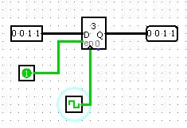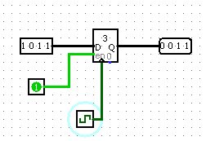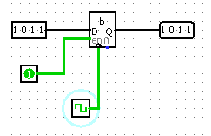

We can store n bit data in a register, 4 bits in this case and the output is constantly available at the output line. With each clock pulse, rising edge in this example, the register updates the stored value and immediately displays it.

Decoders are used to select one output depending on its input. With , k inputs and 2k outputs. In this circuit, a 3x8 decoder is used. As 8 registers are being used, all 8 outputs of the decoder are connected with the enable input of each register. And with the corresponding input to the decoder, we enable the one register we require.

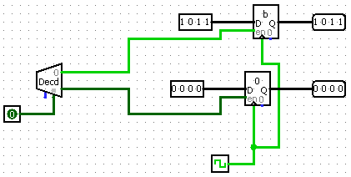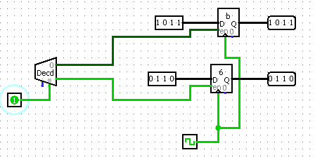

As shown, when the select input of the decoder is 0, only one register is active, and the data stored in it is displayed. And when we change the select input to 1, the other register is active, and its data is displayed.

Splitters are used to divide data into single bits, separately. As in this circuit it is used to split the 4 bit output of each register, into 4 separate data lines.

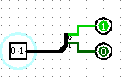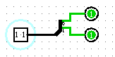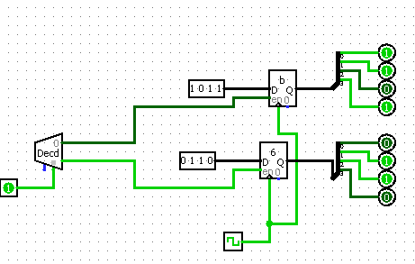

As in these examples, it only outputs the input data into separate lines.

Multiplexers take many inputs and have only one output. With 2k inputs and one output. As in this circuit 8x1 Mux are used. It is used to select only one of its inputs to be displayed at the output, as a data selector. Using its select input, which is k bits, we select which of its inputs we want to access.

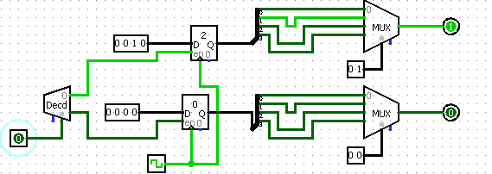

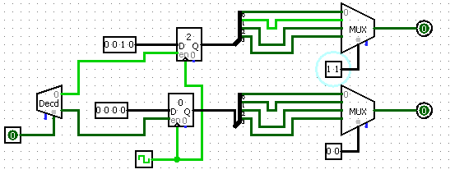

As in these examples, the Mux only outputs the data of the line, corresponding to the select input.

**LOGIC**

* To make the 4x8 register file, I placed 8 register with 4 bit width.
* All 8 of them have common clock inputs and data input.
* Each of their enable input in connected to one output of a 2x8 decoder.
* Each of the registers 4 bit output, is divided into separate data lines, using splitters.
* We require 4 Mux to display the output of 1 register. The least significant bit of each register output is connected to the same mux, which would display the least significant bit. Similarly till the Most significant bit.
* We use another set of 4 mux, which can be used to access data from another register. Allowing the register file to access data from 2 registers.
* 1 set of 4 mux uses the same select input.
* So by inputting a select value to the decoder, we select the register we want to access. We then use the data input to load data on to the register. With the clock pulses rising edge the data is loaded.
* Then by giving the same select input as the decoder, to the multiplexer set, we can access the data stored on the register, we had previously chosen.

**SIMULATION**

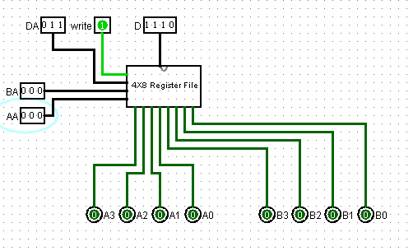 **1.** Data (1110) is loaded onto R3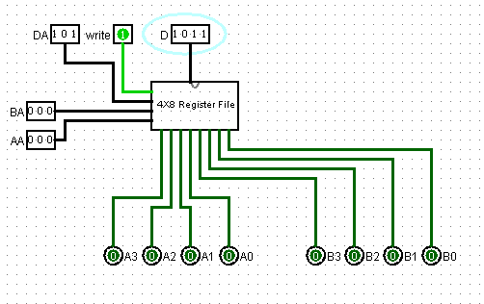**2.** Data (1011) is loaded onto R5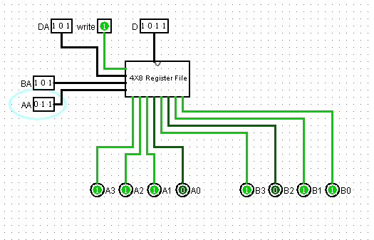**3.** The data of R3 and R5 are displayed.