**DATA INSERTION**

use FCC;

CREATE TABLE Dept (

DEPTNO INT PRIMARY KEY,

DNAME VARCHAR (20) NOT NULL,

LOC VARCHAR (20) NOT NULL,

);

CREATE TABLE Emp (

EMPNO INT PRIMARY KEY,

ENAME VARCHAR (20) NOT NULL,

JOB VARCHAR (25) NOT NULL,

MGR INT DEFAULT NULL,

HIREDATE VARCHAR (20) NOT NULL,

SAL INT NOT NULL,

COMM INT DEFAULT NULL,

DEPTNO INT NOT NULL,

FOREIGN KEY (DEPTNO) REFERENCES Dept (DEPTNO)

);

INSERT INTO Dept ( DEPTNO, DNAME, LOC) VALUES (10,'ACCOUNTING','NEW YORK');

INSERT INTO Dept ( DEPTNO, DNAME, LOC) VALUES (20,'RESEARCH','DALLAS');

INSERT INTO Dept ( DEPTNO, DNAME, LOC) VALUES (30,'SALES','CHICAGO');

INSERT INTO Dept ( DEPTNO, DNAME, LOC) VALUES (40,'OEPRATIONS','BOSTON');

INSERT INTO Emp ( EMPNO, ENAME, JOB, MGR, HIREDATE, SAL,DEPTNO ) VALUES ( 7368,'SMITH','CLERK',7902,'17-DEC-80',800,20 );

INSERT INTO Emp ( EMPNO, ENAME, JOB, MGR, HIREDATE, SAL, COMM, DEPTNO ) VALUES ( 7499,'ALLEN','SALESMAN',7698,'20-FEB-81',1600,300,30 );

INSERT INTO Emp ( EMPNO, ENAME, JOB, MGR, HIREDATE, SAL, COMM, DEPTNO ) VALUES ( 7521,'WARD','SALESMAN',7698,'22-FEB-81',1250,500,30 );

INSERT INTO Emp ( EMPNO, ENAME, JOB, MGR, HIREDATE, SAL,DEPTNO ) VALUES ( 7566,'JONES','MANAGER',7839 ,'02-APR-81',2975 ,20 );

INSERT INTO Emp ( EMPNO, ENAME, JOB, MGR, HIREDATE, SAL, COMM, DEPTNO ) VALUES ( 7654,'MARTIN','SALESMAN',7698,'28-SEP-81',1250,1400,30 );

INSERT INTO Emp ( EMPNO, ENAME, JOB, MGR, HIREDATE, SAL,DEPTNO ) VALUES ( 7698,'BLAKE','MANAGER',7839 ,'01-MAY-81',2850,30 );

INSERT INTO Emp ( EMPNO, ENAME, JOB, MGR, HIREDATE, SAL,DEPTNO ) VALUES ( 7782,'CLARK','MANAGER',7839 ,'09-JUN-81',2450 ,10 );

INSERT INTO Emp ( EMPNO, ENAME, JOB, MGR, HIREDATE, SAL,DEPTNO ) VALUES ( 7788,'SCOTT','ANALYST',7566 ,'09-DEC-82',3000 ,20 );

INSERT INTO Emp ( EMPNO, ENAME, JOB, HIREDATE, SAL,DEPTNO ) VALUES ( 7839,'KING','PRESIDENT','17-NOV-81',5000 ,10 );

INSERT INTO Emp ( EMPNO, ENAME, JOB, MGR, HIREDATE, SAL,DEPTNO ) VALUES ( 7844,'TURNER','SALESMAN',7698 ,'08-SEP-81',1500 ,30 );

INSERT INTO Emp ( EMPNO, ENAME, JOB, MGR, HIREDATE, SAL,DEPTNO ) VALUES ( 7876,'ADAMS','CLERK',7788 ,'12-JAN-83',1100 ,20 );

INSERT INTO Emp ( EMPNO, ENAME, JOB, MGR, HIREDATE, SAL,DEPTNO ) VALUES ( 7900,'JAMES','CLERK',7698 ,'03-DEC-81',950 ,30 );

INSERT INTO Emp ( EMPNO, ENAME, JOB, MGR, HIREDATE, SAL,DEPTNO ) VALUES ( 7902,'FORD','ANALYST',7566 ,'03-DEC-81',3000 ,20 );

INSERT INTO Emp ( EMPNO, ENAME, JOB, MGR, HIREDATE, SAL,DEPTNO ) VALUES ( 7934,'MILLER','CLERK',7782 ,'23-JAN-82',1300 ,10 );

/* 1 */

select * from Emp

select * from Dept

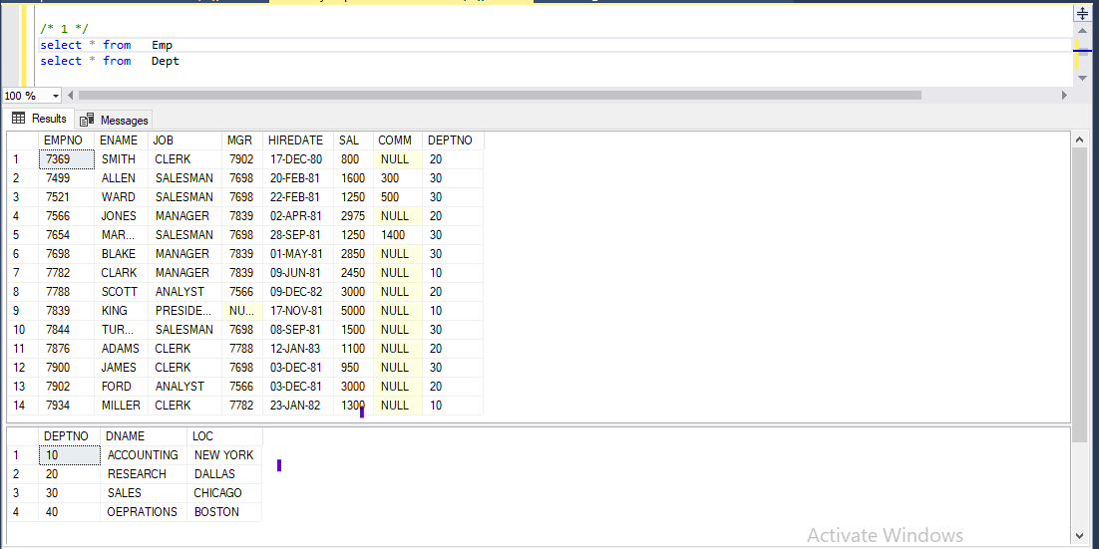

/* 2 */

select SAL,COMM

from emp

where ENAME = 'JONES'

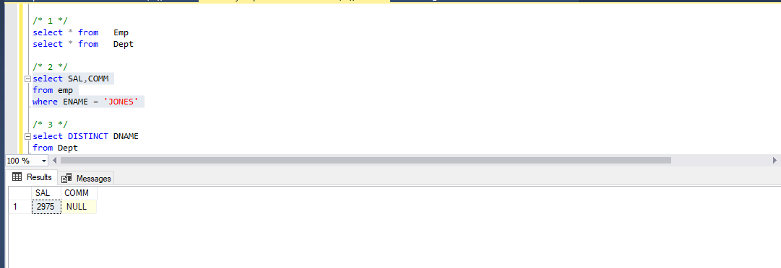

/* 3 */

select DISTINCT DNAME

from Dept

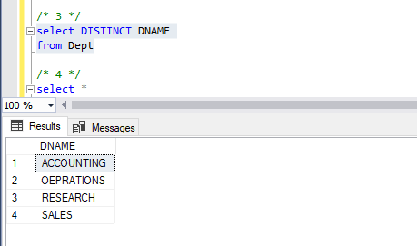

/* 4 */

select *

from Emp

where ENAME like '%LL%'

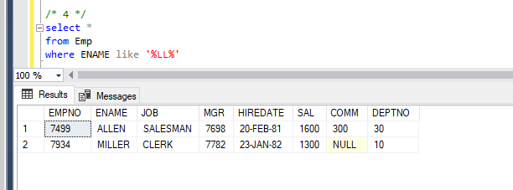

/* 5 */

select *

from Emp

where datediff(day,HIREDATE,SYSDATETIME()) < datediff(day,'08-SEP-81',SYSDATETIME())

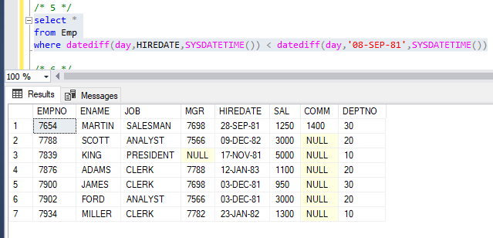

/* 6 */

select SAL

from Emp

where JOB = 'CLERK' or JOB = 'SALESMAN'

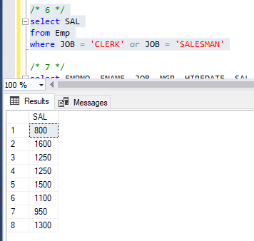

/* 7 */

select EMPNO, ENAME, JOB, MGR, HIREDATE, SAL, SAL*100 'actual_sal',DEPTNO

from Emp

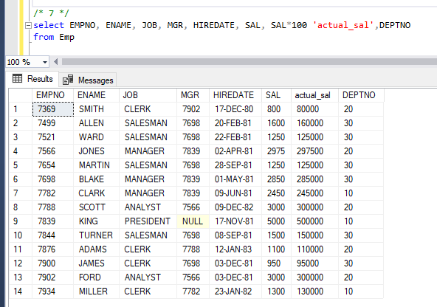

/* 8 */

select *

from Emp

where COMM between 500 and 1200

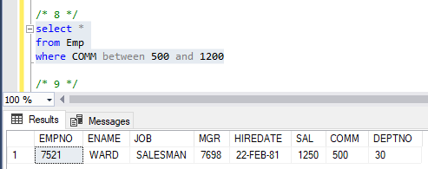

/* 9 */

select *

from Emp

where COMM NOT IN (500,300)

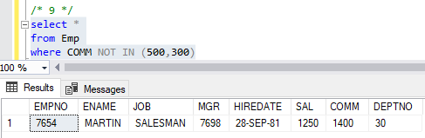

/* 10 */

select COUNT(DEPTNO) AS 'Grand Total'

from Emp

where DEPTNO = 30

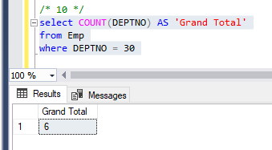

/* 11 */

select EMPNO, ENAME,CONCAT(ENAME,' is in dept ',DEPTNO) AS 'con', JOB, MGR, HIREDATE, SAL,DEPTNO

from Emp

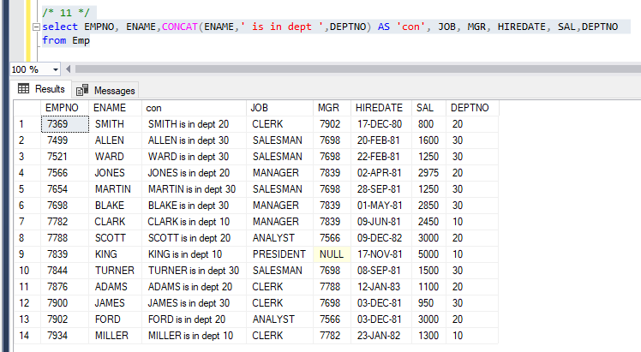

/* 12 */

select Emp.SAL,Dept.DEPTNO,Dept.DNAME, Dept.LOC

from Emp,Dept

order by SAL DESC

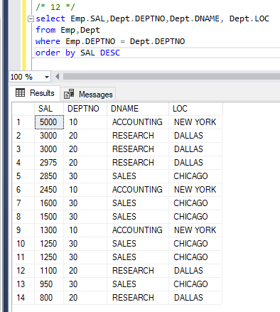

/* 13 */

select Emp.ENAME,Emp.SAL, Emp.JOB, Dept.LOC

from Emp,Dept

where (Emp.COMM * 5) = SAL

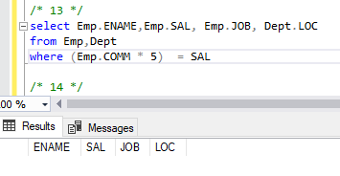

/* 14 */

select ENAME,SAL, CASE JOB when 'CLERK' then

(CASE SAL when 800 then SAL+300 else SAL end) else SAL end 'Salary + 300'

from Emp

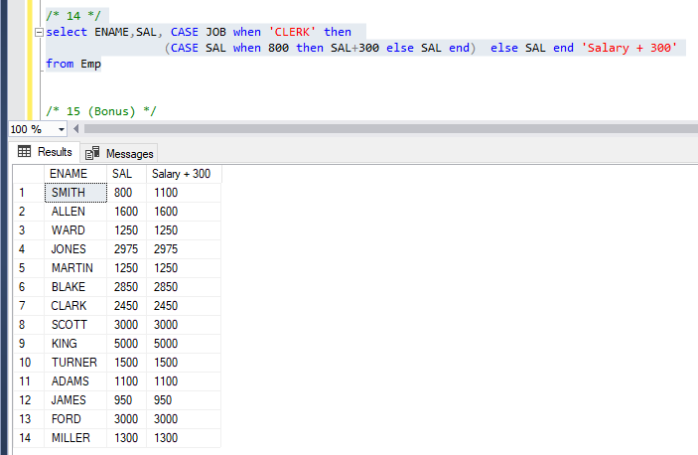

/* 15 (Bonus) */

select SAL

from Emp,Dept

where Emp.DEPTNO = Dept.DEPTNO AND ( MGR = 7902 or LOC = 'Boston' )

