**DATA INSERTION** – (From LAB 2)

use FCC;

CREATE TABLE Dept (

DEPTNO INT PRIMARY KEY,

DNAME VARCHAR (20) NOT NULL,

LOC VARCHAR (20) NOT NULL,

);

CREATE TABLE Emp (

EMPNO INT PRIMARY KEY,

ENAME VARCHAR (20) NOT NULL,

JOB VARCHAR (25) NOT NULL,

MGR INT DEFAULT NULL,

HIREDATE VARCHAR (20) NOT NULL,

SAL INT NOT NULL,

COMM INT DEFAULT NULL,

DEPTNO INT NOT NULL,

FOREIGN KEY (DEPTNO) REFERENCES Dept (DEPTNO)

);

INSERT INTO Dept ( DEPTNO, DNAME, LOC) VALUES (10,'ACCOUNTING','NEW YORK');

INSERT INTO Dept ( DEPTNO, DNAME, LOC) VALUES (20,'RESEARCH','DALLAS');

INSERT INTO Dept ( DEPTNO, DNAME, LOC) VALUES (30,'SALES','CHICAGO');

INSERT INTO Dept ( DEPTNO, DNAME, LOC) VALUES (40,'OEPRATIONS','BOSTON');

INSERT INTO Emp ( EMPNO, ENAME, JOB, MGR, HIREDATE, SAL,DEPTNO ) VALUES ( 7368,'SMITH','CLERK',7902,'17-DEC-80',800,20 );

INSERT INTO Emp ( EMPNO, ENAME, JOB, MGR, HIREDATE, SAL, COMM, DEPTNO ) VALUES ( 7499,'ALLEN','SALESMAN',7698,'20-FEB-81',1600,300,30 );

INSERT INTO Emp ( EMPNO, ENAME, JOB, MGR, HIREDATE, SAL, COMM, DEPTNO ) VALUES ( 7521,'WARD','SALESMAN',7698,'22-FEB-81',1250,500,30 );

INSERT INTO Emp ( EMPNO, ENAME, JOB, MGR, HIREDATE, SAL,DEPTNO ) VALUES ( 7566,'JONES','MANAGER',7839 ,'02-APR-81',2975 ,20 );

INSERT INTO Emp ( EMPNO, ENAME, JOB, MGR, HIREDATE, SAL, COMM, DEPTNO ) VALUES ( 7654,'MARTIN','SALESMAN',7698,'28-SEP-81',1250,1400,30 );

INSERT INTO Emp ( EMPNO, ENAME, JOB, MGR, HIREDATE, SAL,DEPTNO ) VALUES ( 7698,'BLAKE','MANAGER',7839 ,'01-MAY-81',2850,30 );

INSERT INTO Emp ( EMPNO, ENAME, JOB, MGR, HIREDATE, SAL,DEPTNO ) VALUES ( 7782,'CLARK','MANAGER',7839 ,'09-JUN-81',2450 ,10 );

INSERT INTO Emp ( EMPNO, ENAME, JOB, MGR, HIREDATE, SAL,DEPTNO ) VALUES ( 7788,'SCOTT','ANALYST',7566 ,'09-DEC-82',3000 ,20 );

INSERT INTO Emp ( EMPNO, ENAME, JOB, HIREDATE, SAL,DEPTNO ) VALUES ( 7839,'KING','PRESIDENT','17-NOV-81',5000 ,10 );

INSERT INTO Emp ( EMPNO, ENAME, JOB, MGR, HIREDATE, SAL,DEPTNO ) VALUES ( 7844,'TURNER','SALESMAN',7698 ,'08-SEP-81',1500 ,30 );

INSERT INTO Emp ( EMPNO, ENAME, JOB, MGR, HIREDATE, SAL,DEPTNO ) VALUES ( 7876,'ADAMS','CLERK',7788 ,'12-JAN-83',1100 ,20 );

INSERT INTO Emp ( EMPNO, ENAME, JOB, MGR, HIREDATE, SAL,DEPTNO ) VALUES ( 7900,'JAMES','CLERK',7698 ,'03-DEC-81',950 ,30 );

INSERT INTO Emp ( EMPNO, ENAME, JOB, MGR, HIREDATE, SAL,DEPTNO ) VALUES ( 7902,'FORD','ANALYST',7566 ,'03-DEC-81',3000 ,20 );

INSERT INTO Emp ( EMPNO, ENAME, JOB, MGR, HIREDATE, SAL,DEPTNO ) VALUES ( 7934,'MILLER','CLERK',7782 ,'23-JAN-82',1300 ,10 );

use FCC;

/* Task1 */

select ROUND (194.382, 2)

select ROUND(194.382, -2)

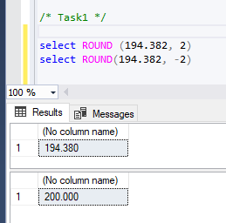

/* Task2 */

/* 1 */

select ENAME AS 'Employee', HIREDATE AS 'Hiring Date', EMPNO AS 'Employee Number',Dept.DNAME AS 'Department Name'

from Emp,Dept

where Emp.DEPTNO = Dept.DEPTNO and (Emp.MGR = 7698 or Emp.MGR = 67839)

ORDER by Emp.EMPNO ASC

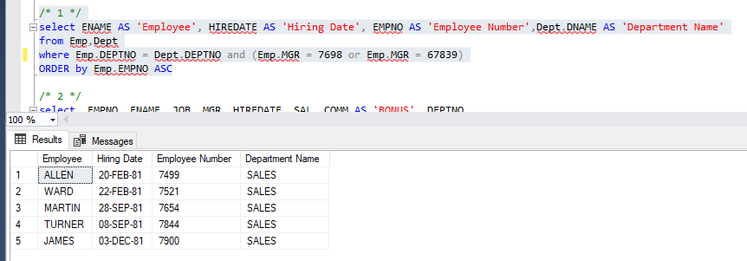

/* 2 */

select EMPNO, ENAME, JOB, MGR, HIREDATE, SAL, COMM AS 'BONUS', DEPTNO

from Emp

where JOB != 'CLERK' AND JOB != 'SALESMAN'

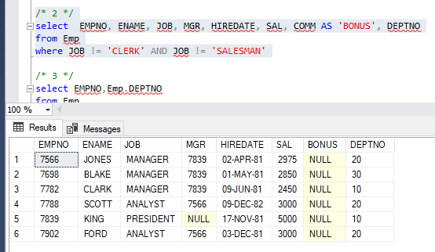

/* 3 */

select EMPNO,Emp.DEPTNO

from Emp

FULL OUTER JOIN Dept ON Emp.DEPTNO = Dept.DEPTNO

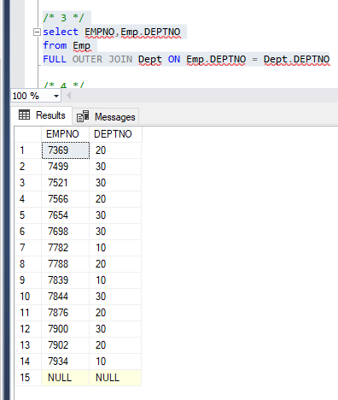

/* 4 */

select *

from Emp,Dept

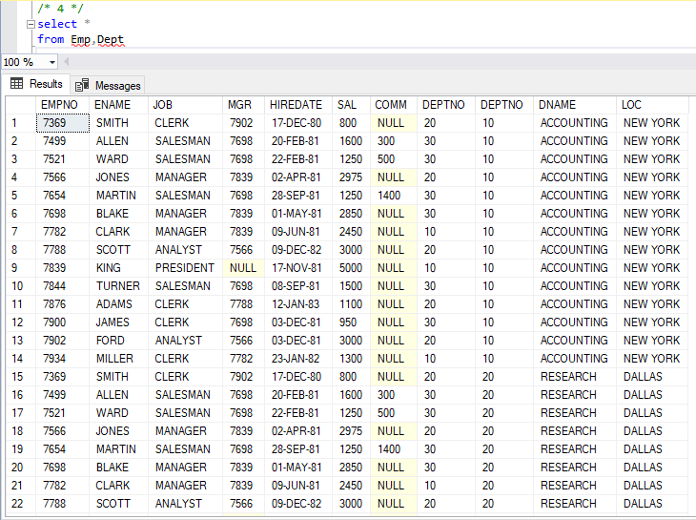

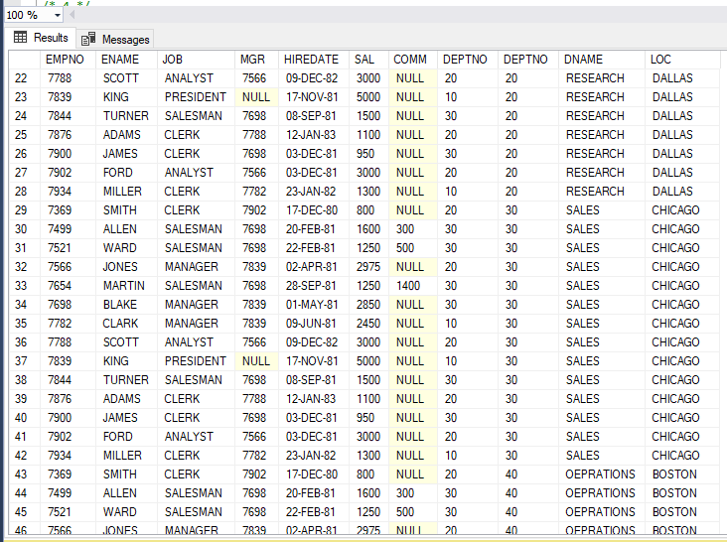

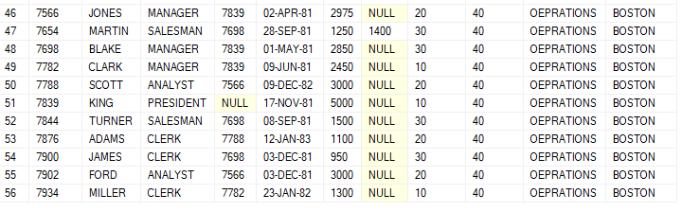

/* 5 */

select ( SUM(comm) / COUNT(EMPNO) ) AS ' Including NULL Values'

from Emp

select AVG(COMM) AS ' Excluding NULL Values'

from Emp

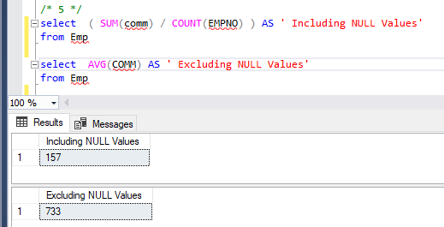

/* 6 */

select *

from Emp job, Emp emp

where job.EMPNO = emp.EMPNO

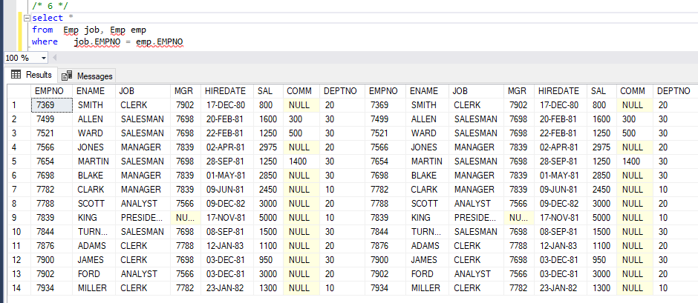

/* 7 */

select COUNT(EMPNO)

from Emp,Dept

where Emp.DEPTNO = Dept.DEPTNO and (DNAME ='SALES' or DNAME = 'OPERATIONS')

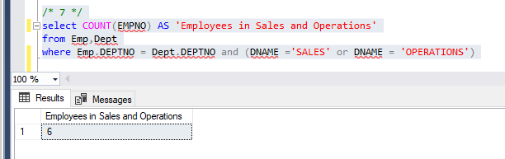

/* 8 */

select SUM(SAL) AS 'Salary Distributed to Research Department'

from Emp,Dept

where Emp.DEPTNO = Dept.DEPTNO and DNAME = 'RESEARCH'

