**#QUESTION 1**

(A.)

XYZ + X’Y + XYZ’ = XY (Z + Z’ ) + X’Y = XY + X’Y

🡺 Y( X + X’) = Y

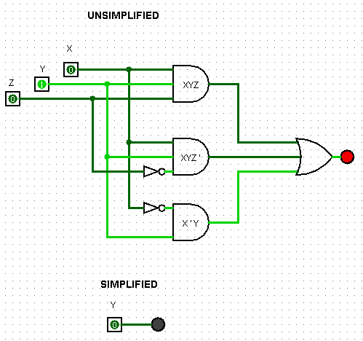

(B.)

(BC’+ A’D) (AB’ + CD’) = (BC’ ⋅ AB’) + (BC’ ⋅ CD’) + (A’D ⋅ AB’) + (A’D ⋅ CD’)

As , X ⋅ X’ = 0

🡺 0

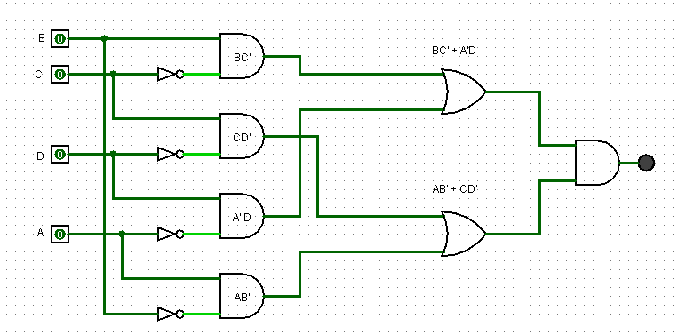

**#QUESTION 2**

A’B (D + C’D) + B (A + A’CD) = A’BD + A’BC’D + AB + A’BCD = A’BD ( 1 + C’ +C ) + AB

= A’BD + AB = B(A’D+A)

As, X’ Y + X = Y + X

= B(A+D)

🡺 AB + BD

**#QUESTION 3**

F= Z + Z’(V’W + XY)

F’ = ( Z’) ( Z + V + W’) ( Z + X’ +Y’)

= ( Z’Z + Z’V + Z’W’) ( Z + X’ + Y’) = ( Z’V + Z’W’) ( Z + X’ + Y’)

= Z’ZV + Z’V+X’ + Z’VY’ + Z’ZW’ + Z’W’X’ + Z’W’Y’

= Z’V+X’ + Z’VY’ + Z’W’X’ + Z’W’Y’

🡺 Z’ ( VX’ + VY’ + W’X’ + W’Y’ )

**#QUESTION 4**

- F(A,B,C) = A’B+A’C’+ABC

|  |  |  |  |  |  |  |
| --- | --- | --- | --- | --- | --- | --- |
| A | B | C | A’B | A’C’ | ABC | F |
| 0 | 0 | 0 | 0 | 1 | 0 | 1 |
| 0 | 0 | 1 | 0 | 0 | 0 | 0 |
| 0 | 1 | 0 | 1 | 1 | 0 | 1 |
| 0 | 1 | 1 | 1 | 1 | 0 | 1 |
| 1 | 0 | 0 | 0 | 0 | 0 | 0 |
| 1 | 0 | 1 | 0 | 0 | 0 | 0 |
| 1 | 1 | 0 | 0 | 0 | 0 | 0 |
| 1 | 1 | 1 | 0 | 0 | 1 | 1 |

* SOM :

🡺 A’B’C’ + A’BC’ + A’BC + ABC

* POM :

🡺 (A+B+C’) (A’+B+C) (A’+B+C’) (A’+B’+C)

* POS:

(A+B+C’) (A’+B+C) (A’+B+C’) (A’+B’+C)

(AB+AC+A’B+B+BC+A’C’+BC’)(A’+A’B’+A’C+A’B+BC+A’C’+B’C’)

[ B(A+A’)+B(C+C’)+AC+A’C’+B ] [A’(B’+B)+A’(C+C’)+BC+B’C’+A’]

(B+B+AC+A’C’+B)(A’+A’+BC+B’C’+A’)

(B+AC+A’C’)(A’+BC+B’C’)

A’B+BC+ABC+A’C’+A’B’C’

🡺 A’B + BC +A’C’

**#QUESTION 5**

(A.)

* SOM(F1):

🡺 A’B’C’ + A’BC’ + A’BC + AB’C’ + ABC

(B.)

* POM(F2):

= (A+B’+C) ( A’+B+C) (A’ + B’ +C’)

= (AB + AC + A’B’ + B’C + A’C + BC +C ) (A’ + B’ +C’)

= [ C ( A + B’ + A’ + B +1) + AB + A’B’] (A’ + B’ +C’)

= (C + AB + A’B’) (A’ + B’ +C’)

= A’C + B’C + ABC’ + A’B’ + A’B’ + A’B’C’

= A’C + B’C + ABC’ + A’B’ +A’B’C’

= A’C + B’C + ABC’ + A’B’ ( 1 + C’)

🡺 A’C + B’C + ABC’ + A’B’