FORMAN CHRISTIAN COLLEGE (A CHARTERED UNIVERSITY)


CSCS 306 – Embedded Systems
Fall 22
Lab - 03

Muhammad Sameed Gilani - 231488347

You should attach the hard copy of signed and graded lab / assignment handout as second page of this report.
From third page onwards following headings should be included:
- Introduction
  - Should carry information of all major library /user defined functions used in this lab/assignment.
- Your logic / algorithm in simple English. Bullet points are appreciated.
- Your code
- Circuit diagram (drawn using some online tool. Hand drawn diagrams are not accepted)
- Picture of the running hardware.
- Screen shots of at least three outputs of your code with appropriate inputs.
- References if any

INTRODUCTION:
Simulated a gas pump using a 4x4 keypad with Arduino uno.
Used the Keypad library to map a 4x3 keypad onto the 4x4 keypad. With the keypad, the user enters the amount of fuel they want. Appropriate text is printed in response and an LED blinks in response to how much fuel is being dispensed.

LOGIC:
- Using the given skeleton code and Keypad library, we map the keypad keys to their inputs.
- The necessary pins are set to output and the program is in an initializing state as the the led blinks 5 times.
- The user is prompted to enter a the amount of money for fuel. The # button is the submit button. Until # is pressed, each number entered is printed on the Serial monitor and each digit is stored in the array keypadInp. Each digit is received using the keypad.getKey() method in the void loop().
Once # is pressed, the array is converted to int using atoi().
- After calculating the amount of fuel, from the money the user enters. We display an error message if the entered value is smaller then allowed. Entering an error state using a while(1) infinite loop.
Otherwise the number of liters is printed on the serial monitor.
- Then an LED blinks 3 times, per liter of fuel that is dispensed using a for loop.
- After finishing the LED turns off and a message is displayed to the user. After which it enters a while(1) infinite loop to simulate the end of the program.

CODE:

#include <Keypad.h>

int ledPin = 2;
int actLed = 13;
char keypadInp[6];
int numOfLitres = 0;
int blink = 0;

int inpCounter = 0;
int i = 0;

const byte ROWS = 4; //four rows
const byte COLS = 3; //three columns
char keys[ROWS][COLS] = {
{'1', '2', '3'},
{'4', '5', '6'},
{'7', '8', '9'},
{'*', '0', '#'}
};

byte rowPins[ROWS] = {6,7,8,9}; //connect to the row pinouts of the keypad
byte colPins[COLS] = {10,11,12}; //connect to the column pinouts of the keypad
Keypad keypad = Keypad( makeKeymap(keys), rowPins, colPins, ROWS, COLS );
void setup(){
Serial.begin(9600);
pinMode(ledPin,OUTPUT);
pinMode(actLed,OUTPUT);

Serial.println("Initializing. Please wait...");
for(i; i != 6; i++){
digitalWrite(actLed,HIGH);
delay(400);
digitalWrite(actLed,LOW);
delay(400);
}

Serial.print("Please Enter The Amount Of Fuel: ");

}

void loop(){

char key = keypad.getKey();

if (key != NO_KEY){
if(key == '#'){
//Serial.println(keypadInp);
//Serial.println(inpCounter);

int inInt;
inInt = atoi(keypadInp);

numOfLitres = inInt / 200;
Serial.println();
Serial.print(numOfLitres);
if(numOfLitres < 1){
Serial.println("We Cannot Dispense This Amount Of Fuel");
Serial.println("Thank You For Visitng");
while(1);
}
Serial.println("L Will be filled");

delay(1000);

Serial.println("Dispensing Fuel Please Wait..");
for(blink; blink != numOfLitres; blink++){
digitalWrite(ledPin,HIGH);
delay(400);
digitalWrite(ledPin,LOW);
delay(400);
digitalWrite(ledPin,HIGH);
delay(400);
digitalWrite(ledPin,LOW);
delay(400);
digitalWrite(ledPin,HIGH);
delay(400);
digitalWrite(ledPin,LOW);
delay(800);

}
Serial.println("Thank you for visitng us");
Serial.println();
while(1);

}
else{
Serial.print(key);
keypadInp[inpCounter] = key;
inpCounter++;
}

}

}

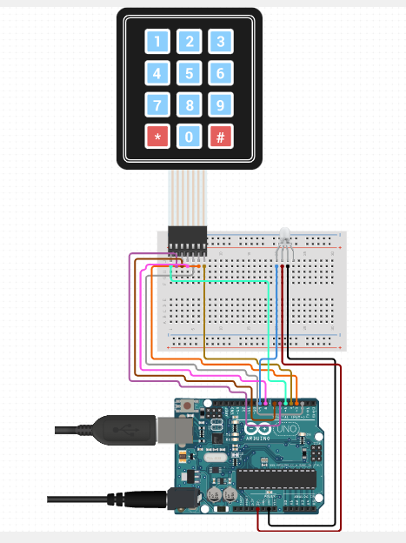
CIRCUIT DIAGRAM:

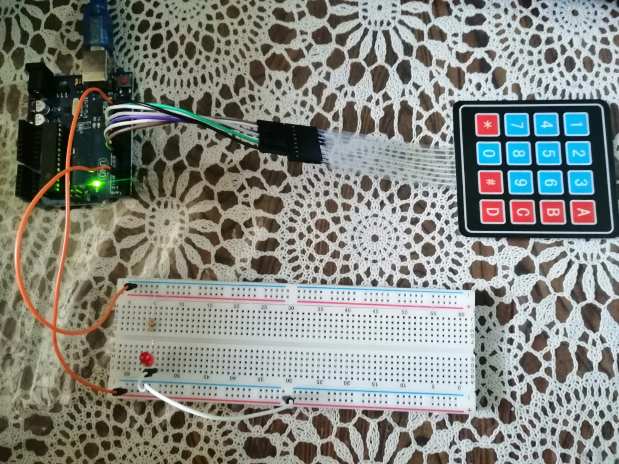

OUTPUT:
