FORMAN CHRISTIAN COLLEGE (A CHARTERED UNIVERSITY)


Compiler Construction - COMP 451 A
Spring 22

LAB - 01

Muhammad Sameed Gilani - 231488347

Introduction

TASK 1

For Task 1 we had to open a text file, whose name we received from a command line argument.
We then had to read the file and obtain the longest line on the file and display it on the console. We used builtin C string functions in this part.
After reading the file line by line we could compare lengths of the lines through strlen() and use strcpy() to copy the longer string onto a predefined character array.

TASK 2
For Task 2 we did the same as Task 1, except we used user defined functions for strlen() and strcpy().

Major functions/library calls used in the program:

TASK 1

- Command line arguments:
    - int argc:
This stores the number of arguments passed by the user when the run the program. This also includes the program name.

- Char* argv[]:

This is an array of character pointers, which point to the address of the command line arguments that were passed. argv[0] always stores the program name.

- fopen() → <stdio.h>

- This is a C library function that uses a file pointer to open a file with in the chosen mode. In our case, “r” (read) was used.
- It returns a file pointer if file opens successfully or Null when it fails.
- We use this function to open and read the text file.

Function Signature:

FILE *fopen(const char *file_name, const char *mode_of_operation);

Sample from program:

FILE *fp;
fp = fopen(argv[1],"r");

if (fp == NULL){
printf("Error opening file");
exit(0);
}

- malloc() → <stdlib.h>

- This function is used to dynamically allocate a single block of memory in the heap, with a size of our choice.
- It returns a pointer to the allocated memory.
- It does not initialize memory on execution.
- We use this to allocate a block of memory to store the line by line that we read from the file.

Function Signature:

ptr = (cast-type*) malloc(byte-size)

Sample from program:

char* buff = (char*) malloc(sizeof(char)*1000);

- sizeof() returns the size of the data type in bytes. (2 for char).
So this allocates a memory of 2000 bytes. With buff as the
pointer.

- fgets() → <stdio.h>

- This function reads line by line from the file. It keeps reading a line until a \n is encountered or the max number of characters is reached or end of file is reached.
- The lines read are stored with a character pointer.
- It returns the string/line that is read.

Function Signature:

char *fgets(char *str, int n, FILE *stream)

Sample from program:

while(fgets(buff,1000,fp) != NULL){}

- where buff (Memory from our malloc() call) stores the lines read, 1000 is the max character count and fp is the file pointer, from which it will read the lines.

- strlen() → <string.h>

- This function returns the length of the string that is passed.
- It does not count the ‘\0’ character.
- In our program we use to to get and compare the length of the line read from the file and the current largest line.

Function Signature:

int strlen(const char *str);

Sample from program:

if (strlen(buff) > strlen(longest_str)){
strcpy(longest_str,buff);
}

- strcpy() → <string.h>

- We use this function to copy a string to a character array.
- It returns a pointer to the destination string.
- In our program we use it to to copy the lines read from the file onto a per-defined character array.

Function Signature:

char* strcpy(char* dest, const char* src);

Sample from program:

if (strlen(buff) > strlen(longest_str)){
strcpy(longest_str,buff);
}

- We pass it a destination (longest_str) and a source (buff) in this case. The string in buff is copied to longest_str.

TASK 2

Same functions as Task 1 are used, except strlen() and strcpy() are user defined.

- get_length()

- The function will return the length(int) of the string passed to it.
- We pass the character pointer of the string to it, pointing to the start of the string.
- We use a while loop that terminates once the character pointer is a ‘\n’, newline characters i.e end of the current line
- It increments the variable int len = 0, by 1 each loop
- The character pointer s, is also incremented. But it increments by 2 bytes each loop as a char is 2 bytes.

Sample from program:

if (get_length(buff) > get_length(longest_str)){
cpy_strings(longest_str,buff);
}

Function:

int get_length(char *s){

int len = 0;

while(*s != '\n'){
len ++;
s++;
}
return len;
}

- cpy_strings()

- This function does not return anything.
- It copies a string from a source to a destination character array.
- We pass two character pointers, one pointing to the start of the destination array and other at the sources.
- We use a while loop that terminates once the source char pointer is a ‘\0’ terminating character for a string. Which tells us that the source string has ended.
- First it copies the character from the source pointer to the destination pointer. Then both the source and character pointers are incremented. (+2 bytes as char is 2 bytes)
- In our program we use it to copy the line from the file to a char array to store the longest string.

Sample from program:

if (get_length(buff) > get_length(longest_str)){
cpy_strings(longest_str,buff);
}

Function:

void cpy_strings(char *destination, char *source){

while (*source != '\0'){
*destination = *source;
destination++;
source++;
}

The Program

TASK 1:

#include <stdio.h>
#include <stdlib.h>
#include <string.h>

int main(int argc, char *argv[]){
FILE *fp;
char longest_str[100];

//check number of args
if(argc != 2){
printf("This program needs a text file as argument\n");
exit(0);
}

fp = fopen(argv[1],"r");

if (fp == NULL){
printf("Error opening file");
exit(0);
}

char* buff = (char*) malloc(sizeof(char)*1000);

while(fgets(buff,1000,fp) != NULL){

if (strlen(buff) > strlen(longest_str)){
strcpy(longest_str,buff);
}
//fputs(buff,stdout);
}

printf("Longest line in the file is: %s\n",longest_str);

//your logic goes here
return 0;
}

TASK 2:

#include <stdio.h>
#include <stdlib.h>

int get_length(char *);
void cpy_strings(char *destination, char *source);
int main(int argc, char *argv[]){

FILE *fp;
char longest_str[100] = "ee\n";

//check number of args
if(argc != 2){
printf("This program needs a text file as argument\n");
exit(0);
}

fp = fopen(argv[1],"r");

if (fp == NULL){
printf("Error opening file");
exit(0);
}

char* buff = (char*) malloc(sizeof(char)*1000);

while(fgets(buff,1000,fp) != NULL){
//printf("%d\n",get_length(longest_str));

if (get_length(buff) > get_length(longest_str)){
cpy_strings(longest_str,buff);
}
}

printf("Longest line in the file is: %s\n",longest_str);

//your logic goes here
return 0;

}

int get_length(char *s){

int len = 0;

while(*s != '\n'){
len ++;
s++;
}
return len;
}

void cpy_strings(char *destination, char *source){

while (*source != '\0'){
*destination = *source;
destination++;
source++;
}

}

///////// END OF PROGRAM//////////
Output / Screen Shots

TASK 1

- When wrong number of arguments are passed
- when wrong file is passed
- when correct number of arguments and correct file is passed
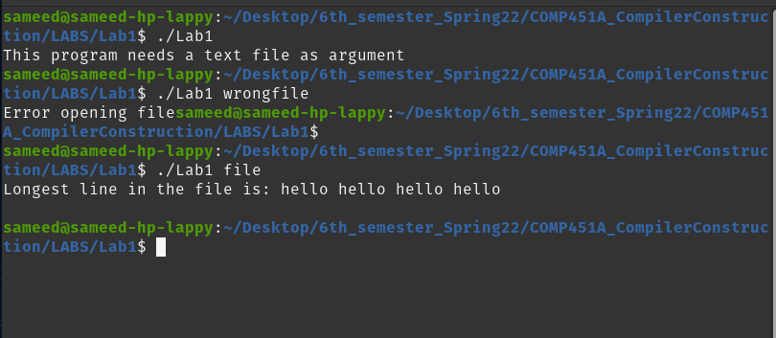

TASK 2

- When wrong number of arguments are passed
- when wrong file is passed
- when correct number of arguments and correct file is passed

