**Exercise 1: Employee Management System - Overview and Setup**

**Business Scenario:**

You are developing an employee management system that will manage employee data, departments, and their relationships.

**Instructions:**

1. **Creating a Spring Boot Project:**
   * Initialize a new Spring Boot project named **EmployeeManagementSystem**.
   * Add dependencies: **Spring Data JPA, H2 Database, Spring Web, Lombok**.

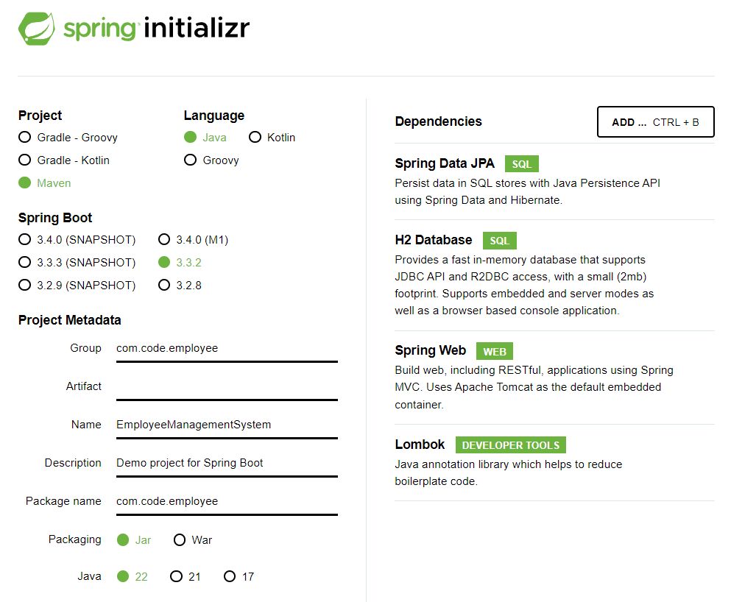

1. **Configuring Application Properties:**
   * Configure **application.properties** for H2 database connection.

*spring.datasource.url=jdbc:h2:mem:testdb*

*spring.datasource.driverClassName=org.h2.Driver*

*spring.datasource.username=sa*

*spring.datasource.password=password*

*spring.jpa.database-platform=org.hibernate.dialect.H2Dialect*

**application.properties 🡪**

spring.application.name=EmployeeManagementSystem

spring.datasource.url=jdbc:h2:mem:testdb

spring.datasource.driverClassName=org.h2.Driver

spring.datasource.username=sa

spring.datasource.password=password

spring.jpa.database-platform=org.hibernate.dialect.H2Dialect

server.port=8819