proj1phase1-徐涵-202293010207

结果展示：

Matlab的fig文件以及完整截图保存在assets目录中。

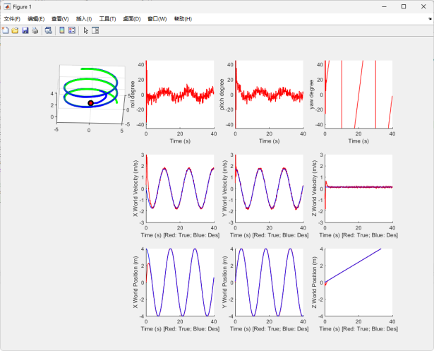 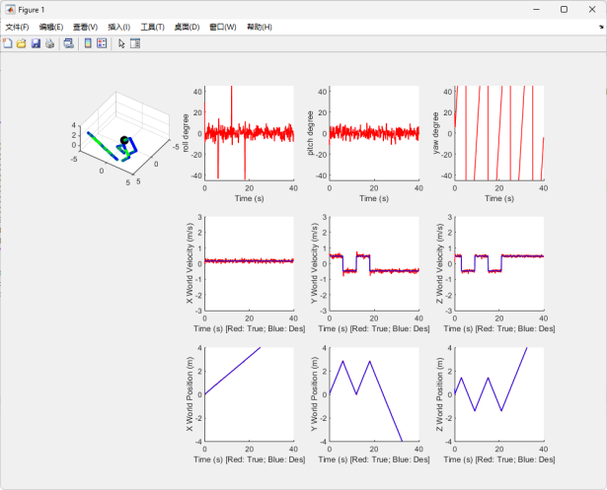

circle轨迹 diamond轨迹

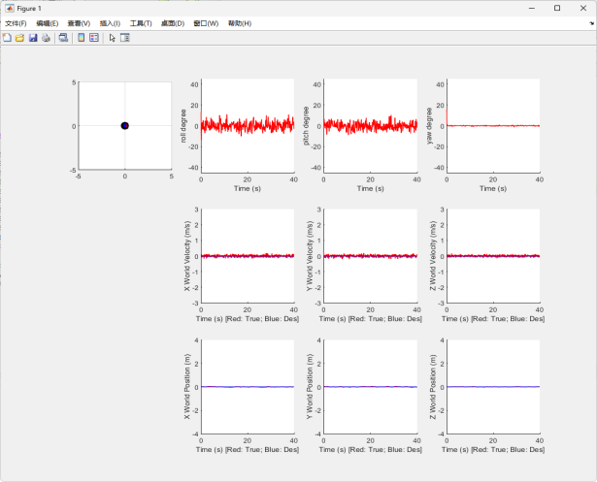 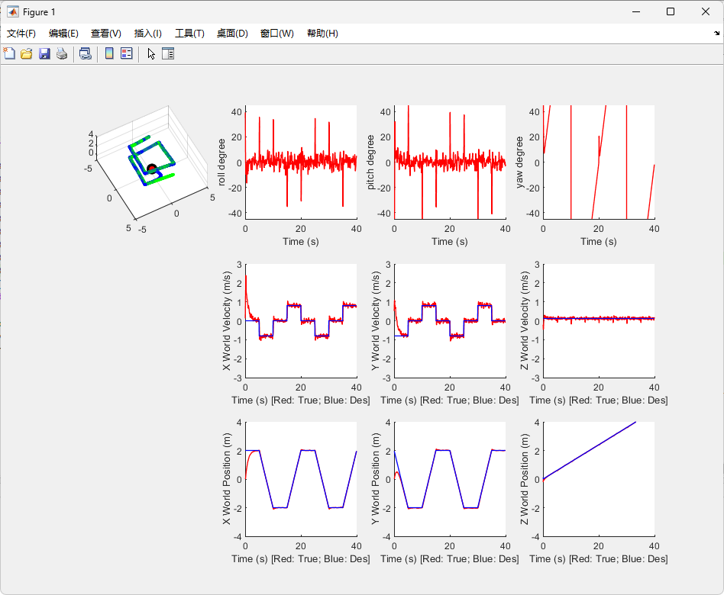

hover轨迹 自定义轨迹

均方根误差统计：

|  |  |  |  |  |  |  |
| --- | --- | --- | --- | --- | --- | --- |
|  | x | y | z | dx | dy | dz |
| circle | 0.5097 | 0.0545 | 0.0465 | 0.4821 | 0.1204 | 0.1337 |
| diamond | 0.0146 | 0.0219 | 0.0136 | 0.0597 | 0.0962 | 0.0592 |
| hover | 0.0155 | 0.0156 | 0.0075 | 0.0545 | 0.0610 | 0.0411 |
| custom | 0.2385 | 0.2268 | 0.0153 | 0.2711 | 0.2612 | 0.0626 |

|  |  |  |  |  |  |  |  |
| --- | --- | --- | --- | --- | --- | --- | --- |
|  | q1 | q2 | q3 | q4 | dphi | dtheta | dpsi |
| circle | 1.0371 | 0.0626 | 0.0660 | 1.0097 | 3.1034 | 3.1145 | 1.2748 |
| diamond | 0.9981 | 0.0391 | 0.0400 | 0.9850 | 0.9849 | 1.282 | 0.7232 |
| hover | 0.0013 | 0.0305 | 0.026 | 0.0051 | 0.8870 | 0.7929 | 0.3196 |
| custom | 1.0360 | 0.0592 | 0.0627 | 1.0089 | 1.7972 | 1.8890 | 0.8234 |

参数以及代码解释：

代码遵循向量化操作。

1. PD控制参数

*kp_xyz = [10.5; 10.5; 30.5]; % Position gain  
kd_xyz = [10.5; 10.5; 15.5]; % Velocity gain  
kp_angle = [900; 900; 900]; % Attitude gain  
kd_angle = [50; 50; 50]; % Angular velocity gain*

1. 数据读取部分：

*x = s(1:3); % 当前位置  
d_x = s(4:6); % 当前速度  
quat = s(7:10); % 当前四元数  
d_angle = s(11:13); % 当前角速度*  
*x_c = s_des(1:3); % 期望位置  
d_x_c = s_des(4:6); % 期望速度  
quat_c = s_des(7:10); % 期望四元数  
d_angle_c = s_des(11:13); % 期望角速度*

1. 计算输出F和M：

*x_error = x_c - x;  
d_x_error = d_x_c - d_x;  
dd_x_c = [0;0;0];  
dd_x = dd_x_c + kp_xyz .* x_error + kd_xyz .* d_x_error;  
F = m * (dd_x(3) + g);  
% ---------------- 姿态控制 ----------------  
[phi_c,theta_c,psi_c] = RotToRPY_ZXY(QuatToRot(quat_c));  
[phi,theta,psi] = RotToRPY_ZXY(QuatToRot(quat));  
% refactor phi_c and theta_c  
phi_c = 1/g * (dd_x(1) * sin(psi) - dd_x(2) * cos(psi));  
theta_c = 1/g * (dd_x(1) * cos(psi) + dd_x(2) * sin(psi));  
phi_error = phi_c-phi;  
theta_error = theta_c-theta;  
psi_error = psi_c-psi;  
psi_error = mod(psi_error, 2*pi);  
if(psi_error<=-pi)  
 psi_error=psi_error + 2 * pi;  
elseif(psi_error>=pi)  
 psi_error=psi_error - 2 * pi;  
end  
angle_error = [phi_error;theta_error;psi_error];  
d_angle_error = d_angle_c - d_angle;  
Rotation = QuatToRot(quat);  
dd_angle = kp_angle .* angle_error + kd_angle .* (d_angle_error);  
M = I * dd_angle + cross(Rotation * d_angle, (I * Rotation * d_angle));*

1. 自定义轨迹说明：

自定义轨迹文件是custom_trajectory.m，定义了一个在xOy平面沿正方形轨迹，z方向线性上升的轨迹。