proj1phase2-徐涵-202293010207

轨迹生成方法：Minimum-snap trajectory

相关的部分代码：

*waypoints = size(path, 1);*

*% TODO: Minimum-snap trajectory*

*% Prepare the Q matrix for a 7th-order polynomial*

*Q = zeros(8 * num_segment, 8 * num_segment);*

*Q_block = zeros(8,8);*

*for k=1:num_segment*

*for i=4:7*

*for j=4:7*

*Q_block(i+1,j+1)=((i*(i-1)*(i-2)*(i-3)*j*(j-1)*(j-2)*(j-3))/(i+j-7))*(time_interval(k,1)^(i+j-7));*

*end*

*end*

*Q ((k-1)*8+1:k*8,(k-1)*8+1:k*8) =Q_block;*

*end*

*% TODO:*

*% Prepare the mapping matrix (polynomial coefficients --> derivatives of states)*

*M = zeros(8 * num_segment, 8 * num_segment );*

*M_block=zeros(8,8);*

*for i = 1:num_segment*

*M_block(1,1:end)=[1,0,0,0,0,0,0,0];*

*M_block(2,1:end)=[0,1,0,0,0,0,0,0];*

*M_block(3,1:end)=[0,0,2,0,0,0,0,0];*

*M_block(4,1:end)=[0,0,0,6,0,0,0,0];*

*%positon*

*M_block(5,1:end)=[1,time_interval(i,1)^1,time_interval(i,1)^2,time_interval(i,1)^3,time_interval(i,1)^4,time_interval(i,1)^5,time_interval(i,1)^6,time_interval(i,1)^7];*

*%velocity*

*M_block(6,1:end)=[0,1,2*time_interval(i,1)^1,3*time_interval(i,1)^2,4*time_interval(i,1)^3,5*time_interval(i,1)^4,6*time_interval(i,1)^5,7*time_interval(i,1)^6];*

*%acceleration*

*M_block(7,1:end)=[0,0,2,6*time_interval(i,1)^1,12*time_interval(i,1)^2,20*time_interval(i,1)^3,30*time_interval(i,1)^4,42*time_interval(i,1)^5];*

*%jerk*

*M_block(8,1:end)=[0,0,0,6,24*time_interval(i,1)^1,60*time_interval(i,1)^2,120*time_interval(i,1)^3,210*time_interval(i,1)^4];*

*%assignment*

*M((i-1)*8+1:i*8,(i-1)*8+1:i*8) = M_block;*

*end*

4个路径的结果展示：

Matlab的fig文件以及完整截图保存在assets目录中。

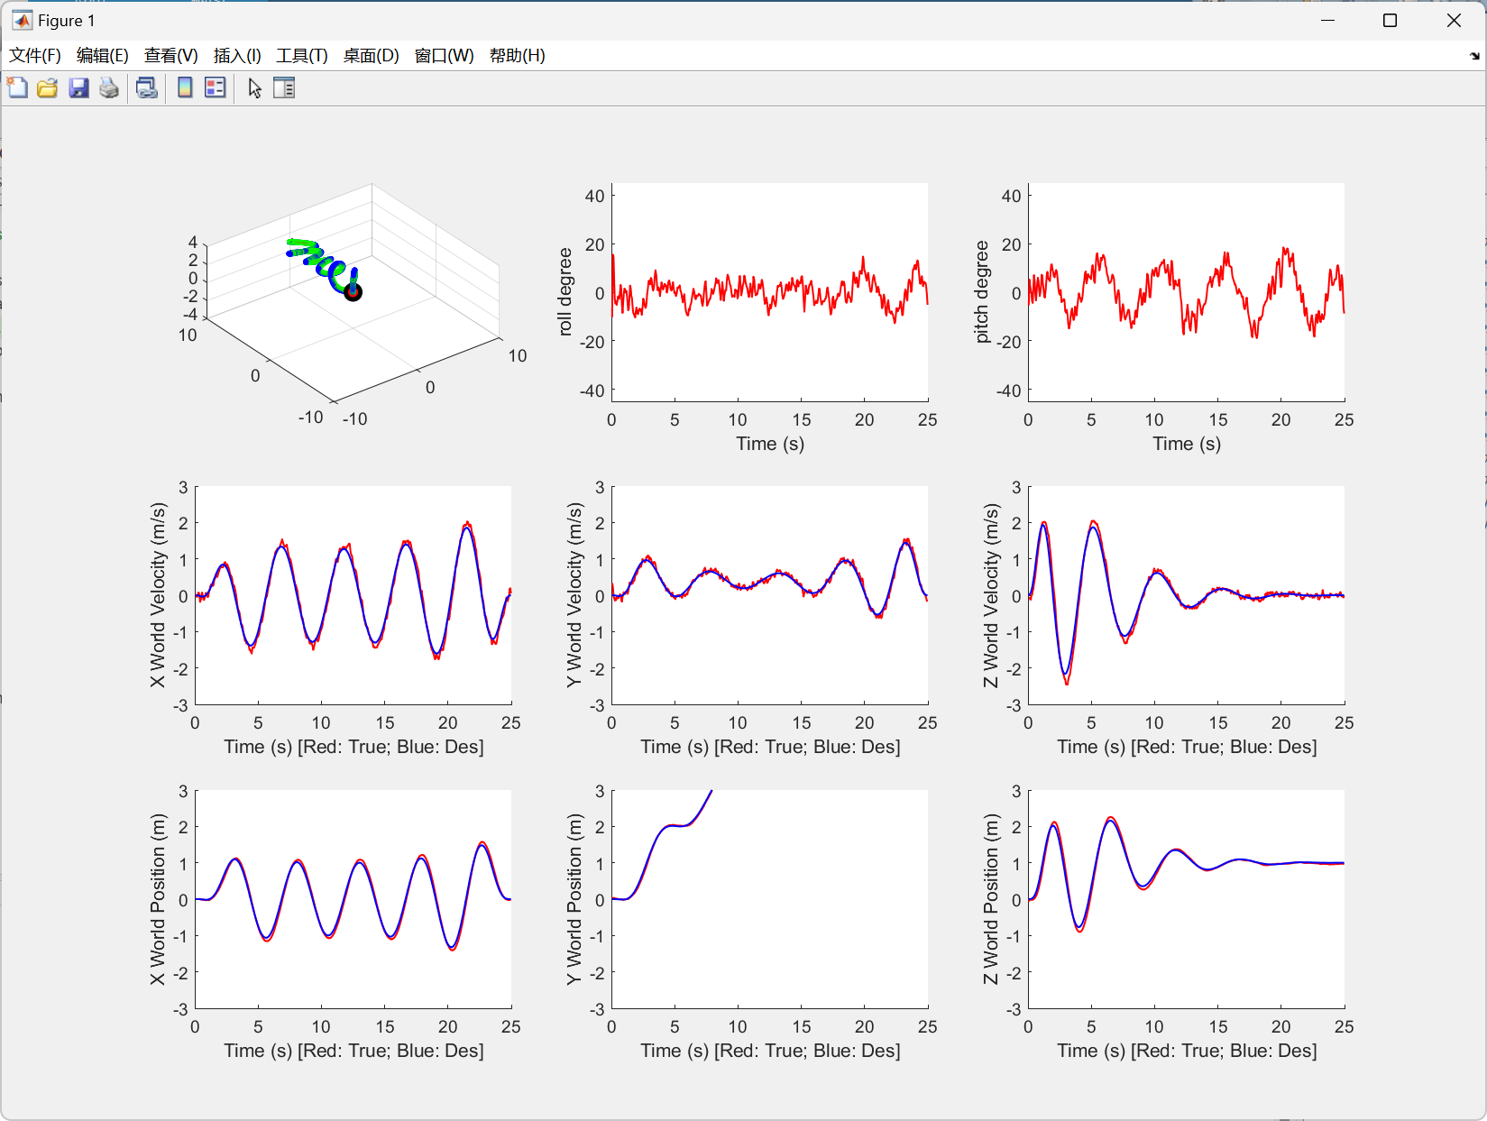 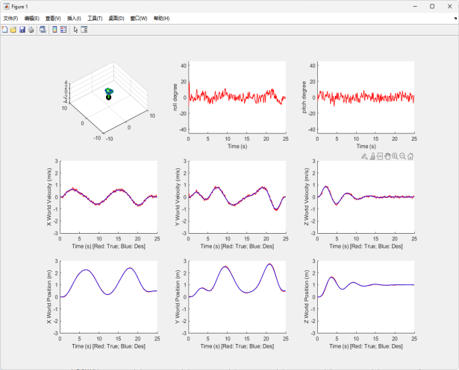

path1 path2

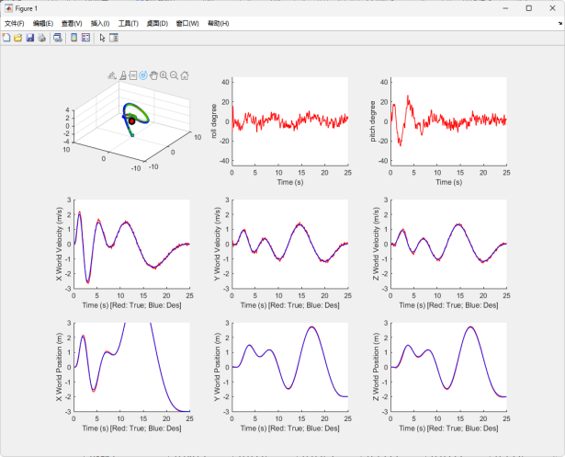 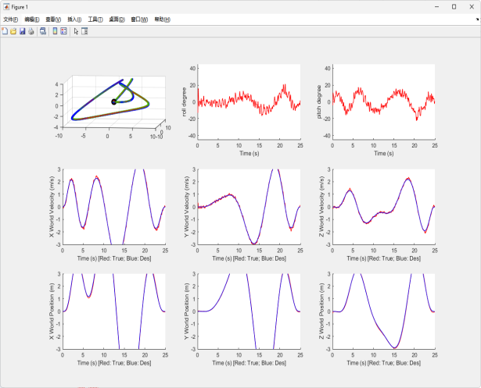

path3 path4

PD控制参数（遵循向量化操作，同phase1）

*kp_xyz = [10.5; 10.5; 30.5]; % Position gain  
kd_xyz = [10.5; 10.5; 15.5]; % Velocity gain  
kp_angle = [900; 900; 900]; % Attitude gain  
kd_angle = [50; 50; 50]; % Angular velocity gain*

均方根误差统计：

|  |  |  |  |  |  |  |
| --- | --- | --- | --- | --- | --- | --- |
|  | x | y | z | dx | dy | dz |
| Path1 | 0.0812 | 0.0375 | 0.0757 | 0.1222 | 0.0773 | 0.1275 |
| Path2 | 0.0215 | 0.0301 | 0.0255 | 0.0614 | 0.0670 | 0.0554 |
| Path3 | 0.0626 | 0.0368 | 0.0507 | 0.1080 | 0.0655 | 0.0655 |
| Path4 | 0.1086 | 0.0791 | 0.0579 | 0.0985 | 0.0830 | 0.0672 |

|  |  |  |  |  |  |  |  |
| --- | --- | --- | --- | --- | --- | --- | --- |
|  | q1 | q2 | q3 | q4 | dphi | dtheta | dpsi |
| Path1 | 0.0053 | 0.0428 | 0.0764 | 0.0117 | 0.9617 | 0.9370 | 0.3.79 |
| Path2 | 0.0023 | 0.0358 | 0.0305 | 0.0119 | 0.9730 | 0.9444 | 0.3169 |
| Path3 | 0.0055 | 0.0372 | 0.0651 | 0.0120 | 0.9421 | 0.9331 | 0.3149 |
| Path4 | 0.0068 | 0.0583 | 0.0767 | 0.0130 | 0.9644 | 0.9171 | 0.3242 |