proj2phase1-徐涵-202293010207

1. rivz结果展示：完整截图保存在assets目录中。

绿色为使用梯度下降算法的优化后的相机pose，红色为使用PnP解算出的相机Pose。

**(bonus)如果有毛刺，是由于优化算法收敛于局部最优导致的。可以看到，我的结果几乎消除了所有毛刺。**

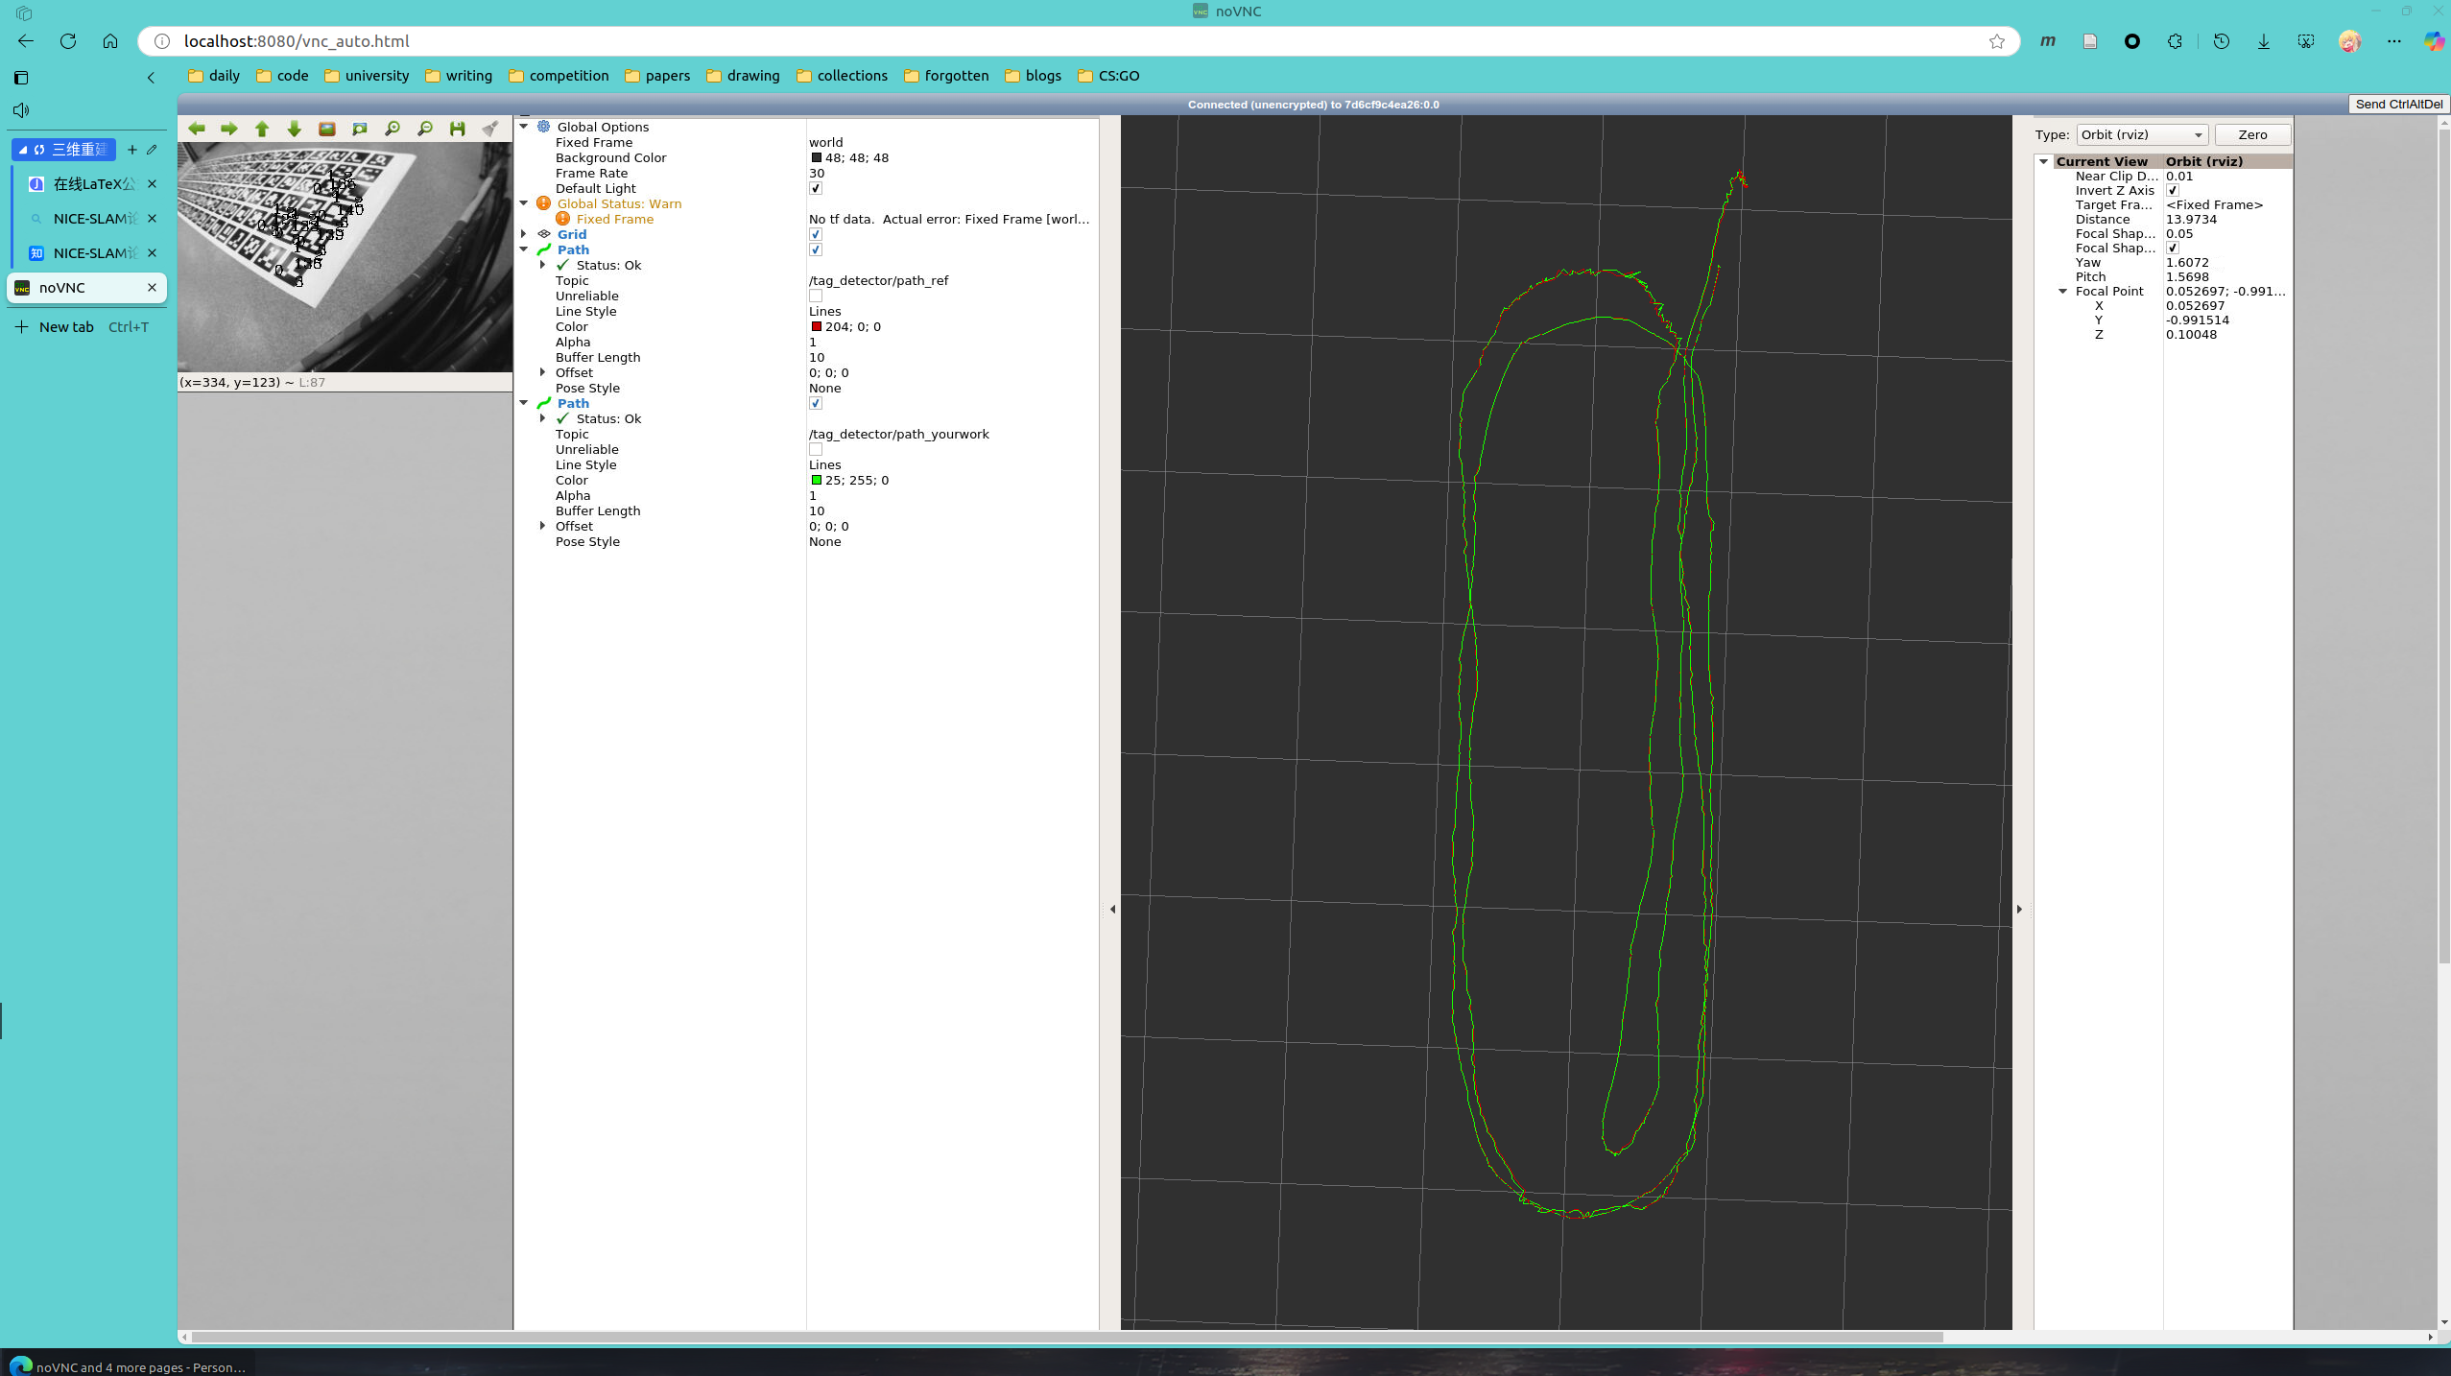

result1

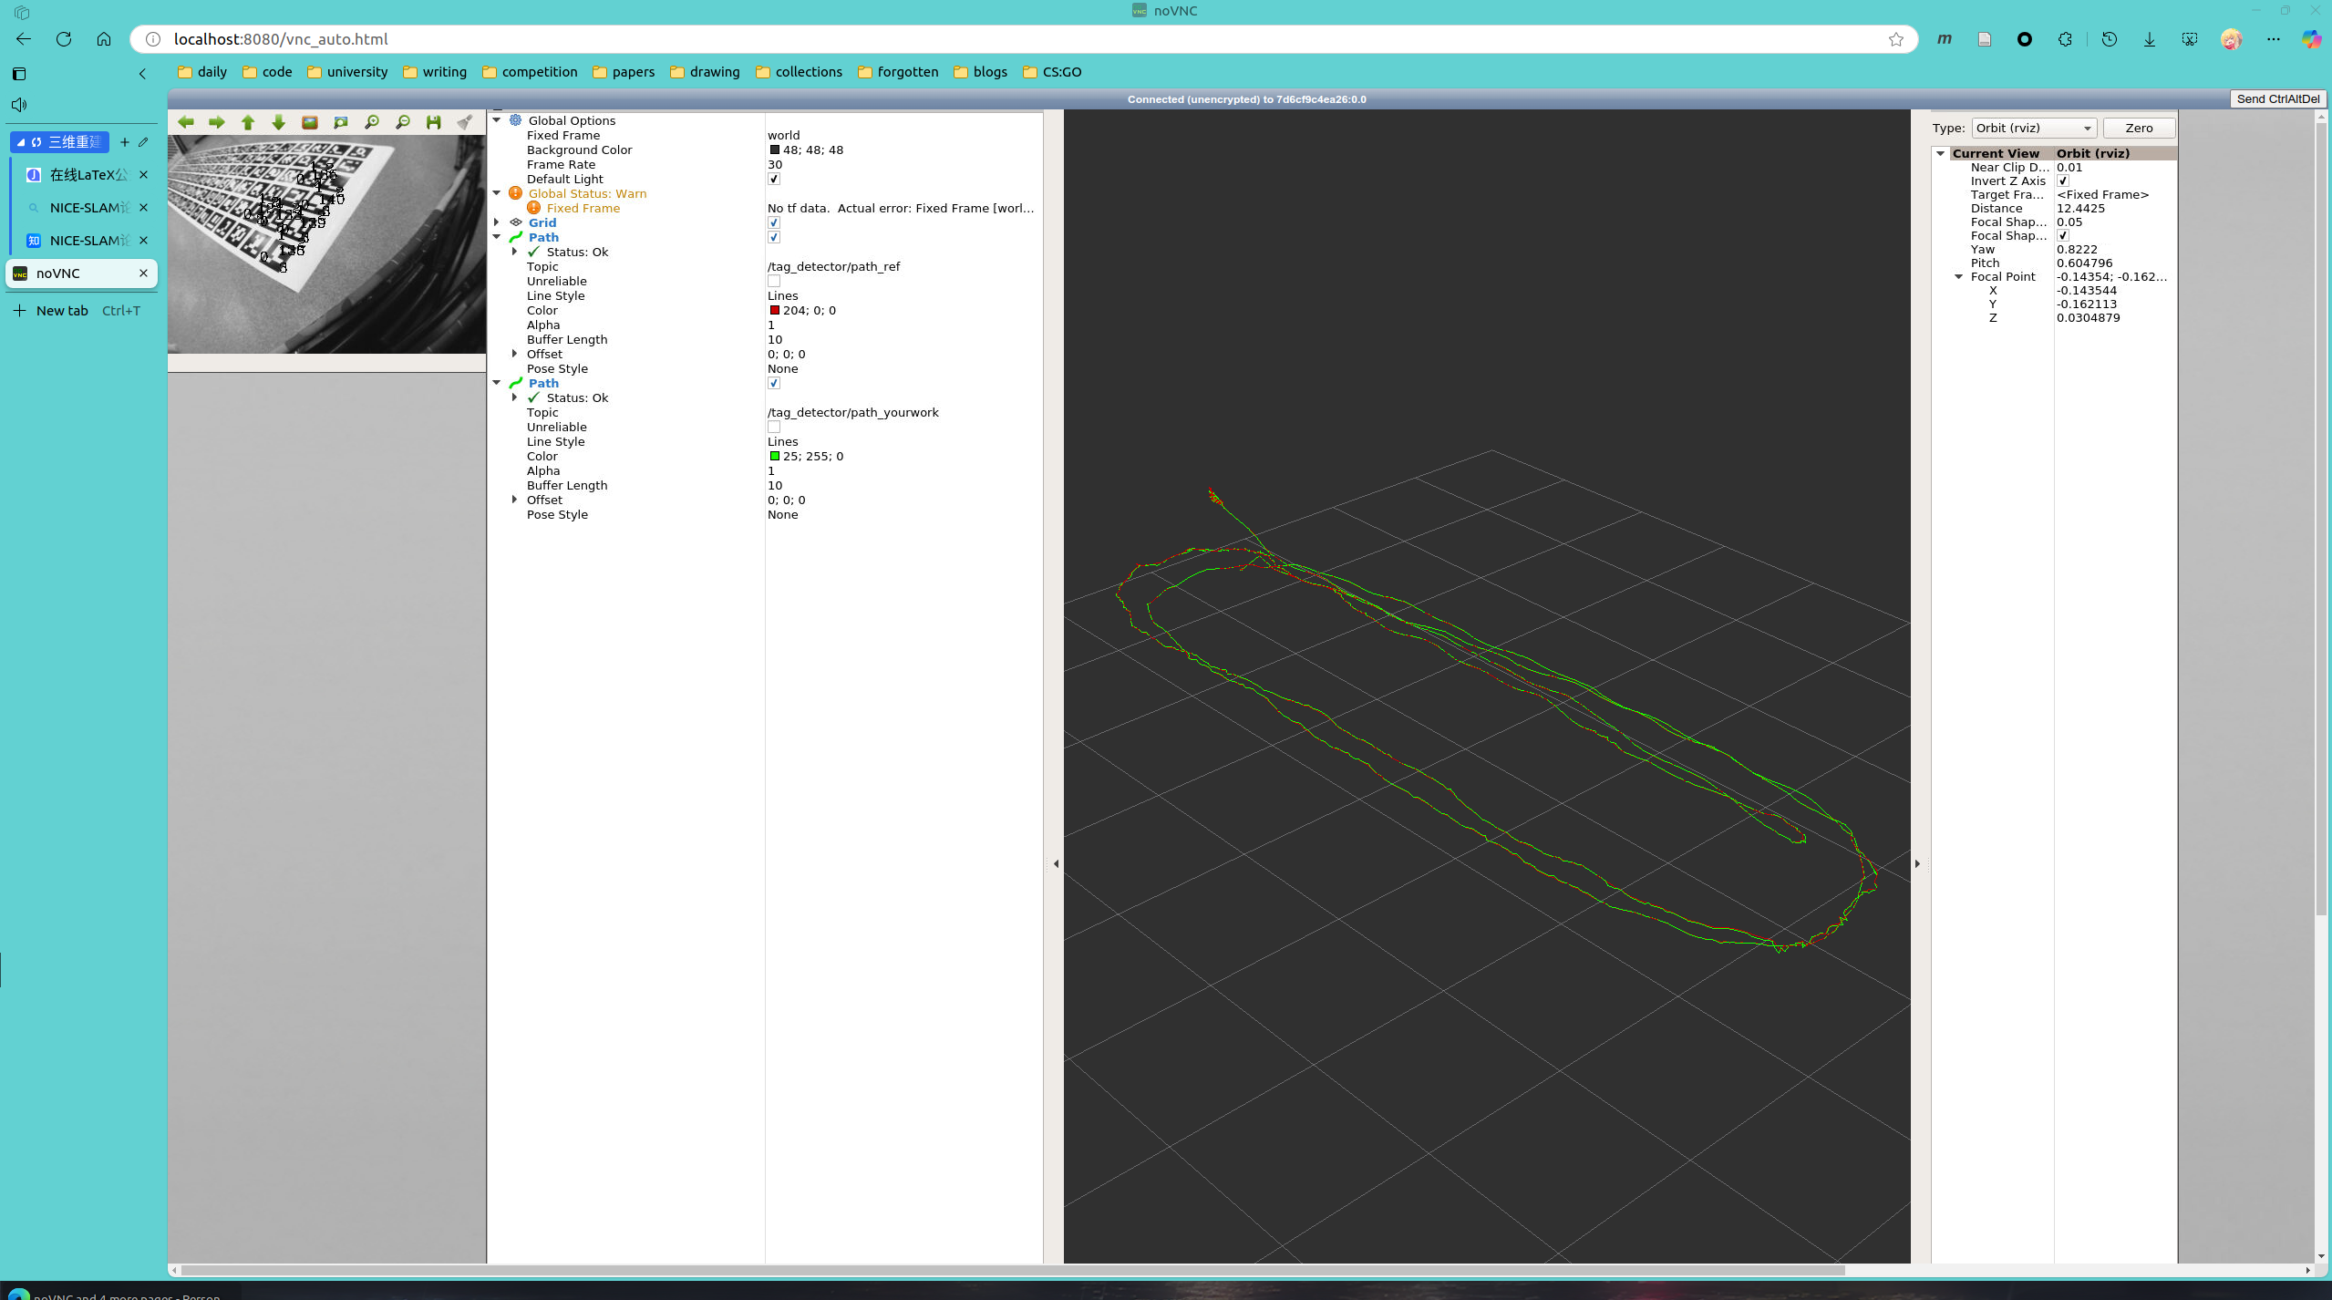

result2

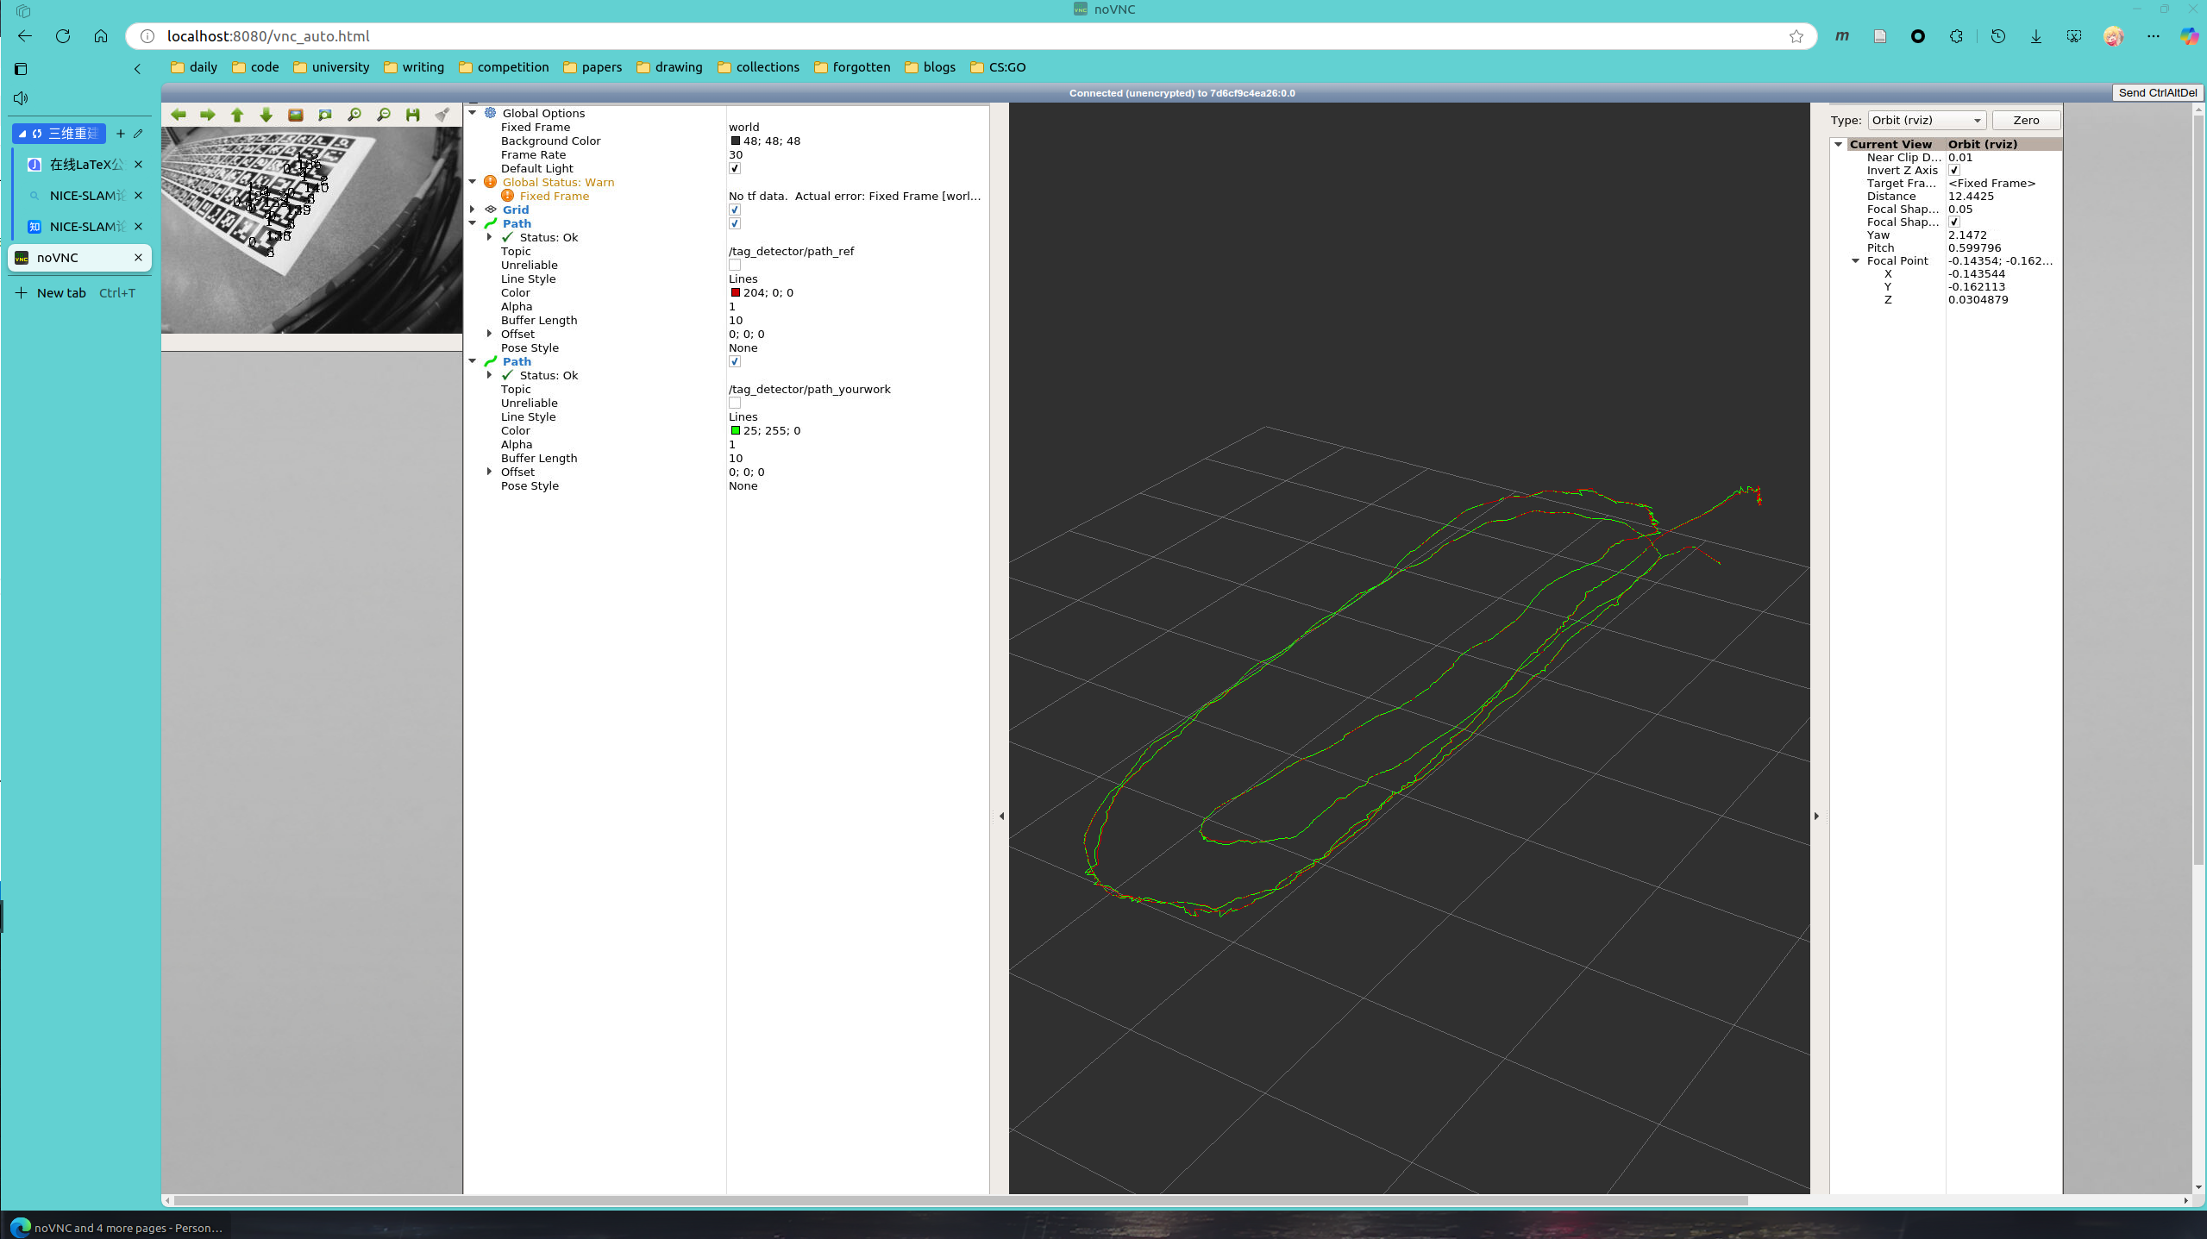

result3

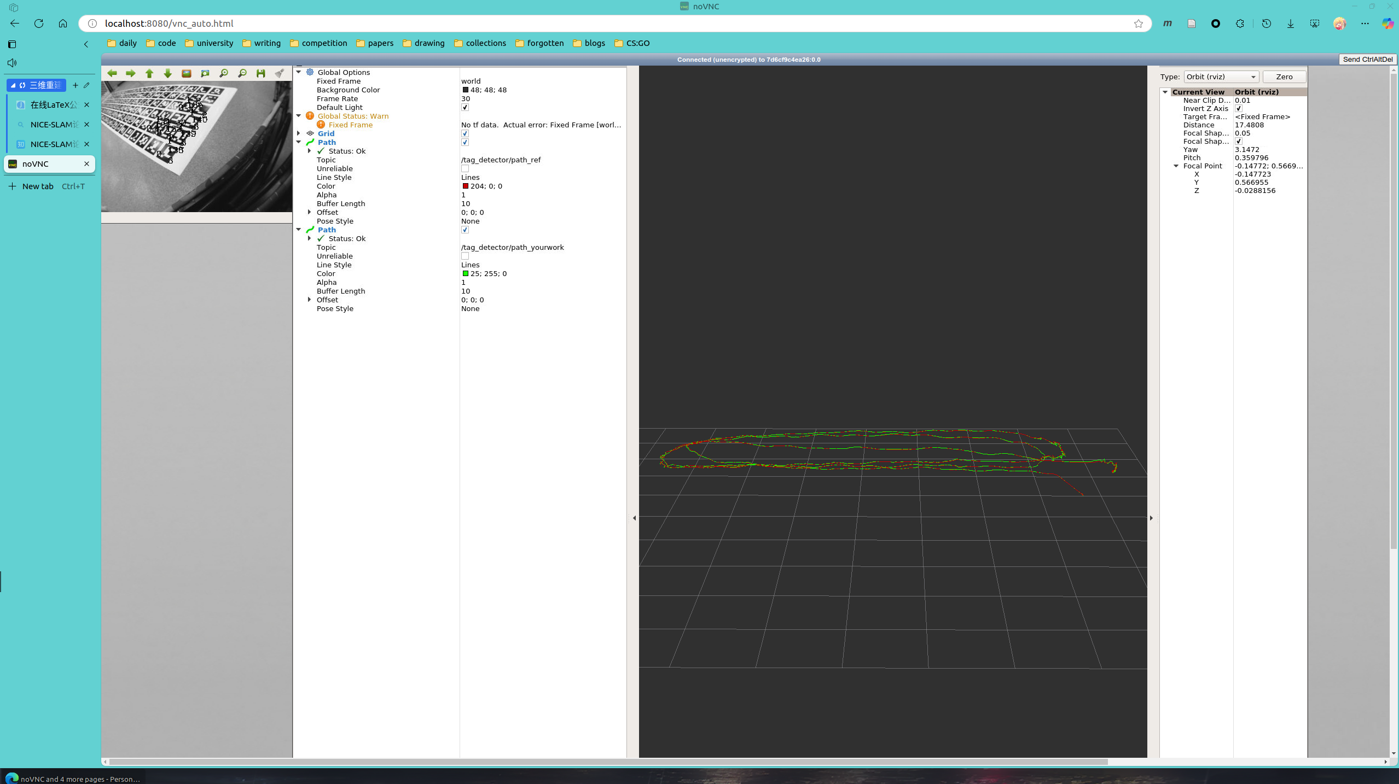

result4

(b) Statistics about the result.这里我计算了像素坐标系下和归一化相机坐标系下两种情况的error。可以看到像素坐标系下error数值比较大，这是因为一个像素对应的物理尺寸是非常小的，所以这个结果也是合理的。而在归一化相机坐标系中，error就非常小了，所以rviz图中的绿线和红线基本是完全吻合的。

像素坐标系下的error：

[ INFO] [1732962306.785898367]: RMSE X, Y, Z, roll, pitch, yaw:

0.001188, 0.001016, 0.006289, 0.003171, 0.001591, 0.000319

ref error75.4489

res error74.7122

[ INFO] [1732962306.826466623]: RMSE X, Y, Z, roll, pitch, yaw:

0.001188, 0.001015, 0.006291, 0.003170, 0.001593, 0.000319

ref error74.2416

res error72.8336

[ INFO] [1732962306.860473438]: RMSE X, Y, Z, roll, pitch, yaw:

0.001187, 0.001014, 0.006295, 0.003169, 0.001595, 0.000318

ref error90.1345

res error88.1427

[ INFO] [1732962306.888490535]: RMSE X, Y, Z, roll, pitch, yaw:

0.001186, 0.001013, 0.006295, 0.003167, 0.001602, 0.000318

ref error74.0466

res error73.119

[ INFO] [1732962306.921782520]: RMSE X, Y, Z, roll, pitch, yaw:

0.001185, 0.001012, 0.006292, 0.003164, 0.001606, 0.000318

ref error67.4535

res error66.3266

归一化相机坐标系下的error：  
[ INFO] [1732962553.021147856]: RMSE X, Y, Z, roll, pitch, yaw:

0.001009, 0.001212, 0.003643, 0.002641, 0.001275, 0.000326

ref error0.399912

res error0.400227

[ INFO] [1732962553.054152883]: RMSE X, Y, Z, roll, pitch, yaw:

0.001007, 0.001218, 0.003665, 0.002640, 0.001273, 0.000328

ref error0.425551

res error0.426367

[ INFO] [1732962553.082345136]: RMSE X, Y, Z, roll, pitch, yaw:

0.001005, 0.001221, 0.003679, 0.002636, 0.001271, 0.000328

ref error0.424916

res error0.422953

[ INFO] [1732962553.115326532]: RMSE X, Y, Z, roll, pitch, yaw:

0.001002, 0.001223, 0.003689, 0.002633, 0.001268, 0.000328

ref error0.433257

res error0.431232

[ INFO] [1732962553.153791722]: RMSE X, Y, Z, roll, pitch, yaw:

0.001001, 0.001229, 0.003718, 0.002633, 0.001265, 0.000329

ref error0.410064

res error0.411601

对应计算代码：

void calculateReprojectionError(

const vector<cv::Point3f> &pts_3, // the input 3D points

const vector<cv::Point2f> &pts_2, // the input 2D features that are corresponding to the 3D points

const cv::Mat R, // the under-estimated rotation matrix

const cv::Mat t){ // the under-estimated translation{

// 本地初始化重投影误差

double sum=0;

// 校正畸变，undistortPoints得到的是归一化相机坐标系

vector<cv::Point2f> corrected_pts_2;

cv::undistortPoints(pts_2, corrected_pts_2, K, D);

for (size_t i = 0; i < pts_3.size(); i++){

cv::Mat point_w(3, 1, CV_64FC1);

point_w.at<double>(0, 0) = pts_3[i].x;

point_w.at<double>(1, 0) = pts_3[i].y;

point_w.at<double>(2, 0) = pts_3[i].z;

// 转相机坐标系并归一化

cv::Mat p_camera = (R * point_w + t);

cv::Mat p_camera_homogeneous = p_camera/p_camera.at<double>(2);

// 如果在像素坐标系下...

// cv::Mat p_pixel = K * p_camera_homogeneous;

// float fx = K.at<double>(0, 0);

// float fy = K.at<double>(1, 1);

// float cx = K.at<double>(0, 2);

// float cy = K.at<double>(1, 2);

// cv::Point2f temp_pts_2_pixel(fx*corrected_pts_2[i].x+cx,fy*corrected_pts_2[i].y+cy);

// sum = sum + sqrt(pow(temp_pts_2_pixel.x-p_pixel.at<double>(0),2)+pow(temp_pts_2_pixel.y-p_pixel.at<double>(1),2));

// 如果在归一化相机坐标系下...

sum = sum + sqrt(pow(corrected_pts_2[i].x-p_camera_homogeneous.at<double>(0),2)+

pow(corrected_pts_2[i].y-p_camera_homogeneous.at<double>(1),2));

}

reproj_error = sum;

}

(c) Descriptions about the implementation.

1.使用PnP算法计算和

cv::solvePnPRansac(pts_3, pts_2, K, D, rvec, t);

cv::Rodrigues(rvec, r);

2.发布到rviz，需要和

// publish reference path. Use publishPath().

Quaterniond Q_ref;

Eigen::Vector3d t_ref;

for(size_t i = 0; i < 3; i++)

t_ref(i) = t.at<double>(i,0);

Q_ref = R_ref.inverse();t_ref = -R_ref.inverse()*t_ref;

publishPath(frame_time, t_ref, Q_ref, path_ref, pub_path_ref);

3.计算初始解，按照ppt中对应方法即可

Eigen::MatrixXd A(2*pts_3.size(),9);

for (uint i=0;i<pts_3.size();i++){

A.block<2,9>(2*i,0) << pts_3[i].x, pts_3[i].y, 1, 0,0,0, -corrected_pts_2[i].x*pts_3[i].x, -corrected_pts_2[i].x*pts_3[i].y, -corrected_pts_2[i].x,

0,0,0, pts_3[i].x, pts_3[i].y, 1, -corrected_pts_2[i].y*pts_3[i].x, -corrected_pts_2[i].y*pts_3[i].y, -corrected_pts_2[i].y;

}

Eigen::JacobiSVD<MatrixXd> A_svd(A, Eigen::ComputeThinU | Eigen::ComputeThinV);

Eigen::VectorXd init_solve = A_svd.matrixV().rightCols(1);

Eigen::Matrix3d H_hat, H_orthogonal;

H_hat << init_solve[0], init_solve[1], init_solve[2], init_solve[3], init_solve[4], init_solve[5], init_solve[6], init_solve[7], init_solve[8];

if (H_hat(2,2)<0){

H_hat = -H_hat;

}

H_orthogonal << H_hat.col(0), H_hat.col(1), H_hat.col(0).cross(H_hat.col(1));

Eigen::JacobiSVD<MatrixXd> H_hat_svd(H_orthogonal, Eigen::ComputeThinU | Eigen::ComputeThinV);

Eigen::Matrix3d R_hat;Eigen::Vector3d T_hat;R_hat.setIdentity();T_hat.setZero();

R_hat = H_hat_svd.matrixU()*(H_hat_svd.matrixV().transpose());

T_hat = H_hat.col(2)/(H_hat.col(0).norm());

4.使用梯度下降算法进行优化迭代：这里我写了在像素坐标系下和归一化相机坐标系下两个版本，都是可以的。

4.1 准备阶段，我选择按ZXY顺序分解

// 残差初始化

Eigen::MatrixXd gamma(2, pts_3.size());

// 雅可比矩阵的列表

Eigen::MatrixXd JacobianMatrix[pts_3.size()];

// 最大迭代次数

int iter_threshold = 1000;

// 待优化参数初始化

Eigen::VectorXd parameters(6, 1);

// 按psi,phi,theta顺序分解并连接它们

Eigen::Vector3d eulerAngles = R_hat.eulerAngles(2, 0, 1);

parameters << eulerAngles[0],eulerAngles[1],eulerAngles[2],T_hat[0],T_hat[1],T_hat[2];

Eigen::MatrixXd tmp_J(2,6);

4.2 迭代过程

4.2.1 计算残差，注意残差是target在前，prediction在后，因此所有的Jacobian在求导后要加上负号

// compute residual,target在前，prediction在后

Eigen::Vector3d pt_3_eigen(pts_3[i].x, pts_3[i].y, pts_3[i].z);

Eigen::Vector3d p_camera = temp_R * pt_3_eigen + temp_T;

Eigen::Vector3d p_camera_homogeneous = p_camera / p_camera[2];

// 如果在像素坐标系下...

// 貌似版本过低，无法使用这个函数，手动赋值

// Eigen::Matrix3d K_eigen;

// // Eigen::cv2eigen(K,K_eigen);

// for (size_t i = 0; i < 3; i++){

// for (size_t j = 0; j < 3; j++){

// K_eigen(i, j) = K.at<double>(i, j);

// }

// }

// Eigen::Vector3d p_pixel = K_eigen * p_camera_homogeneous;

// float fx = K.at<double>(0, 0);

// float fy = K.at<double>(1, 1);

// float cx = K.at<double>(0, 2);

// float cy = K.at<double>(1, 2);

// cv::Point2f temp_pts_2_pixel(fx*corrected_pts_2[i].x+cx,fy*corrected_pts_2[i].y+cy);

// gamma.block<2,1>(0,i) << temp_pts_2_pixel.x - p_pixel[0],

// temp_pts_2_pixel.y - p_pixel[1];

// 如果在归一化相机坐标系下...

gamma.block<2,1>(0,i) << corrected_pts_2[i].x - p_camera_homogeneous[0],

corrected_pts_2[i].y - p_camera_homogeneous[1];

4.2.2 计算Jacobian，如果在像素坐标系下，对应的Jacobian只需要多乘以一个fx或fy。Jacobian的数学计算公式过程从略。

// 如果在归一化相机坐标系下...

gamma.block<2,1>(0,i) << corrected_pts_2[i].x - p_camera_homogeneous[0],

corrected_pts_2[i].y - p_camera_homogeneous[1];

double x,y,z;x = pts_3[i].x;y = pts_3[i].y;z = pts_3[i].z;

double dpcamera1_dpsi = (-sin(psi)*cos(theta)-cos(psi)*sin(phi)*sin(theta))*x

-cos(psi)*cos(phi)*y

+ (-sin(psi)*cos(theta)+cos(theta)*cos(psi)*sin(phi))*z;

double dpcamera3_dpsi = 0;

double dpcamera1_dphi = -sin(psi)*cos(phi)*sin(theta)*x

+sin(phi)*sin(psi)*y

+cos(theta)*sin(psi)*cos(phi)*z;

double dpcamera3_dphi = sin(phi)*sin(theta)*x

+cos(phi)*y

-sin(phi)*cos(theta)*z;

double dpcamera1_dtheta = (-cos(psi)*sin(theta)-sin(psi)*sin(phi)*cos(theta))*x

+(-cos(psi)*sin(theta)-sin(theta)*sin(psi)*sin(phi))*z;

double dpcamera3_dtheta = -cos(phi)*cos(theta)*x

-cos(phi)*sin(theta)*z;

double dpcamera2_dpsi = (cos(theta)*cos(psi)-sin(psi)*sin(phi)*sin(theta))*x

-sin(psi)*cos(phi)*y

+(cos(psi)*sin(theta)+sin(psi)*sin(phi)*cos(theta))*z;

double dpcamera2_dphi = cos(psi)*cos(phi)*sin(theta)*x

-cos(psi)*sin(phi)*y

-cos(psi)*cos(phi)*cos(theta)*z;

double dpcamera2_dtheta = (-sin(theta)*sin(psi)+cos(psi)*sin(phi)*cos(theta))*x

+(sin(psi)*cos(theta)+cos(psi)*sin(theta)*sin(phi))*z;

// 如果是在像素坐标系下...

// du/dt1

// tmp_J(0, 3) = -fx*(1/p_camera[2]);

// // du/dt2

// tmp_J(0, 4) = 0;

// // du/dt3

// tmp_J(0, 5) = -fx*(-p_camera[0]/(p_camera[2]*p_camera[2]));

// // dv/dt1

// tmp_J(1, 3) = 0;

// // dv/dt2

// tmp_J(1, 4) = -fy*(1/p_camera[2]);

// // dv/dt3

// tmp_J(1, 5) = -fy*(-p_camera[1]/(p_camera[2]*p_camera[2]));

// // du/dpsi

// tmp_J(0, 0) = -fx*(dpcamera1_dpsi*p_camera[2]-p_camera[01]*dpcamera3_dpsi)/(p_camera[2]*p_camera[2]);

// // du/dphi

// tmp_J(0, 1) = -fx*(dpcamera1_dphi*p_camera[2]-p_camera[0]*dpcamera3_dphi)/(p_camera[2]*p_camera[2]);

// // du/dtheta

// tmp_J(0, 2) = -fx*(dpcamera1_dtheta*p_camera[2]-p_camera[0]*dpcamera3_dtheta)/(p_camera[2]*p_camera[2]);

// // dv/dpsi

// tmp_J(1, 0) = -fy*(dpcamera2_dpsi*p_camera[2]-p_camera[1]*dpcamera3_dpsi)/(p_camera[2]*p_camera[2]);

// // dv/dphi

// tmp_J(1, 1) = -fy*(dpcamera2_dphi*p_camera[2]-p_camera[1]*dpcamera3_dphi)/(p_camera[2]*p_camera[2]);

// // dv/dtheta

// tmp_J(1, 2) = -fy*(dpcamera2_dtheta*p_camera[2]-p_camera[1]*dpcamera3_dtheta)/(p_camera[2]*p_camera[2]);

// // 如果是在归一化相机坐标系下...

// du/dt1

tmp_J(0, 3) = -(1/p_camera[2]);

// du/dt2

tmp_J(0, 4) = 0;

// du/dt3

tmp_J(0, 5) = -(-p_camera[0]/(p_camera[2]*p_camera[2]));

// dv/dt1

tmp_J(1, 3) = 0;

// dv/dt2

tmp_J(1, 4) = -(1/p_camera[2]);

// dv/dt3

tmp_J(1, 5) = -(-p_camera[1]/(p_camera[2]*p_camera[2]));

// du/dpsi

tmp_J(0, 0) = -(dpcamera1_dpsi*p_camera[2]-p_camera[01]*dpcamera3_dpsi)/(p_camera[2]*p_camera[2]);

// du/dphi

tmp_J(0, 1) = -(dpcamera1_dphi*p_camera[2]-p_camera[0]*dpcamera3_dphi)/(p_camera[2]*p_camera[2]);

// du/dtheta

tmp_J(0, 2) = -(dpcamera1_dtheta*p_camera[2]-p_camera[0]*dpcamera3_dtheta)/(p_camera[2]*p_camera[2]);

// dv/dpsi

tmp_J(1, 0) = -(dpcamera2_dpsi*p_camera[2]-p_camera[1]*dpcamera3_dpsi)/(p_camera[2]*p_camera[2]);

// dv/dphi

tmp_J(1, 1) = -(dpcamera2_dphi*p_camera[2]-p_camera[1]*dpcamera3_dphi)/(p_camera[2]*p_camera[2]);

// dv/dtheta

tmp_J(1, 2) = -(dpcamera2_dtheta*p_camera[2]-p_camera[1]*dpcamera3_dtheta)/(p_camera[2]*p_camera[2]);

4.2.3 应用更新并进行收敛性判断

// update the optimization variables

Eigen::VectorXd delta_p = An.inverse()*bn;

parameters += delta_p;

// std::cout << "update:" << delta_p<< endl;

if (delta_p.cwiseAbs().sum() < 0.0001){

break;

}

5.优化结果发布到rviz，仍然需要和

Eigen::Matrix3d R;R = AngleAxisd(parameters[0], Vector3d::UnitZ()) * AngleAxisd(parameters[1], Vector3d::UnitX()) * AngleAxisd(parameters[2], Vector3d::UnitY());

Eigen::Vector3d T(parameters[3],parameters[4],parameters[5]);

// publish path

Quaterniond Q_yourwork;

Q_yourwork = R.transpose();

Eigen::Vector3d T_wc = -R.transpose()*T;

publishPath(frame_time, T_wc, Q_yourwork, path, pub_path);