Reese Cochran

Professor Neumayer

9/9/2024

Assignment 01

Assignment 01 Code Output

1. Cochran_problem_1 Code Output:

1. Cochran_problem_2 Code Output:

User game exit (with examples of invalid input):

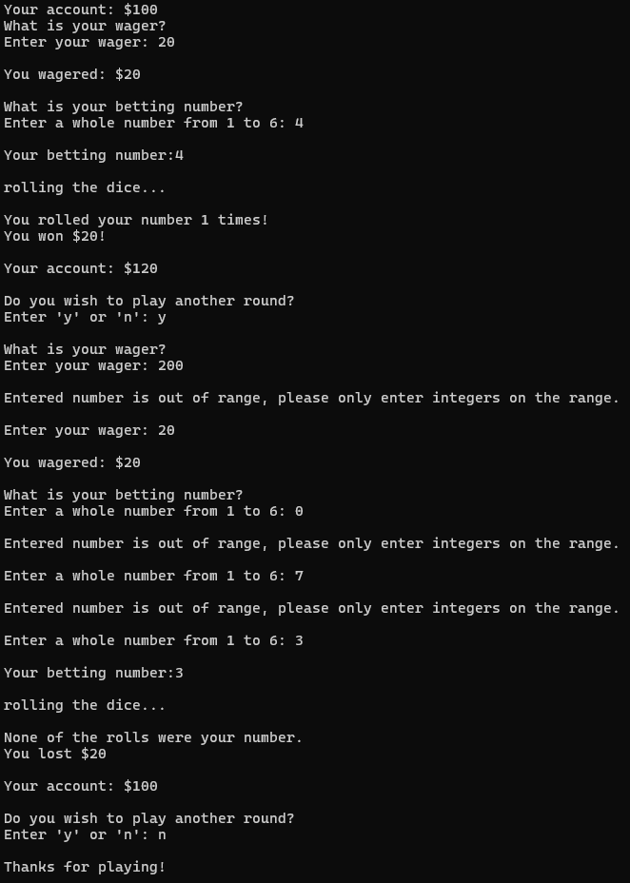

Out-of-cash game exit:

1. No code output for Maze Generation and Solving, see Cochran_README.txt file for question response.
2. Cochran_problem_4 Code output:

