Connor Deakin

ART 210

Mike Adams

12 - 3 - 2018

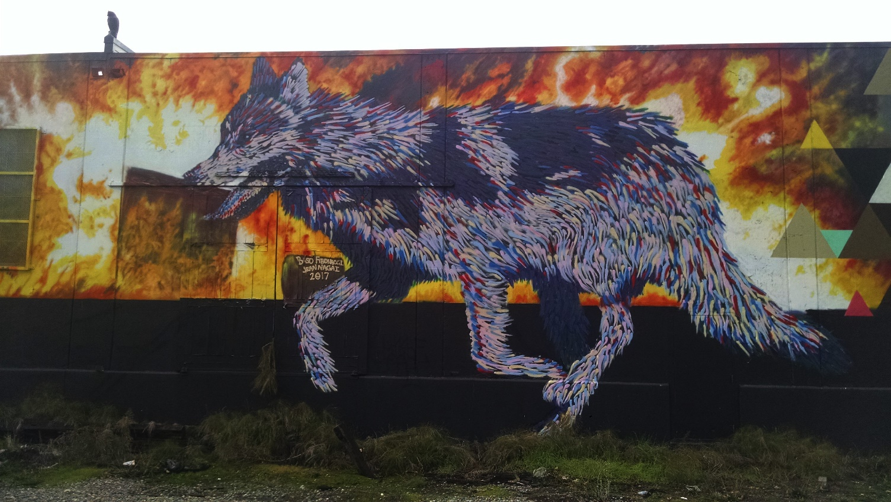SoDo’s *Escaping a Burning Culture*

On Saturday, December 1st, I went to SoDo with my father to find a piece of public art on the walls of SoDo buildings. SoDo is loaded with graffiti and street art and I saw it as the perfect place to find a piece of artwork to write about. While walking up and down the SoDo Busway, I came across the piece that had the largest effect on me, *Escaping a Burning Culture* by Baso Fibonacci and Jean Nagai (2017).

Located on a building wall near the West Seattle Bridge, the painting depicts a wolf running from a background being taken over by flames. The fire is almost entirely full of warm orange and red colors and it makes up a large majority of the piece. In fact, besides the bottom, the flames make up the entire background. The wolf starkly contrasts the fire. It is not composed of shades of brown and black like one would expect. Instead, the wolf's form is developed with strokes of different colors. Vibrant portions of the wolf contain cool blues, saturated yellows, and hints of dominant reds. Other patches on the animal are solid shades of blue. This wolf acts as the primary figure in the painting as it is the first place our eyes go to investigate more. Below the wolf's body and fire, Fibonacci and Nagai decided to fill the rest of the surface with a pitch black, heavily contrasting with the rest of image.

There are many possible themes that this piece could be playing with. The obvious classification is the natural world, but the piece does more than just paint a picture of nature. Instead, it communicates a story with a bit of imagination. The wolf is fleeing from the hot approaching fires in the background. From the piece, it is unclear what is burning, but we do know that it was where the wolf once resided. The fire is forcing the wolf to run away from the place it occupied because staying there would put it in danger. Though it is not directly depicted, we could assume that this was the wolf's stomping grounds. A fire does not only create an immediate threat to the animal, though. It will also forever change the landscape that was there. It will become a barren wasteland and the wolf will have no way to continue its way of life there after the flames subside. This could all act as a metaphor for someone deciding to leave a place due to something that is out of their control. In this case, the fire forces the wolf away from its home such that it may never return.

Fibonacci and Nagai make use only a few visual elements to get their idea across. When presented with the picture, one of our first questions is "Where is the wolf looking?" The wolf is not looking back at the fire. Instead, the implied line emerging from the wolf's eyes show it facing away and demonstrates its intent to move towards safety. Rather than just showing what the wolf wants to do, Fibonacci and Nagai make it clear that the wolf is already on its way out. Though showing the wolf in a running position would be enough, they take it a bit further with their texturing of the wolf. Its body is composed of hundreds of fur lines. Each of these are a single stroke and a majority show the wolf's fur flowing to the right as if under the effect of wind. This and the wolf's raised front legs show us a full image of it in motion.

Another major visual element of the piece that helps communicate its story is the vibrant selection of colors used. The wolf's fur is almost entirely composed of cool colors with some tinted patches and other heavily shaded areas. This demonstrates more than just a depiction of the wolf. It is trying to communicate the calmness of the wolf in the place it once inhabited. This idea is further elaborated upon when we notice the shaded red and dim yellow furs on some sections of the wolf's side profile. These clearly share color qualities with the fire in the background, possibly demonstrating that the wolf's fur reflects the environment it is living in. Additionally, when we step back and take in the entire piece, it is impossible to ignore the stark contrast between the wolf's fur and the flames. The cool blue clashes with the warm reds, indicating that the wolf and whatever it is that the fire represents are at ends with one another.

The thematic elements are further supported by the composition of the piece. It is not immediately obvious, but upon further inspection, we can see directional difference between the wolf and the flames in the background. Notice that the flames generally move towards the right while the wolf moves towards the left. Like the contrast between the colors of the fire and the wolf, this compositional choice highlights the wolf's decision to separate itself from the fire. This is even further stressed when we notice the lack of any clear symmetry in the piece. The flames have no significant pattern and we are only shown a side profile of the wolf. It's as if the fire and the wolf represent two wildly different ideas, therefore presenting us with strong conceptual variety.

Though this image conveys much more than what one sees on the surface, I did not need to do much digging to find meaning in the piece. I come from California originally and when I saw this on the wall at SoDo, global warming and the rampant wild fires that tear through the state instantly came to mind. I saw a wolf covered with color being driven away from its home due to a burning mass that will soon leave the entire land barren. To me, the colors in the wolf’s fur represent the elements of the natural world affected by wild fires; the creatures and landscapes left behind. Those large red flames are responsible for forcing that color out of its home. In many ways, this viewpoint is similar to the idea prompted by the painting, but it is hard for me to look at the piece and see anything else.

Works Cited

“Escaping a Burning Culture.” *SoDo Track*, 2017,

https://sodotrack.com/artists/baso-fibonnaci-jean-nagai/