**Connor Deakin**

**10/05/18**

**MAT 345**

**Project 1**

**1[a-d]**

There is a file included with the zip that this document came in called main.R. It contains the R code that was used to load in and clean the data. Data was considered invalid if the gross square footage was equal to zero or the sale price was less than 100.

**2[a-b]**

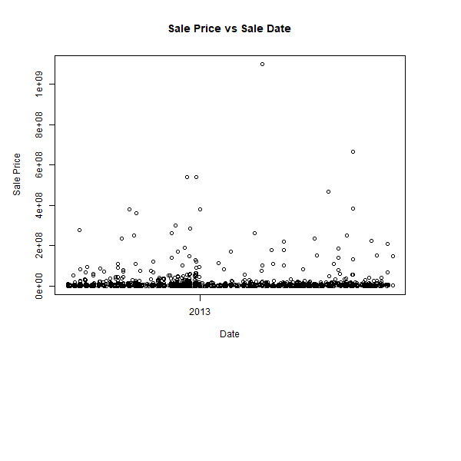

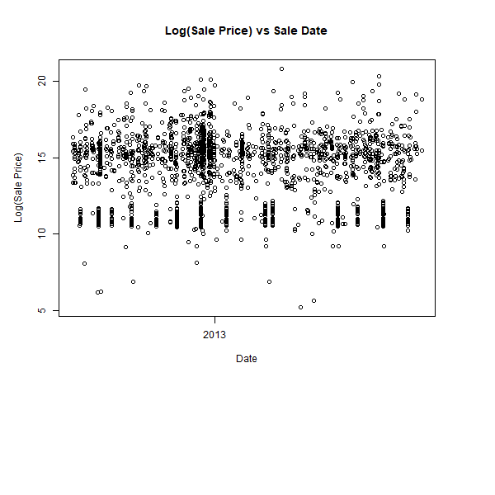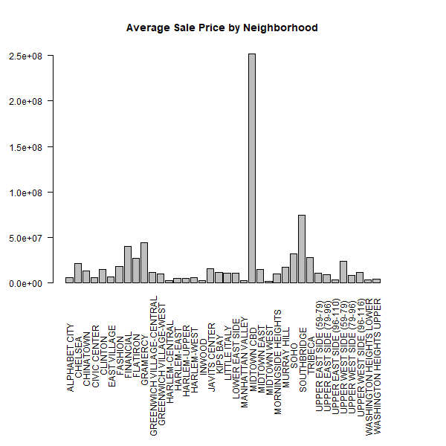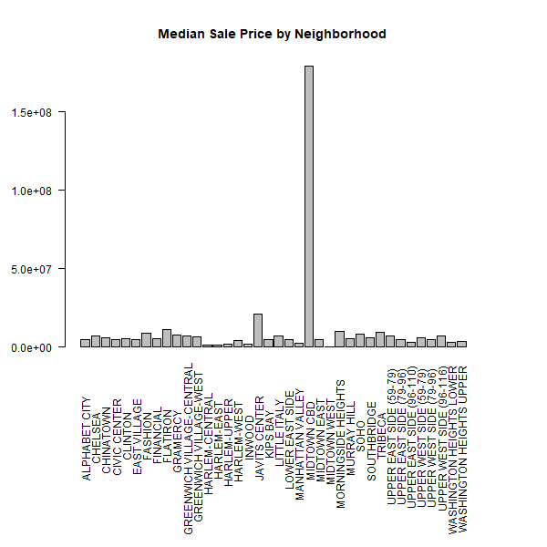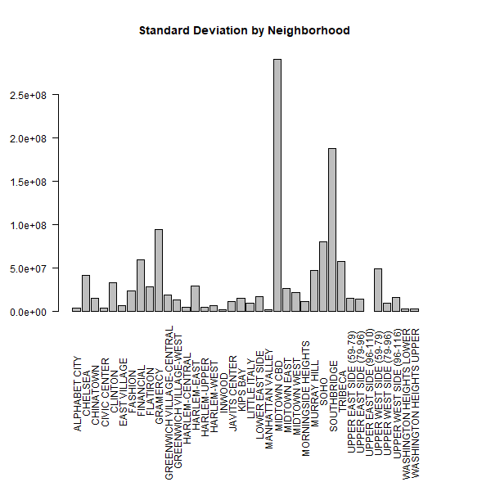

**3[a]**

**Range of sale prices for all data:** [1.83e+02, 1.10e+09]

**Range of sale prices for each neighborhood**

**NEIGHBORHOOD MINUMUM MAXIMUM**

1 ALPHABET CITY 283 15500000

2 CHELSEA 242000 284429879

3 CHINATOWN 1950000 53183682

4 CIVIC CENTER 1200000 13650000

5 CLINTON 600000 170000000

6 EAST VILLAGE 635000 41000000

7 FASHION 1300000 103000000

8 FINANCIAL 2000000 151000000

9 FLATIRON 2769455 111500000

10 GRAMERCY 318000 380000000

11 GREENWICH VILLAGE-CENTRAL 295162 101000000

12 GREENWICH VILLAGE-WEST 560000 96436875

13 HARLEM-CENTRAL 500 55000000

14 HARLEM-EAST 183 252000000

15 HARLEM-UPPER 110000 19600000

16 HARLEM-WEST 500000 24000000

17 INWOOD 440000 9498200

18 JAVITS CENTER 1150000 27500000

19 KIPS BAY 725000 39000000

20 LITTLE ITALY 325000 33500000

21 LOWER EAST SIDE 1400000 103466615

22 MANHATTAN VALLEY 50246 7380000

23 MIDTOWN CBD 6192000 1100000000

24 MIDTOWN EAST 490 115000000

25 MIDTOWN WEST 10000 470000000

26 MORNINGSIDE HEIGHTS 2365764 18386667

27 MURRAY HILL 133000 300000000

28 SOHO 550000 540829842

29 SOUTHBRIDGE 1400000 539000000

30 TRIBECA 3300000 223000000

31 UPPER EAST SIDE (59-79) 28000 141510000

32 UPPER EAST SIDE (79-96) 729500 95000000

33 UPPER EAST SIDE (96-110) 3350000 3350000

34 UPPER WEST SIDE (59-79) 15220 221000000

35 UPPER WEST SIDE (79-96) 360547 52500000

36 UPPER WEST SIDE (96-116) 512750 60000000

37 WASHINGTON HEIGHTS LOWER 265000 14450000

38 WASHINGTON HEIGHTS UPPER 9586 12000000

**3[b]**

**Median of sale prices for all data:** 875000

**Median of sale prices for each neighborhood**

**NEIGHBORHOOD MEDIAN**

1 ALPHABET CITY 4653771

2 CHELSEA 6990000

3 CHINATOWN 6140000

4 CIVIC CENTER 4931000

5 CLINTON 5243000

6 EAST VILLAGE 5116961

7 FASHION 9000000

8 FINANCIAL 5700000

9 FLATIRON 11250000

10 GRAMERCY 7523375

11 GREENWICH VILLAGE-CENTRAL 7250000

12 GREENWICH VILLAGE-WEST 6575000

13 HARLEM-CENTRAL 1300000

14 HARLEM-EAST 1250000

15 HARLEM-UPPER 1900000

16 HARLEM-WEST 4250000

17 INWOOD 2258707

18 JAVITS CENTER 21250000

19 KIPS BAY 4750000

20 LITTLE ITALY 6950000

21 LOWER EAST SIDE 4825000

22 MANHATTAN VALLEY 2770780

23 MIDTOWN CBD 179625000

24 MIDTOWN EAST 4750000

25 MIDTOWN WEST 57900

26 MORNINGSIDE HEIGHTS 10376216

27 MURRAY HILL 5750000

28 SOHO 8500000

29 SOUTHBRIDGE 6225625

30 TRIBECA 9500000

31 UPPER EAST SIDE (59-79) 7000000

32 UPPER EAST SIDE (79-96) 4900000

33 UPPER EAST SIDE (96-110) 3350000

34 UPPER WEST SIDE (59-79) 6110000

35 UPPER WEST SIDE (79-96) 5025000

36 UPPER WEST SIDE (96-116) 6950000

37 WASHINGTON HEIGHTS LOWER 3300000

38 WASHINGTON HEIGHTS UPPER 3860126

**3[c]**

**Mean of sale prices for all data:** 8662951

**Mean of sale prices for each neighborhood**

**NEIGHBORHOOD MEAN**

1 ALPHABET CITY 5897204

2 CHELSEA 21540533

3 CHINATOWN 12985063

4 CIVIC CENTER 6030542

5 CLINTON 14856886

6 EAST VILLAGE 7159309

7 FASHION 18571245

8 FINANCIAL 39986667

9 FLATIRON 27591907

10 GRAMERCY 44527171

11 GREENWICH VILLAGE-CENTRAL 12026421

12 GREENWICH VILLAGE-WEST 10269727

13 HARLEM-CENTRAL 2563649

14 HARLEM-EAST 5503330

15 HARLEM-UPPER 4866437

16 HARLEM-WEST 6196898

17 INWOOD 3094446

18 JAVITS CENTER 15492857

19 KIPS BAY 11606250

20 LITTLE ITALY 10764088

21 LOWER EAST SIDE 10617596

22 MANHATTAN VALLEY 3054686

23 MIDTOWN CBD 252020355

24 MIDTOWN EAST 14787857

25 MIDTOWN WEST 2179821

26 MORNINGSIDE HEIGHTS 10376216

27 MURRAY HILL 17648795

28 SOHO 32515954

29 SOUTHBRIDGE 74206406

30 TRIBECA 28210357

31 UPPER EAST SIDE (59-79) 11171130

32 UPPER EAST SIDE (79-96) 9429458

33 UPPER EAST SIDE (96-110) 3350000

34 UPPER WEST SIDE (59-79) 23711921

35 UPPER WEST SIDE (79-96) 8248005

36 UPPER WEST SIDE (96-116) 12112997

37 WASHINGTON HEIGHTS LOWER 3937385

38 WASHINGTON HEIGHTS UPPER 4609474

**3[d]**

**Standard deviation of sale prices for all data:** 40249762

**Standard deviation of sale prices for each neighborhood**

**NEIGHBORHOOD STANDARD DEVIATION**

1 ALPHABET CITY 3877376

2 CHELSEA 41912252

3 CHINATOWN 15668884

4 CIVIC CENTER 4214875

5 CLINTON 33333589

6 EAST VILLAGE 6751300

7 FASHION 23765787

8 FINANCIAL 59350242

9 FLATIRON 29038627

10 GRAMERCY 94421252

11 GREENWICH VILLAGE-CENTRAL 19471467

12 GREENWICH VILLAGE-WEST 13923195

13 HARLEM-CENTRAL 4816716

14 HARLEM-EAST 29536932

15 HARLEM-UPPER 5411304

16 HARLEM-WEST 6505611

17 INWOOD 2429118

18 JAVITS CENTER 11288247

19 KIPS BAY 15011429

20 LITTLE ITALY 9992874

21 LOWER EAST SIDE 17168704

22 MANHATTAN VALLEY 1828899

23 MIDTOWN CBD 290619315

24 MIDTOWN EAST 27177034

25 MIDTOWN WEST 21850195

26 MORNINGSIDE HEIGHTS 11328489

27 MURRAY HILL 46983884

28 SOHO 80093116

29 SOUTHBRIDGE 187963326

30 TRIBECA 57698249

31 UPPER EAST SIDE (59-79) 15103714

32 UPPER EAST SIDE (79-96) 14074042

33 UPPER EAST SIDE (96-110) NA

34 UPPER WEST SIDE (59-79) 49307740

35 UPPER WEST SIDE (79-96) 10076774

36 UPPER WEST SIDE (96-116) 16543803

37 WASHINGTON HEIGHTS LOWER 3170301

38 WASHINGTON HEIGHTS UPPER 3266536

**Conclusions**

The first data to analyze is the graph of sale prices versus time. Though there are spikes here and there, this graph lacks a recognizable pattern. To see if there was any trend over the short timespan covered by the data, I plotted the sale prices on a logarithmic scale. This is the second graph in part 2. Even with this change in scale, no pattern is clear.

On the other hand, the bar plots of the sale prices for each neighborhood are easy to draw conclusions from. As shown by the graph of average sale prices, Midtown CBD and Southbridge have the highest prices of any residential area. Though this might be useful if one is looking for housing in the area, it isn’t very interesting.

When combined with the graph of standard deviations for each neighborhood, some intriguing patterns show up. In general, it appears that neighborhoods with higher average prices also have a higher standard deviation in prices. When viewed side by side, it is easy to see this relationship as the graphs look very similar. This means that a neighborhood with a higher average price will likely contain a large range of prices. Take Southbridge versus Midtown West as an example. The minimum sale price for a property in Southbridge is lower than highest sale price in Midtown West. This would not be obvious if we only considered the graph of average sale prices.

Another interesting property shows up when comparing the graph of medians to averages. The medians are lower than the averages for almost all neighborhoods. This indicates that cheaper housing is more common than expensive housing. To confirm this suspicion, I created one last graph to show all prices for each neighborhood. This graph is on the next page.

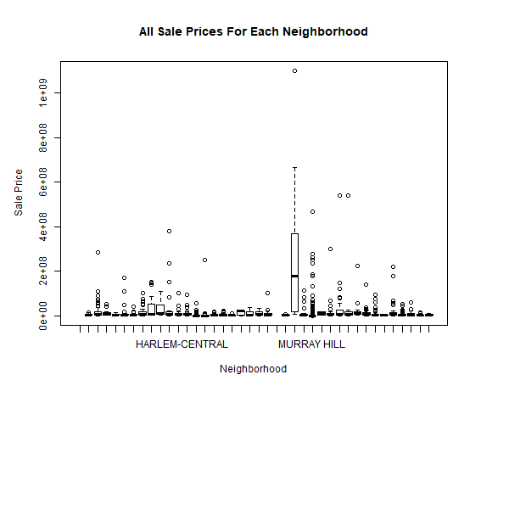

**Additionally**

Apologies for the poor formatting and the lack of more luxurious graphs. This was my first time using R. I used R for cleaning the data, creating graphs and calculating statistical data. I could have finished this project more quickly but using R for the first time slowed me down. I do not believe that R was very effective for this task. It would have been faster and more hassle free to use Python for calculating statistical data and Excel for producing graphs. However, because an R example was provided, I took the opportunity to pick up the language and complete the project using it.