Implement website

-----We build up a website to simulate our database for practical usage.

In practice, the database manager is the only one who can insert new data, so we create an Admin table to store the administer account information.

Pre-requirement

1. Packages

Werkzeug==1.0.1

Flask_Excel==0.0.7

SQLAlchemy==1.3.24

Flask_Mail==0.9.1

WTForms==2.3.1

Flask_WTF==0.14.3

XlsxWriter==1.2.7

PyMySQL==0.9.2

Flask==1.1.2

Flask_SQLAlchemy==2.4.3

Flask_Login==0.5.0

flask_bootstrap==3.3.7.1

1. Environment

Python 3.9

Chrome

1. Read the readme.md

1. "**\*\*pip install -r requirements.txt\*\***”run this command for all package

2. In **\*\*config.py\*\*** to confige **\*\*mysql\*\***'account and password

3. run **\*\*views.py\*\***

4. ctrl + click on "**\*\*http://127.0.0.1:5000.\*\***"

4.

Administer account and password：

- admin-123456

Website functions

1. ---log in

You can log in to get more authority as a administer (see figure 1.1)

Otherwise, you will be warned when you try to register a new player.(see figure 1.2)

To ensure the correctness of the database, we will not allow the administrator front-end registration, of course, we will provide the administrator account and password to meet the requirements of the staff.

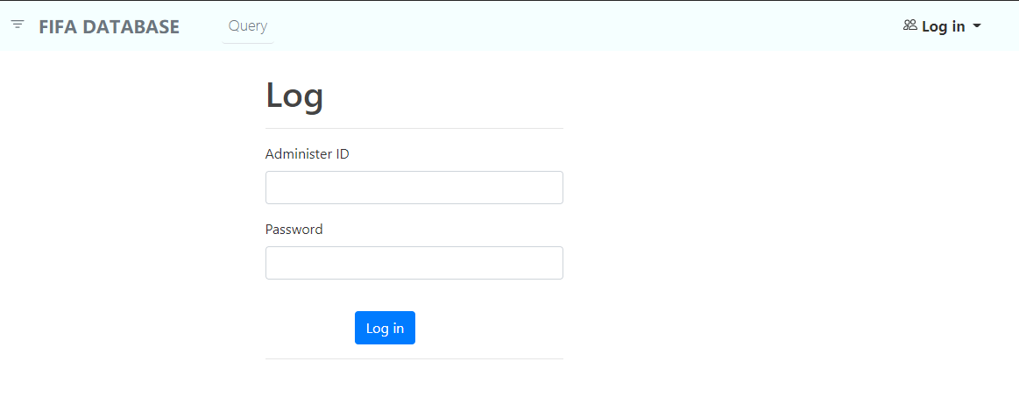

Figure 1.1

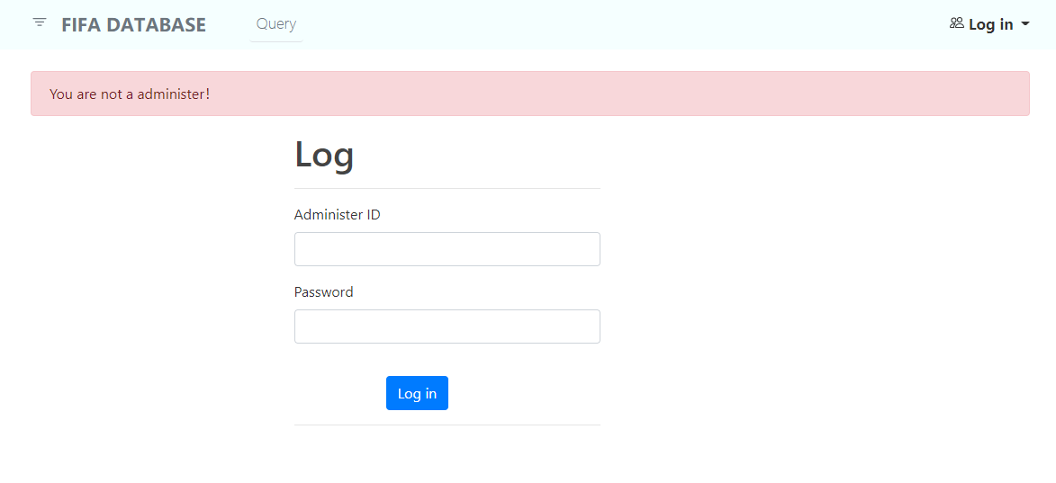

Figure 1.2

2.---Administer Only

Administer can insert new data

*The new player must have a unique id and season, we will check it if you insert duplicate information. (see figure 2.1)

*The new player must have all information otherwise we will warn you about that.(see figure 2.2)

*Once the information complete, the new_player's information will be stored in the waiting list for further confirmation.(see figure 1.3)

*Of course, the overall value should be guaranteed to be less than or equal to the potential. Our backstage will automatically detect the correctness of the input data to ensure the integrity of the database.

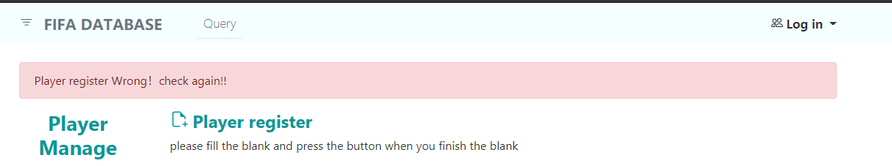

Figure 2.1

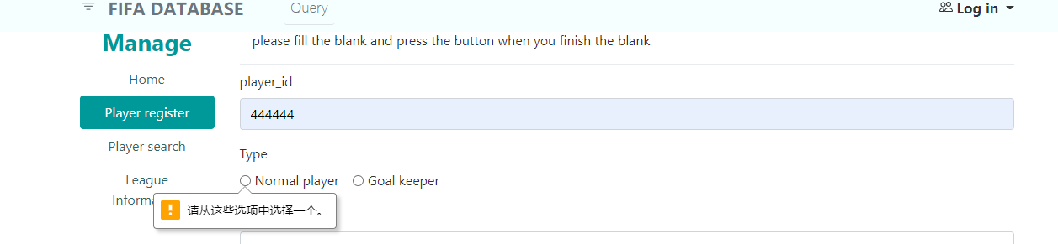

Figure 2.2

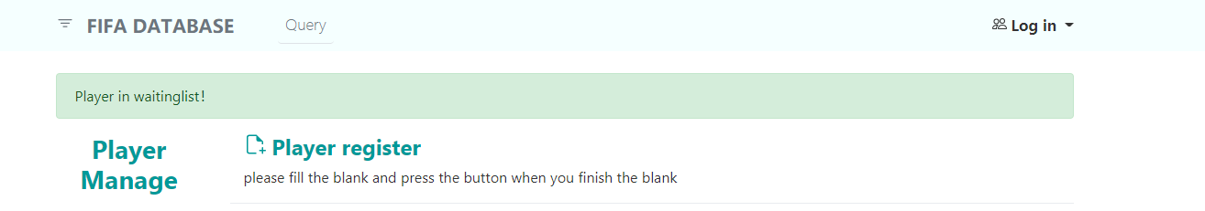

Figure 2.3

3.----Administer and User both can

**You can search players information when you get one of the search keys (Player_id, season, player_best_position, league, club_name, nationality, overall , potential)see figure(3.1) and you will get the information include (Player_id, season, player_best_position, league, club_name, nationality, overall , potential,value(euro)) .see figure(3.2)

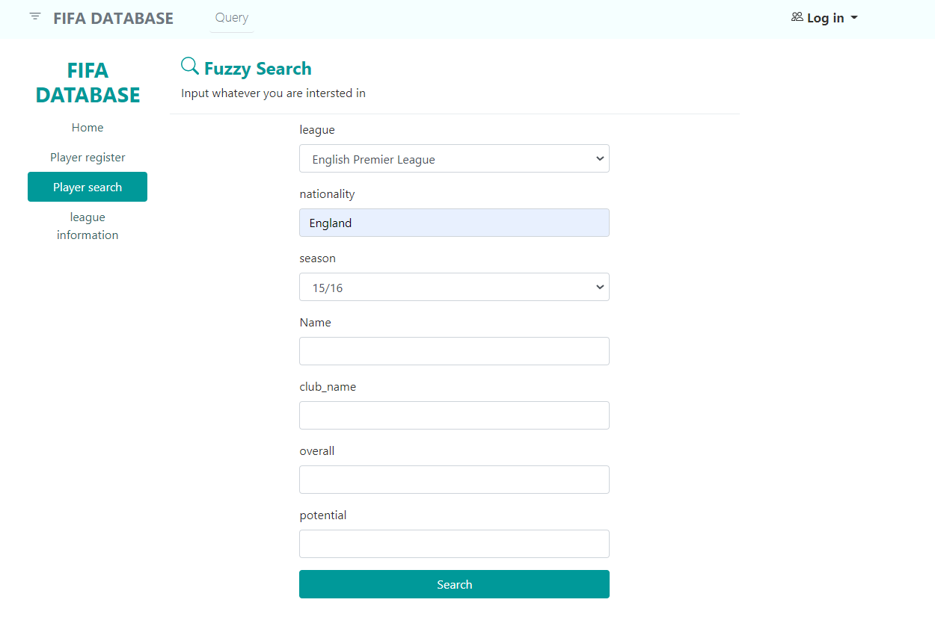

Figure 3.1

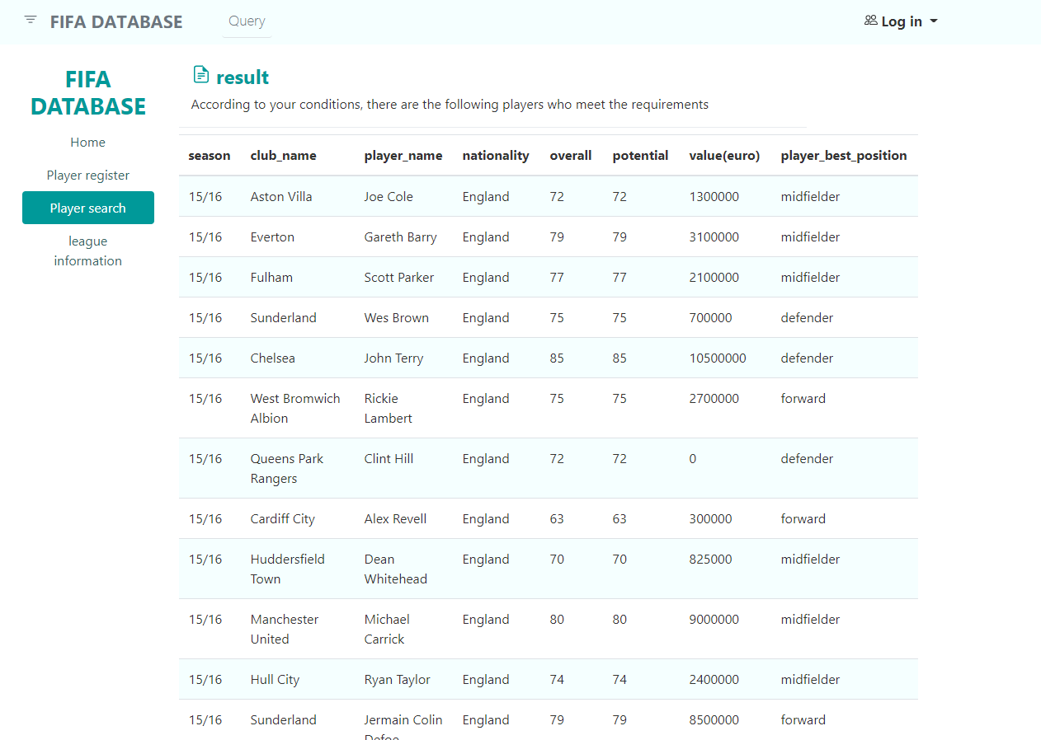

Figure 3.2

**If you are not so familiar with the league and the club and their belongings, or you are not sure whether this club has been promoted in a certain season, then we have also prepared a page for you to get more information(see figure 3.3）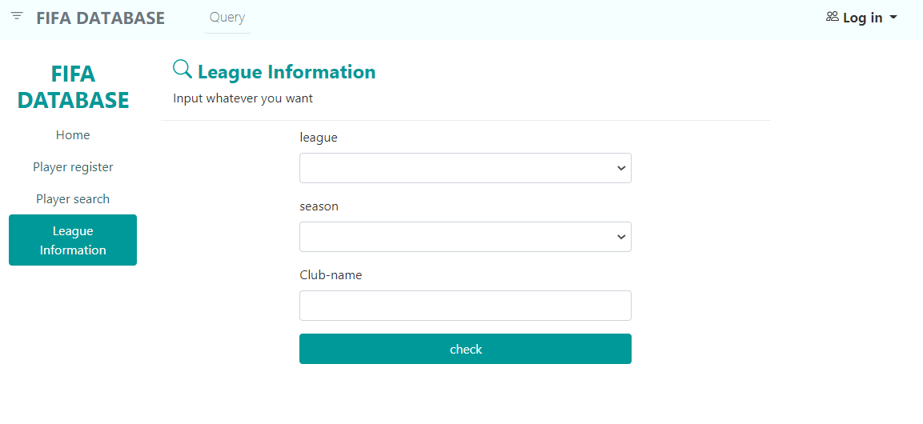

Figure 3.3

You can enter whatever you want to know (league, club, season information) to get information. (see figure 3.4）

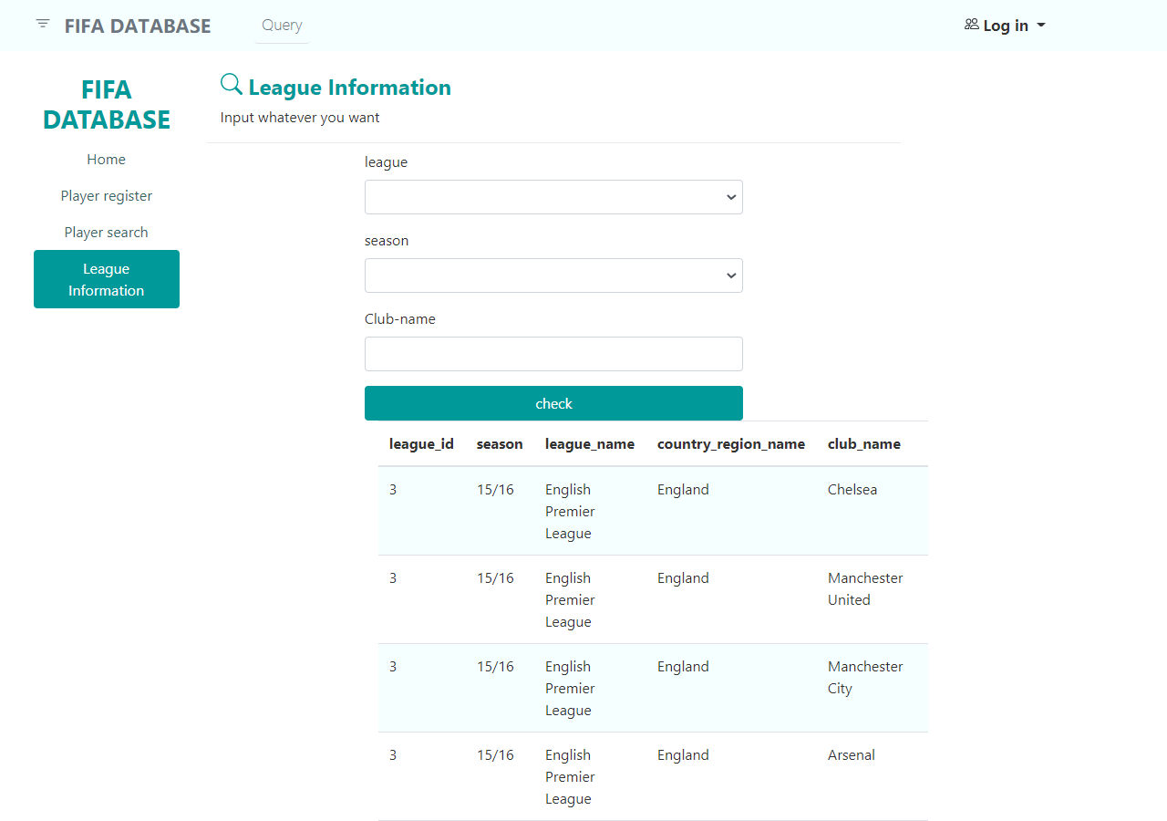

Figure 3.4