Problem

Since the end of 2020, the price of Bitcoin (BTC) has been increasing rapidly. This sharp rise has stimulated the whole market of cryptocurrencies. Consequently, mining of tokens based on Proof of Work (PoW) mechanism has been more than popular around the world. Some of this type of tokens, for instance, BTC, BCH, and LTC, need application-specific integrated circuits (ASIC) for mining, while others can be mined using GPU of PC. Among the latter, Ether (ETH) of Ethereum is the most favored since it provides the highest profit.

Currently, ETH miners can choose between two kinds of software. One is pure mining programs with no graphical user interface (GUI), the other is commercial mining software with GUI and some additional functionalities such as temperature monitoring and virtual memory setting. Unfortunately, both types of software have some shortcomings. The open-source ones are not user-friendly due to the lack of GUI. Users have to learn and type command lines to configure and run the program, which could be annoying for unsophisticated users. Furthermore, this type of mining programs can do nothing but mining. That is, users need to use other software to monitor temperatures, set the size of virtual memory, and/or check network latency, which is inconvenient. On the other hand, although the commercial ones implement GUI and integrate some utilities, they have the following drawbacks: First, they take 1-5 percent of mining output as their profit, which could be a significant loss for users in the long run. On the contrary, pure mining software usually takes less than 1 percent. Second, their functionalities are still insufficient. For example, they provide neither an estimation of daily output in dollars nor statistics on computational power and temperature. Besides, some of them do not supply utilities for GPU overclocking. The ones which do provide overclocking setting do not provide automatic overclocking. Users must set the overclocking parameters by themselves, test system performance and stability, and then adjust the overclocking parameters accordingly. To achieve optimization of the system, users may need to repeat the above process for multiple rounds, which could be time-consuming and tiring. Third, their user experiences are unsatisfactory. In terms of user interface, their GUIs are filled with texts and lack graphs, which are neither concise nor elegant. As for interoperability, they do not provide sufficient tips or feedback. For instance, on the overclocking setting panel of Easy Miner, there is no prompt about the parameters. For naïve users, this may cause confusion. Worse still, if the naïve users set the parameters improperly, the hardware can be damaged. Moreover, there is no notification when the system is not running smoothly. For example, if the cooling of hardware is poor or the clock frequency of GPU is set too high, the power of GPU will be reduced compulsively by the driver. As a result, the computational power will decrease. However, in this kind of situations, these software do not notify the users directly. Users can realize the problem only by checking the status manually and actively.

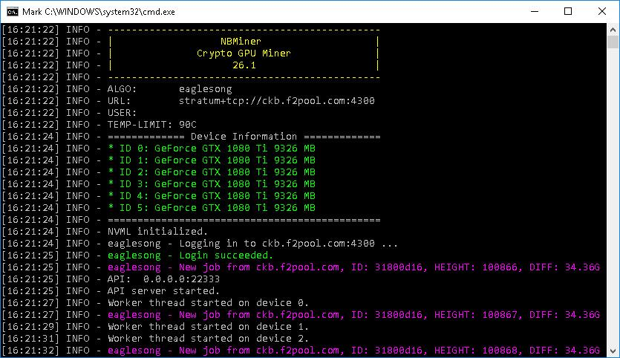

Figure X: The User Interface of NBMiner

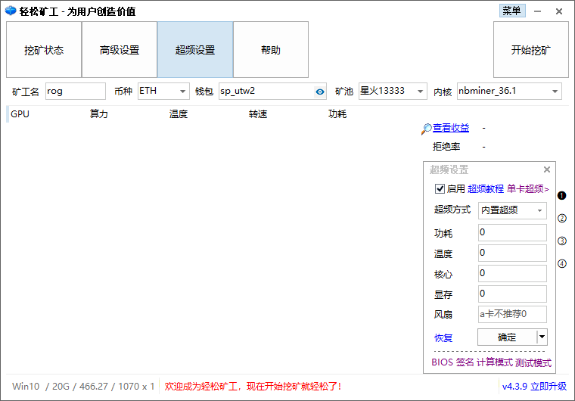

Figure X: The User Interface of EasyMiner