**Reflections on the Global Frontier Nexus Field Trip**

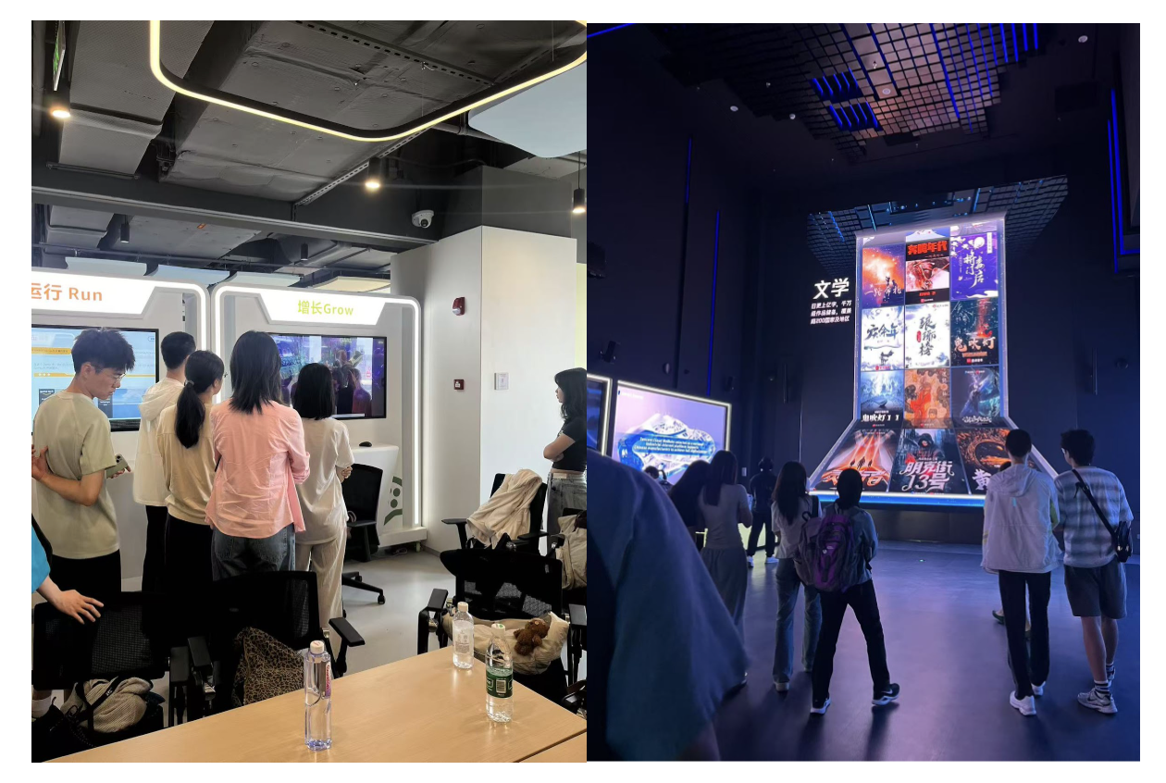

*Fig 3.* ***AWS vs. Tencent*** *- Visiting* ***AWS (Amazon)*** *and* ***Tencent*** *revealed that both firms focus on scalable AI platforms and automation, cloud computing, and applications across multiple sectors, while also reflecting differences in institutional and cultural approaches to innovation.*

**Part A: Comparative Reflection**

Contemporary challenges require innovative approaches, which makes applying machine learning to social science problems highly promising. ML offers time-efficient methods to uncover patterns in massive datasets, anticipate behaviors, and inform policies with greater precision. Yet, these systems are not free from bias, and such biases can amplify inequality if left unchecked.

On a global scale, leading nations are investing heavily in large-scale models and data infrastructures, reflecting a shared commitment to computational advancement. This represents a convergence in technological ambition, yet divergence emerges through political and institutional contexts. From the field trip to Tencent and AWS (Amazon) I see that the United States relies on private-sector innovation and decentralized research ecosystems like AWS (Amazon), while China adopts a state-driven model that integrates AI into national strategies and planning.

Amid these trajectories, ethical and societal concerns remain urgent. Challenges surrounding data governance, fairness, and accountability directly align with the UN Sustainable Development Goals. Ensuring algorithmic equity is vital for Reduced Inequalities (SDG 10), applying AI responsibly in healthcare supports Good Health and Well-Being (SDG 3), and fostering transparent urban applications advances Sustainable Cities (SDG 11). Embedding ethics into the design and deployment of ML is therefore essential to ensure that technological progress contributes to social good.

**Part B: Liberal Arts & Global Leadership Reflection**

Equal and responsible ML innovation depends not only on technical breakthroughs but also on how thoughtfully we reflect on its broader impact. The promises of ML in health, climate, and education are immense, yet realizing them requires critical reflection on unintended consequences, interdisciplinary reasoning to connect technical and human perspectives, and ethical imagination to envision futures where technology advances the common good.

I think a liberal arts university like Duke Kunshan University is an ideal place to foster this mindset. Interdisciplinary perspectives form the foundation of responsible ML innovation, ensuring that we approach problems from multiple angles. Beyond the curriculum, DKU’s diverse student body—representing cultures and viewpoints from around the world—exposes us to different ways of thinking. Here, we learn to examine issues from a truly global perspective, and that perspective is essential in shaping how we apply ML responsibly and inclusively.