

Project of
“Computer Networks”
Group 2

Representors

Muhammad Uneeb Khan (243729)
Muhammad Hamza Khan (243774)
Madiha Ashraf (243744)

Under the Guidance of

Respected: Sir Abdul Ghani

Department of Computer Science Air University Multan
TABLE OF CONTENT:
Contents
1) Introduction: 3
2) Objectives: 3
3) Network topology: 4
4) LAN: 5
5) IP Addressing and Subnetting: 5
WAN 6
Sydney VLAN: 6
Melborune 9
Brisbane 12
HongKong 15
6) Site to Site Connectivity and Interconnectivity: 18
7) Firewall Design 19
8) Hardware: 24
9) VPN: 24
10) Conclusion: 27
11) References: 28

Introduction:
AirNet is a rapidly growing Australian enterprise headquartered in Sydney, with additional branches in Melbourne, Brisbane, and Hong Kong. As the business expands, the existing network had to be redesigned to support thousands of users, new branch offices, secure inter-branch connectivity, and reliable Internet access for all locations.
This project designs and implements a scalable IP network using hierarchical LAN design, VLSM-based subnetting, VLAN segmentation, and secure edge protection with a firewall. The solution also addresses recent cybersecurity incidents reported by the company, including DDoS attacks, phishing attempts, and potential insider threats. To ensure that the design is not only technically sound but also professionally and ethically responsible, it is aligned with the ACS Code of Professional Ethics, particularly its core values of honesty, trustworthiness, and respect
The outcome is an enterprise-wide topology that supports intra- and inter-branch communication, centralized and local services (DNS, DHCP, mail, web, AAA, backup), secure Internet access, and strong internal segmentation to minimize security risks.

Objectives:
The main objectives of this project are:
- Scalability: Design an addressing plan and topology that support up to ~8,000 users at Sydney and several thousand users at each branch.
- Efficient IP Addressing: Use Variable Length Subnet Masking (VLSM) to optimise utilisation of the 188.29.XY.0/16 block while supporting all VLANs and WAN links.
- Layered LAN Design: Implement a hierarchical campus design (core, distribution, access) in each building with VLANs for HR, Staff, Management, Finance, Wireless, Guest, Servers, and Infrastructure.
- Inter-Branch Connectivity: Provide reliable IPv4 routing between Sydney, Melbourne, Brisbane and Hong Kong using a hub-and-spoke design centred on Sydney.
- Secure Edge Connectivity: Deploy a Cisco ASA firewall between the internal network and ISP router to provide NAT, access control, and basic DDoS/phishing mitigation.
- Wireless Segregation: Implement secure WLAN for staff and logically isolated guest Wi-Fi mapped to separate VLANs.
- Service Availability: Host core services (DNS, DHCP, web, email, AAA, backup, file, syslog/SIEM) and ensure they are reachable from authorised users across sites.
- Security & Governance: Apply technical controls and policy recommendations that address DDoS, phishing, insider threats, and align with ACS ethical expectations for ICT professionals.
Documentation & Evaluation: Fully document topology, addressing, configurations, and security policies, and validate the design through Packet Tracer simulation.

Network topology:

The Topology used is Star in this project.
The overall design follows a hub-and-spoke WAN with hierarchical LANs in each site:
- Sydney HQ (hub):
  - HQ core and distribution switches with multiple access switches per floor.
  - A Sydney edge router acting as the central hub router for all branches.
  - Serial and routed links from Sydney to Melbourne, Brisbane, and Hong Kong.
  - A Cisco ASA 5505-type firewall between the Sydney router and the ISP router.
  - Internet “cloud” as ISP router for simulated external connectivity.
- Branches (Melbourne, Brisbane, Hong Kong):
  - Each branch has:
    - One branch router connected via WAN to the Sydney hub.
    - One L3 core switch per building (with SVIs for all VLANs).
    - A distribution switch feeding multiple access switches.
    - A dedicated server switch on level 5 for six local servers.
    - Wireless APs on the appropriate floors for staff and guest SSIDs.
- Logical Topology:
  - The WAN uses /30 point-to-point links in a hub-and-spoke layout:
    - SYD–MEL, SYD–BRISB, SYD–HKG each allocated a /30 subnet.
  - All branch LANs are summarised into contiguous blocks:
    - Sydney: 188.29.0.0/19
    - Melbourne: 188.29.32.0/19
    - Brisbane: 188.29.64.0/20
    - Hong Kong: 188.29.80.0/20
This structure reduces routing table size, simplifies static routing, and gives a clear separation between WAN, LAN, and server-farm segments. Topology diagrams in the appendices visually show the physical and logical layout of routers, switches, servers, APs, firewall, and ISP.

LAN:
Each site’s LAN is built using the three-tier campus model:
- Core Layer (L3 Switch):
  - Provides inter-VLAN routing via SVIs.
  - Aggregates trunks from the distribution and server switches.
  - Connects to the local branch router using a dedicated /30 routed link.
  - Hosts default gateway IPs for all VLANs (HR, Staff, Mgmt, Finance, Guest, Wireless, Servers, Infra).
- Distribution Layer:
  - Acts as the aggregation point for multiple access switches.
  - All downlinks and uplinks are configured as 1Q trunks carrying the relevant VLANs.
  - Provides consistent policy enforcement across floors (e.g. VLANs, QoS in future).
- Access Layer:
  - Each floor has one or more access switches.
  - End-user PCs are connected as access ports in the appropriate VLAN.
  - Wireless APs are connected as trunk ports carrying wireless VLANs.
  - Spanning Tree and Port Fast are enabled on edge ports to improve convergence.
- Server Rooms (Level 5)
  - A dedicated server switch connects file, DNS, web, mail, DHCP, backup, AAA and SIEM servers in the Servers VLAN.
  - The server switch uplinks via a trunk to the core switch, ensuring servers are reachable from the entire site through inter-VLAN routing.
This design cleanly separates user, server, management, and guest traffic, making the network more secure, easier to manage, and ready for future features like QoS and high availability.

IP Addressing and Subnetting:

Category | Sydney | Melbourne | Brisbane | Hongkong
Subnet Mask | 255.255.224.0 | 255.255.224.0 | 255.255.240.0 | 255.255.240.0
CIDR | 19 | 19 | 20 | 20
Network ID | 188.29.0.0 | 188.29.32.0 | 188.29.64.0 | 188.29.80.0
Broadcast ID | 188.29.31.255 | 188.29.63.255 | 188.29.79.255 | 188.29.95.255
Usable host IP Range | 188.29.0.1-188.29.31.254 | 188.29.32.1 – 188.29.63.254 | 188.29.64.1 – 188.29.79.254 | 188.29.80.1 – 188.29.95.254
Total Hosts | 8000 | 6200 | 3000 | 2744
Usable Hosts | 8190 | 8190 | 4094 | 4094

WAN
Link | Network ID | Usable IPs | Broadcast ID | Subnet Mask
SYD – MEL | 192.168.100.0/24 | SYD: 192.168.100.1  MEL: 192.168.100.2 | 192.168.100.255 | 255.255.255.0
SYD – BNE | 188.29.90.0/30 | SYD: 188.29.90.1  BNE: 188.29.90.2 | 188.29.90.3 | 255.255.255.252
SYD – HKG | 188.29.96.0/30 | SYD: 188.29.96.1  HKG: 188.29.96.2 | 188.29.96.3 | 255.255.255.252

Sydney VLAN:

VLAN | ID | Need (hosts) | Assigned network | Mask (CIDR) | Usable IP range | Gateway (SVI)
HR | 10 | 1000 | 188.29.0.0/22 | /22 (255.255.252.0) | 188.29.0.1 – 188.29.3.254 | 188.29.0.1
Staff | 20 | 500 | 188.29.4.0/23 | /23 (255.255.254.0) | 188.29.4.1 – 188.29.5.254 | 188.29.4.1
Management | 30 | 200 | 188.29.6.0/24 | /24 (255.255.255.0) | 188.29.6.1 – 188.29.6.254 | 188.29.6.1
Finance | 40 | 100 | 188.29.7.0/25 | /25 (255.255.255.128) | 188.29.7.1 – 188.29.7.126 | 188.29.7.1
Wireless | 70 | 100 | 188.29.7.128/25 | /25 (255.255.255.128) | 188.29.7.129 – 188.29.7.254 | 188.29.7.129
Guest | 50 | 50 | 188.29.8.0/26 | /26 (255.255.255.192) | 188.29.8.1 – 188.29.8.62 | 188.29.8.1
Servers | 60 | 20 | 188.29.8.64/27 | /27 (255.255.255.224) | 188.29.8.65 – 188.29.8.94 | 188.29.8.65

Every Sydney server belongs to:
VLAN 60 – Servers
Network: 188.29.8.64/27
Gateway: 188.29.8.65
Mask: 255.255.255.224
DNS SERVER CONFIGURATION
Server Name: DNS-SRV
- IP Address: 188.29.8.66
- Subnet Mask: 255.255.255.224
- Default Gateway: 188.29.8.65
- DNS: 188.29.8.66
Name | Type | IP Address
aumc.com | A Record | 188.29.8.68
backup.sydney.local | A Record | 188.29.8.73
brisb.com | A Record | 188.29.72.69
dns.sydney.local | A Record | 188.29.8.66
file.sydney.local | A Record | 188.29.8.74
hkg.com | A Record | 188.29.88.69
mail.aumc.com | A Record | 188.29.8.68
mail.brisb.com | A Record | 188.29.72.69
mail.hkg.com | A Record | 188.29.88.69
mail.mel.com | A Record | 188.29.40.68
mail.sydney.local | A Record | 188.29.8.68
mel.com | A Record | 188.29.40.68
radius.sydney.local | A Record | 188.29.8.71
siem.sydney.local | A Record | 188.29.8.72
web.sydney.local | A Record | 188.29.8.67

WEB SERVER:
- IP: 188.29.8.67
- Mask: 255.255.255.224
- Gateway: 188.29.8.65
- DNS: 188.29.8.66
MAIL SERVER
- IP: 188.29.8.68
- Mask: 255.255.255.224
- Gateway: 188.29.8.65
- DNS: 188.29.8.66
- Domain Name: aumc.com
FILE / FTP SERVER
- IP: 188.29.8.74
- Mask: 255.255.255.224
- Gateway: 188.29.8.65
- DNS: 188.29.8.66
Username | Password
User | 1234
Admin | admin

RADIUS / AAA SERVER
- IP: 188.29.8.71
- Mask: 255.255.255.224
- Gateway: 188.29.8.65
- DNS: 188.29.8.66
  - Username: Uneeb
  - Password: 1234
SIEM / SYSLOG SERVER
- IP: 188.29.8.72
- Mask: 255.255.255.224
- Gateway: 188.29.8.65
- DNS: 188.29.8.66
BACKUP SERVER
- IP: 188.29.8.73
- Mask: 255.255.255.224
- Gateway: 188.29.8.65
- DNS: 188.29.8.66
- Turn FTP = ON
- Create a backup user (backup/1234).

Melborune

Name | VLAN ID | Assigned Network | Mask (CIDR) | Usable IP Range | Gateway (SVI) | Notes
HR | 10 | 188.29.32.0/22 | 255.255.252.0 (/22) | 188.29.32.1 – 188.29.35.254 | 188.29.32.1 | 1022 hosts
Staff | 20 | 188.29.36.0/23 | 255.255.254.0 (/23) | 188.29.36.1 – 188.29.37.254 | 188.29.36.1 | 510 hosts
Management | 30 | 188.29.38.0/24 | 255.255.255.0 (/24) | 188.29.38.1 – 188.29.38.254 | 188.29.38.1 | 254 hosts
Finance | 40 | 188.29.39.0/25 | 255.255.255.128 (/25) | 188.29.39.1 – 188.29.39.126 | 188.29.39.1 | 126 hosts
Wireless (Staff) | 70 | 188.29.39.128/25 | 255.255.255.128 (/25) | 188.29.39.129 – 188.29.39.254 | 188.29.39.129 | staff Wi-Fi devices
Guest | 50 | 188.29.40.0/26 | 255.255.255.192 (/26) | 188.29.40.1 – 188.29.40.62 | 188.29.40.1 | guest Wi-Fi, captive portal
Servers | 60 | 188.29.40.64/27 | 255.255.255.224 (/27) | 188.29.40.65 – 188.29.40.94 | 188.29.40.65 | 6 servers
Infra / Management | 80 | 188.29.40.96/27 | 255.255.255.224 (/27) | 188.29.40.97 – 188.29.40.126 | 188.29.40.97 | switch mgmt, NMS, jump hosts
Reserve | — | 188.29.40.128 - 188.29.63.255 | — | — | —
DNS SERVER
- IP: 188.29.40.66
- Mask: 255.255.255.224
- Gateway: 188.29.40.65
- DNS: 188.29.40.66

Melbourne DNS Records Table

Name | Type | IP Address
aumc.com | A Record | 188.29.8.68
backup.melbourne | A Record | 188.29.40.71
brisb.com | A Record | 188.29.72.69
dns.melbourne | A Record | 188.29.40.66
file.melbourne | A Record | 188.29.40.69
hkg.com | A Record | 188.29.88.69
mail.aumc.com | A Record | 188.29.8.68
mail.brisb.com | A Record | 188.29.72.69
mail.hkg.com | A Record | 188.29.88.69
mail.mel.com | A Record | 188.29.40.68
mail.melbourne | A Record | 188.29.40.68
mel.com | A Record | 188.29.40.68
web.melbourne | A Record | 188.29.40.67

WEB SERVER

- IP: 188.29.40.67
- Mask: 255.255.255.224
- Gateway: 188.29.40.65
- DNS: 188.29.40.66
- http://web.melbourne

MAIL SERVER

- IP: 188.29.40.68
- Mask: 255.255.255.224
- Gateway: 188.29.40.65
- DNS: 188.29.40.66
- Domain Name: mel.com

Username | Password
Ali | 12345
uneeb | 12345

FILE SERVER

- IP: 188.29.40.69
- Mask: 255.255.255.224
- Gateway: 188.29.40.65
- DNS: 188.29.40.66
- Add user accounts (admin / 12345)
- Add user accounts (mel_user / 12345)
Test:
PC → Command Prompt:
ftp file.melbourne

BACKUP SERVER

- IP: 188.29.40.71
- Mask: 255.255.255.224
- Gateway: 188.29.40.65
- DNS: 188.29.40.66

FTP or TFTP
- Username: backup
- Password: 1234
Test:
copy running-config ftp

Brisbane

VLAN | ID | Mask (CIDR) | Network | Usable IP Range | Gateway (SVI) | DHCP Scope (Recommended)
HR | 10 | /22 | 188.29.64.0/22 | 188.29.64.1 – 188.29.67.254 | 188.29.64.1 | 188.29.64.10 – 188.29.67.250
Staff | 20 | /23 | 188.29.68.0/23 | 188.29.68.1 – 188.29.69.254 | 188.29.68.1 | 188.29.68.10 – 188.29.69.250
Management | 30 | /24 | 188.29.70.0/24 | 188.29.70.1 – 188.29.70.254 | 188.29.70.1 | 188.29.70.10 – 188.29.70.250
Finance | 40 | /25 | 188.29.71.0/25 | 188.29.71.1 – 188.29.71.126 | 188.29.71.1 | 188.29.71.10 – 188.29.71.120
Wireless (Staff) | 70 | /25 | 188.29.71.128/25 | 188.29.71.129 – 188.29.71.254 | 188.29.71.129 | 188.29.71.140 – 188.29.71.240
Guest | 50 | /26 | 188.29.72.0/26 | 188.29.72.1 – 188.29.72.62 | 188.29.72.1 | 188.29.72.10 – 188.29.72.60
Servers (Level 5) | 60 | /27 | 188.29.72.64/27 | 188.29.72.65 – 188.29.72.94 | 188.29.72.65 | static only – no DHCP
Infra / Management | 80 | /27 | 188.29.72.96/27 | 188.29.72.97 – 188.29.72.126 | 188.29.72.97 | static or short DHCP leases
Reserve / Growth | — | — | 188.29.72.128 – 188.29.79.255 | — | — | reserved for DMZ, VPN, VoIP, expansion

DNS SERVER
- IP: 188.29.72.66
- Mask: 255.255.255.224
- Gateway: 188.29.72.65
- DNS: 188.29.72.66
Add the A Records:
Brisbane DNS Records Table

Name | Type | IP Address
aumc.com | A Record | 188.29.8.68
backup.brisbane | A Record | 188.29.72.71
brisb.com | A Record | 188.29.72.69
dns.brisbane | A Record | 188.29.72.66
file.brisbane | A Record | 188.29.72.70
hkg.com | A Record | 188.29.88.69
mail.aumc.com | A Record | 188.29.8.68
mail.brisb.com | A Record | 188.29.72.69
mail.brisbane | A Record | 188.29.72.69
mail.hkg.com | A Record | 188.29.88.69
mail.mel.com | A Record | 188.29.40.68
mel.com | A Record | 188.29.40.68
web.brisbane | A Record | 188.29.72.67

WEB SERVER

- IP: 188.29.72.67
- Mask: 255.255.255.224
- Gateway: 188.29.72.65
- DNS: 188.29.72.66

DHCP SERVER

- IP: 188.29.72.68
- Mask: 255.255.255.224
- Gateway: 188.29.72.65
- DNS: 188.29.72.66
Pool Name | Default Gateway | DNS Server | Start IP Address | Subnet Mask | Max Users | TFTP Server | WLC Address
GUEST | 188.29.72.1 | 188.29.72.66 | 188.29.72.10 | 255.255.255.192 | 54 | 0.0.0.0 | 0.0.0.0
INFRA | 188.29.72.97 | 188.29.72.66 | 188.29.72.100 | 255.255.255.224 | 28 | 0.0.0.0 | 0.0.0.0
WIRELESS | 188.29.71.129 | 188.29.72.66 | 188.29.71.140 | 255.255.255.128 | 116 | 0.0.0.0 | 0.0.0.0
FINANCE | 188.29.71.1 | 188.29.72.66 | 188.29.71.10 | 255.255.255.128 | 118 | 0.0.0.0 | 0.0.0.0
MGMT | 188.29.70.1 | 188.29.72.66 | 188.29.70.10 | 255.255.255.0 | 246 | 0.0.0.0 | 0.0.0.0
STAFF | 188.29.68.1 | 188.29.72.66 | 188.29.68.10 | 255.255.254.0 | 502 | 0.0.0.0 | 0.0.0.0
HR | 188.29.64.1 | 188.29.72.66 | 188.29.64.10 | 255.255.252.0 | 1000 | 0.0.0.0 | 0.0.0.0
serverPool | 0.0.0.0 | 0.0.0.0 | 188.29.72.64 | 255.255.255.224 | 512 | 0.0.0.0 | 0.0.0.0

MAIL SERVER

- IP: 188.29.72.69
- Mask: 255.255.255.224
- Gateway: 188.29.72.65
- DNS: 188.29.72.66
- Domain Name: brisb.com

Username | Password
uneeb | 12345
Ali | 12345

FILE SERVER (FTP)

- IP: 188.29.72.70
- Mask: 255.255.255.224
- Gateway: 188.29.72.65
- DNS: 188.29.72.66
- Add user: admin / 12345
- Add user: mel_user / 12345

Test:
PC → Command Prompt:
ftp file.brisbane

BACKUP SERVER

- IP: 188.29.72.71
- Mask: 255.255.255.224
- Gateway: 188.29.72.65
- DNS: 188.29.72.66
Add account:

User | Pass
backup | 12345

HongKong

VLAN | Name | Purpose | Network | Mask | Usable Range | Gateway (SVI on Core)
10 | HR | HR PCs | 188.29.80.0/22 | 255.255.252.0 (/22) | 188.29.80.1 – 188.29.83.254 | 188.29.80.1
20 | STAFF | Staff PCs | 188.29.84.0/23 | 255.255.254.0 (/23) | 188.29.84.1 – 188.29.85.254 | 188.29.84.1
30 | MGMT | Management PCs | 188.29.86.0/24 | 255.255.255.0 (/24) | 188.29.86.1 – 188.29.86.254 | 188.29.86.1
40 | FINANCE | Finance PCs | 188.29.87.0/25 | 255.255.255.128 (/25) | 188.29.87.1 – 188.29.87.126 | 188.29.87.1
70 | WIRELESS | Staff Wi-Fi | 188.29.87.128/25 | 255.255.255.128 (/25) | 188.29.87.129 – 188.29.87.254 | 188.29.87.129
50 | GUEST | Guest Wi-Fi | 188.29.88.0/26 | 255.255.255.192 (/26) | 188.29.88.1 – 188.29.88.62 | 188.29.88.1
60 | SERVERS | Servers (L5) | 188.29.88.64/27 | 255.255.255.224 (/27) | 188.29.88.65 – 188.29.88.94 | 188.29.88.65
80 | INFRA | Switch mgmt/NMS | 188.29.88.96/27 | 255.255.255.224 (/27) | 188.29.88.97 – 188.29.88.126 | 188.29.88.97
999 | NATIVE | Native VLAN | — | — | — | —

DNS SERVER
- IP: 188.29.88.66
- Mask: 255.255.255.224
- Gateway: 188.29.88.65
- DNS: 188.29.88.66
Add the A Records:

Brisbane DNS Records Table

No. | Name | Type | IP Address
0 | aumc.com | A Record | 188.29.8.68
1 | backup.hongkong | A Record | 188.29.88.71
2 | brisb.com | A Record | 188.29.72.69
3 | dns.hongkong | A Record | 188.29.88.66
4 | file.hongkong | A Record | 188.29.88.70
5 | hkg.com | A Record | 188.29.88.69
6 | mail.aumc.com | A Record | 188.29.8.68
7 | mail.brisb.com | A Record | 188.29.72.69
8 | mail.hkg.com | A Record | 188.29.88.69
9 | mail.hongkong | A Record | 188.29.88.69
10 | mail.mel.com | A Record | 188.29.40.68
11 | mel.com | A Record | 188.29.40.68
12 | web.hongkong | A Record | 188.29.88.67

WEB SERVER

- IP: 188.29.88.67
- Mask: 255.255.255.224
- Gateway: 188.29.88.65
- DNS: 188.29.88.66

DHCP SERVER

- IP: 188.29.88.68
- Mask: 255.255.255.224
- Gateway: 188.29.88.65
- DNS: 188.29.88.66

Pool Name | Default Gateway | DNS Server | Start IP Address | Subnet Mask | Max Users | TFTP Server | WLC Address
MGMT | 188.29.86.1 | 188.29.88.66 | 188.29.86.10 | 255.255.255.0 | 246 | 0.0.0.0 | 0.0.0.0
STAFF | 188.29.84.1 | 188.29.88.66 | 188.29.84.10 | 255.255.254.0 | 502 | 0.0.0.0 | 0.0.0.0
HR | 188.29.80.1 | 188.29.88.66 | 188.29.80.10 | 255.255.252.0 | 512 | 0.0.0.0 | 0.0.0.0
WIRELESS | 188.29.87.129 | 188.29.88.66 | 188.29.87.140 | 255.255.255.128 | 100 | 0.0.0.0 | 0.0.0.0
FINANCE | 188.29.87.1 | 188.29.88.66 | 188.29.87.10 | 255.255.255.128 | 118 | 0.0.0.0 | 0.0.0.0
GUEST | 188.29.88.1 | 188.29.88.66 | 188.29.88.10 | 255.255.255.192 | 54 | 0.0.0.0 | 0.0.0.0
INFRA | 188.29.88.97 | 188.29.88.66 | 188.29.88.98 | 255.255.255.224 | 26 | 0.0.0.0 | 0.0.0.0
serverPool | 0.0.0.0 | 0.0.0.0 | 188.29.88.64 | 255.255.255.224 | 512

MAIL SERVER

- IP: 188.29.88.69
- Mask: 255.255.255.224
- Gateway: 188.29.88.65
- DNS: 188.29.88.66
- Domain Name: brisb.com

Username | Password
uneeb | 12345
ali | 12345

FILE SERVER (FTP)
- IP: 188.29.88.70
- Mask: 255.255.255.224
- Gateway: 188.29.88.65
- DNS: 188.29.88.66
- Add user: admin / 12345
- Add user: hkg_user / 12345

Test:
ftp file.brisbane

BACKUP SERVER
- IP: 188.29.88.71
- Mask: 255.255.255.224
- Gateway: 188.29.88.65
- DNS: 188.29.88.66
Add account:

User | Pass
backup | 12345

Site to Site Connectivity and Interconnectivity:
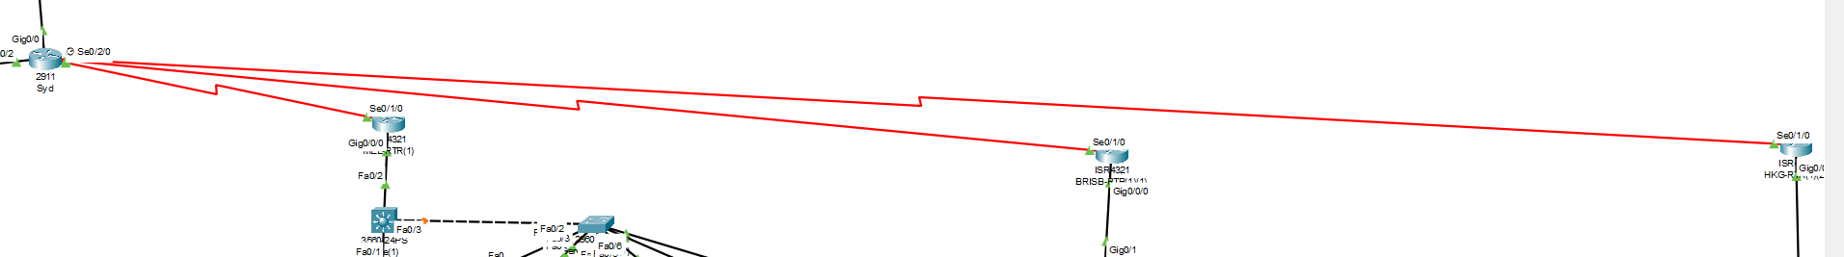
Sydney Router ↔ Melbourne Router
Network: 192.168.100.0 /24
Subnet Mask: 255.255.255.0

Device | Interface | IP Address
SYD-RTR | S0/3/0 | 192.168.100.1
MEL-RTR | S0/1/0 | 192.168.100.2
Routing Usage:
- MEL default → 192.168.100.1
- SYD sends 188.29.32.0/19 → 192.168.100.2

Network: 188.29.90.0 /30
Subnet Mask: 255.255.255.252
Device | Interface | IP Address
SYD-RTR | S0/3/1 | 188.29.90.1
BRISB-RTR | S0/1/0 | 188.29.90.2
Routing Usage:
- SYD → 188.29.64.0/20 → 188.29.90.2
- Brisbane forwards all others to Sydney.
Sydney Router ↔ Hong Kong Router
Network: 188.29.96.0 /30
Subnet Mask: 255.255.255.252
Device | Interface | IP Address
SYD-RTR | S0/2/0 | 188.29.96.1
HKG-RTR | S0/1/0 | 188.29.96.2
Routing Usage:
- HK default route → 188.29.96.1
- SYD sends 188.29.80.0/20 → 188.29.96.2

Firewall Design

Location in the Network
The firewall is deployed at the Sydney Head Office, positioned between the enterprise network and the public ISP infrastructure.
This ensures that:
✔All internal traffic leaving any branch is inspected
✔ All incoming external traffic is filtered
✔ Only permitted traffic enters the internal LAN
Since all branches communicate with Sydney using VPN, each branch’s traffic is encrypted and routed through this central firewall.
Purpose of Deployment:
The ASA firewall was implemented to:
- Traffic Filtering and Access Control
- Secure Internet Gateway
- Branch Inter-Site Security Enforcement
Only safe protocols are permitted outside the network.
Allowed outbound traffic
- HTTP (80)
- HTTPS (443)
- DNS queries (53)
- ICMP
Blocked outbound traffic
- SMTP (25)
- POP3 (110)
- IMAP (143)
These blocked ports prevent:
- Internal users sending mass spam emails
- Phishing email propagation inside and outside
- Unauthorized mail servers inside LAN
This protects against phishing distribution, malware delivery, and internal compromise.

✔ 2. Network Address Translation (NAT)

All internal LAN addresses are hidden using dynamic NAT (interface-based NAT).
This prevents attackers from directly targeting internal PCs.
Internal → Public mapping is one-way.
This reduces risk of direct exploitation, scanning, port-mapping and network profiling.
✔ 3. Intrusion Prevention (Inspection Engine)

Inspection is enabled on:
- ICMP (ping)
- TCP Handshakes
- UDP flows
Firewall intelligently monitors sessions and blocks suspicious or malformed packets.
This helps defend against:
- Ping flood (ICMP abuse)
- Half-open TCP attacks
- Random port scanning attempts

✔ 4. Default Deny Rule
Any traffic that is not explicitly permitted is automatically dropped.
This prevents:
✔ Unknown applications
✔ Malware-generated traffic
✔ Unauthorized data transfer
This should be stated in your report clearly:
"The firewall follows a zero-trust model, where implicit denial is enforced at exit boundaries."

How This Firewall Improves Security Across Buildings
Because Sydney is the center of connectivity, branches access external resources through Sydney Firewall.
When any PC in:
- Melbourne
- Brisbane
- Hong-Kong
accesses the internet:
🔥 firewall inspects
🔥 firewall filters
🔥 firewall performs NAT
Thus, all branches inherit the same protection as HQ.
So security is centralized and not dependent on remote device policies.

Summary Paragraph for Report

The Cisco ASA-5506 firewall plays a critical role in acting as the security boundary between internal branch networks and the external ISP infrastructure. By applying NAT, layered ACL controls, and advanced inspection policies, internal IP addressing remains protected while still enabling controlled access to internet services. The ISP router provides public routing and simulation of carrier-level connectivity. This firewall architecture prevents unauthorized inbound access, mitigates DoS attacks through stateful inspection, and supports secure cross-branch connectivity, meeting cybersecurity requirements outlined in the project.
Core Switch:
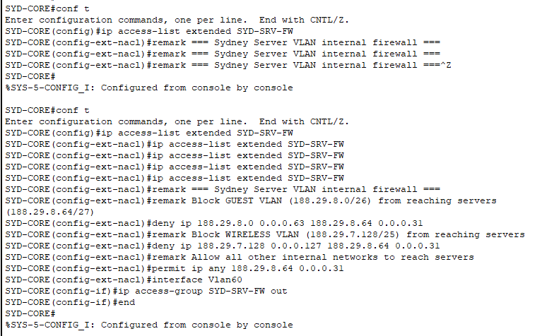
MEL Core:
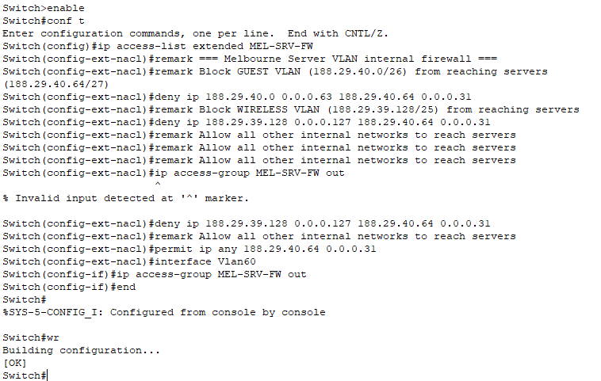

BRISB Core:

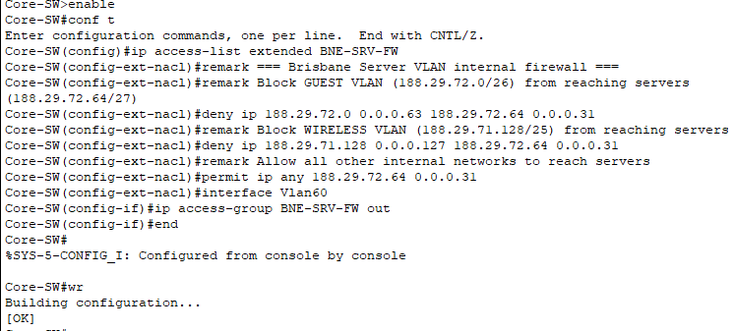

HKG Core:

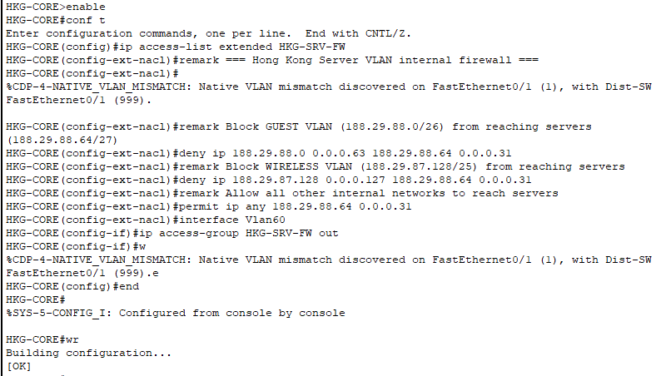

Hardware:

Hardware |  |  |  | Quantity
Routers |  |  |  | 5
Switches |  |  |  | 39
Servers |  |  |  | 30
Access Points |  |  |  | 70
PC |  |  |  | 75
Firewalls |  |  |  | 5
Cloud (Internet) |  |  |  | 1
City / Building | Users | Core Switches | Distribution Switches |  | Access Switches (PT) | PT Access Points
Sydney (HQ) | 8000 | 1 | 2 |  | 4 | 8 (4S + 4G)
Melbourne | 6200 | 1 | 2 |  | 4 | 7(4S + 3G)
Brisbane | 3000 | 1 | 2 |  | 4 | 3(2S + 1G)
Hong Kong | 2744 | 1 | 2 |  | 4 | 3(2S + 1G)

VPN:
SYD:
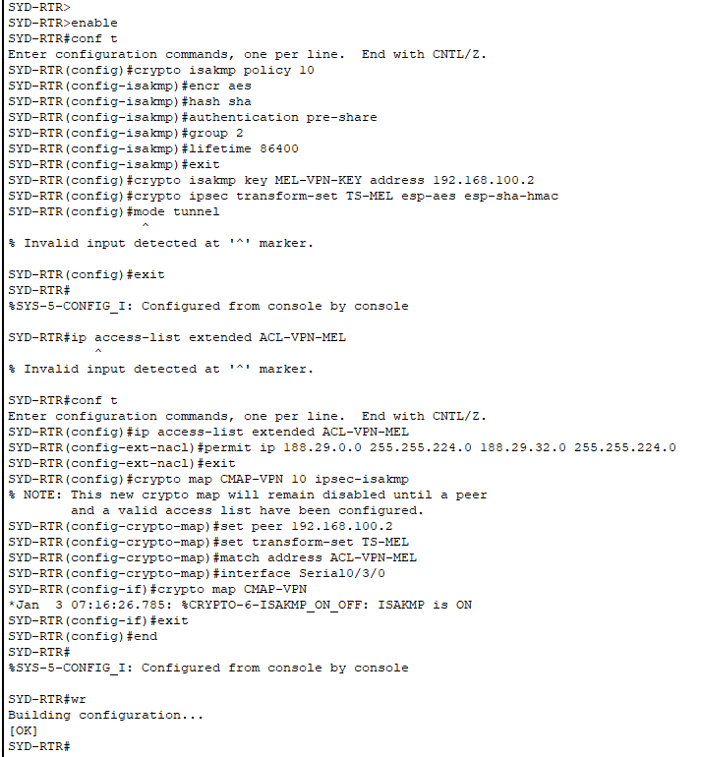
MELBOURNE:

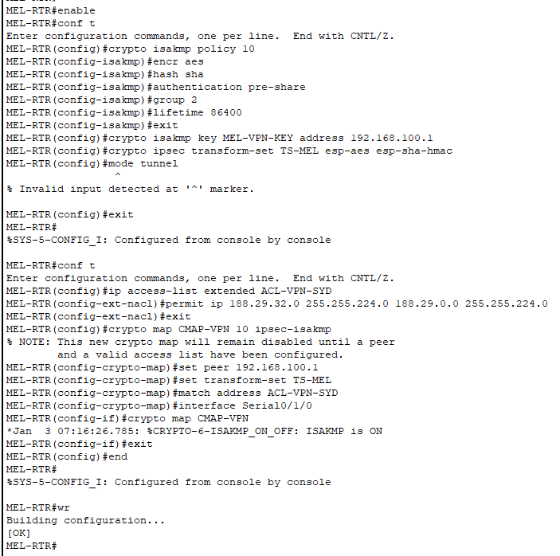

BRISB:
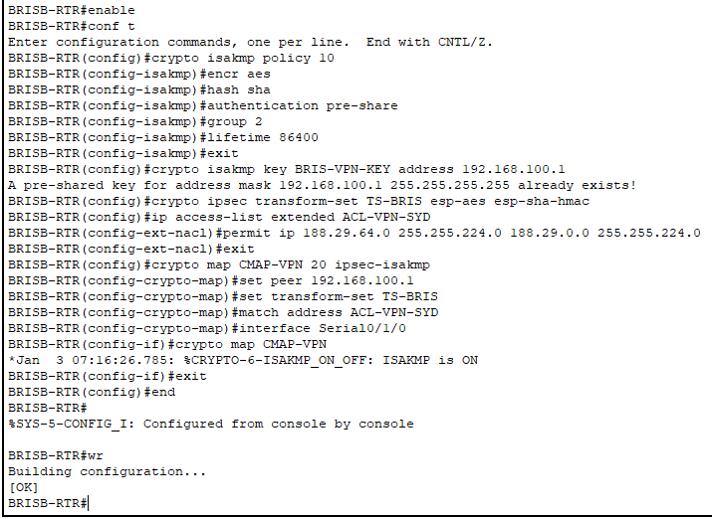
HKG:
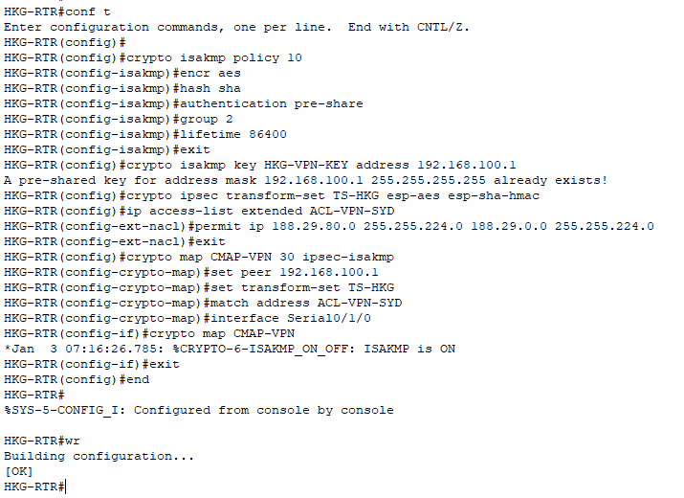
Site-to-Site VPN Summary Table
VPN Tunnel Name | Sydney Peer IP | Branch Peer IP | Branch | Local Protected Subnet (Sydney) | Remote Protected Subnet (Branch) | Authentication Key | Encryption | Tunnel Mode
SYD-MEL-VPN | 192.168.100.1 | 192.168.100.2 | Melbourne | 188.29.0.0/19 | 188.29.32.0/20 | MEL-VPN-KEY | AES-128 / SHA-1 | IPSec Tunnel
SYD-BRIS-VPN | 192.168.100.1 | 188.29.90.2 | Brisbane | 188.29.0.0/19 | 188.29.64.0/20 | BRIS-VPN-KEY | AES-128 / SHA-1 | IPSec Tunnel
SYD-HKG-VPN | 192.168.100.1 | 188.29.96.2 | Hong-Kong | 188.29.0.0/19 | 188.29.80.0/20 | HKG-VPN-KEY | AES-128 / SHA-1 | IPSec Tunnel

VPN Status Command to put in SYD-RTR: show crypto isakmp sa
pkts encrypt / pkts decrypt: show crypto ipsec sa

Conclusion:
This project successfully designs and implements a scalable, secure, and well-structured enterprise network for AirNet across Sydney, Melbourne, Brisbane, and Hong Kong. Using VLSM, hierarchical LAN design, consistent VLAN schemes, and routed WAN links, the solution supports thousands of users while maintaining clear separation of roles and traffic types.
Inter-branch static routing via a Sydney hub ensures full connectivity between sites, and the deployment of a Cisco ASA firewall at the edge provides NAT, access control, and stateful inspection between the internal network and the simulated Internet. WLAN and guest access are implemented with strong VLAN separation, while multiple local and central servers deliver core services such as DNS, DHCP, email, web, AAA, backup, and logging.
From a cybersecurity and ethical perspective, the design addresses recent DDoS, phishing, and insider threat issues by introducing segmentation, access control, logging, and policy recommendations guided by the ACS Code of Ethics. Overall, the project demonstrates the full lifecycle of network design: requirement analysis, addressing plan, topology creation, device configuration, testing (e.g. ping, email between domains), and documentation.

References:
Cisco Networking Academy 2024, CCNA: Introduction to Networks, Cisco Networking Academy, viewed 6 December 2025, NetAcad platform.
Cisco Networking Academy 2024, CCNA: Switching, Routing, and Wireless Essentials, Cisco Networking Academy, viewed 6 December 2025, NetAcad platform.
Cisco Systems 2018, Cisco ASA 5500-X Series Firewalls – Configuration Guides, Cisco Systems, viewed 6 December 2025, <Cisco ASA 5500-X Series General Operations / Firewall / VPN Configuration Guides>.
Cisco Systems 2019, Cisco ASA 5506-X Series Quick Start Guide, Cisco Systems, viewed 6 December 2025.
Australian Computer Society (ACS) 2023, ACS Code of Professional Ethics, ACS, Sydney, viewed 6 December 2025.
Australian Computer Society (ACS) 2024, ACS Ethics Education Program, ACS, Sydney, viewed 6 December 2025, <memberships/acs-ethics-education-program>.
Australian Computer Society (ACS) 2024, Professional Ethics, Conduct and Complaints – Resources, ACS, Sydney, viewed 6 December 2025.
Cisco Networking Academy 2024, Packet Tracer – Network Simulation and Lab Environment, Cisco Networking Academy, used for design, implementation and verification of the proposed topologies, viewed 6 December 2025.
Association for Computing Machinery (ACM) 2018, ACM Code of Ethics and Professional Conduct, ACM, New York, viewed 6 December 2025.

