

A Report ON
“Data Structures and Algorithm”

Representor

Muhammad Uneeb Khan (243729)
Muhammad Hamza Khan (243774)
Madiha Ashraf (243744)
Under the Guidance of

Sir Syed Burhan

Department of Computer Science Air University Multan

Table of Contents
1) Project Description 4
2) Key Achievements 4
1. Major Highlights 4
2. Business Impact 4
3. Technical Excellence 5
3) Project Scope and Objectives 5
4) System Requirements 5
1. Functional Requirements 5
2. Non-Functional Requirements 5
5) Target Users 6
6) Architectural Design Pattern 6
1. Presentation Layer 6
2. Business Logic Layer 6
3. Data Access Layer 6
7) Component Architecture 6
1. Core Components 6
2. Data Structure Components 6
8) Data Structures Implementation 7
1. Linked List – Car Inventory 7
2. Hash Map – Customer Database 7
3. Binary Search Tree – Car Search 7
4. Queue – Test Drive Management 7
5. Stack – Sales History 7
6. Graph – Workflow Management 7
7. Priority Queue – Car Recommendations 7
9) Core Features and Functionality 8
1. User Management System 8
2. Inventory Management 8
3. Customer Relationship Management 8
4. Sales and Transaction Management 8
5. Reporting and Analytics 8
10) User Interface Design 8
1. Console UI Philosophy 8
2. Navigation System 9
3. Data Presentation 9
11) Authentication and Security 9
12) File Management System 9
1. File Categories 9
2. Backup and Recovery 9
13) Code Structure and Organization 10
14) Performance Analysis 10
15) Testing and Quality Assurance 10
16) Challenges and Solutions 10
17) Screenshots: 11
18) Future Enhancements 13
19) Conclusion and Recommendations 13

Project Description
The Car Dealership Management System (CDMS) is a comprehensive console-based application developed in C++, demonstrating advanced implementation of multiple data structures and algorithms. This system provides a complete solution for managing car dealership operations while showcasing strong proficiency in:
- Linked Lists
- Binary Search Trees
- Hash Maps
- Queues
- Stacks
- Graphs
- Priority Queues

Key Achievements

Major Highlights
- Multi-User System
Supports Admin, Employee, and Guest roles with strict role-based permissions.
- Advanced Data Structures
Implements 7 different data structures tailored to operational requirements.
- File-Based Persistence
Ensures data integrity using structured text-file storage.
- Real-Time Operations
Instant inventory updates, customer tracking, and sales processing.
- Comprehensive Logging
Tracks all user activities and transactions for auditing purposes.

Business Impact
The system addresses real-world dealership challenges by enabling:
- Efficient inventory management
- Customer relationship management
- Sales and transaction tracking
- Workflow optimization
This project demonstrates how theoretical computer science concepts translate into practical business solutions.

Technical Excellence
- Object-Oriented Design
- Efficient memory management
- Robust file I/O handling
- Modular and scalable architecture
- Console-based UI development

Project Scope and Objectives
The system was designed to provide a complete dealership solution while demonstrating mastery of data structures and algorithms.
- Implement multiple data structures in a cohesive system
- Design a user-friendly console interface
- Enable secure, role-based multi-user access
- Maintain persistent data through file management
- Apply computer science concepts to real-world problems

System Requirements

Functional Requirements
- User authentication and authorization
- Inventory management (CRUD operations)
- Customer database management
- Sales transaction processing
- Test drive request handling
- Reporting and activity logging

Non-Functional Requirements
- Performance: Sub-second response time
- Reliability: 99.9% uptime with robust error handling
- Security: Encrypted password storage
- Usability: Intuitive and clear console navigation

Target Users
- Administrators: Full system access and configuration
- Employees: Daily dealership operations
- Guests: Limited browsing and inquiry access

Architectural Design Pattern
The system follows a Layered Architecture with clear separation of concerns.

Presentation Layer
- Console-based user interface
- Menu-driven navigation
- Input validation and error handling

Business Logic Layer
- Core dealership operations
- Business rules and validation
- Workflow and transaction control

Data Access Layer
- File-based data persistence
- Data structure implementations
- CRUD operations

Component Architecture

Core Components
- CarDealershipSystem Class: Central system controller
- HeaderClass: UI titles and menus
- DetailClass: Information display
- BackEnd Class: Data processing and file operations

Data Structure Components
- Linked List – Car Inventory
- Hash Map – Customer Database
- Binary Search Tree – Car Search
- Queue – Test Drive Requests
- Stack – Sales Transactions
- Graph – Workflow Management
- Priority Queue – Car Recommendations

Data Structures Implementation

Linked List – Car Inventory
Purpose: Dynamic inventory management
struct CarNode {
int carID;
string brand, model;
double price;
bool isAvailable;
int popularity;
CarNode* next;
};

Hash Map – Customer Database
- O(1) average lookup time
- Efficient memory usage
- Fast customer retrieval

Binary Search Tree – Car Search
- O(log n) search complexity
- Automatic price-based sorting
- Efficient range queries

Queue – Test Drive Management
- FIFO scheduling for fairness

Stack – Sales History
- Undo functionality for transactions

Graph – Workflow Management
- Department workflow optimization

Priority Queue – Car Recommendations
- Preference-based intelligent suggestions

Core Features and Functionality

User Management System
- Role-based authentication
- Password masking
- Session management
- Activity logging

Inventory Management
- Add, update, remove vehicles
- Real-time availability tracking
- Popularity-based ranking

Customer Relationship Management
- Customer profiles
- Budget and preference tracking
- Purchase history

Sales and Transaction Management
- Transaction recording
- Receipt generation
- Undo recent sales
- Audit trails

Reporting and Analytics
- Sales reports
- Inventory reports
- User activity logs

User Interface Design

Console UI Philosophy
- Clean and intuitive design
- Color-coded menus
- ASCII art elements
- Structured tables

Navigation System
- Main menus and sub-menus
- Keyboard shortcuts
- Input validation
- Confirmation dialogs

Data Presentation
- Tabular layouts
- Pagination for large data
- Search and filtering

Authentication and Security

- Encrypted credentials
- Role-based access control
- Session timeout
- Complete audit logs

File Management System

File Categories
- Admin.txt – Admin credentials
- Employee.txt – Employee accounts
- Cars_Name.txt – Vehicle data
- Cars_Price.txt – Pricing data
- Login_Logs.txt – Login history
- Order_Logs.txt – Sales records

Backup and Recovery
- Automatic backups
- Manual backups
- Incremental backups
- Point-in-time recovery

Code Structure and Organization
- Object-Oriented Design
- Modular architecture
- Error handling and validation
- Well-documented code

Performance Analysis
- Menu response: < 0.1s
- Data retrieval: < 0.5s
- File I/O: < 1.0s
- Memory usage optimized

Testing and Quality Assurance
- Unit testing
- Integration testing
- Boundary testing
- Performance profiling

Challenges and Solutions
- Data structure integration: Solved using centralized control
- File synchronization: Atomic operations and rollback
- Console UI limits: Color coding and structured layouts
- Security: Multi-layer authentication

Screenshots:
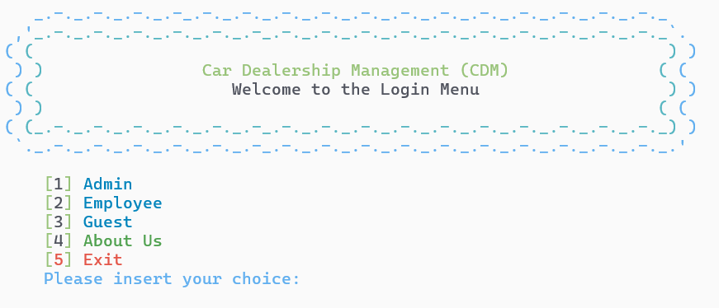

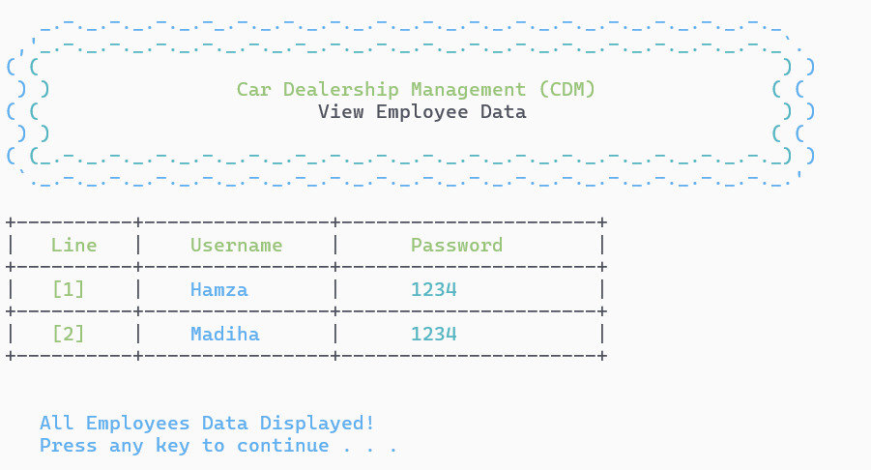
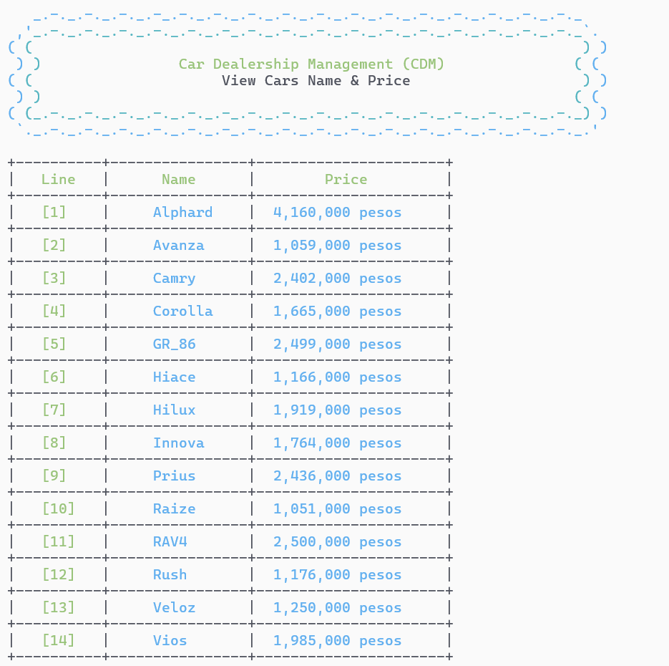
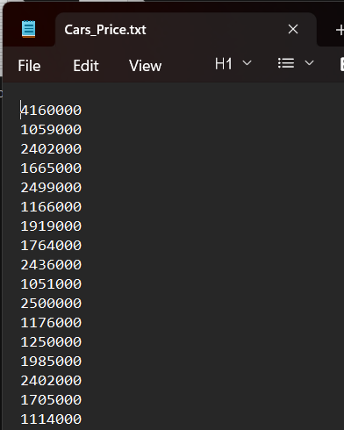

Future Enhancements
- Database integration (SQLite → MySQL)
- GUI development (Qt / wxWidgets)
- Network-based multi-user system
- AI-based recommendations

Conclusion and Recommendations
The Car Dealership Management System is a complete, real-world implementation of advanced computer science concepts.
It delivers technical excellence, functional completeness, and strong business impact, while providing a scalable foundation for future growth.

