TASK 02
Build and Compare Machine Learning Models
Customer Churn Prediction on the Telco Dataset
Author: Unees Ur Rehman Kiani
Date: October 18, 2026
Tools: Python, Pandas, NumPy, Scikit-learn, Matplotlib, Seaborn (Google Colab)
Dataset: Telco Customer Churn (Kaggle, 7,043 records)
Submitted To: Devixo Solutions

1. Executive Summary
This project builds and compares several machine learning models that predict whether a telecom customer will churn (cancel their service). Five algorithms were trained on the Telco Customer Churn dataset: Logistic Regression, Decision Tree, Random Forest, K-Nearest Neighbors (KNN) and Support Vector Machine (SVM). The two strongest candidates were then tuned with GridSearchCV.
Because only about 27% of customers churn, accuracy alone is misleading, so models were ranked mainly by F1 score, supported by recall and ROC-AUC.
Result: The tuned Random Forest was the best model, with an F1 score of 0.626, recall of 0.715 and ROC-AUC of 0.842. Tuned Logistic Regression was a very close second (F1 = 0.613) and trains about 30 times faster.

2. Problem Statement and Dataset
Winning back a customer who has already left is far more expensive than keeping one. The goal is to classify each customer as 'will churn' (1) or 'will stay' (0) using account, service and billing information, so the company can target retention offers early.
Property | Description
Source | Kaggle: Telco Customer Churn (BlastChar)
Records / columns | 7,043 customers, 21 original columns
Target variable | Churn (Yes / No), about 27% positive, so the classes are imbalanced
Feature types | Demographics (gender, senior citizen, partner), services (internet, security, tech support, streaming), account (contract, payment method, tenure) and billing (monthly and total charges)
Task type | Binary classification

3. Data Preprocessing (Part 1)
All preprocessing steps were applied in the order below. Imputation, scaling and encoding were placed inside a Scikit-learn Pipeline so they are fitted on the training data only. This prevents data leakage from the test set.
Step | Action taken
Load data | Read the CSV file into a Pandas DataFrame.
Fix data types | TotalCharges was stored as text because of blank values; it was converted to a numeric column.
Missing values | Blank TotalCharges entries (new customers with tenure 0) became missing values and were filled with the median. Any missing categorical values use the most frequent category.
Duplicates | Duplicate rows were checked and removed, ignoring the unique customerID column.
Drop identifier | customerID was removed because it carries no predictive information.
Feature engineering | Added NumServices (count of subscribed services), AvgMonthlySpend (TotalCharges / tenure) and TenureGroup (0-1, 1-2, 2-4, 4-6 years).
Encoding | Categorical features were converted with One-Hot Encoding.
Scaling | Numerical features were standardised with StandardScaler (important for KNN, SVM and Logistic Regression).
Train/test split | 80% training and 20% testing, stratified on Churn so both sets keep the same churn rate (random_state = 42).

4. Model Development (Part 2)
Five different algorithms were trained, covering linear, distance-based, kernel-based, single-tree and ensemble approaches.
- Logistic Regression: linear baseline (max_iter = 1000).
- Decision Tree: max_depth = 6 to limit overfitting.
- Random Forest: 300 trees.
- KNN: 15 neighbours.
- SVM: RBF kernel with probability estimates.

5. Model Evaluation (Part 3)
Each model was evaluated on the same held-out test set (about 1,400 customers) using the following classification metrics:
- Accuracy: share of all predictions that are correct.
- Precision: of customers predicted to churn, how many actually did.
- Recall: of customers who actually churned, how many were caught. This is the most important business metric here.
- F1 Score: harmonic mean of precision and recall.
- ROC-AUC: how well the model separates churners from non-churners across all thresholds.
- Confusion matrix: counts of true/false positives and negatives for each model (see the file confusion_matrices.png produced by the notebook).
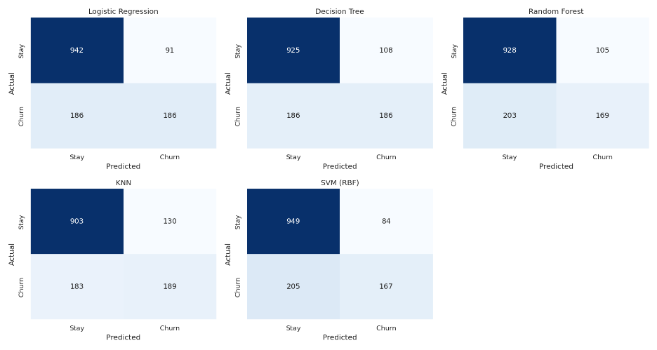
6. Model Comparison (Part 4)

6.1 Performance metrics
Table 1 lists all models ranked by F1 score. The best row is highlighted. Training time for tuned models includes the full 5-fold grid search, so it is not directly comparable with the baseline models.
Model | Training time (s) | Accuracy | Precision | Recall | F1 Score | ROC-AUC
Random Forest (tuned) | 204.6 | 0.774 | 0.556 | 0.715 | 0.626 | 0.842
Logistic Regression (tuned) | 6.1 | 0.747 | 0.515 | 0.758 | 0.613 | 0.840
Logistic Regression | 0.2 | 0.803 | 0.671 | 0.500 | 0.573 | 0.841
Decision Tree | 0.2 | 0.791 | 0.633 | 0.500 | 0.559 | 0.828
KNN | 0.1 | 0.777 | 0.592 | 0.508 | 0.547 | 0.818
SVM (RBF) | 7.8 | 0.794 | 0.665 | 0.449 | 0.536 | 0.788
Random Forest | 4.4 | 0.781 | 0.617 | 0.454 | 0.523 | 0.819
Table 1. Test-set results for all models, ranked by F1 score.
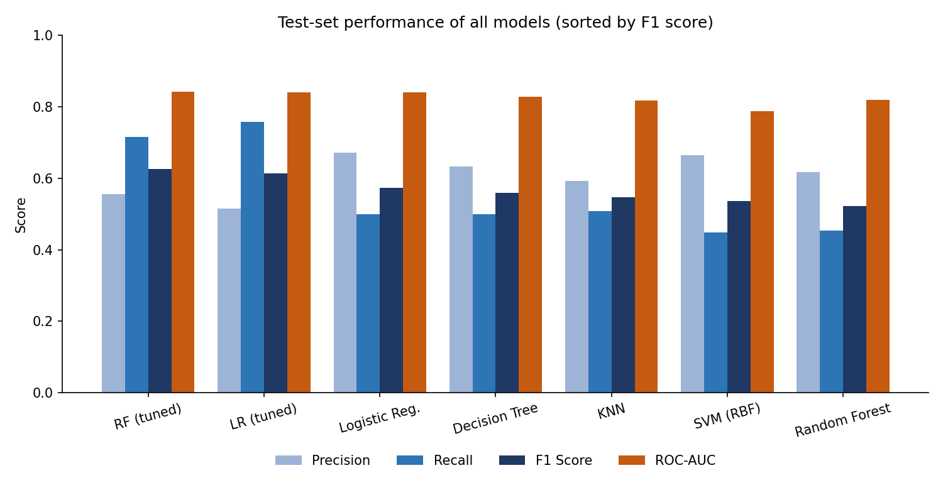
Figure 1. Precision, recall, F1 score and ROC-AUC for all seven models.

6.2 Advantages and limitations
Model | Training time (s) | Advantages | Limitations
Logistic Regression | 0.2 | Fast, interpretable coefficients, good probability estimates, strong baseline | Assumes a linear relationship with the log-odds; may miss complex interactions
Decision Tree | 0.2 | Very easy to explain, handles non-linear rules, needs no scaling | Overfits easily and is unstable to small changes in the data
Random Forest | 4.4 | Robust to noise, captures feature interactions, gives feature importance | Slower to train, harder to interpret, larger memory footprint
KNN | 0.1 | Simple, no real training phase, adapts to local patterns | Slow predictions on large data, sensitive to scaling and irrelevant features
SVM (RBF) | 7.8 | Handles non-linear boundaries, effective in high-dimensional space | Slow on large datasets, hard to interpret, needs careful tuning
Table 2. Advantages and limitations of each algorithm (baseline training times).

7. Hyperparameter Tuning (Bonus)
GridSearchCV with 5-fold cross-validation was used on Logistic Regression and Random Forest, optimising the F1 score. The search covered:
- Logistic Regression: regularisation strength C in {0.01, 0.1, 1, 10} and class_weight in {None, balanced}.
- Random Forest: n_estimators in {200, 400}, max_depth in {6, 10, None}, min_samples_leaf in {1, 3} and class_weight in {None, balanced}.
Best settings found:
===== TUNING (GridSearchCV) =====
Logistic Regression | best CV F1: 0.63
best params: {'model__C': 0.01, 'model__class_weight': 'balanced'}
Random Forest | best CV F1: 0.632
best params: {'model__class_weight': 'balanced', 'model__max_depth': 10, 'model__min_samples_leaf': 3, 'model__n_estimators': 400}

Tuning improved the Random Forest substantially: F1 rose from 0.523 to 0.626 and recall from 0.454 to 0.715. Tuned Logistic Regression improved from F1 0.573 to 0.613 and recall from 0.500 to 0.758. Most of this gain comes from class balancing, which makes the model pay more attention to the smaller churn group. The cost is lower precision, because the tuned models flag more customers who would not actually have left.

8. Key Drivers of Churn
The tuned Random Forest ranks features by importance. The ten strongest are shown below.
Rank | Feature | Importance | Plain-language meaning
1 | Contract: month-to-month | 0.118 | Flexible contracts churn the most
2 | Tenure | 0.102 | Newer customers are more likely to leave
3 | Total charges | 0.082 | Reflects customer age and spend
4 | Average monthly spend | 0.064 | Engineered feature
5 | Monthly charges | 0.063 | Higher bills raise churn risk
6 | No online security | 0.050 | Fewer add-on services
7 | Contract: two year | 0.048 | Long contracts keep customers
8 | No tech support | 0.047 | No support add-on
9 | Internet: fiber optic | 0.046 | Fiber customers churn more
10 | Tenure group: 0-1 year | 0.038 | First-year customers are at highest risk
Table 3. Top 10 features of the best model.

9. Conclusion (Part 5)
Seven models were compared. Logistic Regression had the highest accuracy (0.803), but its recall was only 0.500, meaning it missed half of the customers who actually left. In churn prediction, missing a churner is the costly mistake, so the models were judged mainly on F1 score and recall.
Recommended model: tuned Random Forest (F1 = 0.626, recall = 0.715, ROC-AUC = 0.842). It had the best F1 and the best ROC-AUC of all models.

Why it performed better
- It combines many decision trees, so it captures non-linear patterns and interactions, such as a short tenure together with a month-to-month contract.
- Averaging many trees reduces the overfitting that affects a single Decision Tree.
- Tuning added class balancing and depth limits, which lifted recall from 0.454 to 0.715.

Trade-offs and limitations
- Tuned Logistic Regression was almost as good (F1 = 0.613, ROC-AUC = 0.840), had slightly higher recall (0.758), and trained in about 6 seconds instead of 205. It is the better choice if speed and explainability matter most.
- Tuned models have lower precision (about 0.52 to 0.56), so some retention offers will go to customers who would have stayed.
- The gap between the top two models is small and results come from a single train-test split, so the ranking should not be treated as definitive for every situation.

Business recommendation
Use the tuned Random Forest to score customers regularly and focus retention offers on new customers on month-to-month contracts who lack online security or tech support. Encouraging these customers to move to one- or two-year contracts and adding support services is likely to reduce churn.

