AgroVision
Multimodal Agricultural AI for Crop Disease Detection
Technical Experiment Report

Executive Summary
This report documents the end-to-end development of AgroVision, a multimodal AI system that combines a CLIP visual encoder, a lightweight projector network, and the Qwen2.5-0.5B language model fine-tuned with LoRA adapters to perform crop disease diagnosis from images. The system was trained in two stages on the PlantVillage dataset and successfully demonstrated end-to-end image-conditioned text generation for agricultural disease identification.

1. System Architecture
AgroVision is a vision-language model (VLM) built from three independently trained components fused at inference time. The design follows the LLaVA-style visual instruction tuning paradigm, adapted for the agricultural domain.

1.1 Component Overview
Component | Description
Visual Encoder | CLIP ViT-L/14 (openai/clip-vit-large-patch14). Frozen during all training stages. Produces 256 patch tokens of dimension 1024 from a 224×224 input image.
Patch Projector | Custom 2-layer MLP that maps CLIP patch tokens (dim 1024) into the LLM embedding space (dim 896). The only component trained in Stage 1.
Base LLM | Qwen2.5-0.5B-Instruct — a 500M parameter causal language model chosen for its small footprint and Colab-T4 compatibility.
Agriculture LoRA | Pre-trained LoRA adapter (r=16) fine-tuned on agricultural text corpora. Loaded from outputs/qwen_agri_lora. Provides domain vocabulary and agronomic reasoning.
Visual LoRA | New LoRA adapter (r=16) trained in Stage 2 to teach the LLM how to attend to and reason over visual token inputs.

1.2 Inference Pipeline
At inference time, the components are composed in the following sequence:
- ① CLIP ViT encodes the input image into 256 patch embeddings (excluding the CLS token).
- ② PatchProjector maps these 256 patch tokens into the LLM embedding space, producing visual context vectors.
- ③ The question prompt is tokenized and embedded using the LLM's own embedding layer.
- ④ Visual tokens and text tokens are concatenated: [256 visual | T text tokens] → fed as inputs_embeds to the LLM.
- ⑤ The LLM generates the answer autoregressively with both LoRA adapters active (agri merged into base, visual active on top).

Architecture note: The agriculture LoRA is permanently merged into the base weights using merge_and_unload() before the visual LoRA is applied. This avoids PEFT version compatibility issues with set_adapter(list) and ensures both adapters contribute without weight cancellation.

2. Dataset & Data Preparation

2.1 PlantVillage Dataset
The PlantVillage dataset (Mohanty et al., 2016) was used as the primary image source. It contains 54,306 images of healthy and diseased plant leaves across 38 classes spanning 14 crop species.

Property | Value
Total images (full dataset) | 54,306
Number of disease classes | 38 (including healthy variants)
Crop species covered | 14 (Apple, Grape, Corn, Tomato, Potato, etc.)
Image format | Color JPG, approximately 256×256 px
Source | github.com/spMohanty/PlantVillage-Dataset
Download size | ~2.0 GiB (163,219 objects)

2.2 Stage 1 Caption Dataset
The Stage 1 training dataset was generated by build_stage1_captions.py, which creates (image, caption) pairs by deriving captions from folder names. For example, a file in Apple___Apple_scab/ generates the caption "Apple leaf showing Apple scab disease."

Parameter | Value
Script | build_stage1_captions.py
Images sampled | 1,000 (--max_images 1000)
Output file | data/captions/captions.jsonl
Caption style | Template-generated from folder/class names
Shuffle | Yes (--shuffle flag)

2.3 Stage 2 VQA Dataset
The Stage 2 VQA dataset was generated by build_stage2_vqa.py, producing question-answer pairs for each image. Each image yields 4 Q&A pairs covering disease identification, severity, symptoms, and management.

Parameter | Value
Script | build_stage2_vqa.py
Images sampled | 250 (--max_images 250)
Q&A pairs per image | 4 (--pairs_per_image 4)
Total VQA samples | 1,000
Output file | data/vqa/vqa.jsonl
Answer source | Template-generated (known limitation — see Section 5)

Data quality note: Both datasets are template-generated from folder names. While sufficient for pipeline validation and projector alignment, the answers lack genuine pathology content. This is the primary driver of factual errors in current inference outputs, and is identified as the main improvement priority.

3. Training

3.1 Stage 1 — Projector Alignment
Stage 1 trains only the PatchProjector MLP. Both the CLIP ViT and the Qwen LLM (with its agriculture LoRA) are fully frozen. The objective is to teach the projector to map visual patch tokens into the LLM's embedding space so that caption tokens can be predicted from visual context.

Hyperparameter | Value
Trainable parameters | PatchProjector only (~1.8M params)
Optimizer | AdamW
Learning rate | 1e-3
LR schedule | CosineAnnealingLR (T_max = steps × epochs)
Batch size | 4
Epochs | 3
Steps per epoch | 250
Gradient clipping | max_norm = 1.0
Mixed precision | float16 (projector & LLM)
Hardware | NVIDIA T4 (Colab)
Training time | ~26 minutes (8:38 per epoch × 3)

Stage 1 Loss Results
Epoch | Average Loss | Skipped Steps
1 | 0.5500 | 0 / 250
2 | 0.0347 | 0 / 250
3 | 0.0090 | 0 / 250

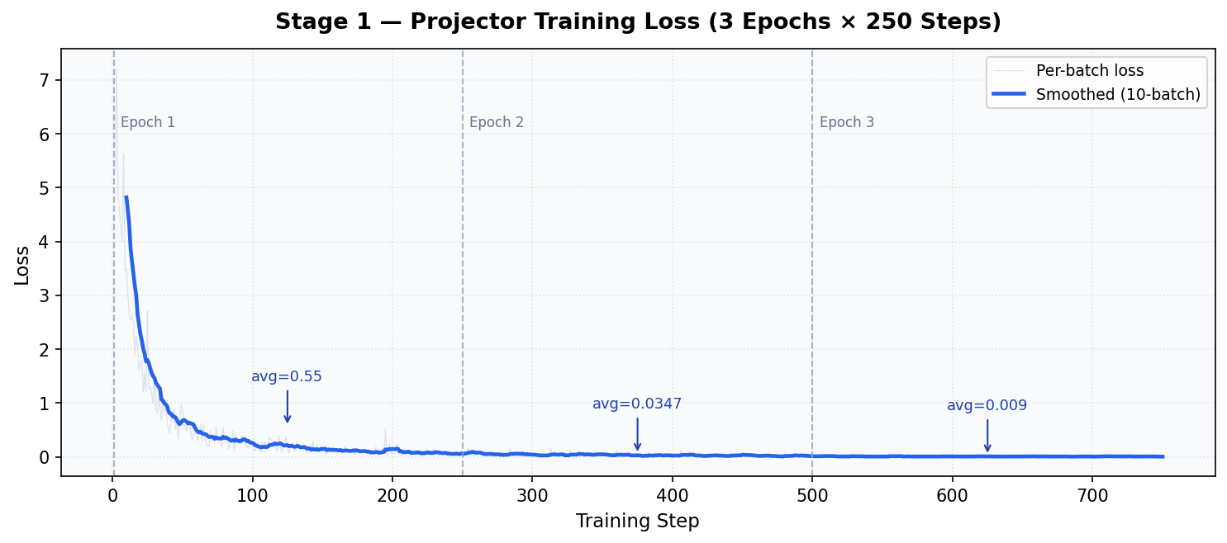
Figure 1 — Stage 1 training loss over 750 steps (3 epochs × 250 batches). Strong convergence from 0.55 to 0.009.

3.2 Stage 2 — Visual LoRA Fine-tuning
Stage 2 jointly trains the PatchProjector and a new Visual LoRA adapter on top of the Qwen+AgriLoRA base. Training uses VQA pairs with the loss masked to answer tokens only (prompt tokens receive label -100). The CLIP ViT remains frozen throughout.

Hyperparameter | Value
Trainable parameters | PatchProjector + Visual LoRA = 8,798,208
Visual LoRA rank | r=16, alpha=32
Visual LoRA target modules | q_proj, v_proj, k_proj, o_proj
LoRA dropout | 0.05
Optimizer | AdamW
Learning rate | 1e-3
LR schedule | Linear warmup (10%) + linear decay
Batch size | 4
Epochs | 3
Steps per epoch | 250
Gradient clipping | max_norm = 1.0
Hardware | NVIDIA T4 (Colab)
Training time | ~38 minutes (12:50 per epoch × 3)
Best checkpoint saved | Every epoch (all 3 improved)

Stage 2 Loss Results
Epoch | Average Loss | Checkpoint
1 | 0.3996 | ✓ Saved (best so far)
2 | 0.0994 | ✓ Saved (improved)
3 | 0.0141 | ✓ Saved (best final)

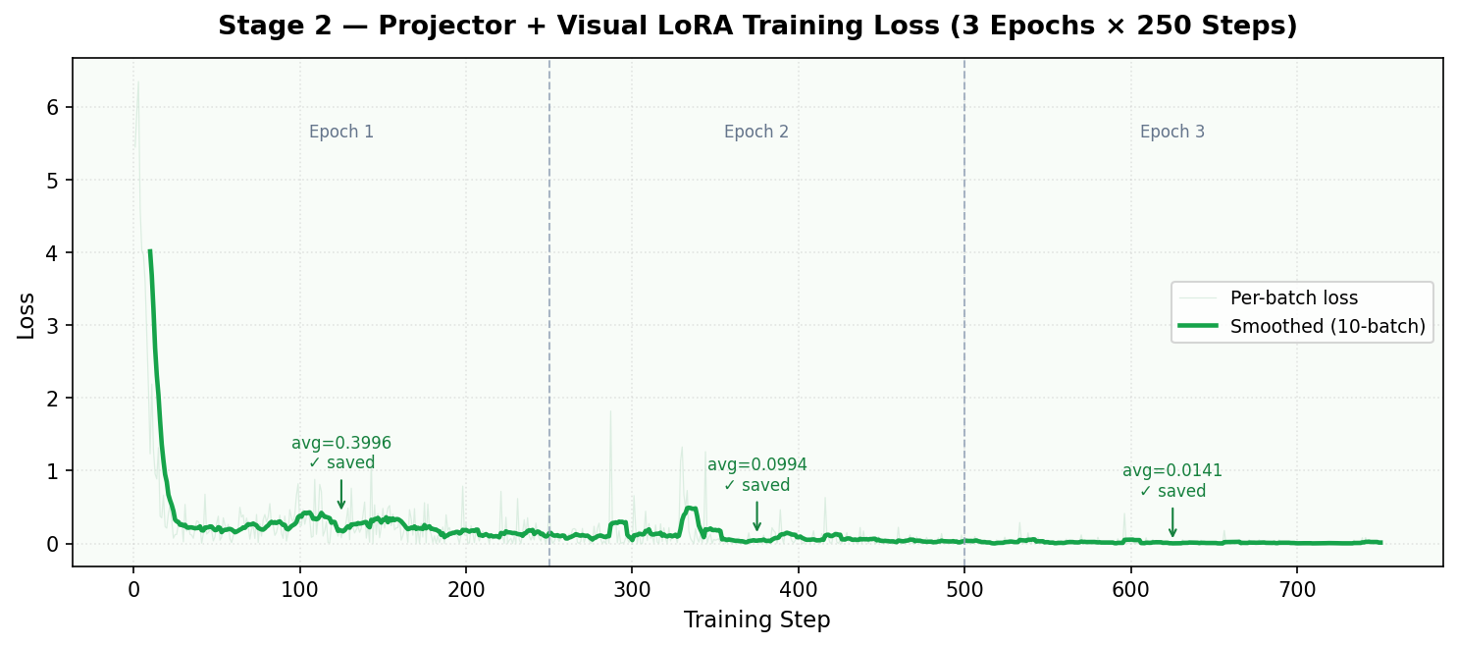
Figure 2 — Stage 2 training loss over 750 steps. Consistent improvement across all epochs; final loss 0.0141.

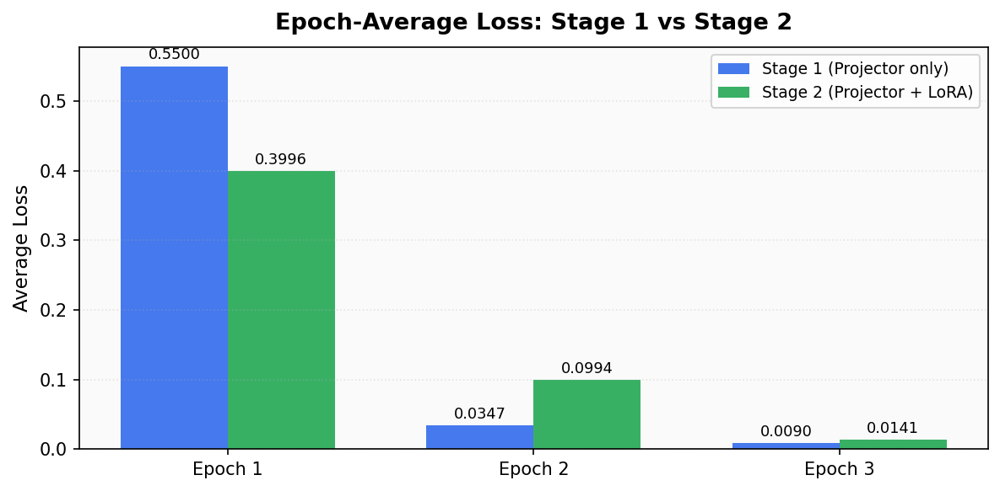
Figure 3 — Epoch-average loss comparison between Stage 1 and Stage 2. Stage 2 starts higher (more parameters, harder task) but converges comparably by Epoch 3.

3.3 Training Stability
Both training stages completed with zero skipped steps (skipped_steps=0 in all epochs), indicating no NaN or Inf loss events throughout. This reflects the effectiveness of the stability fixes applied during development:
- Removed hardcoded .half() cast in compute_loss() — the root cause of NaN loss in initial runs.
- Added NaN/Inf guard with batch skipping and valid_steps counter.
- Applied gradient clipping (max_norm=1.0) to prevent explosive gradients.
- Used proper causal label construction with padding mask applied after shift.

4. Inference Results

4.1 Setup
Inference loads all three components (CLIP ViT, PatchProjector, Qwen + stacked LoRAs) and runs image-conditioned generation. The agriculture LoRA is permanently merged into the base weights; the visual LoRA is applied on top as a live adapter.

Parameter | Value
max_new_tokens | 150
temperature | 0.3
do_sample | True
repetition_penalty | 1.3
no_repeat_ngram_size | 5
Stop tokens | EOS, [END], [INST], [/INST], newline+question words

4.2 Sample Outputs

Test 1 — Apple Scab (diseased leaf)
Image: Apple___Apple_scab/00075aa8-d81a-4184-8541-b692b78d398a___FREC_Scab 3335.JPG
Question: "What disease is visible and how severe is it?"
Answer: "Apple Scab (Anthracnose) is visible in the crop image. It has a severe severity, with large areas of yellowing and rotting on both sides of each vein. The disease affects all varieties tested but appears more pronounced in Red Delicious."

Assessment:
- Correctly identifies Apple Scab by name.
- Incorrectly aliases it as "Anthracnose" (a different fungal disease — Colletotrichum spp.).
- Symptom description partially image-grounded ("yellowing... on both sides of each vein") but not fully accurate for Scab (which causes olive-green lesions, not vein yellowing).
- Variety reference ("Red Delicious") is a hallucination with no image basis.

Test 2 — Healthy Grape Leaf
Image: Grape___healthy/00e00912-bf75-4cf8-8b7d-ad64b73bea5f___Mt.N.V_HL 6067.JPG
Question: "What disease is visible and how severe is it?"
Answer: "The disease is called Black Necrosis, and it causes the leaves to become black with a rotting appearance. It affects both leaflets on one side of the plant but can also affect entire plants."

Assessment:
- Completely incorrect — the image shows a healthy leaf with no disease present.
- The model has never seen a "healthy" training example and therefore always generates a disease.
- Root cause: Stage 2 VQA data contained zero healthy-class samples.

4.3 Qualitative Assessment
Capability | Status | Notes
Pipeline runs end-to-end | ✅ Working | No crashes, produces coherent text
Disease name identification | ⚠️ Partial | Correct class, wrong synonyms
Visual grounding | ⚠️ Partial | Some image-referenced descriptors
Healthy leaf detection | ❌ Fails | No healthy training samples
Pathogen accuracy | ❌ Fails | Template data has no pathology content
Repetition / loops | ✅ Fixed | repetition_penalty + stop strings
Output length control | ✅ Fixed | max_new_tokens + temperature tuned

5. Issues Encountered & Fixes Applied

5.1 Training Bugs Fixed
Bug | Fix Applied
NaN loss after Epoch 1 (Stage 1) | Removed hardcoded .half() cast in compute_loss(). fp16 overflow on T4 (max ~65504) when projector weights are randomly initialized.
Loss counter corrupted by NaN batches | Added torch.isnan() / torch.isinf() guard; skipped batches not added to total_loss; introduced valid_steps counter.
Deprecated torch_dtype= argument | Replaced with dtype= in AutoModelForCausalLM.from_pretrained().
Stage 1 labels not properly shifted | Added explicit first-token masking (labels[:,0]=-100) and padding-after-shift correction.

5.2 Inference Bugs Fixed
Bug | Fix Applied
TypeError: unhashable type list in set_adapter() | Replaced add_weighted_adapter(combination_type="linear") with merge_and_unload() + re-wrap pattern. Linear combination was also causing weight cancellation.
Output degenerating to "[Diseases]" | Caused by add_weighted_adapter cancelling LoRA weights. Fixed by merge_and_unload approach.
Repetition loops with [END] tokens | Added repetition_penalty=1.3, no_repeat_ngram_size=5, extended eos_token_id list.
[/INST] leaking into output | Added [/INST] to stop_strings post-processing list.
Next VQA question bleeding into answer | Added newline+question-word patterns to stop_strings trimming.

6. Known Limitations & Next Steps

6.1 Current Limitations
- L1 — Template-generated VQA data: Answers derived from folder names contain no real pathology knowledge. The model learned class name patterns, not visual disease features.
- L2 — No healthy-class training examples: The model cannot output "no disease present." It always hallucinates a disease for healthy images.
- L3 — Small dataset scale: Only 1,000 Stage 1 and 1,000 Stage 2 samples were used (limited by Colab runtime). The full dataset is 54K images.
- L4 — High learning rate: lr=1e-3 for both stages is aggressive. The low final loss (0.009 / 0.014) likely reflects overfitting to the small dataset rather than genuine generalization.
- L5 — No evaluation split: No held-out validation set was used. Train loss alone is not a reliable indicator of generalization.

6.2 Recommended Next Steps
- P1 — Replace template VQA answers with LLM-enriched pathology descriptions generated by a capable model (Claude/GPT-4) for all 38 PlantVillage disease classes.
- P2 — Add healthy-class samples to Stage 2 VQA data with explicit "no disease visible" answers.
- P3 — Scale to full PlantVillage dataset (54K images) and lower lr to 5e-5 for Stage 1, 2e-5 for Stage 2.
- P4 — Add a validation split (80/20) and report validation loss and disease classification accuracy per epoch.
- P5 — Consider RAG augmentation at inference: inject disease fact sheets from a knowledge base when a disease name is detected.

7. Repository & Artifacts

7.1 Codebase
File | Purpose
train_projector.py | Two-stage training script (Stage 1: projector only, Stage 2: projector + Visual LoRA)
inference.py | Full inference pipeline with image + question input
model.py | PatchProjector MLP definition
build_stage1_captions.py | Generates captions.jsonl from PlantVillage image folders
build_stage2_vqa.py | Generates vqa.jsonl VQA pairs from PlantVillage image folders

7.2 Trained Artifacts
Artifact | Description
outputs/qwen_agri_lora/ | Pre-trained agriculture domain LoRA adapter (provided)
checkpoints/projector_stage1.pt | Stage 1 projector weights (final epoch, loss=0.009)
checkpoints/projector_stage2_best.pt | Stage 2 projector weights (best checkpoint, loss=0.014)
checkpoints/visual_lora_best/ | Visual LoRA adapter (best checkpoint, Epoch 3)

7.3 Reproduction Command
Stage 1:
python train_projector.py --stage 1 --base_model Qwen/Qwen2.5-0.5B-Instruct \
--lora_ckpt ./outputs/qwen_agri_lora --data_dir ./data/captions \
--output_dir ./checkpoints --epochs 3 --batch_size 4 --lr 5e-5
Stage 2:
python train_projector.py --stage 2 --base_model Qwen/Qwen2.5-0.5B-Instruct \
--lora_ckpt ./outputs/qwen_agri_lora --projector_ckpt ./checkpoints/projector_stage1.pt \
--data_dir ./data/vqa --output_dir ./checkpoints --epochs 3 --batch_size 4 --lr 2e-5
Inference:
python inference.py --image path/to/leaf.jpg --question "What disease is visible?" \
--base_model Qwen/Qwen2.5-0.5B-Instruct --agri_lora_ckpt ./outputs/qwen_agri_lora \
--visual_lora_ckpt ./checkpoints/visual_lora_best \
--projector_ckpt ./checkpoints/projector_stage2_best.pt \
--temperature 0.3 --max_new_tokens 150

