CITY HOTEL
CANCELLATION, OVERBOOKING & DEPOSIT POLICY
Decision Analytics Report
Recommended stance: booking-time calibrated GBM for decision support; 60-room assumed capacity; k=10 overbooking at €200 walk cost; deposits of 0% / 10% / 25% for <20% / 20–40% / >40% predicted risk.
Decision | Headline result
Booking-time GBM | AUC 0.775; AP 0.545; Brier 0.168; ECE 0.056
Near-arrival GBM | AUC 0.800; stronger later-stage signal
Overbooking | k=10; ≈€57/night modeled uplift vs k=0
Deposit policy | ≈437 prevented; ≈209 bookings lost; ≈€168,246 net modeled uplift
Main caveats | Capacity, response assumptions and search-interest data require validation

Contents and executive summary
- 1. Business problem and decision context
- 2. Data, cleaning and temporal design
- 3. Decision analytics and findings
- 3.1 Cancellation behaviour and EDA
- 3.2 Cancellation prediction
- 3.3 SHAP interpretation
- 3.4 Overbooking policy
- 3.5 Deposit policy
- 3.6 Interactive dashboard
- 3.7 Managerial recommendations
- 3.8 Implementation roadmap
- 3.9 Ethical, Legal and Bias
- 4. Conclusion
- References
- Annexures A–E

Executive summary
The analysis converts historic City Hotel bookings into a linked cancellation-risk and revenue-management framework. The booking-time GBM reaches AUC 0.775, AP 0.545, Brier 0.168 and ECE 0.056 on the untouched future test set.
The near-arrival GBM reaches AUC 0.800 after adding booking_changes, room_type_changed and assigned_room_type. It is a late-stage signal, not a booking-time model.
At an assumed 60-room capacity and €200 walk cost, the overbooking optimum is k=10. The recommended deposit tiers are 0% / 10% / 25% by predicted risk; the economic result is scenario-based and needs controlled validation.

1. Business problem and decision context
The hotel needs to identify cancellation risk early enough to act, accept enough demand above capacity to protect revenue, and use deposits selectively so the benefit of lower cancellations exceeds the cost of booking-conversion loss.

Decision questions
- What predicts cancellation at booking creation?
- How much value is added by near-arrival information?
- What overbooking level maximises expected profit under alternative walk costs and capacity assumptions?
- Which risk tiers justify a deposit without unacceptable booking loss?

2. Data, cleaning and temporal design
The supplied pipeline produces 53,273 cleaned City Hotel / H2 rows. The published source contains 79,330 City Hotel observations, covering arrivals from July 2015 through August 2017, with identifying fields removed.
Split | Booking-date rule | Rows
Train | through 2016-12-12 | 37307
Calibration | 2016-12-13 to 2017-02-24 | 8034
Test | 2017-02-25 to 2017-08-31 | 7932
Outcome leakage controls exclude reservation_status and reservation_status_date. Booking-time features exclude variables only known near arrival.

External-data status
Portugal public holidays support holiday markers. Lisbon weather and Google Trends were not supplied; they remain absent rather than being fabricated.

3.1 Cancellation behaviour and EDA
Lead time is the clearest simple signal: cancellation rises from about 11% at 0–7 days to about 51% at 365+ days.
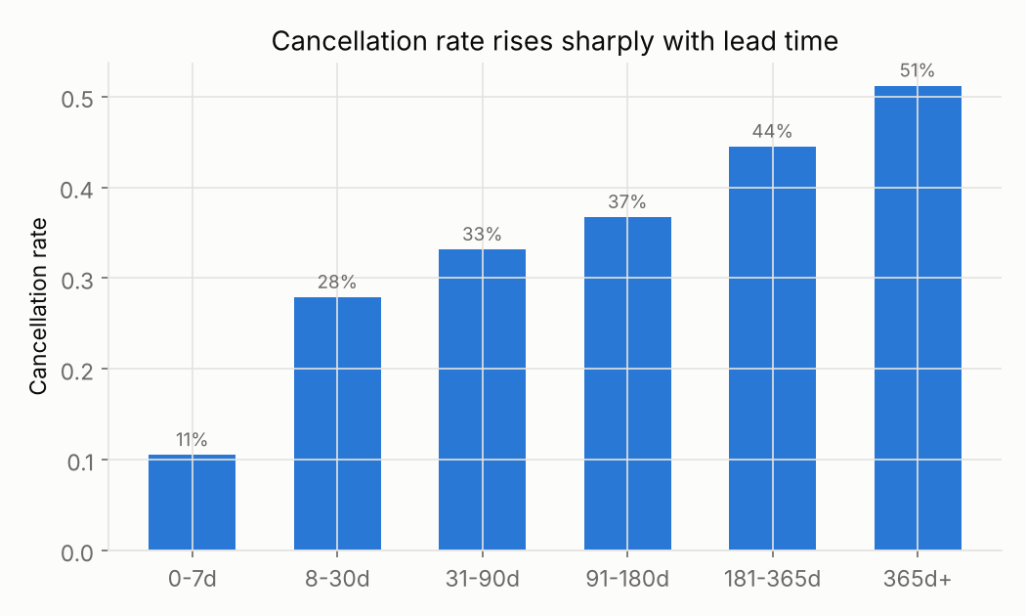
Figure 1. Cancellation rate by lead time.
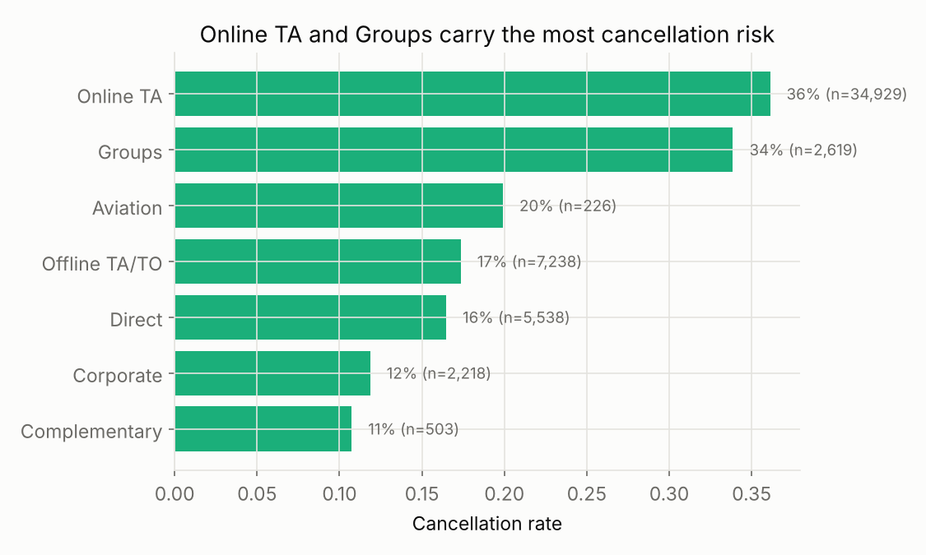
Figure 2. Cancellation rate by market segment.
Segment differences are operationally relevant but also proxy channel and contract structure. Prediction and treatment logic should therefore remain separate.

3.1 Cancellation behaviour and EDA (continued)
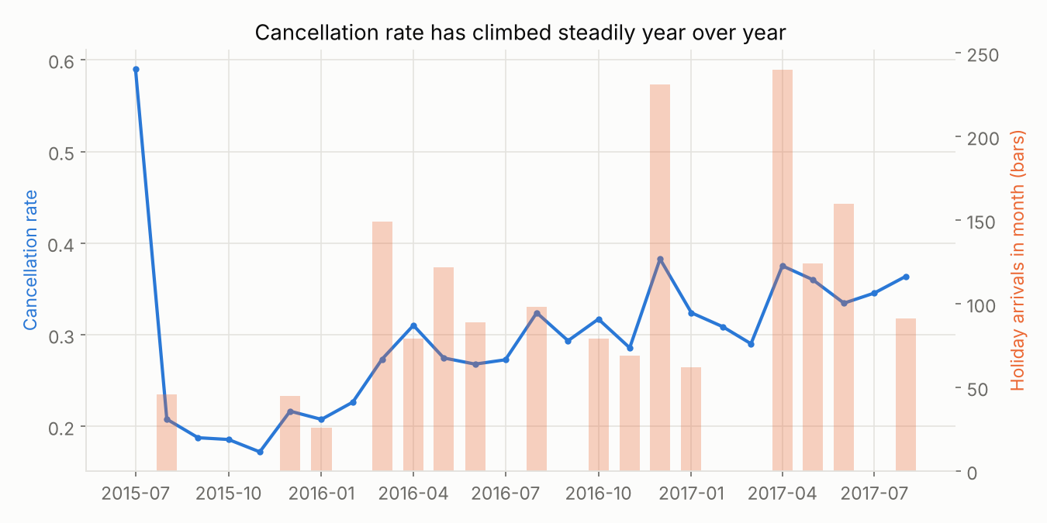
Figure 3. Monthly cancellation trend with holiday-arrival markers.
The historical series combines structural trend and seasonal variation. Holiday markers support planning; case-level decisions should rely on calibrated risk.
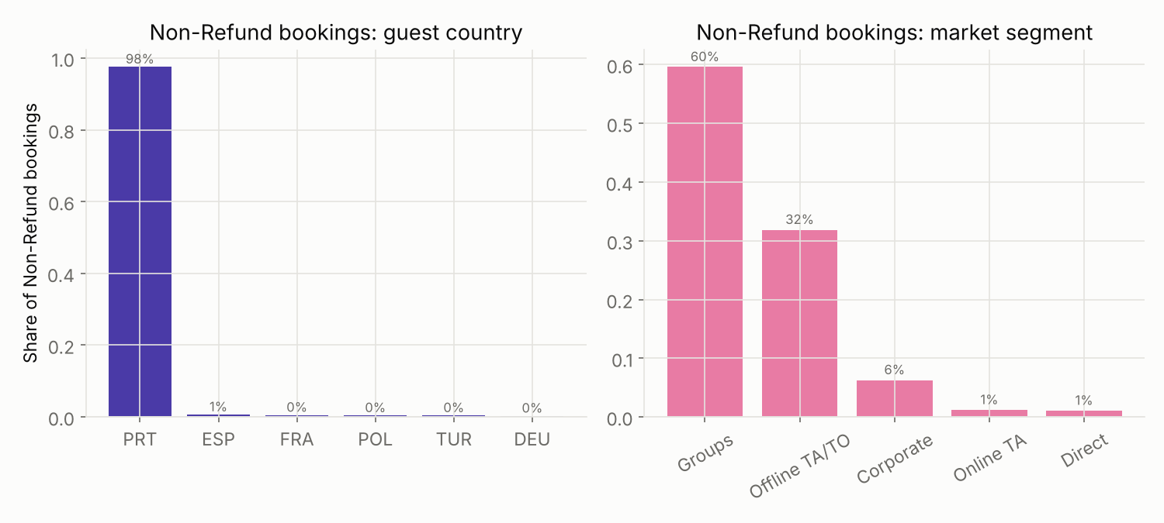
Figure 4. Composition of the Non-Refund category.
Non Refund has very high historical cancellation, but is concentrated in Groups / Offline TA/TO and long lead times, consistent with allotment-release processes. It is not treated as a clean consumer deposit experiment.

3.2 Cancellation prediction
Version | Model | Calibration | AUC | AP | Brier | ECE
Booking-time | Logistic | Sigmoid | 0.750 | 0.555 | 0.169 | 0.018
Booking-time | GBM | Isotonic | 0.775 | 0.545 | 0.168 | 0.056
Near-arrival | Logistic | Sigmoid | 0.768 | 0.574 | 0.165 | 0.018
Near-arrival | GBM | Isotonic | 0.800 | 0.576 | 0.160 | 0.052
Booking-time GBM improves AUC from logistic 0.750 to 0.775. The near-arrival GBM reaches 0.800, reflecting the value of later operational information.
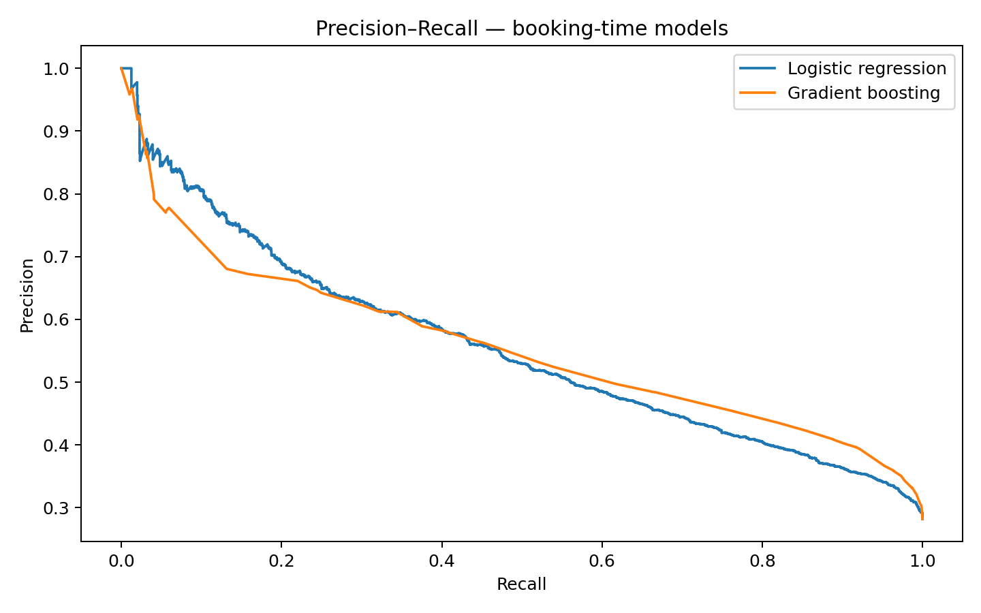
Figure 5. Booking-time precision–recall comparison.

3.3 SHAP interpretation
SHAP explains contribution rather than causality. The strongest booking-time drivers are country, total special requests, market segment, lead time, ADR, parking spaces, customer type and previous cancellations.
Rank | Feature | Mean |SHAP| | Signed
1 | country | 0.748 | -0.086
2 | total_of_special_requests | 0.665 | -0.075
3 | market_segment | 0.648 | 0.214
4 | lead_time | 0.378 | -0.193
5 | adr | 0.351 | 0.276
6 | required_car_parking_spaces | 0.319 | 0.043
7 | customer_type | 0.185 | 0.092
8 | previous_cancellations | 0.149 | -0.056
Country is the largest individual driver and therefore a primary fairness concern. Monitor it as an audit slice rather than using it as a direct deposit-pricing rule.
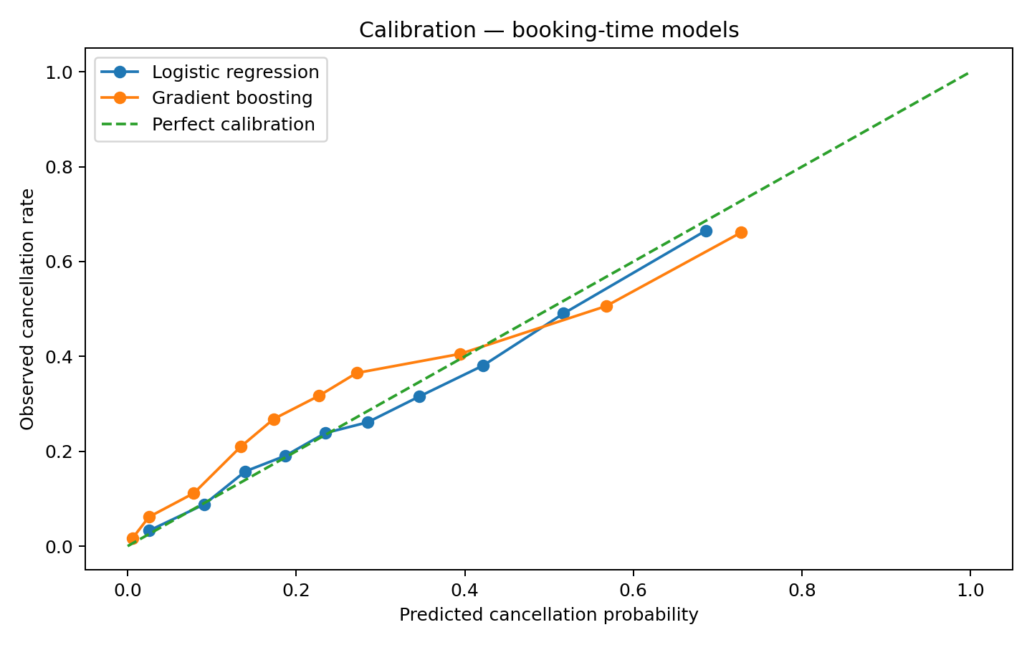
Figure 6. Booking-time calibration comparison.

3.4 Overbooking policy
Inventory is absent, so 60 rooms is an explicit model assumption. Base room value is €98.80; walk costs are €125 / €200 / €300. Calibrated cancellation probabilities rank reservations when the cap is tight.
Walk cost | Optimal k | Expected profit (€) | Walks/night
Base | 10 | 3,048 | 0.057
High | 9 | 3,043 | 0.043
Low | 12 | 3,053 | 0.091
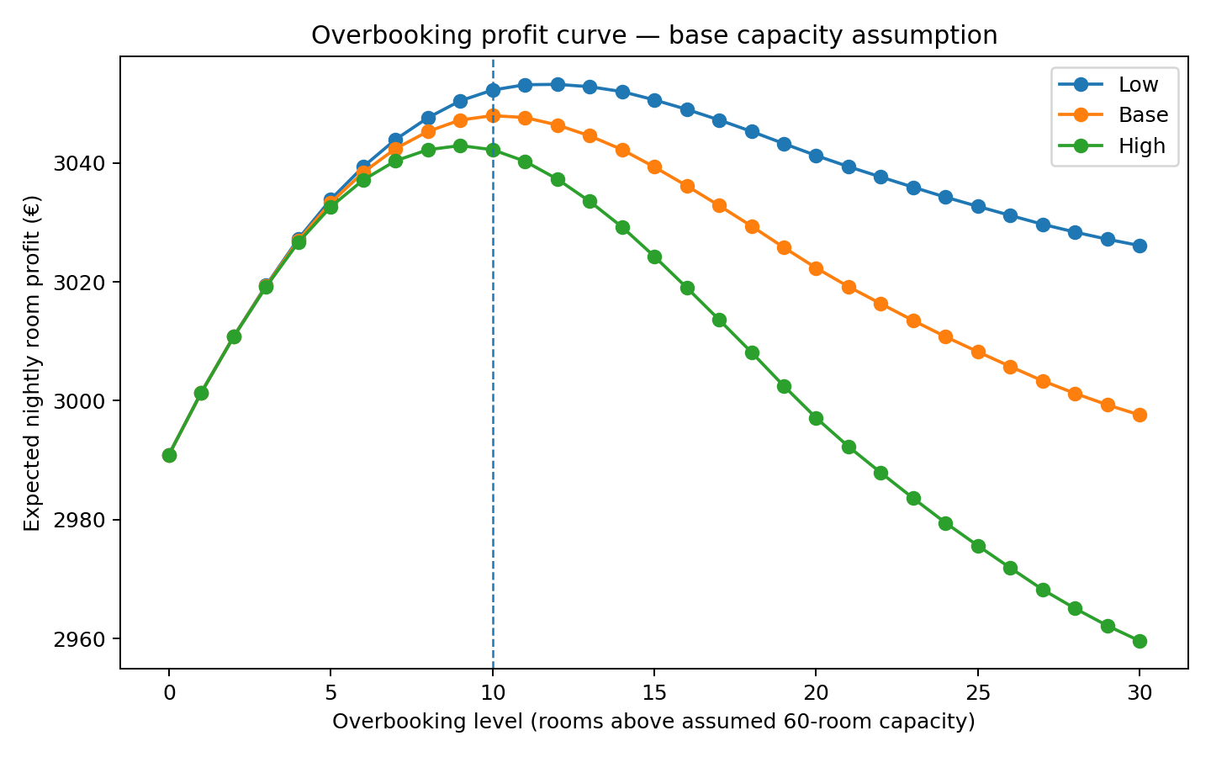
Figure 7. Expected nightly profit across overbooking levels.
Base case: k=10, about €57/night above k=0. The policy should be re-optimised when actual inventory or walk cost changes.

3.5 Deposit policy
Risk tier | Predicted cancellation | Deposit | Deterrence assumption | Booking-loss assumption
Low | <20% | 0% | 0% | 0%
Medium | 20–40% | 10% | 20% | 4%
High | >40% | 25% | 35% | 8%
The consumer deposit lever excludes Non Refund, Groups and Offline TA/TO because their historic cancellation is strongly shaped by process/allotment mechanics.
Scope | Prevented | Bookings lost | Net uplift (€)
Medium risk only | 100 | 75 | 21,337
Medium + High risk | 437 | 209 | 168,246
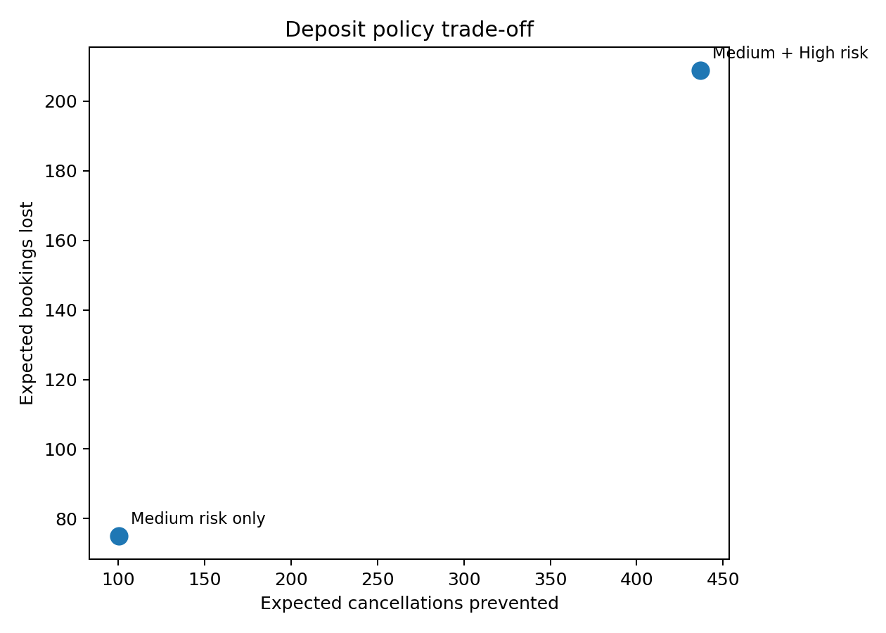
Figure 8. Deposit trade-off.
Base scenario: ≈437 cancellations prevented, ≈209 bookings lost and ≈€168,246 net uplift. Validate via A/B testing.

3.6 Interactive dashboard and 3.7 Managerial recommendations
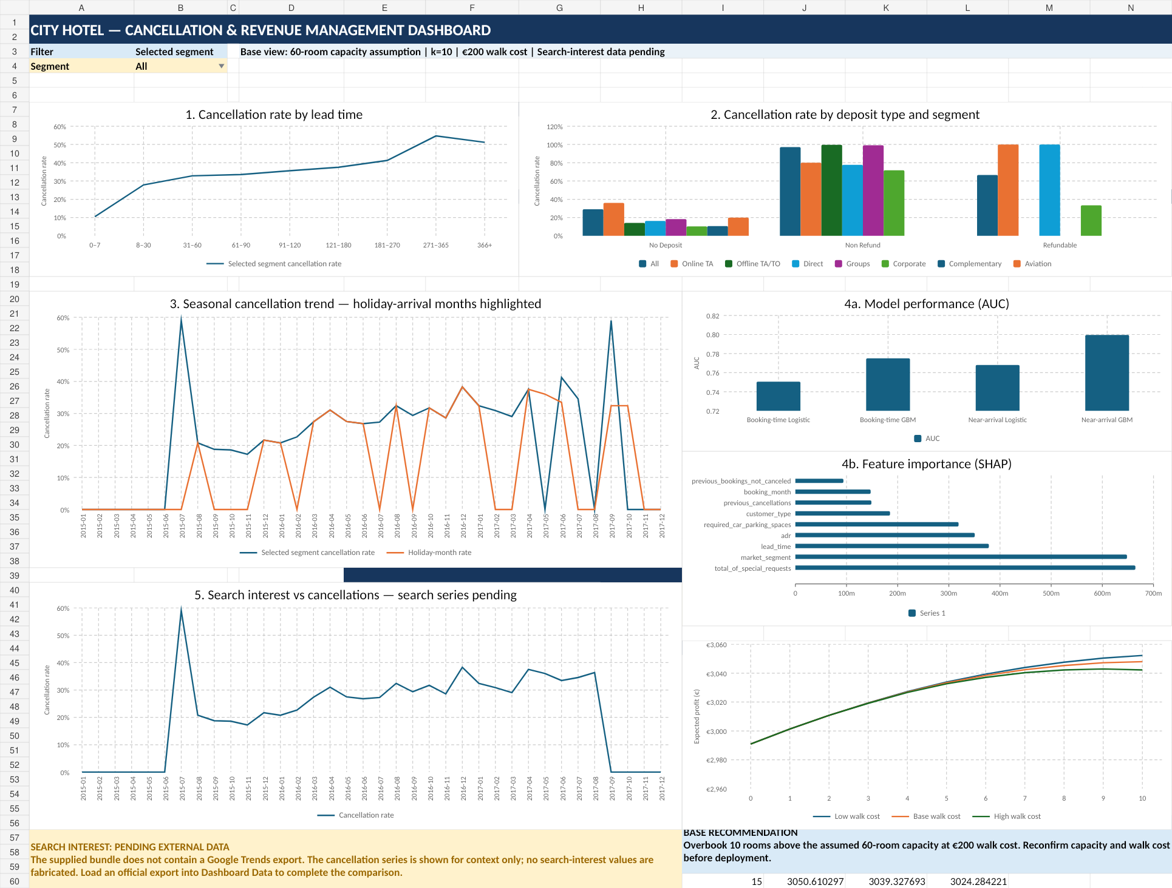
Figure 9. Six-view dashboard; search-interest values intentionally pending.
The dashboard consolidates lead time; deposit type/segment; seasonality/holidays; model performance and SHAP; search interest versus cancellations; and overbooking profit. A segment selector drives the lead-time and seasonal views.

3.7 Managerial recommendations
Strategy: use the calibrated booking-time GBM as a revenue-manager co-pilot, not an autonomous decision maker. Rank risk, support overbooking and deposit decisions, and preserve human override.
Cost-benefit: overbooking offers a modest modeled uplift under the stated assumptions; deposits have larger potential value but are more sensitive to customer-response assumptions.
Short term: shadow scoring, validate current capacity/walk cost/calibration/fairness, then pilot. Long term: rolling retraining, live inventory, measured walk outcomes and governed external features. Change management should cover training, exceptions and rollback.

3.8 Implementation roadmap
A 12-week pilot should move from governance and validation to integration, shadow operation, controlled policy testing and monitored scale-up.
Workstream | Owner | W1–2 | W3–4 | W5–6 | W7–8 | W9–10 | W11–12
Data & governance | Data / DPO | ■ | ■
Model validation | Revenue + DS | ■ | ■ | ■
Policy design | Revenue Mgmt |  | ■ | ■
PMS / RMS integration | IT / Vendor |  |  | ■ | ■ | ■
Shadow pilot | Ops + Revenue |  |  |  | ■ | ■
A/B policy pilot | Ops + Revenue |  |  |  |  | ■ | ■
Scale & monitoring | IT + Analytics |  |  |  |  |  | ■

Resources and training
Role | Allocation | Training | Responsibility
Revenue Management | 0.3 FTE pilot | 90 min | Thresholds, calibration, overrides
Data Science | 0.5 FTE build/validation | 90 min | Monitoring, retraining, fairness
IT / PMS vendor | 0.3 FTE integration | 90 min | API, logging, rollback
Front desk / Ops | 2 h/week supervisor | 60 min | Customer explanation, escalation
DPO / Legal | 0.1 FTE | 60 min | GDPR, transparency, retention
Risk gates: validate current capacity and walk cost; pass calibration and fairness checks; complete legal/DPO review; test rollback; then launch the customer-impacting pilot.

3.9 Ethical, Legal and Bias
Country-based bias: country is the strongest SHAP feature. Do not convert it into a country-based deposit tariff. Use it for monitoring unless legal/DPO review establishes a legitimate, non-discriminatory operational purpose.
Fairness checks: monitor predicted risk, observed cancellation, calibration, deposit assignment, booking loss and net revenue across major geography/customer groups using minimum sample sizes and confidence intervals. An internal five-point gap can trigger investigation; it is not a legal safe harbour.
Hallucination risk: generative AI should not supply numeric policy values. Version model outputs, assumptions, source dates and policy versions; missing Google Trends remains blank rather than inferred.
Privacy and legal basis: reservation data can be personal data in production. GDPR principles include lawfulness/fairness/transparency, purpose limitation, data minimisation, storage limitation and security; where applicable, automated decision-making and consequences should be explained.
EU AI Act: current Commission guidance describes high-risk classification through Article 6 and defined Annex I / III categories. The hotel should document classification with DPO/legal and revisit it if the use case expands.
Limits of 2015–2017 Portuguese data: this is a backtest, not current production truth. OTA behaviour, payments, ADR, traveller mix, capacity and post-pandemic demand may differ. Recalibrate on current data before production.

4. Conclusion
Proceed with a conservative current-data pilot: calibrated booking-time GBM, k=10 starting overbooking under validated assumptions, and 0% / 10% / 25% deposit tiers for actionable risk. Measure contribution margin, walk rate, conversion, calibration and fairness.

References
António, N., de Almeida, A. & Nunes, L. (2019). Hotel booking demand datasets. Data in Brief, 22, 41–49. https://doi.org/10.1016/j.dib.2018.11.126
Lundberg, S. M. & Lee, S.-I. (2017). A Unified Approach to Interpreting Model Predictions. NeurIPS 30.
European Commission. Principles of personal data processing under the GDPR. https://commission.europa.eu/law/law-topic/data-protection/information-business-and-organisations/principles-gdpr_en
European Commission. Draft Commission guidelines on the classification of high-risk AI systems (2026). https://digital-strategy.ec.europa.eu/en/library/draft-commission-guidelines-classification-high-risk-ai-systems
EU AI Act Service Desk. Article 6 — classification rules for high-risk AI systems. https://ai-act-service-desk.ec.europa.eu/en/ai-act/article-6

Annexures A–E
A. Data audit, cleaning and feature dictionary. B. Model metrics and scored test set. C. SHAP outputs. D. Overbooking and deposit sensitivity. E. Dashboard, prompt logbook and implementation repository.

