Name Samuel Frederickson Mark _____________________/50

[**Instructions**: Remove everything that is not a heading below and fill in with your own diagrams, etc.]

## Brief introduction __/3

The feature which I am working on is environmental hazards. These will be objects in the different levels that can be a hazard to you, or to the enemies. The first implementation will be explosive barrels which when they come in contact with a bullet, will explode and deal area damage in a circle around it. The other implementation will be with fire which will open up in the group and can engulf the player in flames, providing a burn affect.

## Use case diagram with scenario __14

### Use Case Diagrams

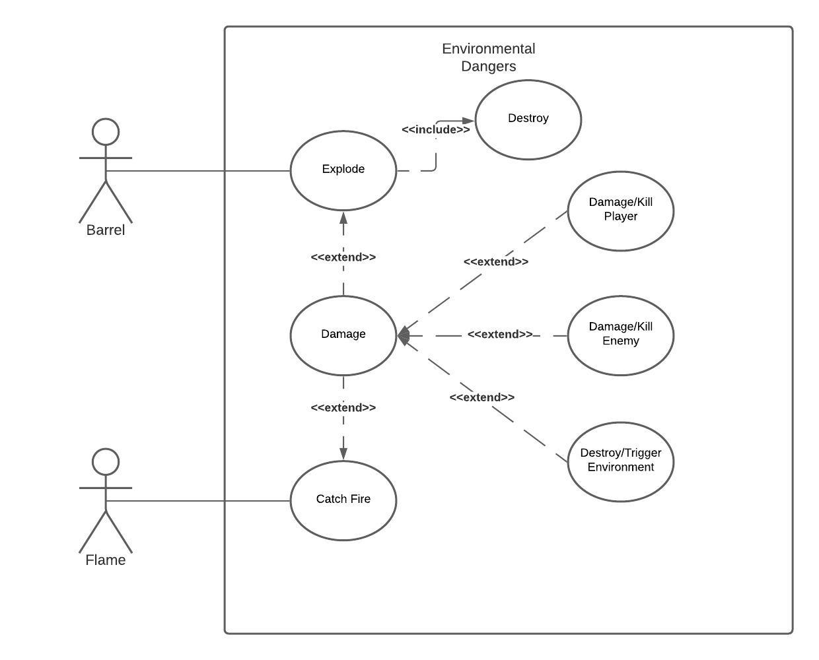

### Scenarios

**Name:** Barrel and Bullet Contact

**Summary:** The barrel will explode and do resulting damages.

**Actors:** Barrel

**Preconditions:** Barrel has been initialized

**Basic sequence:**

**Step 1:** Barrel comes in contact with a bullet .

**Step 2:** Barrel explodes.

**Step 3:** Destroy barrel.

**Step 4:** Damage can extend to either player, enemy, or other hazards.

**Exceptions:**

**Step 1:**If no object in range of exploding barrels, then no damage will be distributed.

**Post conditions:** New barrel is destroyed and damage distributed if any has been applied.

**Priority:** 3

*The priorities are 1 = must have, 2 = essential, 3 = nice to have.

## Data Flow diagram(s) from Level 0 to process description for your feature _______14

### Data Flow Diagrams

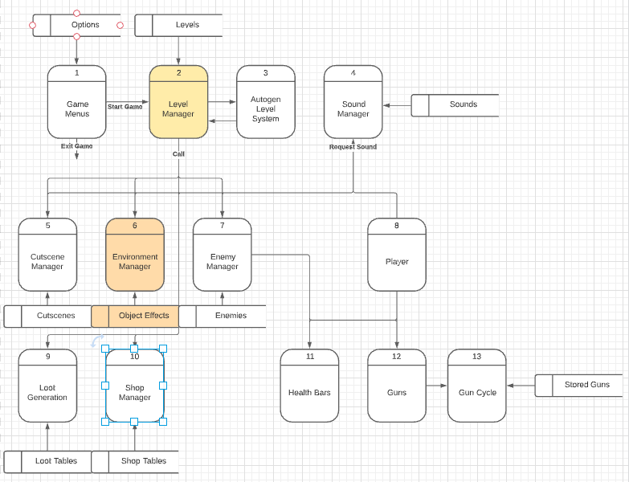

### Process Descriptions

Level Manager:

* Loads main level or procedural generated level

Environment Manager:

* Spawn barrels in specific places in each level. If procedurally generated, spawn randomly as long as barrelcount < maxbarrelcount

Object Effects:

* If a bullet contacts a barrel
  + If max barrel damage radius > distance from barrel to other object (player, enemy, other hazard)
    - Apply damage or trigger environment
  + Explode barrel

## Acceptance Tests ________9

Run feature 30 times having game objects both within the radius of damage, as well as outside the radius

* In this case we will put damage of the barrels to a number higher than the max HP of an enemy.
* Have enemies run into radius of barrel, if they die to the explosion and they are within the radius of the barrel, mark as worked.
* As well as if the enemies are outside the barrel radius and the damage does not apply to the enemy.
* Slowly push the enemies and/or player away from the barrel until distance between the barrel and the object is > the damage radius of the barrel.

**Example for damage diagram**

|  |  |  |  |
| --- | --- | --- | --- |
| Test # | Damage Radius of Barrel | Enemy Distance to Barrel | Notes |
| 1 | 10 | 5 | Explodes (works) |
| 2 | 10 | 8 | Exploded (works) |
| 3 | 10 | 11 | Exploded but no damage(works) |
| 4 | 10 | 14 | Exploded but no damage(works) |

## Timeline _________/10

[Figure out the tasks required to complete your feature]

Example:

### Work items

|  |  |  |
| --- | --- | --- |
| Task | Duration (PWks) | Predecessor Task(s) |
| 1. Requirements Collection | 2 | - |
| 2. Object Design | 2 | 1 |
| 3. Report Design | 3 | 1 |
| 4. User Documentation | 4 | 3 |
| 5. Programming | 5 | 4 |
| 6. Testing | 2 | 5 |
| 7 Installation | 1 | 5, 6 |

### Pert diagram

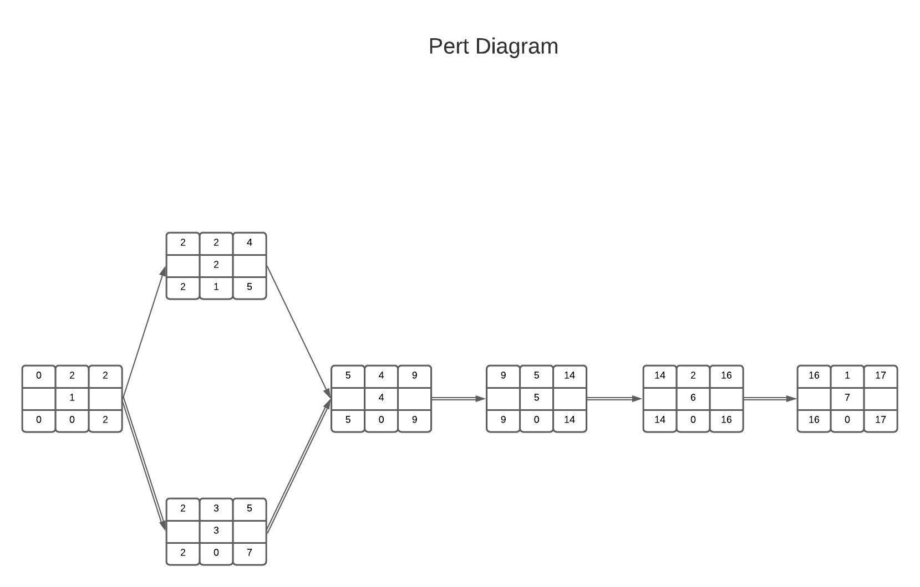

### Gantt timeline

|  |  |  |  |  |  |  |  |  |  |  |  |  |  |  |  |  |  |  |  |  |  |  |  |  |
| --- | --- | --- | --- | --- | --- | --- | --- | --- | --- | --- | --- | --- | --- | --- | --- | --- | --- | --- | --- | --- | --- | --- | --- | --- |
| 1 |  |  |  |  |  |  |  |  |  |  |  |  |  |  |  |  |  |  |  |  |  |  |  |  |
| 2 |  |  | 1 |  |  |  |  |  |  |  |  |  |  |  |  |  |  |  |  |  |  |  |  |  |
| 3 |  |  | 1 |  |  |  |  |  |  |  |  |  |  |  |  |  |  |  |  |  |  |  |  |  |
| 4 |  |  |  |  |  | 3 |  |  |  |  |  |  |  |  |  |  |  |  |  |  |  |  |  |  |
| 5 |  |  |  |  |  |  |  |  |  | 4 |  |  |  |  |  |  |  |  |  |  |  |  |  |  |
| 6 |  |  |  |  |  |  |  |  |  |  |  |  |  |  | 5 |  |  |  |  |  |  |  |  |  |
| 7 |  |  |  |  |  |  |  |  |  |  |  |  |  |  |  |  | 6 |  |  |  |  |  |  |  |
| 8 |  |  |  |  |  |  |  |  |  |  |  |  |  |  |  |  |  |  |  |  |  |  |  |  |
|  | 1 | 2 | 3 | 4 | 5 | 6 | 7 | 8 | 9 | 10 | 11 | 12 | 13 | 14 | 15 | 16 | 17 | 18 | 19 | 20 | 21 | 22 | 23 | 24 |