Name: Tony Velasco

# Introduction of Features

I will be responsible for two features of the Cyberjunk 2020 video game being developed by Unex game studio. The first feature I will be developing will be a feature to handle music and sound effects for the game. Second, I will be developing and implementing a loot drop feature.

The sound handler will be responsible for playing theme music for various scenes as well as video game sound effects coming from player sprites, character sprites, and environment objects and effects.

The loot drop feature will determine the loot that gets dropped by defeated enemies and opened loot chests. The loot will vary between ammunition, money, and health kits or upgraded weapons depending on the difficulty of defeated enemies. Regular enemies will drop predictable amounts of money or ammunition, and boss enemies will drop significantly higher amounts of money and possibly higher tier equipment. Loot chests will drop a predictable amount of money or ammunition, as well as health kits when the player’s health bar is not full.

# Use Case Diagrams

**Use Case Diagrams**

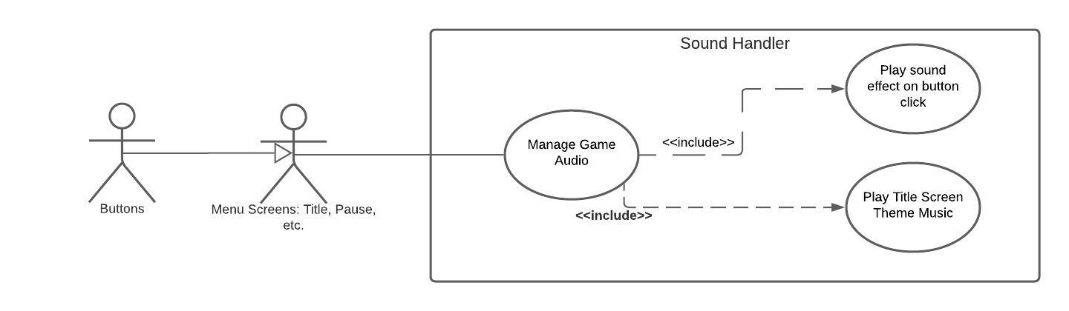

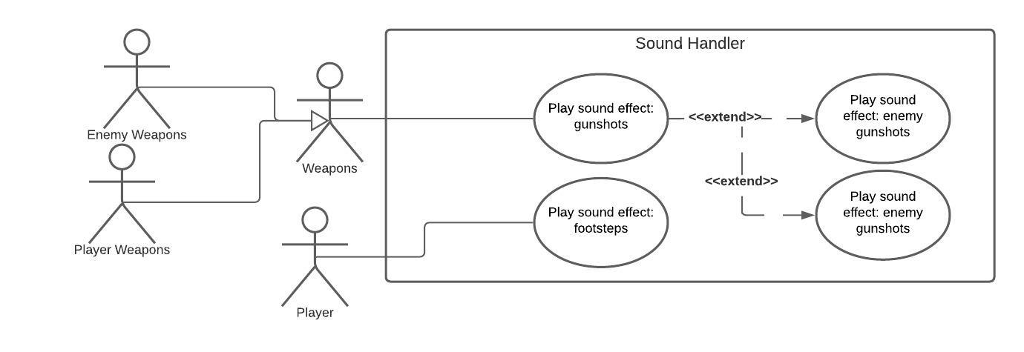

**Scenarios**

**Scenario 1 (1st UC Diagram)**

**Name:** Play Intro Theme Music/Effects

**Summary:** The game is launched, and the title menu opens. A song will play on repeat until the player chooses to start a new game or load a saved one. A sound will be produced when the player clicks a button to advance gameplay.

**Actors:** Menu, buttons

**Preconditions:** Game has been launched; main menu screen is presented.

**Basic Sequence:**

**Step 1:** Sound handler determines which menu song to play (intro song)

**Step 2:** Intro theme song plays on a loop until player selects an option.

**Step 3:** When the player clicks a menu option, button sound will play, and theme song will stopplaying.

**Scenario 2 (2nd UC Diagram)**

**Name:** Play in-game sound effects

**Summary:** When the player is in the game, sound effects will play based on what occurs in-game. Gunshots will play when player or enemies fire their weapons, footsteps will play when player moves.

**Actors:** Player, Player weapons, enemy weapons.

**Preconditions:** Game must be running, the player should have clicked past the opening menu, and player should be actively playing a level.

**Basic Sequence:**

**Step 1:** Player presses any movement keys.

**Step 2:** Footsteps sound effect plays so long as keys are presses and player sprite is moving.

**Step 3:** Playerclicks mouse button to shoot.

**Step 4:** Gunshotsoundeffect plays.

**Step 5:** Enemy fires weapon at player

**Step 6:** Gunshot sound effect plays.

# Data Flow Diagrams

**Diagram 0**

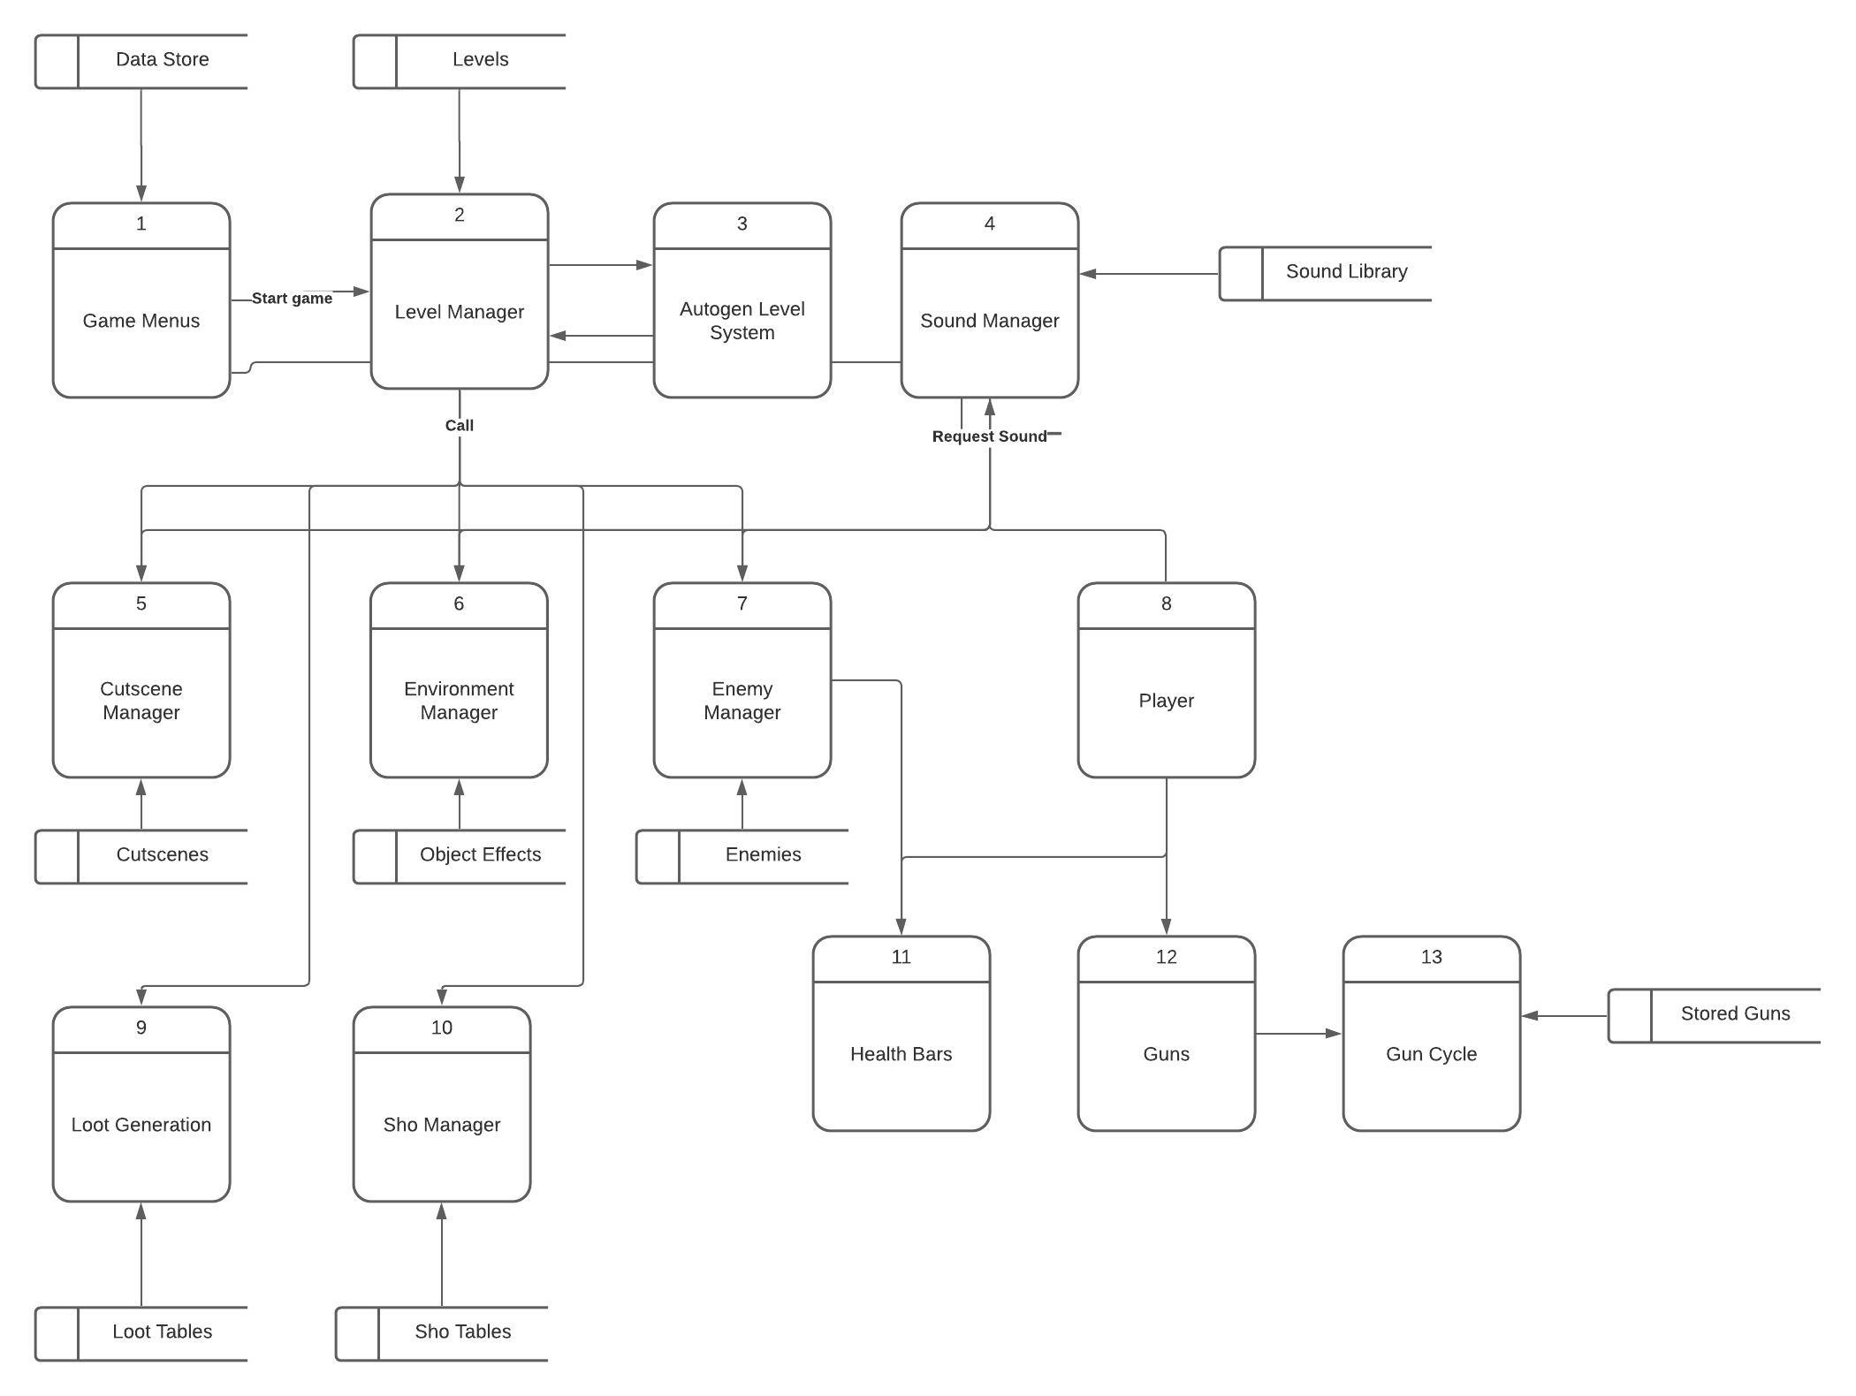

**Data Flow Diagram**

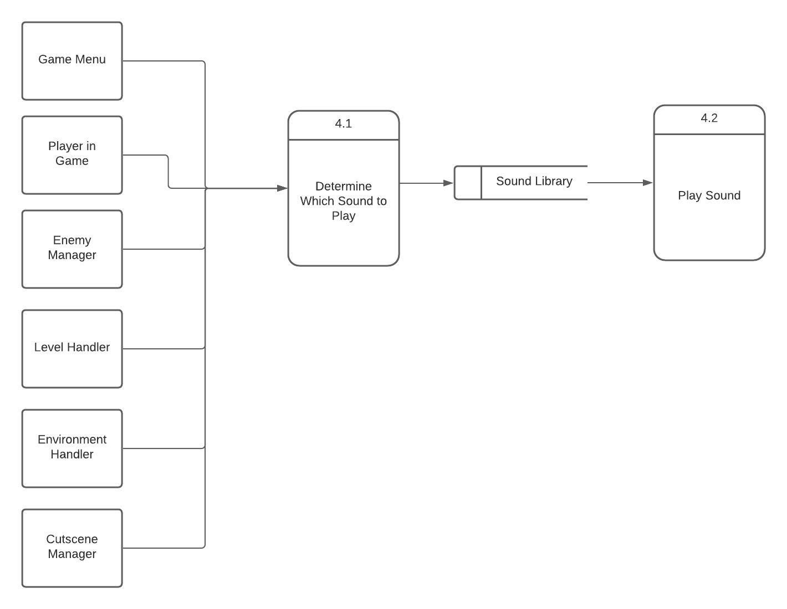

# Acceptance Tests

This feature will depend on user inputs as well as data from the enemy handler feature and the level handler feature. As such, testing will have to be done to determine if the correct sounds are playing at any given time. Tests for theme music for the starting menu, pause menu, and cutscenes, gunshot sound effects, as well as player movement sounds will have to be conducted. Additionally, acceptance tests for theme music that is dependent on which level the player is on in the game will have to be conducted. Acceptance tests for these features are described below.

**Menus:**

Start game and come to Title screen menu, then choose a play option (new game/ load game) 20 times to ensure that theme music starts and stops when necessary, and that a sound is played when an option is selected.

**Player:**

Walk around in-game using input keys for 20 minutes to ensure that footstep sound effects play smoothly every time.

**Cutscene Manager:**

Play game up until first cutscene 10 times to ensure that cutscene music plays at the same moment every time a cutscene is initiated.

**Enemy Manager:**

Stand still in-game and let enemies shoot for 20 minutes to ensure that the gunshot sound effects are played correctly for every individual enemy bullet object.

**Level Handler:**

In the game, walk between every individual level 100 times to ensure that theme music changes correctly for each level.

**Environment Handler:**

Trigger any active obstacles or hazards, such as exploding barrels, 100 times to ensure that the sound effects for each hazard plays correctly without exception.

# Timeline

**Work Items**

|  |  |  |
| --- | --- | --- |
| **Task** | **Duration (Hours)** | **Predecessor Tasks** |
| 1. Assemble sound effects library (intro theme music, level theme music, gunshots, footsteps, cutscene theme, hazard sound effects) | 6 | - |
| 1. Get player movement data from player sprite | 1 | 1 |
| 1. Implement footstep sound effect in sound handler script | 3 | 1,2 |
| 1. Get data to determine when player clicks mouse button | 1 | 1,2 |
| 1. Get data from enemy handler to determine when weapons are fired. | 3 | 1,4 |
| 1. Implement gunshot sound effects in sound handler script | 4 | 1, 5 |
| 1. Get data from level handler to determine which level theme music to play | 2 | 1 |
| 1. Implement theme music for each level in sound handler script | 3 | 1,7 |
| 1. Get data from cutscene manager to determine when cutscene theme song should be played | 2 | 1 |
| 1. Implement cutscene theme song into sound handler script | 3 | 1, 9 |
| 1. Get data from environment handler to determine which hazard sound effect to play and when to play it. | 2 | 1 |
| 1. Implement hazard sound effect in sound handler script | 3 | 1,11 |
| 1. Testing | 6 | 1-12 |

