THE TEST CHIP
μ-scale
(2.3 version)

Usage:
- magnification checking
- adjustment and checking of the size of the imaging field of the monitor and the documentation imaging device
- adjustment and checking of deflection linearity and deflection orthogonality
of the scanning electron microscopes (SEM) within a wide range of magnifications used.
The recommended regime of imaging at the use of the test chip is with the SE detectors.

1. Technical description
The test structures on the chip are etched as reliefs in the polished surface of a single crystal silicon substrate. For their preparation electron beam lithography and anizotropic etching techniques were used. The anizotropically etched reliefs of the motives which create testing structures follow with their geometry the crystalography of silicone (see fig. 3). Geometrical patterns of the testing structures are typical with their high outline sharpness of the edges and dimensional stability in dependence on temperature (linear temperature dilatability of the silicone base is 2.5 x 10⁻⁶K⁻¹).
The chip of the 8 × 8 mm size contains nine different test structures in total. They are positioned on the chip and take up an area of 3 × 3 mm. Individual types of the test structures are, therefore, easy to be reached even in case of small mechanical shifts of the specimen manipulator. The metric of the guaranteed dimensions of the testing structures is deducted from the laser interferometer with the help of which the deflection set of the electron beam lithograph is calibrated before the exposition of these structures. The controlled step of the beam deflection is 50nm.
The arrangement of the individual types of test structures is schematically shown in fig. 1. The types of testing structures are described in the following text and their numbering corresponds to that given in fig. 1.
1 Grating formed of lines, grating dimension (parameter) 30μm
2 Grating formed of lines, grating dimension 50μm
3 Grating formed of lines, grating dimension 100μm
4 Grating formed of lines, grating dimension 10μm
5 Grating formed of lines, grating dimension 5μm
6 Grating formed of lines, grating dimension 3μm
7 The contoures of concentric squares in the sequence of dimensions 1, 0.9, 0.8, 0.7, 0.6, 0.5, 0.4, 0.3, 0.2, 0.1, 0.08, 0.06, 0.04 and 0.02mm. The centre of the structure is for better orientation marked with a little square approximately of 0.002 x 0.002mm (2 x 2μm), which is etched as an relief on the whole surface. The metric of the dimensions is related to the outer edges of the lines which form the contour of the definite dimension.
8 Grating formed of square flats, grating dimension (parameter) 5μm.
9 Right angle formed of two lines. The length of the lines is 0.5mm.The centre of the structure is marked with a little square approximately of 2 x 2μm.
All the gratings are marked in their bottom part with a numeric sign equal to the dimension of the corresponding grating. This numeric marking defines explicitly the configuration of individual types of testing structures also at general positions of the chip in the work chamber of a SEM. Numeric markings of the dimensions of the gratings as well as other texts placed on the chip are not determined for measurement and testing!

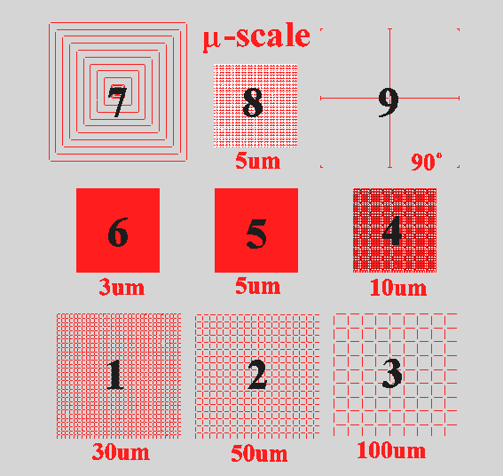

Fig.1. The scheme of the arrangement of individual testing structures on the chip.

2. The definition of the dimensions and their accuracy

The gratings
The dimensions (parameter) of the individual gratings are defined by the distance of the edges of two neighbouring geometrical motives forming the grating (which concerns lines in the case of the structures 1,2,3,4,5,6 and square flats in the case of the grating at the structure 8). The dimensions of gratings are the same in both mutually perpendicular directions X and Y. The dimensional accuracy of the individual gratings is guaranteed as follows:
grating 100 100μm ±0.5μm
grating 50 50μm ±0.5μm
grating 30 30μm ±0.5μm
grating 10 10μm ±0.3μm
grating 5 5μm ±0.15μm
grating 3 3μm ± 0.15μm
The above mentioned values are valid for the laboratory temperature of 23°C.

Contours of the squares
The dimensions in the X-direction and the corresponding dimensions in the Y-direction given in the description of patterns 7 are guaranteed in all the cases with an accuracy of ± 1μm.
- Right angles
The right angle is defined by the angle between two lines from the centre of the structure. Warranted value is 90º ± 0.05º .
The dimensions of the geometrical motives i.e. the lines or, as the case may be, rectangles which form the testing structures, are not described metrically and that is why they are not guaranteed. These dimensions, however, are possible to be found out during work for any particular grating with the help of the above – mentioned defined dimensions of the gratings at a given magnification.
The motives (lines) forming the grating of 3μm have usually the width nearing 1μm (fig.3) and therefore it is possible to exploit them for the definition of magnification in 10⁵x order.
Similarly the depth of the relief of the geometrical motives which form the testing structures is not metrically guaranteed. The anizotropically etched relief in single-crystal silicone has its geometry explicitly defined with the angles between crystal flats (100) and (111) of the cubic crystal system. It is therefore possible to define easily the depth of a w relief of each motive on the testing chip according to the equation:
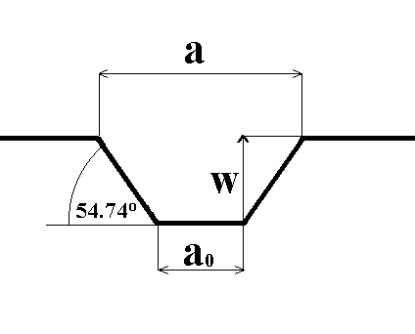
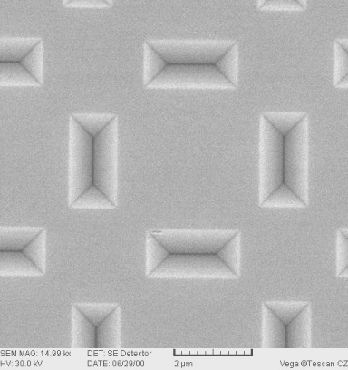
W ={(a – a₀)/2} tg 54.74°, where the meaning a, a_{o} is perceptible from figs.2 and 3.

Fig.2. The scheme of the transverse cut
of the anizotropically etched silicone Fig.3. A photo of a part of the grating 5μm
single- crystal (100). (SEM, SE detector, mag. 14.99kx).

3. General data
The chip is easy to take out from the transport box by pressing mildly the stamping in which it is placed. The chip is possible to be coated with metal if needed, while cathode sputtering seems to be the best way. The thickness of a sputtered layer should not exceed 50nm. To remove dust from the chip, use a piece of soft plastic foam moisturized with a detergent dissolved in a small amount of water. Wipe the chip making several circular motions and afterwards rinse it with a stream of distilled water from a syringe. To remove the remaining water from the chip, use a stream of pure gas (nitrogen from the pressure vessel or developer). Never use alkaline solutions for cleaning the chip or for removing a metal coating off its surface! If organic solvents are used for removing fat spots, do not let remains of these substances dry up on the chip. Remains are recommended to be removed from the chip surface by an intensive stream of pure gas.
We wish you much success at your work and we will be glad if you inform us about your experience with our test chip

Institute of Scientific Instruments, Academy of Sciences of Czech Republic, Královopolská 147, 612 64 Brno

