Iris Analysis

Vincent

2023-09-21

## question 1 ansewer

iris_summary <- iris %>%  
 group_by(Species) %>%  
 summarize(  
 Mean_Sepal.Length = mean(Sepal.Length),  
 Median_Sepal.Length = median(Sepal.Length),  
 Min_Sepal.Length = min(Sepal.Length),  
 Max_Sepal.Length = max(Sepal.Length),  
   
 Mean_Sepal.Width = mean(Sepal.Width),  
 Median_Sepal.Width = median(Sepal.Width),  
 Min_Sepal.Width = min(Sepal.Width),  
 Max_Sepal.Width = max(Sepal.Width),  
   
 Mean_Petal.Length = mean(Petal.Length),  
 Median_Petal.Length = median(Petal.Length),  
 Min_Petal.Length = min(Petal.Length),  
 Max_Petal.Length = max(Petal.Length),  
   
 Mean_Petal.Width = mean(Petal.Width),  
 Median_Petal.Width = median(Petal.Width),  
 Min_Petal.Width = min(Petal.Width),  
 Max_Petal.Width = max(Petal.Width)  
 )

## Answer to Question 2 and Question 3

The Species with the highest average Petal length is Virginica

## [[1]]

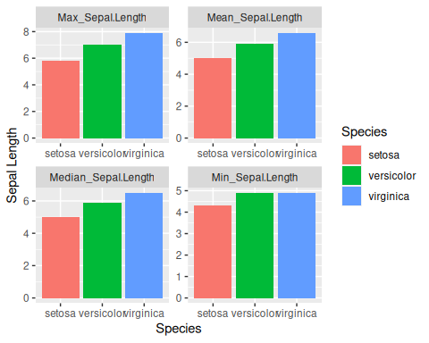

##   
## [[2]]

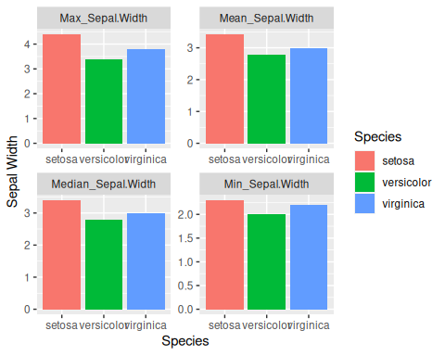

##   
## [[3]]

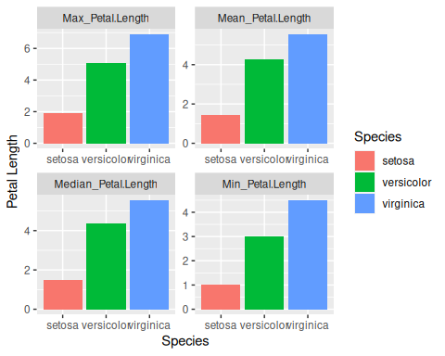

##   
## [[4]]

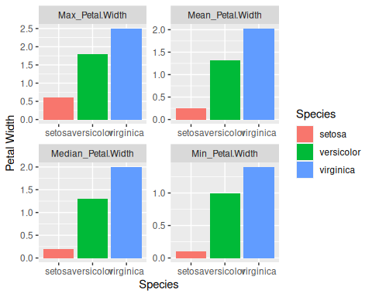 ## answer to question 4

Within the Iris data set there is 4 total outliers within sepal width. Two outliers within the setorsa, and two outliers within viriginica2

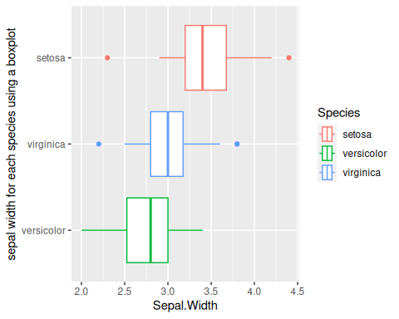 ## answer to question 5

