Anh Duong, Nguyen

Q5:

Car avg, max, std.: 0.86243455497382193, 0.8717277486910995, 0.0089005235602094088

Pen avg, max, std.: 0.90405946255002867, 0.9105202973127502, 0.0038465153096750647

Q6:

Generally speaking, increasing number of hidden layers increases the accuracy and decreases the standard deviation, making the result more reliable. In the case of car dataset, the accuracy increases until about 5 layers, then decreases a little bit.

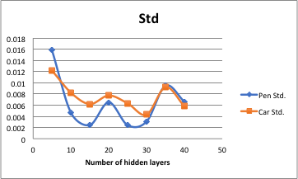

|  |  |  |  |
| --- | --- | --- | --- |
| Car dataset | | | |
| #ofHiddenLayers | Average | Max | Std. |
| 0 | 0.702225131 | 0.702225131 | 0 |
| 5 | 0.831151832 | 0.85078534 | 0.012243643 |
| 10 | 0.815968586 | 0.827879581 | 0.008220062 |
| 15 | 0.822643979 | 0.831151832 | 0.006194848 |
| 20 | 0.814136126 | 0.827879581 | 0.007721404 |
| 25 | 0.820287958 | 0.827225131 | 0.006312647 |
| 30 | 0.811518325 | 0.818717277 | 0.004301486 |
| 35 | 0.814267016 | 0.829842932 | 0.009203349 |
| 40 | 0.809162304 | 0.818717277 | 0.005803612 |



|  |  |  |  |
| --- | --- | --- | --- |
| Pen dataset | | | |
| #ofHiddenLayers | Average | Max | Pen Std. |
| 0 | 0 | 0 | 0 |
| 5 | 0.825843339 | 0.841337907 | 0.015937929 |
| 10 | 0.888164666 | 0.893939394 | 0.0046534 |
| 15 | 0.903887936 | 0.907947399 | 0.002448555 |
| 20 | 0.896912521 | 0.9053745 | 0.006500433 |
| 25 | 0.904802744 | 0.907089766 | 0.002419005 |
| 30 | 0.902744425 | 0.90651801 | 0.003081119 |
| 35 | 0.896283591 | 0.907089766 | 0.009464925 |
| 40 | 0.902001144 | 0.909090909 | 0.006614593 |

