DCP Series / Part 4
DCP: The Draft Spec Before the Discussion
A working draft for an AI-native capability contract - published first, explained next, opened for contribution after that
Discussion draft posture
This part intentionally starts with the current draft shape of DCP. The explanation and the invitation to contribute come after the reader has seen what is being proposed.

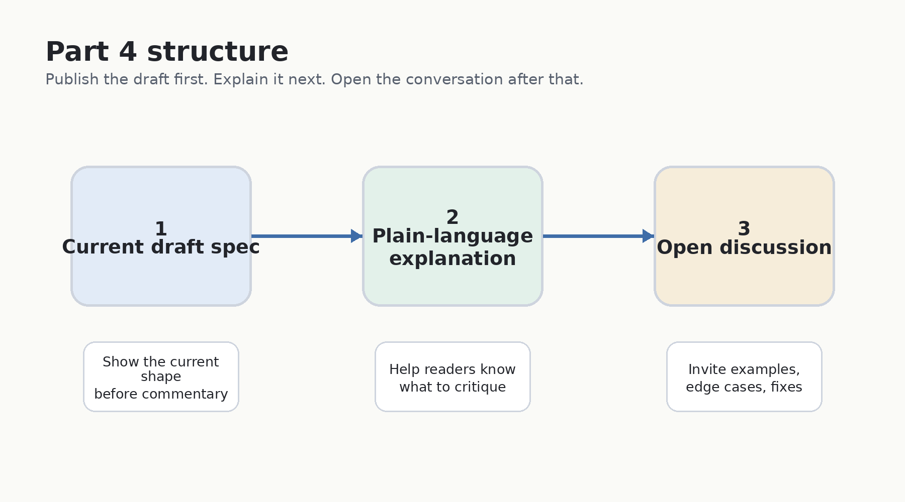
Figure 1. The revised Part 4 structure: spec first, explanation second, discussion third.
Author: Vinay Verma

Part 4: Put the Draft on the Table
If people are going to improve DCP, they should see the draft shape before being asked for ideas.
In the earlier parts of this series, we moved from the missing harness to the software baseline shift, and then to DCP as a capability contract for an AI-native world. Part 4 should do something slightly different.
It should not begin by asking people to comment on an abstract idea. It should first show the current draft: the shape of the protocol, the main primitives, the guardrails, and the questions it is trying to answer. Only after that does it make sense to explain the design and invite discussion.
Why this order matters
A community cannot critique a protocol it has not seen. Starting with the draft spec makes the conversation more precise, more inclusive, and more useful.

Current DCP draft spec - public working shape
The following is not a final standard. It is a public-facing working shape of the current DCP draft: enough structure to make the proposal concrete, while still leaving room for domain feedback and design correction.
DCP stands for Domain Claim Protocol. At the highest level, it is a protocol by which components describe themselves, negotiate how they compose, and invoke one another through a frozen contract rather than ad hoc runtime interpretation.
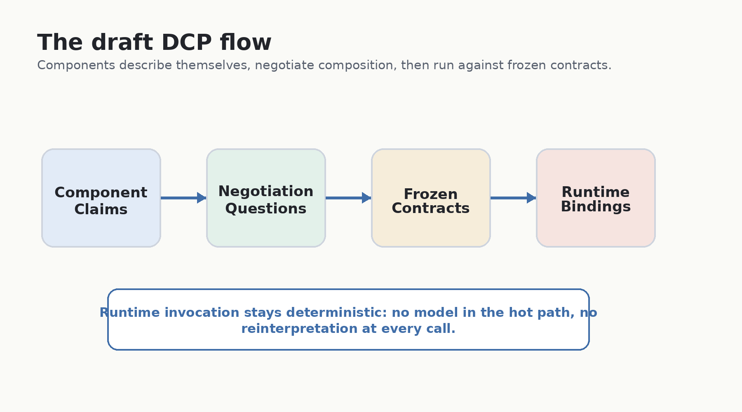
Figure 2. The current draft flow: claims lead to negotiation, contracts, runtime bindings, and deterministic invocation.

1. Purpose and scope
DCP is designed for late-bound enterprise composition. Instead of hardcoding every application topology, components publish claims. Those claims can then be resolved through requirements, policies, context, and bindings.
- A component can be a software service, infrastructure capability, intelligent component, device-facing adapter, workflow engine, connector, or other capability-bearing unit.
- Composition is resolved through claims, requirements, policies, and bindings rather than only through hand-written integration code.
- The output of composition is a frozen artifact that runtime can execute deterministically.
- DCP does not replace business APIs, authentication protocols, hosting systems, or MCP. It sits at the composition layer above them.
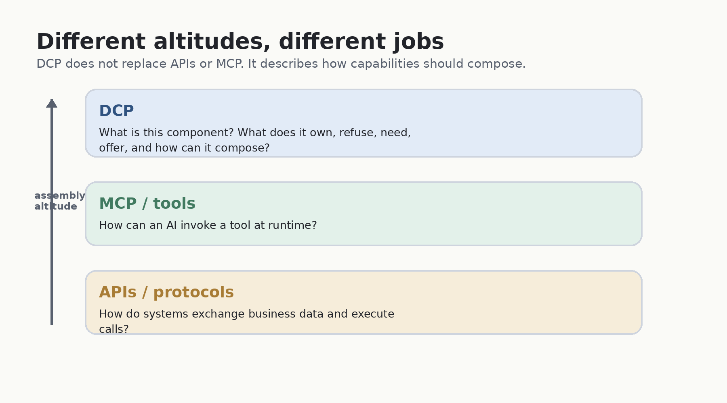
Figure 3. DCP sits at the assembly altitude; MCP and APIs remain useful at their own altitudes.

2. Core primitives in the draft
Primitive | What it answers | Why it matters
Claim | What is this component, what domain does it own, and what does it refuse? | Prevents AI from guessing what a component is responsible for.
Negotiation | Can two claims compose under this context, policy, tenant, and environment? | Moves intelligence to design time, where reasoning is allowed and reviewable.
Composition contract | What exact need binds to what exact offer, with what transport, mapping, expectations, provenance, trust, and invalidation rules? | Freezes the agreement so runtime can execute without rethinking it.
Runtime binding | Where and how is the frozen contract wired in a specific environment or tenant? | Keeps endpoints, secret refs, scaling, telemetry, and runtime policy out of the claim.
Aggregate component | How can a parent capability contain and govern child components, contracts, and bindings? | Makes assembly first-class instead of private planner metadata.
Fault vocabulary | How can a component fail, what does the failure affect, and when may it propagate? | Makes failures machine-readable without turning every runtime incident into AI reasoning.

3. Aggregation of components
Aggregation is not an optional extension to the DCP story. It is how DCP represents a larger capability made from smaller capabilities. A smart room, workflow, module, product surface, or enterprise domain can behave as an aggregate component while still preserving the claims, contracts, and runtime bindings of its children.
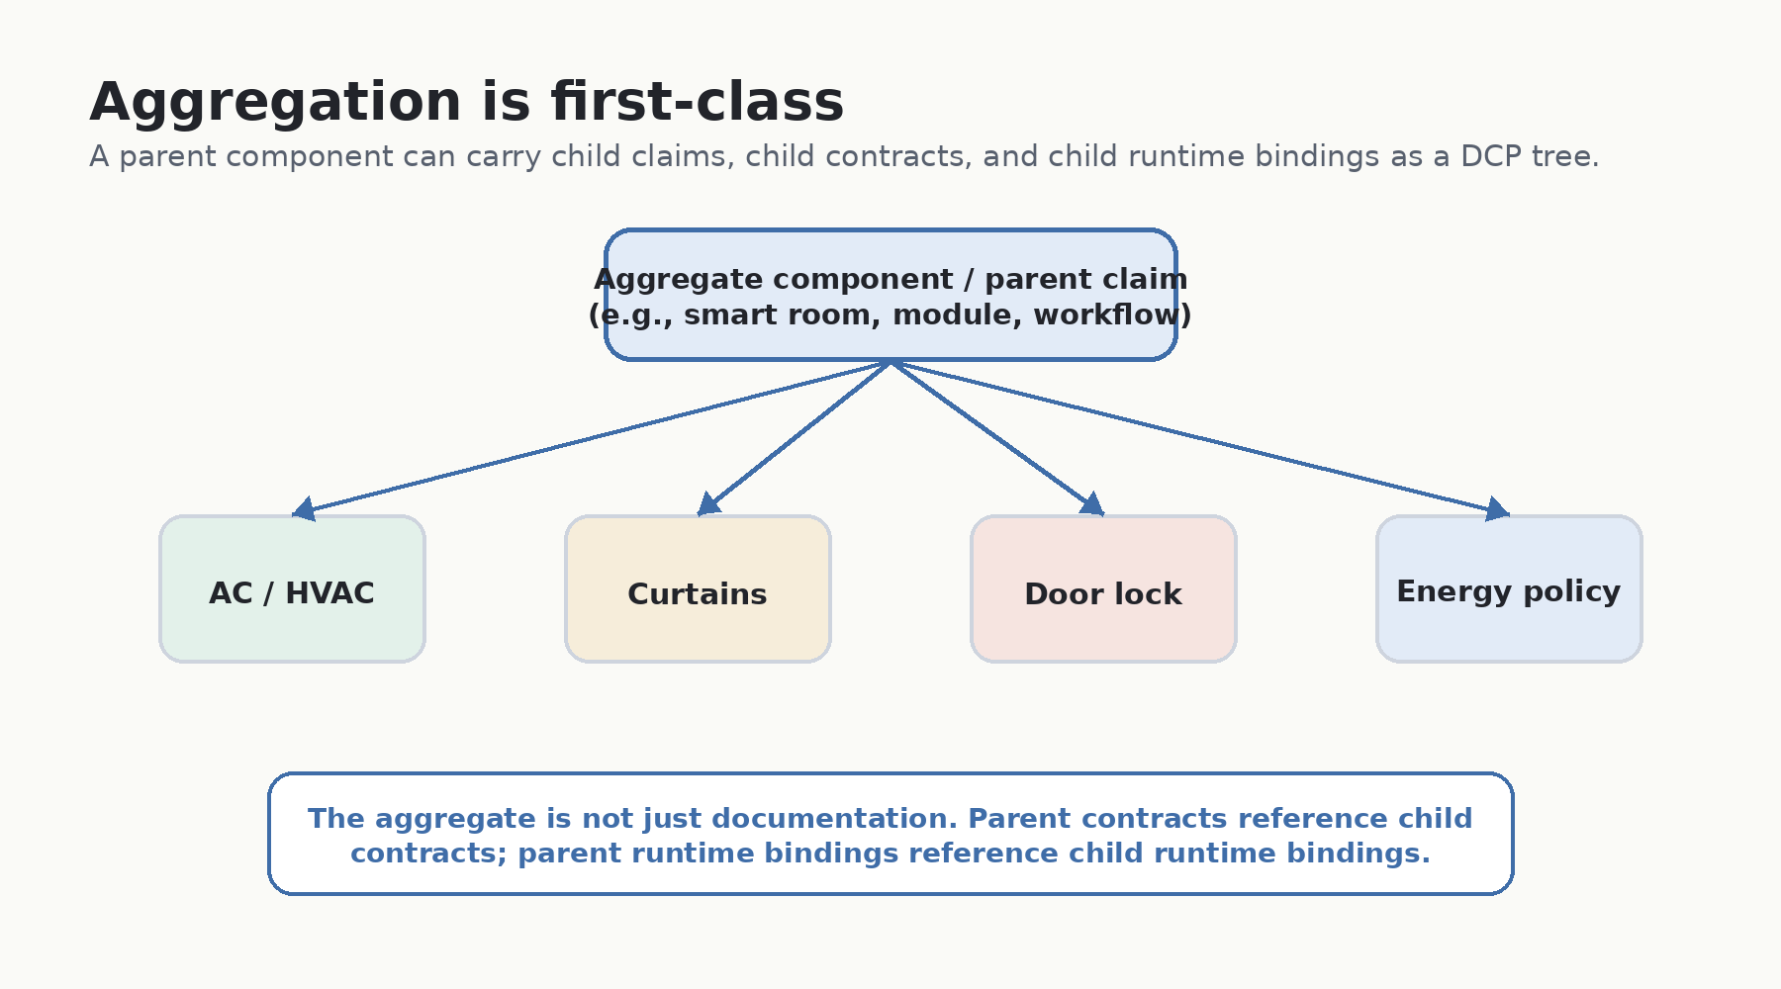
Figure 4. Aggregation makes parent and child capabilities visible as a DCP tree, not private planner metadata.
In the draft shape, aggregation appears at three levels:
Level | Aggregate shape | Why it matters
Claims | Parent claim references child claims. | Larger capabilities remain explainable without erasing child ownership boundaries.
Contracts | Parent contract references child contracts. | Multi-component agreements travel as DCP contract trees, not private planner metadata.
Runtime bindings | Parent binding references child bindings. | Deployment wiring remains inspectable across environments, tenants, and child components.
Public draft note
If aggregation is missing, the spec collapses back into pairwise integration. For an interconnected world, the parent/child composition graph must be part of the protocol surface itself.

- An aggregate component is still a component: it has a domain, boundary, dependencies, offers, refusals, conflicts, faults, and metadata.
- Child components do not disappear inside the parent. Their claims, contracts, and bindings remain independently inspectable.
- A multi-component deployment should be represented as a DCP tree that can be validated, audited, and discussed.
- This is the bridge between ordinary components and systems-of-components: rooms, workflows, modules, enterprises, and future AI-governed environments.

4. Component claim
A claim is the component self-description. It is static, published per component version, and treated as the source of truth for what the component owns and refuses.
Claim section | Draft meaning
identity | Stable URI, name, kind, version, publisher.
domain | Plain-language summary, concerns, owned state, owned decisions, and boundary principles.
refusals | Specific things the component does not own, with rationale and ideally who should own them instead.
dependencies | Required, recommended, and forbidden dependencies.
offers | Capabilities exposed for others to consume, with interface, stability, version, and cost implications when relevant.
conflict_resolution | How overlapping concerns should be handled: exclusive, negotiable, deferring, or consulted.
negotiation_surface | Required when the component is intelligent; defines bounded design-time negotiation capability.
integration_ports | Authentication, authorization, telemetry, monitoring, and AI integration surfaces.
faults | Declared operational-fault vocabulary and propagation policy.
metadata | DCP version, claim version, effective date, references, and related metadata.

5. Negotiation and composition contract
Negotiation is the design-time step that reads two claims and context, then produces a frozen composition contract. It answers questions such as: Does this component own the required concern? Is a dependency satisfied? Is there an exclusive conflict? What owns the refused concern instead?
The composition contract is the artifact that runtime consumes. Conceptually, it carries the parties, binding, data mapping, transport, expectations, provenance, trust, version pins, and invalidation behavior.
Contract field | Purpose
parties | The consumer and provider claims and their pinned versions.
binding | The consumer need and provider capability being connected.
data_mapping | How inputs and outputs map across the boundary.
transport | How invocation occurs: in-process, HTTP/JSON, or gRPC, depending on valid packaging and support.
expectations | Timeouts, idempotency, async behavior, and correlation requirements.
provenance | How the contract was authored: by Fabric, a model, human-in-the-loop, or embedded self.
trust | The recorded trust tier; policy decides what to do with it.
invalidation | When the contract must be re-negotiated; runtime violation hard-fails rather than self-heals.

6. Runtime binding and guardrails
The contract says what is valid. The runtime binding says where and how it is wired in a specific environment, tenant, region, namespace, or deployment target.
- Runtime bindings may include endpoint references, secret references, telemetry routing, scaling policy, rate limits, circuit breakers, rollout controls, and non-secret configuration.
- Runtime bindings must not change the semantic agreement captured by the contract.
- Secrets are references only, never inline values.
- If a runtime assumption is violated, the draft leans toward hard-fail and later design-time re-negotiation, not runtime self-healing.
- The runtime path remains deterministic: no model, no reasoning loop, and no phone-home dependency.

7. Negotiation modes
The draft allows the same negotiation question schema to be answered in different modes, depending on how many parties are intelligent.
Mode | Who answers? | Why it matters
C2C | Component to component, or a model on behalf of components. | The thesis-pure case for autonomous composition.
H2C | A human represents a non-intelligent side. | Useful early on, and produces structured examples for future automation.
H2H | Humans drive composition manually, with structure supplied by the authoring environment. | Keeps the model inclusive for today’s non-intelligent components.

How to read the draft in plain language
The draft may look technical, but the underlying idea is simple: if AI is going to coordinate systems, those systems need to explain themselves before they are coordinated.
An API tells another system how to call something. A tool protocol can tell an AI how to invoke a tool. DCP is asking a broader set of questions: What is this thing? What domain does it serve? What does it own? What does it refuse? What does it need? What does it offer? What happens when it fails? Who should decide when boundaries overlap?
This is why DCP is not merely another interface description. It is a capability contract. Its value is not only in making successful calls possible, but in making unsafe, ambiguous, or invalid composition visible before runtime.

Example: a smart room
Take a smart room with an air conditioner, curtains, a door lock, an occupancy sensor, a user preference profile, and a building energy-management system. Each piece can expose capabilities. But capability alone is not enough.
- The AC may offer cooling, heating, fan speed, power state, and telemetry. It may refuse to own building-wide energy policy.
- The curtains may offer open, close, tilt, and sunlight-blocking modes. They may refuse to own privacy policy.
- The occupancy sensor may offer presence signals. It may refuse to identify a person unless identity is provided by another component.
- The building energy system may own optimization across rooms, but it may need to defer to safety policy, tenant preference, or human override.
- A human may need to approve high-cost, privacy-sensitive, or safety-relevant actions.
The point is not to make every object intelligent. The point is to make every relevant object sufficiently self-describing that intelligence can assemble and govern the system without guessing. The room itself can also be an aggregate component: a parent claim that contains the AC, curtains, lock, sensor, policy layer, and user-preference component as children.

Why the draft begins with boundaries
In ordinary software documentation, refusals are often implicit. A service describes what it does, and everything else is assumed to be out of scope. That is not enough for AI-native composition.
When AI assembles systems, implicit boundaries become dangerous. A component that never says what it refuses may be overused. A component that claims too much may create ownership conflicts. A component that hides failure behavior may cause downstream systems to make unsafe assumptions.
So the draft treats boundaries as first-class. Domain assertions, refusals, conflict resolution, faults, and human escalation are not side notes. They are core protocol material.

Now open it for discussion
Once the draft shape is visible, the invitation becomes more precise. The question is no longer, "Do you like DCP?" The better question is: "Can this draft describe the components, devices, services, workflows, and policies from your domain without lying, oversimplifying, or hiding risk?"
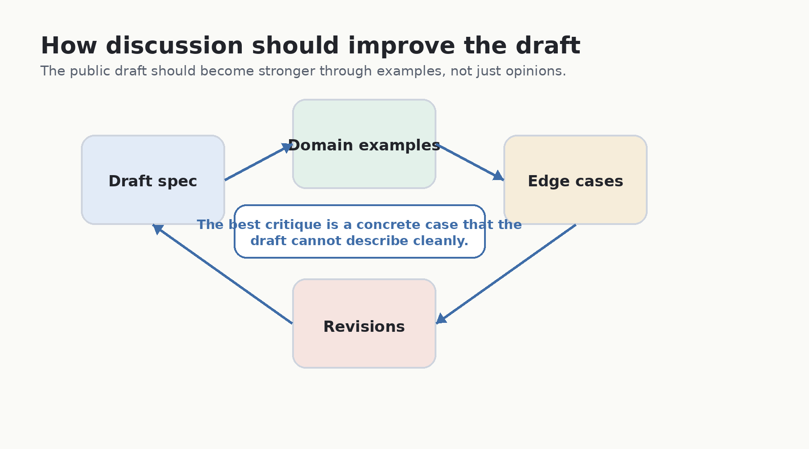
Figure 5. The discussion should improve the draft through concrete domain examples and edge cases.
This is where inclusiveness matters. DCP should not be shaped only by protocol designers or AI engineers. It needs software engineers, platform teams, device builders, security teams, SREs, product teams, UX designers, legal and compliance experts, domain specialists, and people who operate systems in the real world.

What to contribute
The most valuable contribution is a concrete case. Pick one component from your world and try to describe it through the draft spec. Then identify where the draft works, where it feels awkward, and where it fails.
Prompt | What to share | Why it helps
Component | What specific thing are you describing? | Keeps feedback grounded.
Domain | What does it own, and where does that domain end? | Tests domain and boundary language.
Refusals | What must it explicitly not own? | Reveals unsafe or ambiguous claims.
Dependencies | What must exist for it to operate safely? | Tests required, recommended, and forbidden dependencies.
Offers | What capabilities can others consume? | Tests capability versioning and access shape.
Conflicts | Where does ownership overlap with another component? | Tests negotiation and conflict resolution.
Faults | How can it fail, what does that affect, and what remediation is allowed? | Tests operational vocabulary and propagation.
Aggregation | Does this component belong inside a larger parent component or capability? | Tests whether parent and child boundaries remain clear.
Human role | Where should a human decide, approve, or override? | Tests governance and escalation boundaries.

Questions for readers
- Can this draft describe physical-world devices without pretending they are ordinary APIs?
- Can this draft describe aggregates such as smart rooms, workflows, product modules, or enterprise domains without hiding child components?
- Are the boundary and refusal concepts strong enough for regulated domains?
- Does the fault vocabulary capture the failures that operators actually care about?
- Where should the draft force human escalation rather than allow automated negotiation?
- What should be standardized, and what should remain policy-specific?
- Which fields are too abstract, too implementation-shaped, or missing entirely?
- What would make claim authoring easier for engineers and non-engineers?

Discussion norms
To make the discussion productive, feedback should aim to be specific and example-led.
- Start with a real component, device, service, workflow, or policy from your domain.
- State the boundary: what it owns and what it refuses.
- Call out the edge case: where the draft becomes unclear or unsafe.
- Name the human decision point, if one exists.
- Distinguish a missing protocol concept from a product policy choice.
- Prefer small, concrete examples over broad agreement or rejection.

Closing thought
If AI is going to help assemble the future, the capability contract it uses should not be written in isolation. It should be tested against real systems, real domains, real constraints, and real failures.
That is why Part 4 should begin with the draft spec. Then explain it. Then open it for discussion. The order matters because the goal is not applause. The goal is better protocol design.

Grounding notes
- This essay is grounded in the current internal DCP v0.2 model: DCP as description, negotiation, and invocation; late-bound enterprise composition; and the separation between design-time reasoning and runtime execution.
- The draft-spec summary reflects the current claim schema, including identity, domain, refusals, dependencies, offers, conflict resolution, negotiation surface, integration ports, faults, and metadata.
- The aggregation section reflects the current DCP containment model: aggregate contracts and runtime bindings reference child contracts and child bindings rather than hiding multi-component closure as planner metadata.
- The discussion section intentionally comes after the draft-spec summary so readers can critique a concrete shape rather than an abstract slogan.

