DOMAIN CLAIM PROTOCOL SERIES | PART 1
The Missing Harness
Preparing an AI-Native World
A thought leadership blog on why AI needs more than APIs, tools, and invocation protocols. It needs a way to understand domains, capabilities, constraints, and governance.

Author: Vinay Verma
Working Draft | July 2026
Core question
If AI is going to govern an interconnected world, where is the universal harness that tells it what everything is, what it can do, what it depends on, and what rules it must obey?

Table of Contents
Executive Summary
A More Connected World Is No Longer Science Fiction
Every Era Had a Harness
The Shift: AI Is Becoming the Consumer of Capabilities
What Today’s AI Harnesses Solve, and What They Miss
The Air-Conditioner Test
The Missing Harness
Why This Cannot Be Just Another API
Toward Domain Claim Protocol
Suggested Blog Series

Positioning note
This is intentionally written as Part 1: a problem-framing article.
DCP is introduced gently at the end, after the reader understands the gap.
The tone is architectural and exploratory, not promotional.

Executive Summary
Every major computing shift has created a new harness: a layer that makes raw capability understandable, usable, and governable by its primary consumer. The command line exposed computation to technical users. The graphical user interface made computing legible to everyday humans. APIs, SDKs, cloud platforms, and orchestration systems made software capabilities callable by other software.
AI is now becoming a new kind of consumer. It does not merely click buttons or call APIs. Increasingly, it is expected to reason across tools, devices, services, environments, and decisions. Yet the harness we give AI today is still fragmented. We describe tools. We expose endpoints. We register actions. But we rarely provide a universal, domain-aware contract that tells AI what an entity is, what it can do, what it requires, what it affects, and what governs its use.
That is the missing harness. In an interconnected world, every meaningful entity - from a software service to an air-conditioner, from a household device to a smart building, from a business function to a city subsystem - needs a way to declare its domain capabilities in a form that AI can inspect, validate, compose, and govern. This article frames that missing layer and sets up the next part of the series: what every AI-addressable entity should be able to say about itself.
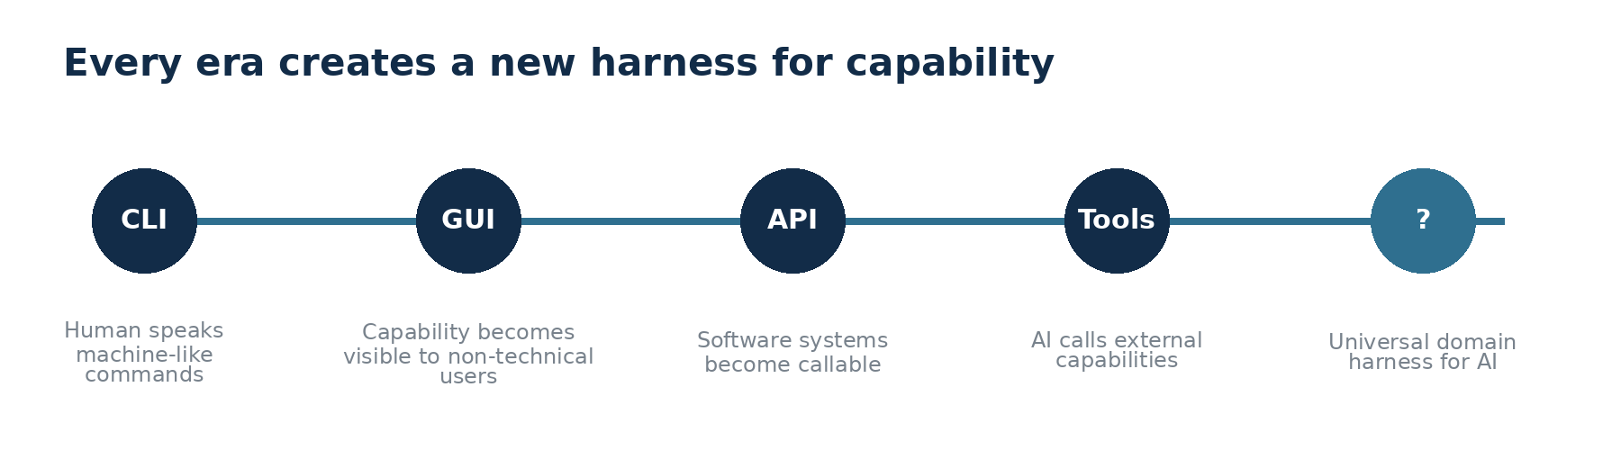

A More Connected World Is No Longer Science Fiction
For more than a century, machine-age fiction imagined worlds where machines did more and more of the work around human beings. Machines prepared things, moved things, opened doors, managed comfort, answered needs, and quietly shaped the environment around us. At the time, this felt like a distant imagination. Today, it feels less like fiction and more like an approaching architecture.
But there is one important difference. Earlier visions mostly imagined machines serving humans directly. A person would press a button, issue a command, or ask for an outcome. In the next phase, many of those machines will not be governed only by humans. They will be interpreted, coordinated, and often acted upon by AI systems.
That changes the problem. If AI becomes the layer that coordinates capabilities across homes, offices, factories, cities, cloud systems, and business processes, then AI needs more than access. It needs understanding.
The connected world does not fail because a device lacks an API. It fails when intelligence cannot understand what the device is, what it means, and what rules govern its use.

Every Era Had a Harness
A harness is an enabling layer. It takes something powerful but difficult to use and makes it accessible to its intended consumer. The command line was a harness for technical users. It allowed humans to operate computation by expressing precise commands. Later, the graphical user interface became a harness for a much wider human audience. People did not need to remember commands; they could see, click, drag, and interact.
The GUI was not just decoration. It translated machine capability into a form humans could understand. It provided affordances, constraints, feedback, and a mental model. In that sense, it was not merely a user interface. It was a capability harness for human cognition.
As software became more networked, APIs, SDKs, protocols, and cloud platforms became another kind of harness. They made software capabilities available to other software. They answered questions like: how do I call this service, what parameters do I pass, what response should I expect, and what errors might occur?
Now AI is creating the next shift. The primary consumer is no longer only a human, and not only another deterministic software program. The consumer is an intelligent agent expected to reason, choose, compose, and act. That agent needs a new kind of harness.

The Shift: AI Is Becoming the Consumer of Capabilities
When a human uses a system, a lot of meaning lives outside the interface. A human can infer context. If they see an air-conditioner, they already know it cools a room, consumes electricity, has safe operating limits, and affects comfort. If they see an inventory dashboard, they understand that stock levels relate to sales, fulfillment, procurement, and customer commitments.
AI cannot be expected to infer all of that reliably from a tool name or API description. It can guess, but guessing is not governance. It can call an endpoint, but calling is not understanding. It can chain tools together, but chaining is not the same as knowing whether the combination is valid, safe, compliant, or meaningful in a domain.
This is why tool-level harnesses are necessary but incomplete. They help AI interact with capabilities. They do not fully explain the domain identity, operational boundaries, dependency model, policy surface, lifecycle state, or compositional role of the capability itself.

What Today’s AI Harnesses Solve, and What They Miss
Today, we are beginning to provide AI with structured ways to use tools. We describe functions. We connect agents to external systems. We expose actions through servers, connectors, and protocols. These are important. They reduce ambiguity around invocation.
But the larger question remains unanswered: what does the thing represent in the real world or in the enterprise domain?
A tool description can say “set temperature.” An API can say “POST /temperature.” A device registry can say “air-conditioner.” But an AI governor may need to know much more: whether it is hot-and-cold or cooling-only, its tonnage, its power dependency, the room it serves, the safe temperature range, the occupancy conditions, maintenance status, energy rules, ownership, override permissions, and whether changing it affects other systems.
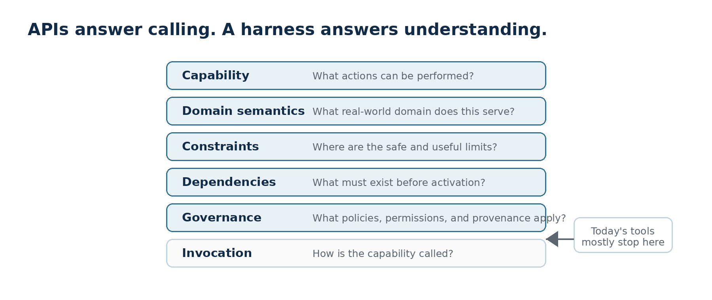
That missing information is not cosmetic. It is the difference between a system that can call a capability and a system that can responsibly reason about it.

The Air-Conditioner Test
Consider a simple air-conditioner. At the most basic level, an AI system may be able to turn it on, turn it off, set a temperature, or change a mode. That is useful, but it is not enough for intelligent governance.
To govern even this ordinary device well, AI may need a richer self-description:
Question AI must answer | Example answer from the entity itself
What domain does this entity serve? | HVAC / climate control
What capabilities does it offer? | Cool, heat, dehumidify, fan, sleep mode
What are its operating constraints? | 1.5 ton, specific voltage range, safe temperature limits
What does it depend on? | Power supply, thermostat, network connectivity, room sensor
What policies govern it? | Energy limits, occupancy rules, user permissions, safety limits
What is its current state? | Mode, set point, compressor state, fault status, firmware version
What relationships does it have? | Serves Room 204, belongs to Floor 2, part of Building A climate system

If this information is unavailable or inconsistent, AI must infer. Inference may work in a demo. It is not enough for a world where AI is expected to operate across real systems, real constraints, and real consequences.

The Missing Harness
The missing harness is a standard way for every AI-addressable entity to describe itself as a domain participant, not merely as an endpoint. It should allow AI to discover and understand the entity before acting on it.
Such a harness would not only say, “Here is how to call me.” It would also say:
• This is what I am.
• This is the domain I belong to.
• These are the capabilities I provide.
• These are the capabilities or resources I require.
• These are my constraints and safe operating boundaries.
• These are the policies and permissions that govern my use.
• This is my current state and lifecycle status.
• This is how I compose with other entities.
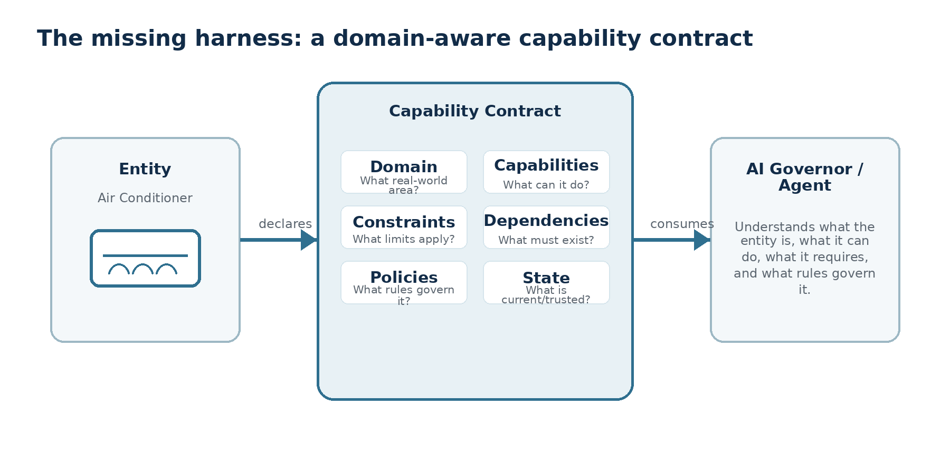
This is the shift from tool invocation to domain understanding. It is also the shift from isolated automation to composable governance.

Why This Cannot Be Just Another API
An API is primarily an invocation surface. It tells a caller how to request an operation. But AI governance needs a semantic and contractual surface as well. The AI must understand not only the available operation, but also the meaning, consequences, constraints, dependencies, and policies around that operation.
This matters because the future interconnected world will not be made of isolated devices and services. It will be made of compositions: rooms inside buildings, buildings inside campuses, services inside platforms, platforms inside business capabilities, and business capabilities inside regulated operating environments.
In such a world, the harness must travel with the entity. The description cannot live only in a central document, a human-maintained wiki, or an integration-specific adapter. The entity itself, or the domain claim representing it, must carry enough structured meaning for AI to inspect it and reason about it.
The future AI-native world needs entities that are self-describing, policy-aware, dependency-aware, and composable by design.

Toward Domain Claim Protocol
This is where the idea of a Domain Claim Protocol begins to emerge. Not as another tool-calling mechanism, and not as a replacement for APIs, MCP-style connectors, cloud orchestration, or existing integration standards. Those remain useful. But they answer only part of the question.
A Domain Claim Protocol can be thought of as a structured claim that an entity makes about itself: its domain, capabilities, requirements, constraints, policies, relationships, and activation rules. In that framing, DCP becomes a candidate for the missing harness: a capability contract that AI can read before it acts.
The important point is not to start with the protocol. The important point is to recognize the architectural gap. AI will increasingly sit above tools, services, devices, and domain systems. If those systems do not describe themselves in a standard, inspectable, composable, and governable way, AI will keep stitching fragments together rather than understanding the systems it is asked to coordinate.
That is the missing harness. And it may become one of the most important architectural layers of the AI-native world.

Closing Thought
The GUI helped humans use computers because it translated machine capability into human-understandable form. The next harness must help AI govern the connected world by translating domain capability into AI-understandable form.
The question, then, is simple: what should every AI-addressable entity be able to say about itself?
That is the question for Part 2.

Suggested Blog Series
Post | Working title | Purpose
Part 1 | The Missing Harness | Frame the architectural gap: AI has tool access, but not universal domain understanding.
Part 2 | What Every AI-Addressable Entity Should Say About Itself | Define the minimum self-description: domain, capabilities, constraints, dependencies, policies, state, and relationships.
Part 3 | Introducing Domain Claim Protocol | Present DCP as a structured domain capability contract, without overloading it with implementation detail.
Part 4 | DCP, APIs, and MCP: Different Layers of the AI Stack | Clarify that invocation, transport, and domain claims solve different problems and should work together.
Part 5 | From Devices to Cities: Recursive Capability Composition | Show how claims compose from devices to rooms, buildings, colonies, sectors, enterprises, and cities.

Recommended next step
Use Part 2 to define the entity self-description schema in plain language before naming YAML, JSON, signatures, validators, or resolvers.
Use the air-conditioner example first, then generalize to enterprise software components and smart-city subsystems.
Introduce DCP as the formalization of the claim, not as the starting point.

Editorial Notes
This draft intentionally avoids naming a specific science-fiction story or author in the opening. That keeps the piece credible while preserving the broader “machines doing more of the work” framing discussed during dictation.
For public publishing, the article can be shortened into a 900-1,200 word LinkedIn post or expanded into a 2,000 word technical essay. The current version is structured as a polished working draft with diagrams for internal review and refinement.

