# IT 230 Coding Activity Submission Template

Submit your work on the coding activities for Modules One, Two, Three, Four, and Six in this document. In addition to this document, you should submit a ZIP file containing all your Visual Studio project files and source code that can be run in Visual Studio on a different computer.

For each coding activity, complete the following steps:

* Download and rename this document to meet the file naming conventions requested in the assignment instructions.
* Fill in the required information below by replacing the bracketed text with the relevant information.
* Submit this document and your ZIP file for grading and feedback. Your ZIP file should follow the same naming conventions.

Document your work in the coding activity by completing each of the following items:

1. Provide a screenshot of the output that resulted from running your program successfully in Visual Studio. See the coding assignment instructions for an example of what should be included in the screenshot. Your screenshot must include the following elements:
   1. Your last name as the first printed text on the screen
   2. Verification that the program is fully functioning and data results are accurate for the given problem

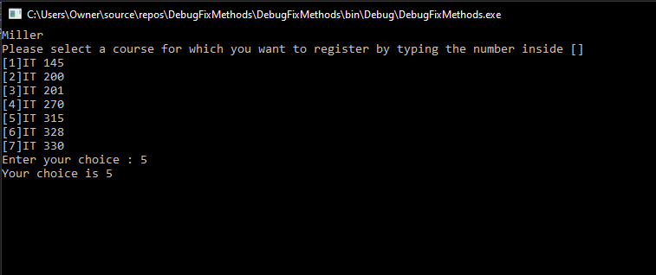

1. Copy and paste the source code text you wrote for this assignment from the *.cs file into the space below. Only providing the *.cs files or a screenshot does not meet the requirements for this part of the assignment. Code should be logically organized. It should also follow proper syntax and conventions noted in the Coding Activity Guidelines and Rubric.

using System;

using System.Collections.Generic;

using System.Linq;

using System.Text;

using System.Threading.Tasks;

namespace DebugFixMethods

{

class Program

{

static void Main(string[] args)

{

(new Program()).run();

}

void run()

{

int choice = 0;

WritePrompt();

choice = ReadChoice();

WriteChoice(choice);

}

void WritePrompt() // Capitalized the lowercase p to match the WritePromt established above.

{

Console.WriteLine("Miller"); // Added line to print my name instead of Teacher's Copy.

Console.WriteLine("Please select a course for which you want to register by typing the number inside []");

Console.WriteLine("[1]IT 145\n[2]IT 200\n[3]IT 201\n[4]IT 270\n[5]IT 315\n[6]IT 328\n[7]IT 330");

Console.Write("Enter your choice : ");

}

int ReadChoice()

{

string s = "";

s = Console.ReadLine();

return Convert.ToInt32(s); // Added Convert.toInt32 to translate the string to integer.

}

void WriteChoice(int choice) // Added int before choice to make sure it's an int and not a string.

{

Console.WriteLine("Your choice is {0}", choice); // Changed the uppercase C in Choice to lowercase

Console.ReadLine(); // Added ReadLine to ensure choice selection is displayed.

}

}

}

1. Show that you understand the task by explaining the design of your program in the space below. Include the process and steps you took to write your code. Explain how you arrived at the solution to the problem and completed the activity.

I reviewed the program to familiarize myself with what it was trying to accomplish. I changed the last entry of Choice to choice as all other references were lowercase (Line 46). After trying to troubleshoot the issue with WritePrompt I eventually realized the second mention of it was incorrectly typed and corrected the lowercase p to an uppercase (Line 28).

Following the path of the input for s I realized I did not want the Write choice to call a string. This meant converting the return (s) to Int32, so I added the ‘Convert.toInt32’ to the return line (Line 41). I also added in the 'int' to the parenthesis after WriteChoice that calls the user selected choice (Line 44). After debugging my program was exiting after entering a selection number and so I added a ReadLine after the final WriteLine in WriteChoice (Line 47). This allowed the WriteLine to be displayed before automatically closing the program.

I then added a WriteLine above the selections in WritePromt to display my last name. I hope this is correct, as I was unsure about this part the last 2 assignments (Line 30).

1. Reflect on your learning experience and what you learned from completing the activity.

I learned that it's a good choice to read through the coding and check for any spelling differences and to take care to look for differences in upper and lowercase. This is a basic but essential place to start. It is also good to think about how the desired item needs to change (or not) to be output correctly. In this case we wanted entered string to become an integer.