Each course selected adds 3 credit hours to the registered courses. The program will not terminate unless the user closes the program.

The program will output “Registration Confirmed for course [user selected course]. The program will output the selected courses, each course equating to 3 credit hours which is shown in the User Interface. The user can register for up to 3 courses, or 9 credit hours.

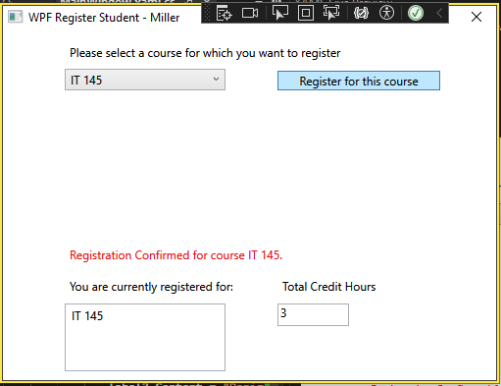

The program will output the message “You have already registered for this [selected course number] course” if the user attempts to register for a course that was already registered.

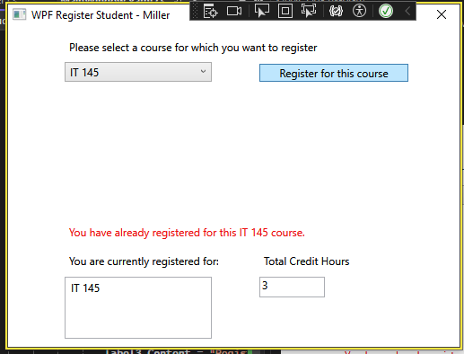

If the user attempts to register for more than 3 courses, or more than 9 credit hours, the program will output “You can not register for more than 9 credit hours.” as shown in the example provided.

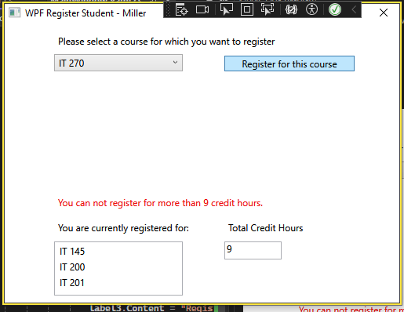

using System;

using System.Collections.Generic;

using System.Linq;

using System.Text;

using System.Threading.Tasks;

using System.Windows;

using System.Windows.Controls;

using System.Windows.Data;

using System.Windows.Documents;

using System.Windows.Input;

using System.Windows.Media;

using System.Windows.Media.Imaging;

using System.Windows.Navigation;

using System.Windows.Shapes;

namespace WPFRegisterStudent

{

/// <summary>

/// Interaction logic for MainWindow.xaml

/// </summary>

public partial class MainWindow : Window

{

Course choice;

private int creditHours = 0;

// Establish private variable for amount of credit hours.

// private to match the parameters of private void button_Click

public MainWindow()

{

InitializeComponent();

}

private void Window_Loaded(object sender, RoutedEventArgs e)

{

Course course1 = new Course("IT 145");

Course course2 = new Course("IT 200");

Course course3 = new Course("IT 201");

Course course4 = new Course("IT 270");

Course course5 = new Course("IT 315");

Course course6 = new Course("IT 328");

Course course7 = new Course("IT 330");

this.comboBox.Items.Add(course1);

this.comboBox.Items.Add(course2);

this.comboBox.Items.Add(course3);

this.comboBox.Items.Add(course4);

this.comboBox.Items.Add(course5);

this.comboBox.Items.Add(course6);

this.comboBox.Items.Add(course7);

this.textBox.Text = "";

}

private void button_Click(object sender, RoutedEventArgs e)

{

choice = (Course)(this.comboBox.SelectedItem);

// TO DO - Create code to validate user selection (the choice object)

// and to display an error or a registation confirmation message accordinlgy

// Also update the total credit hours textbox if registration is confirmed for a selected course

if (listBox.Items.Contains(choice))

// if statement to run user input through iterations.

// listBox references the output box and choice references the user input for course selection.

{

label3.Content = "You have already registered for this " + choice + " course.";

// To prevent picking the same choice more than once. label3 references the box the registered courses should be output.

}

else if (creditHours < 9)

// Boolean for less than 9 credit hours selected.

{

listBox.Items.Add(choice);

// listBox references the name of the box the courses will appear in for the UI, choice retrieves the user choice for course.

creditHours += 3;

// This is to add 3 credit hours for each registered course.

textBox.Text = Convert.ToString(creditHours);

// textBox references the box the amount of hours registered should be output.

label3.Content = "Registration Confirmed for course " + choice + ".";

// Output the confirmation of registered courses selected by the user.

}

else

{ // else to catch iterations that have not yet met criteria.

label3.Content = "You can not register for more than 9 credit hours.";

// To ensure the user does not enroll in more than 9 credit hours.

}

}

}

}