Introduction to Software Engineering

Software Requirements Specification

The student team is required to complete the Software Requirements Specification documentation for the assigned course project, following the attached template.


Software Engineering Department
Faculty of Information and Technology
University of Science

Table of Contents
Objectives 1
1 Member Contribution Assessment 2
2 Introduction 3
2.1 Purpose and Scope 3
2.2 Glossary 4
3 Problem Statement 6
3.1 Business context 6
3.2 Current way of working 6
3.3 Problem summary 7
3.4 Focus: event proposal and approval (F02–F03) 8
3.5 Goals and success criteria 9
3.6 Operating environment 10
3.7 Design and implementation constraints 10
3.8 Evidence base and validation status 11
3.9 Key assumptions 12
4 Stakeholders 14
4.1 Needs, pain points and decision authority 16
4.2 Stakeholders and system actors 17
4.3 Owner-approved PA2 decisions and external validation 18
5 Requirements 21
5.1 Functional Requirements 21
5.2 Non-Functional Requirements 27
5.3 Domain Requirements and Business Rules 31
5.4 Acceptance Criteria 37
6 Use Case Model 55
6.1 Use Case Diagram 55
6.2 Actors 60
6.3 Use Case List 61
7 Use Case Specifications 63
7.1 Use Case UC-01 63
7.2 Use Case UC-02 64
7.3 Use Case UC-03 65
7.4 Use Case UC-04 66
7.5 Use Case UC-05 67
7.6 Use Case UC-06 68
7.7 Use Case UC-07 69
7.8 Use Case UC-08 70
7.9 Use Case UC-09 71
7.10 Use Case UC-10 72
7.11 Use Case UC-11 73
7.12 Use Case UC-12 75
7.13 Use Case UC-13 76
7.14 Use Case UC-14 77
7.15 Use Case UC-15 78
7.16 Use Case UC-16 79
7.17 Use Case UC-17 80
7.18 Use Case UC-18 82
7.19 Use Case UC-19 83
7.20 Use Case UC-20 84
7.21 Use Case UC-21 85
7.22 Use Case UC-22 86
7.23 Use Case UC-23 87
7.24 Use Case UC-24 88
8 Prototype / Mockups 90
8.1 Screen flows for the remaining features 93
9 Requirements Traceability Matrix 97
10 Requirements Review 104
11 AI Usage Log 109

Software Requirements Specification

Objectives
This document focus on the following topics:
- Completing the Software Requirements Specification (SRS) document with the following sections:
  - Problem Statement
  - Stakeholders
  - Functional, non-functional and domain requirements
  - Use case model and use case specifications
  - Prototype / mockups
  - Traceability and requirements review
- Including an AI usage log for this phase
- Understanding the Software Requirements Specification (SRS) document.

1 Member Contribution Assessment
The 25%-per-member contribution allocation (100% total) is confirmed by all four members, as reported by team lead Lê Nguyễn Quốc Học on 2 November 2026. Task board: UniEvent T07 Project. The linked assignments and document history support the contribution record; the team confirmation is recorded in Section 10.
ID | Name | Role(s) | Contribution (%) | Evidence
24127177 | Thái Quang Huy | Business Analyst; Developer; F02/F03; business rules; UC register; RTM; AI log | 25% | Overview #36; F02/F03 #38; Business rules #42; UC model #43; RTM #45; AI log #48.
24127044 | Lê Nguyễn Quốc Học | Team lead / PM; Developer; F01/F08; Introduction; NFR; contribution assessment; integration and submission | 25% | Introduction #35; F01/F08 #37; NFRs #41; Contribution assessment #47; SRS integration #49.
24127196 | Trần Vũ Anh Kiệt | Designer / Architect; Developer; F04/F07; prototype and screens | 25% | F04/F07 #39; Prototype/screens #44. Sections 5 (F04, F07), 7 (UC-14, UC-20–UC-22), 8 (SC-F01–SC-F08 wireframes); Google Docs version history.
24127205 | Nguyễn Văn Minh | Tester / DevOps; Developer; F05/F06; requirements review; payments | 25% | F05/F06 #40; Requirements review #46.

2 Introduction

2.1 Purpose and Scope
This SRS defines the document-owner-approved UniEvent MVP requirements for implementation and verification. It develops PA0 and submitted PA1 Sections 2.3-2.4. The simplification retains F01-F08 and narrows their behaviour in Table 4.3. SePay Payment Gateway is the confirmed F05/F06 provider for this PA2 scope, as instructed by the document owner on 2 November 2026 (BR-16; BR-17). The smaller browser/test profile (NFR-01; NFR-04; NFR-07; NFR-08) and other explicit MVP limits are accepted by the document owner for PA2; cross-owner requirements review is complete as confirmed by the team lead on 2 November 2026; any required TA confirmation remains pending. This provider decision does not by itself establish stakeholder approval or a completed live integration. Intended readers are the team, teaching staff and domain reviewers; this SRS is the reference for PA3 design, PA4 test planning and PA5 implementation.
The required PA5 scope is F01 accounts, organisations and roles; F02 event creation/submission; F03 approval; F04 simple ticket types; F05 one-ticket reservations and VietQR; F06 verified payment, ticket issuance and minimum exception handling; F07 online QR check-in/check-out; F08 three dashboard metrics and attendee CSV. F09-F10 are deferred; F11-F16 remain outside this implementation baseline.
Paid tickets use one authorised live payment channel, with direct settlement to its account holder; the confirmed provider is SePay Payment Gateway under BR-16; BR-17. UniEvent does not hold or aggregate funds. Multi-organiser channel onboarding, credential management and routing; international cards and non-VND currencies; reserved seating; native mobile applications; and direct integration with official university conduct-score or student-information systems are outside PA5. Minimum received-payment exception handling remains required under F05-F06 even if F10 is deferred (PA1 Section 2.4, pp. 23-24).
MVP limits: one ticket per order; one approval stage; no incomplete Draft save, optional revision/approval comment, post-approval content editing, post-sales-start ticket configuration, automatic late-payment reallocation, re-entry, manual attendance override or automatic refunds. UniEvent uses browser clients, one SePay Payment Gateway channel and a transactional e-mail service. Section 8 contains the interactive prototype links and screen images. Internal requirements review is complete as confirmed by the team lead; application-test execution remains planned for PA4/PA5.

2.2 Glossary
Term | Definition
FR / AC / UC | Functional requirement / Given-When-Then acceptance criterion / goal-oriented use case.
NFR / BR / OD | Measurable quality requirement / business rule / recorded scope decision.
RTM | Matrix linking each active FR to its AC, UC, screen and later PA3/PA4 evidence.
Attendee | Verified university-e-mail account; acts only on its own orders and tickets.
Organiser / Approver / Checker / Administrator | Scoped roles defined by the Section 4 access matrix. One account may hold several independent grants.
Organisation / approving unit | Flat Club or Approving Unit register; each Club has one designated approving unit.
Event proposal | Event record in Draft, Submitted, Changes Requested, Approved, Rejected or Published.
Submission number / decision history | Consecutive submission round and its append-only decision evidence; not a full document-version system.
Reservation / allocation | One-ticket order with a 15-minute unpaid hold; confirmed-unissued allocations remain reserved.
Matched receipt | Authenticated successful provider transaction matching the stored order/channel and exact VND amount under BR-17.
Payment channel | Single authorised live SePay Payment Gateway channel; direct settlement to its account holder.
Signed QR ticket | One issued admission ticket represented by a signed ticket reference without personal data.
Payment exception | Received-payment/fulfilment anomaly retained for Administrator review and evidenced resolution.
Audit log | Read-only evidence of the BR-11 actions; each listed database state change and its required audit entry commit together.
Issued tickets / gross confirmed revenue | Distinct issued tickets / distinct matched confirmed receipts; definitions are in BR-22.
Check-in rate | Ever-checked-in distinct issued tickets divided by issued tickets; checkout does not reduce it.
Snapshot / as-of time | Consistent event data at a stated server time; a later CSV may use a newer snapshot.
E1 | Owner-approved acceptance profile on the actual PA5 deployment, specified in OD-10; no measured result is implied.

3 Problem Statement

3.1 Business context
Student clubs, the Youth Union (Đoàn Thanh niên) and the Student Association (Hội Sinh viên) at Vietnamese universities organise workshops, seminars, competitions, performances and volunteer activities. Based on the team’s initial experience, some events use free or low-cost tickets, and attendance records may contribute to students’ conduct-score assessment (điểm rèn luyện), depending on university regulations (PA1 §2.1, p. 5). In the current workflow, the organising committee sends its event plan to the Youth Union or the Student Association by e-mail or on paper, and registration opens after approval (PA1 pp. 5, 7). UniEvent replaces this step with submission to the organisation’s approving unit (F02, p. 22).
UniEvent is a responsive web platform that connects this life cycle in one system: in-system submission and approval of event proposals, ticket configuration, reservation with VietQR payment through one authorised SePay Payment Gateway channel, signed QR tickets, QR check-in and check-out, and a real-time organiser dashboard with CSV export. These are the Must-have features F01–F08 (PA1 §2.4, pp. 21–22). Conduct-score evidence (F09) and cancellation and refund (F10) are Should-have extensions outside the required baseline; F11–F14 are Could-have backlog and F15–F16 are Won’t-have.

3.2 Current way of working
Table 3.1 describes the current workflow as observed by the team lead, a member of the Student Volunteer Team (Đội Sinh viên tình nguyện) who has helped organise several of its activities (PA1 §2.1, pp. 5 and 9). It reflects one organisation’s practice and is therefore PENDING VALIDATION with other organisations.
Table 3.1 – Current event workflow (preliminary, PENDING VALIDATION)
# | Activity | Current means | Observed difficulty | Problem
1 | Prepare and submit the event plan | Plan sent to the approving unit by e-mail or on paper | Organisers cannot see the status of the request; follow-up messages delay the event | P3
2 | Review and decide | Not described in PA1; assumed to be by e-mail or on paper (A-04) | No searchable history of decisions and reasons; the club a submitter represents is not always clear | P3, P6
3 | Register attendees | Google Form | Form ownership and participant data are shared informally | P6
4 | Collect payment | Bank transfer with a free-text description | Transfers matched by hand against form responses; missing, duplicated or mismatched payments | P1
5 | Confirm registration | Confirmation e-mails sent one by one | Slow confirmation and disputes about whether a student has paid | P1
6 | Admit attendees | Spreadsheet or printed list at the door | Queues; forwarded screenshots reused; inconsistent attendance records | P2
7 | Report attendance | Sign-in sheet retyped and sent to the Youth Union | Incomplete, hard-to-verify evidence and repeated retyping | P4
8 | Monitor the event | Spreadsheets updated manually | No live view of sales and check-ins; overselling or empty seats discovered late | P5

3.3 Problem summary
Table 3.2 – Problems addressed by UniEvent
ID | Problem | Who is affected | Impact | Expected solution outcome (feature)
P1 | Manual payment reconciliation | Organisers handling registration and finance; paying students | Slow confirmation; missing, duplicated or mismatched payments; disputes | Confirm payment from an authenticated, matched provider notification, issue exactly one ticket per eligible paid order and flag exceptions (F05-F06).
P2 | Unreliable ticket validation | Check-in volunteers, organisers, attendees | Queues, duplicate admission, inconsistent records | Validate signed QR tickets on the server from a phone browser and record check-in and check-out separately (F06–F07)
P3 | Opaque event approval | Organisers who submit events; approving officers | Status invisible; no searchable record of decisions and reasons; delays | Provide an in-system submission and approval queue with approve, reject-with-reason and request-changes decisions and a complete decision history (F02–F03)
P4 | Weak attendance evidence | Attendees, organisers, officers | Incomplete, hard-to-verify records; appeals hard to settle | Record attendance from QR check-in and check-out with CSV export (F07–F08); optional draft conduct-score evidence (F09, Should)
P5 | No real-time view of the event | Organisers and event leads | Capacity and staffing decided on outdated data | Show issued-ticket count, gross confirmed revenue and check-in rate within the defined refresh target, with CSV export (F08), backed by atomic capacity control (F05).
P6 | Unmanaged organisations and privileges | Administrator, organisers, approvers, attendees | Wrong people can edit or export data; nobody can show who granted access | Register organisations, grant scoped organiser and approver roles, lock accounts and keep an audit log (F01)

3.4 Focus: event proposal and approval (F02–F03)
Event approval distinguishes UniEvent from general ticketing: Organisers need visible status and a retained decision/reason history. The working model uses one approving unit per Club, one decision stage and revision only after Request Changes.
These choices derive from the preliminary PA1 workflow and engineering assumptions, not completed stakeholder interviews. Table 4.3 records the document-owner-approved PA2 scope; Section 10 records completed internal cross-owner review separately from pending external stakeholder validation.

3.5 Goals and success criteria
The goals below refine the preliminary PA1 objectives (PA1 Section 2.1, pp. 11-12; Section 2.2, p. 16). Latency thresholds are retained; payment eligibility and receipt authentication follow BR-17; BR-20, and approval reasons follow BR-03; BR-04. Measurable targets are in Section 5.2 and functional acceptance criteria in Section 5.4.
Table 3.3 – Business goals traced to problems
Goal | Problem | Target refined from PA1 | Specified in
G1 No manual payment reconciliation in the normal case | P1 | For a valid matched payment confirmed before hold expiry under BR-20, one ticket is created and e-mail delivery is initiated within 60 s of authenticated provider notification receipt; exceptions may need manual handling. | F05–F06 requirements; Section 5.2
G2 No overselling and no duplicate tickets | P1, P5 | Unexpired unpaid holds, confirmed-unissued allocations and issued tickets never exceed capacity; repeated authenticated notifications never issue duplicate tickets. | F05–F06 requirements; Section 5.2
G3 Fast and reliable check-in | P2, P4 | At least 95% of scans return valid, used or invalid within 2 s under E1/4G conditions. Each accepted transition retains one timestamp; rejected/repeated scans do not alter attendance. The attendee CSV reports one row per issued ticket with its recorded attendance state. | F07; FR-F08-03; BR-21; OD-09; Sections 5.2 and 5.4
G4 Transparent approval | P3 | Every event shows its approval status; every decision is retained, with a required reason for Reject and a description for Request Changes. Approve needs no optional comment. | FR-F02-*, FR-F03-*; Section 5.4
G5 Real-time visibility | P5 | The dashboard reflects changes to issued-ticket count, gross confirmed revenue and check-in rate within 5 s after the corresponding server commit, using BR-22 definitions. | F08 requirements; Section 5.2
G6 Traceable access to organisations and data | P6 | Every action listed in BR-11, including attendee CSV export, is traceable to a named account | F01 requirements; Section 5.2

3.6 Operating environment
UniEvent is a responsive HTTPS web application. The owner-approved PA5 acceptance profile covers current stable desktop Chrome/Edge and actual Android Chrome/iPhone Safari; versions and limitations are recorded at test execution (NFR-07). QR scanning needs camera permission and network. Dependencies are one authorised live SePay Payment Gateway channel and a transactional e-mail service.

3.7 Design and implementation constraints
Table 3.4 – Design and implementation constraints
Constraint | Content | Source (PA1)
Process | Waterfall model with V-model test planning; phase gates PA0–PA5 and a final presentation within 11 weeks; implementation in W8–W10. | p. 12
Team and budget | Four students; availability of 12 h per member per week in W4–W5, as agreed on 21/10/2026; free tiers of hosting and tools only. | p. 12
Technology | TypeScript front/back end (Next.js, NestJS), PostgreSQL/Prisma, REST and the PA1 WebSocket update channel. PA3 chooses library/configuration details; no new service or framework is required by this simplification. | pp. 12, 27–28
Payments | UniEvent does not hold or aggregate funds. One authorised SePay Payment Gateway channel with direct settlement; multi-organiser onboarding and routing are excluded. The mock adapter supports CI and a labelled contingency demo but does not prove live-channel integration. | pp. 12–13, 23–24
Data protection | Collect only display name, verified e-mail and necessary order/payment/attendance references; QR excludes personal data. Use synthetic test participants; course-data and backup disposal follows OD-11. The SRS makes no legal-compliance certification. | p. 13
Documentation | Course templates for every PA, UML 2.5 for models, the C4 model for architecture, Architecture Decision Records. | p. 13
Platform scope | Responsive web application only. No native mobile applications (F16), seat maps (F15), official conduct-score or student-information integration, or multi-organiser payment routing. | pp. 23–24

3.8 Evidence base and validation status
The domain-evidence register was rechecked on 2 November 2026. It still records only the team lead's first-hand experience, treated in PA1 as preliminary domain knowledge rather than representative statistics. No completed interview, survey or review of other organisations' practice is evidenced in this SRS. The owner review and limited prototype checks recorded elsewhere do not validate external stakeholder needs. Table 3.5 retains the planned WBS 2.1.1-2.1.2 activities pending actual evidence.
Table 3.5 – Proposed validation activities (none conducted yet)
ID | Activity | Target participants | Assumptions and questions covered | Status
V-01 | Short Organiser interviews | At least two Organisers from different Clubs | Fields, complete Draft, submission/revision and publication; A-01/A-03/A-04; OD-02; OD-03 | Planned; not conducted
V-02 | Approver interview | At least one relevant approving officer | Routing, one-stage decision, self-approval, reasons and pilot e-mail; A-01/A-02/A-03/A-04/A-05/A-06; OD-01; OD-02; OD-04; OD-06 | Planned; not conducted
V-03 | Student and Checker interviews | Two to three students and one or two Checkers | One-ticket orders, VietQR, QR scanning and no re-entry; OD-05; OD-06 | Planned; not conducted
V-04 | Review public event information | At least three other Clubs public event posts | Validate field and registration variation; A-03/A-04 | Planned; not conducted
V-05 | Administration and acceptance scope review | Team in the course Administrator role | Organisation/audit simplicity, metrics, CSV, actual-host E1 and retention; OD-07; OD-08; OD-09; OD-10; OD-11 | Planned; not conducted
Planned validation: use a short consent-based interview with Organisers, an Approver, students/Checkers and a team administration review. Store coded role/date notes in /docs/requirements, not personal contact details or recordings. No completed interview is asserted.
After actual validation, update the activity status, assumptions and affected decisions/FR/AC/UC with dated evidence. Only actual participants may confirm human review; AI drafting or this document update does not validate stakeholder needs.

3.9 Key assumptions
The six assumptions below remain pending external validation. Their active identifiers are consecutive in this submission; historical identifiers are retained only in the AI usage log.
Table 3.6 – Key assumptions (none validated yet)
ID | Assumption | Basis | Status | Check in
A-01 | Clubs submit event plans to a designated university unit. | PA1 preliminary workflow | PENDING validation | V-01/V-02
A-02 | One designated unit and one authorised decision stage are sufficient. | Proposed routing model | PENDING validation | V-02
A-03 | The BR-07 fields and poster are sufficient; venue booking remains outside UniEvent. | PA1 F02 | PENDING validation | V-01/V-02
A-04 | Approvers will use a web queue and retained reasons instead of informal follow-up. | PA1 problem | PENDING validation | V-01/V-02
A-05 | Pilot users can verify an address on the proposed university-domain allowlist. | Engineering assumption | PENDING validation | V-02/V-03
A-06 | Approval precedes public registration; one proposal is decided at a time. | PA1 scope | PENDING validation | V-02

4 Stakeholders
Table 4.1 – Stakeholders
# | Stakeholder | Description | Interests / concerns
1 | Project sponsor – course instructor and teaching assistant | Teaching staff of the Software Engineering Department who supervise the project, review each PA and evaluate delivery against the course requirements (PA1 #1). | A complete, consistent and verifiable SRS; working software by PA5; fair, evidenced individual contributions; disclosed AI use. Approves any change to the live-payment delivery boundary (PA1 p. 13).
2 | Club organiser (organising committee member) | Holds an Organiser grant for one club; creates and submits event proposals, configures tickets, assigns check-in staff and monitors the event (PA1 #3; p. 18). | Visible approval status and reasons; simple revision when changes are requested; no manual payment reconciliation; real-time sales and attendance.
3 | Youth Union / Student Association officer (approver) | Holds an Approver grant for one approving unit and decides on proposals routed to it (PA1 #6). | Clear and complete event information; reasoned decisions; a searchable decision history; authority limited to their own unit; reliable attendance evidence.
4 | Student attendee (including guests who browse before registering) | Student with a verified university e-mail who reserves, pays for and attends events (PA1 #2). | Convenient purchase with VietQR; exactly one valid ticket per paid order; an accurate attendance record; minimal personal data collected (derived from the data-protection constraint, PA1 p. 13).
5 | Check-in volunteer (checker) | Club member assigned by an organiser to scan tickets at one event (PA1 #5). | Fast, unambiguous scan results on their own phone; rejection of used and invalid tickets; access limited to assigned events.
6 | System administrator | Operator appointed by the team for PA5; registers organisations, grants organiser and approver roles, locks accounts and records payment-exception resolutions (PA1 #7). | A complete organisation register; secure, scoped role grants; traceable privileged changes.
7 | Pilot organisation and domain expert – Student Volunteer Team | Volunteer organisation known to the team lead; workflow validation and pilot participation depend on its agreement (PA1 #4). | A workflow that fits real volunteer activities; reliable attendance records; a chance to pilot the system.
8 | SePay Payment Gateway (external system) and its authorised account holder | SePay Payment Gateway provides VietQR checkout through the single authorised PA5 channel. This fulfils the external payment-gateway role identified in PA1 #8 (p. 23). | Correct API and webhook use; secure handling of keys; no custody of funds by UniEvent and recorded handling of payment exceptions (derived from PA1 pp. 23–24).
9 | Transactional e-mail service (external system) | Provider that delivers tickets and notifications (PA1 #9). | Correct API use; reliable delivery; secure handling of keys.
10 | Development team T07 | Four students who build UniEvent (PA1 #10). | Achievable scope; clear, stable requirements; balanced workload.
11 | University units that set event and conduct-score regulations (potential) | Not identified in PA1; inferred because approval practice and conduct-score use depend on university regulations (PA1 p. 5). PENDING VALIDATION in V-02. | Compliance of the approval workflow and attendance records with university regulations.

4.1 Needs, pain points and decision authority
Table 4.2 elaborates the stakeholders who interact with UniEvent. Each pain point is an initial hypothesis from PA1 unless stated otherwise; the last column shows its basis and validation status.
Table 4.2 – Stakeholder needs and pain points
Stakeholder | Current workflow and pain points | Needs (features) | Decision authority and constraints | Evidence / status
Organiser | Sends the plan by e-mail or on paper and follows up manually; reconciles transfers by hand; retypes attendance; has no live view (P1, P3–P5). | Create, edit, submit and revise proposals; see status and reasons; configure tickets; dashboard and CSV export (F01–F06, F08). | Acts only for the granted organisation. Its active Organisers may edit that organisation Draft/Changes Requested proposals, subject to BR-05; no live collaborative editor is required. | PA1 pp. 9–10, team experience; PENDING VALIDATION (V-01)
Approver | Receives plans by e-mail or on paper; keeps no searchable record of decisions or reasons; cannot always tell which club a submitter represents (P3, P6). | A queue limited to their unit; complete proposal details including ticket types; approve, reject with a reason, request changes; searchable history (F03). | Decides only for the unit in which they hold a grant. The PA2 rules are one decision stage and no self-approval (OD-01, OD-04); their fit with external organisations remains unvalidated. | PA1 pp. 7, 10, 16; PENDING VALIDATION (V-02)
Attendee | Registers through a form, pays by transfer and waits for manual confirmation; attendance evidence may be lost (P1, P2, P4). | Reserve, pay by VietQR, receive one verified ticket, see attendance (F05–F07). | Bound by ticket limits and the 15-minute reservation hold (F04–F05); needs a VietQR-capable banking app for paid tickets. | PA1 pp. 9, 13; PENDING VALIDATION (V-03)
Check-in volunteer | Looks up names in spreadsheets or printed lists; duplicate admission is hard to detect (P2). | A phone scanner for assigned events with an immediate valid, used or invalid result; separate check-in and check-out (F07). | Scans only for assigned events; no offline admission in the baseline (offline check-in is the Could-have F13). | PA1 p. 10; PENDING VALIDATION (V-03)
Administrator | Organisations and their organisers are recorded nowhere; access is shared informally (P6). | Organisation register, scoped role grants, account lock, audit log, exception records (F01, F06). | Grants organiser and approver roles; does not decide on proposals. | PA1 p. 10; PENDING VALIDATION (V-05)

4.2 Stakeholders and system actors
System actors are the scoped user roles and external services below; sponsor/team/regulatory stakeholders are not additional application roles. The access matrix is shared by every FR and UC. Lock/revoke takes effect on the next protected request; atomic business-state checks remain mandatory for reservation, payment, decisions and attendance.
Table 4.2a Scoped access matrix
Actor | Scope | Permitted responsibility
Guest / Registered User | Public | Browse Published events only; private proposals/history are never public.
Attendee | Own account/orders/tickets | Reserve/pay; view own payment state and issued QR. Elevated roles are never implied.
Organiser | Granted organisation and its events | Create/edit/submit/publish, configure types, assign/remove Checkers, view dashboard/export; no other-organisation access.
Approver | Granted approving unit | Read routed submissions/history and decide; deny decisions if also Organiser for the proposing organisation.
Checker | Assigned event | Scan/check-in/check-out for that event only; no dashboard or attendee export.
Administrator | System administration | Manage organisations/grants/account state/audit/payment exceptions; retry delivery of an existing ticket through the server/mail operations tools. Admin alone does not grant Organiser CSV rights.
SePay Payment Gateway / e-mail service | Configured external integration | Authenticated SePay IPN notifications can record already received money independently of the payer session; the mail service receives only the required delivery request.

4.3 Owner-approved PA2 decisions and external validation
The document owner, Lê Nguyễn Quốc Học, accepted the following MVP decisions for PA2 on 2 November 2026 and requested their integration after the final review. ACCEPTED FOR PA2 below denotes document-owner approval of the requirements scope. Cross-owner review, external stakeholder validation and measured implementation results remain separate activities. Active decision identifiers are renumbered consecutively; the accepted scope is unchanged except for the consistency clarifications in this revision.
Table 4.3 – Owner-approved PA2 decisions; external validation remains separate
ID | Question | Affects | Working decision / validation
OD-01 | Routing and approval | FR-F02-03; FR-F03-01 | ACCEPTED FOR PA2: one designated unit and one decision stage; route immutable. Owner: Học/Huy.
OD-02 | Publication and editing | FR-F02-02; FR-F02-06; BR-05 | ACCEPTED FOR PA2: Organiser publishes after approval and valid ticket types; BR-07 event fields are locked after submission except in Changes Requested. Ticket configuration is separate from event-content approval and remains governed by BR-12.
OD-03 | Draft and event fields | FR-F02-01; BR-07 | ACCEPTED FOR PA2: all event fields required even for Draft; PNG/JPEG <=5 MiB; no optional revision/approval comment.
OD-04 | Roles and duty separation | FR-F01-04; BR-02; BR-09; access matrix | ACCEPTED FOR PA2: multiple independent grants; no self-approval; permission checked on each request, not a universal mid-flight commit guarantee.
OD-05 | Ticket/expiry policies | BR-12; BR-13; BR-14; BR-15; BR-18; BR-20; BR-21 | ACCEPTED FOR PA2: one ticket/order; [sales_start,sales_end); no type additions or edits from the event earliest configured sales_start; expired unpaid holds excluded; late confirmations reviewed manually; no re-entry. Resolves previous OPEN alternatives for the owner-approved PA2 scope; external validation remains pending.
OD-06 | Account verification | FR-F01-01; FR-F01-02; FR-F01-03; BR-08 | ACCEPTED FOR PA2: exact pilot domains; one-use 15-minute link; 60-second resend cooldown; maintained-library throttling. Password 15-128 characters; idle/absolute session 30 minutes/8 hours.; parameter details belong in PA3.
OD-07 | Organisation and audit administration | BR-10; BR-11; FR-F01-07; FR-F01-11; FR-F01-12 | ACCEPTED FOR PA2: flat immutable routing, dependency-blocked deactivation, preserved history; read-only paginated audit; no advanced filters or automatic Checker expiry.
OD-08 | Dashboard definitions and refresh | BR-22; FR-F08-01; FR-F08-02 | ACCEPTED FOR PA2: three defined metrics from one snapshot; connected refresh <=5s; ordinary failure/Retry states without precise outage/reconnect deadlines.
OD-09 | Fixed attendee CSV | FR-F08-03; UC-24 | ACCEPTED FOR PA2: ticket_id,event_title,ticket_type,attendee_name,attendee_email,payment_status,issued_at,check_in_at,check_out_at,attendance_state. One row per issued ticket; UTF-8 BOM, comma, quoted/escaped strings, formula-neutralised text; ISO-8601 +07:00 timestamps; absent timestamps blank. No QR or credentials.
OD-10 | Reference acceptance environment E1 | NFR-01; NFR-04; NFR-05; NFR-08; NFR-10 | ACCEPTED FOR PA2: actual PA5 host and PostgreSQL; 20 concurrent sessions, 10 events and 500 synthetic issued tickets overall (200 in target event). Record actual resources and versions; no unmeasured capacity claim. Test 100 scans/phone, 20 payments/updates, 20 competing final-unit requests.
OD-11 | Course data and retention | NFR-09; NFR-10; Section 3 constraints | ACCEPTED FOR PA2: synthetic participants for testing; no unnecessary phone/ID data; retain identifiable course fixtures/backups only through PA5+30 days then remove/de-identify with recorded maintenance. No statutory-period claim; real pilot handling requires separate responsible-organisation review.

5 Requirements

5.1 Functional Requirements
Source labels: PA1 identifies the submitted feature baseline; Table 4.3 records the document-owner-approved MVP refinements. All 47 active FR are Must for F01-F08. Completed internal peer review is recorded in Section 10; external stakeholder validation and implemented behaviour require separate evidence.
Submission numbering: active FR are consecutive within F01-F08 in logical reading order; AC suffixes start at .1 within each FR. Active A, OD, NFR, BR and RV registers are consecutive, and current references use these IDs. UC-01 to UC-24 retain their meanings and appear in numeric order. Earlier AI-log entries describe historical versions and retain their original IDs.
The 29 October simplification retained F01-F08. This revision incorporates the cross-feature consistency fixes and consecutive identifiers requested on 2 November 2026. Earlier proposals and comments belong to their historical Drive revisions. The current revision is a direct edit requested by the document owner.
Table 5.1 – Functional requirements
ID | Requirement | Feature | Priority | Source
FR-F01-01 | The system shall register an Attendee using a display name, allowlisted university e-mail and password, activating the account only after e-mail verification. | F01 | Must | PA1 Section 2.4 F01; PA2 MVP, Table 4.3.
FR-F01-02 | The system shall authenticate a verified, unlocked account by e-mail and password and provide access according to its current scoped roles. | F01 | Must | PA1 Section 2.4 F01; PA2 MVP, Table 4.3.
FR-F01-03 | The system shall invalidate a session at logout or expiry and require a new sign-in before further protected requests. | F01 | Must | PA1 Section 2.4 F01; PA2 MVP, Table 4.3.
FR-F01-04 | The system shall check the current account status, role and organisation/unit/event scope on the server for each protected request, supporting multiple independent role grants. | F01 | Must | PA1 Section 2.4 F01; PA2 MVP, Table 4.3.
FR-F01-05 | The system shall let Guests and signed-in users browse the catalogue and details of Published events. | F01 | Must | PA1 Section 2.4 F01; PA2 MVP, Table 4.3.
FR-F01-06 | The system shall let an Administrator register an organisation with a unique code, name, type and, for a Club, one active designated approving unit. | F01 | Must | PA1 Section 2.4 F01; PA2 MVP, Table 4.3.
FR-F01-07 | The system shall let an Administrator edit an organisation name or deactivate it subject to BR-10, preserving its code, routing and historical records. | F01 | Must | PA1 Section 2.4 F01; PA2 MVP, Table 4.3.
FR-F01-08 | The system shall let an Administrator grant or revoke Organiser and Approver roles for a selected active organisation or approving unit. | F01 | Must | PA1 Section 2.4 F01; PA2 MVP, Table 4.3.
FR-F01-09 | The system shall let an Administrator lock or unlock accounts without the Administrator role. Locking an account shall invalidate its existing sessions and prevent further authenticated access until it is unlocked. | F01 | Must | PA1 Section 2.4 F01; PA2 MVP, Table 4.3.
FR-F01-10 | The system shall let an Organiser list, assign and remove verified Checker accounts for events of its own organisation. | F01 | Must | PA1 Section 2.4 F01; PA2 MVP, Table 4.3.
FR-F01-11 | The system shall allow only an Administrator to view the shared audit list defined in BR-11, read-only, ordered newest first, with basic pagination. | F01 | Must | PA1 Section 2.4 F01; PA2 MVP, Table 4.3.
FR-F01-12 | The system shall record audit entries for the actions defined in BR-11, including actor, timestamp, action, target/scope and outcome, following the recording and atomicity rules in BR-11. | F01 | Must | PA1 Section 2.4 F01; PA2 MVP, Table 4.3.
FR-F02-01 | The system shall let an Organiser create a Draft event for its organisation using the fields and validation in BR-07. | F02 | Must | PA1 Section 2.4 F02; PA2 MVP, Table 4.3.
FR-F02-02 | The system shall let an Organiser edit its organisation event only in Draft or Changes Requested, without changing the organising organisation. | F02 | Must | PA1 Section 2.4 F02; PA2 MVP, Table 4.3.
FR-F02-03 | The system shall let an Organiser submit a valid Draft to its designated approving unit, recording a submission number and setting the status to Submitted. | F02 | Must | PA1 Section 2.4 F02; PA2 MVP, Table 4.3.
FR-F02-04 | The system shall let an Organiser resubmit a valid Changes Requested event, incrementing its submission number and preserving previous decisions. | F02 | Must | PA1 Section 2.4 F02; PA2 MVP, Table 4.3.
FR-F02-05 | The system shall let an Organiser list its organisation proposals and view their current status and authorised decision history. | F02 | Must | PA1 Section 2.4 F02; PA2 MVP, Table 4.3.
FR-F02-06 | The system shall let an Organiser publish its Approved event after valid ticket types have been configured, making only its public event information available in the catalogue. | F02 | Must | PA1 Section 2.4 F02; PA2 MVP, Table 4.3.
FR-F03-01 | The system shall show an Approver the Submitted proposal queue for its assigned approving units, including event title, organisation and submission time. | F03 | Must | PA1 Section 2.4 F03; PA2 MVP, Table 4.3.
FR-F03-02 | The system shall let an authorised Approver inspect a queued proposal, its previous decisions and any configured ticket types. | F03 | Must | PA1 Section 2.4 F03; PA2 MVP, Table 4.3.
FR-F03-03 | The system shall let an authorised Approver approve a Submitted proposal, recording the decision and setting the state to Approved. | F03 | Must | PA1 Section 2.4 F03; PA2 MVP, Table 4.3.
FR-F03-04 | The system shall let an authorised Approver reject a Submitted proposal with a non-empty reason. | F03 | Must | PA1 Section 2.4 F03; PA2 MVP, Table 4.3.
FR-F03-05 | The system shall let an authorised Approver request changes to a Submitted proposal with a non-empty description of the required revisions. | F03 | Must | PA1 Section 2.4 F03; PA2 MVP, Table 4.3.
FR-F03-06 | The system shall retain and display an append-only decision history to the proposal organisation Organisers and routed-unit Approvers. | F03 | Must | PA1 Section 2.4 F03; PA2 MVP, Table 4.3.
FR-F03-07 | The system shall let an Approver search its units decision history by event title. | F03 | Must | PA1 Section 2.4 F03; PA2 MVP, Table 4.3.
FR-F04-01 | The system shall let an Organiser add a ticket type to its event with name, VND price, quantity, sales window and per-account limit, only before the event configuration lock defined in BR-12. | F04 | Must | PA1 Section 2.4 F04; PA2 MVP, Table 4.3.
FR-F04-02 | The system shall let an Organiser edit a ticket type only before the event configuration lock defined in BR-12. | F04 | Must | PA1 Section 2.4 F04; PA2 MVP, Table 4.3.
FR-F04-03 | The system shall show the Published event ticket types with price, sales window and current availability, without exposing protected administration data. | F04 | Must | PA1 Section 2.4 F04; PA2 MVP, Table 4.3.
FR-F05-01 | The system shall let a verified, unlocked Attendee reserve one ticket of one type for a Published event, atomically enforcing availability and the per-account limit. | F05 | Must | PA1 Section 2.4 F05; PA2 MVP, Table 4.3.
FR-F05-02 | The system shall expire an unpaid reservation at the 15-minute server deadline and release its held capacity once, unless an eligible payment confirmation committed before that deadline; confirmation and expiry must resolve without duplicate or lost allocations. | F05 | Must | PA1 Section 2.4 F05; PA2 MVP, Table 4.3.
FR-F05-03 | The system shall fulfil a zero-price reservation without payment, committing its order, capacity allocation and single ticket together; failure before commit shall leave no accepted free order or consumed capacity, and retry shall use the same stable request reference. | F05 | Must | PA1 Section 2.4 F05; PA2 MVP, Table 4.3.
FR-F05-04 | For the selected SePay Payment Gateway one-time VietQR integration, the system shall prepare a server-signed BANK_TRANSFER checkout for the owned, unexpired paid order using its existing unique invoice reference and fixed VND amount; retries shall not create another payable invoice. | F05 | Must | PA1 Section 2.4 F05; PA2 MVP, Table 4.3.
FR-F05-05 | The system shall display the owned order amount, server expiry, available SePay VietQR checkout instructions and server-confirmed payment/ticket status; it shall not assume a reusable payment URL or accept a browser return as proof of payment. | F05 | Must | PA1 Section 2.4 F05; PA2 MVP, Table 4.3.
FR-F06-01 | For the selected SePay Payment Gateway integration, the system shall authenticate incoming IPN, verify successful VietQR bank-transfer payment status and match unique provider transaction, invoice, channel, currency and exact amount against the stored order before recording a receipt once or granting any entitlement. | F06 | Must | PA1 Section 2.4 F06; PA2 MVP, Table 4.3.
FR-F06-02 | The system shall issue one signed QR ticket per eligible free or confirmed paid order, committing issuance and allocation conversion together and reusing the ticket on retry. | F06 | Must | PA1 Section 2.4 F06; PA2 MVP, Table 4.3.
FR-F06-03 | The system shall initiate e-mail delivery of an issued ticket to its owner, preserving that ticket if delivery fails and reusing it for an authorised delivery retry. | F06 | Must | PA1 Section 2.4 F06; PA2 MVP, Table 4.3.
FR-F06-04 | The system shall let an Attendee list and open only its own issued tickets, including event, type, ticket status and signed QR. | F06 | Must | PA1 Section 2.4 F06; PA2 MVP, Table 4.3.
FR-F06-05 | The system shall retain payment exceptions for eligible paid-but-unissued orders, late/ambiguous confirmations, authenticated unmatched or mismatched receipts, separate extra transfers to a paid order and reported paid orders without an authenticated IPN; evidence shall support safe reconciliation without speculative ticket issuance. | F06 | Must | PA1 Section 2.4 F06; PA2 MVP, Table 4.3.
FR-F06-06 | The system shall let only an active Administrator list and inspect payment exceptions with the evidence necessary for resolution. | F06 | Must | PA1 Section 2.4 F06; PA2 MVP, Table 4.3.
FR-F06-07 | The system shall allow only an active Administrator to resolve a payment exception by safe issuance retry or recording a completed external bank refund with its linked receipt, amount, time, unique transfer reference, proof, reason and payer-notification evidence. Duplicate or excessive refund recognition shall be refused; status, permitted allocation release, financial effect and audit must be consistent, without an in-app transfer or automatic ticket cancellation. | F06 | Must | PA1 Section 2.4 F06; PA2 MVP, Table 4.3.
FR-F07-01 | The system shall let a signed-in Checker open a mobile-browser scanner only for an assigned event. | F07 | Must | PA1 Section 2.4 F07; PA2 MVP, Table 4.3.
FR-F07-02 | The system shall validate a signed QR for the selected event and atomically record one check-in for a ticket not previously checked in. | F07 | Must | PA1 Section 2.4 F07; PA2 MVP, Table 4.3.
FR-F07-03 | The system shall validate a signed QR and atomically record one check-out only after an accepted check-in, with no re-entry in the MVP. | F07 | Must | PA1 Section 2.4 F07; PA2 MVP, Table 4.3.
FR-F07-04 | The system shall display a scan outcome of valid, used or invalid with the operation and relevant recorded time, without changing attendance on a validation failure. | F07 | Must | PA1 Section 2.4 F07; PA2 MVP, Table 4.3.
FR-F08-01 | The system shall show an Organiser its event dashboard with issued-ticket count, gross confirmed revenue and check-in rate as defined in BR-22, refreshed within NFR-05. | F08 | Must | PA1 Section 2.4 F08; PA2 MVP, Table 4.3.
FR-F08-02 | The system shall distinguish loading, empty, unavailable and last-known dashboard data and refresh the current snapshot after a successful retry. | F08 | Must | PA1 Section 2.4 F08; PA2 MVP, Table 4.3.
FR-F08-03 | The system shall let an Organiser export a complete CSV of issued-ticket attendees for its own event using OD-09, with server-side authorisation and an export audit entry. | F08 | Must | PA1 Section 2.4 F08; PA2 MVP, Table 4.3.

5.2 Non-Functional Requirements
Table 5.2 – Non-functional requirements
ID | Category | Requirement (measurable) | How it will be verified
NFR-01 | Scan performance | Under E1, at least 95 of 100 decoded-QR validation requests on each supported phone browser shall show valid/used/invalid within 2 seconds. Network/server failures count as misses; camera aiming is excluded. | Time 100 synthetic requests per phone on documented 4G; retain request/result timestamps, failures and actual device/network details. PA1 target retained; sample size reduced from 500.
NFR-02 | Server authorisation | Every protected endpoint shall enforce the current account and applicable scope at request handling. All defined out-of-role/out-of-scope, lock, revoke and expired-session cases shall have zero unauthorised successes. | Direct-request matrix tests against the Section 4 access matrix and AC, including other-owner tickets and CSV. Universal mid-flight revocation/commit barriers are not promised; business transactions remain atomic.
NFR-03 | Usability and accessibility | At 360x800 and 1366x768 CSS pixels, main F01-F08 screens shall have usable primary actions, no clipped controls, visible labels/focus, keyboard-operable surrounding controls, text errors and normal-text contrast >=4.5:1. | Inspect the Section 8 screens and keyboard/error states at both viewports; measure contrast. Camera aiming is exempt from keyboard operation. no full accessibility certification is claimed.
NFR-04 | Ticket issuance performance | Under E1, each of 20 eligible matched paid-payment cases, with confirmation committed before hold expiry and allocation retained under BR-20, shall durably issue one ticket and initiate e-mail within 60 seconds of authenticated callback receipt. Mailbox arrival time and late-payment exception cases are outside this metric. | Timestamped adapter tests, plus authorised live-channel evidence separately. Duplicate and failed cases remain functional tests. PA1 60-second target retained; 200-case test proposal reduced to 20.
NFR-05 | Dashboard freshness | Under E1 with a connected client, each of 20 recorded ticket/payment/check-in updates shall appear on the dashboard within 5 seconds of server commit. | Compare synchronised server/browser timestamps. Failure and Retry states follow FR-F08-02; exact 10-second outage detection and 5-second reconnect deadlines are withdrawn.
NFR-06 | Transport and sessions | Deployed pages, APIs, callbacks, verification links and update channels shall use HTTPS/WSS. Session cookies shall be Secure and HttpOnly with SameSite and CSRF protection appropriate to cookie authentication; logout/expiry shall invalidate reuse. | Inspect deployment and auth-library settings and run session replay/CSRF cases. Idle/absolute timeouts are 30 minutes/8 hours. Includes essential transport and session checks.
NFR-07 | Browser compatibility | Main flows shall work on the current stable desktop Chrome and Edge, Android Chrome and iPhone Safari recorded for PA5. Camera flows shall be tested on actual phones. | Record browser/OS/device versions and smoke-test sign-in, catalogue, reservation, payment return, scanner, dashboard and CSV. This owner-approved PA2 profile narrows PA1 latest-two versions across four desktop browsers.
NFR-08 | Transaction integrity | With 20 simultaneous attempts on the last admission unit and 20 deliveries of one valid callback, capacity shall never be exceeded and an order shall have at most one issued ticket and one applied successful payment transition. | Check final database allocations, receipts, tickets and dashboard totals; include confirmation/expiry and duplicate-scan races. Confirmed-unissued allocations count under BR-14. Test concurrency reduced from 50 attempts.
NFR-09 | Credentials and data exposure | Passwords shall be salted adaptive hashes using the maintained authentication library configuration. Verification tokens shall be random, single-use and stored as digests. No password, reusable secret or payment credential shall appear in logs/CSV; QR shall exclude personal data. | Inspect chosen library/configuration and synthetic DB/log/CSV/QR samples, then exercise invalid/expired tokens. Record algorithm parameters in PA3; QR checks are retained here and in ticket AC.
NFR-10 | Course-data recovery | Before the PA5 deployment/acceptance run, the team shall make a protected database backup and successfully restore it into an isolated database within 60 minutes. | Record one actual backup/restore exercise and compare organisation, grant, order, receipt, ticket, attendance and audit counts. Automated daily backups and a continuing 24-hour RPO are deferred; OD-11 governs disposal.

5.3 Domain Requirements and Business Rules
Table 5.3 contains 22 active business rules, numbered consecutively. Authorisation is defined in Table 4.2a; event/ticket validation is consolidated in BR-07; BR-12. QR/security and retention are in NFR-09 and the constraints. Owner-approved scope decisions are distinct from external stakeholder validation.
Table 5.3 – Business rules and domain requirements
ID | Rule | Source (policy, law, standard)
BR-01 | Each Club has one designated active approving unit; approval is single-stage. Existing proposal routing is fixed after creation. | PA1 F02-F03; OD-01; OD-07.
BR-02 | Only a routed-unit Approver may decide a Submitted proposal. An account that also holds Organiser authority for its organisation may not decide it. | PA1 scoped roles; OD-04. Access matrix defines other roles.
BR-03 | Reject requires a non-empty reason. Rejected proposals cannot be revised/resubmitted; a fresh attempt needs a new proposal. | PA1 F03; OD-02.
BR-04 | Request Changes requires a non-empty description. The Organiser may revise and resubmit that proposal; an optional revision note is outside MVP. | PA1 F03; optional revision notes are deferred.
BR-05 | Allowed states: Draft -> Submitted; Submitted -> Approved, Rejected or Changes Requested; Changes Requested -> Submitted; Approved -> Published. Only Draft/Changes Requested event fields under BR-07 are editable; ticket configuration follows BR-12 separately; organisation identity never changes. | PA1 F02-F03; OD-02.
BR-06 | Each submission has a consecutive number and at most one committed decision. Decision history is append-only; concurrent later decisions cannot overwrite the first. | PA1 approval history; state consistency.
BR-07 | Saving or submitting an event requires title, description, start/end, venue, positive integer capacity and PNG/JPEG poster <=5 MiB. End follows start; submission start is future-dated. Saving a Draft requires all fields and the poster specified above; incomplete Drafts cannot be saved. Saving revised event fields must preserve the BR-12 capacity and sales-window constraints of existing ticket types; otherwise the save is refused without automatically changing those types. | PA1 F02; removal of partial Draft save (OD-03).
BR-08 | Registration uses display name, password and verified e-mail from the exact configured pilot domains student.hcmus.edu.vn or hcmus.edu.vn. It grants Attendee only; no domain grants elevated authority. | PA1 F01; OD-06. Pilot domains require human confirmation.
BR-09 | Administrator grants/revokes Organiser and Approver; an Organiser assigns/removes Checkers for its own events. One account may hold several independent grants; duplicate active grants do not add authority. Checker assignments have no automatic end+2h expiry in MVP. | PA1 F01; automatic assignment expiry is deferred.
BR-10 | Organisation code, type and designated unit are immutable after creation. Admin may edit the name or deactivate only if no active dependent Club, Submitted proposal, future/ongoing Published event, unreleased allocation or unresolved payment exception exists. No history is deleted; Attendees retain own issued-ticket access. | PA1 organisation administration; simplified OD-07.
BR-11 | Shared audit policy: The system shall audit successful role grants/revocations and Checker assignments/removals; administrative account lock/unlock and organisation deactivation (F01); proposal creation, submission and resubmission (F02); approval decisions (F03); payment exception resolutions (F06); and attendee CSV exports (F08). Each entry shall contain actor, timestamp, action, target/scope and outcome. Application users, including Administrators, shall not be allowed to edit or delete audit entries. Each listed database state change and its audit entry shall commit atomically. A CSV export shall be recorded before the file is made available for download. Registration, e-mail verification/activation and organisation creation/rename are outside this shared audit list; their normal account/organisation records remain. | PA1 audit baseline; shared creation/submission/decision audit scope.
BR-12 | Each ticket type has a name, non-negative integer VND price, positive quantity and per-account limit, and sales_start < sales_end <= event start. Sum of configured quantities does not exceed event capacity. Adding or editing any ticket type is allowed only while server_time is strictly before the earliest currently configured sales_start of the event. The first type must have a future sales_start; after any permitted change, the earliest proposed sales_start must still be in the future. At the lock boundary or later, both adding and editing are refused. Orders retain their stored price. This configuration is separate from approval of the BR-07 event fields; its availability follows this time-based lock rather than proposal status. | PA1 F04; [start,end) boundary in OD-05.
BR-13 | An unpaid, unconfirmed reservation holds one unit while server_time < created_at + 15 minutes. At the exact deadline or later it releases once unless its eligible payment confirmation has already committed; a pre-deadline confirmed-but-unissued order retains its allocation. Confirmation/expiry races must resolve to exactly one committed state. A paid hold created within the sales window retains its original 15-minute deadline even if sales close or the event starts before that deadline. | PA1 15-minute hold; clarified expiry/confirmed allocation.
BR-14 | For each type and event, unexpired unpaid holds + confirmed-unissued allocations + issued tickets never exceed configured capacity. Paid issuance converts a retained allocation once. Free reservation and ticket issuance commit in one transaction; a pre-commit failure retains no free order, ticket or allocation, while retry after commit returns the same ticket. No persistent free-payment hold or payment-expiry job is required. Database failure leaves no partial mutation. | PA1 no overselling; NFR-08 verifies concurrency.
BR-15 | Per-account type limits count issued tickets, unexpired unpaid holds and confirmed-unissued allocations. Expired unpaid reservations do not count; another one-ticket order is allowed only within the remaining allowance. | PA1 F04; proposed resolution of expired-hold counting.
BR-16 | Zero-price tickets bypass payment. Selected F05/F06 provider: paid orders use one authorised SePay Payment Gateway merchant with BANK_TRANSFER-only VietQR one-time checkout in VND. Funds settle directly to the linked bank account managed by one team member; UniEvent does not hold, route or split funds. Card/NAPAS, multiple accounts and automated refunds are excluded. SePay banking-webhook integration is not part of this selected Payment Gateway contract. Live merchant configuration and integration verification remain implementation tasks. | PA1 F05/payment scope; single authorised channel.
BR-17 | Under the selected SePay Payment Gateway model, paid entitlement requires an authenticated SePay IPN and all applicable success conditions: notification_type=ORDER_PAID, order.order_status=CAPTURED, transaction.transaction_status=APPROVED, transaction.transaction_type=PAYMENT and transaction.payment_method=BANK_TRANSFER; stored invoice matches order.order_invoice_number; order and transaction currencies are VND; order and transaction amounts each equal the stored integer-VND price. Checkout HMAC-SHA256 signs the outgoing form; IPN is authenticated separately using the merchant-configured method (X-Secret-Key only when auth type SECRET_KEY is configured). Persist each unique provider transaction once and one successful transition per order. Another distinct paid transfer to an already-paid order is an exception, not a new ticket; browser returns or screenshots are not payment proof. | PA1 F06; payment trust-boundary AC.
BR-18 | One order reserves one ticket of one type and may issue one signed QR for one attendee admission. Group quantities/QRs and ticket transfer are outside MVP. | Proposed decision resolving original BR-18; supports PA1 one-ticket-per-order statement.
BR-19 | F06 records minimum received-payment exception resolutions, not automated F10 refunds. Only the receiving bank-account holder transfers money outside UniEvent. Automatic recording of a completed resolution is limited to one evidenced full refund of a uniquely identified authenticated incoming receipt, whether matched to an order or unmatched. The refund amount must equal that receipt's entire received amount, with no earlier recognised refund against it; a smaller amount is a partial refund and cannot close this flow. Require completion time, unique transfer reference/proof, reason and payer-notification evidence. Reject duplicate proof, duplicate resolution and excess amounts. Partial/multiple returns and refunds associated with issued/used tickets retain evidence for separate manual policy review and do not close automatically. A permitted full-refund resolution, its audit and any release of an unissued order's retained allocation commit together exactly once. Unmatched receipts need no invented order/ticket; unmatched or expired cases without allocation release nothing. No ticket is cancelled or re-entitled. Refund recording does not alter BR-22 gross confirmed revenue; unmatched receipts are excluded from that metric in the first place. | PA1 minimum exception handling, pp.23-24; F10 remains deferred.
BR-20 | Eligibility for automatic ticket issuance is determined by the time the first successful, authenticated, matched confirmation commits on the UniEvent server: strictly before the original unpaid hold expiry, with its allocation retained. A first confirmation committed exactly at or after expiry, including when bank-transfer time appears earlier but IPN arrives late, is preserved as a late-payment exception without automatic allocation/ticket issuance. Concurrent expiry and confirmation yield only one consistent outcome; repeated delivery of an already timely confirmation is not newly late. The timing policy and its cross-feature consistency were accepted in the internal PA2 review, as confirmed by the team lead on 2 November 2026. | Proposed resolution of original BR-20; server verification/commit time defines the boundary.
BR-21 | Per ticket: NOT_CHECKED_IN -> CHECKED_IN -> CHECKED_OUT, once each, for the assigned event. No re-entry/manual attendance override is offered. Valid means the requested transition committed; used means that operation was already consumed or re-entry is attempted; invalid covers bad QR, wrong event or checkout before check-in. Validation and transition are atomic. The MVP adds no separate clock-based scanning window; the current Checker assignment and ticket-state checks still apply before, during and after the event. | PA1 F07; one-way attendance, no re-entry.
BR-22 | Dashboard: issued tickets=count distinct issued IDs; gross revenue=sum distinct matched confirmed receipts, including paid-but-unissued and excluding unmatched/free payments; manual returns do not reduce gross. Check-in rate=100 x distinct ever-checked-in issued tickets / issued tickets, one decimal, 0.0% when none. CSV has one row per issued ticket. | PA1 F08; OD-08; OD-09. Checkout does not reduce participation.

5.4 Acceptance Criteria
Synthetic fixtures for independent acceptance scenarios: C1/C2 Clubs route to U1/U2; O1 organises C1, A1 approves U1, K1 checks assigned event E1, S1/S2 are verified Attendees, D is Administrator. E1 is Published with a paid type (50000 VND) and a free type. Every scenario starts from its stated server state; no real participant data is required.
The criteria below are planned Given/When/Then tests, not executed results. Shared permission, field-validation and exact-boundary checks are parameterised under their parent FR rather than duplicated for every screen. PA4 expands the invalid-input partitions and the expiry/concurrency boundaries.
Table 5.4 Acceptance criteria for F01-F04 and F07-F08
ID | FR | Given | When | Then
AC-F01-01.1 | FR-F01-01 | a new allowlisted e-mail and valid registration fields | the holder opens the current verification link before expiry | one verified Attendee account exists; no elevated role is granted
AC-F01-01.2 | FR-F01-01 | a pending account | the link is invalid, expired or already used | activation is refused; an allowed resend replaces the old link without creating another account
AC-F01-02.1 | FR-F01-02 | a verified unlocked account | valid credentials are submitted | a new authenticated session is created
AC-F01-02.2 | FR-F01-02 | invalid credentials, an unverified account or a locked account | sign-in is attempted | no session is created; a generic failure is shown and repeated failures are throttled
AC-F01-03.1 | FR-F01-03 | an authenticated session | the user signs out | reusing that session is rejected
AC-F01-03.2 | FR-F01-03 | a session at its configured expiry | a protected request is made | the request requires sign-in; the previous mutation is not replayed
AC-F01-04.1 | FR-F01-04 | an Organiser of C1 only | the account directly requests protected data or an action for C2 | access is denied and no protected data or mutation is returned
AC-F01-04.2 | FR-F01-04 | an account with grants for C1 and C2 | its C1 grant is revoked | the next C1 request is denied while its valid C2 grant remains usable
AC-F01-05.1 | FR-F01-05 | one Published and one Draft event | a Guest opens the catalogue or a direct event URL | only Published event information is accessible
AC-F01-05.2 | FR-F01-05 | no Published events | the catalogue is opened | an empty-state message is displayed without private proposal data
AC-F01-06.1 | FR-F01-06 | an Administrator and an active approving unit | a Club with a unique code and valid fields is created | one active Club is stored with that unit
AC-F01-06.2 | FR-F01-06 | a duplicate code or missing/inactive approving unit | creation is submitted | the reason is displayed and no organisation is created
AC-F01-07.1 | FR-F01-07 | an active organisation | the Administrator changes its name | the name changes while code, routing and linked history are preserved
AC-F01-07.2 | FR-F01-07 | an organisation with no blocking dependencies under BR-10 | the Administrator deactivates it | new protected work for that organisation is denied and historical records remain
AC-F01-07.3 | FR-F01-07 | an organisation with a blocking dependency | deactivation is requested | the operation is refused with the dependency reason
AC-F01-08.1 | FR-F01-08 | a verified unlocked target account and active scope | an Administrator grants the same role/scope twice | one active grant exists
AC-F01-08.2 | FR-F01-08 | an active grant | an Administrator revokes it | the next protected request in that scope is denied and the grant history is retained
AC-F01-09.1 | FR-F01-09 | an active target account without the Administrator role | an Administrator locks then unlocks it | old sessions stay invalid; a new sign-in is required
AC-F01-09.2 | FR-F01-09 | a target account that holds the Administrator role | locking that account is attempted | the action is refused; this use case does not manage Administrator grants
AC-F01-10.1 | FR-F01-10 | an Organiser of C1 and a verified unlocked account | the account is assigned to a C1 event | one event-scoped Checker grant appears in the list
AC-F01-10.2 | FR-F01-10 | an account has independent Checker assignments for events E1 and E2, and the Organiser is authorised for E1 | the Organiser removes the E1 assignment | the next E1 scan is denied; the independent E2 assignment remains usable. An Organiser cannot create/remove an assignment outside its own organisation scope
AC-F01-11.1 | FR-F01-11 | stored audit entries | an Administrator opens the log | entries are listed newest first and cannot be edited or deleted
AC-F01-11.2 | FR-F01-11 | a non-Administrator | the account directly requests the log | access is denied without exposing log contents
AC-F01-12.1 | FR-F01-12 | a role grant or revocation, Checker assignment or removal, administrative account lock/unlock or organisation deactivation, proposal creation/submission/resubmission, approval decision, payment-exception resolution or attendee CSV export listed in BR-11 | the action succeeds | The corresponding audit entry records actor, timestamp, action, target/scope and outcome, without secrets or attendee-row payloads
AC-F01-12.2 | FR-F01-12 | A database state change listed in BR-11 that requires an audit entry | its database or audit write fails | neither the mutation nor a false success record commits
AC-F02-01.1 | FR-F02-01 | an Organiser of C1 | valid event fields and an allowed poster are saved | one Draft owned by C1 is created with its creator and creation time
AC-F02-01.2 | FR-F02-01 | a missing required field, invalid time/capacity or poster outside BR-07 | Save is selected | field errors are displayed and no invalid Draft is stored
AC-F02-02.1 | FR-F02-02 | a Draft or Changes Requested event in the Organiser scope | valid revised fields that preserve existing BR-12 ticket constraints are saved | the current editable content is updated
AC-F02-02.2 | FR-F02-02 | a Submitted, Approved, Rejected or Published event, or proposed event-field changes that invalidate existing ticket capacity or sales windows | an edit is attempted | the applicable state, scope or ticket-constraint error is shown; the event and ticket configuration remain unchanged
AC-F02-03.1 | FR-F02-03 | a valid Draft with an active designated unit | the Organiser submits it | submission 1 is stored and the event appears once in that unit queue
AC-F02-03.2 | FR-F02-03 | an already Submitted event or no valid designated unit | submission is attempted or retried | no additional submission is created; the current state or routing error is shown
AC-F02-04.1 | FR-F02-04 | A Changes Requested event with valid event data under BR-07 | the Organiser resubmits it | the next submission number is recorded, the status is Submitted and prior decisions remain
AC-F02-04.2 | FR-F02-04 | a Rejected event | resubmission is attempted | it is refused; a fresh attempt requires a new proposal
AC-F02-05.1 | FR-F02-05 | proposals of C1 and C2 | an Organiser of C1 opens My proposals | only C1 proposals and their current statuses are shown; opening a C1 proposal shows its retained decision history, if any
AC-F02-05.2 | FR-F02-05 | a private proposal outside the requester scope | its status or history URL is requested directly | access is denied
AC-F02-06.1 | FR-F02-06 | an Approved event with valid ticket types | its Organiser publishes it | the state becomes Published and the public catalogue shows it
AC-F02-06.2 | FR-F02-06 | an unapproved event or missing/invalid ticket configuration | Publish is requested | publication is refused and private history remains inaccessible publicly
AC-F03-01.1 | FR-F03-01 | Submitted proposals routed to U1 and U2 | an Approver of U1 opens the queue | only U1 Submitted proposals are listed once, each showing event title, organising organisation and submission time
AC-F03-01.2 | FR-F03-01 | no eligible submissions | the queue is opened | an empty-state message is displayed
AC-F03-02.1 | FR-F03-02 | a proposal in the Approver unit queue | its detail page is opened | the submitted event fields, previous decisions and any configured ticket types are shown
AC-F03-02.2 | FR-F03-02 | a proposal routed to another unit | its detail URL is requested | access is denied
AC-F03-03.1 | FR-F03-03 | a Submitted proposal and eligible Approver | Approve is committed | one Approved decision is stored; the event is not yet publicly Published
AC-F03-03.2 | FR-F03-03 | a decided submission or an account that also organises the proposing organisation | Approve is attempted | the decision is refused without changing the existing outcome
AC-F03-04.1 | FR-F03-04 | an eligible Submitted proposal | Reject with a reason is committed | the state is Rejected and the reason is recorded
AC-F03-04.2 | FR-F03-04 | a Submitted proposal with either a blank rejection reason or an actor who also holds Organiser authority for its proposing organisation | Reject is submitted | the invalid or self-decision request is refused; the proposal stays Submitted and no decision is stored
AC-F03-05.1 | FR-F03-05 | an eligible Submitted proposal | Request Changes with a description is committed | the state is Changes Requested and the description is recorded
AC-F03-05.2 | FR-F03-05 | a Submitted proposal with either a blank change description or an actor who also holds Organiser authority for its proposing organisation | Request Changes is submitted | the invalid or self-decision request is refused; the proposal stays Submitted and no decision is stored
AC-F03-06.1 | FR-F03-06 | a C1 proposal routed to U1 with two submission rounds and retained decisions | an active C1 Organiser or authorised U1 Approver opens that proposal history | each decision shows type, unit, time and submission number, plus a reason for Reject or description for Request Changes; Approve needs no comment. The deciding account is retained internally
AC-F03-06.2 | FR-F03-06 | two concurrent decisions for the same submission | both requests attempt to commit | one decision is stored; the other receives the current state and cannot overwrite history
AC-F03-07.1 | FR-F03-07 | decision history in U1 and U2 | a U1 Approver searches an event title | matching U1 decisions only are returned
AC-F03-07.2 | FR-F03-07 | no matching title | Search is selected | an empty result is displayed without changing decisions
AC-F04-01.1 | FR-F04-01 | an event in the Organiser scope whose configuration is not locked under BR-12 | a valid ticket type is saved | its configuration is stored; price 0 denotes a free ticket
AC-F04-01.2 | FR-F04-01 | invalid fields, quantities exceeding event capacity, a non-future proposed sales start, or an event already at/after its BR-12 configuration lock | Save is selected | the invalid configuration is refused
AC-F04-02.1 | FR-F04-02 | a ticket type whose event has not reached its BR-12 configuration lock | valid changes are saved | the configuration is updated without changing any existing order price snapshot
AC-F04-02.2 | FR-F04-02 | server_time has reached the earliest configured sales_start of the event, even if the target type starts later | a configuration change is attempted | the change is refused; reservation/release/issuance may still change inventory
AC-F04-03.1 | FR-F04-03 | a Published event with free and paid types | its public page is opened | the configured type names, prices and current availability are displayed
AC-F04-03.2 | FR-F04-03 | a type is sold out or outside its sales window | the attendee views it | its unavailable state is shown and a direct reservation request is refused
AC-F07-01.1 | FR-F07-01 | a Checker assigned to E1 | the scanner is opened | E1 can be selected and the camera can be requested
AC-F07-01.2 | FR-F07-01 | camera permission/network is unavailable or E2 is not assigned | scanning is attempted | a clear failure/retry message is shown and no attendance change is made
AC-F07-02.1 | FR-F07-02 | an authentic E1 ticket not checked in | an E1 Checker scans it in check-in mode | one check-in time is stored and valid is shown Event time alone does not reject the scan under BR-21.
AC-F07-02.2 | FR-F07-02 | the same ticket is scanned twice, including concurrently | check-in is attempted | at most one succeeds and subsequent scans show used
AC-F07-02.3 | FR-F07-02 | a tampered, unknown or other-event QR | check-in is attempted | invalid is shown and attendance remains unchanged
AC-F07-03.1 | FR-F07-03 | an E1 ticket currently checked in | an assigned Checker scans it in check-out mode | one check-out time is stored and valid is shown
AC-F07-03.2 | FR-F07-03 | a never-checked-in or already-checked-out ticket | check-out or re-entry is attempted | checkout before check-in returns invalid; repeated checkout or attempted re-entry returns used. The prior attendance state is preserved
AC-F07-04.1 | FR-F07-04 | a completed check-in/check-out request | the server returns its result | the scanner shows the operation, outcome and recorded time where one exists
AC-F07-04.2 | FR-F07-04 | the server cannot confirm a scan result | the connection fails | the scanner shows an error and refresh/retry guidance; it does not claim a successful scan
AC-F08-01.1 | FR-F08-01 | four issued tickets, three matched payments of 100000 VND, one paid-but-unissued receipt of 50000 VND and two ever-checked-in tickets | the dashboard snapshot is loaded | cards show 4, 350000 VND and 50.0%; holds and duplicate callbacks do not inflate totals
AC-F08-01.2 | FR-F08-01 | no issued tickets or receipts | the dashboard is loaded | cards show 0, 0 VND and 0.0%; another organisation dashboard remains inaccessible
AC-F08-02.1 | FR-F08-02 | an initial data request fails | the dashboard is displayed | unavailable and Retry are shown instead of invented zero values
AC-F08-02.2 | FR-F08-02 | a previous snapshot is displayed and refresh fails | the Organiser retries successfully | the old snapshot is labelled last known with its time, then replaced by current data
AC-F08-03.1 | FR-F08-03 | issued tickets with names containing commas, quotes, Vietnamese characters or formula-like prefixes | the Organiser exports attendees | one authorised row per ticket is safely encoded in the fixed schema; no QR/secret is included
AC-F08-03.2 | FR-F08-03 | one of three separate scenarios: (a) no issued tickets and valid authority; (b) denied export authority; (c) generation or required audit failure | export is requested | (a) release a header-only CSV after audit; (b) deny export and release no file; (c) show failure/Retry and release no partial or complete file
Payment fixtures use quantity 1 and one stable order/ticket identity. At unpaid expiry t, time <t retains the hold and time >=t expires it; confirmed-unissued allocations remain held. BR-18; BR-20; BR-21 are the owner-approved PA2 quantity, late-payment and attendance policies used by these planned tests.
Table 5.5 – Acceptance criteria for F05–F06
ID | FR | Given | When | Then
AC-F05-01.1 | FR-F05-01 | an eligible event/type in its sales window with stock and account allowance | one ticket is reserved | one order stores owner, event/type, fixed VND price, stable request/order references and a 15-minute server expiry A later sales close or event start does not shorten that existing deadline.
AC-F05-01.2 | FR-F05-01 | the same request reference and unchanged reservation inputs | the attendee retries after a lost response | the original order is returned; changed inputs with that reference are refused
AC-F05-01.3 | FR-F05-01 | one remaining admission unit and two competing accounts | both attempt to reserve it | at most one succeeds and allocated capacity never exceeds the limit
AC-F05-01.4 | FR-F05-01 | an unpublished/inactive event, out-of-window type, exceeded account limit or quantity other than 1 | reservation is attempted | it is refused without partial inventory or order changes
AC-F05-02.1 | FR-F05-02 | an unpaid hold with expiry t | server time reaches t | the hold and account allowance are released exactly once unless an eligible confirmation already committed before t; capacity is never counted both held and released
AC-F05-02.2 | FR-F05-02 | an eligible payment confirmation committed on the server strictly before expiry t but its ticket is not yet issued | time reaches t | its allocation remains reserved until issuance or evidenced exception resolution
AC-F05-02.3 | FR-F05-02 | confirmation and expiry compete for the same reservation exactly around expiry t | both operations attempt to commit, including one confirmation at t | exactly one state wins: a confirmation committed before t retains allocation, otherwise the unpaid hold releases once and any later received money is reviewed; capacity never exceeds its limit
AC-F05-03.1 | FR-F05-03 | a valid zero-price reservation request with stock and account allowance | free fulfilment commits | one order, one capacity allocation/conversion and one signed ticket commit together with no SePay operation or persistent unpaid hold
AC-F05-03.2 | FR-F05-03 | free fulfilment fails before commit, or its response is lost after a successful commit | the attendee retries the same request reference | a pre-commit failure leaves no stored free order/ticket or capacity consumption and may retry subject to current availability; after a prior commit, the existing ticket is returned without another allocation
AC-F05-04.1 | FR-F05-04 | an owned payable order before expiry | the server prepares the one-time checkout | one signed BANK_TRANSFER VietQR checkout form for the same unique invoice and stored VND amount is available; no new invoice/order is created
AC-F05-04.2 | FR-F05-04 | a checkout submission has failed or its result is unknown, and the existing invoice has not been authoritatively reconciled | the user retries | the original invoice and expiry are preserved; the system shows pending/retry guidance and never creates a second payable invoice or assumes the former checkout URL can be reused
AC-F05-04.3 | FR-F05-04 | a checkout is initiated, then the browser returns with unknown success or the original 15-minute hold expires | the attendee attempts a repeat checkout | the server retains the original invoice/amount; no additional payable invoice is generated and expired orders are marked not payable even if a provider page remains open
AC-F05-05.1 | FR-F05-05 | an owned pending paid order | its payment page is opened | the exact VND amount, original 15-minute deadline, current server status and applicable SePay checkout instructions are shown without secrets or promises that a link remains usable after expiry
AC-F05-05.2 | FR-F05-05 | a browser success/cancel/return URL without authenticated SePay IPN | the return page is opened | the current server state is shown; the return alone neither confirms payment nor cancels a paid order
AC-F06-01.1 | FR-F06-01 | an IPN authenticated with the configured Payment Gateway method, with ORDER_PAID, CAPTURED, APPROVED, PAYMENT and BANK_TRANSFER, matching invoice and exact stored order/transaction amounts in VND | it is processed | one provider-identified matched receipt and one order success transition are durable before successful acknowledgment; the outgoing checkout signature by itself grants no entitlement
AC-F06-01.2 | FR-F06-01 | the same authenticated provider transaction ID is delivered repeatedly/concurrently, or an independently identified extra transfer targets an already-paid order | callbacks are processed | repeated delivery has no extra receipt, payment or ticket effect; a distinct extra received-money event becomes an exception without issuing another ticket
AC-F06-01.3 | FR-F06-01 | the configured IPN authentication credential is absent or invalid (including X-Secret-Key when SECRET_KEY auth is configured) | the callback is received | the callback is rejected without confirming payment, issuing a ticket or recording an untrusted receipt as confirmed
AC-F06-01.4 | FR-F06-01 | an authenticated IPN has an unknown invoice, nonmatching amount, or a distinct extra transfer to a paid order | matching fails | no new entitlement is granted; authenticated received-money anomalies retain provider evidence for review without inventing a matching payment
AC-F06-01.5 | FR-F06-01 | an authenticated IPN has a non-success notification/order/transaction status, wrong transaction_type, wrong payment_method, or non-VND currency | the message is evaluated | payment is not confirmed and no ticket is issued; any credible received-money discrepancy is retained as a review exception, not an entitlement
AC-F06-02.1 | FR-F06-02 | an eligible order with retained allocation | issuance commits | one stable ticket exists and its QR contains a signed ticket reference without personal data or secrets
AC-F06-02.2 | FR-F06-02 | issuance is retried or fails before commit | the operation runs | a committed ticket is returned on retry; otherwise no usable QR or partial allocation conversion is exposed
AC-F06-03.1 | FR-F06-03 | a newly committed ticket | delivery is initiated | the owner verified e-mail receives a delivery request referring to that ticket
AC-F06-03.2 | FR-F06-03 | the e-mail service fails | the active Administrator retries delivery through the existing server/mail operations tools | the same ticket is used; no new payment or ticket is created and My tickets remains usable
AC-F06-04.1 | FR-F06-04 | an account owning an issued ticket | My tickets and ticket detail are opened | the event, type, status and QR are shown even if the organisation later becomes inactive
AC-F06-04.2 | FR-F06-04 | another account ticket or an unissued order | ticket retrieval is requested | no other-owner QR or fabricated ticket is returned; empty/pending/error states are distinguished
AC-F06-05.1 | FR-F06-05 | a matched receipt confirmed before expiry but issuance fails | the failure is recorded | the payment stays confirmed, allocation is retained and an exception links the order and failure
AC-F06-05.2 | FR-F06-05 | a first authenticated matched IPN commits at t or later, where t is the original unpaid-hold deadline, even if a bank transaction timestamp appears before t | the callback is verified | one late-payment exception retains received-money evidence, without restoring expired allocation or issuing a ticket; repeat of a prior timely committed confirmation remains timely
AC-F06-05.3 | FR-F06-05 | the payer reports a transfer but no authentic payment IPN was received, and the order remains unpaid/pending | an authorised operator checks provider records or requests provider redelivery | no ticket or confirmed receipt is fabricated from a browser return or screenshot; a verifiable provider result follows BR-17 and an unresolved anomaly remains for review
AC-F06-06.1 | FR-F06-06 | open payment exceptions | an Administrator opens the list and a detail | the receipt/provider evidence and reason are shown without secrets; order, fulfilment and allocation state are shown only where an order is linked. An unmatched receipt is identified as unmatched without inventing an order or allocation
AC-F06-06.2 | FR-F06-06 | a non-Administrator | exception data is requested directly | access is denied
AC-F06-07.1 | FR-F06-07 | a paid-but-unissued order with retained valid allocation | the Administrator retries issuance | the existing entitlement produces at most one ticket and the outcome is audited
AC-F06-07.2 | FR-F06-07 | an unresolved exception has one authenticated matched or unmatched incoming receipt, no prior recognised refund, no associated issued ticket, and proof of one completed external refund equal to the entire receipt amount | the active Administrator records amount, proof/reference, completion time, reason and notification evidence | one full-refund resolution, its receipt link and audit commit together; only an unissued order's existing allocation is released, exactly once. Unmatched receipts need no order/ticket, and absent allocation releases nothing. BR-22 gross confirmed revenue is unchanged; UniEvent sends no transfer
AC-F06-07.3 | FR-F06-07 | required evidence is missing, proof/resolution is duplicated, the amount exceeds the receipt, or another resolution already committed | closure is attempted | successful closure and financial recognition are refused with no duplicate refund or partial allocation/audit mutation; externally completed evidence is retained for review if applicable
AC-F06-07.4 | FR-F06-07 | a receipt already has a recognised refund, or the proposed return is partial or split into multiple transfers | the Administrator attempts automatic full-refund closure | closure and additional financial recognition are refused; any externally completed transfer evidence remains available for manual review, without allocation release or fabricated completion
AC-F06-07.5 | FR-F06-07 | an externally refunded payment relates to an already-issued or used ticket, with no approved ticket-refund policy | the Administrator records the external-transfer evidence | the evidence is retained and flagged PENDING policy; existing ticket admission state is not automatically changed and the exception is not silently closed

6 Use Case Model

6.1 Use Case Diagram
The four UML views cover UC-01 through UC-24 within F01-F08. All 24 Must-have use cases have specifications below. F09-F16 are outside this MVP model.
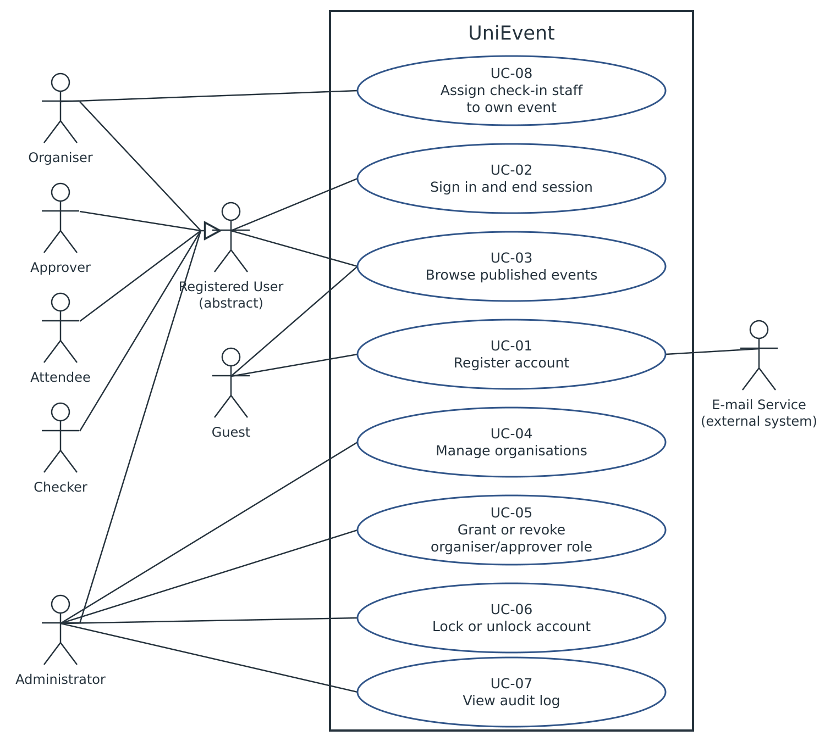
Figure 6.1a – Actors, actor generalisation and F01 use cases
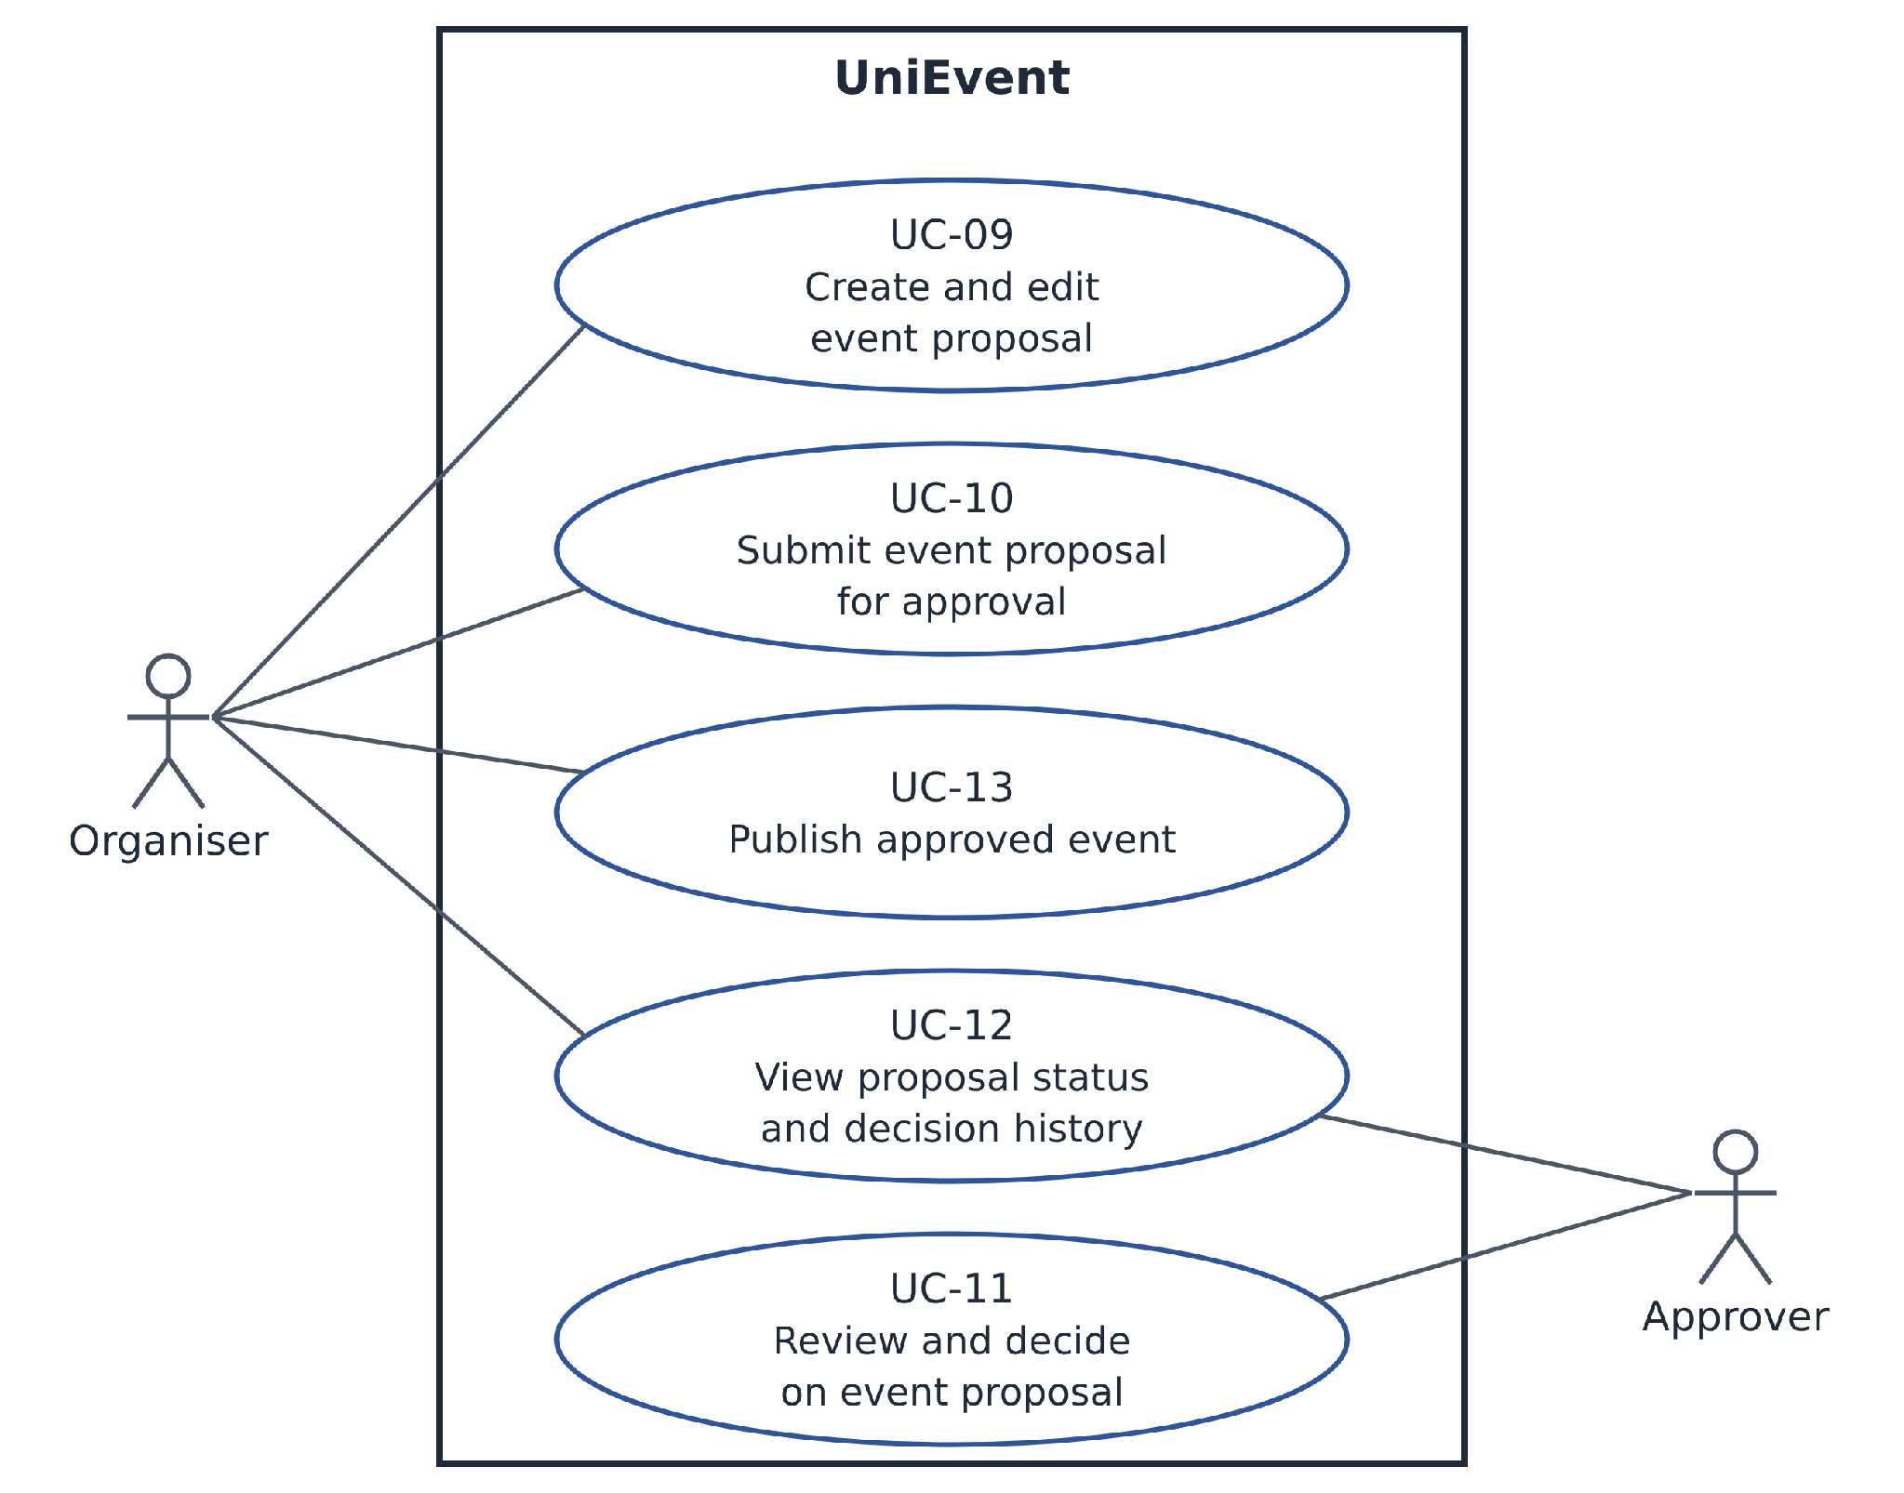
Figure 6.1b – F02 Event creation and submission; F03 Event approval workflow
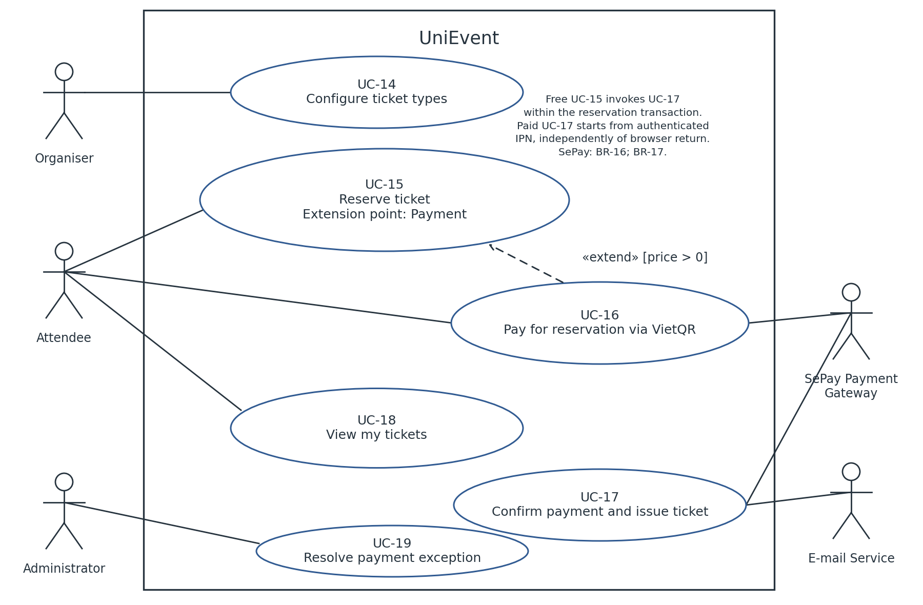
Figure 6.1c – F04–F06 ticketing, reservation and payment
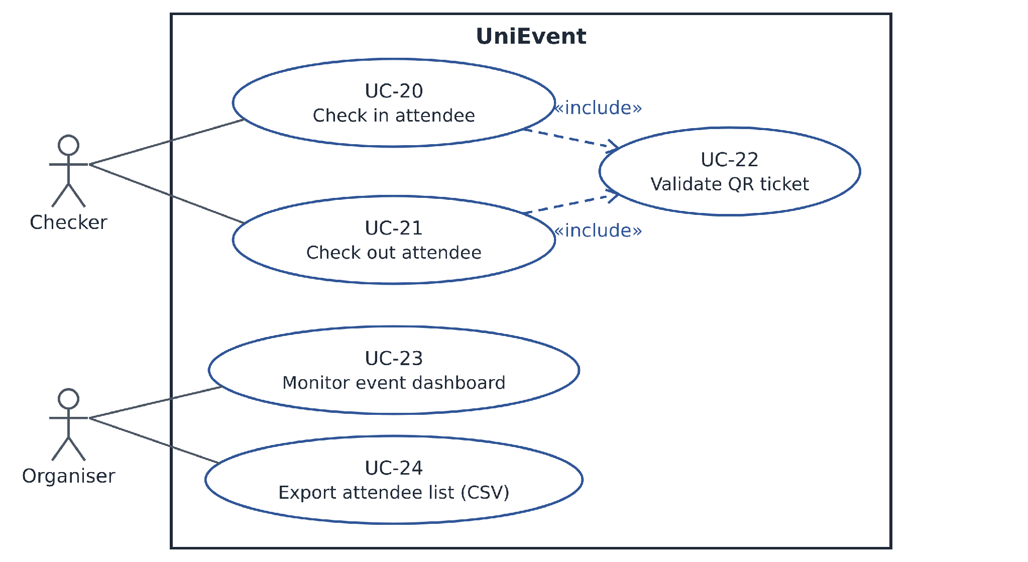
Figure 6.1d – F07 QR check-in/check-out and F08 organiser dashboard
Actor generalisation remains unchanged: Registered User carries shared sign-in/public browsing; scoped roles are independent grants, not inheritance between privileged roles. Authentication is a precondition, not an include use case.
UC-20 and UC-21 include mandatory UC-22, which validates and commits the allowed attendance transition as one atomic operation; the callers only display the result. UC-16 extends UC-15 at Payment when price >0. Free reservation invokes UC-17 within the same order/allocation transaction.
SePay Payment Gateway independently initiates the paid branch of UC-17 through authenticated IPN, whether or not the browser returns. Free fulfilment is an internal UC-15 trigger, not another system actor. The provider is SePay Payment Gateway under BR-16; BR-17; e-mail service is secondary. UC-13 remains a separate Organiser publication step, and UC-12 has scoped Organiser/Approver paths.

6.2 Actors
Table 6.1 – Actors
Actor | Description
Guest | Unauthenticated visitor. Browses published event pages and may register an account (PA1 §2.3, p. 18).
Registered User (abstract) | Modelling construct, not a separate PA1 role. Any account holder; abstract parent of Attendee, Organiser, Checker, Approver and Administrator; carries the behaviour common to every role (sign in, browse published events). One account may hold several roles (PA1 p. 17); multiple roles are a property of the account, not actor inheritance between roles.
Attendee | Student with a verified university e-mail who reserves and pays for tickets, holds QR tickets and views own attendance (PA1 p. 18).
Organiser | Member of a club’s organising committee holding an Organiser grant for one organisation, granted by an Administrator. Creates, submits and revises event proposals, configures ticket types, assigns check-in staff, monitors the dashboard and exports attendees for that organisation only (PA1 p. 18).
Checker | Volunteer assigned by an Organiser to one event. Scans tickets and records check-in and check-out for assigned events only (PA1 p. 18).
Approver | Youth Union or Student Association officer holding an Approver grant for one approving unit, granted by an Administrator. Approves, rejects with a reason or requests changes to proposals routed to that unit only (PA1 p. 18).
Administrator | System operator appointed by the team for PA5. Manages organisations, organiser and approver grants, account status and the audit log, and records the resolution of payment exceptions (PA1 p. 18).
SePay Payment Gateway (external system) | SePay Payment Gateway is the confirmed single F05/F06 provider, supporting BANK_TRANSFER VietQR checkout and authenticated IPN under BR-16; BR-17.
E-mail Service (external system) | Transactional e-mail provider that delivers tickets and notifications (PA1 p. 17).

6.3 Use Case List
Table 6.2 – Use case register
ID | Use case | Primary actor | Priority | Related FR
UC-01 | Register account | Guest | Must | FR-F01-01
UC-02 | Sign in and end session | Registered User | Must | FR-F01-02; FR-F01-03
UC-03 | Browse published events | Guest; Registered User | Must | FR-F01-05; FR-F04-03
UC-04 | Manage organisations | Administrator | Must | FR-F01-06; FR-F01-07; FR-F01-12
UC-05 | Grant or revoke organiser/approver role | Administrator | Must | FR-F01-04; FR-F01-08; FR-F01-12
UC-06 | Lock or unlock account | Administrator | Must | FR-F01-09; FR-F01-12
UC-07 | View audit log | Administrator | Must | FR-F01-11
UC-08 | Assign check-in staff to event | Organiser | Must | FR-F01-04; FR-F01-10; FR-F01-12
UC-09 | Create and edit event proposal | Organiser | Must | FR-F02-01; FR-F02-02; FR-F01-12
UC-10 | Submit event proposal for approval | Organiser | Must | FR-F02-03; FR-F02-04; FR-F01-12
UC-11 | Review and decide on event proposal | Approver | Must | FR-F03-01; FR-F03-02; FR-F03-03; FR-F03-04; FR-F03-05; FR-F01-12
UC-12 | View proposal status and decision history | Organiser; Approver | Must | FR-F02-05; FR-F03-06; FR-F03-07
UC-13 | Publish approved event | Organiser | Must | FR-F02-06
UC-14 | Configure ticket types | Organiser | Must | FR-F04-01; FR-F04-02
UC-15 | Reserve ticket | Attendee | Must | FR-F05-01; FR-F05-02; FR-F05-03; FR-F04-03
UC-16 | Pay for reservation via VietQR | Attendee | Must | FR-F05-04; FR-F05-05
UC-17 | Confirm payment and issue ticket | SePay Payment Gateway (paid branch); none for internal free fulfilment | Must | FR-F06-01; FR-F06-02; FR-F06-03; FR-F06-05; FR-F05-03
UC-18 | View my tickets | Attendee | Must | FR-F06-04
UC-19 | Resolve payment exception | Administrator | Must | FR-F06-05; FR-F06-06; FR-F06-07; FR-F01-12
UC-20 | Check in attendee | Checker | Must | FR-F07-01; FR-F07-02
UC-21 | Check out attendee | Checker | Must | FR-F07-01; FR-F07-03
UC-22 | Validate QR ticket | Included behaviour; no independent primary actor | Must | FR-F07-01; FR-F07-02; FR-F07-03; FR-F07-04
UC-23 | Monitor event dashboard | Organiser | Must | FR-F08-01; FR-F08-02
UC-24 | Export attendee list CSV | Organiser | Must | FR-F08-03; FR-F01-12

Working ownership remains Học: F01/F08; Huy: F02/F03 and shared register; Kiệt: F04/F07 and prototype; Minh: F05/F06 and tests. The team lead confirmed that all four members completed the cross-feature requirements review and accepted the current document baseline on 2 November 2026. Existing UC IDs remain unchanged.

7 Use Case Specifications

7.1 Use Case UC-01
Use case ID | UC-01
Use case name | Register account
Brief description | Register account within the MVP scope.
Primary actor | Guest
Secondary actors | E-mail service
Priority | Must
Related requirements | FR-F01-01
Trigger | The primary actor selects Register account.
Pre-conditions | 1. No verified account exists for the supplied e-mail.  2. Registration is accessible without an authenticated session.
Post-conditions | Success: verified Attendee account. Failure: no activation or elevated grant. Registration/verification is not a shared BR-11 administrative audit event.
Main flow | 1. The Guest enters display name, university e-mail and password.  2. The system validates BR-08 and OD-06, then creates a pending account and a single-use token.  3. The system requests delivery of the verification link.  4. The Guest opens the current link before expiry.  5. The system atomically consumes the valid token, activates Attendee only and offers sign-in.
Alternative flows | A1 (step 3). An allowed resend replaces the old link after the cooldown; remain pending until step 4.
Exception flows | E1 (step 2). Invalid fields/domain: show field errors; do not activate.  E2 (step 3). E-mail failure: retain pending status and offer an allowed retry.  E3 (step 5). Invalid, expired, used or superseded token: refuse activation.  E4 (steps 2 or 5). Persistence failure: commit no partial account activation.
Business rules | BR-08
Non-functional constraints | NFR-02; NFR-03; NFR-06; NFR-07; NFR-09

7.2 Use Case UC-02
Use case ID | UC-02
Use case name | Sign in and end session
Brief description | Sign in and end session within the MVP scope.
Primary actor | Registered User
Secondary actors | None
Priority | Must
Related requirements | FR-F01-02; FR-F01-03
Trigger | The account holder opens Sign in or selects Sign out.
Pre-conditions | 1. An account exists for sign-in.  2. A current authenticated session exists for sign-out.
Post-conditions | Success: authenticated session; after logout/expiry that session is unusable.
Main flow | 1. The holder enters e-mail and password.  2. The system checks throttling, credentials and verified/unlocked account status.  3. The system creates a new protected session with the OD-06 idle/absolute limits.  4. The system displays navigation permitted by current role and scope.
Alternative flows | A1 (step 4). The user selects Sign out; invalidate that session and return to sign-in.  A2 (any protected request). An expired session requires a fresh sign-in; do not replay a prior mutation.  A3 (step 4). No privileged grant exists; show Attendee functions only.
Exception flows | E1 (step 2). Invalid credentials or unverified/locked account: generic failure, no session; throttle repeated failures.  E2 (step 3). Session/database failure: report temporary failure without successful authentication.  E3 (step 4). A protected request exceeds the current scope: deny it.
Business rules | BR-08, BR-09
Non-functional constraints | NFR-02; NFR-03; NFR-06; NFR-07; NFR-09

7.3 Use Case UC-03
Use case ID | UC-03
Use case name | Browse published events
Brief description | Browse published events within the MVP scope.
Primary actor | Guest; Registered User
Secondary actors | None
Priority | Must
Related requirements | FR-F01-05; FR-F04-03
Trigger | The primary actor selects Browse published events.
Pre-conditions | None; an empty catalogue is an alternative outcome.
Post-conditions | Only public Published event data is displayed.
Main flow | 1. The visitor opens the catalogue.  2. The system lists only Published events.  3. The visitor selects an event.  4. The system displays public details, ticket types, price, sales window and current availability.
Alternative flows | A1 (step 2). No Published event exists: show an empty state.  A2 (step 4). Reserve starts UC-15; an unauthenticated visitor first signs in through UC-02.
Exception flows | E1 (steps 2 or 4). Retrieval fails: show Retry without fabricated data.  E2 (step 4). Unknown or unpublished direct URL: expose no private proposal data.
Business rules | Section 4 access matrix; applicable data/security constraints.
Non-functional constraints | NFR-02; NFR-03; NFR-06; NFR-07; NFR-09

7.4 Use Case UC-04
Use case ID | UC-04
Use case name | Manage organisations
Brief description | Manage organisations within the MVP scope.
Primary actor | Administrator
Secondary actors | None
Priority | Must
Related requirements | FR-F01-06; FR-F01-07; FR-F01-12
Trigger | The primary actor selects Manage organisations.
Pre-conditions | 1. The requester is an active Administrator.  2. A target organisation exists for rename/deactivate.
Post-conditions | Success: a valid organisation is created/renamed, or deactivation and its required audit commit together. Failure: no partial change.
Main flow | 1. The Administrator opens the organisation register and selects Create.  2. The Administrator supplies code, name, type and an active designated approving unit for a Club.  3. The system validates uniqueness and BR-10.  4. The Administrator confirms; the system stores the organisation and displays its state.
Alternative flows | A1 (step 1). Rename: change only the name; preserve code, type, routing and history.  A2 (step 1). Deactivate: check all BR-10 dependencies, confirm, then commit inactive status and BR-11 audit atomically. Attendees retain access to their own issued tickets.  A3 (before commit). Cancel: leave the register unchanged.
Exception flows | E1 (step 3 or A2). Invalid/duplicate fields, inactive unit or a blocking dependency: refuse with a reason.  E2 (step 4 or A2). A database or required audit write fails: no partial mutation commits.  E3 (any request). Missing Administrator authority: deny the action.
Business rules | BR-10, BR-11
Non-functional constraints | NFR-02; NFR-03; NFR-06; NFR-07; NFR-09

7.5 Use Case UC-05
Use case ID | UC-05
Use case name | Grant or revoke organiser/approver role
Brief description | Grant or revoke organiser/approver role within the MVP scope.
Primary actor | Administrator
Secondary actors | None
Priority | Must
Related requirements | FR-F01-04; FR-F01-08; FR-F01-12
Trigger | The primary actor selects Grant or revoke organiser/approver role.
Pre-conditions | 1. The requester is an active Administrator.  2. The target account and scope exist; a new grant requires a verified, unlocked target and active scope.
Post-conditions | Only the selected grant changes; unrelated grants remain.
Main flow | 1. The Administrator selects the target account, Organiser or Approver role, and corresponding organisation/unit.  2. The system validates target eligibility, scope and duplicate grants.  3. The Administrator confirms the selected grant.  4. The system commits the grant and BR-11 audit together, preserving unrelated grants.
Alternative flows | A1 (step 1). Revoke an existing Organiser/Approver grant; after confirmation commit revocation and audit. The next protected request in that scope is denied.  A2 (step 2). An identical active grant exists: return it without duplication.  A3 (step 3). Cancel: make no change.
Exception flows | E1 (step 2). Invalid target/scope or missing authority: refuse.  E2 (step 4 or A1). Mutation/audit failure: commit neither.  E3 (A1). Grant already revoked: return its current state without reactivation.
Business rules | BR-09, BR-11
Non-functional constraints | NFR-02; NFR-03; NFR-06; NFR-07; NFR-09

7.6 Use Case UC-06
Use case ID | UC-06
Use case name | Lock or unlock account
Brief description | Lock or unlock account within the MVP scope.
Primary actor | Administrator
Secondary actors | None
Priority | Must
Related requirements | FR-F01-09; FR-F01-12
Trigger | The primary actor selects Lock or unlock account.
Pre-conditions | 1. The requester is an active Administrator.  2. The target account exists and has no Administrator role.
Post-conditions | Locked-account sessions are invalid; unlock requires a new sign-in.
Main flow | 1. The Administrator selects a non-Administrator account and Lock.  2. The system checks current authority and target eligibility.  3. The Administrator confirms.  4. The system commits account lock, session invalidation and BR-11 audit consistently.  5. The system shows Locked; subsequent authenticated access is denied.
Alternative flows | A1 (step 1). Unlock: confirm and atomically record unlocked status and audit; old sessions remain invalid and a fresh sign-in is required.  A2 (step 2). The requested state already exists: return it without another transition.  A3 (step 3). Cancel: make no change.
Exception flows | E1 (step 2). Target has an Administrator role, including the caller: refuse under FR-F01-09.  E2 (step 4 or A1). Persistence/session/audit failure: do not report success or leave a partial administrative change.
Business rules | BR-11
Non-functional constraints | NFR-02; NFR-03; NFR-06; NFR-07; NFR-09

7.7 Use Case UC-07
Use case ID | UC-07
Use case name | View audit log
Brief description | View audit log within the MVP scope.
Primary actor | Administrator
Secondary actors | None
Priority | Must
Related requirements | FR-F01-11
Trigger | The primary actor selects View audit log.
Pre-conditions | The requester is an active Administrator.
Post-conditions | Read-only entries are displayed; no business data is changed.
Main flow | 1. The Administrator opens Audit log.  2. The system verifies Administrator access.  3. The system displays BR-11 entries newest first with basic pagination.  4. The Administrator may move to the next page.
Alternative flows | A1 (step 3). No entries: show an empty state.  A2 (step 4). No further entries: show the end of results.
Exception flows | E1 (step 2). Unauthorised access: deny without exposing log contents.  E2 (steps 3 or 4). Read failure: show Retry rather than an empty successful result.  E3 (any step). Edit/delete attempt: reject; audit entries remain unchanged.
Business rules | BR-11
Non-functional constraints | NFR-02; NFR-03; NFR-06; NFR-07; NFR-09

7.8 Use Case UC-08
Use case ID | UC-08
Use case name | Assign check-in staff to event
Brief description | Assign check-in staff to event within the MVP scope.
Primary actor | Organiser
Secondary actors | None
Priority | Must
Related requirements | FR-F01-04; FR-F01-10; FR-F01-12
Trigger | The primary actor selects Assign check-in staff to event.
Pre-conditions | 1. The requester is an active Organiser of the event organisation.  2. The event exists; assigning requires a verified, unlocked target account.
Post-conditions | The selected event-scoped Checker assignment is stored/removed and audited.
Main flow | 1. The Organiser opens the event staff list.  2. The Organiser selects an account to assign as Checker.  3. The system checks own-event scope, target status and duplicate assignment.  4. The Organiser confirms; the system commits the event-scoped assignment and audit together.  5. The system displays the current staff list.
Alternative flows | A1 (step 2). Remove an existing assignment; confirm and commit removal with audit. The next scan for that assignment is denied; other event grants remain usable.  A2 (step 3). Identical active assignment exists: show it without duplication.  A3 (before step 4). Cancel: make no change.
Exception flows | E1 (step 3). Other-organisation event, unverified/locked target or missing authority: refuse.  E2 (step 4 or A1). Persistence/audit failure: commit no partial change.
Business rules | BR-09, BR-11
Non-functional constraints | NFR-02; NFR-03; NFR-06; NFR-07; NFR-09

7.9 Use Case UC-09
Use case ID | UC-09
Use case name | Create and edit event proposal
Brief description | Create and edit event proposal within the MVP scope.
Primary actor | Organiser
Secondary actors | None
Priority | Must
Related requirements | FR-F02-01; FR-F02-02; FR-F01-12
Trigger | The primary actor selects Create and edit event proposal.
Pre-conditions | 1. The requester is an active Organiser for the selected organisation.  2. Editing requires an own-organisation Draft or Changes Requested proposal.
Post-conditions | Valid Draft/revision is stored; its organisation is unchanged.  Failure: no proposal is created, and the stored values of an existing proposal are unchanged.
Main flow | 1. The Organiser opens a new proposal and selects its organising organisation.  2. The Organiser enters all BR-07 fields and attaches the required poster.  3. The system validates the fields and organisation scope; revised event fields must also preserve BR-12 constraints for existing ticket types.  4. The Organiser saves; the system stores a complete Draft with creator/time and the BR-11 creation audit atomically.  5. The system displays the saved status.
Alternative flows | A1 (step 1). Edit an existing Draft/Changes Requested proposal: load its fields and any requested changes, then follow steps 2-5. Preserve its organisation, status and creation metadata; ordinary edits need no additional audit event.  A2 (step 5). Submit/Resubmit starts UC-10.  A3 (before commit). Cancel: discard unsaved changes.
Exception flows | E1 (step 3). Missing/invalid field or poster: show errors and store no incomplete Draft.  E2 (step 4). Proposal is no longer editable: refuse and display its current status.  E3 (any protected request). Locked/revoked/out-of-scope access: deny.  E4 (step 4). Storage or required audit failure: preserve the previous saved state; report failure.
Business rules | BR-05; BR-07; BR-11
Non-functional constraints | NFR-02; NFR-03; NFR-06; NFR-07; NFR-09

7.10 Use Case UC-10
Use case ID | UC-10
Use case name | Submit event proposal for approval
Brief description | Submit event proposal for approval within the MVP scope.
Primary actor | Organiser
Secondary actors | None
Priority | Must
Related requirements | FR-F02-03; FR-F02-04; FR-F01-12
Trigger | The primary actor selects Submit event proposal for approval.
Pre-conditions | 1. The requester is an active Organiser of the proposal organisation.  2. The proposal is Draft or Changes Requested.
Post-conditions | One new submission exists in the designated queue; old decisions remain.  Failure: status, content and submission records are unchanged.
Main flow | 1. The Organiser opens the proposal and selects Submit/Resubmit.  2. The system validates BR-07, current editable status and the fixed active designated approving unit.  3. The system names that unit and asks the Organiser to confirm.  4. The system atomically sets Submitted, records the next submission number, submitting account/time and BR-11 audit.  5. The system shows Submitted and lists the proposal once in the unit queue.
Alternative flows | A1 (step 4). First submission uses number 1; resubmission increments the number and preserves previous decisions. No optional revision note or changed-field comparison is required.  A2 (step 3). Cancel: leave the proposal unchanged.
Exception flows | E1 (step 2). Invalid fields, inactive/missing route or forbidden scope: refuse with a reason.  E2 (step 4). Duplicate or stale submission, or an ineligible current state: return current state without another submission.  E3 (step 4). Database/audit failure: commit neither status, submission nor audit.
Business rules | BR-01; BR-04; BR-05; BR-07; BR-11
Non-functional constraints | NFR-02; NFR-03; NFR-06; NFR-07; NFR-09

7.11 Use Case UC-11
Use case ID | UC-11
Use case name | Review and decide on event proposal
Brief description | Review and decide on event proposal within the MVP scope.
Primary actor | Approver
Secondary actors | None
Priority | Must
Related requirements | FR-F03-01; FR-F03-02; FR-F03-03; FR-F03-04; FR-F03-05; FR-F01-12
Trigger | The primary actor selects Review and decide on event proposal.
Pre-conditions | 1. The requester is an active Approver for the routed unit.  2. Deciding requires a Submitted proposal and no Organiser grant for its proposing organisation.
Post-conditions | Success: one decision, the corresponding state and BR-11 audit commit together. No decision/cancel/failure: no new committed decision and no partial state change.
Main flow | 1. The Approver opens the unit Submitted queue.  2. The system lists event title, organising organisation and submission time within authorised units.  3. The Approver opens a proposal; the system shows submitted details, poster, prior decisions and any configured ticket types.  4. The Approver selects Approve and confirms.  5. The system checks BR-02 and the current submission, then atomically records Approved, decision history and BR-11 audit.  6. The system shows the result and removes the proposal from the pending queue. Publication remains UC-13.
Alternative flows | A1 (step 4). Reject: require a non-empty reason; confirm and store Rejected at step 5.  A2 (step 4). Request Changes: require a non-empty description; confirm and store Changes Requested at step 5. Revision/resubmission follows UC-09/10.  A3 (step 2). Empty queue: display an empty state.  A4 (before step 5). Leave/cancel: retain Submitted with no decision.
Exception flows | E1 (step 4). Blank required reason/description: show validation; no decision.  E2 (step 5). Already-decided or concurrent submission: preserve the first decision and show current state.  E3 (any protected request). Wrong scope, locked/revoked authority or BR-02 self-decision: deny.  E4 (step 5). Database/audit failure: commit no partial decision or state.
Business rules | BR-01; BR-02; BR-03; BR-04; BR-05; BR-06; BR-11
Non-functional constraints | NFR-02; NFR-03; NFR-06; NFR-07; NFR-09; OD-11 governs course-data retention.

7.12 Use Case UC-12
Use case ID | UC-12
Use case name | View proposal status and decision history
Brief description | View proposal status and decision history within the MVP scope.
Primary actor | Organiser; Approver
Secondary actors | None
Priority | Must
Related requirements | FR-F02-05; FR-F03-06; FR-F03-07
Trigger | The primary actor selects View proposal status and decision history.
Pre-conditions | The requester is an active Organiser of the proposal organisation or an Approver of its routed unit.
Post-conditions | Authorised status/history is shown without mutation.
Main flow | 1. The Organiser opens My proposals, or the Approver opens unit decision history.  2. The system applies the applicable organisation/unit scope and lists proposal statuses.  3. The user selects a proposal.  4. The system displays its status and decisions by submission number, with decision type, unit, time and required reason/description; the deciding account is retained internally.
Alternative flows | A1 (step 2, Approver path). Search by event title within authorised units.  A2 (step 2). No match: show an empty result.  A3 (step 4). No decision exists: display the current proposal status without invented history.  A4 (step 4, Organiser path). Changes Requested permits editing through UC-09.
Exception flows | E1 (any protected request). Other-scope or invalid authority: deny without private data.  E2 (steps 2 or 4). Retrieval failure: show unavailable/Retry; do not alter records.
Business rules | BR-06; Section 4 access matrix.
Non-functional constraints | NFR-02; NFR-03; NFR-06; NFR-07; NFR-09

7.13 Use Case UC-13
Use case ID | UC-13
Use case name | Publish approved event
Brief description | Publish approved event within the MVP scope.
Primary actor | Organiser
Secondary actors | None
Priority | Must
Related requirements | FR-F02-06
Trigger | The primary actor selects Publish approved event.
Pre-conditions | 1. The requester is an active Organiser of the event organisation.  2. The event is Approved and has valid ticket types.
Post-conditions | Event is published and visible publicly; decision history is preserved.
Main flow | 1. The Organiser opens the Approved event and selects Publish.  2. The system verifies scope, current Approved state and valid BR-12 ticket configuration.  3. The system atomically sets Published.  4. The system exposes the public event page and displays its link.
Alternative flows | A1 (step 2). Already Published: show the existing publication state without another transition.
Exception flows | E1 (step 2). Unapproved event, forbidden scope or missing/invalid ticket types: refuse; retain current state.  E2 (step 3). Concurrent state change or database failure: do not report a new successful publication.
Business rules | BR-05, BR-12
Non-functional constraints | NFR-02; NFR-03; NFR-06; NFR-07; NFR-09

7.14 Use Case UC-14
Use case ID | UC-14
Use case name | Configure ticket types
Brief description | Configure ticket types within the MVP scope.
Primary actor | Organiser
Secondary actors | None
Priority | Must
Related requirements | FR-F04-01; FR-F04-02
Trigger | The primary actor selects Configure ticket types.
Pre-conditions | Active Organiser for the event; configuration is not locked under BR-12.
Post-conditions | Success: valid types are stored without changing prior order price snapshots. A rejected or failed save leaves the stored configuration unchanged.
Main flow | 1. The Organiser opens the event ticket configuration.  2. Select Add or Edit while server time is before the event earliest configured sales_start; the first type requires a future sales_start.  3. Enter name, VND price, quantity, sales window and per-account limit, then select Save.  4. The system rechecks the current event lock and validates BR-12, including a future earliest proposed sales_start.  5. The system commits the valid configuration without changing existing order price snapshots and displays the saved values.
Alternative flows | A1 (step 3). Price 0 configures free registration.  A2 (steps 2-4). Multiple simple types are allowed within event capacity.
Exception flows | E1 (steps 3-4). Invalid fields/capacity or a non-future proposed sales start: show field errors and store no change.  E2 (steps 2 or 4). At/after the event earliest configured sales_start, refuse both Add and Edit, including a type whose own sales have not started.  E3 (step 5). A database failure or conflicting configuration change prevents the commit: preserve the prior configuration and report failure/reload guidance.
Business rules | BR-12
Non-functional constraints | NFR-02; NFR-03; NFR-06; NFR-07; NFR-09

7.15 Use Case UC-15
Use case ID | UC-15
Use case name | Reserve ticket
Brief description | Reserve ticket within the MVP scope.
Primary actor | Attendee
Secondary actors | None
Priority | Must
Related requirements | FR-F05-01; FR-F05-02; FR-F05-03; FR-F04-03
Trigger | The primary actor selects Reserve ticket.
Pre-conditions | Verified unlocked Attendee; Published event in active organisation.
Post-conditions | Success: one paid hold/order, or one atomically committed free order and ticket. Rejection or pre-commit failure leaves no partial reservation. If a response is lost, the client treats the outcome as unknown and queries/retries the same request reference.
Main flow | 1. The Attendee selects one ticket type; quantity is fixed at 1.  2. The system checks sales window, current stock, scope and account allowance.  3. For price >0, atomically allocate one unit and store a stable order with its fixed price and original 15-minute server deadline. For price 0, invoke UC-17 free fulfilment within the same transaction that stores the order and allocates/converts capacity; commit all or none.  4. At extension point Payment, invoke UC-16 only for the paid order. For a committed free order, show its issued ticket.
Alternative flows | A1 (step 3). Retry the same request reference: return the existing order.A2 (after step 3). An unpaid hold expires once at the server deadline unless an eligible payment confirmation committed earlier; a race cannot double-release capacity.
Exception flows | E1 (steps 1-3). Sold out, limit reached, invalid quantity/window or persistence failure: refuse without partial allocation.  E2 (after step 3). Resolve a lost response using the original request reference; do not infer rollback from a network error.  E3 (step 3, free branch). Issuance failure before commit rolls back the free order and allocation; retry checks current availability. There is no persistent free hold to expire.
Business rules | BR-12, BR-13, BR-14, BR-15, BR-16, BR-18
Non-functional constraints | NFR-02; NFR-03; NFR-06; NFR-07; NFR-09; NFR-04; NFR-08

7.16 Use Case UC-16
Use case ID | UC-16
Use case name | Pay for reservation via VietQR
Brief description | Initiate an existing paid reservation through the selected SePay Payment Gateway VietQR checkout, without interpreting browser navigation as proof of payment.
Primary actor | Attendee
Secondary actors | SePay Payment Gateway (one-time VietQR)
Priority | Must
Related requirements | FR-F05-04; FR-F05-05
Trigger | The primary actor selects Pay for reservation via VietQR.
Pre-conditions | Attendee owns an unexpired payable order with a fixed VND amount and unique invoice; SePay Payment Gateway is the selected provider under BR-16; BR-17.
Post-conditions | Invoice and deadline are unchanged. Only unpaid, unexpired orders remain payable; display the current server state. Payment requires an authenticated, successful, matched IPN under BR-17; eligible fulfilment follows UC-17.
Main flow | 1. Prepare a server-signed one-time SePay BANK_TRANSFER checkout for the stored invoice and exact VND amount without creating another order.  2. Show the payment instructions and original reservation deadline; SePay checkout availability does not extend that deadline.  3. The Attendee initiates payment in the bank/SePay checkout interface.  4. On return or refresh, the system shows the server-confirmed order/ticket state, never treating a success/cancel URL as proof of settlement.
Alternative flows | A1 (steps 3-4). Authenticated SePay ORDER_PAID IPN triggers UC-17 independently of the browser return.  A2 (step 1). A repeat attempt retains the original invoice and checks the server/provider state; it does not assume a stable reusable URL or create another payable invoice.
Exception flows | E1 (steps 1-3). An uncertain checkout result remains pending against the existing invoice and is reconciled before another attempt; no duplicate payable invoice is generated.  E2 (step 1). Expired, fulfilled or other-owner order: deny new checkout; later received funds, if any, follow UC-17/19 exception review.
Business rules | BR-13, BR-16, BR-17
Non-functional constraints | NFR-02; NFR-03; NFR-06; NFR-07; NFR-09; NFR-04; NFR-08

7.17 Use Case UC-17
Use case ID | UC-17
Use case name | Confirm payment and issue ticket
Brief description | Confirm payment and issue ticket within the MVP scope.
Primary actor | SePay Payment Gateway (paid branch); none for internal free fulfilment
Secondary actors | E-mail service
Priority | Must
Related requirements | FR-F06-01; FR-F06-02; FR-F06-03; FR-F06-05; FR-F05-03
Trigger | An incoming SePay IPN or accepted free order starts fulfilment; IPN authenticity and all paid-success fields are checked before any paid entitlement.
Pre-conditions | For free fulfilment, a valid reservation request is being processed in the same order/allocation transaction. For IPN, authenticity and order matching are evaluated in the flow; an invalid or unmatched message may be received.
Post-conditions | Paid branch: an authenticated received-money record is retained once when applicable; only an eligible matched confirmation grants entitlement, and anomalies remain visible. Free branch: order, allocation conversion and one ticket commit together or none do. Either branch issues at most one ticket; unauthenticated messages grant no entitlement.
Main flow | 1. For paid IPN, authenticate independently of checkout HMAC; verify ORDER_PAID, CAPTURED, APPROVED, PAYMENT, BANK_TRANSFER, invoice, VND and both exact amounts against the stored order.  2. Persist the unique authenticated provider transaction and apply order success once; compare first server confirmation with expiry atomically under BR-13; BR-20.  3. For an eligible timely paid confirmation, issue one signed ticket and convert the retained allocation atomically. For a free request, commit the order, allocation/conversion and ticket in the single UC-15 transaction.  4. After commit, initiate e-mail delivery of the existing ticket; delivery retry never reissues it.
Alternative flows | A1 (steps 1-3). Repeated IPN uses the existing receipt/ticket; a distinct extra received payment becomes an exception, not another ticket.  A2 (step 1). Free fulfilment skips steps 1-2 and performs step 3 in the UC-15 transaction, without a payment receipt.
Exception flows | E1 (steps 1-2). Unauthenticated/non-success messages grant no entitlement; authenticated unmatched, mismatched or extra received-money events retain review evidence.  E2 (step 2). First matched confirmation at/after expiry becomes a late-payment exception, even if provider transaction time is earlier; no new allocation/ticket.  E3 (step 3). Paid issuance failure retains its confirmed receipt/allocation and opens an exception. Free issuance failure rolls back order, ticket and allocation; retry uses the original request reference.  E4 (step 4). Mail failure preserves the ticket in My tickets; an active Administrator may retry the same delivery through existing server/mail operations tools. No dedicated resend screen is required.
Business rules | BR-13, BR-14, BR-16, BR-17, BR-18, BR-19, BR-20
Non-functional constraints | NFR-02; NFR-03; NFR-06; NFR-07; NFR-09; NFR-04; NFR-08

7.18 Use Case UC-18
Use case ID | UC-18
Use case name | View my tickets
Brief description | View my tickets within the MVP scope.
Primary actor | Attendee
Secondary actors | None
Priority | Must
Related requirements | FR-F06-04
Trigger | The primary actor selects View my tickets.
Pre-conditions | Signed-in verified unlocked Attendee.
Post-conditions | Only the requester own issued tickets and QR are displayed.
Main flow | 1. Open My tickets.  2. Load owned issued tickets.  3. Select one ticket.  4. Recheck ownership and show event, type, status and signed QR.
Alternative flows | A1 (step 2). No issued tickets: show empty; pending orders remain distinct from tickets.
Exception flows | E1 (step 4). Another-owner URL: deny without QR disclosure.  E2 (steps 2 or 4). Read/network failure: show Retry without fabricating a ticket.
Business rules | Section 4 access matrix; applicable data/security constraints.
Non-functional constraints | NFR-02; NFR-03; NFR-06; NFR-07; NFR-09

7.19 Use Case UC-19
Use case ID | UC-19
Use case name | Resolve payment exception
Brief description | Resolve payment exception within the MVP scope.
Primary actor | Administrator
Secondary actors | None
Priority | Must
Related requirements | FR-F06-05; FR-F06-06; FR-F06-07; FR-F01-12
Trigger | The primary actor selects Resolve payment exception.
Pre-conditions | Signed-in active Administrator; exception exists.
Post-conditions | A safe, evidenced exception outcome is stored once without an in-app transfer, duplicate refund recognition or an implicit ticket cancellation.
Main flow | 1. An active Administrator inspects the exception, authenticated receipt/provider evidence and any linked order, allocation and ticket. An unmatched receipt need not have an order.  2. Choose eligible issuance retry or recording of one completed external full refund under BR-19.  3. For issuance retry, verify timely matched entitlement, retained allocation and no recognised refund; issue or reuse the single ticket under UC-17 and consistently record the exception outcome and audit. A failed retry keeps the exception open and the confirmed allocation retained.  4. For refund closure, record receipt, amount, completion time, unique transfer reference/proof, reason and payer-notification evidence. Verify the amount equals the entire receipt, no earlier refund is recognised and no issued ticket is linked; recheck proof uniqueness and the exception version.  5. Atomically commit the permitted refund resolution, any existing unissued allocation release and audit. Unmatched or expired cases with no allocation release nothing.
Alternative flows | A1 (step 3). Retry after prior successful issuance returns the same ticket without another entitlement or allocation effect.  A2 (steps 2 or 4). The account holder completes a transfer outside UniEvent. Partial/multiple returns or refunds of already-issued tickets retain evidence for separate manual policy review and do not close automatically.
Exception flows | E1 (steps 2-5). Missing provider/refund evidence, duplicate proof, over-refund, unapproved partial flow, already-issued-ticket refund or stale resolution: do not close automatically; keep received-money history for review.  E2 (steps 3 or 5). Database or required audit failure: no partial resolution, allocation or financial change commits; retain the prior confirmed entitlement and report failure.
Business rules | BR-11, BR-19
Non-functional constraints | NFR-02; NFR-03; NFR-06; NFR-07; NFR-09; NFR-04; NFR-08

7.20 Use Case UC-20
Use case ID | UC-20
Use case name | Check in attendee
Brief description | Check in attendee within the MVP scope.
Primary actor | Checker
Secondary actors | None
Priority | Must
Related requirements | FR-F07-01; FR-F07-02
Trigger | The primary actor selects Check in attendee.
Pre-conditions | Current event-scoped Checker; camera and network available.
Post-conditions | Confirmed success: one check-in is recorded. Confirmed rejection or failed transaction: attendance is unchanged. A lost response has an unknown client outcome; retrieve current server state without assuming rollback.
Main flow | 1. The Checker selects the assigned event and Check-in mode.  2. Read a QR with the phone camera.  3. Invoke UC-22, which validates and commits at most one allowed attendance transition atomically.  4. Display the returned result and recorded time; do not perform another commit.
Alternative flows | A1 (step 3). A consumed check-in or attempted re-entry shows used.
Exception flows | E1 (step 3). Bad signature, unknown ticket or wrong event: invalid.  E2 (steps 3-4). Concurrent duplicate or network failure: no second success; refresh/retry current server state.
Business rules | BR-21
Non-functional constraints | NFR-01; NFR-02; NFR-06; NFR-07; NFR-08; NFR-09

7.21 Use Case UC-21
Use case ID | UC-21
Use case name | Check out attendee
Brief description | Check out attendee within the MVP scope.
Primary actor | Checker
Secondary actors | None
Priority | Must
Related requirements | FR-F07-01; FR-F07-03
Trigger | The primary actor selects Check out attendee.
Pre-conditions | Current event-scoped Checker; camera and network available.
Post-conditions | Confirmed success: one check-out is recorded after check-in. Confirmed rejection or failed transaction: attendance is unchanged. A lost response has an unknown client outcome; retrieve current server state without assuming rollback.
Main flow | 1. The Checker selects the assigned event and Check-out mode.  2. Read a QR with the phone camera.  3. Invoke UC-22, which validates and commits at most one allowed attendance transition atomically.  4. Display the returned result and recorded time; do not perform another commit.
Alternative flows | A1 (step 3). An already-consumed check-out shows used.
Exception flows | E1 (step 3). Checkout before check-in, bad QR or wrong event: invalid.  E2 (steps 3-4). Concurrent duplicate/network failure: no duplicate transition or invented success.
Business rules | BR-21
Non-functional constraints | NFR-01; NFR-02; NFR-06; NFR-07; NFR-08; NFR-09

7.22 Use Case UC-22
Use case ID | UC-22
Use case name | Validate QR ticket
Brief description | Validate QR ticket within the MVP scope.
Primary actor | Included behaviour; no independent primary actor
Secondary actors | None
Priority | Must
Related requirements | FR-F07-01; FR-F07-02; FR-F07-03; FR-F07-04
Trigger | UC-20 or UC-21 submits a decoded QR for the selected event and operation.
Pre-conditions | Invoked by UC-20 or UC-21 with event, operation and QR.
Post-conditions | Validation and any requested attendance transition share one atomic outcome.
Main flow | 1. Check current Checker assignment and the selected event.  2. Verify the token signature and resolve the issued ticket.  3. Check the ticket event and requested operation/state under BR-21.  4. In this same atomic operation, commit one allowed transition and return valid with its recorded time; otherwise return used/invalid without mutation. UC-20/21 only display this result.
Alternative flows | A1 (steps 3-4). For a previously consumed operation, return used without changing records.
Exception flows | E1 (steps 1-3). Unauthorised event, invalid token or ineligible state: refuse mutation.  E2 (step 4). If the client cannot confirm the response, show a technical error and reconcile current server state; do not report valid or assume the transaction rolled back.
Business rules | BR-21
Non-functional constraints | NFR-01; NFR-02; NFR-06; NFR-07; NFR-08; NFR-09

7.23 Use Case UC-23
Use case ID | UC-23
Use case name | Monitor event dashboard
Brief description | Monitor event dashboard within the MVP scope.
Primary actor | Organiser
Secondary actors | None
Priority | Must
Related requirements | FR-F08-01; FR-F08-02
Trigger | The primary actor selects Monitor event dashboard.
Pre-conditions | The requester is an active Organiser for the selected active organisation/event.
Post-conditions | Authorised current/last-known metrics are displayed; no business records change.
Main flow | 1. The Organiser opens the event dashboard.  2. The system checks scope and reads one consistent server snapshot.  3. The system displays the three BR-22 metrics and snapshot time.  4. While connected, committed ticket/payment/check-in updates refresh within NFR-05.
Alternative flows | A1 (step 3). No tickets/receipts: show 0, 0 VND and 0.0%.  A2 (step 4). After a failed refresh, preserve last-known values and timestamp; successful Retry replaces them with a current snapshot.  A3 (step 3). Export starts UC-24 using its own snapshot.
Exception flows | E1 (step 2). Wrong scope or inactive organisation: deny.  E2 (steps 2-3). Initial read/aggregation failure: show unavailable/Retry, not fabricated zero or mixed snapshots.  E3 (step 4). Refresh failure: show last-known data and Retry; no separate outage/reconnect deadline is promised.
Business rules | BR-22
Non-functional constraints | NFR-02; NFR-03; NFR-06; NFR-07; NFR-09; NFR-05

7.24 Use Case UC-24
Use case ID | UC-24
Use case name | Export attendee list CSV
Brief description | Export attendee list CSV within the MVP scope.
Primary actor | Organiser
Secondary actors | None
Priority | Must
Related requirements | FR-F08-03; FR-F01-12
Trigger | The primary actor selects Export attendee list CSV.
Pre-conditions | The requester is an active Organiser for the selected active organisation/event.
Post-conditions | One complete authorised CSV release is audited; failed release exposes no file.
Main flow | 1. The Organiser selects Export attendees.  2. The system checks scope and reads one issued-ticket snapshot.  3. The system builds the fixed OD-09 CSV with one row per issued ticket, safe quoting and formula-neutralised text.  4. The system verifies release permission and records the BR-11 export audit before making the complete file available.
Alternative flows | A1 (step 3). No issued tickets: create a header-only CSV after the same checks.  A2 (step 2). A later export may use newer data than the displayed dashboard.  A3 (after step 4). Interrupted download may be retried as a newly authorised/audited export.
Exception flows | E1 (steps 2 or 4). Forbidden scope or invalid authority: release no file.  E2 (steps 2-4). Generation/audit failure: release no partial file and show Retry.  E3 (after step 4). Server release does not prove browser receipt; do not claim delivery completion.
Business rules | BR-11, BR-22
Non-functional constraints | NFR-02; NFR-03; NFR-06; NFR-07; NFR-09

8 Prototype / Mockups
This section uses six screenshots from the existing demo to illustrate the main MVP flow: event creation and approval, SePay checkout and ticket issuance, check-in and reporting (Figures 8.1-8.6). The screenshots are design discussion aids; they do not add functional requirements or prescribe the final visual design. The SC keys in the tables below support FR/UC traceability and may be combined into shared pages or states; they do not require 22 separate application pages. The existing interactive demo is optional supporting material, publicly viewable using the link below. All demo data and payment outcomes are simulated; no real account, e-mail, payment or bank request is created. Internal requirements/mockup review is complete as confirmed by the team lead; remaining keyboard/mobile checks and implementation tests retain their planned status. A screen mapping may identify the direct action, its displayed result or a place to inspect evidence; it is not a one-to-one mapping between a use case and a page. The illustrative screenshots omit some required detail: the final screens must show the exact server expiry on SC-F05-02, ticket type on SC-F06-01 and recorded scan time on SC-F07-01, as specified in Section 5.
Optional interactive demo: https://unievent-pa2-prototype.solecone.chatgpt.site/#index
Short walkthrough: create event → review/approve → SePay checkout → issued ticket → check-in → dashboard. Use the screenshots for document review and the existing demo only when an interaction needs clarification.
Table 8.1 – Logical screen keys for F01-F08 traceability (not a required page count)
Screen | Related use case(s) | Mockup / link
SC-F01-01 Registration and verification | UC-01 | Open SC-F01-01
SC-F01-02 Sign in and session | UC-02 | Open SC-F01-02
SC-F01-03 Public catalogue and event detail | UC-03; UC-15 | Open SC-F01-03
SC-F01-04 Role administration | UC-05 | Open SC-F01-04
SC-F01-05 Organisation register | UC-04 | Open SC-F01-05
SC-F01-06 Account administration | UC-06 | Open SC-F01-06
SC-F01-07 Event staff | UC-08 | Open SC-F01-07
SC-F01-08 Audit list | UC-07 | Open SC-F01-08
SC-F02-01 Proposal editor | UC-09 | Open SC-F02-01
SC-F02-02 Submit or resubmit | UC-10 | Open SC-F02-02
SC-F02-03 My proposals and decision history | UC-12 | Open SC-F02-03
SC-F02-04 Publication confirmation | UC-13 | Open SC-F02-04
SC-F03-01 Approver queue | UC-11 | Open SC-F03-01
SC-F03-02 Proposal review | UC-11 | Open SC-F03-02
SC-F03-03 Approver history | UC-12 | Open SC-F03-03
SC-F04-01 Ticket configuration | UC-14 | Open SC-F04-01
SC-F05-01 One-ticket reservation | UC-15 | Open SC-F05-01
SC-F05-02 VietQR payment and status | UC-16; UC-17 | Open SC-F05-02
SC-F06-01 My tickets and detail | UC-18 | Open SC-F06-01
SC-F06-02 Payment exceptions | UC-19 | Open SC-F06-02
SC-F07-01 Mobile scanner | UC-20; UC-21; UC-22 | Open SC-F07-01
SC-F08-01 Dashboard and CSV | UC-23; UC-24 | Open SC-F08-01
Table 8.2 – Screen content, states and navigation for F02–F03 (input to the prototype)
Screen key | Content and actions | States to mock (empty, validation, error) | Navigation
SC-F02-01 | Complete required fields, poster upload, editable/locked state and field errors. | Shared loading/empty/validation/error states. | Organiser: My proposals -> editor -> save Draft -> submit/status.
SC-F02-02 | Current submission number, routing, validation and duplicate-submit feedback. | Shared loading/empty/validation/error states. | Organiser: Draft/Changes Requested -> submit/resubmit -> proposal status.
SC-F02-03 | Scoped list/status and append-only decisions by submission. | Shared loading/empty/validation/error states. | Organiser: My proposals -> status/history; Changes Requested -> editor.
SC-F02-04 | Approved event, valid ticket configuration and Publish action. | Shared loading/empty/validation/error states. | Organiser: Approved event -> ticket configuration -> publish -> public page.
SC-F03-01 | Unit-scoped Submitted list and empty/error states. | Shared loading/empty/validation/error states. | Approver: unit queue -> selected proposal review.
SC-F03-02 | Submitted content, configured types if any, Approve/Reject/Request Changes and reason errors. | Shared loading/empty/validation/error states. | Approver: review -> confirm decision -> queue/history; no publication action.
SC-F03-03 | Unit-scoped history and title search; no date/multi-field filters. | Shared loading/empty/validation/error states. | Approver: unit decision history -> title search -> authorised proposal history.
Basic prototype check — 2 November 2026, ChatGPT-assisted browser inspection at 1363x936 CSS pixels: the public demo opened without a sign-in prompt. SC-F02-01, SC-F03-02, SC-F05-02, SC-F06-01, SC-F07-01 and SC-F08-01 loaded. Sampled form controls exposed labels; on SC-F02-01, Tab moved from Event title to Venue with a visible 3 px focus outline, and submitting an empty title displayed “Please fill out this field.” Seven sampled opaque text/background colour pairs from main headings, body text, labels and buttons measured 5.75:1 to 14.78:1, exceeding 4.5:1. These are limited prototype results, not application acceptance or a complete accessibility audit. Remaining NFR-03 checks: full keyboard paths, other states/screens, and the specified 360x800 and 1366x768 viewports. Record the reviewer/date and corrections when those checks occur.

8.1 Screen flows for the remaining features
Working screen key | Use cases | Content, navigation and states
SC-F01-01 | UC-01 | Fields, pending/verified/expired link, resend and validation errors.
SC-F01-02 | UC-02 | Credentials, generic failure, throttled/expired state and Logout.
SC-F01-03 | UC-03; UC-15 | Published events, free/paid types, sale window, availability and reserve action.
SC-F01-04 | UC-05 | Account, role and active scope; target/scope validation and grant/revoke feedback.
SC-F01-05 | UC-04 | Create, rename, deactivate; routing immutable; dependency errors.
SC-F01-06 | UC-06 | Lock/unlock, session invalidation and safeguards.
SC-F01-07 | UC-08 | Assigned Checkers, add/remove; no automatic end+2h lifecycle UI.
SC-F01-08 | UC-07 | Read-only newest-first entries and basic pagination; no advanced filter builder.
SC-F04-01 | UC-14 | Type fields, shared event-level Add/Edit lock under BR-12 and capacity errors.
SC-F05-01 | UC-15 | Quantity fixed at 1, stock/limit feedback and hold expiry.
SC-F05-02 | UC-16; UC-17 | Stored amount, original expiry and current checkout instructions; pending, confirmed, expired, uncertain and exception states.
SC-F06-01 | UC-18 | Owned ticket list with event, type, status and QR; empty, pending and retrieval-error states.
SC-F06-02 | UC-19 | Admin list/detail, safe retry/manual outcome, required evidence and closure errors.
SC-F07-01 | UC-20; UC-21; UC-22 | Assigned event, mode, camera permission, valid/used/invalid/time and network retry.
SC-F08-01 | UC-23; UC-24 | Three cards, as-of time, last-known/unavailable state, Retry and fixed CSV export.
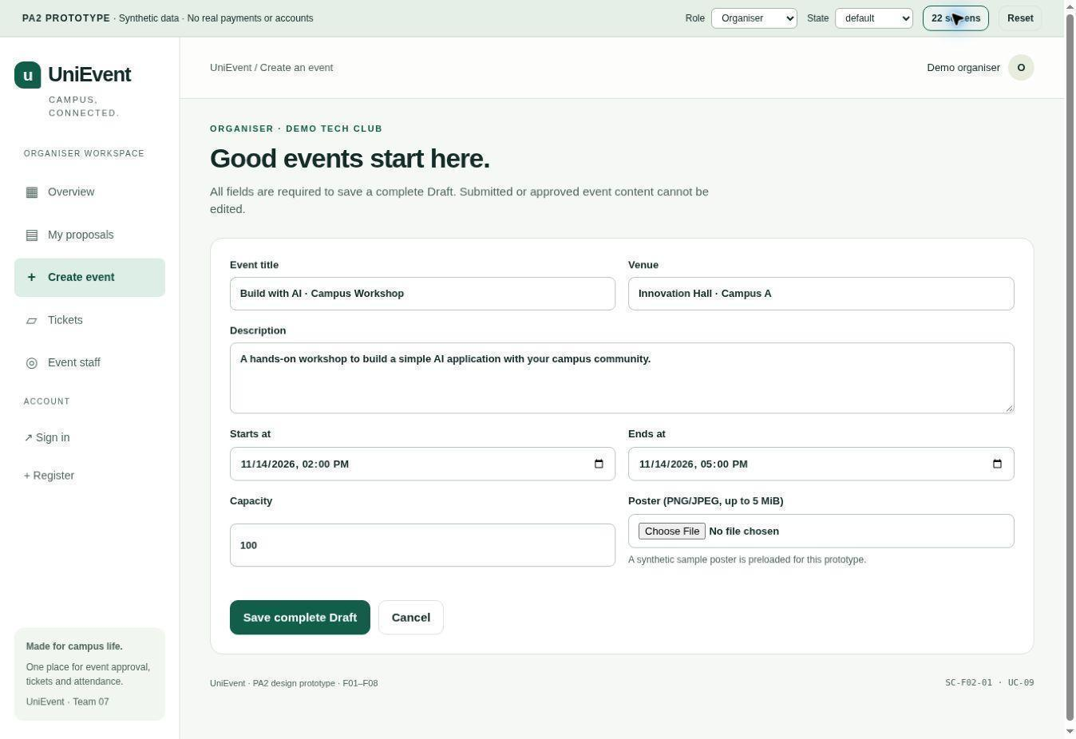
Figure 8.1 – SC-F02-01: Create a complete event draft
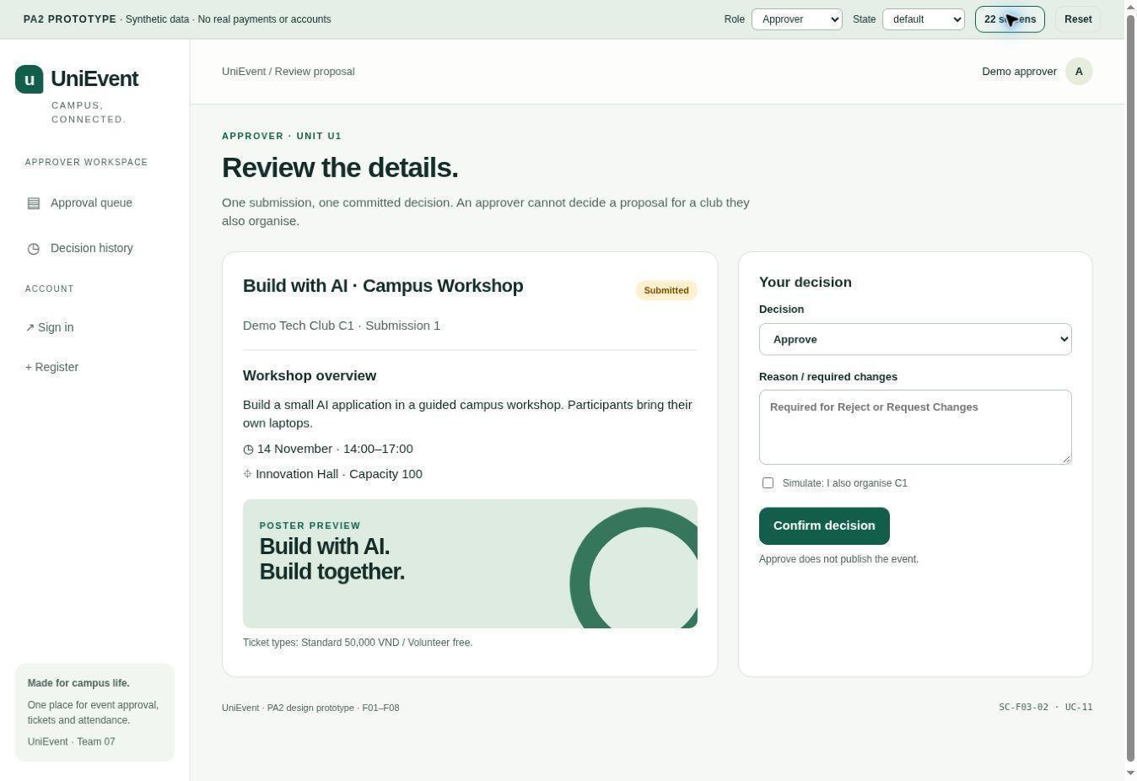
Figure 8.2 – SC-F03-02: Review and decide on a proposal

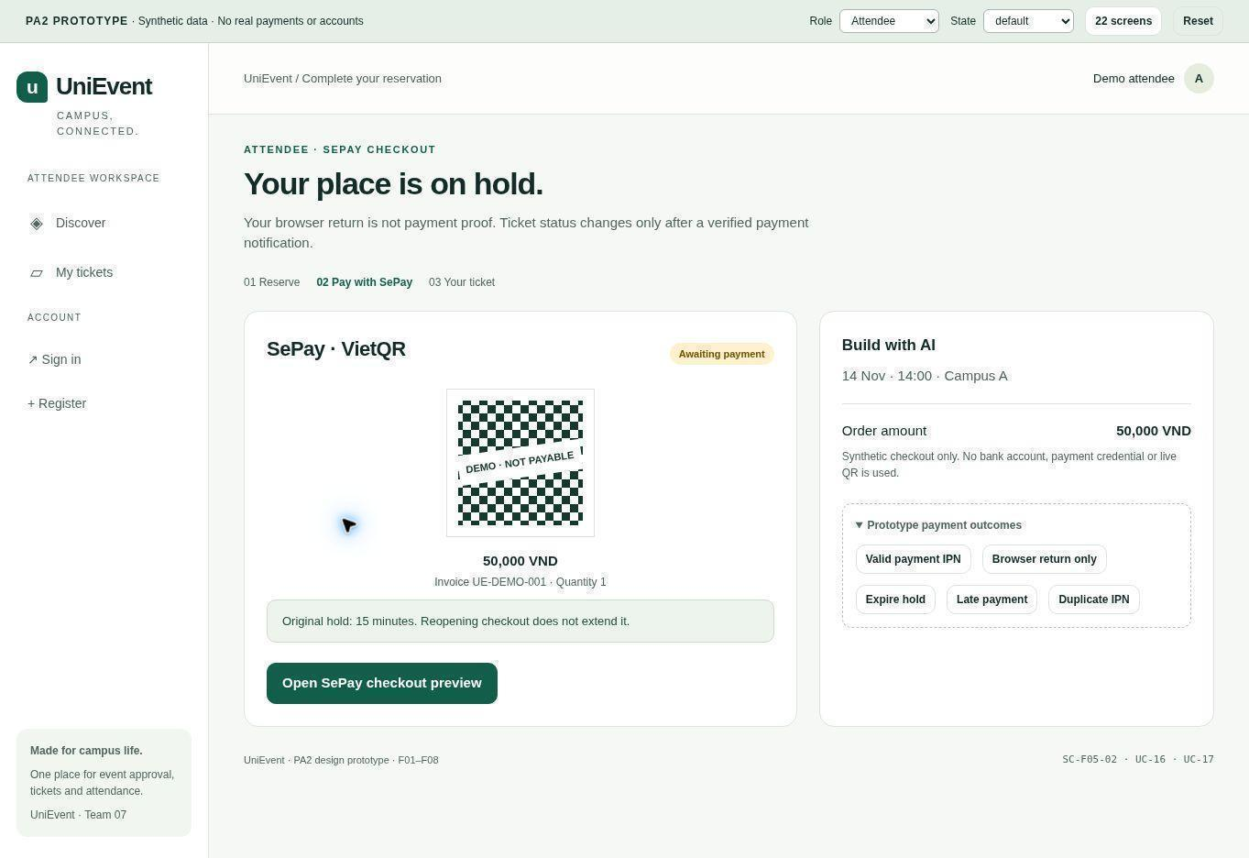
Figure 8.3 – SC-F05-02: SePay checkout (simulated payment)
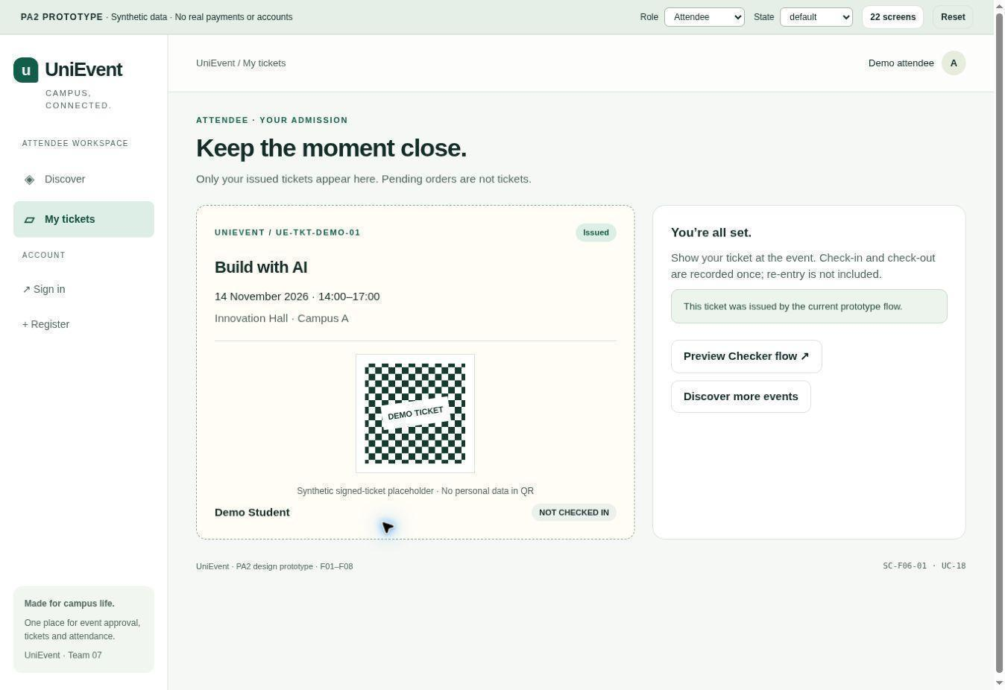
Figure 8.4 – SC-F06-01: View the issued ticket

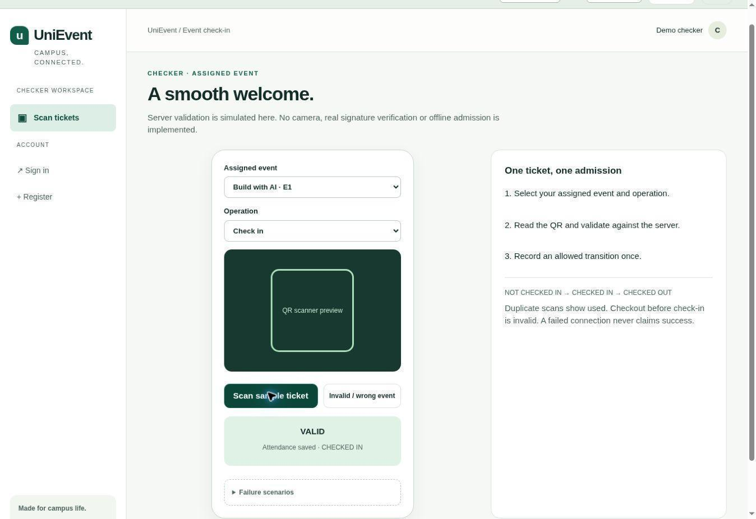
Figure 8.5 – SC-F07-01: Check in a sample ticket
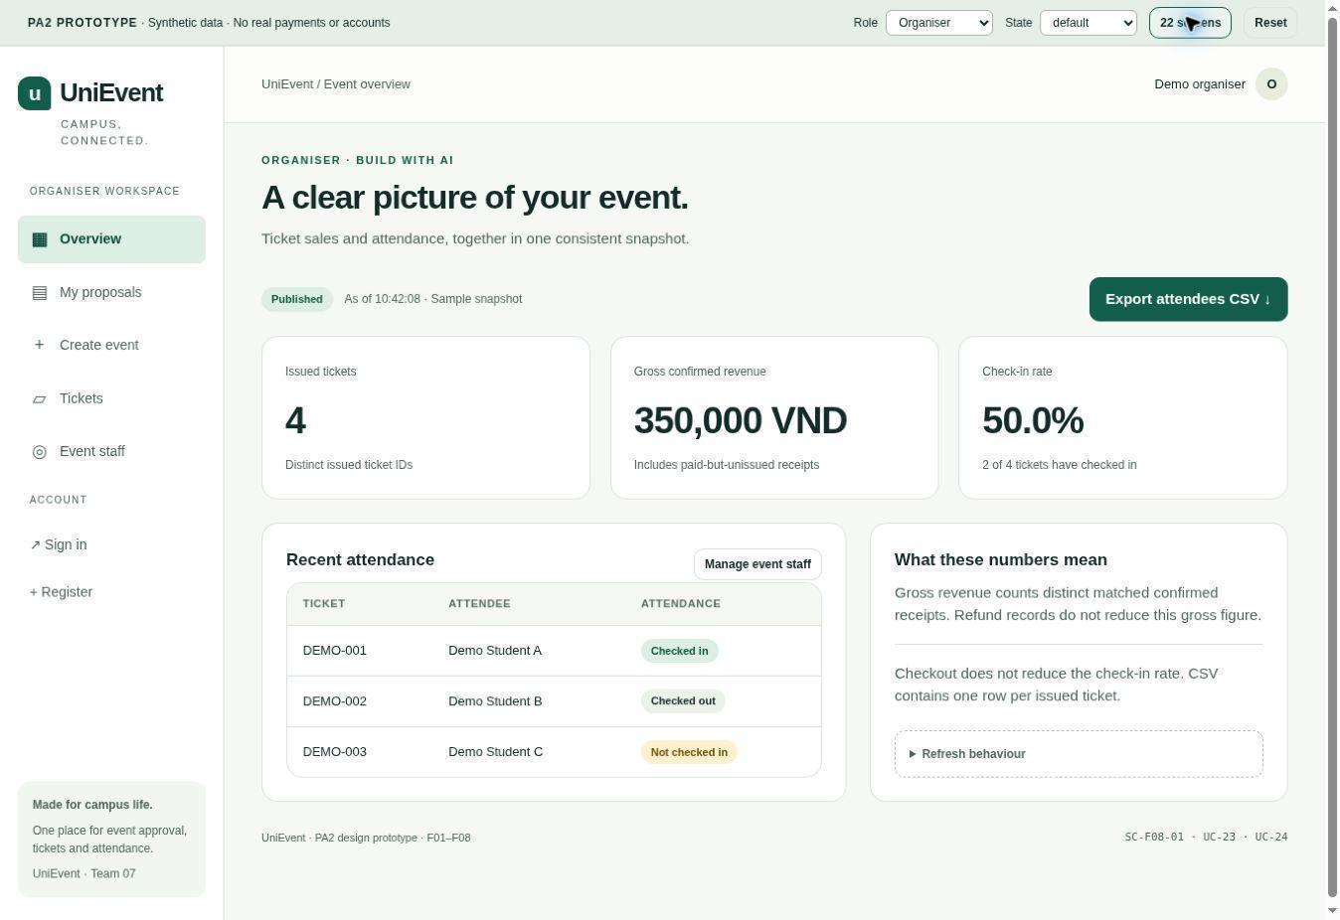
Figure 8.6 – SC-F08-01: Review event metrics and CSV action

9 Requirements Traceability Matrix
The RTM covers all active F01-F08 FR, their planned AC, retained UC identities and Section 8 screen keys. PA3 design and PA4 test IDs remain pending until actual artefacts exist. Current references use the consecutive identifiers in Section 5; earlier AI-log entries retain historical IDs.
Table 9.1 – Feature coverage in this version
Feature | Owner | Use cases | Functional requirements | Acceptance criteria | Status
F01 | Học | UC-01; UC-02; UC-03; UC-04; UC-05; UC-06; UC-07; UC-08; UC-09; UC-10; UC-11; UC-19; UC-24 | 12 active FR | 25 planned AC | Internally reviewed and accepted on 2 November 2026; application tests remain planned for PA4/PA5.
F02 | Huy | UC-09; UC-10; UC-12; UC-13 | 6 active FR | 12 planned AC | Internally reviewed and accepted on 2 November 2026; application tests remain planned for PA4/PA5.
F03 | Huy | UC-11; UC-12 | 7 active FR | 14 planned AC | Internally reviewed and accepted on 2 November 2026; application tests remain planned for PA4/PA5.
F04 | Kiệt | UC-03; UC-14; UC-15 | 3 active FR | 6 planned AC | Internally reviewed and accepted on 2 November 2026; application tests remain planned for PA4/PA5.
F05 | Minh | UC-15; UC-16; UC-17 | 5 active FR | 14 planned AC | Internally reviewed and accepted on 2 November 2026; application tests remain planned for PA4/PA5.
F06 | Minh | UC-17; UC-18; UC-19 | 7 active FR | 21 planned AC | Internally reviewed and accepted on 2 November 2026; application tests remain planned for PA4/PA5.
F07 | Kiệt | UC-20; UC-21; UC-22 | 4 active FR | 9 planned AC | Internally reviewed and accepted on 2 November 2026; application tests remain planned for PA4/PA5.
F08 | Học | UC-23; UC-24 | 3 active FR | 6 planned AC | Internally reviewed and accepted on 2 November 2026; application tests remain planned for PA4/PA5.
Table 9.2 Requirements traceability matrix for F01-F08
Req. ID | Use case / linked AC (PA2) | Screen (working key) | Design element (PA3) | Test cases (PA4)
FR-F01-01 | UC-01; AC: AC-F01-01.1, AC-F01-01.2 | SC-F01-01 | Pending actual PA3 design ID | Pending actual PA4 test ID
FR-F01-02 | UC-02; AC: AC-F01-02.1, AC-F01-02.2 | SC-F01-02 | Pending actual PA3 design ID | Pending actual PA4 test ID
FR-F01-03 | UC-02; AC: AC-F01-03.1, AC-F01-03.2 | SC-F01-02 | Pending actual PA3 design ID | Pending actual PA4 test ID
FR-F01-04 | UC-05; UC-08; AC: AC-F01-04.1, AC-F01-04.2 | SC-F01-04; SC-F01-07; all other protected screens use the same authorisation rule | Pending actual PA3 design ID | Pending actual PA4 test ID
FR-F01-05 | UC-03; AC: AC-F01-05.1, AC-F01-05.2 | SC-F01-03 | Pending actual PA3 design ID | Pending actual PA4 test ID
FR-F01-06 | UC-04; AC: AC-F01-06.1, AC-F01-06.2 | SC-F01-05 | Pending actual PA3 design ID | Pending actual PA4 test ID
FR-F01-07 | UC-04; AC: AC-F01-07.1, AC-F01-07.2, AC-F01-07.3 | SC-F01-05 | Pending actual PA3 design ID | Pending actual PA4 test ID
FR-F01-08 | UC-05; AC: AC-F01-08.1, AC-F01-08.2 | SC-F01-04 | Pending actual PA3 design ID | Pending actual PA4 test ID
FR-F01-09 | UC-06; AC: AC-F01-09.1, AC-F01-09.2 | SC-F01-06 | Pending actual PA3 design ID | Pending actual PA4 test ID
FR-F01-10 | UC-08; AC: AC-F01-10.1, AC-F01-10.2 | SC-F01-07 | Pending actual PA3 design ID | Pending actual PA4 test ID
FR-F01-11 | UC-07; AC: AC-F01-11.1, AC-F01-11.2 | SC-F01-08 | Pending actual PA3 design ID | Pending actual PA4 test ID
FR-F01-12 | UC-04; UC-05; UC-06; UC-08; UC-09; UC-10; UC-11; UC-19; UC-24; AC: AC-F01-12.1, AC-F01-12.2 | SC-F01-08 (audit viewing); source action screens SC-F01-04/05/06/07, SC-F02-01/02, SC-F03-02, SC-F06-02 and SC-F08-01 | Pending actual PA3 design ID | Pending actual PA4 test ID
FR-F02-01 | UC-09; AC: AC-F02-01.1, AC-F02-01.2 | SC-F02-01 | Pending actual PA3 design ID | Pending actual PA4 test ID
FR-F02-02 | UC-09; AC: AC-F02-02.1, AC-F02-02.2 | SC-F02-01 | Pending actual PA3 design ID | Pending actual PA4 test ID
FR-F02-03 | UC-10; AC: AC-F02-03.1, AC-F02-03.2 | SC-F02-02 | Pending actual PA3 design ID | Pending actual PA4 test ID
FR-F02-04 | UC-10; AC: AC-F02-04.1, AC-F02-04.2 | SC-F02-02 | Pending actual PA3 design ID | Pending actual PA4 test ID
FR-F02-05 | UC-12; AC: AC-F02-05.1, AC-F02-05.2 | SC-F02-03 | Pending actual PA3 design ID | Pending actual PA4 test ID
FR-F02-06 | UC-13; AC: AC-F02-06.1, AC-F02-06.2 | SC-F02-04 | Pending actual PA3 design ID | Pending actual PA4 test ID
FR-F03-01 | UC-11; AC: AC-F03-01.1, AC-F03-01.2 | SC-F03-01 | Pending actual PA3 design ID | Pending actual PA4 test ID
FR-F03-02 | UC-11; AC: AC-F03-02.1, AC-F03-02.2 | SC-F03-02 | Pending actual PA3 design ID | Pending actual PA4 test ID
FR-F03-03 | UC-11; AC: AC-F03-03.1, AC-F03-03.2 | SC-F03-02 | Pending actual PA3 design ID | Pending actual PA4 test ID
FR-F03-04 | UC-11; AC: AC-F03-04.1, AC-F03-04.2 | SC-F03-02 | Pending actual PA3 design ID | Pending actual PA4 test ID
FR-F03-05 | UC-11; AC: AC-F03-05.1, AC-F03-05.2 | SC-F03-02 | Pending actual PA3 design ID | Pending actual PA4 test ID
FR-F03-06 | UC-12; AC: AC-F03-06.1, AC-F03-06.2 | SC-F02-03; SC-F03-03 | Pending actual PA3 design ID | Pending actual PA4 test ID
FR-F03-07 | UC-12; AC: AC-F03-07.1, AC-F03-07.2 | SC-F03-03 | Pending actual PA3 design ID | Pending actual PA4 test ID
FR-F04-01 | UC-14; AC: AC-F04-01.1, AC-F04-01.2 | SC-F04-01 | Pending actual PA3 design ID | Pending actual PA4 test ID
FR-F04-02 | UC-14; AC: AC-F04-02.1, AC-F04-02.2 | SC-F04-01 | Pending actual PA3 design ID | Pending actual PA4 test ID
FR-F04-03 | UC-03; UC-15; AC: AC-F04-03.1, AC-F04-03.2 | SC-F01-03 | Pending actual PA3 design ID | Pending actual PA4 test ID
FR-F05-01 | UC-15; AC: AC-F05-01.1, AC-F05-01.2, AC-F05-01.3, AC-F05-01.4 | SC-F05-01 | Pending actual PA3 design ID | Pending actual PA4 test ID
FR-F05-02 | UC-15; AC: AC-F05-02.1, AC-F05-02.2, AC-F05-02.3 | SC-F05-01 | Pending actual PA3 design ID | Pending actual PA4 test ID
FR-F05-03 | UC-15; UC-17; AC: AC-F05-03.1, AC-F05-03.2 | SC-F05-01 | Pending actual PA3 design ID | Pending actual PA4 test ID
FR-F05-04 | UC-16; AC: AC-F05-04.1, AC-F05-04.2, AC-F05-04.3 | SC-F05-02 | Pending actual PA3 design ID | Pending actual PA4 test ID
FR-F05-05 | UC-16; AC: AC-F05-05.1, AC-F05-05.2 | SC-F05-02 | Pending actual PA3 design ID | Pending actual PA4 test ID
FR-F06-01 | UC-17; AC: AC-F06-01.1, AC-F06-01.2, AC-F06-01.3, AC-F06-01.4, AC-F06-01.5 | SC-F05-02 | Pending actual PA3 design ID | Pending actual PA4 test ID
FR-F06-02 | UC-17; AC: AC-F06-02.1, AC-F06-02.2 | SC-F06-01 | Pending actual PA3 design ID | Pending actual PA4 test ID
FR-F06-03 | UC-17; AC: AC-F06-03.1, AC-F06-03.2 | SC-F06-01 | Pending actual PA3 design ID | Pending actual PA4 test ID
FR-F06-04 | UC-18; AC: AC-F06-04.1, AC-F06-04.2 | SC-F06-01 | Pending actual PA3 design ID | Pending actual PA4 test ID
FR-F06-05 | UC-17; UC-19; AC: AC-F06-05.1, AC-F06-05.2, AC-F06-05.3 | SC-F06-02 | Pending actual PA3 design ID | Pending actual PA4 test ID
FR-F06-06 | UC-19; AC: AC-F06-06.1, AC-F06-06.2 | SC-F06-02 | Pending actual PA3 design ID | Pending actual PA4 test ID
FR-F06-07 | UC-19; AC: AC-F06-07.1, AC-F06-07.2, AC-F06-07.3, AC-F06-07.4, AC-F06-07.5 | SC-F06-02 | Pending actual PA3 design ID | Pending actual PA4 test ID
FR-F07-01 | UC-20; UC-21; UC-22; AC: AC-F07-01.1, AC-F07-01.2 | SC-F07-01 | Pending actual PA3 design ID | Pending actual PA4 test ID
FR-F07-02 | UC-20; UC-22; AC: AC-F07-02.1, AC-F07-02.2, AC-F07-02.3 | SC-F07-01 | Pending actual PA3 design ID | Pending actual PA4 test ID
FR-F07-03 | UC-21; UC-22; AC: AC-F07-03.1, AC-F07-03.2 | SC-F07-01 | Pending actual PA3 design ID | Pending actual PA4 test ID
FR-F07-04 | UC-22; AC: AC-F07-04.1, AC-F07-04.2 | SC-F07-01 | Pending actual PA3 design ID | Pending actual PA4 test ID
FR-F08-01 | UC-23; AC: AC-F08-01.1, AC-F08-01.2 | SC-F08-01 | Pending actual PA3 design ID | Pending actual PA4 test ID
FR-F08-02 | UC-23; AC: AC-F08-02.1, AC-F08-02.2 | SC-F08-01 | Pending actual PA3 design ID | Pending actual PA4 test ID
FR-F08-03 | UC-24; AC: AC-F08-03.1, AC-F08-03.2 | SC-F08-01 | Pending actual PA3 design ID | Pending actual PA4 test ID

10 Requirements Review
Owner review record - 2 November 2026: Le Nguyen Quoc Hoc reviewed the AI-assisted readiness assessment asynchronously and requested integration. The owner accepted SePay Payment Gateway and the Table 4.3 MVP scope. This revision incorporates the subsequent consistency corrections and consecutive identifiers as direct edits requested by the document owner. The document contains 47 FR, 10 NFR, 22 BR, 107 AC and 24 UC specifications, with an AC and RTM row for every FR. In a follow-up asynchronous confirmation on 2 November 2026, Học confirmed that the current content is satisfactory for the MVP. This is owner review and document verification, not an all-member meeting, stakeholder interview or application test.
Completed cross-owner review - confirmation recorded on 2 November 2026: Học, Huy, Kiệt and Minh reviewed the current PA2 requirements, accepted the document-level issue dispositions and agreed to 25% contribution each, as confirmed by team lead Học. Scopes: Học - F01/F08 and NFRs; Huy - F02/F03, BR, UC model and RTM; Kiệt - F04/F07 and mockups; Minh - F05/F06 and review. Reviewed version: source saved on 2 November 2026 at 21:32 GMT+7, before this status update. The requirements content is accepted as the team baseline. External validation and remaining prototype/application/live-channel/backup checks retain their recorded status and phases.
Changes from PA1 retained in PA2: SePay Payment Gateway replaces the previously selected payOS provider; F01-F08, one authorised live channel and the 2 s / 60 s / 5 s targets remain. The MVP narrows browser coverage, fixes one ticket per order and one approval stage, locks ticket configuration at the event’s earliest sales start and excludes re-entry and automated refunds. Table 4.3 records these owner-approved decisions; external validation and any required TA confirmation are tracked separately. Approval reasons refine the PA1 wording: every decision retains its actor, time and outcome, while only Reject requires a reason and Request Changes a description; Approve needs no comment (BR-03; BR-04; UC-11). The clarifications also define atomic free fulfilment, one attendance commit and evidence-based full-refund closure without expanding F09/F10.
Internal review and the 25%-per-member contribution allocation are confirmed. Before submission, finish or record remaining prototype keyboard/mobile checks, refresh the automatic table of contents and inspect the final PDF. Submit T07-PA2.pdf plus source on Moodle and commit them to /pa/PA2. Task references: #46 for review, #47 for contribution and #49 for finalisation.
Requirements review checklist
Check | Review area | Required evidence / acceptance of review | Reviewer and result
RV-01 | PA1/MVP scope | Confirm F01-F08 remain and record the proposed narrower behaviour in Section 2 / Table 4.3. | COMPLETED: all four members accepted the internal PA2 scope. External validation and any required TA confirmation remain pending.
RV-02 | Requirement quality | Check the 47 FR, 10 NFR, 22 BR and 107 planned AC for clear behaviour, measurable boundaries and sources. | COMPLETED: feature owners reviewed and accepted the 47 FR, 10 NFR, 22 BR and 107 AC.
RV-03 | Traceability | Resolve every active FR/AC/UC/screen reference; PA3/PA4 stay pending until actual evidence. | COMPLETED: Huy and feature owners accepted the links; 47/47 FR have AC and RTM coverage. PA3/PA4 IDs await actual artefacts.
RV-04 | UC and UML | Read all 24 specifications; retained diagrams use the same IDs and include/extend model. | COMPLETED: responsible owners accepted all 24 specifications and four UML views.
RV-05 | Access/security | Review specified own/other scopes, locked accounts, revoked grants, session expiry and QR/secret exclusions at the PA2 document walkthrough. Execute corresponding application tests in PA4/PA5. | COMPLETED: Học/Minh requirements-level access review. Application execution remains planned for PA4/PA5.
RV-06 | Policy decisions | Approve or reject q=1, late-payment quarantine, expired-hold counting, no post-sales edits and no re-entry. | COMPLETED: owner and affected-owner policy acceptance. External domain validation remains pending.
RV-07 | NFR feasibility | Review feasibility of E1, browser scope, samples and the planned backup/restore exercise; retain PA1 latency thresholds. Record actual measurements and restoration results in PA5. | COMPLETED: responsible owners accepted requirements feasibility. E1 measurements and the actual backup/restore exercise remain PA5 work.
RV-08 | Prototype/evidence | Review the six illustrative screenshots (Figures 8.1-8.6), using the existing demo as optional supporting material; supply contribution evidence, an actual review record. External interview evidence remains separately tracked in Section 3.8. | COMPLETED: internal mockup and contribution review. Remaining keyboard/mobile checks and external validation retain their recorded status.
RV-09 | Money/capacity/attendance | Walk through the specified expiry and concurrent reserve/callback/scan cases for consistency; distinguish paid receipt from issued ticket. Execute the cases in PA4/PA5. | COMPLETED: Minh/Kiệt requirements-level money/capacity/attendance review. Application execution remains planned for PA4/PA5.
Source-supported requirements issue log
MR-01 to MR-08 retain their issue identities. The team lead confirmed the internal review and document-level issue dispositions on 2 November 2026. MR-07 is closed for the internal review/contribution record. External stakeholder validation remains pending under Section 3.8; application-test results and the remaining prototype checks are not asserted complete.
Issue ID / reported / severity | Reference and issue | Assigned owner / corrective action | Status / evidence / closure date
MR-01 / 28-10 / High | Expired unpaid holds in account limit | BR-15 now specifies excluding expired unpaid holds; active/confirmed allocations and issued tickets still count. | RESOLVED: document correction and affected-owner review accepted on 2 November 2026. Applicable application tests remain planned for PA4/PA5.
MR-02 / 28-10 / High | Order-ticket-QR cardinality | BR-18 and F05/F06/F07/F08 now use one ticket/order, one QR/ticket and per-type account allowance. | RESOLVED: document correction and affected-owner review accepted on 2 November 2026. Applicable application tests remain planned for PA4/PA5.
MR-03 / 28-10 / High | Late payment and timing boundary | BR-20 now specifies first confirmation at/after unpaid expiry -> exception, no auto reallocation; earlier confirmed replays remain idempotent. | RESOLVED: document correction and affected-owner review accepted on 2 November 2026. Applicable application tests remain planned for PA4/PA5.
MR-04 / 28-10 / High | Paid cancellation/refund | F10 remains deferred; minimum received-payment evidence and manual external-outcome recording remain in F06/BR-19. | RESOLVED: document correction and affected-owner review accepted on 2 November 2026. Applicable application tests remain planned for PA4/PA5.
MR-05 / 28-10 / High | Ticket changes and lifecycle | BR-12; BR-13; BR-14 define pre-sales edits, stored price, exact expiry and retained confirmed allocation; BR-10 blocks unsafe deactivation. | RESOLVED: document correction and affected-owner review accepted on 2 November 2026. Applicable application tests remain planned for PA4/PA5.
MR-06 / 28-10 / Medium | Incomplete cross-feature registers | Added F04/F07 FR and AC, UC-14/20/21/22 specs, all-feature screen inventory and 47-row RTM. | RESOLVED: integrated requirements/mockups and cross-owner review accepted on 2 November 2026.
MR-07 / 28-10 / Medium | Internal review and contribution confirmation not recorded; external validation tracked separately | Record completed four-member review, accepted document resolutions and the agreed 25%-per-member allocation; retain external validation separately in Section 3.8. | CLOSED: internal review/contribution confirmation recorded on 2 November 2026. External stakeholder validation remains PENDING in Section 3.8.
MR-08 / 28-10 / High | Metrics, E1 and live payment acceptance | BR-22 uses distinct receipts/issued units; OD-10 uses the owner-approved actual-host profile. Live-channel evidence remains required by PA1; mock does not replace it. | RESOLVED: internal scope/access/feasibility review accepted. Measurements and authorised live-channel evidence remain PA5 deliverables.

11 AI Usage Log
Table 11.1 – AI usage log for PA2
# | Member | Tool | Task / purpose | How the output was verified and changed
1 | Thái Quang Huy | Claude (Anthropic, Claude Opus 5.5) | 26–27/10/2026: Analysed PA2, PA1, PA0, the Week 4 plan and the UniEvent repository; drafted Sections 3–4 (preliminary needs and problems), F02–F03 FRs and ACs (§5), the shared UC register and PlantUML diagrams (§6), and UC-09–UC-12 specifications (§7). Generated issues, assumptions and handoff notes, edited a local document copy, and performed AI self-audits to produce v0.2–v0.3. No shared repository or Drive document was modified by Claude. | AI checks included PlantUML/document rendering, reference consistency and comparisons with PA1. These are automated checks, not independent human or stakeholder validation. Huy’s verification and peer review: PENDING; record actual checks and changes after they occur.
2 | Thái Quang Huy | ChatGPT (OpenAI, GPT-6) | 27/10/2026: Assisted with document and UML layout (v0.4–v0.7), then a working-baseline review: removed instructor sample rows and template prompts, selected provisional F02–F03 rules, added BR-01–BR-11, FR-F02-24, FR-F03-17, corresponding AC, UC-13 and initial RTM mapping, and redrew the F02–F03 diagram as a working UML view, removing the outdated UC-13 pending marker. All external stakeholder validation and real team approval remain pending. | AI-assisted document rendering, reference checks, table-font checks (table cells 10 pt; table captions 12 pt) and use-case diagram replacement were performed. No stakeholder validation, acceptance testing or team approval is claimed. Huy’s personal review and peer review: PENDING.
3 | Thái Quang Huy | Claude Sonnet 5.5 (Anthropic), Claude desktop app, Cowork mode. | 27/10/2026: Compared the Week 4 meeting minutes with this draft (v0.7), PA0 and PA1, then produced v0.8: the master business-rule register BR-12 to BR-40 drafted from PA1 for the feature owners to confirm and the identifier conventions and table captions (§5); the validation protocol for V-01 to V-05 (§3.8); the use-case diagrams redrawn in one style and the published use-case register note (§6); the F02–F03 screen list, content, states and navigation for the prototype (§8); the feature coverage table and the RTM Screen column with working screen keys, with UC-07 added to FR-F02-22 and FR-F03-16 (§9); the roles in Table 1 aligned with the Week 4 plan; this log. Also prepared a Vietnamese interview kit and a draft /docs/ai-usage/PA2.md. | Automated checks only: a script that resolves every FR, AC, UC, BR, OD, A and V identifier and checks that each FR has an AC and a use case; PA1 page citations compared with the PA1 text; the document rendered to PDF and inspected page by page. The repository sub-folders could not be read in this session, so no repository content was used. No interview, stakeholder validation or team approval is claimed. Huy’s review and Kiệt’s peer review: PENDING; record the actual checks and changes after they occur.
4 | Lê Nguyễn Quốc Học | ChatGPT (OpenAI) | 28–29/10/2026: Drafted and simplified scope/glossary, F01/F08 requirements and AC, NFR targets, owned UC specifications and screen/RTM handoffs from PA0/PA1; prepared tracked proposals and rationale comments. | Source comparisons, identifier/coverage checks, accept/reject reconstruction and document rendering. Provisional policies were kept separate from approval; Học subsequently accepted the documented MVP scope.
5 | Lê Nguyễn Quốc Học | ChatGPT (OpenAI) | 02/11/2026: Reviewed PA2 against PA0/PA1, the official rubric and prior-cohort feedback; clarified cross-feature rules, UC/RTM links, refunds, atomic attendance and recorded PA1 refinements. | Reference/coverage and preservation checks plus rendered inspection. Học subsequently confirmed completed cross-owner requirements review and the 25%-per-member allocation on 2 November 2026. External validation and application tests remain pending.
6 | Lê Nguyễn Quốc Học | ChatGPT (OpenAI) | 02/11/2026: Confirmed SePay Payment Gateway wording; created the interactive prototype with 22 logical screens/states and synthetic data; integrated six screenshots, links and a shorter Section 8 walkthrough. | Source checks, selected browser interactions, sampled labels/focus/errors/contrast and document rendering. This supports the illustrative prototype, not live payment verification or a complete accessibility audit.
7 | Lê Nguyễn Quốc Học | ChatGPT (OpenAI) | 02/11/2026: Integrated accepted revisions as direct edits; renumbered active identifiers/references, reordered UC specifications and normalised typography/tables. Corrected edit/hold/scan timing, UC-16/19, the extend arrow and screenshot captions. | Recovered the stable source after an unreadable tracked revision; checked content/assets, numbering, RTM coverage and rendered layout. Historical identifiers in earlier logs remain historical.
8 | Lê Nguyễn Quốc Học | ChatGPT (OpenAI) | 02/11/2026: Prepared the review form from verified GitHub task assignments; recorded the team lead confirmation of completed review and 25% contribution each; updated Sections 1/10 and related review statuses. Consolidated repeated AI sessions into these five records. | Checked the current PA2, task sources, preserved requirements/references and rendered layout. Review/contribution completion is recorded from Học’s confirmation; external validation, remaining prototype checks and application execution remain separate.
9 | Nguyễn Văn Minh | ChatGPT (OpenAI, GPT-6) | 01/11/2026: Reviewed PA2 F05–F06 against the decision to use SePay/VietQR, a single authorised receiving bank account and manual fund returns. Identified ambiguities and edge cases in FR/BR/AC/UC for provider notifications, 15-minute reservations, late/duplicate payments, retries and refund evidence; drafted a scoped revision plan and updated F05–F06 proposal. | AI-assisted requirements cross-checks and review of relevant SePay technical documentation. The exact SePay integration mode and some timing/refund policies were marked for team confirmation. No live provider integration, stakeholder approval or executed application tests were claimed.
10 | Nguyễn Văn Minh | ChatGPT (OpenAI, GPT-6) | 02/11/2026: Integrated the proposed F05–F06 revisions into the original PA2 Word file: updated six FR and five BR, refined UC-15/UC-16/UC-17/UC-19 and expanded F05–F06 acceptance criteria from 29 to 35. Diagram, NFR, RTM and other owners’ work were left for cross-owner coordination. | AI-assisted identifier/coverage checks, OOXML content-preservation checks (including the 51 original tables and embedded assets) and rendered-page inspection were performed. The shared Drive file was updated, but human review, SePay live verification and PA4/PA5 tests remained pending.
Học’s repeated sessions are consolidated into five records by work purpose. Other members’ entries retain their historical content and review status for those earlier drafts. Completed current internal review and contribution confirmation are recorded in Sections 1/10; external validation and executed tests require separate evidence.

