CAN BUS INTRUSION DETECTION SYSTEM (CANIDS)
Replay Attack Detection and Naming on the SynCAN Dataset
An unsupervised, forecast-based pipeline with a Temporal Convolutional Network, replay-specific alert refinement and a replay-versus-other naming rule

Project: CAN Bus Intrusion Detection System, replay-focused branch
Dataset: SynCAN (ETAS / Bosch)
Forecaster: Temporal Convolutional Network (TCN), trained on normal driving only
Report type: Technical project report, final stage
Date: October 2026

Contents
1. Abstract
2. Introduction (scope, objective, methodology / model, expected results / outcome, conclusion)
3. Literature Review
4. Methodology (4.1 Datasets and sample data size, 4.2 to 4.6 pipeline and replay-specific work)
5. Results and Discussion
6. Conclusion and Future Work
7. References
8. Appendix

1. Abstract
Replay attacks on a vehicle’s Controller Area Network (CAN) bus play back genuine, previously recorded signal values, so every individual value looks believable. This report describes a replay-focused intrusion detection pipeline built on the SynCAN dataset and trained on normal driving only. A Temporal Convolutional Network (TCN) forecasts the next state of 20 signals. A windowed detector combines the forecast errors with staleness, frozen-value and cross-ID partner evidence into one score with a single threshold calibrated on normal data (0.1 false alarms per minute).
On top of this baseline we added replay-specific work: (i) a scorecard that scores replay detected and replay named separately, with settings chosen on the first half of the replay file and reported on the second half; (ii) a start walk-back and a short-window end-finder that correct where each alert begins and ends; (iii) a resting-value test that tells a replay of a flat signal apart from a plateau attack; and (iv) a cross-ID reconstruction experiment that did not pass its feasibility gate and was stopped.
On the replay file (93 attack intervals, 449,994 ticks) tick-level F1 rose from 0.922 to 0.939 (0.9205 to 0.9335 on the held-out second half), precision rose from 0.934 to 0.975, 92 of 93 attacks were found, and the share of replay alerts correctly named “replay” rose from 90.5% to 96.4% (98.6% on the second half). The 0.95 tick-level F1 target was not reached: the remaining errors are alerts that break up or fade inside an attack. Because the naming clue was found while examining the real attack files, the naming figures are optimistic as a general claim.
Keywords: CAN bus, intrusion detection, replay attack, SynCAN, temporal convolutional network, unsupervised anomaly detection, forecasting residuals.

2. Introduction
Modern vehicles contain dozens of electronic control units (ECUs) that exchange short messages over the Controller Area Network [1]. The protocol has no sender authentication, so a compromised or attached node can transmit messages that other ECUs accept as genuine; practical attacks on production cars have been demonstrated repeatedly [2], [3]. An intrusion detection system (IDS) on the bus therefore has to decide, from the traffic alone, whether what it sees is normal driving.
A replay attack records a stretch of genuine traffic and later re-transmits it while the car is doing something else. Every transmitted value is real and plausible, and its own recent history looks normal. What is wrong is only that the signal is out of step with the true present state of the vehicle, which the other IDs still describe. This is why replay is the hardest of the SynCAN attack types for a forecasting-based detector: the forecast is surprised when the replay begins, then the replayed signal soon follows a believable path and the error disappears while the attack continues.

2.1 Scope
- In scope: detecting replay attacks on the SynCAN dataset, and naming them: of the alerts raised on real attacks, calling replay “replay” and every other attack “other”. Evaluation at tick level (0.01 s) and event level (attack intervals and alerts).
- Detection and naming are scored separately. Replay detected asks whether an alert covers the attack. Replay named asks whether that alert carries the right label. An alert that overlaps no attack is a false alarm, a detection error, and is kept out of the naming figures.
- Out of scope: tuning for flooding, suppression, plateau or drift (the other four SynCAN attack types are used only to check that they are not mislabelled “replay”); fuzzing (SynCAN has no real fuzzing file); real-time deployment; the TCN training itself (a teammate’s branch, used here as given). The main branch is untouched; on this branch other attack types are allowed to get worse.

2.2 Objective
The project owner set a bar of at least 95% on the replay metrics. The objectives of the replay branch are therefore:
- Reach a tick-level F1 of at least 0.95 on the replay file, and find all 93 attack intervals.
- Name replay attacks correctly (“replay”) for at least 95% of the alerts raised on them, while keeping other attacks from being called “replay”.
- Keep every setting tied to normal data or to the first half of the file; report the second half; never fit a model or threshold on attack labels.
- Report honestly where the bar is not met, and keep the work easy to roll back (new files only).

2.3 Methodology / Model
The pipeline (Figure 1) resamples the asynchronous CAN frames onto a common 0.01 s grid, builds a joint (value, staleness) state vector for the 20 signals, and trains a TCN forecaster on normal data only. The detector divides four kinds of evidence by what normal driving produces and flags a tick when the largest of them crosses one threshold. Branch 2 (message-rate limits) is part of the system but irrelevant to replay. The replay branch adds alert-boundary refinement, a replay-versus-other naming rule and a replay scorecard (shaded in the figure). Section 4 describes every stage.
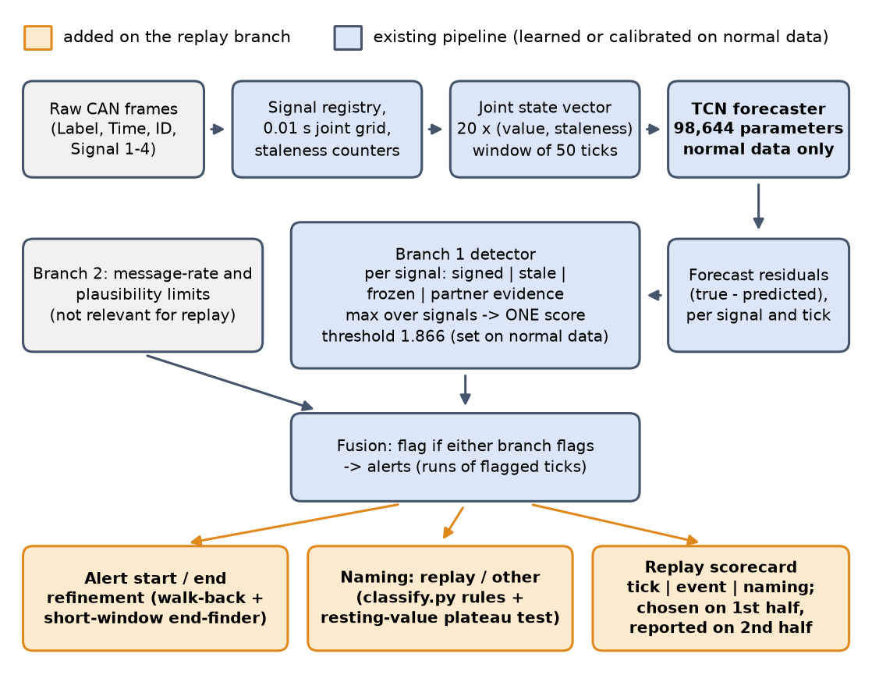
Figure 1. Overall pipeline. Shaded boxes are the replay-specific additions of this branch; everything else is the existing system, learned or calibrated on normal data only.

2.4 Expected Results / Outcome
Before the work, a diagnosis of the baseline on the cached forecasts predicted that post-processing alone would reach about 0.93 tick F1, and that 0.95 would need new evidence. The expected outcome was therefore a measurable but partial improvement from cheap fixes, and a go / no-go decision on a heavier cross-ID model. The targets and what was found are compared in Table 1.
Table 1. Targets set for the replay file and the outcome (details in Section 5).
Metric | Baseline | Final | Target / verdict
Tick-level F1 | 0.922 | 0.939 (2nd half 0.934) | ≥ 0.95: not met
Attack intervals found | 92 / 93 | 92 / 93 | 93 / 93: not met
Event-level strict F1 | 0.973 | 0.973 | ≥ 0.95: met
Replay alerts named “replay” | 90.5% | 96.4% (2nd half 98.6%) | ≥ 95%: met
Precision of the “replay” label | 79.0% | 89.2% | ≥ 95%: not met
False alarms, unseen normal driving | 0.080 per min | 0.080 per min | no worse: met

2.5 Conclusion (summary of the introduction)
The replay branch turns a detector that was already strong at event level (strict F1 0.973) into one whose tick boundaries and replay names are much more accurate, but not yet good enough at tick level to clear the 0.95 bar. The rest of the report reviews related work (Section 3), explains the data and every pipeline stage (Section 4), presents the measured results and the negative results (Section 5), and closes with limits and next steps (Section 6).

3. Literature Review

3.1 CAN security and attack types
The CAN protocol [1] was designed for reliability, not security: frames carry an identifier and up to eight data bytes, with no authentication. Koscher et al. [2] and Miller and Valasek [3] showed that an attacker with bus access can inject frames to control safety-relevant functions. The attack types used in SynCAN follow from this: flooding (too many frames), suppression (a signal is silenced), plateau (a signal is frozen at a constant), continuous change or drift (a signal is pushed along a ramp) and playback or replay (genuine recorded values are re-sent) [9].

3.2 Detection families
- Timing and frequency based. Entropy of the message stream [4] and clock-skew fingerprints of ECUs [5] detect injected or foreign frames from timing alone. They catch flooding-like behaviour, but a replay may keep the original cadence, so timing evidence may be weak for it.
- Supervised learning. Deep neural networks and convolutional networks classify frames or windows as normal or attack [6], [7]. They need labelled attack data in training, so they only recognise attacks they have seen; the present project forbids fitting anything on attack labels.
- Unsupervised sequence models. Forecast-based detectors learn normal behaviour and flag deviations. Taylor et al. [8] predict the next data word with an LSTM [12]; CANet [9] uses an LSTM-based autoencoder over all IDs and introduced the SynCAN dataset. Their appeal is that no attack data is needed.

3.3 Sequence models used here
Gated recurrent units [11] and LSTMs [12] are the classic choice for sequence forecasting. Temporal convolutional networks, built from causal, dilated convolutions with residual connections [10], match or exceed recurrent networks on many sequence tasks, train in parallel and have a fixed, known receptive field. The project compared a GRU baseline with a TCN and chose the TCN as the final forecaster, rather than a Transformer, because SynCAN’s normal-only training data is limited and a Transformer overfits more readily at that scale. Isolation Forest [14] was built as an equal second branch over rate and plausibility features, tested, and dropped: it found no attack that the forecaster plus simple limits miss, and it cannot flag values beyond its training range. General background on anomaly detection is given in [13].

3.4 Gap addressed by this work
Forecast-residual detectors are strong when an attack makes the signal surprising, and weak when it does not. A replay is surprising only at its onset. The practical questions for a replay detector are these: where exactly the alert starts and ends at the 0.01 s level, how to tell a replay of a flat signal from a plateau attack, and how to report detected and named separately so that a good detector is not hidden behind a naming problem, or the reverse. This report addresses those three questions on the real SynCAN replay file, under a strict normal-data-only protocol.

4. Methodology

4.1 Datasets
SynCAN (ETAS / Bosch) is a synthetic CAN dataset made from real-vehicle signal statistics [9]. Each CSV row is Label, Time, ID, Signal1_of_ID … Signal4_of_ID. There are 10 CAN IDs carrying 20 signals in total (Table 2). The bus is asynchronous: IDs transmit at different, sometimes irregular periods, and signal values are already scaled to the range 0 to 1.
Table 2. The 10 CAN IDs and 20 signals of SynCAN. Signals marked † have a cross-ID partner model (12 of 20).
CAN ID | Signals | Signal names (registry order)
id1 | 2 | id1_sig1†, id1_sig2
id10 | 4 | id10_sig1†, id10_sig2, id10_sig3†, id10_sig4†
id2 | 3 | id2_sig1†, id2_sig2†, id2_sig3†
id3 | 2 | id3_sig1, id3_sig2†
id4 | 1 | id4_sig1
id5 | 2 | id5_sig1, id5_sig2†
id6 | 2 | id6_sig1†, id6_sig2
id7 | 2 | id7_sig1, id7_sig2
id8 | 1 | id8_sig1†
id9 | 1 | id9_sig1†
Total | 20 | 12 with a partner model, 8 without

Sample data and data size
The raw files are CSV. A normal row and the first attacked row of the replay file look like Table 3; during an attack interval every ID’s rows are labelled 1, so the label does not say which signal was replayed.
Table 3. Sample rows of syncan_test_replay.csv (first rows, and the first attacked rows).
Label | Time (s) | ID | Signal 1 | Signal 2 | Signal 3 | Signal 4
0 | 72007.5195029 | id9 | 0.3453
0 | 72007.5200364 | id3 | 0.2000 | 1.0000
0 | 72007.5204139 | id10 | 0.3467 | 1.0000 | 0.7803 | 0.3594
0 | 72007.5204195 | id5 | 0.1405 | 0.8207
1 | 72048.5895029 | id9 | 0.4178
1 | 72048.5917062 | id5 | 0.2878 | 0.9994
1 | 72048.5921519 | id3 | 0.6000 | 1.0000

Data sizes are in Table 4. One tick is 0.01 s; the tick counts are the valid forecast ticks after the grid is built. Normal training and validation use the four normal-only files; all attack and test files are used for scoring only.
Table 4. Dataset files, sizes and roles.
File | Role | Rows (frames) | Ticks | Duration | Attacked ticks
syncan_train_1..4 | Normal; first 80% fit, last 20% validate | ≈ 7.42 M each | ≈ 1.55 M each | ≈ 259 min each | 0
syncan_test_normal | Unseen normal check | ≈ 2.15 M | 449,994 | 75.0 min | 0
syncan_test_replay | Replay (target) | ≈ 2.15 M | 449,994 | 75.0 min | 59,202 (13.2%)
syncan_test_plateau | Other attack (naming check) | ≈ 2.15 M | 449,995 | 75.0 min | 73,421 (16.3%)
syncan_test_drift | Other attack (naming check) | ≈ 2.15 M | 449,996 | 75.0 min | 60,161 (13.4%)
syncan_test_suppression | Other attack (naming check) | ≈ 2.11 M | 449,994 | 75.0 min | 79,714 (17.7%)
syncan_test_flooding | Other attack (naming check) | ≈ 2.58 M | 449,995 | 75.0 min | 74,104 (16.5%)

The replay file holds 93 attack intervals, each 420 to 831 ticks long (4.2 to 8.3 s) and at least 21 s apart. Figure 2 shows how much of each test file is attacked. SynCAN has no real fuzzing file, so fuzzing is not part of this study.
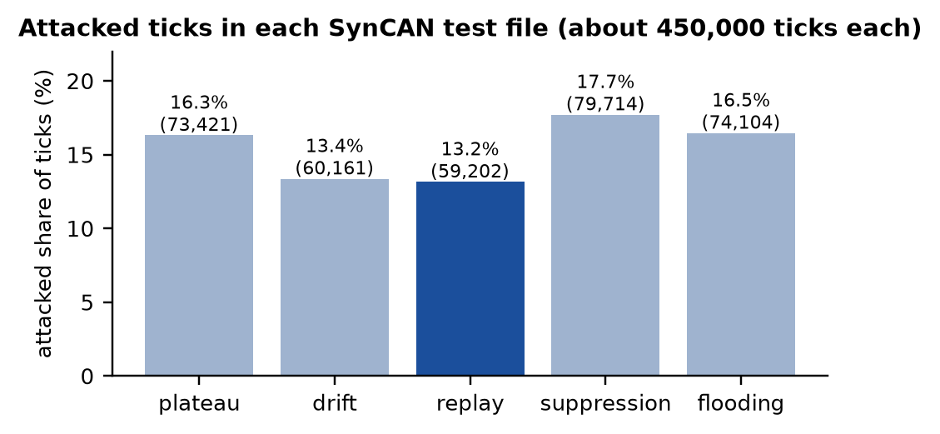
Figure 2. Share of ticks inside attack intervals in each real SynCAN test file.

4.2 Preprocessing
- Signal registry. A fixed mapping from (CAN ID, signal slot) to a global name and a vector index (signal i has its value at column 2i and its staleness at 2i+1). It is built once and reused by training, inference, both branches and attribution.
- Joint time grid. The asynchronous per-ID streams are resampled to a common 0.01 s grid; a signal that did not transmit at a tick keeps its last observed value (forward fill).
- Staleness counters. For each signal, the number of ticks since it last genuinely transmitted (0 on a real update). Staleness is computed directly and never forecast.
- Windowing. Sliding windows of 50 ticks (0.5 s) over the 40-dimensional joint vector, shared by every model. Windows never cross file boundaries.
- Scaling. SynCAN’s signals are already in the range 0 to 1, so no further scaling is applied.
- Split discipline. Normal files are split in time order (first 80% to fit, last 20% to validate); attack files are used for scoring only.

4.3 Branch 1 forecaster: Temporal Convolutional Network
The forecaster reads a 50-tick window of the joint vector and predicts the 20 signal values at the next tick; staleness is never forecast, so learned prediction and directly observed metadata are not mixed. The residual (true minus predicted value) of each signal is the raw material of the detector. The network is a stack of four causal, dilated residual blocks with weight normalisation [10], [16] (Table 5). A GRU seq2seq model served as the baseline; the TCN is the final model.
Table 5. TCN forecaster configuration and training.
Item | Value
Input / output | 50 ticks × 40 channels (20 values + 20 staleness) → 20 values at the next tick
Blocks | 4 residual blocks, 2 weight-normalised causal convolutions each, dilations 1, 2, 4, 8, kernel 3
Channels / dropout | 64 / 0.1; receptive field 61 ticks; 98,644 parameters
Training data | train_1..4, first 80% of each (4 × 1,242,035 windows); validation: last 20% (4 × ≈310,469 windows)
Optimiser | AdamW [15], learning rate 1e-3, weight decay 1e-5, batch 512, gradient clipping 1.0
Schedule | ReduceLROnPlateau (factor 0.5, patience 2); early stopping patience 6; best weights restored
Run | 34 epochs on an NVIDIA GTX 1650 (≈ 193 s per epoch); best validation MSE 3.3e-5 at epoch 28

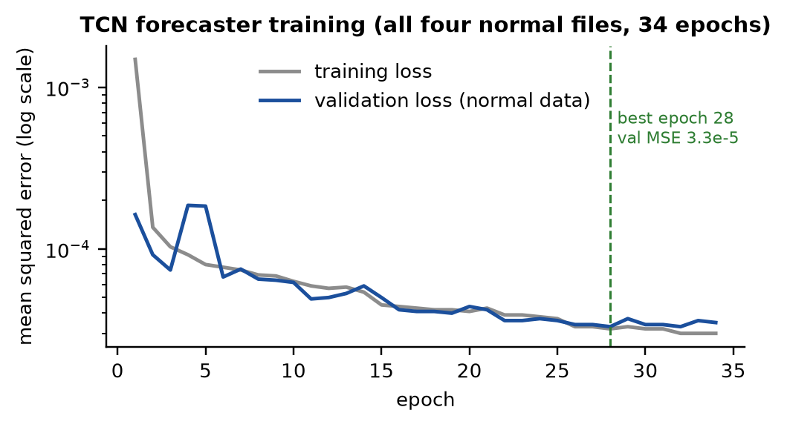
Figure 3. TCN training and validation loss (mean squared error, log scale).
On the unseen normal test file the all-files TCN reaches a mean squared error of 1.62e-4, about four times lower than the TCN trained on train_1 only (6.47e-4) and eleven times lower than the GRU (1.844e-3). A more accurate forecaster gives a smaller normal error, which makes a surprise from an attack easier to see (Table 6).
Table 6. Mean squared forecast error on unseen normal driving (syncan_test_normal.csv).
Model | Mean MSE | Relative to TCN (all files)
TCN, all four normal files (final) | 0.000162 | 1.0×
TCN, train_1 only | 0.000647 | 4.0×
GRU, train_1 only (baseline) | 0.001844 | 11.4×

4.4 Detector: one score, one threshold
For every tick the detector takes, per signal, four kinds of evidence (Table 7). Each is divided by a per-signal scale learned from normal driving (the 99.9th percentile, with a floor of 0.01 on the signed channel so that an extremely accurate forecaster does not get an alarm line at a sliver of a signal’s range). The tick’s score is the maximum over all signals and channels. A tick is flagged when the score exceeds a single threshold τ, set on normal data (the train_1 validation part plus the validation tails of train_2, train_3 and train_4) as the smallest value giving at most 0.1 alerts per minute. With the TCN-all forecaster τ = 1.866; on 207 minutes of calibration traffic this gave 0.039 alerts per minute, and on 75 minutes of unseen normal driving 6 alerts, 0.080 per minute.
Table 7. The four evidence channels of the Branch 1 detector, and their weight on replay ticks.
Channel | What it measures | Scale from normal data | On flagged replay ticks
signed | Absolute value of the 0.5 s running mean of the signed forecast residual (a persistent bias, not noise) | 99.9th percentile, floor 0.01 | 86%
stale | Ticks since the signal last transmitted (suppression) | 1.5 × largest normal staleness | 0%
frozen | Length of a run of identical values (plateau) | 99.99th percentile, at least 1 | 0%
partner | Distance of a signal from what its cross-ID partners imply (ridge regression on partner values now and 10 ticks earlier; kept only if R² ≥ 0.95 on unseen normal data; 12 of 20 signals) | 99.9th percentile | 69%

The percentages are the share of flagged replay ticks on which the channel is above the line (a tick can carry several). Replay is carried almost entirely by the signed-residual and partner channels. Branch 2 (message-rate and plausibility limits, all taken from normal data) and the fusion rule (flag if either branch flags) complete the system; Branch 2 is irrelevant for replay and is not discussed further.
An alert is a flagged run, merged across gaps of at most 10 ticks. At event level, ground-truth intervals are formed by merging labelled ticks across gaps of at most 100 ticks, because SynCAN labels individual frames.

4.5 Naming rules (baseline)
Each alert is named by plain rules, with no training, checked in this order; the first that fires wins (Table 8). “Replay” is what is left when none of the others fires, so it has no evidence of its own.
Table 8. Attack-type rules of classify.py, in priority order.
# | Label | Rule
1 | flooding / fuzzing | At least a quarter of the alert’s ticks carry Branch 2’s “too many messages” / “values out of range” evidence
2 | suppression | The staleness channel is above its threshold
3 | plateau | The frozen-value channel fires; or the biggest-error signal at the alert’s peak has been flat for a whole detector window and the freeze is “informative” (began at the alert, or the signal is not naturally flat)
4 | drift | Some signal moves smoothly in one direction (a noise-free straight or steadily curving line) during the alert or the 360 ticks after it
5 | replay | None of the above

4.6 Replay-specific modifications
All replay work was added in new files, and no existing pipeline file was changed (Table 9); the new code only calls the existing functions.
Table 9. Replay-specific components added on this branch.
Component | File | Purpose
Replay scorecard | replay_eval.py, replay_cache.py, scripts/replay_scorecard.py | Tick, event and naming metrics on the replay file; first half / second half; detector rebuilt from cached forecasts
Detected vs named report | replay_naming.py, scripts/replay_report.py | “replay” vs “other” naming, false alarms listed apart
Start walk-back (Phase 1) | replay_post.py | Move an alert’s start back while the score is still above 0.6 τ (up to 50 ticks)
Short-window end-finder | replay_bounds.py, scripts/replay_end_finder.py | Find where an alert really ends; error budget of false / missed ticks
Resting-value plateau test | replay_naming.py | Tell a replay of a flat signal from a plateau attack
Cross-ID TCN (experiment) | models/tcn_xid.py, scripts/xid_feasibility.py | Feasibility gate for a replay-aimed reconstruction model (stopped)

4.6.1 Evaluation protocol: detected vs named, first half vs second half
Detected is measured on the replay file only. At tick level, each 0.01 s tick is a prediction against the Label ground truth: TP, FP, FN, TN, accuracy, precision, recall and F1. Tick accuracy is not a headline number, because about 87% of ticks are normal. At event level, each attack interval counts as found if any tick of it is flagged, each alert is counted once, and strict precision requires an alert to lie at least 50% inside attacks. Named counts only alerts that overlap a real attack: replay alerts named “replay”, other-attack alerts named “other”, and the precision of the “replay” label. Alerts that overlap no attack are false alarms and are reported separately.
Every replay setting was chosen on the first half of the replay file (cut at a quiet point at least 1,000 ticks from any attack) and reported on the second half; the whole-file figures are optimistic because half of the file chose the settings. The detector threshold and all channel scales come from normal data only.

4.6.2 Start walk-back and the short-window end-finder
The detector’s score is a 50-tick running mean, so it crosses the threshold some ticks after an attack begins and stays above it for 25 to 50 ticks after the attack ends. Of the baseline’s 3,793 false-positive ticks, 3,440 lie within 100 ticks after an attack (the error budget is in Section 5.3). Two corrections were added, both using hindsight (they look at ticks up to the alert’s end, so they improve the tick-level numbers and not the real-time delay):
- Start walk-back. Move an alert’s first tick back while the score stays above α·τ, for at most 50 ticks, never into the previous alert (α = 0.6).
- End-finder. Compute the same evidence with a short running mean (20 ticks instead of 50), calibrated on normal data by the same recipe, and cut the alert after the last tick where that short score is above 0.75 times its own threshold, plus a margin of −10 ticks. Alerts are never created, removed or extended and interior gaps are untouched. Windows of 5 to 15 ticks were useless: their normal-data threshold is 12 to 31, far too high to see an attack.
The window, line multiple, margin and the start settings were each picked from a small grid on the first half (window 20; line 0.75; margin −10; α 0.6; walk-back 50).

4.6.3 Resting-value plateau test
Replays and plateaus both produce a flat line on some signals, so the baseline rules confuse them: 9 of 137 replay alerts were named plateau, and 25 plateau alerts were named replay because the flat signal was not the biggest-error one at the alert’s peak. The new clue comes from normal data. A replay plays back values that really occurred, so a flat stretch it shows sits at a value the signal normally rests at. A plateau freezes the signal at an arbitrary constant, which for a signal that is rarely or never flat in normal driving is not a resting value. For every signal, the values it takes while sitting in a flat run of at least 50 ticks in normal data are recorded. An alert is then named plateau if the frozen-value channel fires, or if any signal the detector blames is flat for at least 70% of the alert at a value holding less than 10% of that signal’s normal flat-run ticks. This replaces the “informative freeze” test; the other rules and their order are unchanged. Flat share (0.5 or 0.7) and rest share (0.05, 0.2, 0.5) were compared on the first half.

4.6.4 Cross-ID reconstruction (experiment)
Idea: train a TCN that predicts one ID’s values from the other IDs only, with that ID’s channels hidden and a one-hot “which ID is hidden” input. A replayed ID has believable history but is out of step with the other IDs for the whole attack, so the reconstruction error should stay high where the forecast error fades. A short model (101,204 parameters, 12,000 steps of 512, normal data only) was trained as a feasibility gate before committing to the two-hour full recipe. The gate asks two questions: can the model reconstruct each signal on held-out normal data (R² ≥ 0.9), and does its error stay high through the whole of the 17 weakest attacks? If not, stop.

5. Results and Discussion
All numbers are from the replay file (449,994 ticks) computed from the forecast cache, and are reproducible with scripts/replay_report.py and scripts/replay_end_finder.py. The cache stores forecasts as float32, so tick counts can differ from a live run by a few ticks.

5.1 Baseline behaviour
The baseline detects replay quickly: the first flagged tick comes a median of 4 ticks after the start (90th percentile 11, maximum 26), so the misses are not a slow start. The errors are concentrated: 17 of the 93 attacks hold 4,048 of the 5,308 missed ticks (Figure 5), because in those the score peaks early and then fades back under the threshold while the attack continues (Figure 4b), a replayed signal soon following a plausible path. Two attacks (at ticks 375,756 and 31,825) never rise above 0.84 and 1.49 times the threshold: essentially no evidence. In quiet traffic the score already sits at 0.5 to 0.8 times the threshold, so there is no headroom to recover a fading attack by lowering the line.
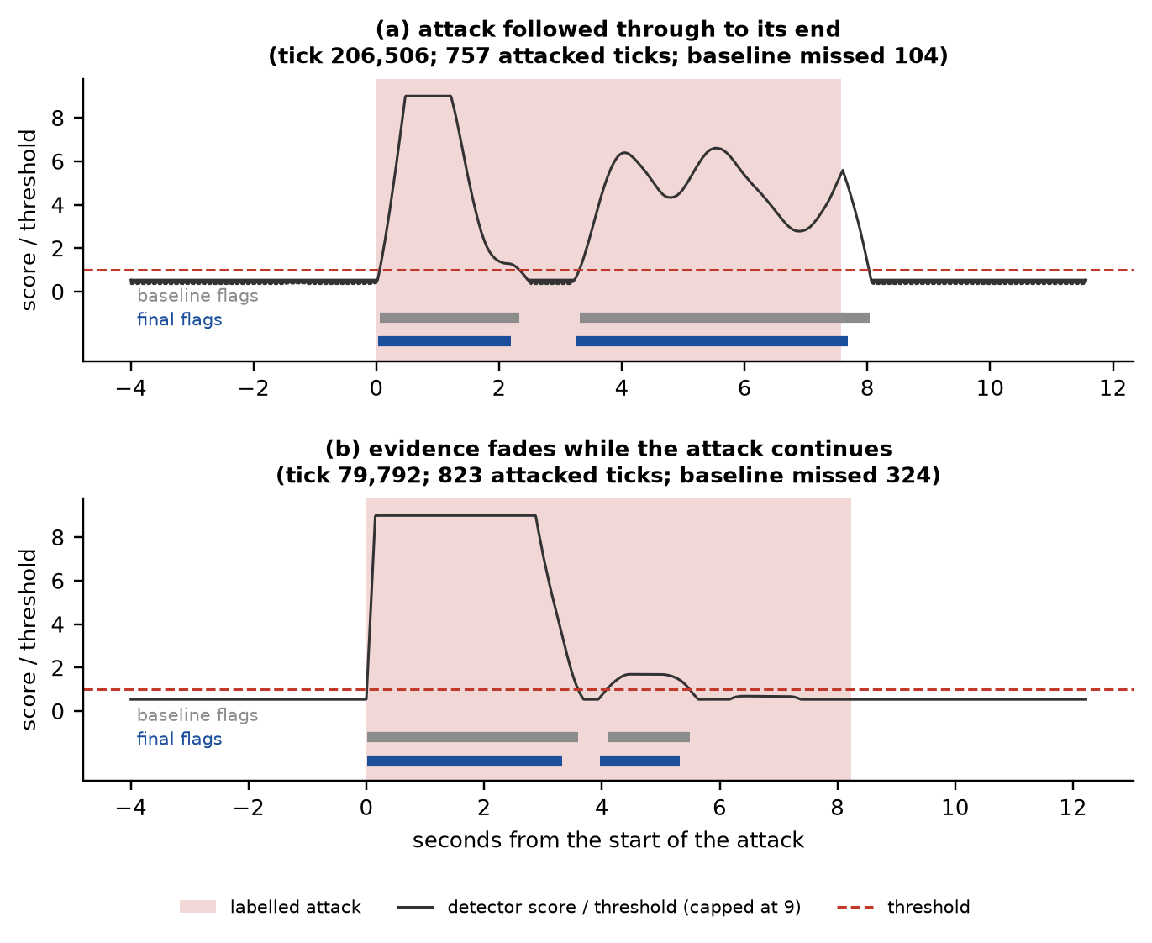
Figure 4. Two replay attacks. (a) The alert follows the attack; the final flags (blue) end where the evidence ends, cutting the baseline’s tail (grey). (b) The evidence fades while the attack continues, so the alert breaks up and ends early.
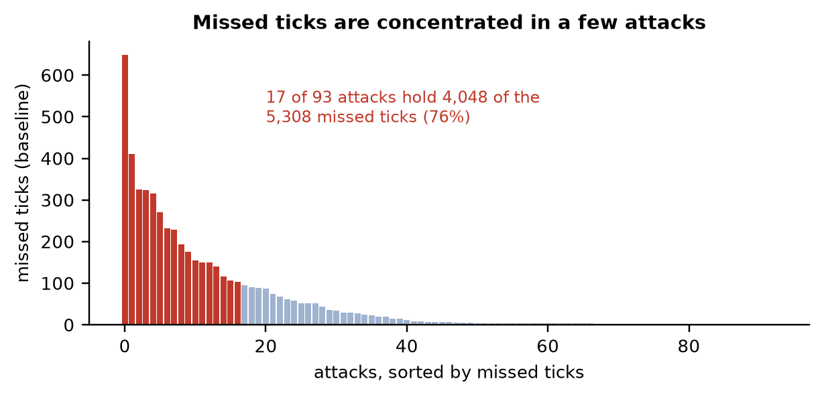
Figure 5. Missed ticks of the baseline, per attack, sorted. 17 of 93 attacks account for 76% of all missed ticks.

5.2 Effect of the replay-specific refinement
Table 10 gives the full confusion matrix and metrics at each stage, for the whole file and for each half. Stage D (start walk-back plus end-finder) is the final setup.
Table 10. Tick-level results on the replay file (TP, TN, FP, FN, accuracy, precision, recall, F1).
Stage | Span | TP | TN | FP | FN | Accuracy | Prec. | Recall | F1
A. Baseline (current pipeline) | whole | 53,894 | 386,999 | 3,793 | 5,308 | 0.9798 | 0.934 | 0.910 | 0.9221
 | 1st half | 25,585 | 194,561 | 2,044 | 2,167 | 0.9812 | 0.926 | 0.922 | 0.9240
 | 2nd half | 28,309 | 192,438 | 1,749 | 3,141 | 0.9783 | 0.942 | 0.900 | 0.9205
B. Phase 1: start walk-back + 25-tick trim | whole | 53,242 | 388,756 | 2,036 | 5,960 | 0.9822 | 0.963 | 0.899 | 0.9302
 | 1st half | 25,421 | 195,465 | 1,140 | 2,331 | 0.9845 | 0.957 | 0.916 | 0.9361
 | 2nd half | 27,821 | 193,291 | 896 | 3,629 | 0.9799 | 0.969 | 0.885 | 0.9248
C. End-finder alone | whole | 52,675 | 389,647 | 1,145 | 6,527 | 0.9830 | 0.979 | 0.890 | 0.9321
 | 1st half | 25,059 | 195,930 | 675 | 2,693 | 0.9850 | 0.974 | 0.903 | 0.9370
 | 2nd half | 27,616 | 193,717 | 470 | 3,834 | 0.9809 | 0.983 | 0.878 | 0.9277
D. Start walk-back + end-finder (final) | whole | 53,603 | 389,441 | 1,351 | 5,599 | 0.9846 | 0.975 | 0.905 | 0.9391
 | 1st half | 25,571 | 195,833 | 772 | 2,181 | 0.9868 | 0.971 | 0.921 | 0.9454
 | 2nd half | 28,032 | 193,608 | 579 | 3,418 | 0.9823 | 0.980 | 0.891 | 0.9335

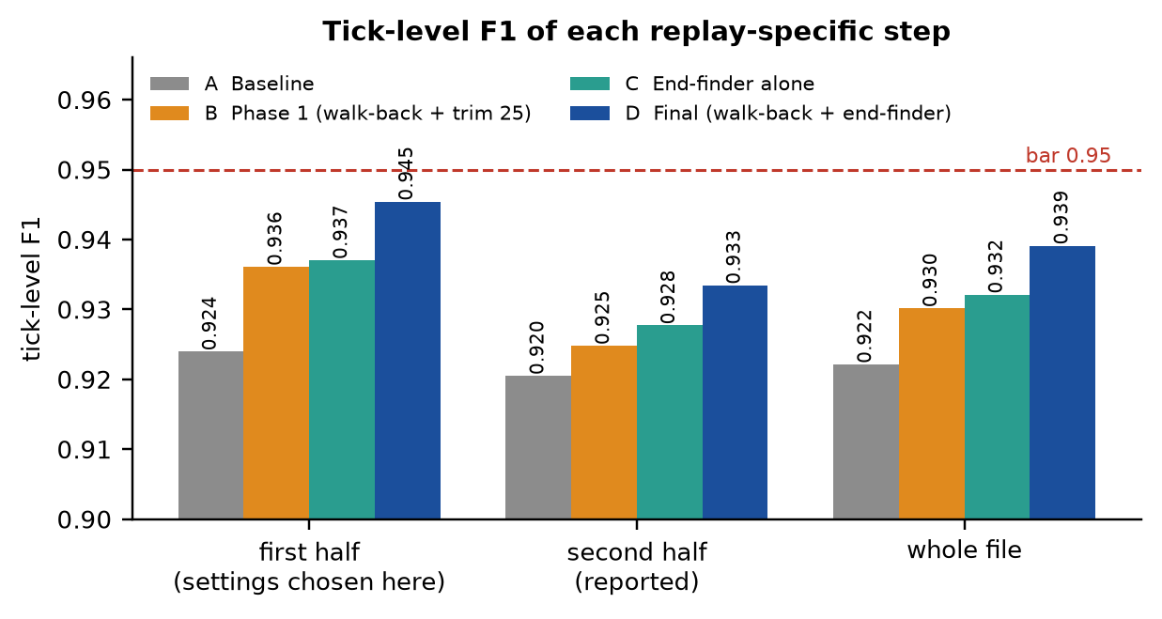
Figure 6. Tick-level F1 of each step, on the first half (settings chosen), the second half (reported) and the whole file.
The final stage lifts the tick-level F1 from 0.9221 to 0.9391 over the whole file and from 0.9205 to 0.9335 on the held-out second half. The gain comes from precision (0.934 → 0.975); recall is essentially unchanged (0.910 → 0.905). Accuracy rises from 0.9798 to 0.9846. The end-finder alone (C) beats the older fixed 25-tick trim (B), and combining it with the start walk-back (D) is best on both halves. Event-level results are identical for all four stages, since the refinement changes tick boundaries, not which alerts exist: 92 of 93 attacks found, 142 alerts of which 5 are false alarms, strict precision 0.958 and strict F1 0.973.
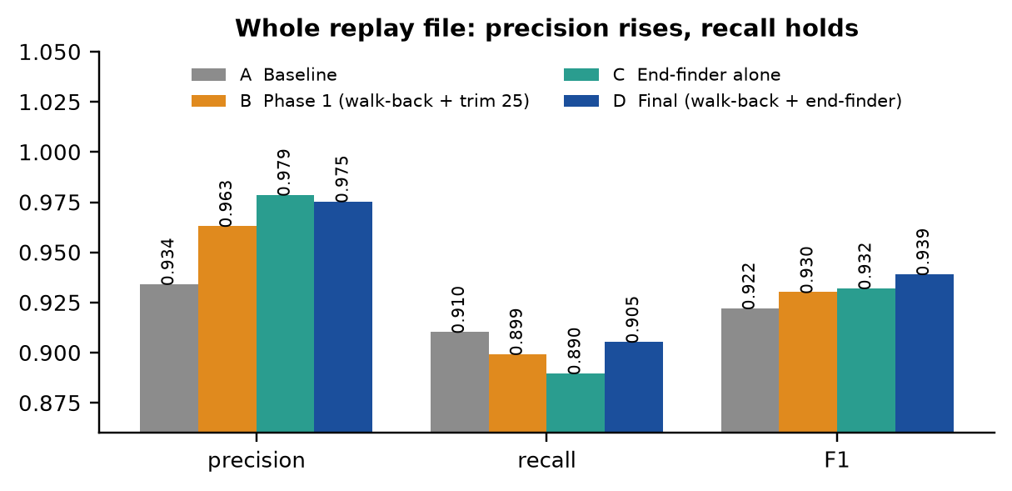
Figure 7. Whole replay file: precision, recall and F1 at each stage.

5.3 Where the remaining errors are
Splitting every error by where it falls (Table 11, Figure 8) shows what was fixed and what is left. False-positive ticks fell from 3,793 to 1,351: the tail after an attack dropped from 3,440 to 912, and 164 are label holes (flagged ticks inside an attack interval where the ground-truth label has a hole, which are not real errors). Missed ticks rose slightly, from 5,308 to 5,599, because trimming a tail can also remove real attack ticks after the evidence faded. The remaining gap to 0.95 is therefore on the recall side: 2,951 missed ticks in gaps in the middle of attacks, 1,773 where the alarm faded out early, and 649 in the one attack never found.
Table 11. Error budget: where false-positive and missed ticks fall (whole replay file).
Error type | Baseline | Final (D)
FP: tail after an attack (≤ 100 ticks) | 3,440 | 912
FP: just before an attack | 38 | 127
FP: label holes inside an attack (not real errors) | 164 | 164
FP: isolated false alarms | 151 | 148
False positives, total | 3,793 | 1,351
FN: attack never found | 649 | 649
FN: before the first alarm | 469 | 226
FN: gaps between first and last alarm | 2,750 | 2,951
FN: alarm faded out early | 1,440 | 1,773
Missed ticks, total | 5,308 | 5,599

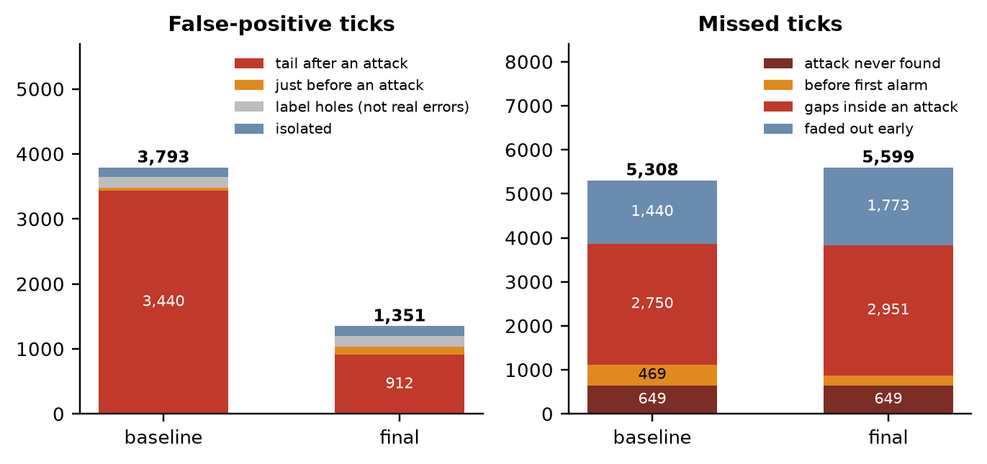
Figure 8. Composition of the false-positive and missed ticks before and after the refinement.
Removing the after-attack tail alone, with nothing else lost, would give an F1 of about 0.950; in practice the end-finder removes most of the tail (3,440 → 912) but also some real ticks, ending at 0.939. The two nearly invisible attacks (events at ticks 31,825 and 375,756) are outside the reach of boundary refinement.

5.4 Naming: replay versus other
Naming results use the five real files (replay, plateau, drift, suppression, flooding), counting only alerts that overlap a real attack (Table 12, Figure 9). With the baseline rules, 124 of 137 replay alerts are named “replay” (90.5%); the 13 errors are 9 replays named plateau and 4 named drift (replays of naturally flat signals such as id6_sig1, id4_sig1 and id2_sig1). 33 of 485 other-attack alerts are named “replay”: 25 plateau and 8 drift. Suppression and flooding alerts are never named replay.
Table 12. Naming of alerts that overlap a real attack (“replay” vs “other”).
Rule / span | Replay named replay | Other attacks named other | “Replay” label precision | “Replay” label F1 | Overall accuracy
classify.py rules, whole | 124/137 = 90.5% | 452/485 = 93.2% | 79.0% | 0.844 | 92.6%
first half | 57/65 = 87.7% | 228/241 = 94.6% | 81.4% | 0.844 | 93.1%
second half | 67/72 = 93.1% | 224/244 = 91.8% | 77.0% | 0.843 | 92.1%
Resting-value rule, whole | 132/137 = 96.4% | 469/485 = 96.7% | 89.2% | 0.926 | 96.6%
first half | 61/65 = 93.8% | 235/241 = 97.5% | 91.0% | 0.924 | 96.7%
second half | 71/72 = 98.6% | 234/244 = 95.9% | 87.7% | 0.928 | 96.5%

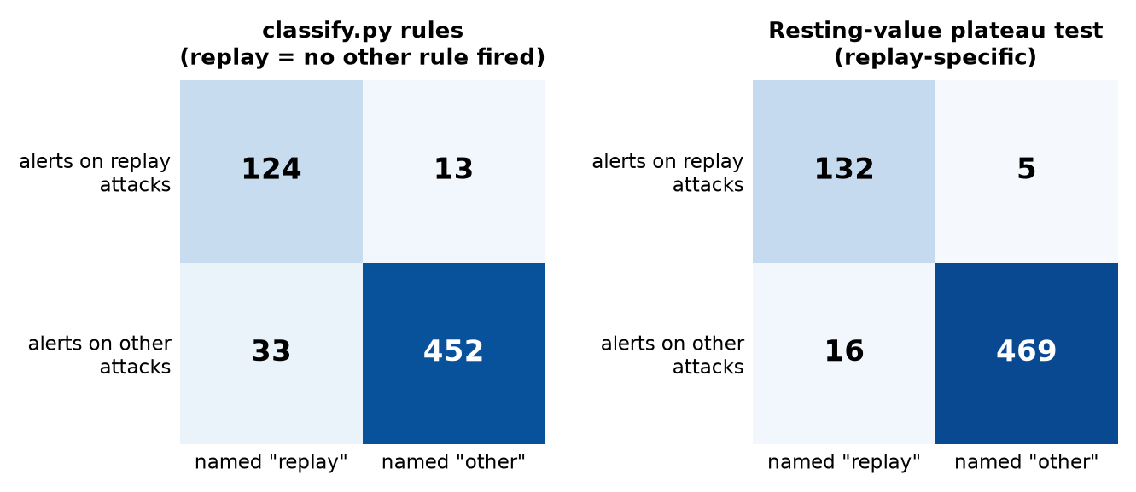
Figure 9. Naming confusion matrices before (left) and after (right) the resting-value plateau test.
The resting-value test measures the held value of a signal that is flat for most of an alert, against the values that signal takes in normal flat runs. On the 119 plateau alerts and 47 replay alerts where a blamed signal is flat, the share of normal flat time at the held value has a median of 0.99 for replays and 0.00 for plateaus (AUC 0.90, Figure 10). On signals that are never flat in normal driving, a plateau’s value is never a resting value (71 alerts, 1 exception). Replacing the informative-freeze test with this clue raises the replay alerts named “replay” from 124 to 132 of 137 and cuts other attacks wrongly named “replay” from 33 to 16, with detection unchanged. Remaining errors: 5 replay alerts named drift (a smooth stretch inside the replay), 8 drift and 8 plateau alerts named replay (about half of them carry only partner evidence, and the plateau ones sit on resting values). The 44 false alarms named “replay” are a detection problem, not a naming one.
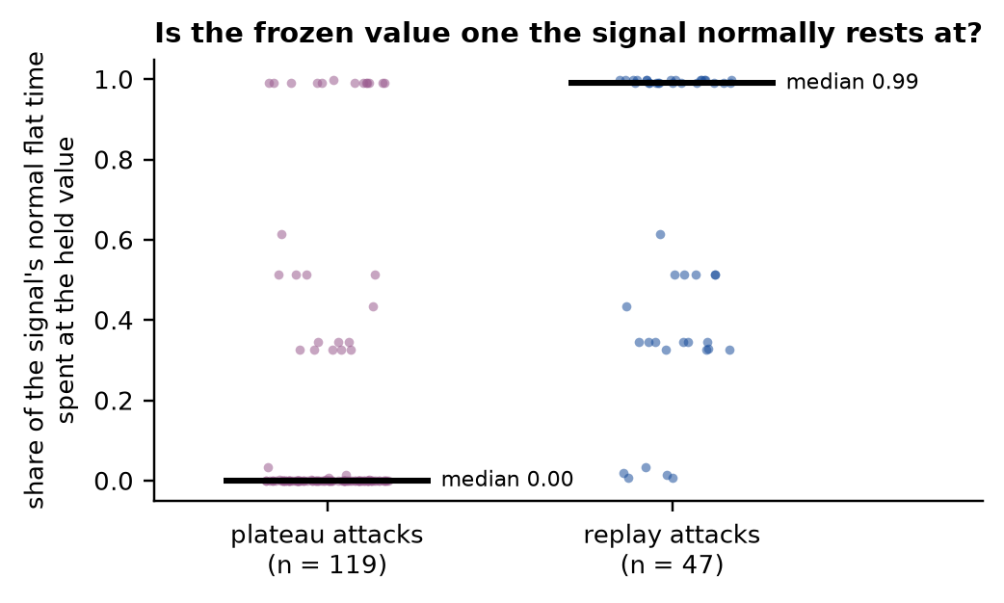
Figure 10. The held value of a frozen signal: share of the signal’s normal flat time spent at that value. Replays freeze at a value the signal normally rests at; plateaus almost never do.
Before settling on this clue, simpler variants of the naming rule only traded one error for the other (Table 13): each loses true replays when it removes wrong ones, and the replay-label F1 stays near 0.84. A strict positive rule on the largest value jump (“≤ 6× the normal maximum and no blamed signal flat for ≥ 70%”) is precise but names only 54 to 64% of replays, because replays also have large jumps at their start.
Table 13. Naming-rule variants tried on the classify.py rules (alerts overlapping real attacks; first half / second half). None beat the replay-label F1 of about 0.84; the resting-value rule reaches 0.926.
Rule variant | Replay named replay (1st / 2nd) | Other attacks named replay (1st / 2nd)
Current classify.py rules | 57/65, 67/72 | 13/241, 20/244
Plateau test on any blamed signal | 52/65, 62/72 | 7/241, 12/244
… and signed error must carry ≥ 30% of the alert | 49/65, 57/72 | 2/241, 9/244
Resting-value rule (final) | 61/65, 71/72 | 6/241, 10/244

5.5 Negative result: the cross-ID reconstruction model
The feasibility gate failed (Table 14, Figure 11), so the two-hour training was not run. Fifteen of the 20 signals reached R² ≥ 0.9 on held-out normal driving, but only 3 of the 8 signals that have no partner model (id4_sig1, id5_sig1, id7_sig1); the others scored 0.63, 0.78, −0.10, 0.85 and 0.63. On the 17 weakest attacks the reconstruction error did not stay high: it flagged at least 80% of the second half of the attack in only 5 of 17 (mean 0.53, against 0.60 for the current detector), so the two channels fade together. A preview that adds the channel to the detector reduced missed ticks from 5,308 to about 4,580, lifted tick F1 only from 0.922 to 0.928 (before any refinement), and recovered one attack (649 missed ticks down to 28), which brings the events to 93 of 93, but it raised false alarms on unseen normal driving from 0.08 to 0.33 per minute. The second invisible attack stayed invisible (peak at 0.86× its threshold). The verdict is that the added evidence is too small to justify the training cost.
Table 14. Cross-ID feasibility gate and its preview on the replay file (no refinement).
Measure | Current detector | + xid channel (union) | + xid (one score)
Signals with held-out R² ≥ 0.9 | n/a | 15 of 20 (3 of the 8 uncovered) | same
Tick F1 (no refinement) | 0.922 | 0.928 | 0.927
Missed ticks | 5,308 | 4,586 | 4,578
Attack intervals found | 92 / 93 | 93 / 93 | 93 / 93
False alarms, unseen normal, per minute | 0.080 | — | 0.333
Weak attacks with xid ≥ 80% in 2nd half | n/a | 5 of 17 | —

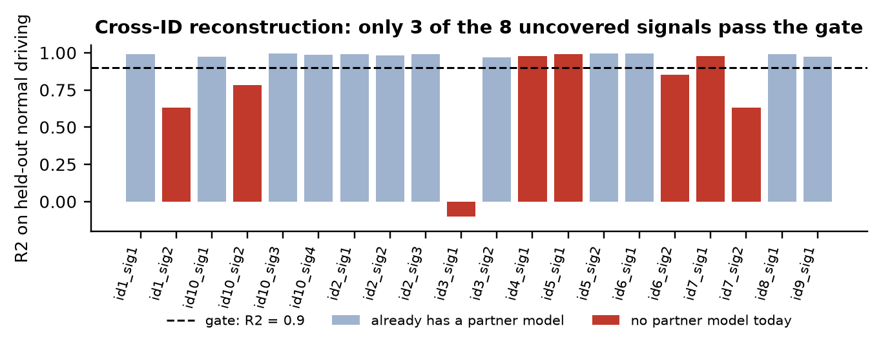
Figure 11. Cross-ID reconstruction accuracy on held-out normal driving; only 3 of the 8 signals without a partner model reach the R² = 0.9 gate.

5.6 Comparison with the targets and discussion
Table 15. Final status against the 95% bar.
Bar | Result | Verdict
Tick-level F1 ≥ 0.95 | 0.939 whole, 0.934 second half | Not met (gap 0.011 to 0.016)
Attack intervals found 93 / 93 | 92 / 93 | Not met
Event-level strict F1 ≥ 0.95 | 0.973 | Met
Replay named “replay” ≥ 95% | 96.4% whole, 98.6% second half | Met
Precision of the “replay” label ≥ 95% | 89.2% (second half 87.7%) | Not met
Tick accuracy ≥ 0.99 (stretch) | 0.9846 | Not met

What worked. Finding the true start and end of each alert removed 64% of the false-positive ticks at almost no cost to recall, and the resting-value test fixed most of the replay-versus-plateau confusion with a clue taken from normal data. What did not. Hysteresis, dropping short weak alerts, naming incidents from the union of their alerts, a plateau-onset-jump clue and a cross-ID model each gave no gain or too little (Section 4.6 and Appendix). Why 0.95 is still out of reach. The remaining 5,599 missed ticks are mostly alerts that break up inside an attack (2,951) or fade early (1,773): the evidence is simply weak there, because a replayed signal follows a believable path and the other IDs do not contradict it strongly enough. Lowering the threshold does not help because quiet traffic already sits at 0.5 to 0.8 times it.
Threats to validity. (i) The attack-type rules, and the resting-value clue, were designed while examining the real SynCAN attack files, so the naming figures are optimistic as a general claim; the first-half / second-half split checks stability inside one file, not generalisation to unseen attacks. (ii) The refinement uses hindsight and improves tick-level numbers, not real-time delay. (iii) The whole-file figures of a tuned setting are optimistic; the second-half column is the honest one. (iv) Only one replay file exists, and the practice replay file (injected attacks) was not available for an extra out-of-sample check. (v) Cached float32 forecasts differ from the live pipeline by a few ticks.

6. Conclusion and Future Work

6.1 Conclusion
A forecast-based detector trained on normal driving only detects almost all replay attacks quickly, but its 50-tick running mean makes the alert boundaries blurry and its default naming rule treats “replay” as a leftover. Separating detected from named showed that the two problems are different. Correcting alert boundaries with a short-window end-finder and a start walk-back raised tick-level F1 from 0.922 to 0.939 (0.934 on the held-out half) and precision from 0.934 to 0.975, and a resting-value test, taken from normal data, raised the share of replay alerts named correctly from 90.5% to 96.4% while halving the number of other attacks wrongly called replay. The 0.95 tick-level target and the 93-of-93 target were not met; a cross-ID reconstruction model did not pass its feasibility gate. The work stays on a separate branch in new files and can be rolled back by deleting them.

6.2 Future work
- Bridge or hold alerts through dips inside an attack. The largest remaining error is 2,951 missed ticks in gaps in the middle of attacks. Doing this needs a gap length chosen from attack data, like the other settings but with a stronger tie to attack structure; it should only be done with the owner’s explicit approval and reported on the second half.
- New evidence for faded and invisible attacks: a different property of the data (for example how groups of signals move together over time), or a stronger cross-ID model for the five signals that cannot be predicted from the others.
- Positive replay naming: a tiered label that says “replay” only with positive evidence and otherwise “other attack”, to push the precision of the replay label above 95%; the open case is a replay on a signal whose plateau also lands on its resting value.
- Wire the new rules into the live pipeline (they currently run in the report scripts), and re-evaluate on the final TCN residuals after the teammate’s branch is merged.
- Out-of-sample checks: rebuild the practice replay file from held-out normal data and score the chosen settings there; evaluate on additional recordings if available.

7. References
[1] Robert Bosch GmbH, “CAN Specification, Version 2.0,” Stuttgart, 1991.
[2] K. Koscher et al., “Experimental security analysis of a modern automobile,” in Proc. IEEE Symposium on Security and Privacy, 2010.
[3] C. Miller and C. Valasek, “Remote exploitation of an unaltered passenger vehicle,” Black Hat USA, 2015.
[4] M. Müter and N. Asaj, “Entropy-based anomaly detection for in-vehicle networks,” in Proc. IEEE Intelligent Vehicles Symposium, 2011.
[5] K.-T. Cho and K. G. Shin, “Fingerprinting electronic control units for vehicle intrusion detection,” in Proc. USENIX Security Symposium, 2016.
[6] M.-J. Kang and J.-W. Kang, “Intrusion detection system using deep neural network for in-vehicle network security,” PLoS ONE, vol. 11, no. 6, e0155781, 2016.
[7] H. M. Song, J. Woo and H. K. Kim, “In-vehicle network intrusion detection using deep convolutional neural network,” Vehicular Communications, vol. 21, 100198, 2020.
[8] A. Taylor, S. Leblanc and N. Japkowicz, “Anomaly detection in automobile control network data with long short-term memory networks,” in Proc. IEEE Int. Conf. on Data Science and Advanced Analytics (DSAA), 2016.
[9] M. Hanselmann, T. Strauß, K. Dormann and H. Ulmer, “CANet: An unsupervised intrusion detection system for high dimensional CAN bus data,” IEEE Access, vol. 8, pp. 58194–58205, 2020.
[10] S. Bai, J. Z. Kolter and V. Koltun, “An empirical evaluation of generic convolutional and recurrent networks for sequence modeling,” arXiv:1803.01271, 2018.
[11] K. Cho et al., “Learning phrase representations using RNN encoder–decoder for statistical machine translation,” in Proc. EMNLP, pp. 1724–1734, 2014.
[12] S. Hochreiter and J. Schmidhuber, “Long short-term memory,” Neural Computation, vol. 9, no. 8, pp. 1735–1780, 1997.
[13] V. Chandola, A. Banerjee and V. Kumar, “Anomaly detection: A survey,” ACM Computing Surveys, vol. 41, no. 3, art. 15, 2009.
[14] F. T. Liu, K. M. Ting and Z.-H. Zhou, “Isolation forest,” in Proc. IEEE Int. Conf. on Data Mining (ICDM), pp. 413–422, 2008.
[15] I. Loshchilov and F. Hutter, “Decoupled weight decay regularization,” in Proc. ICLR, 2019.
[16] T. Salimans and D. P. Kingma, “Weight normalization: A simple reparameterization to accelerate training of deep neural networks,” in Advances in Neural Information Processing Systems (NeurIPS), 2016.
[17] CANIDS project documentation: docs/10-detector.md, docs/11-real-data-results.md, docs/12-branch2.md, docs/13-partner-channel.md, docs/14-replay-branch.md, and REPLAY_PLAN.txt.

8. Appendix

Appendix A. Reproducing the results
From the repository root, in the canids environment. The forecast cache (*.npz) is git-ignored and must be regenerated first (about 20 minutes on a GTX 1650):
python -u scripts/cache_gru_outputs.py data/cache_tcn_all --forecaster tcn \
--model-path models/tcn_syncan_all.pt \
--normal train2v=data/processed/syncan_train_2_val.csv \
--normal train3v=data/processed/syncan_train_3_val.csv \
--normal train4v=data/processed/syncan_train_4_val.csv

# then, each with the cache folder as its argument:
python scripts/replay_scorecard.py data/cache_tcn_all
python scripts/replay_report.py data/cache_tcn_all
python scripts/replay_end_finder.py data/cache_tcn_all
python scripts/xid_feasibility.py data/cache_tcn_all
python -m pytest -q
The four scripts print, in order: the baseline scorecard; replay detected vs replay named under both naming rules; the start walk-back and end-finder with the error budget; and the cross-ID feasibility gate. The test suite has 278 tests.

Appendix B. Constants used
Table 16. Main constants of the detector and of the replay-specific work.
Constant | Value | Where it comes from
Grid step / window length | 0.01 s / 50 ticks | Fixed once for all models
Detector window | 50 ticks (0.5 s) | Chosen on real data (docs/10)
False-alarm budget | 0.1 per minute | Normal data
Evidence scale percentile (signed, partner) | 99.9 | Normal data
Frozen-run percentile / stale margin | 99.99 / 1.5× | Normal data
Signed-scale floor | 0.01 | Final TCN run
Partner channel: lag, minimum R² | 10 ticks, 0.95 | Normal data (unseen part)
Alert merge gap / event merge gap | 10 / 100 ticks | Evaluation convention
Smooth-ramp test (lag, eps, min change) | 60 ticks, 0.03, 0.02 | First halves of drift / replay files
Threshold τ (TCN-all) | 1.866 | Normal data only
Start walk-back: α, max back | 0.6, 50 ticks | First half of replay file
End-finder: window, line, margin | 20 ticks, 0.75 × 1.88, −10 | First half of replay file
Resting-value rule: flat share, rest share, eps | 0.7, 0.10, 0.01 | First half of the files; normal data

Appendix C. Cross-ID reconstruction accuracy per signal
Table 17. Held-out normal R² of the short cross-ID model, per signal (gate R² ≥ 0.9).
Signal | R² | Partner model today | Signal | R² | Partner model today
id1_sig1 | 0.992 | yes | id3_sig2 | 0.970 | yes
id1_sig2 | 0.632 | no | id4_sig1 | 0.978 | no
id10_sig1 | 0.975 | yes | id5_sig1 | 0.992 | no
id10_sig2 | 0.782 | no | id5_sig2 | 0.996 | yes
id10_sig3 | 0.997 | yes | id6_sig1 | 0.996 | yes
id10_sig4 | 0.985 | yes | id6_sig2 | 0.854 | no
id2_sig1 | 0.990 | yes | id7_sig1 | 0.980 | no
id2_sig2 | 0.984 | yes | id7_sig2 | 0.633 | no
id2_sig3 | 0.992 | yes | id8_sig1 | 0.990 | yes
id3_sig1 | −0.098 | no | id9_sig1 | 0.975 | yes

Appendix D. Dead ends (do not retry the same way)
- Dropping short, weak incidents to remove false alarms: no setting keeps every first-half attack, because short weak alerts include real attacks.
- Naming each incident once from the union of its alerts: no gain.
- Hysteresis (keep an alert open while the score stays above β·τ): β = 0.7 equal or worse; β ≤ 0.5 floods the file with false positives, because quiet traffic already sits at 0.5 to 0.8 times the threshold.
- “A plateau holds the old value, a replay jumps” as an onset clue: fails, because real plateau alerts jump at their start just like replays.
- Detector window and false-alarm budget grid (window 50 / 75 / 100 / 150 × 0.03 / 0.1 / 0.3 alerts per minute): window 50 at 0.1 per minute is already best for replay.
- Short-window end-finders with windows of 5 to 15 ticks: the normal-data threshold is too high to see an attack.
- Cross-ID reconstruction model as a replay channel: failed its feasibility gate (Section 5.5).

Appendix E. Files added on this branch
- src/canids/replay_eval.py, replay_cache.py, replay_post.py, replay_naming.py, replay_bounds.py, models/tcn_xid.py.
- scripts/replay_scorecard.py, replay_phase1.py, replay_detector_grid.py, replay_report.py, replay_end_finder.py, xid_feasibility.py.
- tests/test_replay_naming.py, tests/test_replay_bounds.py; docs/14-replay-branch.md; REPLAY_PLAN.txt.
- Rollback = delete the files above; no existing pipeline file was changed.

Appendix F. Glossary
Term | Meaning
Tick | One step of the 0.01 s joint time grid
Residual | True value minus the forecaster’s prediction, per signal and tick
Staleness | Ticks since a signal last genuinely transmitted
Alert | A run of flagged ticks, merged across gaps of at most 10 ticks
Replay detected | An alert covers a replay attack (tick and event metrics)
Replay named | An alert on a real attack carries the right label: “replay” for replay, “other” for any other attack
Strict precision | Share of alerts with at least 50% of their ticks inside attacks
Label holes | Ticks inside an attack interval whose ground-truth label is 0; flagging them is counted as a false positive but is not a real error
Resting value | A value a signal holds during long flat runs in normal driving

