**Assignment #2**

Report

**Team Members:**

|  |  |  |  |
| --- | --- | --- | --- |
| Name | Email | Contribution | Tasks |
| John Lee | hyunmail94@csu.fullerton.edu | 33% | Brainstorm  Coding  Debug/Troubleshoot  Testing/Build  Documentation |
| Qiyuan Liu | qiyuan.liu@csu.fullerton.edu | 33% | Brainstorm  Testing/Build  Troubleshoot  Documentation |
| Andre Victoria | andreappstuff@csu.fullerton.edu | 33% | Brainstorm  Coding  Testing/Build  Documentation |

Pseudocode and strategy on next Page.

**Shape 1**

**Part 1 (Crown Shape?)**

1. (Assume turtle begins at (0,0).
2. Arbitrarily set a height and width for the shape.
3. Move in the positive y direction (0,height) and use MoveGoal() to move the turtle there.
4. Use MoveGoal() to move to the center of the shape (width/2,height/2).
5. Use MoveGoal() to move to the top right corner of the shape. (width,height)
6. Use MoveGoal() to move to the bottom right corner of the shape (width,0)
7. Use MoveGoal() to move back to start position (0,0).

**Pseudocode:**

DrawCrown()

    float Height = 5

    float Width = 5

    Pose startPose = turtleSimPose

    Pose destinationPose

    destinationPose.x = startPose.x

    destinationPose.y = startPose.y+height

    MoveGoal(destinationPose)

    destinationPose.x = startPose.x + width/2

    destinationPose.y = startPose.y + height/2

       MoveGoal(destinationPose)

       destinationPose.x = startPose.x + width

    destinationPose.y = startPose.y + height

       MoveGoal(destinationPose)

       destinationPose.x = startPose.x + width

    destinationPose.y = startPose.y

       MoveGoal(destinationPose)

       destinationPose = startPose;

       MoveGoal(destinationPose)

**Shape 2**

Biggest circle: circle1, radius = 2r. Mid-sized circle: circle2, radius = r. Small circles: circle 3.1 and circle 3.2, radius = r/2.

From start point, rotate 150 degree clockwise on circle1, then rotate 145 degree clockwise on circle3.1, then rotate 300 degree counterclockwise on circle2, then rotate 145 degree clockwise on circle3.2, then rotate 150 degree clockwise on circle1

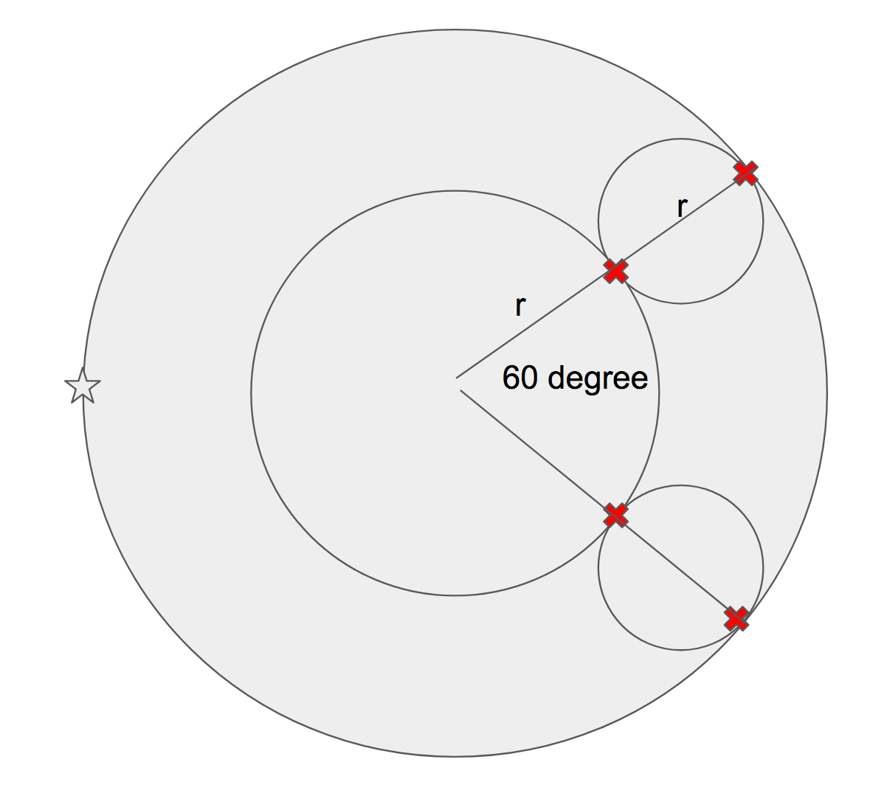

**Pseudocode:**

DrawC()

rotate(degrees2radians(150), clockwise); // Big Circle

rotate(degrees2radians(145), clockwise); // switch to upper Small Circle

rotate(degrees2radians(300), counterclockwise); // switch to Medium Circle

rotate(degrees2radians(145), clockwise); // switch to lower Small Circle

rotate(degrees2radians(150), clockwise); // switch back to Big Circle