IZMIR UNIVERSITY OF ECONOMICS

FACULTY OF ENGINEERING

CE 475 PROJECT REPORT



Emre ASLAN
20160602075

OUTLINE
- Identification and Significance of problem
- Methodology
- Implementation
- Results
- Conclusion

- Identification and Significance of problem
The problem I am trying to solve in this project is the non-personalized book purchasing experience. I've tried to solve the book buying problems here. In this way, someone will be able to access the recommendations based on the book bought by him/her. Actually, most people have an online experience where a website makes personalized recommendations in hopes of future sales or ongoing traffic. Amazon tells you “Customers Who Bought This Item Also Bought”, Udemy tells you “Students Who Viewed This Course Also Viewed”. Based on all this, I have developed a book suggestion system in this project. These personalized recommendations are so important, because it affects user experience and sales well. Also, Netflix awarded* a $1 million prize to a developer team in 2009, for an algorithm that increased the accuracy of the company’s recommendation system by 10 percent.
(*According to https://www.wired.com/2012/04/netflix-prize-costs/)

- Methodology
Firstly, I searched for a dataset to use and I found. It contains 1.1 million ratings of 270,000 books by 90,000 users. The ratings are on a scale from 1 to 10. I decided to use two different methods for the book recommendations. With a simple user interface, the user can select the method that he/she wants to use. These methods are as shown below.
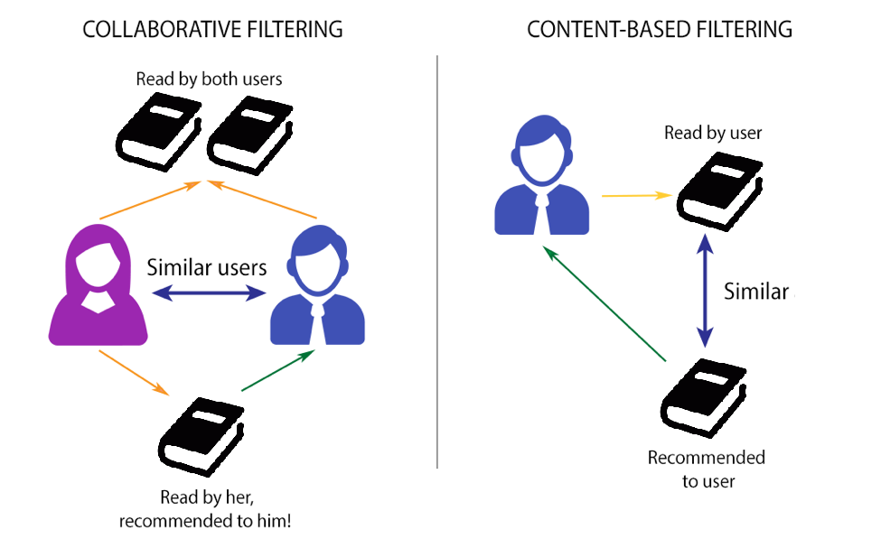
Content-based recommendation works with existing profiles of users. A profile has information about a user and their interest. Interest is based on user rating for different items. Generally, whenever a user creates his profile, recommendation system does a user survey to get initial information about the user in order to avoid new user problem. In the recommendation process, the system compares the items that are already positively rated by the user with the items he didn’t rate and looks for similarities. Items similar to the positively rated ones will be recommended to the user. Here, based on user’s interest and behavior a content-based model can be built by recommending books relevant to user’s interest.
The idea of collaborative filtering is finding users in a community that share appreciations. If two users have same or almost same rated items in common, then they have similar interest. Such users build a group or a so-called neighborhood. A user gets recommendations for those items that user hasn’t rated before but was positively rated by users in his/her neighborhood.

- Implementation
I started coding using PyCharm. First, the necessary libraries were imported. These are pandas, matplotlib and warnings libraries. Pandas; is an open source library that facilitates data analysis and data preprocessing. Matplotlib graphical drawing package is one of the most important tools of scientific programming with Python. With Matplotlib, a very powerful package, we can visualize data interactively and prepare high quality printouts for publishing. Warnings library provides control of warning messages. These are typically issued in situations where it is useful to alert the user of some condition in a program. However, we wanted to ignore some of them because there were too many warning messages in this design. The program basically does 5 operations. The first two, collaborative and content-based book suggestion functions. Third, print information about the dataset. Fourth is the graph of ratings distribution and the last one is graph of age distribution.

- Results
As a result, I have successfully used various filtering methods using Python. I've created user-friendly graphics and provided data set information. The user interface is as follows. You should make the selection and continue the operation.

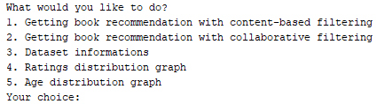
Here, the aim is to be simple and understandable. If you want content-based suggestions, give ‘1’ as the input and enter the ISBN of the book you purchased. The output will be created with a little delay because there are too many data. The output will be as follows.

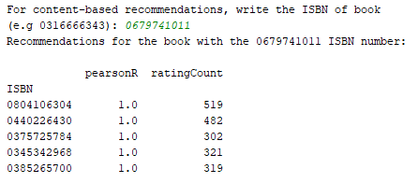

If you want to work with more advanced collaborative filtering, select 2 in the user interface. At this point, I narrowed the contents of the book in order to avoid various memory problems. Enter the index number of any of the 746 selected books to continue. The output will be as follows.

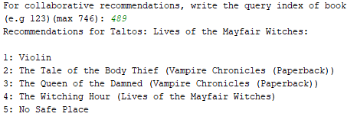

The output of the dataset information is as follows.

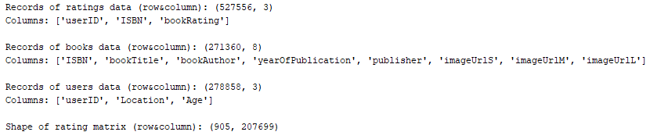

Evaluation and age distribution graphs are created as follows. There are too many unrated books that have 0 points in the data set. So, the first graph is formed in this way.
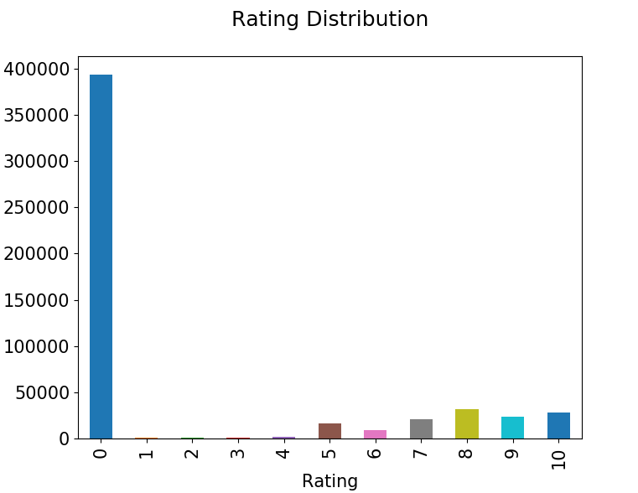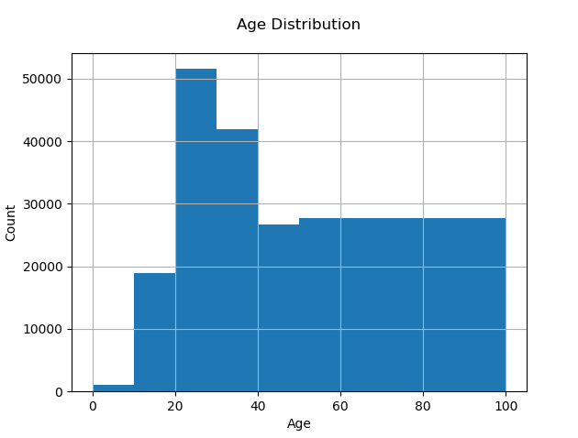

- Conclusion
During the study I learned about various machine learning methods. In the meantime, I realized that the lesson labs were very helpful.

