GESTURE RECOGNITION.
Abhishek
S V Girish

Problem Statement.

As a data scientist at a home electronics company which manufactures state of the art smart televisions. You want to develop a cool feature in the smart-TV that can recognize five different gestures performed by the user which will help users control the TV without using a remote. The gestures are continuously monitored by the webcam mounted on the TV. Each gesture corresponds to a specific command.

- Thumbs up: Increase the volume.
- Thumbs down: Decrease the volume.
- Left swipe: ‘Jump’ backwards 10 seconds.
- Right swipe: ’Jump’ forward 10 seconds.
- Stop: Pause the movie.

Understanding the dataset.

The training data consists of a few hundred videos categorized into one of the five classes. Each video (typically 2-3 seconds long) is divided into a sequence of 30 frames (images). These videos have been recorded by various people performing one of the five gestures in front of a webcam – similar to what the smart TV will use.

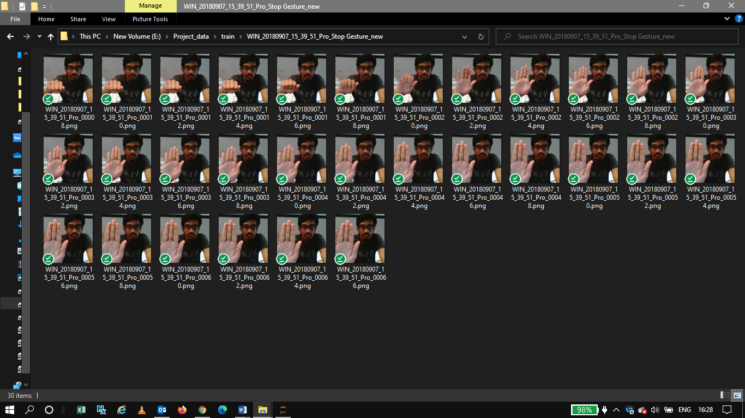

Project Objective.
Our task is to train a model on the train folder which performs well on the ‘val’ folder as well. We have with held the test folder for evaluation purposes – final model’s performance will be tested on the ‘test’ set.

Suggested Architecture.
Two Architectures: 3D Convs and CNN-RNN Stack

Convolutions + RNN
The conv2D network will extract a feature vector for each image, and a sequence of these feature vectors is then fed to an RNN-Based network. The output of the RNN is a regular softmax (for a classification problem such as this one).

3D Convolutional Network, or Conv3D
3D convolutions are a natural extension to the 2D convolutions you are already familiar with. Just like in 2D conv, you move the filter in two directions (x and y), in 3D conv, you move the filter in three directions (x,y and z). In this case, the input to a 3D conv is a video (which is a sequence of 30 RGB images). If we assume that the shape of each image is 100x100x3, for example, the video becomes a 4-D tensor of shape 100x100x3x30 which can be written as (100x100x30) x 3 where 3 is the number of channels. Hence, driving the analogy from 2-D convolutions where a 2-D kernel/filter (a square filter) is represented as (fxf)xc where f is filter size and c is the number of channels, a 3-D kernel/filter (a ‘cubic’ filter) is represented as (fxfxf)xc (here c = 3 since the input images have three channels). This cubic filter will now ‘3D-Convolve’ on each of the three channels of the (100x100x300 tensor.
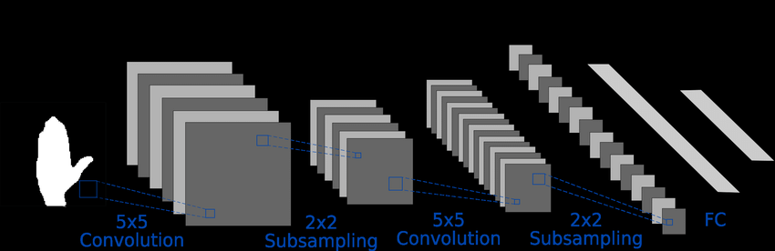
3D-CNN Representation.

CNN + RNN Architecture.

The conv2D network will extract a feature vector for each image, and a sequence of these feature vectors is then fed to an RNN-based network. The output of the RNN is a regular softmax (for a classification problem such as this one).
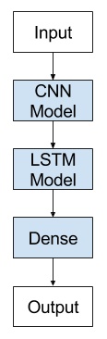
CNN+LSTM Architecture – Representation.
Data Generator
This is one of the most important part of the code. The overall structure of the generator has been given. In the generator, we are going to pre-process the images as you have images of 2 different dimensions as well as create a batch of video frames. You have to experiment with img_idx, y,z and normalization such that you get high accuracy.

Data Pre-Processing.
- Resizing and cropping of the images. This was mainly done to ensure that the they are two different shapes and the conv3D will throw error if the inputs in the batch have different shapes.
- Normalization of the images. Normalizing the RGB values of an image is very important activity to avoid light and shadows distortions.

Model Building.
Here you make the model using different functionalities that Keras provides. Remember to use conv3D and Max pooling 3D and not Conv2D and Max pooling 2D for a 3D convolution model. You would want to use Time Distributed while building a Conv2D + RNN model. Also remember that the last layer is the softmax. Design the network in such a way that the model is able to give good accuracy on the least number of parameters so that it can fit in the memory of the webcam.
Now that you have written the model, the next step is to compile the model. When you print the summary of the model, you'll see the total number of parameters you have to train.
Let us create the train_generator and the val_generator which will be used in fit _generator.
The steps_per_epoch and validation_steps are used by fit_generator to decide the number of next () calls it need to make.
Let us now fit the model. This will start training the model and with the help of the checkpoints, you'll be able to save the model at the end of each epoch.

Observations.
It is observed that as the Number of training parameters increase, the model takes much more time for training.
Batch size ∝ GPU memory / available compute. A large batch size can throw GPU Out of memory error, and thus here we had to play around with the batch size till we were able to arrive at an optimal value.

Experiment Number | Model | Result | Decision + Explanation | Parameters
1 | Conv3D | Training Accuracy 1.61  Validation Accuracy 1.59 | Overfitting Increase | 51,24,93,701
2 | Conv2D+LSTM | Training Accuracy 1.61  Validation Accuracy 1.60 | Good Results | 99,63,557
Final Model | Conv2D+LSTM | Training Accuracy 1.61  Validation Accuracy 1.60 | Good Results | 99,63,557

