ENNEAD

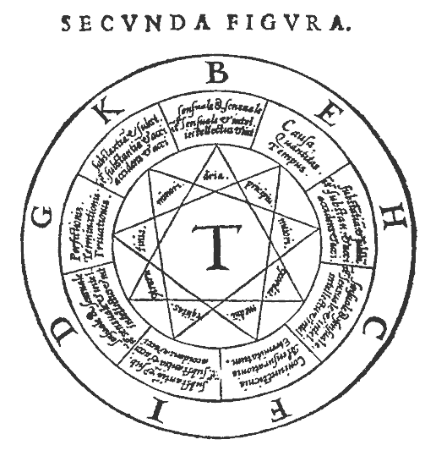

Raymond Lull in Artis Magnae Sciendi

HIGHER SYSTEMS

With the nine-term system we enter the domain of the last group of systems (in the series of twelve) from ennead to duodecad. The idea of the three domains was introduced in the essay on the octad. It will be useful to consider the relations between members of the three groups.
The elementary systems – monad to tetrad – recur in the higher systems. The monad and dyad are ubiquitous, as we should expect since they are the most universal. As we progress through the systems, we should expect that the higher the system the rarer is its realization, which means that it is less likely to recur. One of the most apparent kinds of recurrence is exemplified in the relation of the triad to the hexad and ennead, and in the relation of the tetrad to the octad and the duodecad. In these cases, we have a simple multiplication: 3 = 3 x 1, 6 = 3 x 2, 9 = 3 x 3 and 12 = 3 x 4; 4 = 4 x 1, 8 = 4 x 2, 12 = 4 x 3. The idea here is that the larger the multiplication, or recurrence, the less likely it is.
We have looked at the hexad and octad as dual combinations of triads and tetrads and can continue this thread in treating the ennead as a triple combination of triads.
The whole spectrum then has a structure that looks like this:
1 – 2 – 3 – 4 – 5 – 6 – 7 – 8 – 9 – 10 – 11 – 12
The simple picture leaves out, of course, the special place of the primes. Excluding 1 and 2, these are 3, 5, 7 and 11. Since these cannot be derived from other numbers, they probably signify the entry of something new. Traditionally, for example, the number 7 was called ‘virginal’ because it could not be derived from the other numbers. The sequence of simple multiplications and the sequence of primes between them articulate the series of twelve systems, in which the decad appears as a multiple of 5 to complete the scheme.
1 – 2 – (3) – 4 – (5) – 6 – (7) – 8 – 9 – 10 – (11) – 12
The interplay of 3 and 4, plus the sequence of primes covers nearly all of the systems and makes 12 a natural culmination.
In our treatment of the ennead then, we will address the implications of 9 = 3 x 3. In the form 9 = 3² we will also find a representation in what Sigurd Anderson and I call a class of N-grams. In this class, we have the series of squares 1 = 1² , 4 = 2² , 9 = 3² . The relation involving powers extends our picture of the systems because it goes beyond addition and multiplication. In the case of the twelve systems, it suggests a special relation between the tetrad and the ennead that we might not suspect otherwise. The N-gram of 9 is widely known in the symbol of the enneagram.

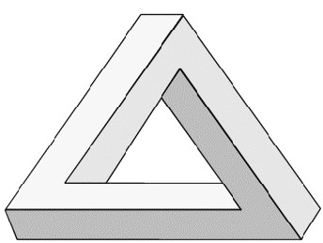TRIAD OF TRIADS
The ‘impossible’ triangle shown here symbolises the interweaving of three components, but we have to imagine each of the lines as itself a similar triangle. The image delineates the way in which each component acts on the other, changing direction, to return into itself. Traditional representations of enneads appear to lack any element of structural complexity of this kind. This may be because it just was not possible to represent this aspect by the languages or formalisms of the time and not because it was not understood. Representations either in words or pictures tend to be linear or flat and it is only in mythical narrative that it is possible that structural elements may be discovered since these can tap into inner visualizations. It is a relatively modern invention to be able to draw ‘impossible objects’ such as the one shown. Even most modern treatments represent the ennead as a matrix with two axes because they are ‘flat’.
In its association with the nine gods of Egyptian mythology, the ennead is the principle of creation. We interpret this basic idea as involving three kinds of creation or god-principle. We know that, as for example in Hinduism, there is a long tradition of three aspects of God, the Hindu example being Brahma (creator per se or demiurge), Vishnu (preserver and dreamer) and Shiva (destroyer-creator). But we rarely find any explicit treatment of the way in which the three are related together in one process. The linking of nine with creation is imprinted on our minds by the fact that there are nine months of gestation before we are born. Perhaps as a consequence, any process of transformation is considered to take nine units of time.
Navaratri is a composite festival celebrated all over India. Depending on gauna - local tradition, but for most beginning with the New Moon (Amavasya - dark moon night) or for some on the ninth day of the month of Virgo (Kanya) just prior to the Amavasya, or on the first day of the Hindu month of Ashwina (Padmanabha - Vaishnava mase), various ceremonies are performed. The essence of this festival consists of fasts and worship of nine aspects of Durga, one on each of the nine days.
Rishi Markyndya has given detail about Ma Durga and its nine forms. She is a form of "Shakti and power". The evolution of Shri Maha Saraswati, Shri Maha Laxmi and Shri Mahakali (the 3 main forms of "Shakti") took place from Shri Brahma, Shri Vishnu and Shri Mahesh respectively. Each of these 3 deities gave rise to 3 more forms and hence in all, these 9 forms together are known as Nav-Durga
In modern terms, the three aspects act in succession as ‘corrections’ or ‘improvements’ on the preceding. In ancient mythology, the initial phases of creation concern the action of proto-gods, impersonal principles of separation and union. This is succeeded by a phase in which the ‘personal’ gods appear and these, in turn give way to humanity. The idea of three different phases is universally prevalent but obscurely described. In many creation myths, the proto-gods create the gods who then disturb their progenitors and eventually overcome them. This leads into the third phase when humans arise. First they are servants of the gods but then they become autonomous and the gods ‘retreat’ or ‘die’. This suggests that there are three different kinds of creation and that the transition from one to the next is marked by a crisis. Such a picture was enfolded in the enneagram symbol as introduced by Gurdjieff nearly a hundred years ago.
The psychological meaning of the Hindu Trimurti is that Brahma is the creator, Vishnu the maintainer and Shiva the destroyer. This is differently reflected in Christianity in the cycle Creation, Incarnation and Perfection. The Hindu approach is useful in considering basic phenomena such as thinking: Brahma gets thoughts moving, Vishnu is the sustained meditation and Shiva is the emptying to give way to direct perception. This easily relates to the idea of a series of successive operations, or progressive corrections. It is also to be found in the thinking of William Pensinger in the guise of time-operators, which is largely based on Bennett’s scheme of three kinds of time and its development by the physicist David Bohm.
Three-fold operator-time, acting (at limiting velocities, accelerations, and time rates of change of acceleration of given limited spacetime domains) as a composite logical operator, decomposing and recomposing a multivalued reference space, is a generalization of the above described “three kinds of time” and an extension of Bohm’s notion of “active information”. It must be understood, however, that repetition in time, T, the parameter of hyparxis, is not the “everyday” sort of repetition associated with cyclic motion of a physical object in ponderable x,y,z-space relative to the (as commonly regarded) passive linear-time reference parameter, t. T is a larger context than that of t. T does not exist in t; t exists in T. The same applies to the relationship of t to t; t is a larger context than that of t. t does not exist in t; t exits in t . t repeats itself in t ;t repeats itself in T. t repeating itself in t can be imagined as analogous to a spinning circular disc moving continuously around the interior of the inner tube (a torus) of a turning automobile tire. t repeating itself in T can be imagined as analogous to a twisting cylinder moving continuously around the interior of a non-orientable, self-reentrant, spinning Klein bottle. These are chronotopological analogies only valid as viewed through the perspective established by a single-valued logic, whereas the reality of the involved relationships, as viewed through the perspectives established by m-valued logics, is that of 3-fold operator-time acting as composite logical operator to decompose and recompose a multivalued reference space.
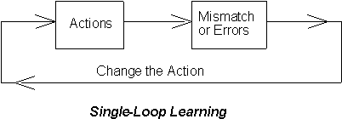This rather complex description can be supplemented by considering Bateson’s three levels of learning, a concept that has had considerable impact since it was first formulated decades ago. The following diagrams illustrate the scheme.

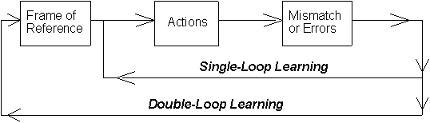
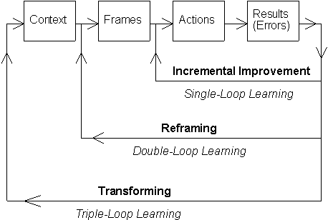

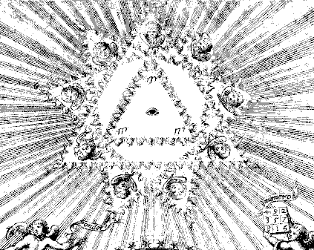A triplicity of processes seems fairly widespread but this does not address the prospect of a triplicity of triads. Gurdjieff adopted the approach of a triplicity of processes in his explanations of the enneagram, where he depicts three octaves coming into play at a triangle of points, where octaves signify processes and therefore embody time. A triplicity of triads means that elements in the three processes form three distinct relationships. This has been addressed by Richard Knowles in his analysis of organisation as composed of three kinds of management: Control and command; Task-orientation and Leadership in self-organisation. We can then envisage that there are two main perspectives on the ennead. In the one, we see an overlapping of three processes; while in the other we see a combination of three relationships or ‘laws’.
In the Finnish myth the Kalevela a mysterious object called the Sampo appears. It is nine-sided and the source of plenty or wealth.
On one side the flour is grinding,
On another salt is making,
On a third is money forging,
And the lid is many-colored.
Well the Sampo grinds when finished,
To and fro the lid in rocking,
Grinds one measure at the day-break,
Grinds a measure fit for eating,
Grinds a second for the market,
Grinds a third one for the store-house
The Sampo is a model of the cosmos directly springing from the traditions of Siberian mythology, which has many features in common with Finnish myth: the cosmic axis, shamanic journeys to the Polestar (the Nail of the North), the Sacred Tree with three, seven, or nine levels, the shaman's tent with its central pole and the starry "ciphered cover." Nine heavy doors shut it in, and nine locks of strongest metal make each door fast and safe. No man nor men can seize the mighty Sampo, but it is stolen and the earth is plunged into winter and hardship. This is now interpreted as a reference to the precession of the equinoxes and the shift of the celestial axis from one epoch to another. We will see later that the idea of three ‘grindings’ relates to the three processes incorporated into Gurdjieff’s enneagram.

NARRATIVE STRUCTURE
According to Joseph Campbell, the number 9 is associated with the Mother Goddess.
We should expect higher term systems to have an order of complexity that corresponds to that of ‘creative compositions’ such as intentional narratives. Myths of creation and legends of heroes are echoed in our time in novels, movies, computer games and plays. The main thrust of narrative is a character who moves through episodes of conflict and resolution; and it is notable that it largely retains the classical structure of three phases – in the case of plays, three acts – which correspond to the three stages of transformation through hazard. Hazard was a concept developed by Bennett, which he considered central to his vision of a ‘dramatic universe’. Hazard is the way in which the apparent negatives of uncertainty and ignorance can lead to progress. One of Bennett’s central arguments was that progress was not possible through any calculation based on past knowledge and existing powers.
Craig A. Lindley writes about narrative structure:
A very common narrative structure used in computer games, borrowed from film scriptwriting, is the three-act restorative structure (Dancyger and Rush, 1995). The three-act restorative structure has a beginning (the first act) in which a conflict is established, followed by the playing out of the implications of the conflict (the second act), and is completed by the final resolution of the conflict (the third act). The three-act restorative structure includes a central protagonist, a conflict involving a dilemma of normative morality, a second act propelled by the hero’s false resolution of this dilemma, and a third act in which the dilemma is resolved once and for all by an act that reaffirms normative morality. Each act within the three-act structure culminates in a point of crisis, the resolution of which propels the plot into the following act, or to the final resolution.
Computer games also exhibit three levels of structure: simulation, play and discourse. The first sets up the ‘physical’ characteristics and constraints of the game. The play brings in the time structure of moves and gain and loss. The third concerns the conversation and interpretation players can bring to the game.
The structure of narrative is also to be found in the vision quest. In a typical account, the seeker:
- leaves his home, his normality and comfort
- fasts and otherwise prepares himself in isolation
- encounters – as a sign, an ally, etc. – a guide into another world of experience
- undergoes ordeals
- comes to a crucial moment of choice
- separates from this second world
- forms a bridge between the two worlds
- creates something
- returns home bringing his gift to the people

These nine steps are variously described and sometimes amplified or reduced. A prime reference point is the monomyth of the hero as presented by Joseph Campbell and discussed by many since. Point 1 is now the ‘call to adventure’. Point 2 can be a refusal of the adventure or some demand it places upon him. Point 3 is now a combination of supernatural aid and passing the threshold into a ‘second world’, a kind of death, which has a guardian. In step 4, the hero is undergoing a series of tests or trials that stretch him to his limits. Point 5 is critical. In one aspect he reaps his reward, but is also subject to temptation to turn away from the true spirit of his quest into personal indulgence. He also sometimes has to face his ultimate authority figure and find a reconciliation, which is point 6. Point 6 is a new kind of test. The hero may not want to return but to keep to himself his newly acquired powers or insights. He may have to be awakened or called back by humanity. He undergoes a new birth, just as at point 3 he faced a new death. At point 7 he has mastered the two worlds and can move at will between them. At point 8 he is able to help his fellow men. At point 9 he may become indistinguishable from the rest of humanity.
The sketch of the Hero’s Journey shown here also exhibits a universal property of such narrative structures. First of all, it is circular; because it depicts a going away and a return. Secondly, it shows a kind of complementarity across the circle, as is highlighted in the drawing by the horizontal line in the middle. Such structures have been analyzed by Mary Douglas, as in her treatment of the Book of Numbers and the Iliad. She makes special mention of the top and bottom points. The bottom point she calls the ‘turn’ because it is the point at which the process turns from going outwards to coming inwards. Gurdjieff referred to this as the harnel-aoot which roughly means ‘the middle of the eight’. In this description he was starting from his idea of an octave (in completion of 8 notes) and it differed from his other treatment of ninefoldness known as the enneagram. Commentators have often combined the two treatments. Douglas calls the top point the ‘latch’ because it combines beginning and end. The theme expressed in manifold ways by T. S. Eliot – ‘In my end is my beginning’ – is a recurrent aspect of mythical and dramatic narrative.
In Mary Douglas’s work, the number of events varies according to the text. The cross connections can become more complex as in including triads and tetrads as well as complimentary pairs of items. Any generalization must miss out important content but the schema of three phases composed of three types of event and linked at three critical points can serve us well as a guide. The romantic, dramatic, heroic myth can even be seen to apply to our every day life.
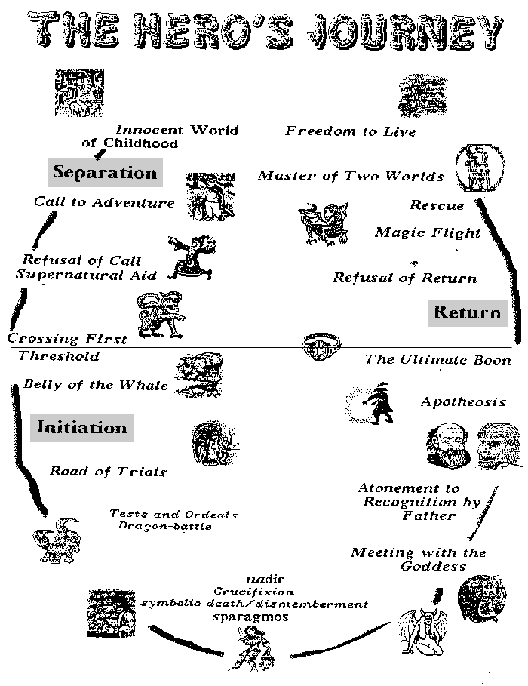

Both dramatic fiction and mythology concur in ascribing great significance and danger to a few critical moments. These are thresholds between different realities where help is needed to get through. The critical points are points of hazard. Nearly all traditions agree in ascribing a different kind of help to the second transition than to the first. Speaking in very general terms, the first concerns power while the second concerns love. The second kind of help is exemplified in western literature by the character of Margaret in Peer Gynt whose prayers redeem the self-indulgent ‘hero’ and prevent him being melted down by the Button Moulder back into the soul-stuff pool. The ‘eternal feminine’ waits for the hero as in Dante’s Divine Comedy.
The great theme of the return of the hero has an extraordinary development in the transition of Buddhism from the Hinayana to the Mahayana teaching, from seeking salvation for oneself to even renouncing it for the sake of all sentient creatures. If we look for it, we can find references to the cases when the total process halts before completion, as at the threshold of the sixth point. At this point in Hamlet the dying hero declares ‘the rest is silence’ because he cannot pass into the ‘normalisation’ hoped for in the future. In the Bible, Moses cannot himself enter the Promised Land. In Greek theatre, there was an established mechanism for depicting the transition through point 6, called later in Latin the Deus ex Machina or ‘god out of the machine’: a basket would be lowered to the stage containing the god who could resolve the conflicts the humans could not. Bennett pointed out that in classical terms comedy indicated a complete process while tragedy stopped at the sixth point (perhaps a soap opera or farce stops at point 3!). Even in crime thrillers, there is a standard formula that the detective figure faces death to enter into the last act of actually solving the crime.
Though much the same elements are used in any narrative they can be transformed into radically new meanings by the way they are interpreted and structured. We can see the life, teachings death and resurrection of Christ as a heroic tale following traditional lines but this would be to miss what was most important. Gurdjieff introduced an important concept in his idea of legominism. He said that significant information was transmitted consciously to future generations through works of art in which the expected pattern was broken just at key points where the significant information could then be discovered. When in traditional narrative we find the theme of intervention as at the critical thresholds, we might also be coming across a distant echo of an understanding of legominism.
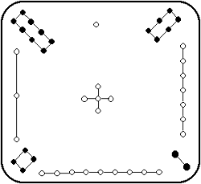The ennead then has an interpretation that takes us into the heart of narrative, the very way by which we express the making of meaning and intelligent action. It is a far cry from any simplistic pantheon of gods. It involves a human protagonist who takes risks, has limited understanding and needs help to make it through. This entails that any defined model serves only as a starting point and can never be adequate to the creative reality. In discussion of the enneagram as an N-gram we will briefly describe a 16 term system of complex structure that might be taken as a more adequate model of concrete narrative, but there are higher forms still and in practice we operate with basic chunks of story or events that are themselves complex and changeable. It is in entering the third domain of the systems that we begin to discover that that the terms of a system can become as complex as the whole system.

THE MAGIC SQUARE
In a magic square, numbers add up the same total along any line. One of the earliest from China is shown here (where the total is 15). A magic square of 3 x 3 elements is one of the simplest. Though the existence of magic squares can be treated as a mere exercise in number games, they have an important connotation, which stems from the property of ‘adding to the same number in every direction’. This implies a self-consistency in terms of the three directions (horizontal, vertical and diagonal) and can be interpreted as a means of checking that the arrangement of terms supports the harmony of the whole.
3 x 3 tables are used fairly widely, but usually in the reduced sense of being defined in two directions only. The table shown below is one of the tools in the TRIZ method of innovation. The cross-connections are left implicit. The term ‘system’ refers to some kind of device.

SUPER
SYSTEM

SYSTEM

SUB-SYSTEM
PAST PRESENT FUTURE

It is significant that the three directions can be seen as corresponding with the three kinds of time or with the three levels or loops of learning. The horizontal line is that of ordinary time. The vertical corresponds with eternity and levels. The diagonals will then correspond with the ‘hyparchic’ or truly inventive aspects. The evident fact that the representation tends to reduce our thinking to only two dimensions points to the deeper fact that the third component is relatively obscure and elusive.
The symmetry and form of the 3 x 3 matrix leads to treating the middle point as special. In traditional theologies, it is the ‘supreme god’. In speaking of the Ogdoad in our essay on the octad we mentioned that the eight gods form or give rise to Atum.
Magic squares appear in many guises. One of them is in Euler Squares, which can be illustrated diagrammatically as follows. In the case of a 3 x 3 square there is a given set of three shapes which can take three colours (shadings):
One then looks for an arrangement in which every row and column contains all three shapes and they are each of a different colour. One such is shown on the right. There are nine different ones depending on which element is placed in the centre. The diagonals will always consist of one shape in three colours or one colour in three shapes.
Such structures are useful when we have triads with three interpretations: the terms corresponding to shapes and the interpretations to colours. An example of this is fundamental to Bennett’s work. He postulates a basic triad of experience: Function – Being – Will; but he also gives this triad three interpretations from three perspectives: Objective – Subjective – Cosmic. There are therefore nine elements to consider. By arranging them in an Euler square we can bring out relationships between the elements; the simple matrix is replaced by a more intricate one as shown below. It exemplifies how a table of nine elements can be mapped into an alternative arrangement. The results may or may not be found to be meaningful.

Consciousness  Subjective aspect of being | Process  Objective aspect of function | Will  Cosmic term
Laws  Objective aspect of will | Being  Cosmic term | Knowledge  Subjective aspect of function
Function  Cosmic term | Understanding  Subjective aspect of will | Matter  Objective aspect of being
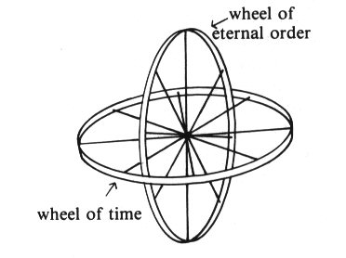In China, the nine digits had another form to that of the magic square; von Franz relates it to eternity. The sequence of the numbers now marks out a complex spiral that intersects with itself. In this arrangement, again the number 5 appears in the middle place and we may be reminded of the number 4 appearing in the middle of the heptad. All the odd number systems can have this property of a middle term that relates to a change of direction or change of nature. But the two arrangements reflect a general principle that von Franz refers to in terms of two kinds of time. The image here is taken from Wolfgang Pauli’s reports on his dreams. Looking at this figure, one can imagine it in terms of two quaternaries, one designated as 1 – 2 – 3 – 4 and the other as 6 – 7 – 8 – 9, with 5 at the centre. One can also consider that the two ‘wheels’ intersect with each other at two critical points while having a common centre that makes a third critical point.
7
2
8 3 5 4 9
1
6
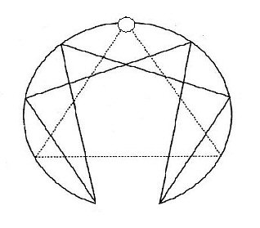The three points can be portrayed in a two-dimensional way as a triangle. This will relate to our understanding of the ennead as an N-gram in which the triangle represents three transitions. By bearing in mind the idea of the intersection of time and eternity we can better appreciate the multi-dimensionality of the nine-term system. One of the versions of the 9-gram is the enneagram sometimes depicted in this form with a gap between its two sides. In this form, following our discussion, point 5 would be at the top, 1 – 2 – 3 – 4 on the right and 6 – 7 – 8 – 9 on the left. However, it is more usual to have the numbers in sequence around the circle, 1 – 9, with 9 at the top.
This variation of position is inevitable. In one view of the system, we take the mid-point as most significant while, in the other, we take the end-point as most significant. In the case of the triad, the two views coincide because we have 1 – 2 – 3 and 3 is also mid-point between 1 and 2. In the case of the pentad we have 1 – 2 – 3 – 4 – 5 with 3 as the midpoint. The mid-point is associated with the essence or ipseity, while the end point is associated with the ‘master’ or culmination of the essence. It is possible to take either of these as most significant out of the five terms. In the case of the heptad, we have the end point 7 ‘completion’ as most significant or the mid-point 4 ‘harmonization’ (that is, between the two halves of the process) in that role.

AN N-GRAM
An N-gram is defined as a structure in which there are N points in a circle and which contains two patterns of connection between them. An important aspect of this approach is that it uses different number-bases for different N-grams. If N is 9 for example, the number base is our familiar decimal one. But if the number N is different than the number base is different. In every case, the number-base M = N + 1. It is from M, the number-base that we come to the way in which two different patterns will be obtained. In the case of N = 9 and hence M = 10, the two patterns derive from 10 = 3 + 7. There is a class of such N-grams for which N = x² where x can take the series of integral values 1, 2, 3, etc. Hence, N will equal 1, 4, 9, 16 and so on.
N-grams are depicted as circles of points with the two patterns inscribed in them. The patterns are derived by dividing 1 by each of the two derivative numbers a and b which come from the equation M = a + b. In the case of the 9-gram, the two numbers are 3 and 7. M is different in each case. In the 4-gram, the number-base is 5, which leads to a = 2 and b = 3. On dividing in base 5, these yield the following sequences:
½ = .222 recurring 1/3 = .131313 recurring
We also have to note that 2/2 = .4444 recurring, 2/3 = .313131 recurring and 3/3 = .333 recurring.
1
2
3
4

In the trivial case of the 1-gram (related to the monad)
1

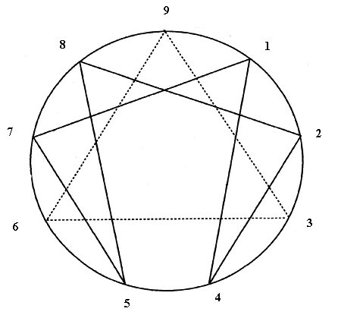The 9-gram is more widely known as the enneagram. Though it is far more complex, it has the same pattern as the preceding two simple cases of N = 1 and N = 4.
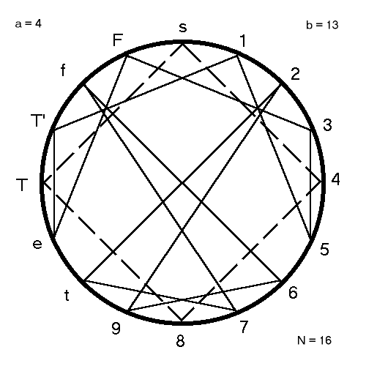The top point 9 is also a member of the pattern defined by the division of 7. 1/7 = .142857 recurring which sequence also appears in 2/7, 3/7 and so on, but 7/7 comes out as .999 recurring. The three points of the triangle derive from 1/3 as .333 recurring, .666 recurring and .999 recurring. N-grams of this type grow ever more complex rapidly, as is illustrated below for the 16-gram (4²) where the number base is 17.
The diagrams suggest that the two patterns will be of different nature and the one deriving from the smaller number a (in the equation M = a + b) will represent the overall organisation while the larger number b will represent the ‘workings out’ or adjusting process. In the case of the 4-gram the overall organisation or law is dyadic (points 2 and 4) and the figure corresponds closely to our intuitions of the tetrad: points 2 and 4 can be taken as actual and ideal, while points 1 and 3 interact as practical and theoretical, or instrumental. We should note that in the 16-gram shown here the two hexadic cycles are actually connected because they both derive from 13.
The division of the connectivities into two patterns distinguishes this representation from our previous ones because it is more structural. In his writings about systematics, Bennett loosely defined structure in terms of combinations of systems, but the N-gram approach gives a more definite form. Again we see a progression at work; in this case a progression in terms of number of distinct patterns. Structure arises when we have two such patterns working with each other, and there may be cases in which three or more patterns work together.

SRI YANTRA
The root of the word yantra means to 'sustain'. Originally the term yantra referred to a kind of machine or mechanical device; the meaning of the term then expanded to religious practices. Yantra in that context is an abstract geometrical design intended as a tool or aid for meditation and increased awareness.
The word "Tantra" comes from the root tan, to "extend", "continue", multiply". "Tantra" means "what extends knowledge"
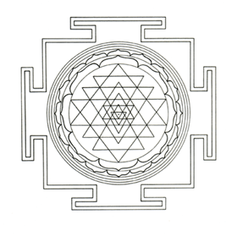In the Hindu symbol, related to Tantra, there are four upward pointing triangles (feminine or shakti) and five downward pointing ones (masculine or shiva). This appears as a simplistic rendering of nine: 9 = 5 + 4. But it has the same property of interlocking of shapes that we found in the enneagram. George Joseph writes:
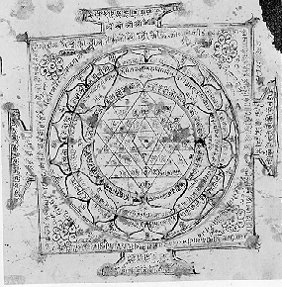A hymn from Atharavaveda is dedicated to an object that closely resembles this. The sriyantra ('great object') belongs to a class of devices used in meditation, mainly by those belonging to the Hindu tantric tradition. The diagram consists of nine interwoven isosceles triangles four point upwards, representing Sakti, the primordial female essence of dynamic energy, and five point downwards, representing Siva, the primordial male essence of static wisdom The triangles are arranged in such a way that they produce 43 subsidiary triangles, at the centre of the smallest of which there is a big dot (known as the bindu). These smaller triangles are supposed to form the abodes of different gods, whose names are sometimes entered in their respective places. . . . The square represents the boundaries within which the deities reside, protected from the chaos and disorder of the outside world.

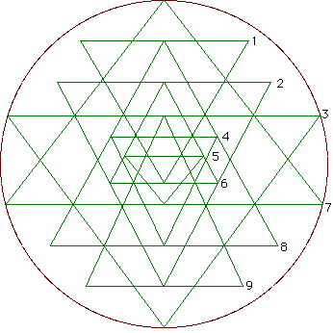Tantric tradition suggests that there are two ways of using the sriyantra for meditation. In the 'outward approach', one begins by contemplating the bindu and proceeds outwards by stages to take in the smallest triangle in which it is enclosed, then the next two triangles, and so on, slowly expanding outwards through a sequence of shapes to the outer shapes in which the whole object is contained. This outward contemplation is associated with an evolutionary view of the development of the universe where, starting with primordial matter represented by the dot, the meditator concentrates on increasingly complex organisms, as indicated by increasingly complex shapes, until reaching the very boundaries of the universe from where escape is possible only through one of the four doors into chaos. The 'inward' approach to meditation, which starts from a circle and then moves inwards, is known in Tantric literature as the process of destruction.
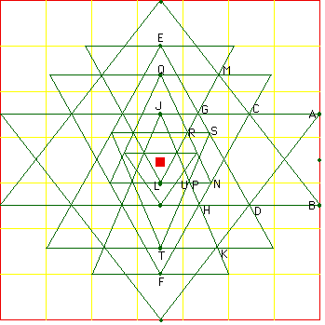
Of some interest is the construction of the Sri Yantra from a 7 x 7 checkerboard (click on the image above for an animation).
The Yantra and the Enneagram are two very different representations of the ennead. Both exhibit complex structure and both embody interlocking triangles, though a far cry from the simple form of three equal triangles spaced around a circle. The Yantra has remained a kind of icon specifically associated with Tantra and used in meditation, while the enneagram has been interpreted in modern terms and used to analyze and guide all sorts of structured process without any particular attachment to any spiritual content. The existence of these two forms highlights the fact that the higher systems cannot be represented in any complete abstract way. A figure of 9 points showing them all as equi-distant from each other would require 8 dimensions! Kulaichev says that constructing the Sri Yantra exactly from an algebraic equation would require 10¹¹ operations!
The two representations we have are highly individual and special. They can be seen as ways of structuring complex information for a given community. Gurdjieff once said that the enneagram was the emblem of a secret society. The idea of Sri Tantra comes from the text Yogini Hridaya (Heart of the Yogini Tantra) which starts:
From the fivefold Shakti comes creation and from the fourfold Fire dissolution. The sexual union of five Shaktis and four Fires causes the chakra to evolve. O Sinless One! I speak to you of the origin of the chakra.
When she, the ultimate Shakti, of her own will (svecchaya) assumed the form of the universe, then the creation of the chakra revealed itself as a pulsating essence. From the void-like vowels with the visarga emerged the bindu, quivering and fully conscious. From this pulsating stream of supreme light emanated the ocean of the cosmos, the very self of the three mothers.
The baindava of the chakra has a triple form, dharma, adharma and atma, and matri, meya and prama. The chakra of nine yonis is the great mass of consciousness bliss and is the ninefold chakra and the nine divisions of the mantra.
There are nine mandalas or patterns to be found in the Sri Yantra and numerous other sets involving 4, 9, 10, 15, 27, 51 etc. members. It is striking that Gurdjieff also said that the enneagram constituted an encyclopaedia in that everything one knows can be put onto it. The two versions also concur in dealing with energy - or shakti in Hinduism – and form. That is why Gurdjieff’s enneagram can be used to understand transformation. We saw the general property of N-grams in combining two orders, one giving the overall ‘law’ of the process or its form and the other giving the ‘workings out’ in practice or its energies. So it is in Tantra, according to M. Alan Kazlev :

The Tantrics call the Self-creative Power of the Supreme Absolute Shakti (usually transliterated as "S'akti"), from the Sanskrit root S'ak, "to be able, to have force to do, to act" [Arthur Avalon, Shakti and Shakta, Dover books, p. ].
Without Shakti, there is no Creation. As the Bengali Shakta Tantrics are fond of saying: "Shiva (the Absolute Consciousness-Being) without Shakti is a corpse" (i.e. lifeless, inert). Hence there must also be a Power of manifestation. This is Shakti.
So the Absolute Reality is made up of two fundamental principles: Shiva, the Absolute in its own essential, perfect, unchanging, non-dual Consciousness, nature; and Shakti, which is that Absolute's own Power of self-manifestation. As Jaideva Singh explains, "Shakti is nothing separate from Shiva, but is Shiva Himself in His creative aspect" [p.9].
Shiva is nivritti (state of rest) and Shakti is pravritti (state of activity), in the ultimate state they remain in a union of oneness. This is the principle of non-duality (advaya) which is described in the Tantric texts in terms of maithuma (sexual intercourse) or kama-kala ("unit of desire"). One text, the Kama-kala-vilasa describes Shiva or Mahesha as pure illumination or self-shining (prakasha-matra-tanu) with all the principles of activity contracted within it. Shakti the seed of the future world (bhavi-chachara-bijam). Shiva realises himself through Shakti, reflection [Shashibhusan Dasgupta, Obscure Religious Cults, p.333 (1969 Firma KLM Private Ltd, Calcutta)]
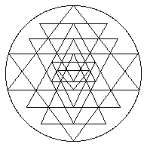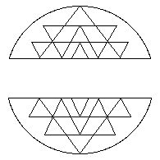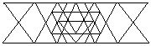Translating the Hindu idea of Shiva-Shakti into the enneagram, the triangle would represent Shiva and the hexadic figure Shakti. Instead of the 5 + 4 of Yantra we have 6 + 3. At the centre of Sri Yantra is the bindu or point from which creation begins. In the enneagram the equivalent is hidden in the top point 9, because it is also taken to be 0. There is another correspondence between the two figures in their combination of symmetry and asymmetry.
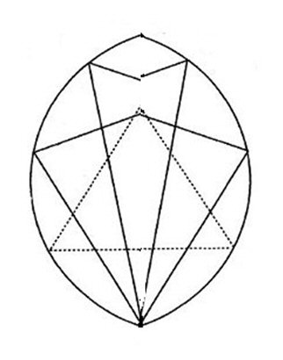The enneagram has symmetry about the vertical and, cutting out the middle region, we see an interesting figure, which we can call the ‘seed’ or ‘egg’ form of the enneagram.
SEED OR EGG FORM OF ENNEAGRAM
It has been a puzzle that the form of the enneagram has a kind of gap in it (between points 4 and 5) when the figure opens up into its complete form. It then appears that the gap at the bottom is progressively resolved – through 6-3, 7-2, 8-1 – until it is overcome completely at the top 9-0. This is like the seed germinating or the egg cracking open to allow the new life to emerge. It has been noticed that the enneagram with opening (figure repeated here) represents a womb which amplifies the association between nine and the Divine Mother or shakti.

MODEL OF PROGRESSION
The meaning of nine is much influenced by the decimal system or base-10 counting system we are used to, because in this system we only need 9 digits (the zero is a special case) and so including all nine means that everything is covered. This does make a strong association between the ennead and the idea of a complete encyclopaedia. However, this is not a matter of containing information about everything but rather about how what we know can be organized. The ennead can be seen as a way of organizing knowledge, where organization is understood as the ableness to combine different orders. An order is where one has a rule for getting from one item to another such that all the items are included; the simplest being a list. Organization is related to recapitulation, which basically means going over the same material again but implies that the order may change in doing so. Typically, the personal discipline of recapitulating the day proceeds backwards.
0 – 1 – 2 – 3 – 4 - 5 – 6 – 7 – 8 - 9
9 – 8 – 7 – 6 – 5 – 4 – 3 – 2 – 1 - 0
Sequences carry in them information about the numbers. Take the sequence of numbers marked in the following way.
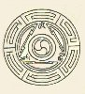 0 – 1 – 2 – 3 – 4 - 5 – 6 – 7 – 8 - 9
The numbers in italics make up a geometric series 1, 2, 4, 8. It may be interesting that the series continues into 16, 32, 64, 138, etc. that yield by ‘theosophical addition’ 7, 5, 1 etc. There is therefore a series 1, 2, 4, 8, 7, 5, recurring which is a rearrangement of the inner cycle 1, 4, 2, 8, 5, 7. The other numbers 3, 6, 9 make up the inner triangle. The point of such games with number is not to suppose any deep hidden wisdom but simply the property that organization comes out of combining two or more orders, where these orders can be explicitly understood as definite sequences.
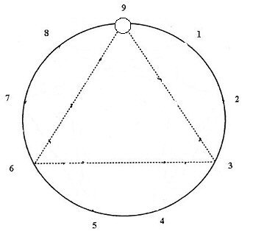A much simpler approach considers the sequence of nine numbers to embody the series of the first nine systems. In this guise we can amplify the association between ennead and encyclopaedia: if we understand the systems, then each carries for us a distillation of diverse experience and knowledge as well as just the abstract form of the system; and the recapitulation of all the systems creates an embodiment of all our knowledge and experience and understanding. The ennead is then a symbol for the organization of all our experience. It was in this light that Gurdjieff said that ‘everything a man knows can be put on the enneagram’.
He enneagram provides a clear illustration of organization as the ability to transform one order into another, which is particularly shown in having a linear order around the circle and an inner order trough the cycle of six points.
The sequence of numbers around the enneagram as the sequence of systems makes this symbol into a representation of progression. In this representation, the systems are grouped into threes and not fours as discussed in the preamble. Taking the enneagram numbering but representing the connections as three triangles, the grouping in threes comes out as shown. The black triangle is the same as in the enneagram. The grey triangle can be called the triangle of ‘tensions’ or the dramatic aspect and each of the points (according to the enneagram) is at a threshold of a new reality. The white triangle can be called the ‘stabilising’. Reverting to the earlier discussion of three gods, we can feel correlations with God the Father (black), God the Son (grey) and God the Holy Ghost (white), or speculate about a correlation with Shiva, Vishnu and Brahma. The enneagram’s own grouping leads to the open-ended 1-4-2 and 8-5-7 as well as the closed 3-6-9.
The first three systems are global properties of the design. The monad is the whole circle. It has two complementary sides as a dyad, which we will discuss later. The triangle indicates a triadic structure. Jumping to the three systems heptad, octad and ennead: the heptad is in the seven points of the hexad plus the top one (as explained in the section on N-grams); the octad in the eight points leaving out the top one (Atum in the Egyptian Ogdoad), and the ennead in the whole figure. The middle systems are obscure.
The nine makes a set of partitions 9 = 9 + 0 = 8 + 1 = 7 + 2 = 6 + 3 = 5 + 4. These are aspects of complementarity. The partition 8 + 1 resonates with the Ogdoad – the gods creating a principle of order (Atum) out of chaos. The partition 7 + 2 represents the heptad resolving the opposition of the dyad. Looked at in this way, the left hand systems appear as ‘hidden’ in the right hand ones. This also applies to the pentad being ‘hidden’ in the tetrad (5 + 4), as in the ancient conception of the fifth element, the ether, underlying the four elements. In China, the ninefold pattern is actually a development of the basic pentadic structure of the Chinese cosmos, the central point plus the four cardinal directions. The partition 6 + 3 reflects the idea that the ‘law of three’ implies six ‘laws’. In this approach, we have a complementarity equivalent to that of the explicate (on the right) and the implicate (on the left) which also resonates with the structure of ancient texts discussed in the section on narrative.
An extremely important possibility of the arrangement is that we can regard the systems on the right as natural and the systems on the left as intentional. It is then as if in going from tetrad to pentad we pass from what is given to what we have to create. This may be why it is that many people have found this transition enigmatic. In the exemplification of the enneagram in a kitchen/restaurant the transitional region is exactly where fire transforms the raw food into cooked. It is the meeting point of destruction and creation. The old dies and the new is born. The two sides of the enneagram, reflecting the structure of ancient texts and narrative in general, produces a mirror order such that the correlation is between 1-2-3-4 and 8-7-6-5.
If we consider all the possible linkages we have surveyed, then each of the six points 1-2-4-5-7-8 has four points with which it is connected. Take, for example, point 1. It links with 8 as a complementarity, where 8 is the ‘secret’ of 1. It links with 7 as its ‘informing principle’. It links with 4 as the element it informs. And it links with 2 as the ‘next step’. In this light, there is a series of pentads.
These speculations serve at least to support the view that the progression of systems is not a simple linear affair. There is a structure within this progression. We have looked at this structure in terms of complementarity, relationship and cyclicity. What needs to be spelled out is that in the higher systems, the system as a whole represents a framework for its contained systems as elements. This makes it difficult to articulate the properties of each system, because it operates in the context of the others. An interesting attempt comes from the tradition of Kabbalah, as enunciated by Carlos Suares in Cipher of Genesis, which is expressed in terms of life. For each of the nine archetypes he describes, we attach a simplistic equation to link and contrast the Kabbalistic with the systematic descriptions.

NINE PROJECTIVE ARCHETYPES
The systematics of the projective language which is the Qabala has two assets:
1. Nine letters symbolizing nine archetypal projective activities (or functions)
2. Two modes of projection of these archetypal forms. Namely:
- Projections into actual existences, states or conditions (or organs)
- Projections into exalted states or conditions of existence.
There is not the space to give more than a glimpse of what this means. Some of it will, it is hoped, become clearer from illustrations later. We will at this stage confine the exposition mainly to the concept symbolized by the first nine projective archetypes. These are the Hebrew letters whose numbers run from 1 to 9. The letters from 10 to 90 are 2.1 above, those from 100 to 900 are 2.2.
The first nine archetypes symbolize tremendous unifying concepts. They must do, if they apply to everything that exists throughout the universe, on every scale. They express the forces or powers which organize and maintain everything in an immense structure of energy transformations.

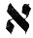1 ALEPH As existence is a mystery so is the existence of life a mystery. ALEPH tells us no more. There is no more to tell.
existence = wholeness

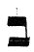2 BAYT There is no life apart from living things. The containers of life.
container = complementarity

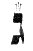3 GHIMEL Everything changes. If there is ALEPH and BAYT together there must be some transformation of energy. Inside all living things something is going on. Foods are converted to the energies of life. Eating occurs, and being eaten. All living things show the function of nutrition.
change = dynamism

4 DALLET This letter projects the concept of resistance to 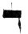disruptive forces. In inorganic structures this is no more than the restoring forces which hold them together against disturbing forces from without. In atomic nuclei it is recognizably the role of the binding energy. In living organisms it projects itself as the characteristic function of response to stimuli. It is the archetypal principle of challenge and response discernible in the movements of rise and fall of individuals, societies and civilizations.
binding energy = order

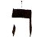5 HAY Life is a projective archetype in its own right, not merely as such but in its completely generalized concept of participation in the universal drama as an intermediary. All life, throughout the universe, is engaged in a common task which only life can perform: the task of transmitting impulses which maintain the balance of a hazardous universal harmony. Life can both give and take, and because it is sensitive it can adjust to 'fit in' with environmental pressures and requirements which go beyond the needs of its own self-preservation or self-expression. In living things this is projected as the ecological function.
hazardous harmony = essence significance

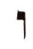6 VAV This is the archetype of fertility or copulative impregnation. As in Latin: six means sex. (VAV is the grammatical copulative). Projected into living organisms it is the function of reproduction. It is the power of living recurrence, the ageless force of perpetuation connecting old and new, old and young.
reproduction = coalescence

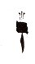7 ZAYN This is the archetypal structured movement towards the indeterminate potentialities opened up by VAV. In the living cell it is immediately recognisable as motion.

structured movement = transformation

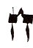8 HHAYT conveys the concept of a storehouse of potentialities able to be drawn upon when necessary, like a bank balance. A pool of unstructured energy of qualitative characteristics which may be used to give form to structures. The 'collective unconscious' of depth psychology and, in living things, the gene-pool of hereditary characteristics, are both projections of the archetypal concept symbolized by HHAYT.
pool unstructured energy = completedness

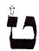9 TAYT is exemplified by its projection, in living organisms, as the character of the cell itself. The function of the cell is essentially the female one of drawing upon the reservoir of unstructured characteristics symbolized by HHAYT and building them up into the necessary structures. The womb is the place of gestation, of bringing to birth. Nest-building aptly typifies TAYT.
womb = harmonization

EULER’S CIRCLE
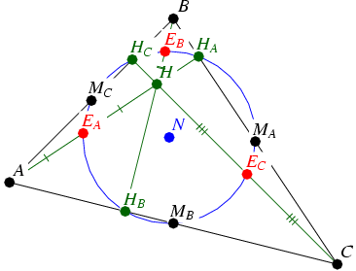Take any triangle and drop the perpendiculars from each corner and draw a circle through the three points H. This circle will intersect the triangle again at points M – which are the midpoints of the sides of the triangle - and the perpendiculars at points E. It now has nine points on its circumference. Inside the circle is H the orthocentre and N its own centre. Outside the circle are the three points of the original triangle. When the triangle is equilateral, two sets of points coincide and it appears there are only six. The centre of the circle and the centre of the triangle also coincide. If we omit the central point and include the triangular ones, then we have nine points again. The more symmetrical figure is more likely to turn up in symbols than the asymmetrical forms. This is because of the tendency inherent in symbolism towards symmetry. This in turn reflects operations in mental space which are the source of such theories such as that of archetypes and some models of the unconscious. The inherent properties of number are projected into this space. In the higher systems, it becomes ever more significant. If pure qualitative number is the masculine side, then this inner space is the feminine side.
In ancient Egypt, the goddess Hathor evokes the sense of inner magical space in which new life can be conceived. As the ’beautiful one’, ‘ mistress of the vagina’, goddess of love, motherhood and female sexuality, Hathor is a quintessential Alchemical/Tantric Goddess whose priestesses were schooled in the sacred feminine arts of adornment and lovemaking. They are often shown holding a mirror with Hathor’s face carved on its handle. The mirror has many symbolic meanings. At first glance, it represents beauty, and the art of adornment. However, its meaning and usage go much deeper. It is both a tool for perceiving the inner working of the mind and a symbol for the act of self-observation. In ancient Egypt, it was used by the priestesses in magical practices for sending back negative energies to their source, as well as a medium for seeing through time, space and the more subtle dimensions of reality. While gazing into its depths, they would expand their awareness to journey from the earth to the stars and from the outer material form to the inner spiritual essence.
According to the eminent scholar of Egyptian studies E. A. Wallis Budge, Hathor was perceived as "the great Mother of the World," and the "power of nature that was perpetually conceiving and bringing forth, rearing and maintaining all things, both great and small." In this role she represented the fullness of the feminine experience. "She was the mother of her father, and the daughter of her son. Heaven, earth and the underworld were under her rule and she was the mother of every god and every Goddess."
